SECURITY IMPLEMETATION

CREATE USER

Method: POST

URL: <http://localhost:8081/user>

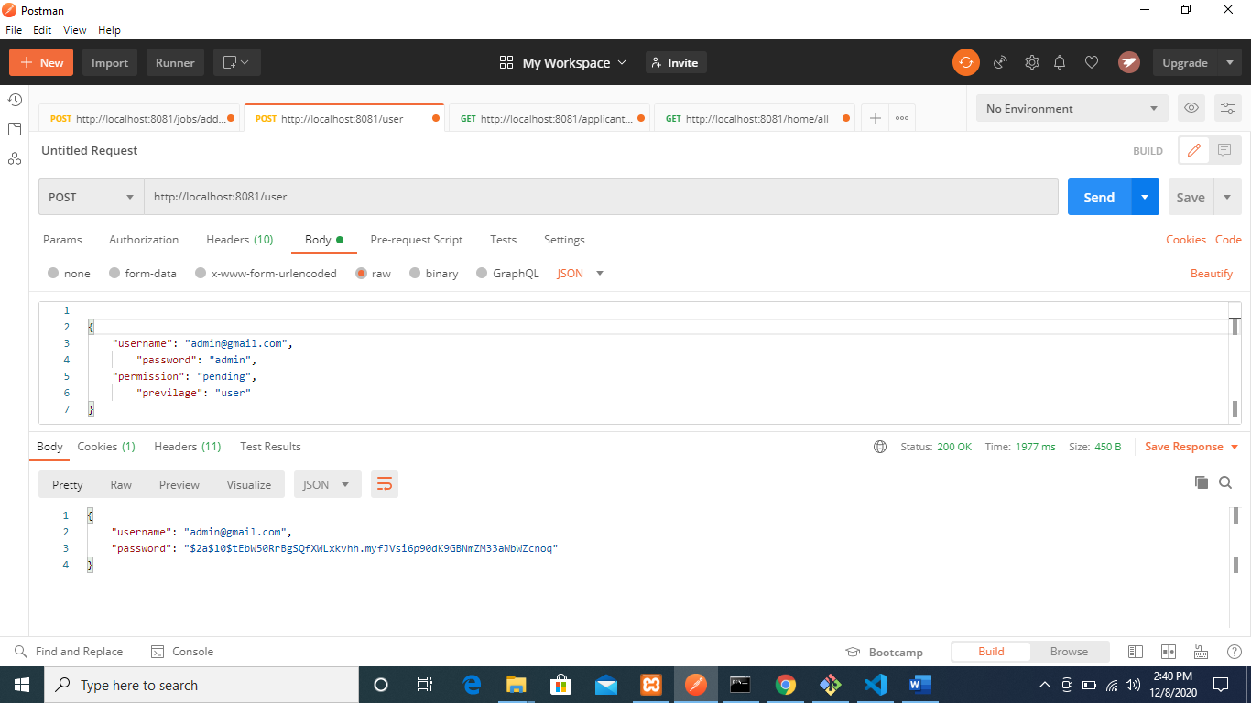

USER AUTHENTICATION

Method: POST

URL: <http://localhost:8081/authenticate>

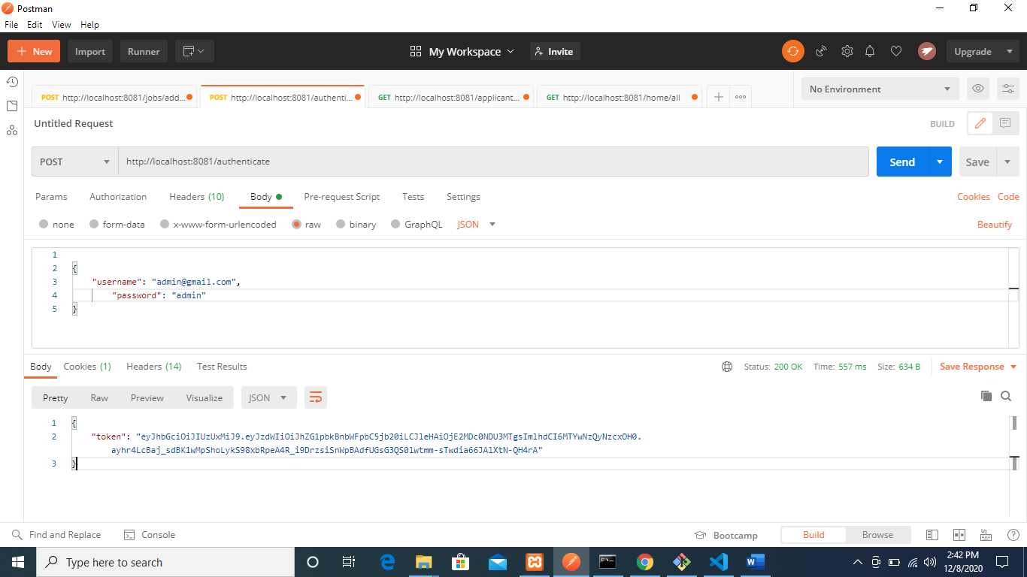

CREATE A JOB

Method: POST

Url: <http://localhost:8081/jobs/addjob>

Paste the token on the header as AUTHORIZATION

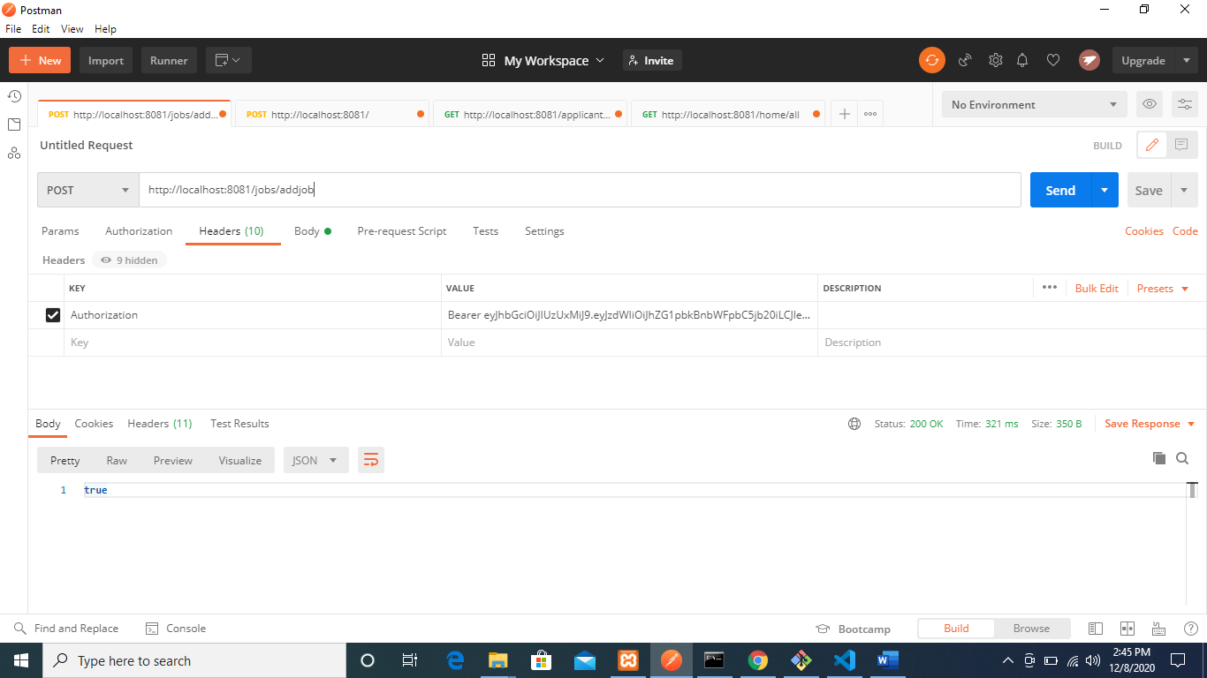

Fill the message body as show

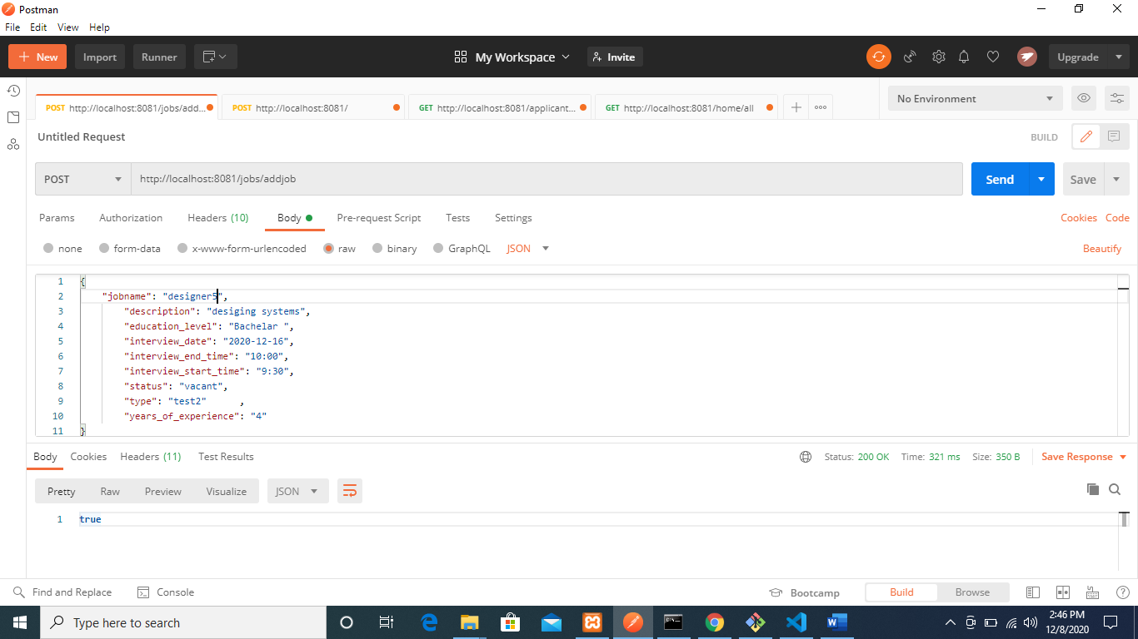

UPDATE A JOB

Method: PUT

Url: <http://localhost:8081/jobs/update/designer5>

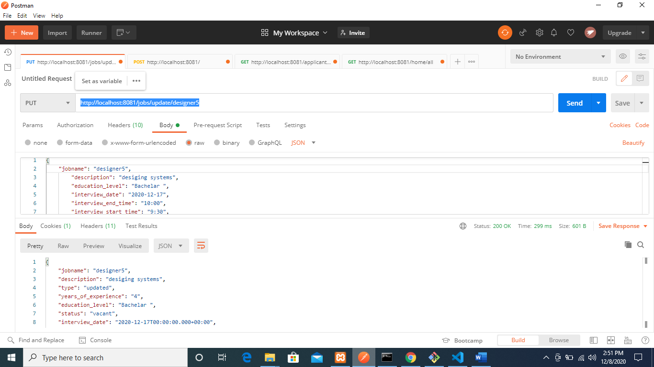

GET ALL JOBS

Method: GET

Url: <http://localhost:8081/jobs/all>

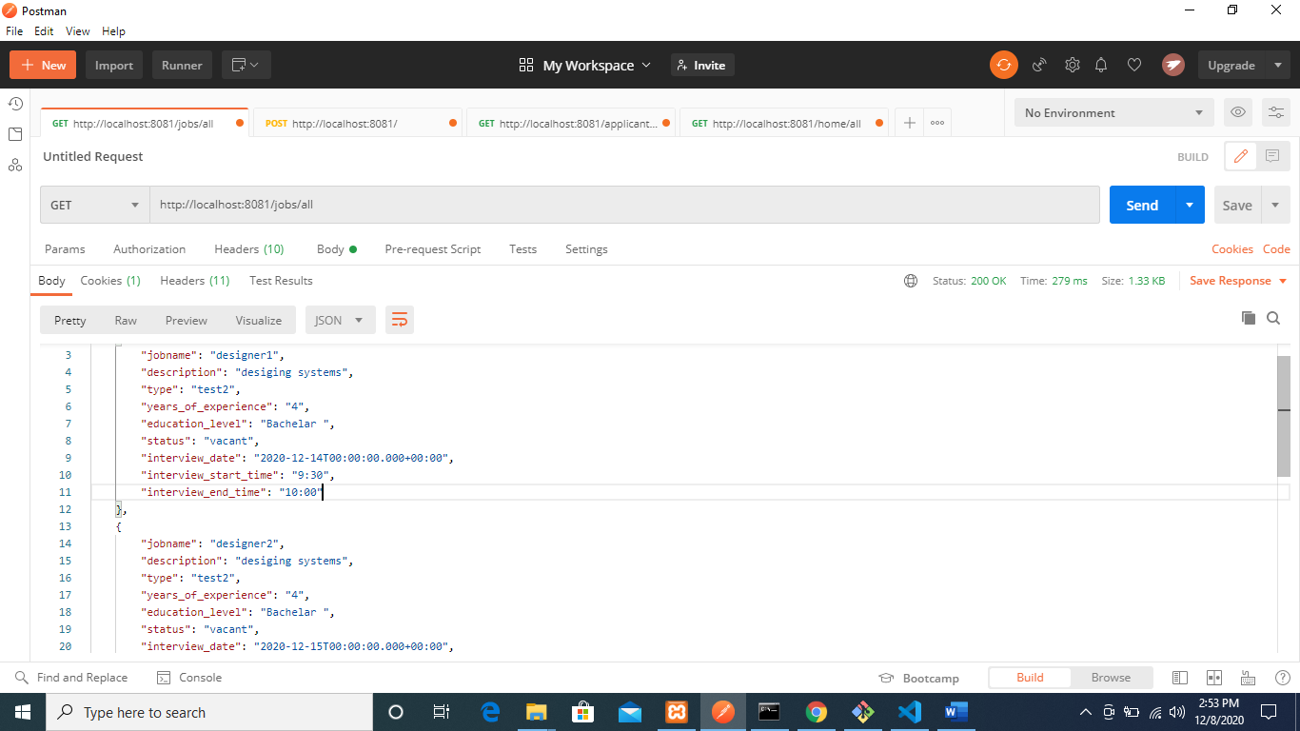

DELETE A JOB

Method: DELETE

Url: <http://localhost:8081/jobs/delete/designer5>

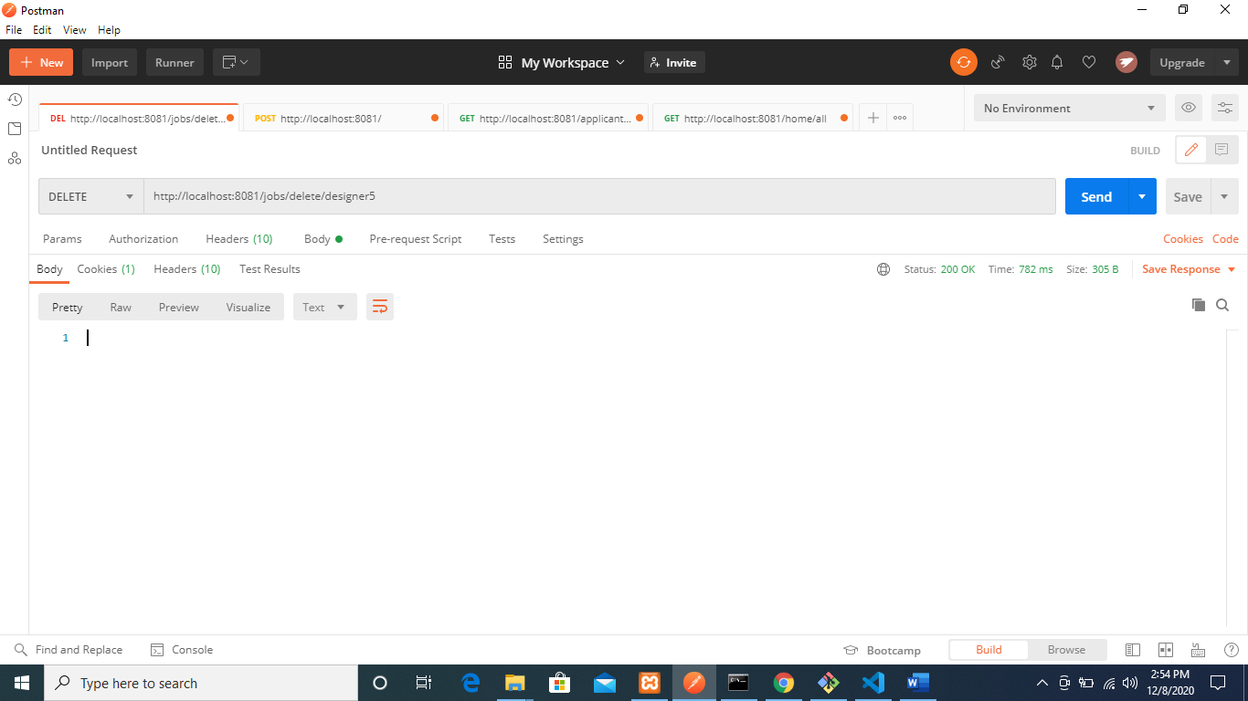

JOB APPLICANT CREATING ACCOUNT (Using similar Authorization as Above)

Method: POST

Url: <http://localhost:8081/applicants/register>

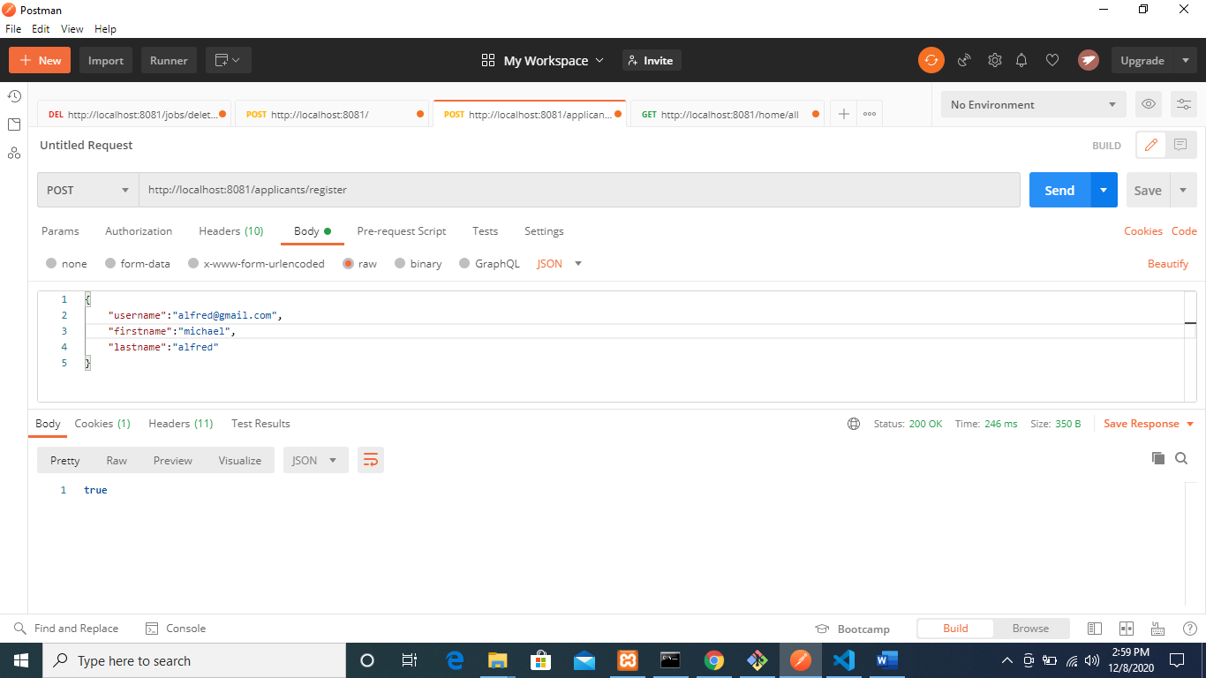

UPDATE APPLICANT PROFILE

Method: PUT

Url: <http://localhost:8081/applicants/update/alfred@gmail.com>

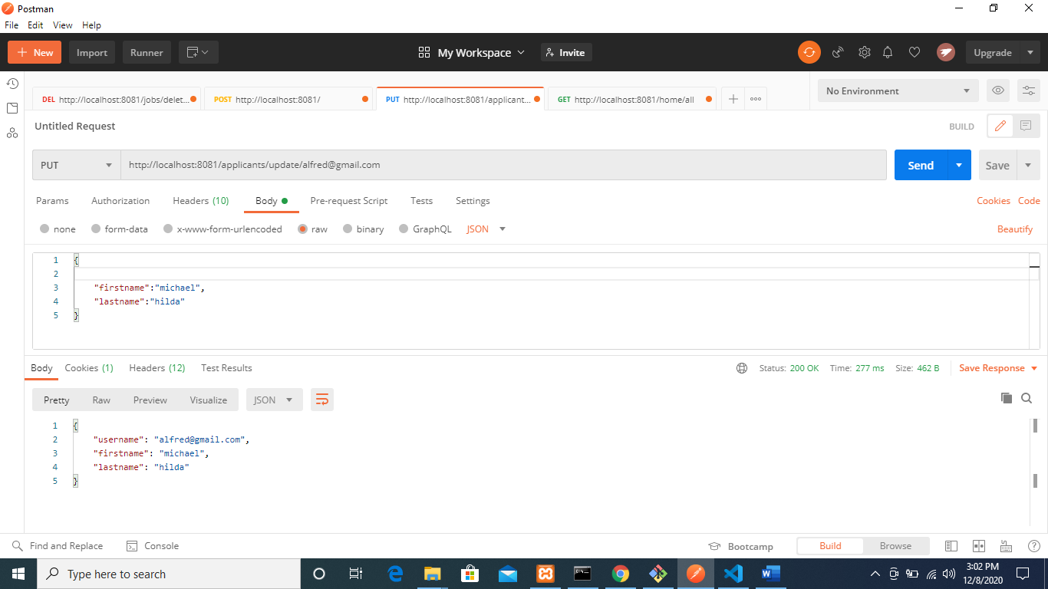

GET ALL APPLICANTS

Method: GET

Url: <http://localhost:8081/applicants/all>

