Modeling Human Activity States Using Hidden Markov Models
Student: Kagaba S. Etienne Course: ML Tech II University: ALU Repository: Link

Background and motivation
To alert caregivers of high-risk falls in Parkinson's patients, continuous iPhone accelerometer and gyroscope readings model hidden activity states (still, standing, walking, jumping) via a discrete HMM, using short-window sensor features as observed emissions.

Data collection and pre-processing
Data was collected on Oct 30, 2026, via Sensor Logger (21 zip files per activity). Calibrated/uncalibrated accelerometer and gyroscope data were logged at 100 Hz.
Device | iPhone
App | Sensor Logger
Sensors | Accelerometer, Gyroscope
Sampling rate | 100 Hz
A single device ensured a consistent 100 Hz sampling rate across all recordings.
Activity recording video links: Standing (video), Walking (video), Jumping (video), Still (video).
Timestamp-sorted streams were joined into 5-s non-overlapping windows (500 rows at 100 Hz) to capture gait/jump cycles; trailing partial windows were discarded.
Across all four activities (Still, Standing, Walking, and Jumping), 21 raw zip files were recorded per activity. This produced 35 windows (175 s) for Still, 44 windows (220 s) for Standing, 30 windows (150 s) for Walking, and 30 windows (150 s) for Jumping.
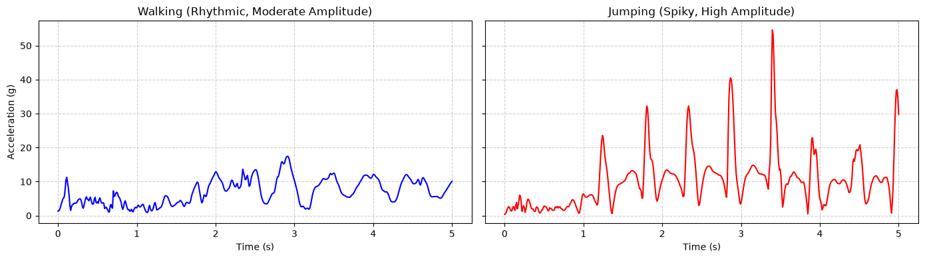
Figure 1. Acceleration magnitude over 5 seconds. Walking stays in a moderate repeating band. Jumping produces sharp spikes above 40 g.
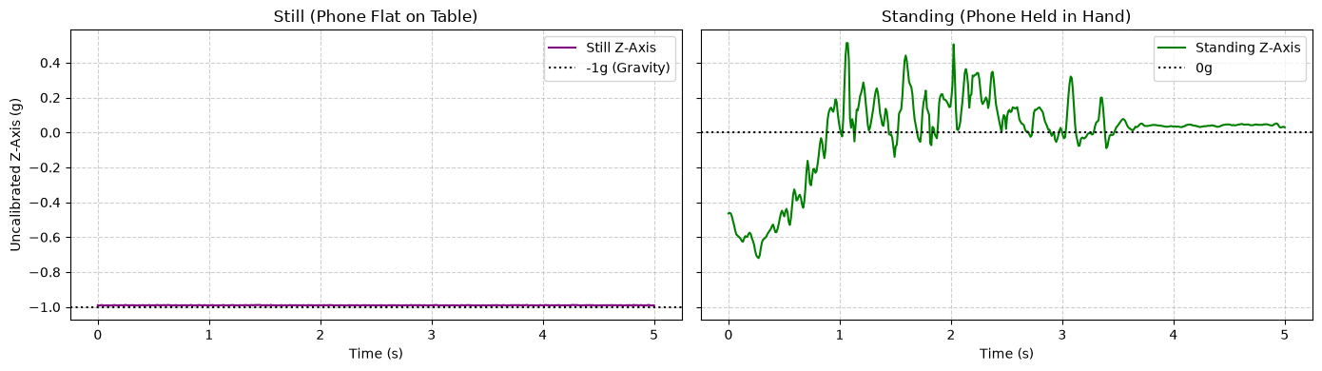
Figure 2. Uncalibrated Z axis. With the phone flat, the trace sits near −1 g. While standing with the phone in hand, it wanders around 0 g.

Feature extraction
Each 5-second window is transformed into a single observation vector of 5 domain-specific features across time and frequency domains.
Feature | Domain | Why it separates the activities
acc_mag_var | Time | Spread of acceleration magnitude. Jumping varies far more than standing or still.
acc_mag_rms | Time | Average power of the acceleration magnitude. Active windows sit above quiet ones.
uncal_z_mean | Time | Mean uncalibrated Z. A flat phone (still, near −1 g) differs from an upright phone (standing, near 0 g) when both are almost motionless.
gyr_y_var | Time | Variance of gyroscope Y. Walking swings the phone; still and standing do not.
dominant_freq | Frequency | Frequency of the largest FFT peak of acceleration magnitude above 0.5 Hz. The cutoff drops slow handling drift. The sample walking window peaks at 2.00 Hz, about two steps per second.
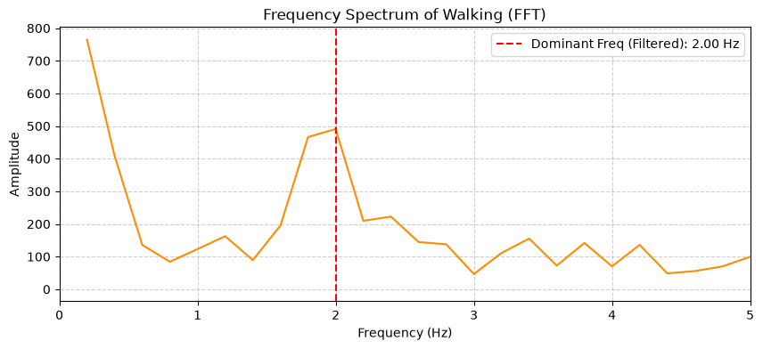
Figure 3. FFT of one walking window. The peak kept as the dominant frequency is 2.00 Hz.
Features are standardized using StandardScaler. K-Means quantization is fitted strictly on the training split.

HMM setup and implementation
The 5 continuous features were quantized into 10 discrete symbols via K-Means (random_state=42) on 70% of the data. Windows were grouped into sequence blocks of length 10 (9 training, 4 validation).
Element | Choice in this project
Hidden states (Z) | still, standing, walking, jumping
Observations (X) | 10 K-Means symbols from the five features
Transition probabilities (A) | 4×4 matrix, learned by Baum–Welch
Emission probabilities (B) | 4×10 matrix, learned by Baum–Welch
Initial state probabilities (π) | Four values, learned by Baum–Welch
Rows were split 70/30 per activity prior to quantization, then grouped into 10-window sequences (9 training, 4 validation sequences total).
Baum–Welch training converged at iteration 66 (final log-likelihood −103.59). Viterbi decoding inferred log-space state paths, mapped to ground truth via majority voting.

Results and interpretation
Evaluation was performed on 30% held-out test windows (10 still, 10 standing, 9 walking, 9 jumping).
State (Activity) | Number of Samples | Sensitivity | Specificity | Overall Accuracy
Still | 10 | 100% | 100% | 100%
Standing | 10 | 100% | 100% | 100%
Walking | 9 | 100% | 100% | 100%
Jumping | 9 | 100% | 100% | 100%
The learned transition matrix shows strict diagonal persistence (1.000) since each training sequence comprised a single continuous activity.
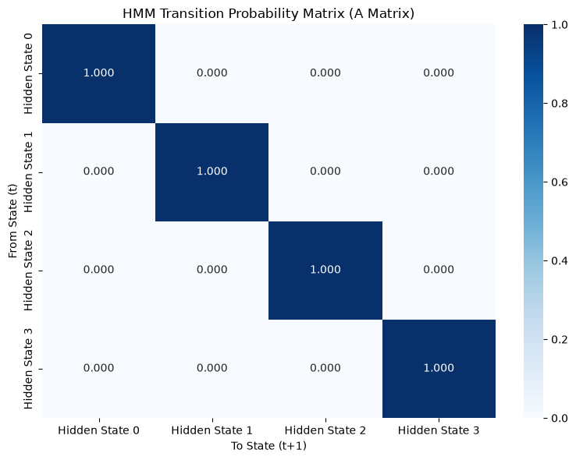
Figure 4. Learned transition matrix. Each hidden state stays in itself with probability 1.
The emission matrix distinctly separates states: Standing uses symbol 0; Still uses symbols 3-4; Walking uses symbol 6; Jumping uses symbols 1, 7, and 8.
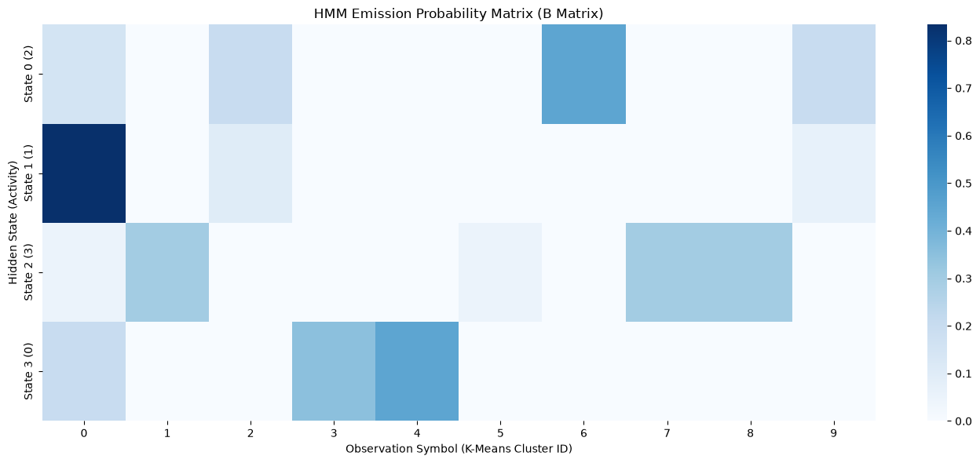
Figure 5. Emission matrix. Each hidden state concentrates on a different set of observation symbols. The number in parentheses is the mapped activity id: 0 still, 1 standing, 2 walking, 3 jumping.

Viterbi decoding achieved 100% accuracy on unseen test sequences, with all 38 scored test windows correctly classified.
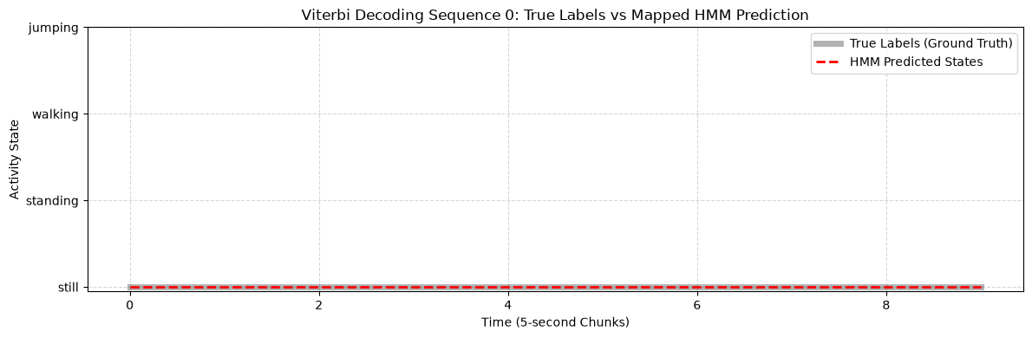
Figure 6. Viterbi path for holdout sequence 0, a run of still windows. The prediction matches the true labels.
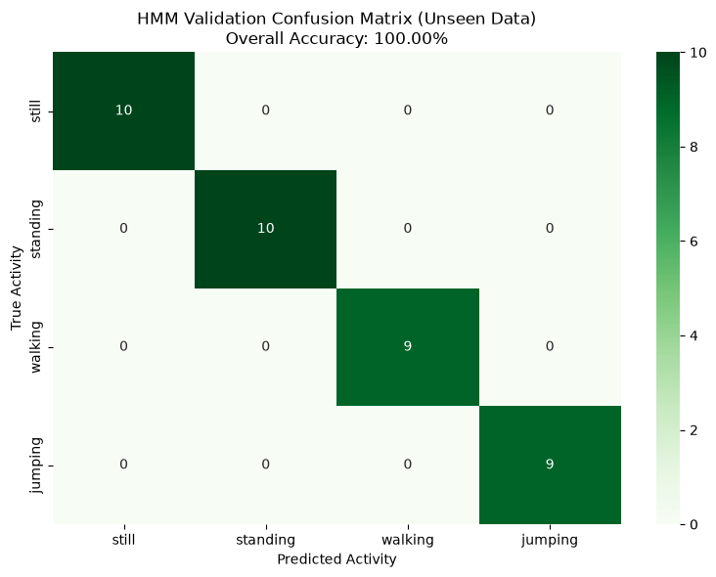
Figure 7. Confusion matrix on the unseen windows. Overall accuracy is 100%.

Discussion and conclusion
Distinct signal traits enable full separability: jumping causes high-amplitude spikes, walking shows ~2 Hz periodicity, and still/standing differ by phone orientation on uncalibrated Z-axis.
To improve real-world robustness, future work should incorporate multi-session and multi-subject data featuring continuous activity transitions to learn non-zero off-diagonal transition probabilities.
Ultimately, a discrete HMM using five sensor features accurately models basic human activity states from single-device smartphone recordings, providing a reliable, automated framework for differentiating safe daily movements from high-risk anomalies in elderly patient care.

