Assignment2 - Quantum circuit analysis Report

CMT304 -Programming Paradigms

1. **Quantum circuit analysis**

1.1 circuit operators

There are 2 common single qubit gates in this circuit.

1. Pauli X Gate. This operator could half turn (π) around X, Y, Z axis which transform|0⟩ to |1⟩ and |1⟩ to |0⟩.

X = $\begin{matrix}0 & 1 \\ 1 & 0\end{matrix}$

1. Control. This operator could control the gates in the same column, these gate only can work if this control meets the state |1⟩.

There are 3 multi-qubit gates in this circuit.

1. Swap Gate. This operator could swap the values of two qubits, which transforms |01⟩ to |10⟩ and |10⟩ to |01⟩.

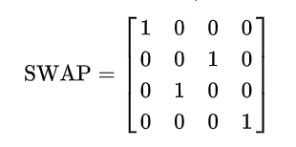

1. Controlled-not (CNOT) gate. This operator contains a control and operates some qubits, and the x gates performs NOT operation only when the control is 1, otherwise it remains unchanged.

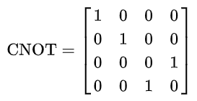

1. Fredkin gate. This operator is a controlled swap gate that do the swap if control is 1, otherwise it remains unchanged.

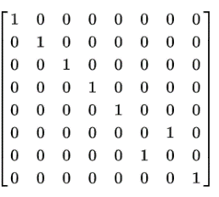

Fredkin gate =

* 1. mapping

According to Input * (A|00b00a⟩ + B|00b01a⟩ + C|00b10a⟩ + D|00b11a⟩+ E|01b00a⟩+ F|01b01a⟩+ G|01b10a⟩+ H|01b11a⟩+ I|10b00a⟩+ J|10b01a⟩+ K|10b10a⟩+ L|10b11a⟩+ M|11b00a⟩+ N|11b01a⟩+ O|11b10a⟩+ P|11b11a⟩) = Output

and after some experiments by Quirk we got the input-output mapping for |A⟩|B⟩ to |A’⟩|B’⟩:

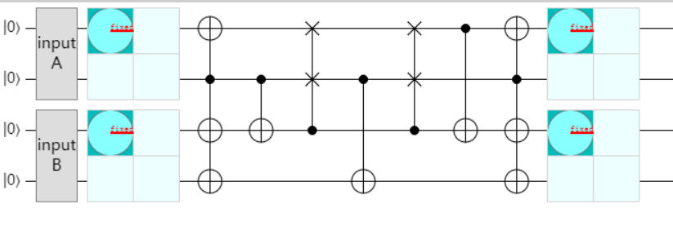

Figure 1 – quantum circuit for |A⟩|B⟩ to |A’⟩|B’⟩

|  |  |  |  |  |
| --- | --- | --- | --- | --- |
|  | Input |B⟩ | Input |A⟩ | Output |B’⟩ | Output |A’⟩ |
| A | |00⟩ | |00⟩ | |00⟩ | |00⟩ |
| B | |00⟩ | |01⟩ | |01⟩ | |01⟩ |
| C | |00⟩ | |10⟩ | |10⟩ | |10⟩ |
| D | |00⟩ | |11⟩ | |11⟩ | |11⟩ |
| E | |01⟩ | |00⟩ | |01⟩ | |00⟩ |
| F | |01⟩ | |01⟩ | |10⟩ | |01⟩ |
| G | |01⟩ | |10⟩ | |11⟩ | |10⟩ |
| H | |01⟩ | |11⟩ | |00⟩ | |11⟩ |
| I | |10⟩ | |00⟩ | |10⟩ | |00⟩ |
| J | |10⟩ | |01⟩ | |11⟩ | |01⟩ |
| K | |10⟩ | |10⟩ | |00⟩ | |10⟩ |
| L | |10⟩ | |11⟩ | |01⟩ | |11⟩ |
| M | |11⟩ | |00⟩ | |11⟩ | |00⟩ |
| N | |11⟩ | |01⟩ | |00⟩ | |01⟩ |
| O | |11⟩ | |10⟩ | |01⟩ | |10⟩ |
| P | |11⟩ | |11⟩ | |10⟩ | |11⟩ |

Table1 - input-output mapping for |A⟩|B⟩ to |A’⟩|B’⟩

According to the mapping data, finally we got the transformation matrix as below:

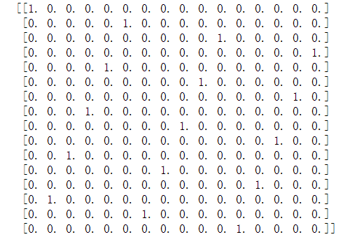

1.3 the operation does the circuit implement

According to the input-output mapping above we can easily get that:

The input |A⟩ and output |A’⟩ is totally same, do nothing. This is because we can easily see that the two swaps are offset each other, and the two X Gates are also offset each other.

The input |B⟩ and output |B’⟩ will do the add operation, value of output |B’⟩ equals to the sum of value of |A⟩ and value of |B⟩. And the upper limit is 11 and the data will overflow if the upper limit is exceeded

**2. Inverse quantum circuit**

2.1 the inverse circuit

By reverse the original circuit we simply get the inverse circuit:

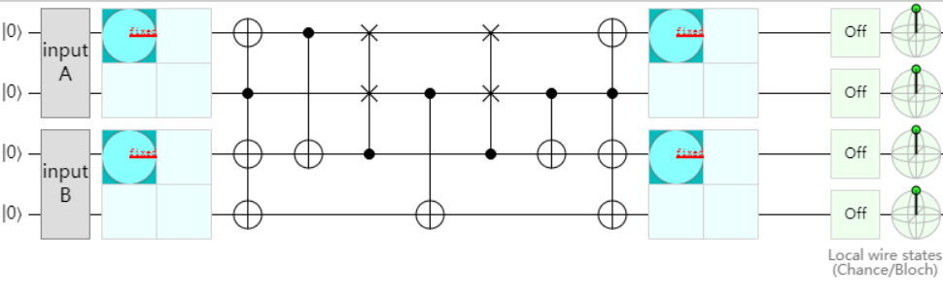

Figure 2 – quantum circuit of |A’⟩|B’⟩ to |A⟩|B⟩

Regarding the whole process as a unitary transformation, and according to the formula:

UU† = U†U = I

Then we got inverse transformation matrix:

U† =

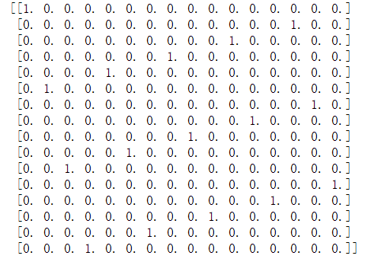

2.2 correctness

And after some operations by Quirk we got the input-output mapping for |A’⟩|B’⟩ to |A⟩|B⟩ :

|  |  |  |  |  |
| --- | --- | --- | --- | --- |
|  | Input |B’⟩ | Input |A’⟩ | Output |B⟩ | Output |A⟩ |
| A | |00⟩ | |00⟩ | |00⟩ | |00⟩ |
| B | |00⟩ | |01⟩ | |11⟩ | |01⟩ |
| C | |00⟩ | |10⟩ | |10⟩ | |10⟩ |
| D | |00⟩ | |11⟩ | |01⟩ | |11⟩ |
| E | |01⟩ | |00⟩ | |01⟩ | |00⟩ |
| F | |01⟩ | |01⟩ | |00⟩ | |01⟩ |
| G | |01⟩ | |10⟩ | |11⟩ | |10⟩ |
| H | |01⟩ | |11⟩ | |10⟩ | |11⟩ |
| I | |10⟩ | |00⟩ | |10⟩ | |00⟩ |
| J | |10⟩ | |01⟩ | |01⟩ | |01⟩ |
| K | |10⟩ | |10⟩ | |00⟩ | |10⟩ |
| L | |10⟩ | |11⟩ | |11⟩ | |11⟩ |
| M | |11⟩ | |00⟩ | |11⟩ | |00⟩ |
| N | |11⟩ | |01⟩ | |10⟩ | |01⟩ |
| O | |11⟩ | |10⟩ | |01⟩ | |10⟩ |
| P | |11⟩ | |11⟩ | |00⟩ | |11⟩ |

Table2 - input-output mapping for |A’⟩|B’⟩ to |A⟩|B⟩

After careful comparison values of table 1(mapping for |A⟩|B⟩ to |A’⟩|B’⟩) and table 2(mapping for |A’⟩|B’⟩ to |A⟩|B⟩), the output value of inverse circuit is totally same as the input value of the original circuit ,therefore we can prove the correctness of this inverse circuit.