**Appendix**

**The time spent at each part of Fastflow program as below:**

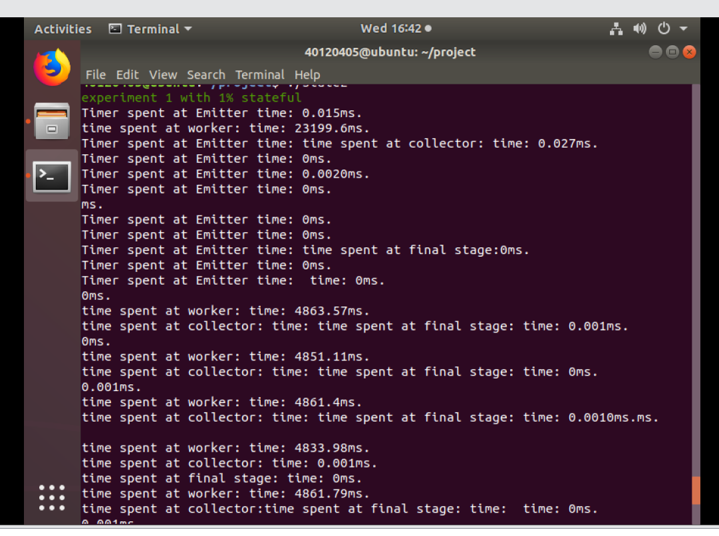

From the graph we can see that the time spent at emitter, collector and final stage is very short and can be neglected.:

Emitter: around 0.002ms

Worker: around 5000ms(normal) and 25000ms(adapt pattern)

Collector: around 0.001ms

Final stage: around 0.001ms

**Therefore, the main time spent on worker.**