**Experiments of State Access Pattern:**

Experiment purpose:

1. Demonstating patterns work
2. Demonstrating the performance results are as predicted.

Experiment condition:

Cpu: Intel i7-7700HQ

Number of parallel: up to 128

Operation System: linux 4.15.0-generic

Compiler: g++ 7.3.0

FastFlow version: v.2.2

Workload: 100 transactions

Experiment:

Experiment with diffident percentage of state access pattern (0%,10%,20%,40%,60%).

Execute the program with different parallelism degree (1,2,3,4)

**Experiment result:**

**Experiment:**

**Experiment with none state access pattern.**

**Experiment with 10% state access pattern.**

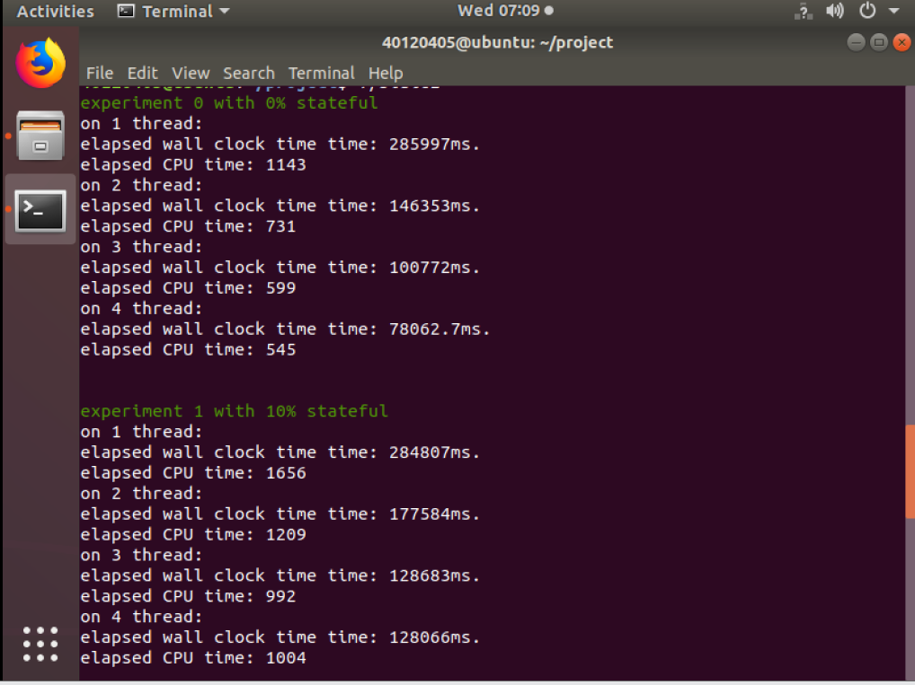

**Experiment with 20% state access pattern.**

**Experiment with 40% state access pattern:**

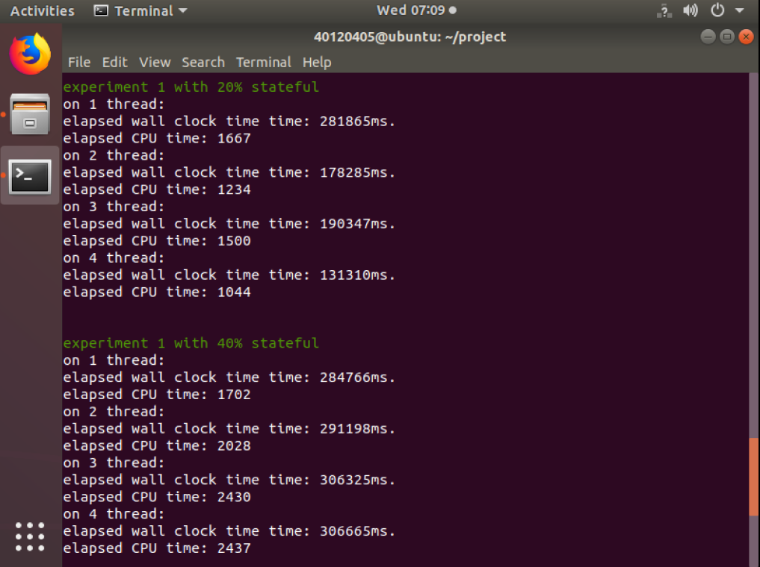

**Experiment with 60% state access pattern:**

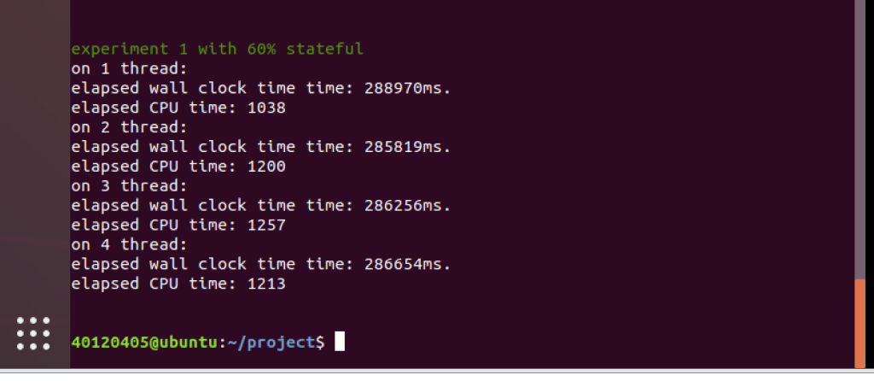

**Wall clock time of processing:**

|  |  |  |  |  |
| --- | --- | --- | --- | --- |
| Workers Number: | 1 | 2 | 3 | 4 |
| P=0 | 286.0s | 146.4s | 100.8s | 78.1s |
| P=0.1 | 284.8s | 177.6s | 128.7s | 128.1s |
| P=0.2 | 281.9s | 178.3s | 190.3s | 131.3s |
| P=0.4 | 284.8s | 291.2s | 306.3s | 306.7s |
| P=0.6 | 288.9s | 285.8s | 286.3s | 286.7s |

**The calculated ideal speedup:**

|  |  |  |  |  |
| --- | --- | --- | --- | --- |
| Workers Number: | 1 | 2 | 3 | 4 |
| P=0 | 1 | 2 | 3 | 4 |
| P=0.1 | 1 |  |  |  |
| P=0.2 | 1 |  |  |  |
| P=0.4 | 1 |  |  |  |
| P=0.6 | 1 |  |  |  |

**Parallel speedup**:

|  |  |  |  |  |
| --- | --- | --- | --- | --- |
| Workers Number: | 1 | 2 | 3 | 4 |
| P=0 | 1 | 1.95 | 2.84 | 3.66 |
| P=0.1 | 1 | 1.60 | 2.21 | 2.22 |
| P=0.2 | 1 | 1.58 | 1.48 | 2.15 |
| P=0.4 | 1 | 0.98 | 0.93 | 0.93 |
| P=0.6 | 1 | 1.01 | 1.01 | 1.01 |

From the result and graph above we can see the execute time with different parallelism degrees,

It’s cannot get accelerate so almost fit the ideal situation