When kinematic constraints conflict with rocket telemetry: sparse trajectory reconstruction across two real-flight datasets
Target journal: Acta Astronautica · Article type: Original research · Status: Revised scientific draft with verified RQ1 and RQ2 results, integrated results figures and a verified bibliography; author-controlled declarations remain to be completed.
Author: Kağan Yurtkölesi
Affiliation: Department of Aerospace Engineering, Izmir University of Economics, Izmir, Türkiye
Corresponding author: kagan.yurtkolesi@std.iue.edu.tr

Abstract
Real rocket telemetry is scarce, heterogeneous and sparsely sampled. We tested whether kinematic constraints improve neural reconstruction of altitude and velocity in two real-flight studies. RQ1 used 40 Falcon 9 flights sampled at 1 Hz over the first 120 s, with 28 training, six outer-validation and six held-out test flights. RQ2 development used 335 public FlightSketch flights from 41 provisional uploader-plus-normalized-title groups. Both studies compared matched unconstrained and kinematically constrained neural networks under fixed sparse-observation masks. At 5% observations in the RQ1 test set, the constraint reduced altitude RMSE from 2304.55 to 1920.30 m and the kinematic-violation rate from 0.4262 to 0.0612, but increased speed RMSE from 46.77 to 69.87 m/s. Combined standardized error increased by 0.018634; the constrained model won on one of six flights. A targeted Iridium-family replication met the flight-level improvement criterion on only two of five flights, below the prespecified four-of-five threshold. In RQ2 development, a small benefit at 5% observations (score 0.3479 to 0.3449; three of five seeds) reversed in all 20 paired comparisons at 10–100%. Because the original final-test artifact and exact historical assignments were absent, we performed a versioned confirmatory reconstruction using all plausibly development-exposed groups only for fit/validation and 46 held-out flights from eight newly allocated provisional groups. At 5% observations, NN versus constrained NN altitude RMSE was 44.73 versus 57.52 m, velocity RMSE 10.14 versus 11.04 m/s, and combined score 0.6096 versus 0.7145 (paired difference 0.1049 ± 0.0558 SD; zero of five seed wins). The mean mismatch between the altitude derivative and recorded velocity was 5.55 m/s in the historical development cohort. Physical plausibility did not guarantee improved predictive generalization: constraints must respect measurement semantics and be tested across flights.
Keywords: rocket telemetry; sparse trajectory reconstruction; kinematic constraints; physics-informed machine learning; measurement consistency; held-out evaluation

Highlights — separate submission file after final wording check
- Matched neural models were evaluated on two real rocket telemetry sources.
- A kinematic constraint reduced physical violations but worsened combined Falcon 9 test error.
- A targeted flight-family replication failed its prespecified consistency criterion.
- A versioned group-held-out FlightSketch replication found no constrained-model wins across five seeds.
- Measured channel mismatch offers a plausible, nonexclusive explanation for the failure.

1. Introduction
Sparse observations make flight trajectory reconstruction an underdetermined task. Neural networks can reconstruct smooth altitude and velocity histories, while physical penalties may discourage implausible outputs. Yet the variables in a recorded telemetry stream need not correspond exactly to the state variables in an idealized physical law. Imposing an equality on filtered, quantized or differently timed channels can shift a prediction away from the measurements it is meant to reconstruct.
We examine this issue in early Falcon 9 webcast telemetry and public FlightSketch records. These are complementary observational settings, not interchangeable vehicle populations. Falcon 9 webcast speed denotes total speed; with unknown flight-path angle it should not be equated with vertical altitude rate. FlightSketch altitude and recorded velocity appear closer to a vertical kinematic pair, but their processed 1 Hz channels disagree empirically. Our primary question is whether adding the respective kinematic penalty improves held-out predictive accuracy under sparse observations, beyond increasing equation compliance.
This study contributes (i) a matched NN versus kinematically constrained NN comparison with fixed observation masks and held-out evaluations; (ii) flight-level scrutiny and a targeted replication of an apparently favorable case; and (iii) a measurement-channel audit to interpret an unfavorable held-out result. The contribution concerns empirical limits of this particular regularization on these telemetry sources. It does not imply that richer dynamics models, other observation models or all physics-informed methods fail.
Physics-informed neural networks incorporate governing equations or related physical residuals into learning objectives [1,2]. Their training can nevertheless be sensitive to imbalance between data and physics gradients and to the resulting optimization dynamics [3,4]. In aerospace estimation, machine learning has been applied across orbit-estimation tasks [5], including trajectory reconstruction for a nanosatellite in very low Earth orbit [6], while recent work has investigated physics-informed orbit determination for X-GEO space situational awareness [7]. The present study addresses a narrower measurement-consistency question: whether simple kinematic regularizers improve sparse reconstruction of altitude and velocity channels in real rocket-flight telemetry when evaluated across held-out flights or provisional groups.

2. Data and experimental design

2.1 Falcon 9 webcast telemetry (RQ1)
Forty flights contribute altitude and speed at 1 Hz from launch through 120 s (121 samples per flight). The fixed split has 28 training, six outer-validation and six held-out test flights. Training includes an inner fit/validation division of 22/6 flights. The outer-validation flights were visible during development and are not an independent final test. The six test flights were evaluated once with frozen models and no subsequent tuning. The measured speed is a magnitude, not an independently established vertical velocity. Record the specific extraction source, flight roster, units, preprocessing and sample provenance in the final supplement.
The matched RQ1 networks received eight inputs: normalized time, standardized payload, a payload-missing indicator and one-hot indicators for Falcon 9 Blocks 1–5. Both used two 32-unit tanh hidden layers and standardized altitude and speed outputs with scaling learned only from the relevant fit partition. Learning rate and Adam weight decay were screened on the 100% inner-fit condition over {0.0003, 0.001} and {0, 10⁻⁶, 10⁻⁵, 10⁻⁴}, respectively, using paired seeds 11, 29 and 47. Both methods selected learning rate 0.001 and weight decay 10⁻⁴; the frozen final training lengths were 560 epochs for NN and 400 epochs for KC-NN. These settings were retained for the 100, 50, 25, 10 and 5% observation masks and paired seeds 11, 29, 47, 71 and 97.

2.2 FlightSketch telemetry (RQ2)
The public index audit identified 4,040 records, 617 deterministic candidates and 614 initial technical passes. All 614 historical source-file SHA-256 values were restored and verified for the reconstruction. The frozen historical development cohort contains 335 flights, 17,864 processed 1 Hz samples and 41 provisional uploader-plus-normalized-title groups: 33 groups/257 flights for training and eight groups/78 flights for outer validation. Historical documentation recorded no final test and did not retain the exact 41-group assignment. We therefore defined reconstruction v1.1 conservatively: every canonical operational group containing a source row consistent with the historical development rule was restricted to fit or inner validation. The resulting fit set contained 363 flights/31 groups, inner validation contained 75 flights/six groups, and the newly allocated held-out set contained 46 usable flights/eight groups. Uploader/title membership cannot establish distinct physical airframes or configurations, and contributor concentration limits extrapolation beyond the represented uploader regime.

2.3 Sparse observations and comparison
Historical development used masks retaining 5, 10, 25, 50 or 100% of each trajectory; reconstruction v1.1 evaluated the prespecified primary 5% condition. For each 1 Hz trajectory, endpoints were retained and the remaining observations were chosen by a fixed SHA-256 ordering until max(2, ceil(0.05n)) samples were observed. The two principal models shared paired initialization, inputs, optimizer, mask and evaluation data. Both used two 32-unit tanh hidden layers, two standardized outputs, fit-only scaling, Adam with learning rate 0.001 and coupled L2 weight decay 0.0001, at most 3000 epochs, and inner-validation early stopping with patience 250. Inputs were normalized time, linearly interpolated sparse altitude and velocity, normalized distance to the nearest observation, duration, an observation indicator and log observation ratio. Five paired seeds (11, 29, 47, 71 and 97) were fixed.

3. Kinematic formulations and evaluation
For RQ1, let z_h and z_v denote the standardized network outputs, and recover physical predictions as ĥ = μ_h + σ_h z_h and v̂ = μ_v + σ_v z_v. With normalized time τ = t/120, automatic differentiation gives q = dĥ/dt = (σ_h/120)(dz_h/dτ). Because webcast speed is a magnitude rather than vertical velocity, the model does not impose q = v̂. It instead penalizes violations of the early-ascent inequalities 0 ≤ q ≤ v̂ and v̂ ≥ 0.
The implemented dimensionless penalty was L_kin = mean[ReLU(−q/σ_v)² + ReLU((q−v̂)/σ_v)² + ReLU(−v̂/σ_v)²]. The observed-point data loss was L_data = 0.5[MSE(z_h,z_h,obs) + MSE(z_v,z_v,obs)]. NN minimized L_data, whereas KC-NN minimized L_data + λ_kin L_kin. The single frozen weight was calibrated before model selection on the 100% inner-fit partition: for seeds 11, 29 and 47, r was the ratio ||∇L_kin||/||∇L_data|| at initialization; λ_kin = clip[1/median(r), 0.01, 100]. The recorded median ratio was 0.02968922099, giving λ_kin = 33.68225796 without fallback. L_kin was evaluated at all 121 time coordinates of each fit flight; unobserved altitude and speed targets were not supplied at those collocation points. A violation was counted when q < 0, q > v̂ or v̂ < 0.
For RQ2, let h_i and v_i denote predicted altitude and recorded-channel velocity at adjacent 1 Hz grid points. Reconstruction v1.1 used the normalized finite-difference residual r_i = [(h_{i+1} − h_i)/Δt_i − (v_i + v_{i+1})/2]/σ_v, where σ_v is the fit-set velocity target standard deviation. The NN minimized the mean squared error over the two standardized outputs. KC-NN added 1.91 times the mean squared residual, using the frozen 5% physics weight from development.
Altitude and velocity errors are reported as RMSE in physical units. The combined standardized score is 0.5(RMSE_h/σ_h + RMSE_v/σ_v), using fit-set target standard deviations σ_h and σ_v. Compute KC-NN minus NN within each paired seed, so a positive difference means the constraint worsens the score. Report flight/group-level effects alongside averages. Seed variability measures training sensitivity, not independent flight-level uncertainty. For RQ1, report the existing flight bootstrap interval separately, with its resampling unit and computation rule. All claims of cross-group generalization refer to provisional metadata groups.
After the primary RQ1 analysis was closed, Iridium NEXT-5 was examined in three explicitly post-hoc follow-ups. First, frozen predictions were compared across the five observation fractions and decomposed by trajectory segment and output channel. Second, a term-ablation study used the frozen 5% mask, five paired seeds, the same architecture and optimizer, 400 epochs and the unchanged kinematic weight. Fifteen planned runs removed one hinge at a time from the full penalty. Third, a replication protocol was locked before fitting 75 leave-one-flight-out models. Each of the five Iridium missions in the original training partition (NEXT-1, NEXT-3, NEXT-4, NEXT-6 and NEXT-8) was held out in turn; the other 27 original training flights were used for fitting, and the six original test flights, including NEXT-5, were excluded from all training, normalization and fold evaluation. The compared variants were NN, full KC-NN and an upper-bound-only KC-NN retaining only dh/dt ≤ speed. Internal family replication required the upper-bound-only model to beat NN on at least four of five flights and to have a negative unweighted mean flight-level difference. These analyses diagnose a favorable flight and do not revise the confirmatory RQ1 estimand.
OpenAI ChatGPT and Codex (OpenAI; accessed September 2026) were used as AI-assisted tools to support code drafting and debugging, execution planning, consistency checks of stored metrics and data-visualization scripting. The source telemetry, dataset allocations, model specifications, seeds, checkpoints and recorded numerical outputs were retained in the reproducible workflow; the tools were not used to fabricate or alter source observations or reported results. All reported metrics and figures were generated from the stated datasets and executable analysis workflows and were reviewed by the author.

4. Results

4.1 Falcon 9 held-out evaluation
At 5% observations, NN versus KC-NN altitude RMSE was 2304.55 versus 1920.30 m, while speed RMSE was 46.77 versus 69.87 m/s. The kinematic-violation rate fell from 0.4262 to 0.0612. Yet the prespecified combined score difference (KC-NN minus NN) was +0.018634, with a constrained-model advantage on one of six held-out flights. The RQ1 closure audit reports a flight bootstrap 95% interval of −0.020757 to +0.045011. This interval includes zero; avoid presenting six flights as conclusive evidence of a population-wide effect.
Table 1. RQ1 held-out results at 5% observations. Lower values are better for every metric. The composite score is available as a paired method difference rather than as two independently reported absolute values.
Metric | NN | KC-NN | KC-NN − NN
Altitude RMSE (m) | 2304.55 | 1920.30 | −384.25
Speed RMSE (m/s) | 46.77 | 69.87 | +23.10
Kinematic-violation fraction | 0.4262 | 0.0612 | −0.3650
Standardized composite error | — | — | +0.018634

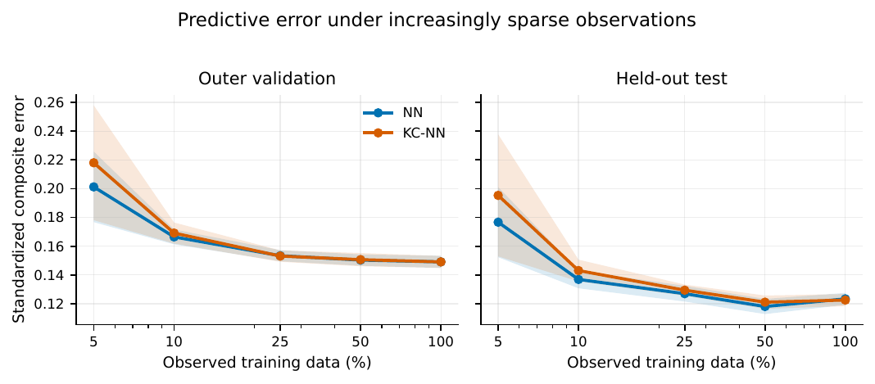
Figure 1. RQ1 predictive error under increasingly sparse observations. Mean standardized composite error is shown for outer validation and the held-out test across fixed observation fractions. Shaded bands show the variability reported in the frozen RQ1 figure artifact. Lower values are better.
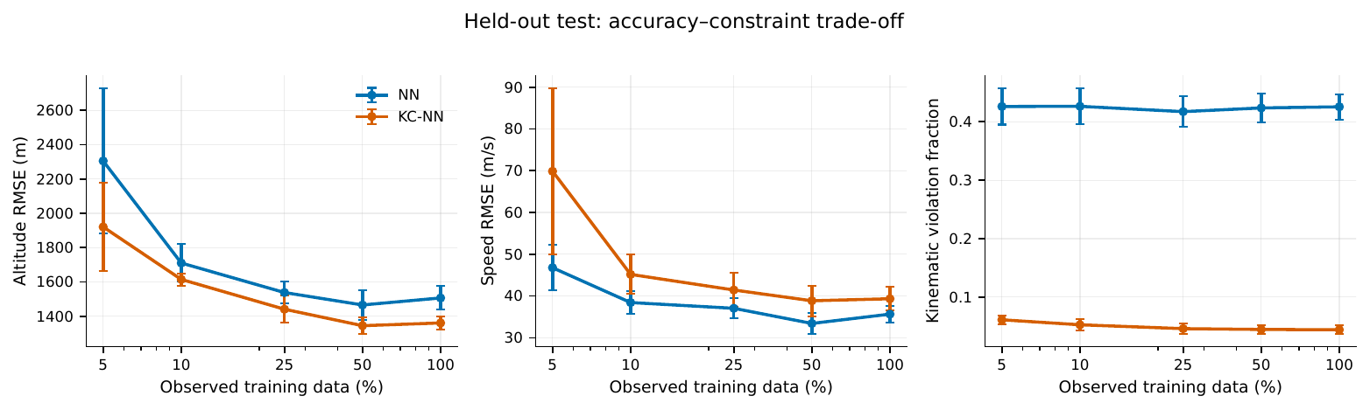
Figure 2. RQ1 held-out accuracy–constraint trade-off. Altitude RMSE, speed RMSE and kinematic-violation fraction are shown across observation fractions. Error bars reproduce the variability in the verified RQ1 figure artifact. At 5% observations, KC-NN improved altitude reconstruction and constraint compliance but worsened speed reconstruction and the combined score.
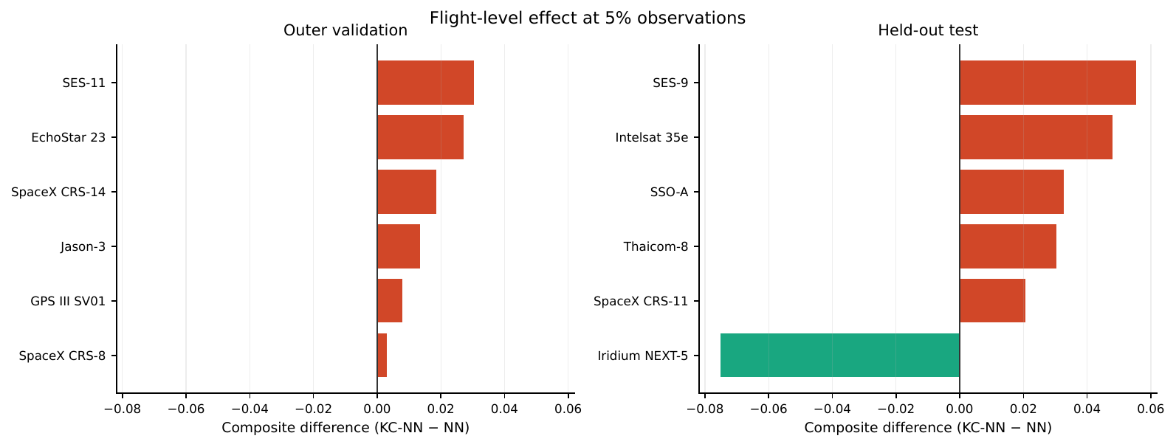
Figure 3. RQ1 flight-level effect at 5% observations. Bars show the standardized composite-score difference (KC-NN minus NN) for six outer-validation and six held-out flights. Negative values favor KC-NN and positive values favor NN. The constrained model improved only Iridium NEXT-5 in the held-out set, illustrating the heterogeneity concealed by an aggregate mean.

4.2 Iridium NEXT-5 mechanism and family replication
Iridium NEXT-5 was the only held-out RQ1 flight on which KC-NN improved the combined score. At 5% observations, its five-seed mean composite error fell from 0.2247 for NN to 0.1494 for KC-NN, with KC-NN better in all five paired seeds. Approximately 79.5% of the composite improvement came from altitude: altitude RMSE fell from 2260.3 to 933.8 m, while speed RMSE fell from 78.88 to 68.96 m/s and improved in four of five seeds. The finite-difference inequality-violation fraction was 38.0% for NN and 5.8% for KC-NN. The NN ensemble overshot the measured altitude after approximately 30 s, particularly during 61–90 s, whereas the constraint suppressed most of this middle-to-late trajectory overshoot.
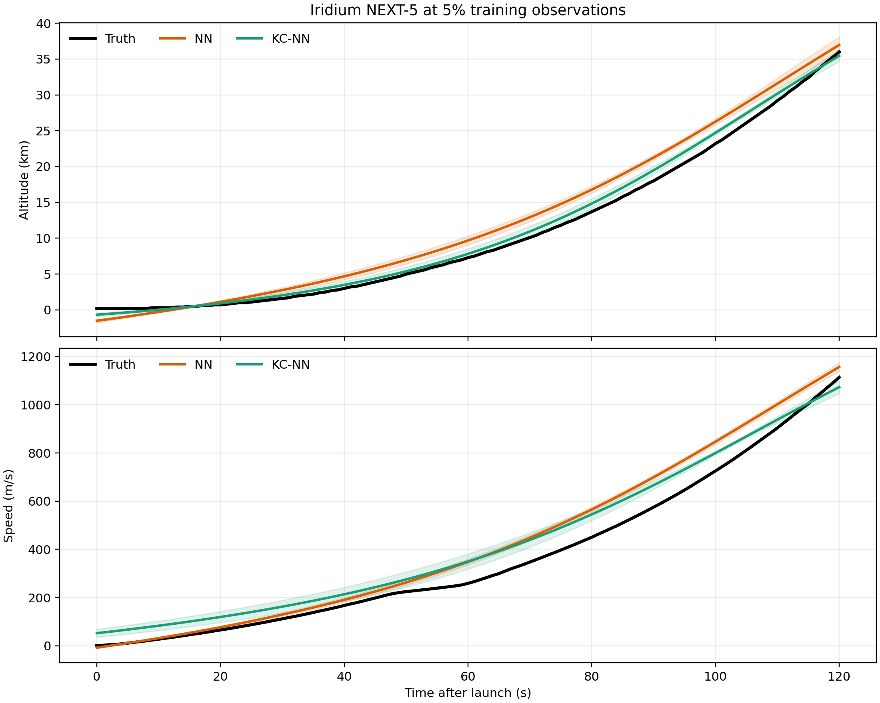
Figure 4. Post-hoc Iridium NEXT-5 trajectory diagnostic at 5% observations. Curves show the measured trajectory and the five-seed mean predictions; bands show ±1 seed standard deviation and are descriptive rather than confidence intervals. KC-NN substantially reduces the NN altitude overshoot.
The NEXT-5 advantage was present at every frozen observation fraction rather than being unique to one sparse mask. NN versus KC-NN composite error was 0.1641 versus 0.1046 at 100%, 0.1378 versus 0.0930 at 50%, 0.1689 versus 0.1130 at 25%, 0.1974 versus 0.1311 at 10%, and 0.2247 versus 0.1494 at 5%. The gap was largest at the sparsest setting.
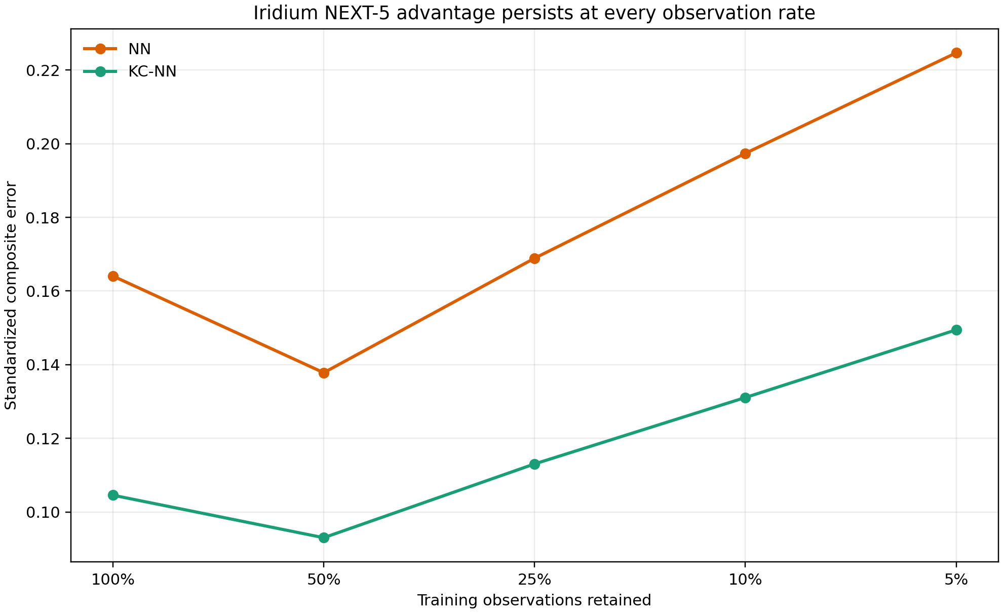
Figure 5. Post-hoc Iridium NEXT-5 sensitivity to the training observation fraction. Values are five-seed mean standardized composite errors from the frozen RQ1 outputs. Lower values are better.
The term ablation isolated the upper-bound hinge as the driver of the favorable result. Removing dh/dt ≤ speed increased the NEXT-5 composite error from 0.1494 to 0.3210, worse than the NN value of 0.2247, and all five seeds deteriorated. Removing the nonnegative-speed hinge produced no numerical change, while removing dh/dt ≥ 0 slightly reduced the mean error to 0.1385. Thus the useful component on this flight was a weak plausibility bound involving total speed, not an exact equality between altitude rate and vertical velocity.
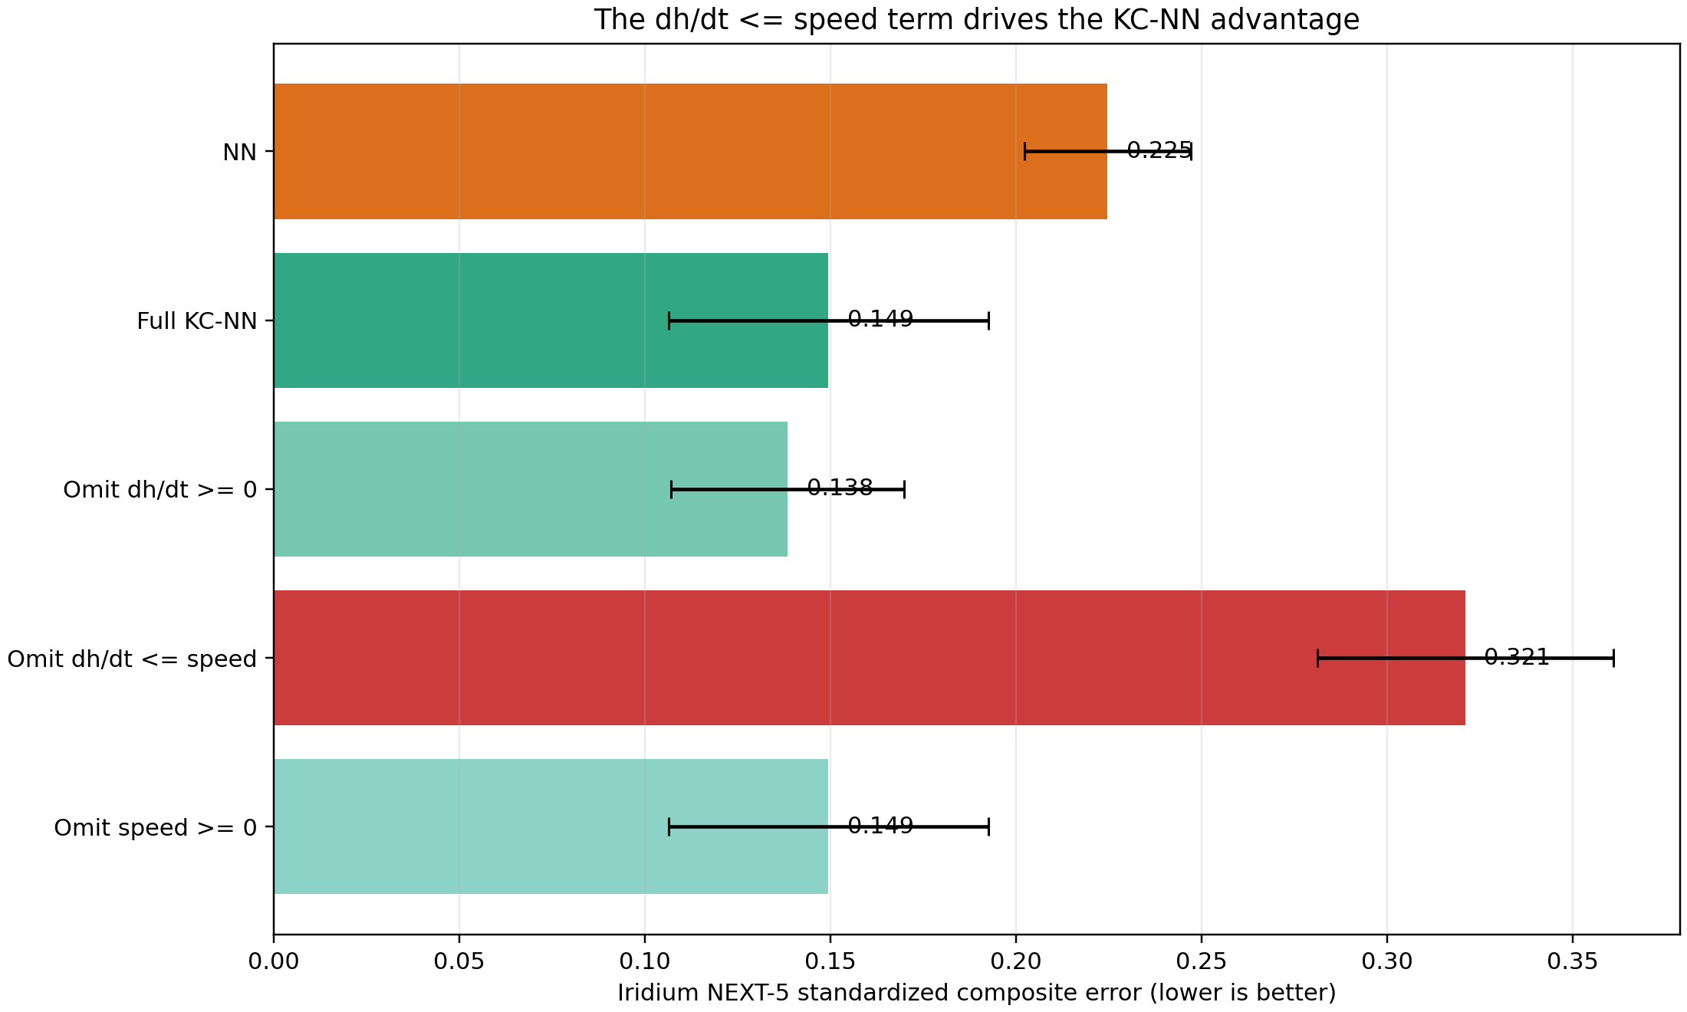
Figure 6. Post-hoc kinematic-term ablation on Iridium NEXT-5 at 5% observations. Bars show five-seed mean standardized composite error and error bars show ±1 seed standard deviation. Removing the dh/dt ≤ speed hinge eliminates the KC-NN advantage.
The locked family replication did not reproduce the NEXT-5 effect consistently. The upper-bound-only model beat NN on NEXT-4 and NEXT-8, but not on NEXT-1, NEXT-3 or NEXT-6; it therefore failed the required four-of-five criterion. Its mean difference was −0.0061 only because the two favorable effects were larger than the three unfavorable effects. Across flights, mean composite errors were 0.1741 for NN, 0.1768 for full KC-NN and 0.1680 for the upper-bound-only model. The direction was stable across seeds within flights: the upper-bound-only model won all five seeds on NEXT-4 and NEXT-8, one of five on NEXT-1, and none on NEXT-3 or NEXT-6.
Table 2. Locked post-hoc Iridium-family leave-one-flight-out replication at 5% observations. Values are five-seed mean standardized composite errors. Lower values are better.
Held-out flight | NN | Full KC-NN | Upper-bound only | Upper-bound only − NN | Favored model
NEXT-1 | 0.0960 | 0.1251 | 0.1129 | +0.0169 | NN
NEXT-3 | 0.1740 | 0.2120 | 0.2111 | +0.0371 | NN
NEXT-4 | 0.2654 | 0.2194 | 0.2080 | −0.0573 | Upper-bound only
NEXT-6 | 0.1180 | 0.1455 | 0.1326 | +0.0146 | NN
NEXT-8 | 0.2169 | 0.1818 | 0.1753 | −0.0416 | Upper-bound only

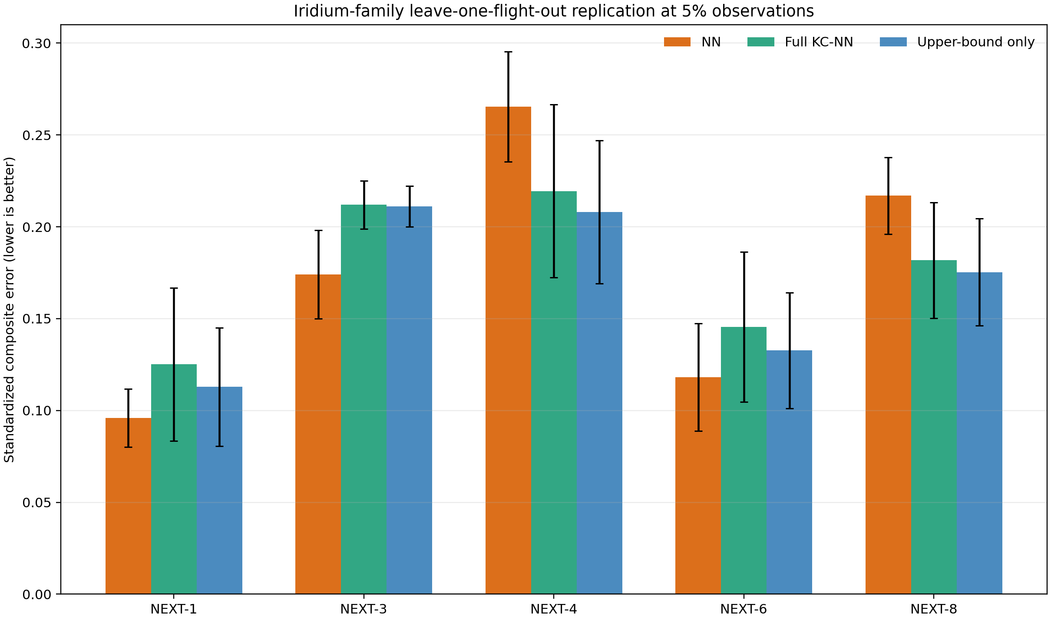
Figure 7. Post-hoc Iridium-family leave-one-flight-out replication at 5% observations. Bars show five-seed mean standardized composite error and error bars show ±1 seed standard deviation. The upper-bound-only model improved two of five flights, below the locked four-of-five requirement.

4.3 FlightSketch development and held-out evaluation
Development at 5% observations gave a combined score of 0.3479 for NN and 0.3449 for KC-NN; the constrained model won three of five paired seeds. At 10, 25, 50 and 100% observations it lost all 20 paired seed comparisons. This development signal did not establish a robust benefit.
Confirmatory reconstruction v1.1 evaluated eight newly allocated provisional groups and 46 usable flights at 5% observations. Across five paired seeds, NN versus KC-NN altitude RMSE was 44.73 ± 3.63 versus 57.52 ± 3.46 m and velocity RMSE was 10.14 ± 0.23 versus 11.04 ± 0.77 m/s. The combined score rose from 0.6096 ± 0.0274 to 0.7145 ± 0.0369. The paired increase was 0.1049 ± 0.0558 (sample SD), with zero of five seed wins for KC-NN. All ten saved checkpoints reproduced the recorded metrics within 10⁻¹², the eight evaluation groups were disjoint from fit/validation groups, and the manifest fingerprint was 9efc8c68fc63ac7603e471e101571417017ac5bfb51398fa2f718396761f8782. Seeds quantify optimization variability and are not independent test cohorts.
Table 3. RQ2 confirmatory reconstruction v1.1 at 5% observations. Values are mean ± sample SD across five paired optimization seeds.
Metric | NN | KC-NN | Direction
Altitude RMSE (m) | 44.73 ± 3.63 | 57.52 ± 3.46 | NN lower
Velocity RMSE (m/s) | 10.14 ± 0.23 | 11.04 ± 0.77 | NN lower
Standardized composite error | 0.6096 ± 0.0274 | 0.7145 ± 0.0369 | NN lower
Paired composite difference | — | +0.1049 ± 0.0558 | KC-NN worse

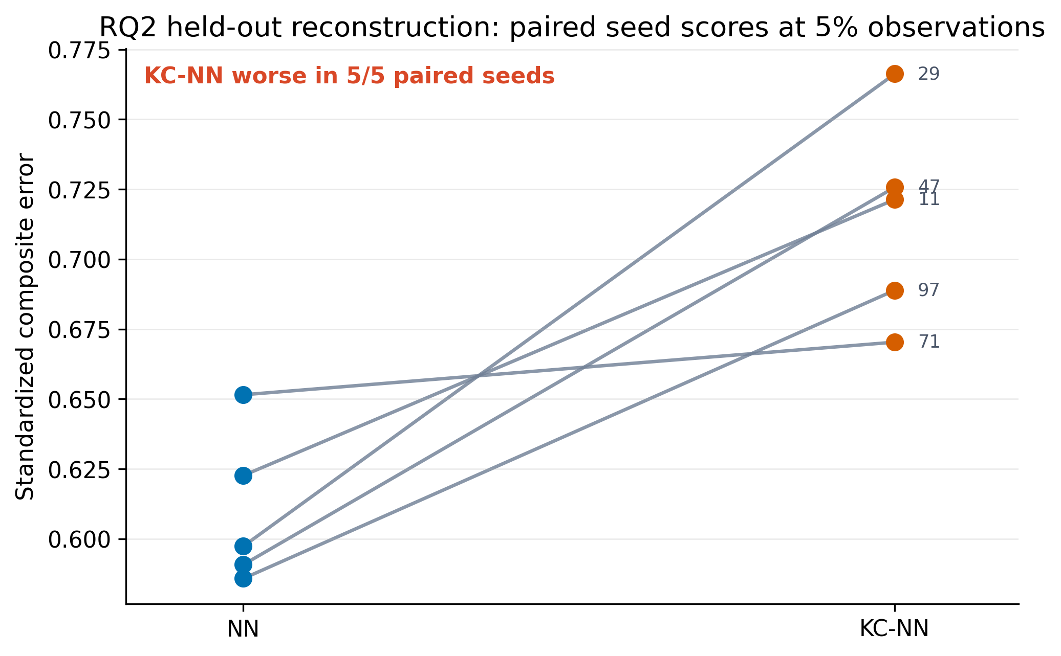
Figure 8. RQ2 paired seed scores at 5% observations. Each line connects NN and KC-NN for one fixed initialization seed. Lower standardized composite error is better. KC-NN was worse in all five paired seeds.
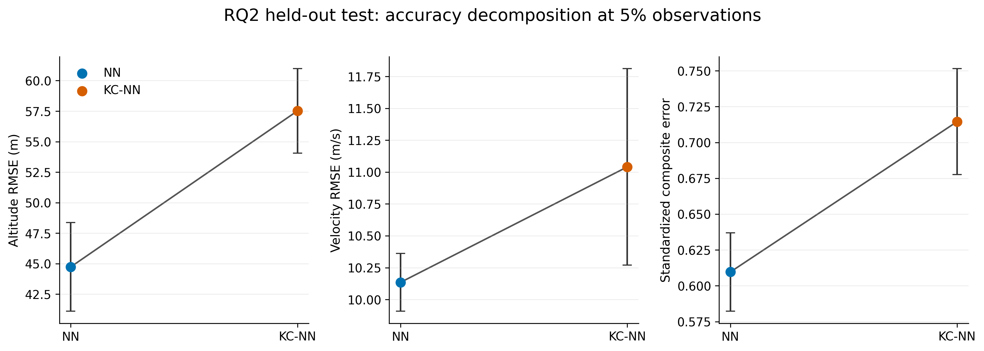
Figure 9. RQ2 held-out accuracy decomposition at 5% observations. Points show the mean across five paired optimization seeds; error bars show sample SD. KC-NN increased altitude RMSE, velocity RMSE and standardized composite error.
Group-level effects were also directionally consistent with the aggregate result. Seven of eight provisional groups favored NN on average. Big Bessie was the only group with a negative mean difference, although its seed-level uncertainty crossed zero. These group summaries are descriptive because the public labels do not establish independent physical airframes.
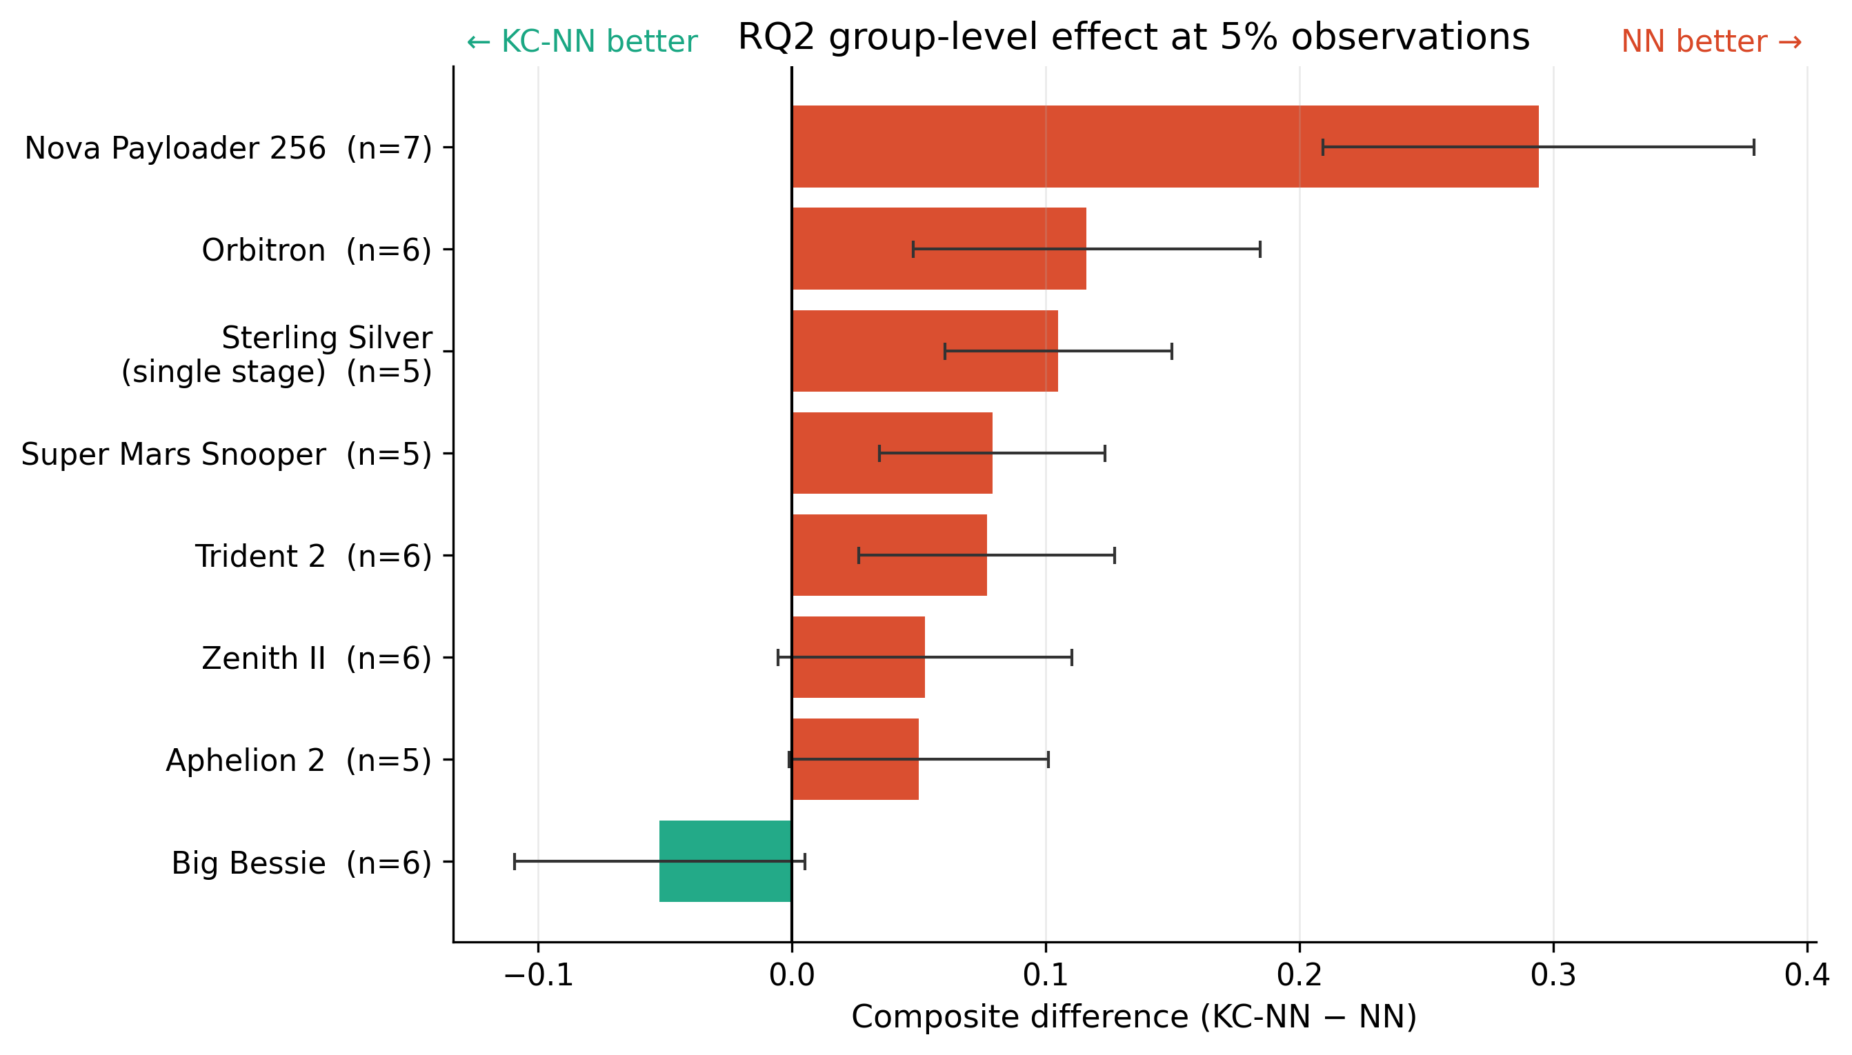
Figure 10. RQ2 group-level effect at 5% observations. Bars show the mean within-group composite-score difference (KC-NN minus NN) across five paired seeds; error bars show sample SD across seeds. Each group mean first averages flight-level differences within a seed. Negative values favor KC-NN and positive values favor NN. Parenthetical values are flight counts.

4.4 Channel mismatch
The development cohort's 1 Hz numerical altitude derivative and recorded velocity disagree by an average residual RMSE of 5.55 m/s across 335 flights (median flight residual RMSE 4.50 m/s), according to the earlier development draft. This is a candidate explanation for the equality penalty's unfavorable behavior; filtering, interpolation, time alignment and channel definition remain unresolved alternatives. The number is not a mean signed error, nor proof of any specific sensor mechanism.

5. Discussion
Constraint compliance and predictive accuracy answer different questions. RQ1 demonstrates the tradeoff directly: fewer inequality violations and better altitude reconstruction occurred alongside worse speed reconstruction and a worse combined score. NEXT-5 shows that a constraint can nevertheless correct a locally misaligned extrapolation: the upper-bound hinge suppressed an altitude overshoot and improved every tested observation fraction. The effect was not family-wide. NEXT-1 and NEXT-4 had identical model-visible static inputs (Block 3 and 9600 kg payload), yet their measured trajectories differed by 731.3 m altitude RMSE and 42.09 m/s speed RMSE over 0–120 s. This input-equivalent pair illustrates how omitted mission variables can make the same regularizer helpful for one flight and harmful for another. RQ2 shows a similarly fragile sparse-data development improvement reversing in a newly versioned group-held-out replication. The equality residual also conflicts with the processed channel pair. These findings favor explicit measurement models, richer flight descriptors and flight-level evaluation when adding a physical penalty to telemetry reconstruction.
The result is deliberately narrow. Falcon 9 is one vehicle family and only its first 120 s were studied. FlightSketch's operational groups are not verified physical vehicles, and its records are dominated by one contributor. The penalty is kinematic rather than a complete thrust, drag, mass-loss and flight-path dynamics model. The channel mismatch identifies a plausible mechanism, not a controlled causal isolation. Neither dataset supports a blanket conclusion about all PINNs, all rockets or unseen confirmed airframes.

6. Conclusion
On these two real-flight telemetry studies, the investigated kinematic penalties did not produce a reliable improvement in the prespecified held-out reconstruction scores. Iridium NEXT-5 provided a genuine flight-level benefit linked to the altitude-rate upper bound, but the effect failed the locked family replication criterion. Greater physical compliance alone was insufficient. A useful constraint must correspond to the recorded channels and survive evaluation across independent flights or defensibly defined groups.

Submission material and author-controlled declarations
Figures and tables: The ten numbered results figures and three numbered results tables are integrated in this draft, including the explicitly labelled post-hoc NEXT-5 mechanism analysis and Iridium-family replication. Still to assemble for the supplement or appendix are the RQ2 development mask curve and the altitude-derivative versus recorded-velocity mismatch diagnostic.
Data and code availability: [Authors to insert final release locations, licenses/permissions, raw versus processed sharing scope, frozen code revision, run manifest and access conditions. A prior draft states FlightSketch redistribution permission is complete; verify the exact written authorization and attribution requirements before release.]
Funding: This research received no external funding. Competing interests: The author declares no known competing financial interests or personal relationships that could have influenced the work. CRediT contributions: [Author to approve roles.] Ethics/permissions: [State only what the source permissions support.]

Declaration of generative AI and AI-assisted technologies in the manuscript preparation process
During the preparation of this work, the author used OpenAI ChatGPT and Codex to assist with literature organization, manuscript structuring and language editing, and to support code drafting, debugging, reproducible execution, numerical cross-checking and data-visualization scripting. After using these tools, the author reviewed and edited the content as needed and takes full responsibility for the content of the publication.

References
1. Raissi M, Perdikaris P, Karniadakis GE. Physics-informed neural networks: A deep learning framework for solving forward and inverse problems involving nonlinear partial differential equations. J Comput Phys 378 (2019) 686–707. https://doi.org/10.1016/j.jcp.2018.10.045
2. Karniadakis GE, Kevrekidis IG, Lu L, Perdikaris P, Wang S, Yang L. Physics-informed machine learning. Nat Rev Phys 3 (2021) 422–440. https://doi.org/10.1038/s42254-021-00314-5
3. Wang S, Teng Y, Perdikaris P. Understanding and mitigating gradient flow pathologies in physics-informed neural networks. SIAM J Sci Comput 43(5) (2021) A3055–A3081. https://doi.org/10.1137/20M1318043
4. Wang S, Yu X, Perdikaris P. When and why PINNs fail to train: A neural tangent kernel perspective. J Comput Phys 449 (2022) 110768. https://doi.org/10.1016/j.jcp.2021.110768
5. Caldas F, Soares C. Machine learning in orbit estimation: A survey. Acta Astronautica 220 (2024) 97–107. https://doi.org/10.1016/j.actaastro.2024.03.072
6. Takahashi Y, Saito M, Oshima N, Yamada K. Trajectory reconstruction for nanosatellite in very low Earth orbit using machine learning. Acta Astronautica 194 (2022) 301–308. https://doi.org/10.1016/j.actaastro.2022.02.010
7. Scorsoglio A, D’Ambrosio A, Le Corre L, Gray B, Reddy V, Furfaro R. Physics-informed orbit determination for X-GEO space situational awareness. Acta Astronautica 238 (2026) 271–285. https://doi.org/10.1016/j.actaastro.2025.09.002

