When kinematic constraints conflict with rocket telemetry: sparse trajectory reconstruction across two real-flight datasets
Author: Kağan Yurtkölesi
Affiliation: Department of Aerospace Engineering, Izmir University of Economics, Izmir, Türkiye
Corresponding author: kagan.yurtkolesi@std.iue.edu.tr

Abstract
Kinematic constraints may improve trajectory plausibility without improving agreement with measured telemetry. We compared unconstrained and kinematically constrained neural networks in two real-flight studies with distinct observation protocols. The Falcon 9 study used 40 flights, with 28 training, six outer-validation and six held-out test flights. At 5% training observations, constraints reduced test altitude RMSE from 2304.55 to 1920.30 m and violation fraction from 0.4262 to 0.0612, but increased speed RMSE from 46.77 to 69.87 m/s. Combined standardized error increased by 0.018634; only one of six flights benefited. Post-hoc ablation linked the Iridium NEXT-5 gain to the altitude-rate upper bound, but a locked family replication improved only two of five flights. The FlightSketch reconstruction used dataset-specific training with complete fitting targets and 5% observations as reconstruction inputs. Its versioned evaluation contained 46 flights from eight provisional metadata groups; it was not a pristine sealed test because historical assignments were unavailable. Across five paired seeds, the constrained model increased the combined score from 0.6096 to 0.7145, with no seed-level wins. The archived penalty uses centered velocity, introducing a constant offset from the physical channel-equality residual. A historical channel-mismatch audit suggests measurement inconsistency as a possible contributor, not an isolated cause. These results support careful matching of constraints to telemetry definitions and evaluation protocols rather than a general advantage of physical regularization.
Keywords: rocket telemetry; sparse trajectory reconstruction; kinematic constraints; physics-informed machine learning; measurement consistency; held-out evaluation

1. Introduction
Sparse observations make flight trajectory reconstruction an underdetermined task. Neural networks can reconstruct smooth altitude and velocity histories, while physical penalties may discourage implausible outputs. Yet the variables in a recorded telemetry stream need not correspond exactly to the state variables in an idealized physical law. Imposing an equality on filtered, quantized or differently timed channels can shift a prediction away from the measurements it is meant to reconstruct.
We examine this issue in early Falcon 9 webcast telemetry and public FlightSketch records. These are complementary observational settings, not interchangeable vehicle populations. Falcon 9 webcast speed denotes total speed; with unknown flight-path angle it should not be equated with vertical altitude rate. FlightSketch altitude and recorded velocity appear closer to a vertical kinematic pair, but their processed 1 Hz channels disagree empirically. Our primary question is whether adding the respective kinematic penalty improves held-out predictive accuracy under sparse observations, beyond increasing equation compliance.
This study contributes (i) a matched NN versus kinematically constrained NN comparison with fixed observation masks and held-out evaluations; (ii) flight-level scrutiny and a targeted replication of an apparently favorable case; and (iii) a measurement-channel audit to interpret an unfavorable held-out result. The contribution concerns empirical limits of this particular regularization on these telemetry sources. It does not imply that richer dynamics models, other observation models or all physics-informed methods fail.
Physics-informed neural networks incorporate governing equations or related physical residuals into learning objectives [1,2]. Their training can nevertheless be sensitive to imbalance between data and physics gradients and to the resulting optimization dynamics [3,4]. In aerospace estimation, machine learning has been applied across orbit-estimation tasks [5], including trajectory reconstruction for a nanosatellite in very low Earth orbit [6], while recent work has investigated physics-informed orbit determination for X-GEO space situational awareness [7]. The present study addresses a narrower measurement-consistency question: whether simple kinematic regularizers improve sparse reconstruction of altitude and velocity channels in real rocket-flight telemetry when evaluated across held-out flights or provisional groups.

2. Data and experimental design

2.1 Falcon 9 webcast telemetry (RQ1)
Forty flights contribute altitude and speed at 1 Hz from launch through 120 s (121 samples per flight). The fixed split has 28 training, six outer-validation and six held-out test flights. Training includes an inner fit/validation division of 22/6 flights. The outer-validation flights were visible during development and are not an independent final test. The six test flights were evaluated once with frozen models and no subsequent tuning. The measured speed is a magnitude, not an independently established vertical velocity. The flight roster, preprocessing and split details are provided in the Supplementary Information and recovered experiment records.
The matched RQ1 networks received eight inputs: normalized time, standardized payload, a payload-missing indicator and one-hot indicators for Falcon 9 Blocks 1–5. Both used two 32-unit tanh hidden layers and standardized altitude and speed outputs with scaling learned only from the relevant fit partition. Learning rate and Adam weight decay were screened on the 100% inner-fit condition over {0.0003, 0.001} and {0, 10⁻⁶, 10⁻⁵, 10⁻⁴}, respectively, using paired seeds 11, 29 and 47. Both methods selected learning rate 0.001 and weight decay 10⁻⁴; the frozen final training lengths were 560 epochs for NN and 400 epochs for KC-NN. These settings were retained for the 100, 50, 25, 10 and 5% observation masks and paired seeds 11, 29, 47, 71 and 97.

2.2 FlightSketch telemetry (RQ2)
The public index audit identified 4,040 records, 617 deterministic candidates and 614 initial technical passes. All 614 historical source-file SHA-256 values were restored and verified for the reconstruction. The frozen historical development cohort contains 335 flights, 17,864 processed 1 Hz samples and 41 provisional uploader-plus-normalized-title groups: 33 groups/257 flights for training and eight groups/78 flights for outer validation. Historical documentation recorded no final test and did not retain the exact 41-group assignment. We therefore defined reconstruction v1.1 conservatively: every canonical operational group containing a source row consistent with the historical development rule was restricted to fit or inner validation. The resulting fit set contained 363 flights/31 groups, inner validation contained 75 flights/six groups, and the newly allocated held-out set contained 46 usable flights/eight groups. Uploader/title membership cannot establish distinct physical airframes or configurations, and contributor concentration limits extrapolation beyond the represented uploader regime.

2.3 Sparse observations and comparison
The observation protocols differ between studies. RQ1 sparsifies training targets; its held-out flights are predicted from time and static flight descriptors. RQ2 reconstruction v1.1 instead uses sparse per-flight altitude and velocity observations as inputs while retaining complete trajectories as fitting targets. Historical RQ2 development examined input fractions of 5, 10, 25, 50 and 100%; v1.1 evaluated the fixed primary 5% input condition. At each 1 Hz trajectory, endpoints were retained and a fixed SHA-256 ordering selected the remaining inputs until max(2, ceil(0.05n)) samples were observed. Both RQ2 models used two 32-unit tanh layers, two standardized outputs, fit-only scaling, Adam with learning rate 0.001 and coupled L2 weight decay 0.0001, at most 3000 epochs, and inner-validation early stopping with patience 250. Inputs were normalized time, interpolated sparse altitude and velocity, normalized distance to the nearest observation, duration, an observation indicator and log observation ratio. Seeds were 11, 29, 47, 71 and 97. The loss and stopping criterion used all fitting and inner-validation time points, respectively; sparsity applies to the inputs, not to the number of available fitting labels. These studies therefore do not constitute the same limited-label estimand across datasets.

3. Kinematic formulations and evaluation
For RQ1, let z_h and z_v denote the standardized network outputs, and recover physical predictions as ĥ = μ_h + σ_h z_h and v̂ = μ_v + σ_v z_v. With normalized time τ = t/120, automatic differentiation gives q = dĥ/dt = (σ_h/120)(dz_h/dτ). Because webcast speed is a magnitude rather than vertical velocity, the model does not impose q = v̂. It instead penalizes violations of the early-ascent inequalities 0 ≤ q ≤ v̂ and v̂ ≥ 0.
The implemented dimensionless penalty was L_kin = mean[ReLU(−q/σ_v)² + ReLU((q−v̂)/σ_v)² + ReLU(−v̂/σ_v)²]. The observed-point data loss was L_data = 0.5[MSE(z_h,z_h,obs) + MSE(z_v,z_v,obs)]. NN minimized L_data, whereas KC-NN minimized L_data + λ_kin L_kin. The single frozen weight was calibrated before model selection on the 100% inner-fit partition: for seeds 11, 29 and 47, r was the ratio ||∇L_kin||/||∇L_data|| at initialization; λ_kin = clip[1/median(r), 0.01, 100]. The recorded median ratio was 0.02968922099, giving λ_kin = 33.68225796 without fallback. L_kin was evaluated at all 121 time coordinates of each fit flight; unobserved altitude and speed targets were not supplied at those collocation points. A violation was counted when q < 0, q > v̂ or v̂ < 0.
For reconstruction v1.1, dataset-specific NN and KC-NN weights were fitted on FlightSketch groups; Falcon 9 checkpoint weights were not transferred. The intended RQ2 relation couples finite-difference altitude rate to the mean adjacent predicted velocity, normalized by the fitting velocity standard deviation. The archived implementation reconstructs centered outputs as h_c = σ_h z_h and v_c = σ_v z_v before forming the residual. Altitude centering cancels in the finite difference, but the velocity mean does not. Consequently, the implemented residual equals the physical-channel residual plus μ_v/σ_v. The stored fitting velocity mean is −0.0058894643 m/s and its standard deviation is 14.3564722162 m/s, giving a normalized constant offset of approximately −0.00041023. NN minimizes full-trajectory standardized target MSE on fitting flights; KC-NN adds 1.91 times the mean squared implemented residual. The reported results describe this archived objective, not a newly corrected and retrained model.
Altitude and velocity errors are reported as RMSE in physical units. The combined standardized score is 0.5(RMSE_h/σ_h + RMSE_v/σ_v), using fit-set target standard deviations σ_h and σ_v. Paired differences were computed as KC-NN minus NN, so a positive difference means the constraint worsens the score. Flight- and group-level effects are reported alongside averages. Seed variability measures training sensitivity, not independent flight-level uncertainty. For RQ1, the flight bootstrap interval is reported separately from optimization-seed variability. All claims of cross-group generalization refer to provisional metadata groups.
After the primary RQ1 analysis was closed, Iridium NEXT-5 was examined in three explicitly post-hoc follow-ups. First, frozen predictions were compared across the five observation fractions and decomposed by trajectory segment and output channel. Second, a term-ablation study used the frozen 5% mask, five paired seeds, the same architecture and optimizer, 400 epochs and the unchanged kinematic weight. Fifteen planned runs removed one hinge at a time from the full penalty. Third, a replication protocol was locked before fitting 75 leave-one-flight-out models. Each of the five Iridium missions in the original training partition (NEXT-1, NEXT-3, NEXT-4, NEXT-6 and NEXT-8) was held out in turn; the other 27 original training flights were used for fitting, and the six original test flights, including NEXT-5, were excluded from all training, normalization and fold evaluation. The compared variants were NN, full KC-NN and an upper-bound-only KC-NN retaining only dh/dt ≤ speed. Internal family replication required the upper-bound-only model to beat NN on at least four of five flights and to have a negative unweighted mean flight-level difference. These analyses diagnose a favorable flight and do not revise the confirmatory RQ1 estimand.
OpenAI ChatGPT and Codex (OpenAI; accessed September–October 2026) were used as AI-assisted tools to support code drafting and debugging, execution planning, consistency checks of stored metrics and data-visualization scripting. The source telemetry, dataset allocations, model specifications, seeds, checkpoints and recorded numerical outputs were retained in the reproducible workflow; the tools were not used to fabricate or alter source observations or reported results. All reported metrics and figures were generated from the stated datasets and executable analysis workflows and were reviewed by the author.

4. Results

4.1 Falcon 9 held-out evaluation
At 5% observations, NN versus KC-NN altitude RMSE was 2304.55 versus 1920.30 m, while speed RMSE was 46.77 versus 69.87 m/s. The kinematic-violation rate fell from 0.4262 to 0.0612. Yet the prespecified combined score difference (KC-NN minus NN) was +0.018634, with a constrained-model advantage on one of six held-out flights. The RQ1 closure audit reports a flight bootstrap 95% interval of −0.020757 to +0.045011. This interval includes zero; the six-flight sample does not establish a population-wide effect.
Table 1. RQ1 held-out results at 5% observations. Lower values are better for every metric. The composite score is available as a paired method difference rather than as two independently reported absolute values.
Metric | NN | KC-NN | KC-NN − NN
Altitude RMSE (m) | 2304.55 | 1920.30 | −384.25
Speed RMSE (m/s) | 46.77 | 69.87 | +23.10
Kinematic-violation fraction | 0.4262 | 0.0612 | −0.3650
Standardized composite error | — | — | +0.018634

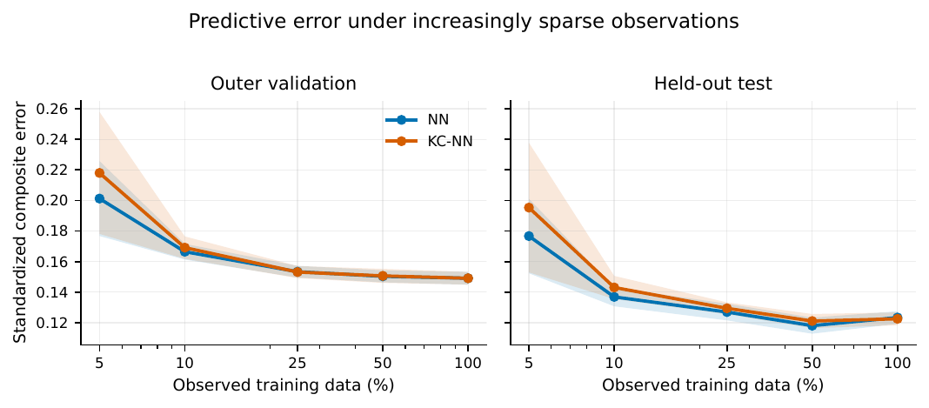
Figure 1. RQ1 predictive error under increasingly sparse training observations. Flight-macro standardized composite error is shown for outer validation and held-out test flights. Lines show means across five paired seeds; shaded bands show ±1 seed standard deviation, not confidence intervals. Lower values are better.
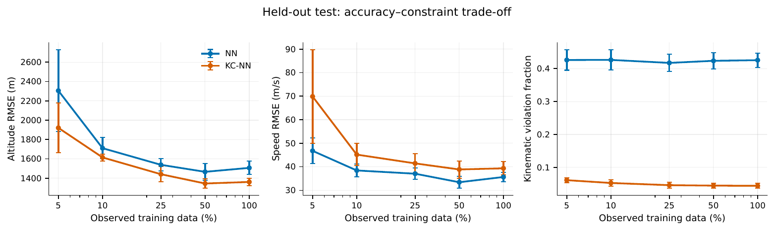
Figure 2. RQ1 held-out accuracy–constraint trade-off. Flight-macro altitude RMSE, speed RMSE and kinematic-violation fraction across training observation fractions. Points show five-seed means and error bars show ±1 seed standard deviation. At 5%, KC-NN improves altitude and compliance but worsens speed and the combined score.
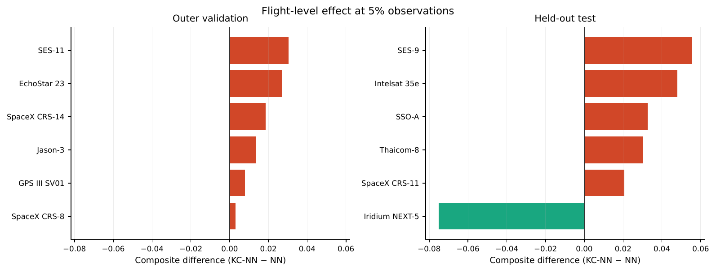
Figure 3. RQ1 flight-level effect at 5% observations. Bars show the standardized composite-score difference (KC-NN minus NN) for six outer-validation and six held-out flights. Negative values favor KC-NN and positive values favor NN. The constrained model improved only Iridium NEXT-5 in the held-out set, illustrating the heterogeneity concealed by an aggregate mean.

4.2 Iridium NEXT-5 mechanism and family replication
Iridium NEXT-5 was the only held-out RQ1 flight on which KC-NN improved the combined score. At 5% observations, its five-seed mean composite error fell from 0.2247 for NN to 0.1494 for KC-NN, with KC-NN better in all five paired seeds. Approximately 79.5% of the composite improvement came from altitude: altitude RMSE fell from 2260.3 to 933.8 m, while speed RMSE fell from 78.88 to 68.96 m/s and improved in four of five seeds. The finite-difference inequality-violation fraction was 38.0% for NN and 5.8% for KC-NN. The NN ensemble overshot the measured altitude after approximately 30 s, particularly during 61–90 s, whereas the constraint suppressed most of this middle-to-late trajectory overshoot.
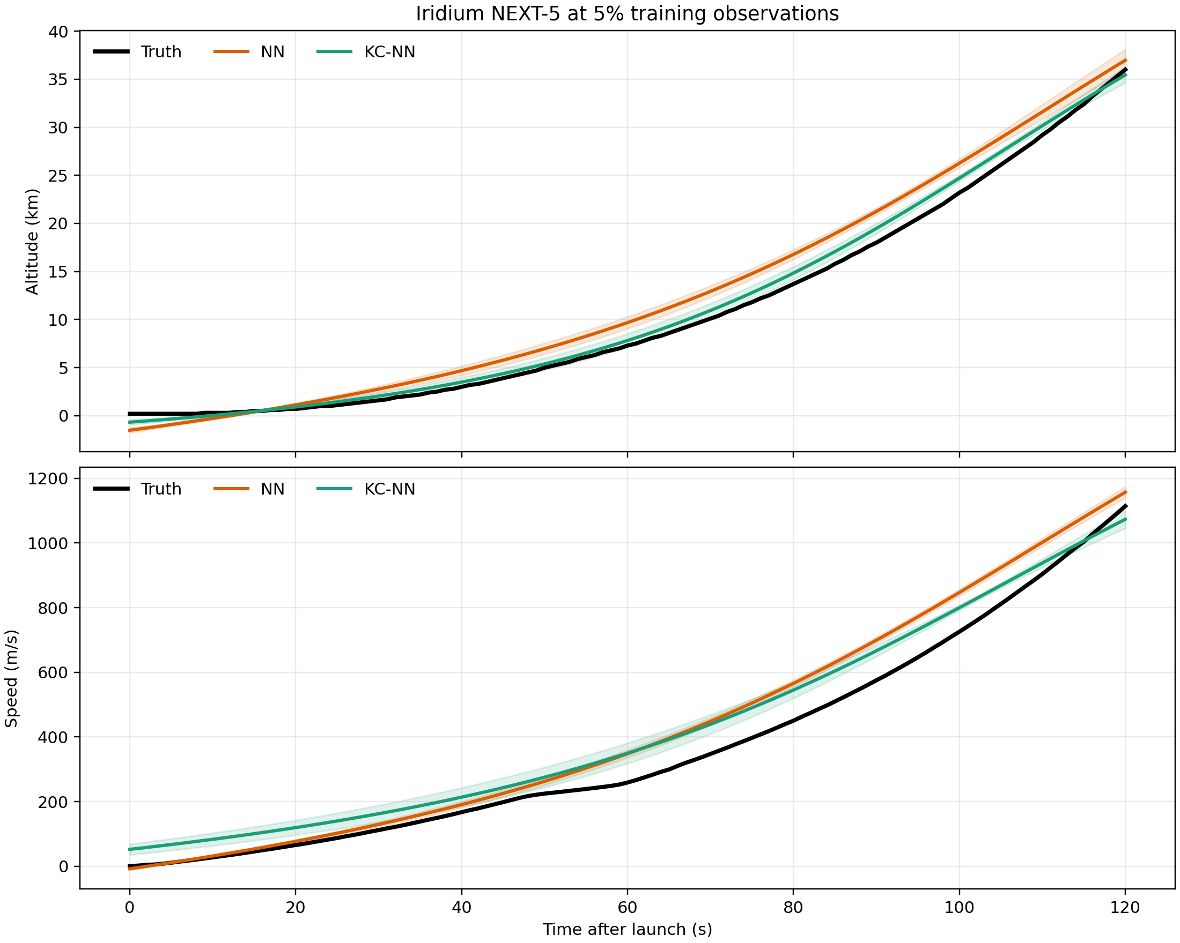
Figure 4. Post-hoc Iridium NEXT-5 trajectory diagnostic at 5% observations. Curves show the measured trajectory and the five-seed mean predictions; bands show ±1 seed standard deviation and are descriptive rather than confidence intervals. KC-NN substantially reduces the NN altitude overshoot.
The NEXT-5 advantage was present at every frozen observation fraction rather than being unique to one sparse mask. NN versus KC-NN composite error was 0.1641 versus 0.1046 at 100%, 0.1378 versus 0.0930 at 50%, 0.1689 versus 0.1130 at 25%, 0.1974 versus 0.1311 at 10%, and 0.2247 versus 0.1494 at 5%. The gap was largest at the sparsest setting.
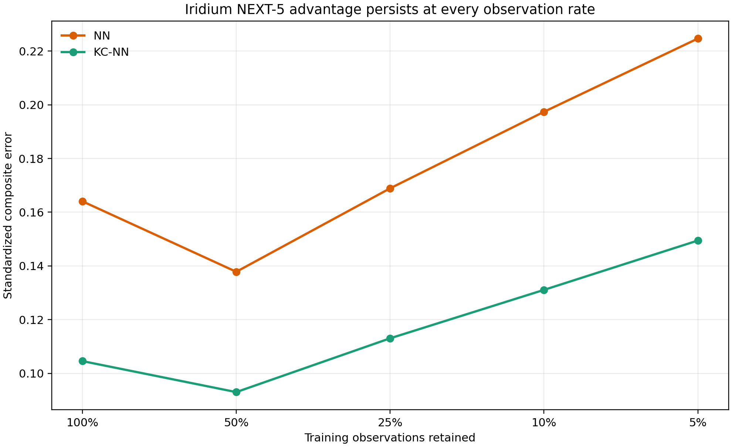
Figure 5. Post-hoc Iridium NEXT-5 sensitivity to the training observation fraction. Values are five-seed mean standardized composite errors from the frozen RQ1 outputs. Lower values are better.
The term ablation isolated the upper-bound hinge as the driver of the favorable result. Removing dh/dt ≤ speed increased the NEXT-5 composite error from 0.1494 to 0.3210, worse than the NN value of 0.2247, and all five seeds deteriorated. Removing the nonnegative-speed hinge produced no numerical change, while removing dh/dt ≥ 0 slightly reduced the mean error to 0.1385. Thus the useful component on this flight was a weak plausibility bound involving total speed, not an exact equality between altitude rate and vertical velocity.
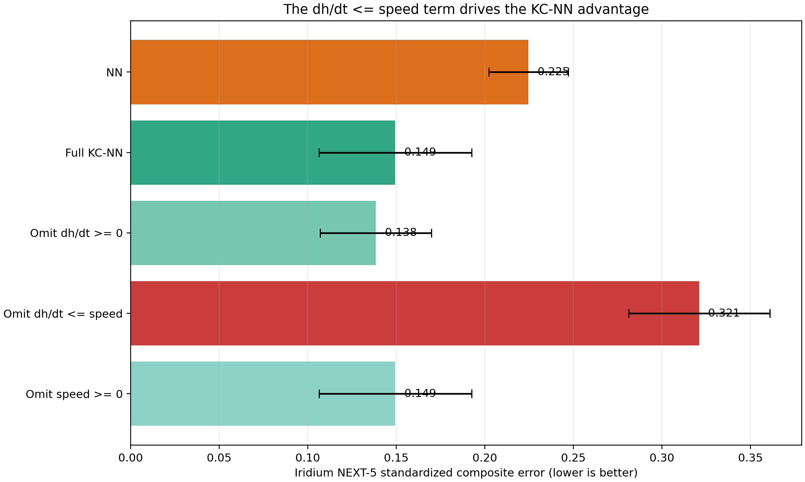
Figure 6. Post-hoc kinematic-term ablation on Iridium NEXT-5 at 5% observations. Bars show five-seed mean standardized composite error and error bars show ±1 seed standard deviation. Removing the dh/dt ≤ speed hinge eliminates the KC-NN advantage.
The locked family replication did not reproduce the NEXT-5 effect consistently. The upper-bound-only model beat NN on NEXT-4 and NEXT-8, but not on NEXT-1, NEXT-3 or NEXT-6; it therefore failed the required four-of-five criterion. Its mean difference was −0.0061 only because the two favorable effects were larger than the three unfavorable effects. Across flights, mean composite errors were 0.1741 for NN, 0.1768 for full KC-NN and 0.1680 for the upper-bound-only model. The direction was stable across seeds within flights: the upper-bound-only model won all five seeds on NEXT-4 and NEXT-8, one of five on NEXT-1, and none on NEXT-3 or NEXT-6.
Table 2. Locked post-hoc Iridium-family leave-one-flight-out replication at 5% observations. Values are five-seed mean standardized composite errors. Lower values are better.
Held-out flight | NN | Full KC-NN | Upper-bound only | Upper-bound only − NN | Favored model
NEXT-1 | 0.0960 | 0.1251 | 0.1129 | +0.0169 | NN
NEXT-3 | 0.1740 | 0.2120 | 0.2111 | +0.0371 | NN
NEXT-4 | 0.2654 | 0.2194 | 0.2080 | −0.0573 | Upper-bound only
NEXT-6 | 0.1180 | 0.1455 | 0.1326 | +0.0146 | NN
NEXT-8 | 0.2169 | 0.1818 | 0.1753 | −0.0416 | Upper-bound only

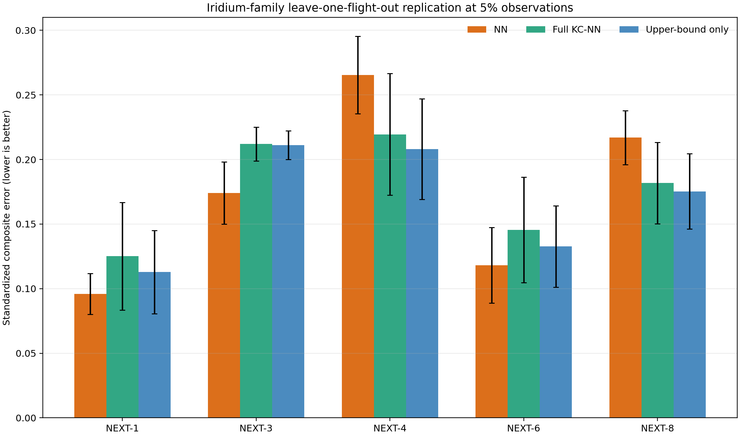
Figure 7. Post-hoc Iridium-family leave-one-flight-out replication at 5% observations. Bars show five-seed mean standardized composite error and error bars show ±1 seed standard deviation. The upper-bound-only model improved two of five flights, below the locked four-of-five requirement.

4.3 FlightSketch development and held-out evaluation
Development at 5% observations gave a combined score of 0.3479 for NN and 0.3449 for KC-NN; the constrained model won three of five paired seeds. At 10, 25, 50 and 100% observations it lost all 20 paired seed comparisons. This development signal did not establish a robust benefit.
Confirmatory reconstruction v1.1 evaluated eight newly allocated provisional groups and 46 usable flights at 5% observations. Across five paired seeds, NN versus KC-NN altitude RMSE was 44.73 ± 3.63 versus 57.52 ± 3.46 m and velocity RMSE was 10.14 ± 0.23 versus 11.04 ± 0.77 m/s. The combined score rose from 0.6096 ± 0.0274 to 0.7145 ± 0.0369. The paired increase was 0.1049 ± 0.0558 (sample SD), with zero of five seed wins for KC-NN. Historical verification records report replay of all ten checkpoints within 10⁻¹², the eight evaluation groups were disjoint from fit/validation groups, and the manifest fingerprint was 9efc8c68fc63ac7603e471e101571417017ac5bfb51398fa2f718396761f8782. Seeds quantify optimization variability and are not independent test cohorts.
Table 3. RQ2 confirmatory reconstruction v1.1 at 5% observations. Values are mean ± sample SD across five paired optimization seeds.
Metric | NN | KC-NN | Direction
Altitude RMSE (m) | 44.73 ± 3.63 | 57.52 ± 3.46 | NN lower
Velocity RMSE (m/s) | 10.14 ± 0.23 | 11.04 ± 0.77 | NN lower
Standardized composite error | 0.6096 ± 0.0274 | 0.7145 ± 0.0369 | NN lower
Paired composite difference | — | +0.1049 ± 0.0558 | KC-NN worse

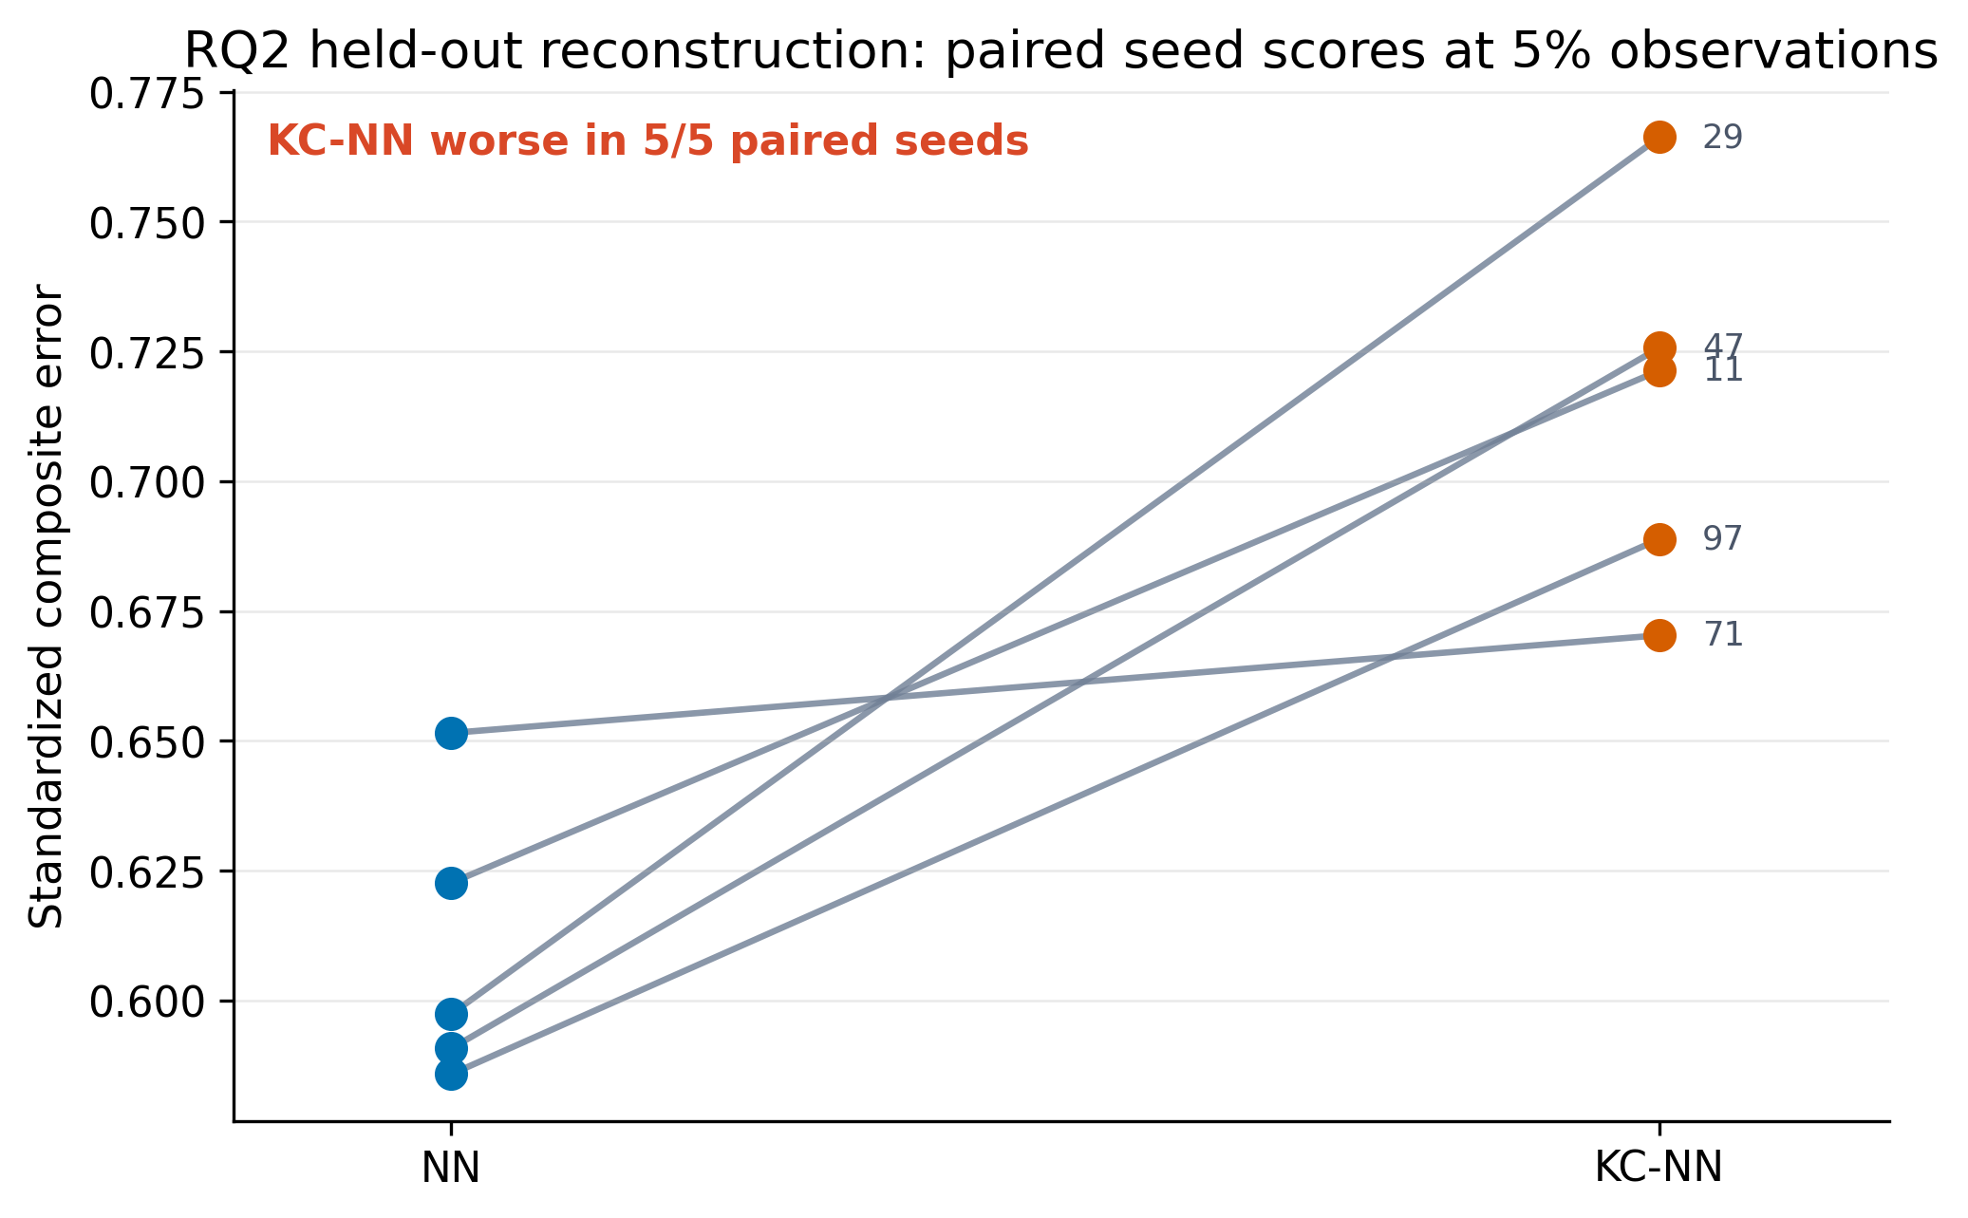
Figure 8. RQ2 paired seed scores at 5% observations. Each line connects NN and KC-NN for one fixed initialization seed. Lower standardized composite error is better. KC-NN was worse in all five paired seeds.
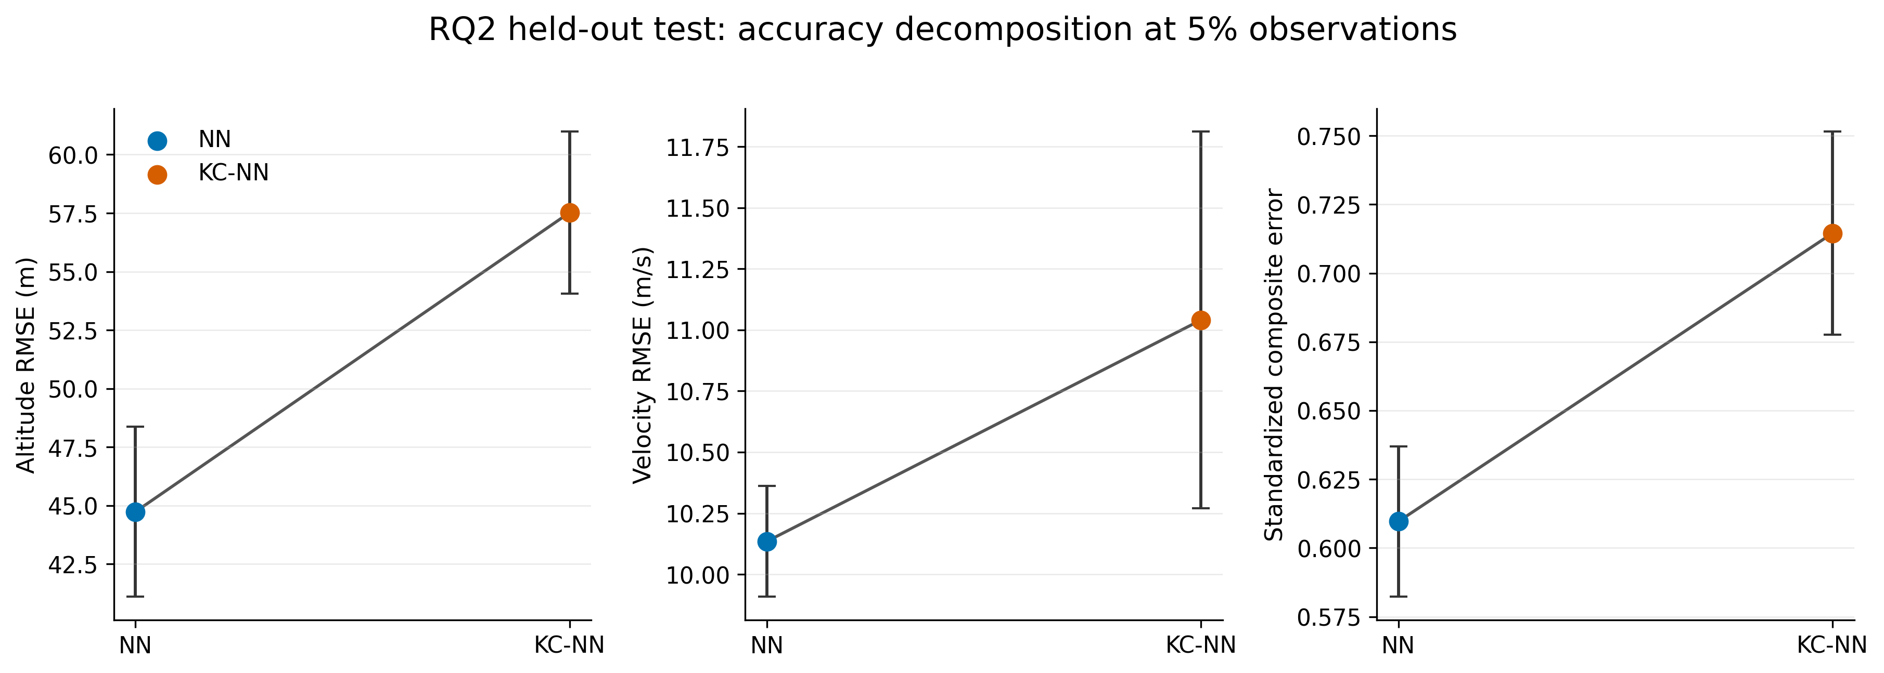
Figure 9. RQ2 held-out accuracy decomposition at 5% observations. Points show the mean across five paired optimization seeds; error bars show sample SD. KC-NN increased altitude RMSE, velocity RMSE and standardized composite error.
Group-level effects were also directionally consistent with the aggregate result. Seven of eight provisional groups favored NN on average. Big Bessie was the only group with a negative mean difference, although its seed-level uncertainty crossed zero. These group summaries are descriptive because the public labels do not establish independent physical airframes.
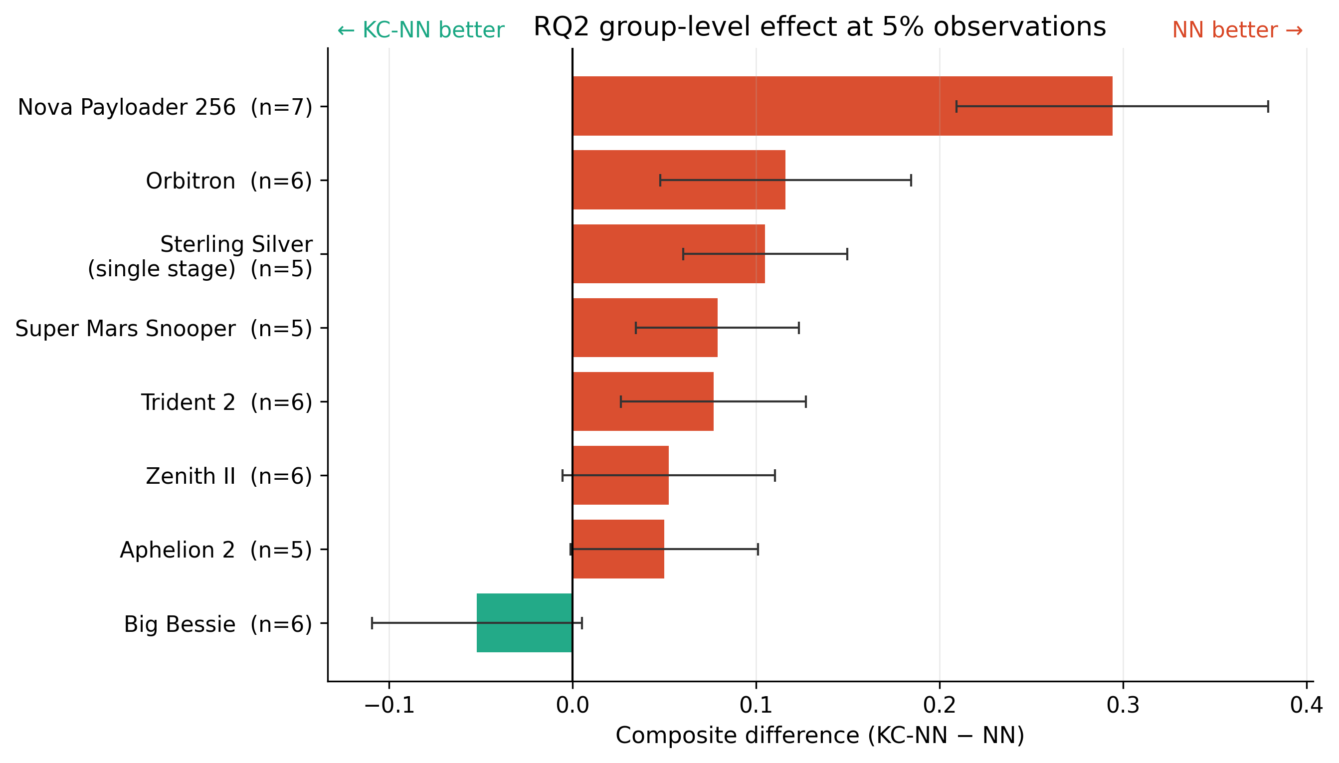
Figure 10. RQ2 group-level effect at 5% observations. Bars show the mean within-group composite-score difference (KC-NN minus NN) across five paired seeds; error bars show sample SD across seeds. Each group mean first averages flight-level differences within a seed. Negative values favor KC-NN and positive values favor NN. Parenthetical values are flight counts.

4.4 Channel mismatch
The development cohort's 1 Hz numerical altitude derivative and recorded velocity disagree by an average residual RMSE of 5.55 m/s across 335 flights (median flight residual RMSE 4.50 m/s), according to the earlier development draft. This is a candidate explanation for the equality penalty's unfavorable behavior; filtering, interpolation, time alignment and channel definition remain unresolved alternatives. The number is not a mean signed error, nor proof of any specific sensor mechanism.

5. Discussion
Constraint compliance and predictive accuracy answer different questions. RQ1 demonstrates the tradeoff directly: fewer inequality violations and better altitude reconstruction occurred alongside worse speed reconstruction and a worse combined score. NEXT-5 shows that a constraint can nevertheless correct a locally misaligned extrapolation: the upper-bound hinge suppressed an altitude overshoot and improved every tested observation fraction. The effect was not family-wide. NEXT-1 and NEXT-4 had identical model-visible static inputs (Block 3 and 9600 kg payload), yet their measured trajectories differed by 731.3 m altitude RMSE and 42.09 m/s speed RMSE over 0–120 s. This input-equivalent pair illustrates how omitted mission variables can make the same regularizer helpful for one flight and harmful for another. RQ2 shows a similarly fragile sparse-data development improvement reversing in a newly versioned group-held-out replication. The equality residual also conflicts with the processed channel pair. These findings favor explicit measurement models, richer flight descriptors and flight-level evaluation when adding a physical penalty to telemetry reconstruction.
The result is deliberately narrow. Falcon 9 is one vehicle family and only its first 120 s were studied. FlightSketch's operational groups are not verified physical vehicles, and its records are dominated by one contributor. The penalty is kinematic rather than a complete thrust, drag, mass-loss and flight-path dynamics model. The channel mismatch identifies a plausible mechanism, not a controlled causal isolation. Neither dataset supports a blanket conclusion about all PINNs, all rockets or unseen confirmed airframes. RQ2 uses dense fitting supervision with sparse reconstruction inputs, unlike RQ1 training-target sparsity. Its archived residual contains the velocity-centering offset described above; the effect of correcting that offset has not been tested. The current inspection checks stored code and records, not a fresh raw-data replay.

6. Conclusion
Under the archived implementations and their distinct observation protocols, the investigated penalties did not produce a reliable improvement in the held-out reconstruction scores. Iridium NEXT-5 provided a flight-level benefit linked to the altitude-rate upper bound, but the effect failed the locked family replication criterion. The FlightSketch result concerns dense-supervised sparse-input reconstruction with the implemented centered-velocity residual. These findings do not establish that physical regularization generally fails. Constraints must be evaluated against the recorded channels and the actual information available during fitting and inference.

Declarations
Supplementary material: The Supplementary Information provides additional experimental specifications, sensitivity analyses, cohort descriptions and integrity records.
Data and code availability: The public version 0.9.0 reproducibility archive is available on Zenodo [8] at https://doi.org/10.5281/zenodo.23080487 and the maintained repository is https://github.com/kaganyurtk/sparse-trajectory-reconstruction. The archive includes RQ1 training and evaluation code, recovered NEXT-5 and Iridium-family runners, and the RQ2 reconstruction v1.1 runner, splits, manifests, checkpoints and historical verification records. Third-party raw telemetry is not redistributed. Historical workflows require permitted source data and configuration of input paths; no clean-environment end-to-end replay is claimed. Code is MIT-licensed and author-written documentation is CC BY 4.0. MANIFEST_PROVENANCE.json distinguishes historical and path-normalized Iridium fingerprints. The archived manuscript is a frozen pre-submission snapshot; this submission text clarifies its methods and availability statements without replacing the archived files or changing numerical results.
Funding: This research received no external funding.
Competing interests: The author declares no known competing financial interests or personal relationships that could have influenced the work.
CRediT author statement: Kağan Yurtkölesi: Conceptualization, Methodology, Software, Validation, Formal analysis, Investigation, Data curation, Writing – original draft, Writing – review & editing, Visualization.
Ethics and data provenance: This study analyzed rocket-flight telemetry and did not involve human participants or animal experiments. RQ2 used publicly accessible FlightSketch flight records and their downloadable CSV files. FlightSketch and its flight-log contributors are acknowledged as sources. Third-party raw telemetry is not redistributed in the code package; its public availability is not treated as a grant to republish those files.

Declaration of generative AI and AI-assisted technologies in the manuscript preparation process
During the preparation of this work, the author used OpenAI ChatGPT and Codex to assist with literature organization, manuscript structuring and language editing, and to support code drafting, debugging, reproducible execution, numerical cross-checking and data-visualization scripting. After using these tools, the author reviewed and edited the content as needed and takes full responsibility for the content of the publication.

References
1. Raissi M, Perdikaris P, Karniadakis GE. Physics-informed neural networks: A deep learning framework for solving forward and inverse problems involving nonlinear partial differential equations. J Comput Phys 378 (2019) 686–707. https://doi.org/10.1016/j.jcp.2018.10.045
2. Karniadakis GE, Kevrekidis IG, Lu L, Perdikaris P, Wang S, Yang L. Physics-informed machine learning. Nat Rev Phys 3 (2021) 422–440. https://doi.org/10.1038/s42254-021-00314-5
3. Wang S, Teng Y, Perdikaris P. Understanding and mitigating gradient flow pathologies in physics-informed neural networks. SIAM J Sci Comput 43(5) (2021) A3055–A3081. https://doi.org/10.1137/20M1318043
4. Wang S, Yu X, Perdikaris P. When and why PINNs fail to train: A neural tangent kernel perspective. J Comput Phys 449 (2022) 110768. https://doi.org/10.1016/j.jcp.2021.110768
5. Caldas F, Soares C. Machine learning in orbit estimation: A survey. Acta Astronautica 220 (2024) 97–107. https://doi.org/10.1016/j.actaastro.2024.03.072
6. Takahashi Y, Saito M, Oshima N, Yamada K. Trajectory reconstruction for nanosatellite in very low Earth orbit using machine learning. Acta Astronautica 194 (2022) 301–308. https://doi.org/10.1016/j.actaastro.2022.02.010
7. Scorsoglio A, D’Ambrosio A, Le Corre L, Gray B, Reddy V, Furfaro R. Physics-informed orbit determination for X-GEO space situational awareness. Acta Astronautica 238 (2026) 271–285. https://doi.org/10.1016/j.actaastro.2025.09.002
8. Yurtkölesi K. Sparse trajectory reconstruction under kinematic constraints, version 0.9.0 [software and reproducibility archive]. Zenodo (2026). https://doi.org/10.5281/zenodo.23080487

