**Tag line** (can we squeeze this into the top menu?)

Melbourne-area therapy for stress, anxiety, depression and other concerns – **first 10 sessions** **free** with Medicare rebate. Call me for a free 10 minute phone consultation.

**Home**

**(stolen from** <http://www.sydneytherapist.com.au/> **-** *we could do something similar, I like the phone call option to rope people in)*

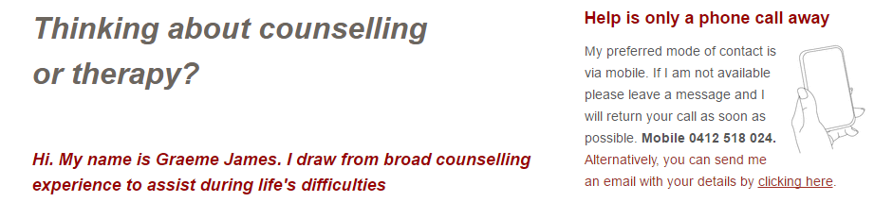

I help people with a range of concerns including:

* Stress
* Anxiety & Panic
* Depression
* Relationships
* Psychological and Childhood Trauma
* Grief and Loss
* Eating Concerns
* Couples therapy
* Workplace issues
* Drug and alcohol problems
* Sexual difficulties
* Self Esteem
* Life difficulties and transitions
* Wellbeing

**About Me** *(add a nice photo)*

* With 3 undergraduate degrees (in X, Y, Z), 2 Masters degrees (in X & Y), I am one of the most highly qualified psychologists in Australia
* I have over X years counselling experience
* I provide[*supervision*](http://www.sydneytherapist.com.au/supervision.html)for other counsellors and therapists

**About**

**Time & Money**

**What I Offer**

**Contact**