ESC 50 Noise Robustness Results Comparison
Enhanced MFCC and Support Vector Machine compared with an improved Spectrogram Convolutional Neural Network and a YAMNet embedding Support Vector Machine
This report compares three environmental sound classifiers on the 2,000-clip ESC-50 dataset using the five official folds. The MFCC solution applies fold-specific ANOVA SelectKBest feature selection to 120 enhanced MFCC, delta, and delta-delta summary features; every outer fold selected 80 features. The third solution classifies mean-pooled 1,024-dimensional embeddings from the pretrained YAMNet network with a standardized, SelectKBest-reduced RBF support vector machine tuned by three-fold grid search inside each training set; every outer fold selected 256 features. All three models were trained on clean audio and evaluated under Clean, 20 dB, 10 dB, 5 dB, and 0 dB Gaussian-noise conditions. YAMNet with SVM achieved the strongest result at every condition, the improved CNN was stronger than MFCC with SVM on clean audio and remained slightly ahead at 20 dB and 10 dB, and all three models degraded sharply under severe noise.

Results contents
Order | Content | Type
1 | Overall Accuracy and Macro F1 | Table I
2 | Accuracy versus Noise Level | Figure 2
3 | Macro F1 versus Noise Level | Figure 3
4 | Confusion Matrices at 0 dB | Figure 4
5 | Computational Performance | Table II
6 | Class wise F1 Comparison | Table III

1 Overall Accuracy and Macro F1
Table I reports the mean five-fold performance for all three models. Clean accuracy was 52.70 percent for the feature-selected MFCC and SVM model, 62.45 percent for the improved spectrogram CNN, and 82.30 percent for YAMNet with SVM. At 0 dB, the models achieved 4.75, 4.45, and 11.85 percent accuracy, respectively, showing substantial sensitivity to severe background noise for all three.
Table I Mean five-fold accuracy and macro F1 by noise condition
Noise level | MFCC SVM  Accuracy | MFCC SVM  Macro F1 | CNN  Accuracy | CNN  Macro F1 | YAMNet SVM  Accuracy | YAMNet SVM  Macro F1
Clean | 0.5270 | 0.5180 | 0.6245 | 0.6065 | 0.8230 | 0.8218
20 dB | 0.3410 | 0.3126 | 0.3660 | 0.3322 | 0.6340 | 0.6255
10 dB | 0.1975 | 0.1591 | 0.2015 | 0.1728 | 0.4085 | 0.3917
5 dB | 0.1125 | 0.0791 | 0.1110 | 0.0888 | 0.2605 | 0.2476
0 dB | 0.0475 | 0.0229 | 0.0445 | 0.0230 | 0.1185 | 0.1047
Macro F1 is the mean of the five per-fold macro F1 scores. YAMNet noisy clips were generated in its own notebook.

2 Accuracy versus Noise Level
Accuracy declined monotonically as the noise level increased for all three models. On clean audio, the CNN led the MFCC and SVM model by 9.75 percentage points, and YAMNet with SVM led the CNN by 19.85 points. At 20 dB, the CNN’s lead over MFCC with SVM was 2.50 points, while YAMNet’s lead over the CNN grew to 26.80 points. YAMNet’s lead over the CNN was 20.70 points at 10 dB, 14.95 points at 5 dB, and 7.40 points at 0 dB, where it still scored about six times the 2 percent random-guess baseline and the other two models approached that baseline.
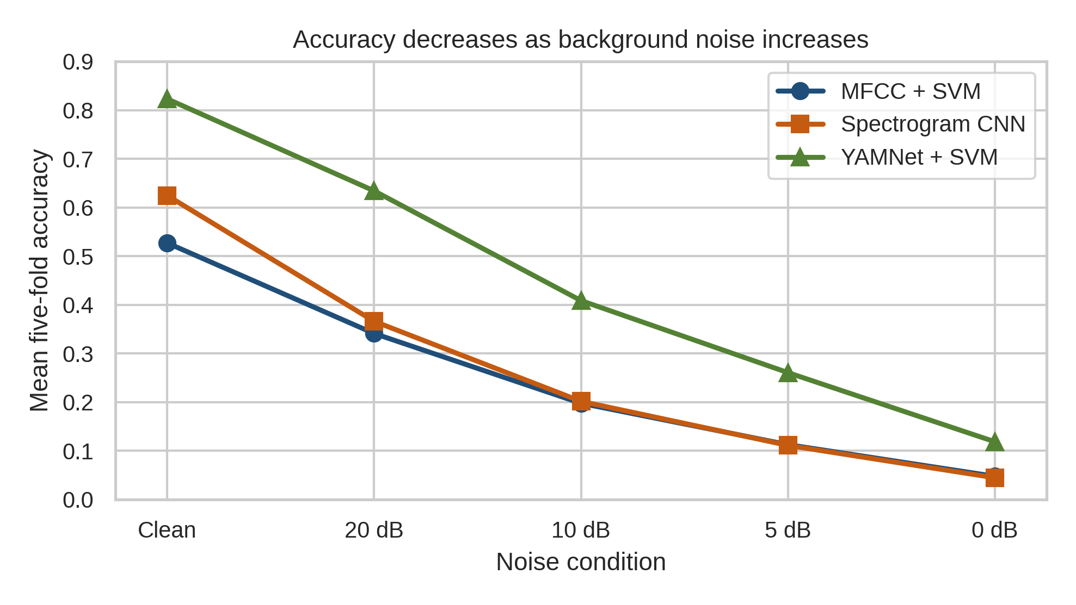
Figure 2 Accuracy versus noise level

3 Macro F1 versus Noise Level
Macro F1 followed the same downward pattern as accuracy for all three models. The larger separation between accuracy and macro F1 at low SNR indicates that errors were not distributed evenly across the 50 classes; for YAMNet at 0 dB, macro F1 (0.1047) was below accuracy (0.1185).
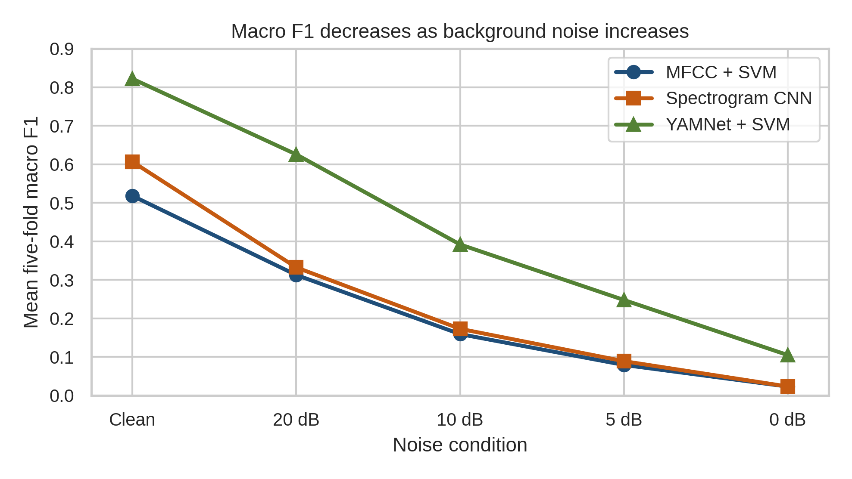
Figure 3 Macro F1 versus noise level

4 Confusion Matrices at 0 dB
The normalized matrices show extensive off-diagonal confusion at 0 dB. The absence of a strong diagonal confirms that none of the clean-trained models generalized reliably when signal and noise power were equal. All three models collapse onto a few predicted classes: the rain column (class index 10) received about 71 percent of MFCC and SVM predictions, 73 percent of CNN predictions, and 52 percent of YAMNet predictions, with vacuum cleaner (index 36) a secondary sink for the first two models and crickets (index 13) for YAMNet. Class indices follow the ESC-50 target order used in Table III.
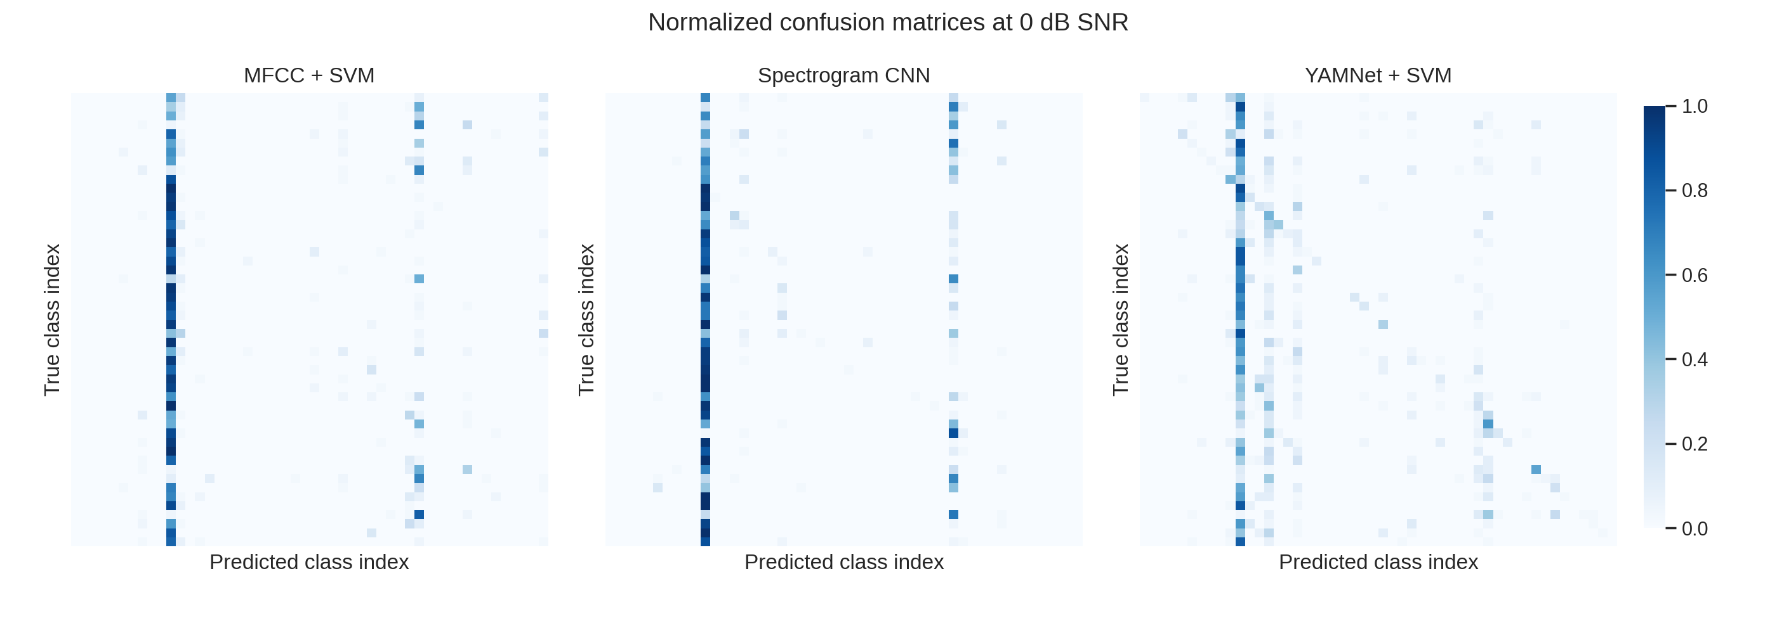
Figure 4 Normalized confusion matrices at 0 dB SNR

5 Computational Performance
Table II summarizes the runtimes recorded during the clean five-fold evaluation. These timings cover model training and, for the first two models, clean-fold prediction; feature extraction was cached separately and was not timed consistently across the three notebooks. For the MFCC solution, the recorded fold runtime includes nested feature selection and SVM tuning. For the CNN, it includes validation-based epoch selection and final retraining on all four non-test folds. For the YAMNet solution, it covers standardization, SelectKBest, the SVM grid search with three-fold inner cross-validation, and the final refit; it excludes clean-fold prediction and embedding extraction, and the notebook ran in a Colab session with parallel grid search, so the timings are not strictly comparable. YAMNet embedding extraction was timed separately at 1.66 minutes in total for all 2,000 clips under the five noise conditions. On the recorded runs, the CNN required substantially more computation than either SVM solution; the YAMNet classifier stage took about eight times as long as the MFCC solution and about one-seventh as long as the CNN. Classifier-only inference for YAMNet averaged about 0.0005 seconds per sample on the test folds.
Table II Recorded clean five-fold computational performance
Model | Device | Mean fold  seconds | Five-fold total  seconds | Recorded scope
MFCC + SVM | CPU | 17.145 | 85.727 | Feature selection, SVM training and clean-fold prediction
Spectrogram CNN | CPU | 946.108 | 4730.539 | Validation selection, final CNN retraining and clean-fold prediction
YAMNet + SVM | CPU | 137.598 | 687.989 | Standardization, feature selection, SVM grid search and refit; excludes embedding extraction (1.66 min total) and prediction

6 Class wise F1 Comparison
Table III compares clean-audio F1 scores for all 50 ESC-50 classes. The Difference column is MFCC minus CNN as before: positive differences indicate that MFCC and SVM achieved the higher class F1 score, and negative differences indicate that the spectrogram CNN performed better. The last two columns subtract the MFCC and CNN scores from the YAMNet score, so positive values indicate that YAMNet with SVM was higher. YAMNet class F1 scores were computed from predictions pooled across the five test folds. YAMNet had the highest F1 in 47 of 50 classes; the CNN remained ahead for door wood knock and mouse click, and MFCC with SVM for airplane. YAMNet’s weakest classes were mouse click (0.4731), airplane (0.4938), and washing machine (0.5250), and it recovered the helicopter class, where the CNN scored only 0.0667 (YAMNet 0.5455).
Table III Clean-audio class-wise F1 comparison
Environmental sound class | MFCC SVM | Spectrogram CNN | Difference  (MFCC − CNN) | YAMNet  SVM | YAMNet  − MFCC | YAMNet  − CNN
dog | 0.6383 | 0.7209 | -0.0826 | 0.9744 | +0.3361 | +0.2535
rooster | 0.6667 | 0.8315 | -0.1648 | 0.8500 | +0.1833 | +0.0185
pig | 0.3023 | 0.4706 | -0.1683 | 0.8312 | +0.5289 | +0.3606
cow | 0.4368 | 0.7073 | -0.2705 | 0.8750 | +0.4382 | +0.1677
frog | 0.5714 | 0.7606 | -0.1891 | 0.8608 | +0.2894 | +0.1002
cat | 0.3947 | 0.5682 | -0.1734 | 0.7895 | +0.3948 | +0.2213
hen | 0.5185 | 0.4308 | +0.0877 | 0.8571 | +0.3386 | +0.4263
insects | 0.2326 | 0.5217 | -0.2892 | 0.7500 | +0.5174 | +0.2283
sheep | 0.7273 | 0.6744 | +0.0529 | 0.9610 | +0.2337 | +0.2866
crow | 0.6377 | 0.6234 | +0.0143 | 0.9474 | +0.3097 | +0.3240
rain | 0.6042 | 0.7500 | -0.1458 | 0.9157 | +0.3115 | +0.1657
sea waves | 0.6154 | 0.7955 | -0.1801 | 0.8718 | +0.2564 | +0.0763
crackling fire | 0.7407 | 0.5714 | +0.1693 | 0.8889 | +0.1482 | +0.3175
crickets | 0.5405 | 0.6216 | -0.0811 | 0.7297 | +0.1892 | +0.1081

Table III continued Clean-audio class-wise F1 comparison part 2 of 3
Environmental sound class | MFCC SVM | Spectrogram CNN | Difference  (MFCC − CNN) | YAMNet  SVM | YAMNet  − MFCC | YAMNet  − CNN
chirping birds | 0.6500 | 0.6250 | +0.0250 | 0.8462 | +0.1962 | +0.2212
water drops | 0.2381 | 0.4918 | -0.2537 | 0.5714 | +0.3333 | +0.0796
wind | 0.4762 | 0.3956 | +0.0806 | 0.5476 | +0.0714 | +0.1520
pouring water | 0.6889 | 0.8372 | -0.1483 | 0.9630 | +0.2741 | +0.1258
toilet flush | 0.8434 | 0.7765 | +0.0669 | 0.9620 | +0.1186 | +0.1855
thunderstorm | 0.7711 | 0.6496 | +0.1215 | 0.9024 | +0.1313 | +0.2528
crying baby | 0.7654 | 0.7765 | -0.0110 | 0.9383 | +0.1729 | +0.1618
sneezing | 0.4158 | 0.6034 | -0.1876 | 0.8500 | +0.4342 | +0.2466
clapping | 0.7123 | 0.6111 | +0.1012 | 0.9744 | +0.2621 | +0.3633
breathing | 0.3582 | 0.3956 | -0.0374 | 0.7586 | +0.4004 | +0.3630
coughing | 0.3448 | 0.6316 | -0.2868 | 0.7765 | +0.4317 | +0.1449
footsteps | 0.2963 | 0.5432 | -0.2469 | 0.7733 | +0.4770 | +0.2301
laughing | 0.3881 | 0.3797 | +0.0083 | 0.8533 | +0.4652 | +0.4736
brushing teeth | 0.6829 | 0.8148 | -0.1319 | 0.8675 | +0.1846 | +0.0527
snoring | 0.6087 | 0.8889 | -0.2802 | 0.9000 | +0.2913 | +0.0111
drinking sipping | 0.3218 | 0.4138 | -0.0920 | 0.8706 | +0.5488 | +0.4568
door wood knock | 0.6667 | 0.8085 | -0.1418 | 0.7901 | +0.1234 | -0.0184
mouse click | 0.4000 | 0.5152 | -0.1152 | 0.4731 | +0.0731 | -0.0421

Table III continued Clean-audio class-wise F1 comparison part 3 of 3
Environmental sound class | MFCC SVM | Spectrogram CNN | Difference  (MFCC − CNN) | YAMNet  SVM | YAMNet  − MFCC | YAMNet  − CNN
keyboard typing | 0.5476 | 0.6600 | -0.1124 | 0.8861 | +0.3385 | +0.2261
door wood creaks | 0.2687 | 0.3333 | -0.0647 | 0.6667 | +0.3980 | +0.3334
can opening | 0.6400 | 0.7765 | -0.1365 | 0.7949 | +0.1549 | +0.0184
washing machine | 0.3421 | 0.3529 | -0.0108 | 0.5250 | +0.1829 | +0.1721
vacuum cleaner | 0.7027 | 0.6486 | +0.0541 | 0.7105 | +0.0078 | +0.0619
clock alarm | 0.6733 | 0.8406 | -0.1673 | 0.9620 | +0.2887 | +0.1214
clock tick | 0.2571 | 0.7105 | -0.4534 | 0.8095 | +0.5524 | +0.0990
glass breaking | 0.5882 | 0.7586 | -0.1704 | 0.9024 | +0.3142 | +0.1438
helicopter | 0.3944 | 0.0667 | +0.3277 | 0.5455 | +0.1511 | +0.4788
chainsaw | 0.7105 | 0.7073 | +0.0032 | 0.9268 | +0.2163 | +0.2195
siren | 0.4872 | 0.6835 | -0.1964 | 0.9286 | +0.4414 | +0.2451
car horn | 0.4444 | 0.5085 | -0.0640 | 0.8101 | +0.3657 | +0.3016
engine | 0.2857 | 0.4308 | -0.1451 | 0.7586 | +0.4729 | +0.3278
train | 0.6136 | 0.5625 | +0.0511 | 0.9268 | +0.3132 | +0.3643
church bells | 0.5476 | 0.7436 | -0.1960 | 0.9756 | +0.4280 | +0.2320
airplane | 0.5714 | 0.4706 | +0.1008 | 0.4938 | -0.0776 | +0.0232
fireworks | 0.4507 | 0.4865 | -0.0358 | 0.9136 | +0.4629 | +0.4271
hand saw | 0.4138 | 0.7692 | -0.3554 | 0.9351 | +0.5213 | +0.1659

Result interpretation
Across the tested setup, YAMNet embeddings with an SVM produced the strongest result at every evaluated condition, ahead of the other two solutions, while the feature-selected MFCC and SVM solution remained far more computationally efficient than the CNN. SelectKBest retained 80 of 120 MFCC-based features and 256 of 1,024 YAMNet dimensions within each training-fold pipeline, preventing test-fold leakage. The CNN used training-only augmentation, validation-based epoch selection, and final retraining without using the official test fold for model selection. The YAMNet result is a transfer-learning result: the network was pretrained on the external AudioSet corpus and used as a frozen feature extractor, whereas the other two models learned only from ESC-50 training folds. All three solutions deteriorated sharply under Gaussian noise, so the results support the research hypothesis that environmental sound classification is strongly affected by changing recording conditions. The comparison should not be generalized beyond these architectures, training schedules, noise type, and dataset split without further experiments.

