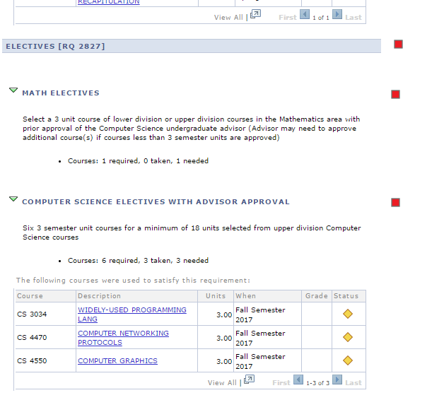

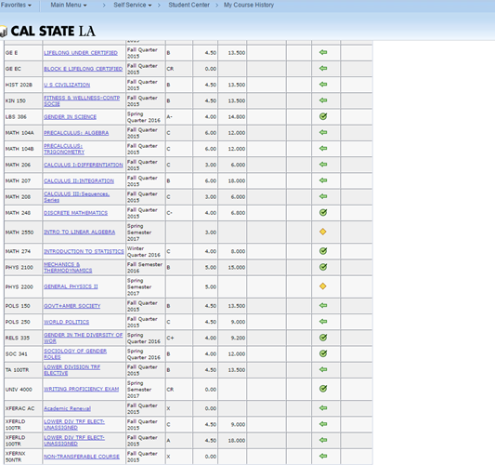

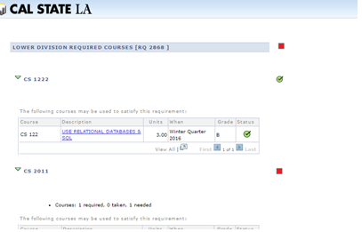

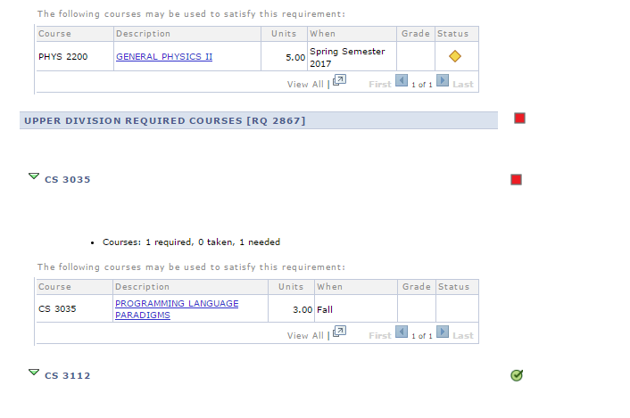

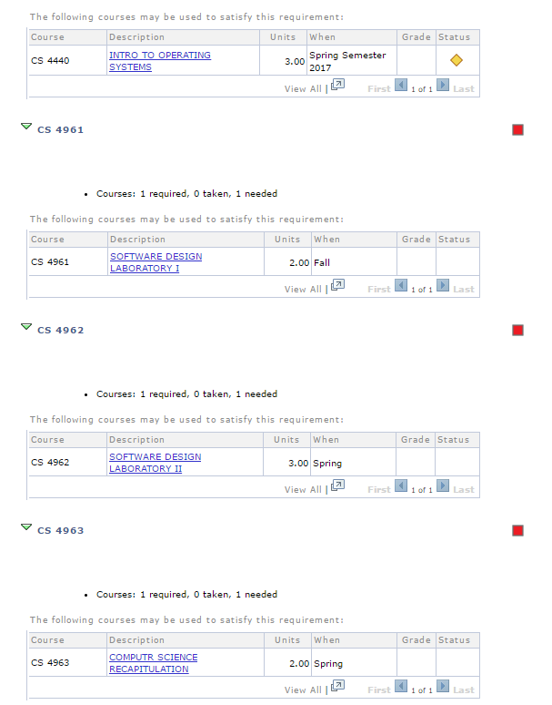

|  |  |  |
| --- | --- | --- |
| **Summer 2017** | **Fall 2017** | **Spring 2018** |
| NA | CS4961 | CS4962 |
| NA | EE3445 | CS4963 |
| NA | MATH 2550 or CS 4550 | Elective |
| NA | CS 4440 or CS 4470 | Elective |
| NA | CS 3034 | Elective |