Java

- Publication Date
- Bestselling
- Alphabetical
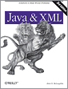Java and XML, Third Edition
December 2006 (est.)
$49.99 USD
This new edition shows you how to cut through all the hype about XML and put it to work. You'll learn how to use the APIs, tools, and tricks of… Read more.

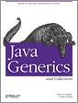Java Generics and Collections
October 2006
$34.99 USD
Java Generics and Collections covers everything from the most basic uses of generics to the strangest corner cases. It teaches you everything you need to know about the collections libraries, so you'll always… Read more.

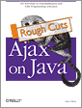Ajax on Java: Rough Cuts Version
September 2006 (est.)
$29.99 USD
This practical guide shows you how to make your Java web applications more responsive and dynamic by incorporating new Ajaxian features: suggestion lists, drag-and-drop, and more. Java developers can choose… Read more.

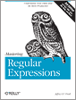Mastering Regular Expressions, Third Edition
August 2006
$44.99 USD
Written in the lucid, entertaining tone that makes a complex, dry topic become crystal-clear to programmers, and sprinkled with solutions to complex real-world problems, Mastering Regular Expressions, Third Edition offers a wealth of… Read more.

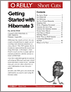Getting Started with Hibernate 3
August 2006
$9.99 USD
Hibernate has clearly arrived. Are you ready to benefit from its simple way of working with relational databases as Java objects? This PDF updates the introductory material from the award-winning… Read more.

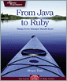From Java to Ruby
June 2006
$29.95 USD
If you're trying to adopt Ruby in your organization and need some help, this is the book for you. Based on a decision tree, (a concept familiar to managers and… Read more.

Rails Recipes
June 2006
$32.95 USD
You've read the tutorials and watched the online videos. You have a strong grasp of all of the ingredients that make up a successful Rails application. But ingredients don't just… Read more.

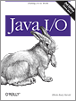Java I/O, Second Edition
May 2006
$49.99 USD
All of Java's Input/Output (I/O) facilities are based on streams, which provide simple ways to read and write data of different types. Java I/O, 2nd Edition tells you all you… Read more.

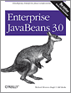Enterprise JavaBeans 3.0, Fifth Edition
May 2006
$49.99 USD
This fifth edition, written by Bill Burke and Richard Monson-Haefel, has been updated to capture the very latest need-to-know Java technologies in the same award-winning fashion that drove the success… Read more.

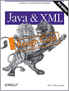Java and XML: Rough Cuts Version, Third Edition
February 2006 (est.)
$49.99 USD
Our third edition of Java & XML is ideal for any Java developer who wants to take advantage of XML without having to become an expert on the markup language.… Read more.

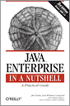Java Enterprise in a Nutshell, Third Edition
November 2005
$44.95 USD
Revised and updated for the new 1.4 version of Sun Microsystems Java Enterprise Edition software, Java Enterprise in a Nutshell, 3rd Edition is a practical guide for enterprise Java developers. Read more.

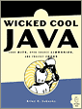Wicked Cool Java
November 2005
$29.95 USD
Wicked Cool Java contains 101 fun, interesting, and useful ways to get more out of Java. This isn't intended as a Java tutorial--it's targeted at developers and system architects who… Read more.

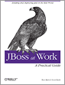JBoss at Work: A Practical Guide
October 2005
$34.95 USD
This convenient guide from O'Reilly takes an in-depth look at JBoss, the fastest growing open source tool on the market. Learn how to integrate JBoss with other open source Java… Read more.

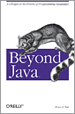Beyond Java
September 2005
$24.95 USD
In Beyond Java, Bruce Tate, author of the Jolt Award-winning Better, Faster, Lighter Java, chronicles the rise of the most successful language of all time, and then lays out, in… Read more.

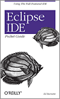Eclipse IDE Pocket Guide
August 2005
$9.95 USD
This practical pocket guide gets you up to speed quickly with Eclipse. It covers basic concepts, including Views and editors, as well as features that are not commonly understood, such… Read more.

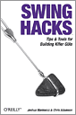Swing Hacks
June 2005
$29.95 USD
Swing Hacks helps Java developers move beyond the basics of Swing, the graphical user interface (GUI) standard since Java 2. The unique Hacks format provides short advanced tricks that you… Read more.

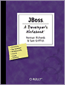JBoss: A Developer's Notebook
June 2005
$29.95 USD
JBoss is a fully certified J2EE 1.4 application server that's free, popular, and competitive with proprietary Java application servers in features and quality. JBoss: A Developer's Notebook takes you on… Read more.

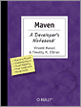Maven: A Developer's Notebook
June 2005
$29.95 USD
Maven: A Developer's Notebook is the first book on the subject to hit the market, so you know the information is fresh and timely. If you're a Java programmer, you'll… Read more.

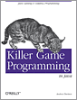Killer Game Programming in Java
May 2005
$44.95 USD
This comprehensive guide has everything you need to program Java games. It offers the most thorough coverage of Java 3D available, and clearly details the older, better-known 2D APIs, 3D… Read more.

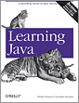Learning Java, Third Edition
May 2005
$44.95 USD
With more changes than any previous version, Java 5.0 makes it easier to develop safe, powerful code. But it isn't any easier to learn. That means the bestselling hands-on tutorial… Read more.

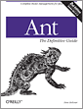Ant: The Definitive Guide, Second Edition
April 2005
$34.95 USD
As the most widely used tool for cross-platform development, Ant has undergone a number of important changes in its functionality and use since its launch. Ant: The Definitive Guide, 2nd… Read more.

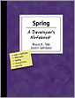Spring: A Developer's Notebook
April 2005
$29.95 USD
This no-nonsense book quickly gets you up to speed on the new Spring open source framework. Favoring examples and practical application over theory, Spring: A Developer's Notebook features 10 code-intensive… Read more.

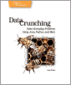Data Crunching
April 2005
$29.95 USD
Programmers always need to move data around, to translate it from one format to another, or extract useful information from it. This book shows the best approaches to "crunching" data… Read more.

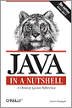Java in a Nutshell, Fifth Edition
March 2005
$44.95 USD
Java in a Nutshell, 5th Edition, covers all the extensive changes implicit in 5.0, the latest and greatest version of Java yet. This classic remake has also undergone a complete… Read more.

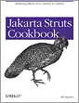Jakarta Struts Cookbook
February 2005
$44.95 USD
The Jakarta Struts Cookbook is an amazing collection of code solutions to common--and uncommon--problems encountered when building web applications with the Struts Framework. With solutions to real-world problems just a… Read more.

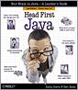Head First Java, Second Edition
February 2005
$44.95 USD
Head First Java delivers a highly interactive, multi-sensory learning experience that lets new programmers pick up the fundamentals of the Java language quickly. Through mind-stretching exercises, memorable analogies, humorous pictures,… Read more.

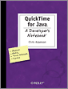QuickTime for Java: A Developer's Notebook
January 2005
$29.95 USD
Java developers who need to add audio, video, or interactive media creation and playback to their applications find that QuickTime Java is a powerful toolkit, but one that's not easy… Read more.

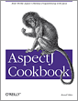AspectJ Cookbook
December 2004
$44.95 USD
This hands-on book shows readers why and how common Java development problems can be solved by using new Aspect-oriented programming (AOP) techniques. With a wide variety of code recipes for… Read more.

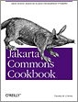Jakarta Commons Cookbook
November 2004
$44.95 USD
This collection provides expert tips for using the utilities of the Java-based Jakarta Commons open source project. You don't have to be an expert, the book's solution-based format contains code… Read more.

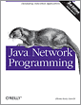Java Network Programming, Third Edition
October 2004
$39.95 USD
Thoroughly revised to cover all the 100+ significant updates to Java Developers Kit (JDK) 1.5, Java Network Programming is a complete introduction to developing network programs (both applets and applications)… Read more.

Head First Design Patterns
October 2004
$44.95 USD
If you've read a Head First book, you know what to expect--a visually-rich format designed for the way your brain works. Using the latest research in neurobiology, cognitive science, and… Read more.

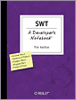SWT: A Developer's Notebook
October 2004
$29.95 USD
In typical Developer's Notebook style, you'll learn how to take SWT out for a spin, make it work for you,and turn it upside down, all without wasted words or space.… Read more.

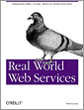Real World Web Services
October 2004
$29.95 USD
The core idea behind Real World Web Services is simple: after years of hype, what are the major players really doing with web services? Standard bodies may wrangle and platform… Read more.

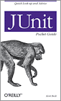JUnit Pocket Guide
September 2004
$9.95 USD
While there are lots of bits of documentation all over the place, there isn't a go-to-manual that serves as a quick reference for JUnit. This Pocket Guide meets the need,… Read more.

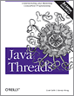Java Threads, Third Edition
September 2004
$39.95 USD
Threads are essential to Java programming, but learning to use them effectively is a nontrivial task. This new edition of the classic Java Threads shows you how to take full… Read more.

Head First Servlets and JSP
August 2004
$44.95 USD
Want to get to know the latest (J2EE 1.4) versions of Servlets & JSPs so well that you can pass the Sun Certified Web Component Developer (SCWCD) 1.4 exam? No… Read more.

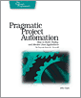Pragmatic Project Automation
July 2004
$29.95 USD
Forget wizards, you need a slave--someone to do your repetitive, tedious and boring tasks, without complaint and without pay, so you'll have more time to design and write exciting code.… Read more.

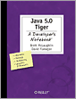Java 5.0 Tiger: A Developer's Notebook
June 2004
$29.95 USD
This no-nonsense, guide by bestselling Java authors Brett McLaughlin and David Flanagan jumps right into Tiger. Using the task-oriented format of this new series, you'll get complete practical coverage of… Read more.

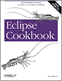Eclipse Cookbook
June 2004
$44.95 USD
Eclipse is a powerful open source platform that gives Java developers a new way to approach development projects. In the Eclipse Cookbook, Java expert Steve Holzner demystifies Eclipse with practical… Read more.

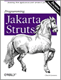Programming Jakarta Struts, Second Edition
June 2004
$44.95 USD
If you want to use the Struts Framework to its fullest potential, this is the book for you. Programming Jakarta Struts, 2nd Edition covers everything the successful earlier edition did… Read more.

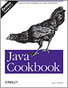Java Cookbook, Second Edition
June 2004
$49.95 USD
Java Cookbook, 2nd Edition gets you to the heart of what you need to know when you need to know it. The completely revised and updated recipes in Java Cookbook,… Read more.

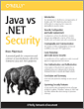Java vs. .NET Security
June 2004
$5.95 USD
A practical guide for comparison and contrast of security features offered by Enterprise Java and .NET platforms. Read more.

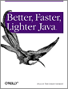Better, Faster, Lighter Java
May 2004
$34.95 USD
In Better, Faster, Lighter Java, authors Bruce Tate and Justin Gehtland argue that the old heavyweight architectures, such as WebLogic, JBoss, and WebSphere, are unwieldy, complicated, and contribute to slow… Read more.

Hibernate: A Developer's Notebook
May 2004
$24.95 USD
Hibernate: A Developer's Notebook shows you how to use Hibernate to automate persistence: you write natural Java objects and some simple configuration files, and Hibernate automates all the interaction between… Read more.

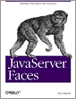JavaServer Faces
April 2004
$39.95 USD
In JavaServer Faces, developers learn how to use the new JavaServer Faces framework to build real-world web applications. The book contains everything you'll need: how to construct the HTML on… Read more.

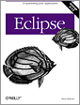Eclipse
April 2004
$44.95 USD
O'Reilly's new guide to the technology, Eclipse, provides exactly what you're looking for: a fast-track approach to mastery of Eclipse. This insightful, hands-on book delivers clear and concise coverage, with… Read more.

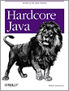Hardcore Java
March 2004
$39.95 USD
Hardcore Java takes this language and breaks it apart, piece by piece, revealing the important secrets and tricks that will take you from a junior-level programmer to a seasoned and… Read more.

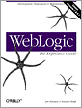WebLogic: The Definitive Guide
February 2004
$49.95 USD
WebLogic: The Definitive Guide presents a 360-degree view of the world of WebLogic. Exhaustive treatment of the WebLogic server and management console answers any question that readers might think to… Read more.

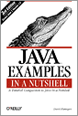Java Examples in a Nutshell, Third Edition
January 2004
$39.95 USD
This third edition covers Java 1.4 and contains 193 complete, practical examples: over 21,900 lines of densely commented, professionally written Java code, covering 20 distinct client-side and server-side APIs. It… Read more.

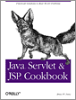Java Servlet & JSP Cookbook
January 2004
$44.95 USD
With literally hundreds of examples and thousands of lines of code, the Java Servlet and JSP Cookbook yields tips and techniques that any Java web developer who uses JavaServer Pages… Read more.

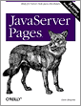JavaServer Pages, Third Edition
December 2003
$44.95 USD
JavaServer Pages, Third Edition is completely revised and updated to cover the substantial changes in the 2.0 version of the JSP specification. It also includes detailed coverage of the major… Read more.

Head First EJB
October 2003
$44.95 USD
With Head First EJB, you'll learn not just what the technology *is*, but more importantly, *why* it is, and what it is and isn't good for. You'll learn tricks and… Read more.

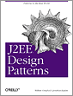J2EE Design Patterns
September 2003
$39.95 USD
Crawford and Kaplan's J2EE Design Patterns approaches the subject in a unique, highly practical and pragmatic way. Rather than simply present another catalog of design patterns, the authors broaden the… Read more.

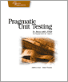Pragmatic Unit Testing in Java with Junit
September 2003
$29.95 USD
Improve your Java coding skills using unit testing: it's really all about coding, not testing. This book shows not just how to test, but what to test. Discover the tricky… Read more.

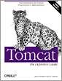Tomcat: The Definitive Guide
June 2003
$39.95 USD
Tomcat: The Definitive Guide offers something for everyone who uses Tomcat. System and network administrators will find detailed instructions on installation, configuration, and maintenance. For users, it supplies insightful information… Read more.

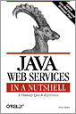Java Web Services in a Nutshell
June 2003
$39.95 USD
Java Web Services in a Nutshell is a high-speed tutorial and a quick reference for the technologies that Sun Microsystems is creating for implementing web services with Java. This book… Read more.

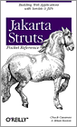Jakarta Struts Pocket Reference
May 2003
$9.95 USD
The Jakarta Struts Pocket Reference gives you an inside track on getting Struts installed, configured, and running smoothly in your enterprise. This book, an essential companion to O'Reilly's Programming Jakarta… Read more.

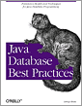Java Database Best Practices
May 2003
$39.95 USD
Unlike other books on this topic, which focus on a single way to do things, Java Database Best Practices takes you through a wide variety of different ways to store… Read more.

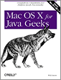Mac OS X for Java Geeks
April 2003
$39.95 USD
Mac OS X for Java Geeks delivers a complete and detailed look at the Mac OS X platform, geared specifically at Java developers. Programmers using the 10.2 (Jaguar) release of… Read more.

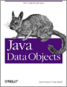Java Data Objects
April 2003
$39.95 USD
This book, written by the JDO Specification Lead and one of the key contributors to the JDO Specification, is the definitive work on the JDO API. It gives you a… Read more.

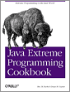Java Extreme Programming Cookbook
March 2003
$34.95 USD
Brimming with over 100 "recipes" for getting down to business and actually doing XP, the Java Extreme Programming Cookbook doesn't try to "sell" you on XP; it succinctly documents the… Read more.

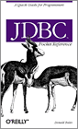JDBC Pocket Reference
January 2003
$9.95 USD
The JDBC Pocket Reference offers quick look-ups for all methods of the standard JDBC classes. These include concise reviews of the procedures for common JDBC tasks such as connecting to… Read more.

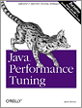Java Performance Tuning, Second Edition
January 2003
$44.95 USD
Java Peformance Tuning, 2nd edition provides a comprehensive and indispensable guide to eliminating all types of performance problems. Using many real-life examples to work through the tuning process in detail,… Read more.

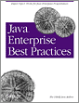Java Enterprise Best Practices
December 2002
$34.95 USD
Until Java Enterprise Best Practices, advanced Java developers relied on the advice of a loose-knit community of fellow developers, time-consuming online searches for examples or suggestions for the immediate problem… Read more.

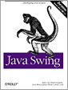Java Swing, Second Edition
November 2002
$59.99 USD
This second edition of Java Swing thoroughly covers all the features available in Java 2 SDK 1.3 and 1.4. More than simply a reference, this new edition takes a practical… Read more.

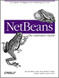NetBeans: The Definitive Guide
October 2002
$44.95 USD
In NetBeans: The Definitive Guide, you'll find out how to use this IDE to its fullest, making your Java programming more efficient and productive than ever before. You'll understand the… Read more.

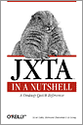JXTA in a Nutshell
September 2002
$34.95 USD
O'Reilly's pioneering reference is the first and last word on this powerful distributed computing technology. JXTA in a Nutshell delivers all the information you need to get started, including an… Read more.

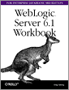Weblogic Server 6.1 Workbook for Enterprise Java Beans
August 2002
$24.95 USD
Although EJB applications themselves are portable, the manner in which developers install and run EJB products varies widely from one vendor to the next. The goal of this WebLogic workbook… Read more.

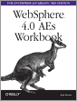WebSphere 4.0 AEs Workbook for Enterprise Java Beans
August 2002
$24.95 USD
Although EJB applications themselves are portable, the manner in which developers install and run EJB products varies widely from one vendor to the next. The goal of this WebSphere AE… Read more.

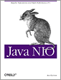Java NIO
August 2002
$34.95 USD
Java NIO explores the new I/O capabilities of version 1.4 in detail and shows you how to put these features to work to greatly improve the efficiency of the Java… Read more.

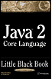Java 2 Core Language Little Black Book
August 2002
$29.99 USD
The focus of this book is on the core Java language as implemented by the new version of Java, version 1.4. The book features a logical, sequential approach with concise… Read more.

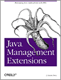Java Management Extensions
June 2002
$34.95 USD
Java Management Extensions is a practical, hands-on guide to using the JMX APIs, Sun Microsystem's new Java-based tool for managing enterprise applications. This one-of-a kind book is a complete treatment… Read more.

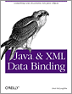Java & XML Data Binding
May 2002
$34.95 USD
This new title provides an in-depth technical look at XML Data Binding. The book offers complete documentation of all features in both the Sun Microsystems JAXB API and popular open… Read more.

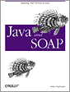Java and SOAP
May 2002
$39.95 USD
Java and SOAP provides Java developers with an in-depth look at SOAP (the Simple Object Access Protocol). Of course, it covers the basics: what SOAP is, why it's soared to… Read more.

C# for Java Programmers
April 2002
$49.95 USD
This book is written for Java programmers who are interested in increasing their flexibility and marketability with a working knowledge of C# and the .NET framework. C# for Java Programmers… Read more.

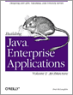Building Java Enterprise Applications
March 2002
$39.95 USD
This isn't just a book about Entity Beans and JNDI. It takes you step by step through building the back end, designing the data store so that it gives you… Read more.

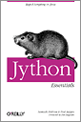Jython Essentials
March 2002
$24.95 USD
Jython is an implementation of the Python programming language written in Java, allowing Python programs to integrate seamlessly with any Java code. The secret to Jython's popularity lies in the… Read more.

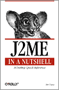J2ME in a Nutshell
March 2002
$29.95 USD
J2ME in a Nutshell provides a solid, no-nonsense reference to the "alphabet soup" of micro edition programming, covering the CLDC, CDC, KVM and MIDP APIs. The book also includes tutorials… Read more.

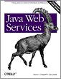Java Web Services
March 2002
$39.95 USD
Java Web Services shows you how to use SOAP to perform remote method calls and message passing; how to use WSDL to describe the interface to a web service or… Read more.

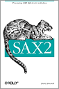SAX2
January 2002
$29.95 USD
This concise book gives you information you need to effectively use the Simple API for XML (SAX2), the dominant API for efficient XML processing with Java. With SAX2, developers have… Read more.

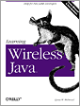Wireless Java
January 2002
$34.95 USD
Learning Wireless Java is for Java developers who want to create applications for the Micro Edition audience using the Connected, Limited Device Configuration and the Mobile Information Device Profile (MIDP).… Read more.

Java Programming with Oracle JDBC
November 2001
$39.95 USD
Learn how to leverage JDBC, a key Java technology used to access relational data from Java programs, in an Oracle environment. Author Donald Bales begins by teaching you the mysteries… Read more.

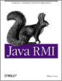Java RMI
October 2001
$39.95 USD
With Java RMI, you'll learn tips and tricks for making your RMI code excel. The book provides strategies for working with serialization, threading, the RMI registry, sockets and socket factories,… Read more.

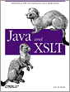Java and XSLT
September 2001
$39.95 USD
Learn how to use XSL transformations in Java programs ranging from stand-alone applications to servlets. Java and XSLT introduces XSLT and then shows you how to apply transformations in real-world… Read more.

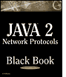Java 2 Network Protocols Black Book
September 2001
$49.99 USD
Java 2 Network Protocols Black Book shows programmers how to leverage open source software, as well as source code unique to the book, to make it easy to handle HTTP,… Read more.

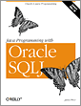Java Programming with Oracle SQLJ
August 2001
$39.95 USD
SQLJ lets you access an Oracle database from a Java program, and is much easier to use than the alternative, JDBC. Java Programming with Oracle SQLJ moves from the basics… Read more.

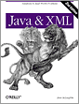Java and XML, Second Edition
August 2001
$44.95 USD
New chapters on Advanced SAX, Advanced DOM, SOAP, and data binding, as well as new examples throughout, bring the second edition of Java & XML thoroughly up to date. Except… Read more.

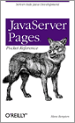JavaServer Pages Pocket Reference
July 2001
$9.95 USD
JavaServer Pages (JSP) is harmonizing how web designers and programmers create dynamic web pages. JavaServer Pages Pocket Reference is the perfect companion volume to O'Reilly's best-selling JavaServer Pages. This book… Read more.

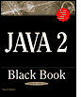Java 2 Black Book, Second Edition
June 2001
$59.99 USD
A great reference tool-jam-packed with easily accessible information. Provides programming tips on a variety of topics including variables, arrays, and operators; conditionals and loops; object-oriented programming; inheritance and inner classes;… Read more.

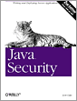Java Security, Second Edition
May 2001
$44.95 USD
The second edition focuses on the platform features of Java that provide security--the class loader, bytecode verifier, and security manager--and recent additions to Java that enhance this security model: digital… Read more.

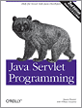Java Servlet Programming, Second Edition
April 2001
$44.95 USD
The second edition of this popular book has been completely updated to add the new features of the Java Servlet API Version 2.2, and new chapters on servlet security and… Read more.

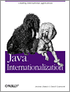Java Internationalization
March 2001
$39.95 USD
Java Internationalization shows how to write software that is truly multi-lingual, using Unicode, a standard system that supports hundreds of character sets for most modern languages and many ancient ones. Read more.

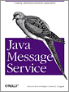Java Message Service
December 2000
$34.95 USD
This book is a thorough introduction to Java Message Service (JMS) from Sun Microsystems. It shows how to build applications using the point-to-point and publish-and-subscribe models; use features like transactions… Read more.

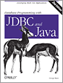Database Programming with JDBC & Java, Second Edition
August 2000
$34.95 USD
This book describes the standard Java interfaces that make portable object-oriented access to relational databases possible, and offers a robust model for writing applications that are easy to maintain. The… Read more.

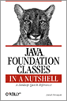Java Foundation Classes in a Nutshell
October 1999
$29.95 USD
Java Foundation Classes in a Nutshell provides an in-depth overview of the important pieces of the (JFC), such as the Swing components and Java 2D. It also includes compact reference… Read more.

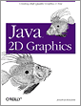Java 2D Graphics
May 1999
$39.95 USD
Java 2D Graphics describes the 2D API from top to bottom, demonstrating how to set line styles and pattern fills as well as more advanced techniques of image processing and… Read more.

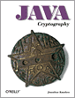Java Cryptography
May 1998
$29.95 USD
Java Cryptography teaches you how to write secure programs using Java's cryptographic tools. It includes thorough discussions of the java.security package and the Java Cryptography Extensions (JCE), showing you how… Read more.

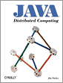Java Distributed Computing
January 1998
$34.95 USD
Java Distributed Computing offers a general introduction to distributed computing, meaning programs that run on two or more systems. It focuses primarily on how to structure and write distributed applications… Read more.

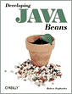Developing Java Beans
June 1997
$29.95 USD
Developing Java Beans is a complete introduction to Java's component architecture. It describes how to write Beans, which are software components that can be used in visual programming environments. This… Read more.

Upcoming Title
Java and XML
by Brett McLaughlin, Justin Edelson
Third Edition December 2006 (est.)
$49.99 USD
More Upcoming Titles

Buy Direct and Save
Buy 2 Books,
Get the 3rd FREE!
Use discount code "opc10"
All orders over $29.95 qualify for free shipping within the US.

Celebrating Open Java

In celebration of the open-sourcing of Java by Sun, we're offering our top 10 best-selling Java books at an extraordinary 40% off until Friday. Use discount code OPENJAVA in our shopping cart when you order the following titles:
- Head First Java
- Java in a Nutshell
- Head First Servlets and JSP
- Learning Java
- Java Cookbook
- Java Servlet & JSP Cookbook
- Java Examples in a Nutshell
- Java Enterprise in a Nutshell
- Enterprise JavaBeans 3.0
- Swing Hacks
All orders over $29.95 qualify for free shipping in the US.

Mike Loukides on Open Source Java
"It's finally happened! Sun has released Java under an open source license. Not only that, they did it in the best possible way..." Read more.

Short Cuts
Good. Fast. Cheap.
O'Reilly Short Cuts
PDF documents on cutting edge topics. Focused information in an easy-to-use, portable package.
New titles include:
- Saving Money and Time with Virtual Server
- How to Build an RSS 2.0 Feed
- Automating InDesign with Regular Expressions
View all Short Cuts

Local Bookstores
Team O'Reilly (US/CA) and Club O'Reilly (International) are stores who have joined in partnership with O'Reilly to ensure plentiful stock of current and earlier titles.
Top of Form
Search

Bottom of Form

Topics
- Business & Culture
  - Business
  - Digital Culture
  - Personal Finance
  - Project & Career Management
- Databases
  - Access
  - MySQL
  - Oracle
  - Other Databases
  - SQL
  - SQL Server
  - Theory
- Design & Graphics
  - Flash & Actionscript
  - Illustration & Graphics
  - Photoshop & Photomanipulation
  - Print Design
- Digital Audio & Video
  - Digital Audio
  - Digital Video
- Digital Photography
  - Digital Photography
  - Photoshop & Photomanipulation
- Hardware
  - Devices & Peripherals
  - Hacks & Modifications
  - PC Hardware
- Home & Office
  - Computer Security & Privacy
  - Games
  - Home Entertainment
  - Home Networking
  - Mac OS X
  - Macintosh Programs
  - PC Hardware
  - Personal Finance
  - Windows 2000 & earlier
  - Windows Programs
  - Windows Vista
  - Windows XP
- Networking & Sys Admin
  - Apache
  - Certification
  - Cisco & other Routers
  - Email
  - Home Networking
  - Project & Career Management
  - Protocols
  - Server Administration
  - Server Security
  - Spam
  - Telephony
  - Wireless
- Operating Systems
  - Linux/Unix
  - Mac OS X
  - Windows 2000 & earlier
  - Windows Vista
  - Windows XP
- Programming
  - .NET & Windows Programming
  - Ajax
  - C#
  - C/C++
  - Certification
  - Games
  - Java
  - Other Programming
  - Perl
  - PHP
  - Project & Career Management
  - Python
  - Ruby
  - Secure Programming
  - Visual Basic
  - Web Services
  - XML
- Science & Math
  - Mapping
  - Math
  - Science
- Security
  - Computer Security & Privacy
  - Secure Programming
  - Server Security
  - Spam
- Software Engineering
  - Design Patterns
  - Enterprise Development
  - Project & Career Management
  - Secure Programming
  - Testing
- The Web
  - Ajax
  - Flash & Actionscript
  - Mapping
  - Web Applications
  - Web Browsers
  - Web Design
  - Web Development
  - Web Services

International Sites

About O'Reilly | Contact | Jobs | Press Room | How to Advertise | Privacy Policy
© 2006, O'Reilly Media, Inc.
All trademarks and registered trademarks appearing on oreilly.com are the property of their respective owners.

