**JAVACODES_FACEPERP(FA02)**

**Phase-1**

**1.)**

**Code:-**

import java.util.Scanner;

public class CalculateSalary {

public static int calculateSal(int salary, int shifts) {

if (salary > 8000) {

System.out.println("Salary too large");

return -1; // Indicating an error

}

if (shifts < 0) {

System.out.println("Shifts too small");

return -1; // Indicating an error

}

if (salary < 0) {

System.out.println("Salary too small");

return -1; // Indicating an error

}

double foodExpense = 0.2 * salary;

double travelExpense = 0.3 * salary;

double additionalIncome = 0.02 * salary * shifts;

int savings = (int) (salary - foodExpense - travelExpense + additionalIncome);

return savings;

}

public static void main(String[] args) {

Scanner scanner = new Scanner(System.in);

System.out.println("Enter salary:");

int salary = scanner.nextInt();

System.out.println("Enter number of shifts:");

int shifts = scanner.nextInt();

int result = calculateSal(salary, shifts);

if (result != -1) { // Only print the savings if there were no errors

System.out.println("Savings: " + result);

}

}

**1-Output:-**

}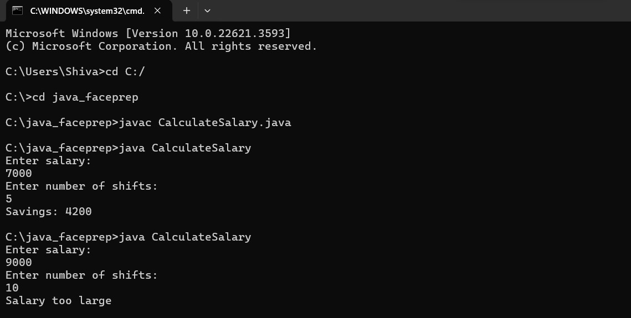

**2.)**

**Code:-**

import java.util.HashMap;

import java.util.Map;

import java.util.Scanner;

public class RepeatedSalaryCount {

public static int countRepeaters(int[] salaries, int size) {

for (int salary : salaries) {

if (salary < 0) {

System.out.println("Invalid Input");

return -1; // Indicating an error

}

}

Map<Integer, Integer> salaryCountMap = new HashMap<>();

for (int salary : salaries) {

salaryCountMap.put(salary, salaryCountMap.getOrDefault(salary, 0) + 1);

}

for (int count : salaryCountMap.values()) {

if (count > 1) {

return count;

}

}

return 0; // If no salaries repeat

}

public static void main(String[] args) {

Scanner scanner = new Scanner(System.in);

System.out.println("Enter the number of employees:");

int n = scanner.nextInt();

if (n < 0 || n > 20) {

System.out.println("Invalid Input");

return;

}

int[] salaries = new int[n];

System.out.println("Enter the salaries:");

for (int i = 0; i < n; i++) {

salaries[i] = scanner.nextInt();

if (salaries[i] < 0) {

System.out.println("Invalid Input");

return;

}

}

int result = countRepeaters(salaries, n);

if (result != -1) { // Only print the count if there were no errors

System.out.println("Number of repeaters: " + result);

}

**2-Output:-** 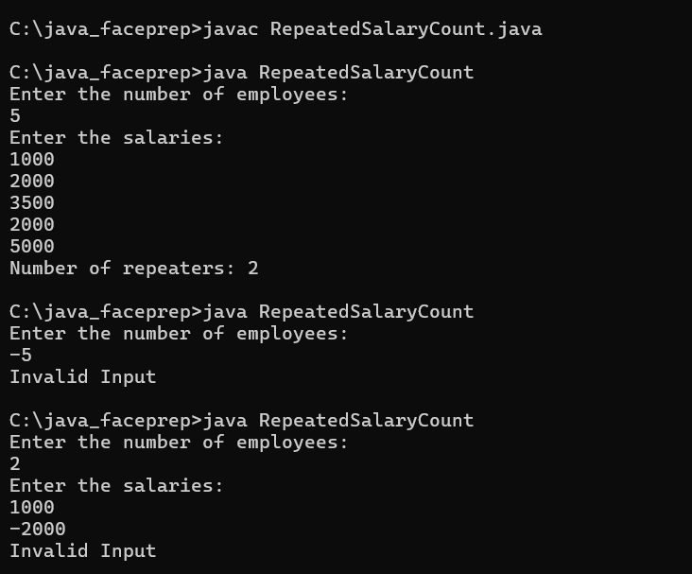

**3.)**

**Code:-**

import java.util.ArrayList;

import java.util.Scanner;

public class CricketerScore {

static ArrayList<Integer> cricketer = new ArrayList<>();

public static void findCricketerId(int[] array, int size, int score) {

if (size < 0) {

System.out.println("Invalid array size");

return;

}

if (score < 0) {

System.out.println("Invalid score");

return;

}

for (int i = 0; i < size; i++) {

if (array[i] < 0) {

System.out.println("Invalid input");

return;

}

}

for (int i = 1; i < size; i += 2) {

if (array[i] > score) {

cricketer.add(array[i - 1]);

}

}

System.out.println("Cricketer IDs who scored more than " + score + ":");

for (int id : cricketer) {

System.out.println(id);

}

}

public static void main(String[] args) {

Scanner scanner = new Scanner(System.in);

System.out.println("Enter the number of elements (should be even number representing pairs of IDs and scores):");

int n = scanner.nextInt();

if (n < 0 || n % 2 != 0) {

System.out.println("Invalid array size");

return;

}

int[] array = new int[n];

for (int i = 0; i < n; i += 2) {

System.out.println("Enter ID of player " + (i / 2 + 1) + ":");

array[i] = scanner.nextInt();

if (array[i] < 0) {

System.out.println("Invalid input");

return;

}

System.out.println("Enter score of player " + (i / 2 + 1) + ":");

array[i + 1] = scanner.nextInt();

if (array[i + 1] < 0) {

System.out.println("Invalid input");

return;

}

}

System.out.println("Enter the score to compare:");

int score = scanner.nextInt();

if (score < 0) {

System.out.println("Invalid score");

return;

}

findCricketerId(array, n, score);

}

}

**3-Output:-**

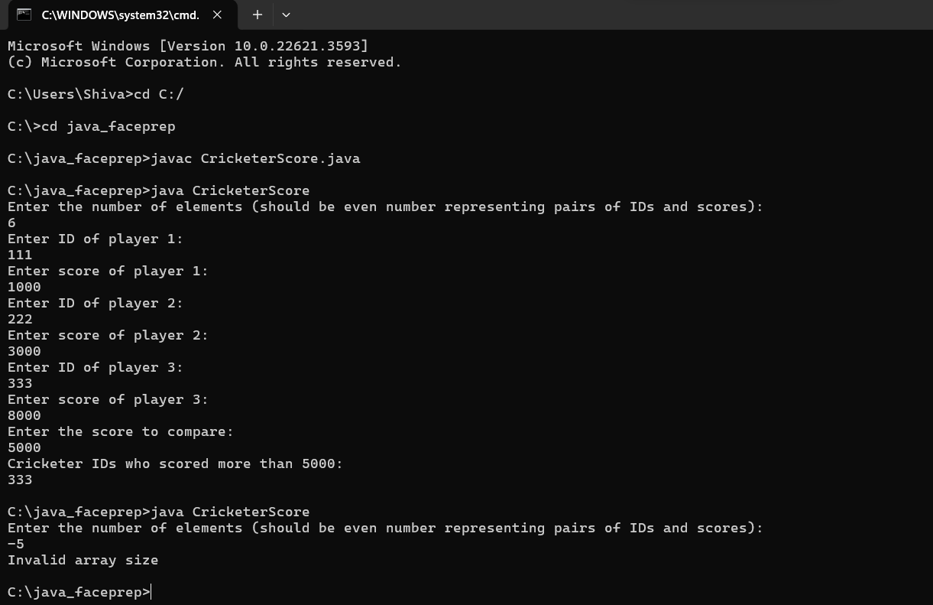

**4.)**

**Code:-**

import java.util.Scanner;

public class Main {

public static void main(String[] args) {

int n, i,j,k=0,count,count1;

Scanner in=new Scanner(System.in);

n = in.nextInt();

if(n < 0) {

System.out.print("Invalid array size");

System.exit(0);

} else

{

int a[]=new int[n];

for(i = 0; i< n; i++) {

a[i] = in.nextInt();

if(a[i] < 0) {

System.out.print("Invalid input");

System.exit(0);

}

}

int b[]=new int[n];

for(i = 0; i< n; i++) {

b[i] = in.nextInt();

if(b[i] < 0) {

System.out.print("Invalid input");

System.exit(0);

}

}

int c[]=new int[100];

for(i=0;i<n;i=i+2) {

count=0;

for(j=0;j<n;j=j+2) {

if(a[i]==b[j]) {

count=1;

if(a[i+1]>b[j+1]) {

c[k]=a[i];

c[++k]=a[i+1];

k++;

} else {

c[k]=a[i];

c[++k]=b[j+1];

k++;

}

}

}

if(count==0) {

c[k]=a[i];

c[++k]=a[i+1];

k++;

}

}

for(i=0;i<n;i=i+2) {

count1=0;

for(j=0;j<n;j=j+2) {

if(b[i]==a[j]) {

count1=1;

}

}

if(count1!=1) {

c[k]=b[i];

c[++k]=b[i+1];

k++;

}

}

for(i=0;i<k;i++) {

System.out.println(c[i]);

}

}

}

}

**4-Output:-**

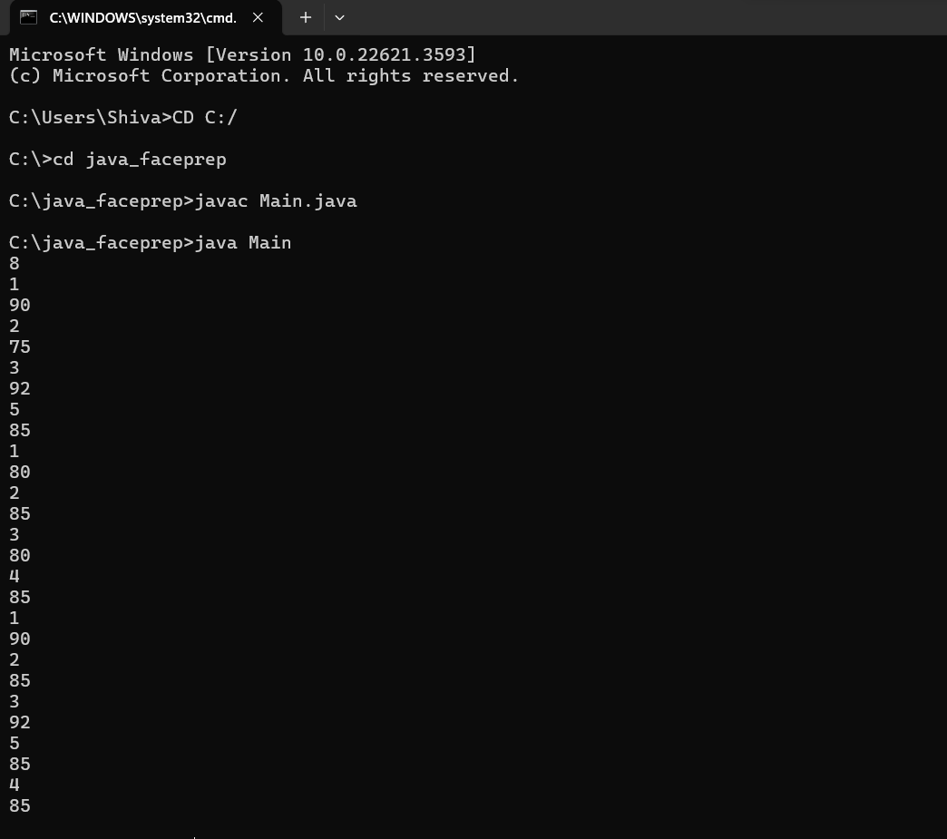

**5.)**

**Code:-**

import java.util.Scanner;

public class PowerOfTwo {

public static void main(String[] args) {

Scanner scanner = new Scanner(System.in);

System.out.println("Enter a number:");

int number = scanner.nextInt();

System.out.println(powerOfTwo(number));

}

public static String powerOfTwo(int n) {

if (n < 0) {

return "Number too small";

} else if (n > 32767) {

return "Number too large";

} else if ((n & (n - 1)) == 0) {

return "Yes";

} else {

return "No";

}

}

}

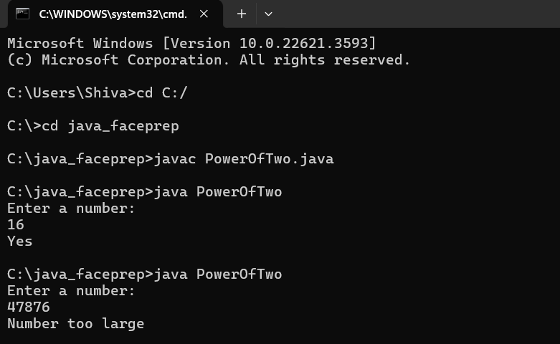

**Phase-2**

**11.)**

**Code:-**

import java.util.Scanner;

public class r {

public static int divisibleBy3(int[] array, int size) {

if (size < 0) {

System.out.println("Invalid Input");

return 0;

}

int count = 0;

for (int i = 0; i < size; i++) {

if (array[i] < 0) {

System.out.println("Invalid Input");

return 0;

}

if (array[i] % 3 == 0) {

count++;

}

}

return count;

}

public static void main(String[] args) {

Scanner scanner = new Scanner(System.in);

System.out.println("Enter the number of elements:");

int size = scanner.nextInt();

if (size < 0) {

System.out.println("Invalid Input");

return;

}

int[] array = new int[size];

System.out.println("Enter the elements:");

for (int i = 0; i < size; i++) {

array[i] = scanner.nextInt();

}

int count = divisibleBy3(array, size);

System.out.println("Number of 3 multiples: " + count);

}

}

**11-Output:-**

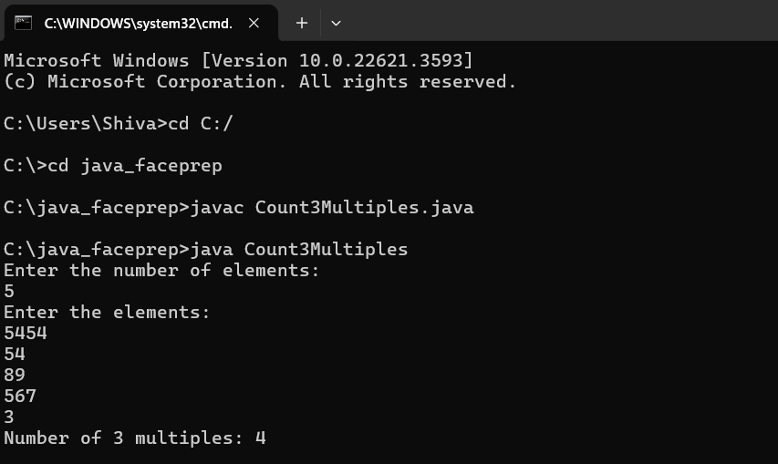

**12)**

**Code:-**

import java.util.Scanner;

public class PlotPassword {

public static void main(String[] args) {

Scanner in = new Scanner(System.in);

int n = in.nextInt();

if (n < 0) {

System.out.println("Invalid Input");

System.exit(0);

}

int[] plots = new int[n];

for (int i = 0; i < n; i++) {

plots[i] = in.nextInt();

if (plots[i] < 0) {

System.out.println("Invalid Input");

System.exit(0);

}

}

float average = avgOddEvenSum(plots, n);

System.out.printf("%.2f\n", average);

}

public static float avgOddEvenSum(int[] array, int size) {

int sumOdd = 0;

int sumEven = 0;

for (int i = 0; i < size; i++) {

if (array[i] % 2 == 0) {

sumEven += array[i];

} else {

sumOdd += array[i];

}

}

float avg = (sumOdd + sumEven) / 2.0f;

return avg;

}

}

**12-Output:-**

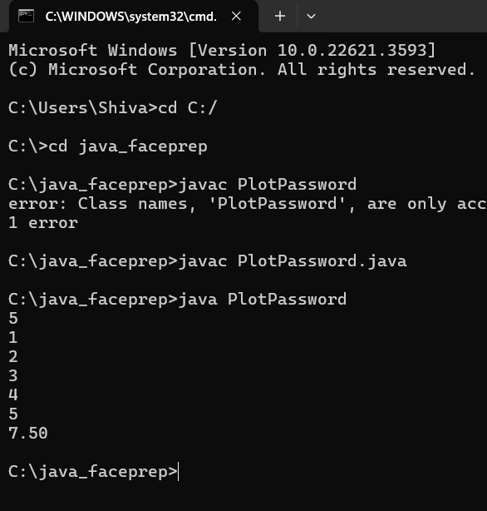

**14)**

**Code:-**

import java.util.Scanner;

public class ArithmeticOperation {

public static void main(String[] args) {

Scanner scanner = new Scanner(System.in);

System.out.println("Enter the first number:");

int num1 = scanner.nextInt();

System.out.println("Enter the second number:");

int num2 = scanner.nextInt();

System.out.println("Enter the operation (1: Addition, 2: Subtraction, 3: Multiplication, 4: Division):");

int operation = scanner.nextInt();

int result = performArithmeticOperation(num1, num2, operation);

if (result == -1) {

System.out.println("Invalid Input");

} else {

System.out.println("Result: " + result);

}

}

public static int performArithmeticOperation(int num1, int num2, int operation) {

if (num1 < 0 || num2 < 0 || num1 > 32767 || num2 > 32767 || operation < 1 || operation > 4) {

return -1;

}

switch (operation) {

case 1:

return num1 + num2;

case 2:

return num1 - num2;

case 3:

return num1 * num2;

case 4:

if (num2 == 0) {

return -1; // Division by zero

}

return num1 / num2;

default:

return -1;

}

}

}

**14-Output:**

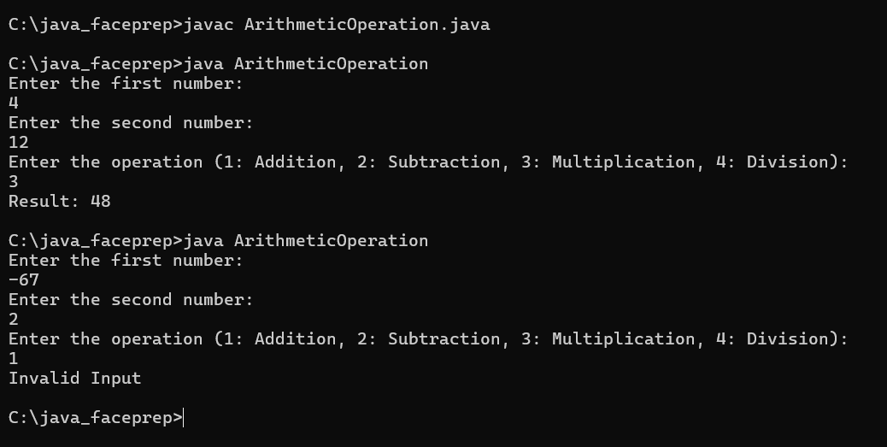

**16)**

**Code:-**

import java.util.Scanner;

public class SearchKeys {

static int[] found;

public static void main(String[] args) {

Scanner scanner = new Scanner(System.in);

System.out.println("Enter the size of the array:");

int size = scanner.nextInt();

if (size < 0) {

System.out.println("Invalid array size");

return;

}

int[] array = new int[size * 2];

for (int i = 0; i < size * 2; i++) {

int value = scanner.nextInt();

if (value < 0) {

System.out.println("Invalid input");

return;

}

array[i] = value;

}

System.out.println("Enter the value to be searched:");

int searchValue = scanner.nextInt();

searchKeys(array, size, searchValue);

if (found == null) {

System.out.println("Key not found");

} else {

for (int key : found) {

System.out.println(key); }

}

}

public static void searchKeys(int[] array, int size, int searchValue) {

int count = 0;

for (int i = 0; i < size * 2; i += 2) {

if (array[i + 1] == searchValue) {

count++;

}

}

if (count == 0) {

found = null;

return;

}

found = new int[count];

int index = 0;

for (int i = 0; i < size * 2; i += 2) {

if (array[i + 1] == searchValue) {

found[index++] = array[i];

}

}

}

}

**16-Output:-**

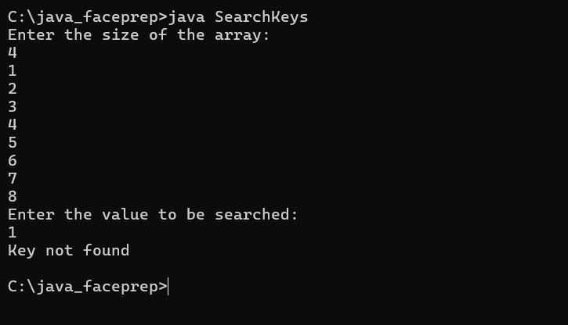

**17)**

**Code:-**

import java.util.Scanner;

public class PassCount {

public static void main(String[] args) {

Scanner scanner = new Scanner(System.in);

System.out.println("Enter the size of the array:");

int size = scanner.nextInt();

if (size < 0) {

System.out.println("Invalid array size");

return;

}

int[] array = new int[size];

System.out.println("Enter the elements of the array (RollNo followed by Marks):");

for (int i = 0; i < size; i++) {

int value = scanner.nextInt();

if (value < 0) {

System.out.println("Invalid input");

return;

}

array[i] = value;

}

int count = passCount(array, size);

System.out.println("Number of students who cleared the exam: " + count);

}

public static int passCount(int[] array, int size) {

int passCount = 0;

for (int i = 1; i < size; i += 2) {

if (array[i] >= 70) {

passCount++;

}

}

return passCount;

}

}

**17-Output:**

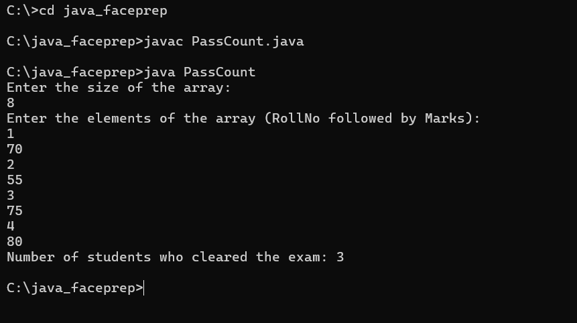

**-------END-------**