1. 版本

mysql官网：<https://www.mysql.com/>

|  |  |  |
| --- | --- | --- |
| 版本号 | 已发布最小 | 已发布最大 |
| 8.0 | [Changes in MySQL 8.0.0 (2016-09-12, Development Milestone)](https://dev.mysql.com/doc/relnotes/mysql/8.0/en/news-8-0-0.html) | [Changes in MySQL 8.0.12 (2018-07-27, General Availability)](https://dev.mysql.com/doc/relnotes/mysql/8.0/en/news-8-0-12.html) |
| 5.7 | Changes in MySQL 5.7.1 (2013-04-23, Milestone 11) | Changes in MySQL 5.7.23 (2018-07-27, General Availability) |
| 5.6 | Changes in MySQL 5.6.2 (2011-04-11, Developer Milestone) | [Changes in MySQL 5.6.41 (2018-07-27, General Availability)](https://dev.mysql.com/doc/relnotes/mysql/5.6/en/news-5-6-41.html) |
| 5.5 | Changes in MySQL 5.5.0 (2009-12-07, Milestone 2) | Changes in MySQL 5.5.61 (2018-07-27, General availability) |

注：查询版本 select version()

1. 下载

官网：<https://www.mysql.com/downloads/>

分为四类版本

|  |  |
| --- | --- |
| Oracle MySQL Cloud Service | 商业使用 |
| MySQL Enterprise Edition | 商业使用 |
| MySQL Cluster CGE | 商业使用 |
| MySQL Community Edition | 社区版本，免费使用 |

进入：<https://dev.mysql.com/downloads/>

选择 [**MySQL Community Server**](https://dev.mysql.com/downloads/mysql/) 的download

进入: <https://dev.mysql.com/downloads/mysql/>

选择指定的操作系统和版本号（根据工作学习需要安装对应版本，不建议强迫自己使用最新版本）

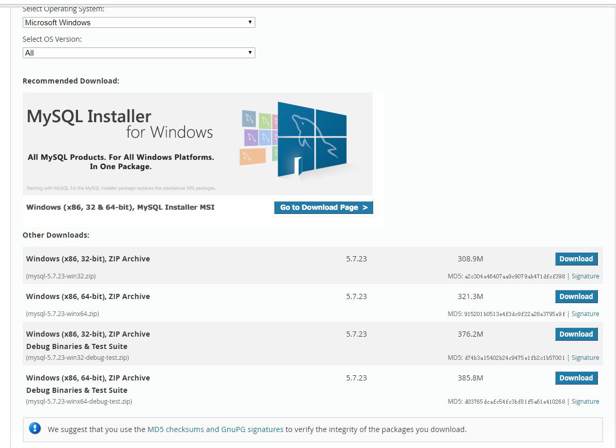

有四种方式可供选择：

|  |  |  |
| --- | --- | --- |
| 在线安装包 | (mysql-installer-web-community-5.7.23.0.msi) | 新手推荐 |
| 离线安装包 | (mysql-installer-community-5.7.23.0.msi) | 新手推荐 |
| 压缩包 | (mysql-5.7.23-winx64.zip) |  |
| 调试压缩包 | (mysql-5.7.23-winx64-debug-test.zip) |  |