T

TIBCO BusinessEvents BUI: Application Lifecycle

Product Suite | TIBCO BusinessEvents
Product | Business User Interface
Product Version | 1.0
Initial Author | Gabe Grigorescu

Copyright Notice
COPYRIGHT© 2008 TIBCO Software Inc. This document is unpublished and the foregoing notice is affixed to protect TIBCO Software Inc. in the event of inadvertent publication. All rights reserved. No part of this document may be reproduced in any form, including photocopying or transmission electronically to any computer, without prior written consent of TIBCO Software Inc. The information contained in this document is confidential and proprietary to TIBCO Software Inc. and may not be used or disclosed except as expressly authorized in writing by TIBCO Software Inc. Copyright protection includes material generated from our software programs displayed on the screen, such as icons, screen displays, and the like.
Trademarks
Technologies described herein are either covered by existing patents or patent applications are in progress. All brand and product names are trademarks or registered trademarks of their respective holders and are hereby acknowledged.
Confidentiality
The information in this document is subject to change without notice. This document contains information that is confidential and proprietary to TIBCO Software Inc. and may not be copied, published, or disclosed to others, or used for any purposes other than review, without written authorization of an officer of TIBCO Software Inc. Submission of this document does not represent a commitment to implement any portion of this specification in the products of the submitters.
Content Warranty
The information in this document is subject to change without notice. THIS DOCUMENT IS PROVIDED "AS IS" AND TIBCO MAKES NO WARRANTY, EXPRESS, IMPLIED, OR STATUTORY, INCLUDING BUT NOT LIMITED TO ALL WARRANTIES OF MERCHANTABILITY OR FITNESS FOR A PARTICULAR PURPOSE. TIBCO Software Inc. shall not be liable for errors contained herein or for incidental or consequential damages in connection with the furnishing, performance or use of this material.
For more information, please contact:
TIBCO Software Inc.
3303 Hillview Avenue
Palo Alto, CA 94304
USA
Table of Contents
1 Change Log 4
1.1 Related Documents 4
2 Introduction 5
2.1 Main Objective 5
2.2 Intended Usage of Decision Tables 5
2.3 Scope 7
2.4 Audience 7
2.5 References 7
3 Acronyms and Vocabulary 8
4 Architecture 8
4.1 High-level View 8
4.2 Data flow 9
4.3 User roles 10
4.3.1 End users 10
4.3.2 Developer: 11

Change Log
.
Date | Version | Name | Description
03/09/2008 | 0.1 | Gabe Grigorescu | Document Creation
03/10/2008 | 0.2 | Gabe Grigorescu | Updated diagram to show DecisionProject stored locally while user is working and not on Management Server
3/19/2008 | 0.3 | Gabe Grigorescu | Updated diagram to show more info and the newly introduced concept of “DecisionProject”
3/26/2008 | 0.4 | Gabe Grigorescu | Added execution semantics section
4/30/2008 | 0.5 | Gabe Grigorescu | Modified architecture diagram to reflect
5/12/2008 | 0.6 | Gabe Grigorescu | Updated based on feedback from Aditya

Related Documents
Document Title | Revision Number | Author
TIBCO BusinessEvents Business User Interface Requirements | 1.0 | Gabe Grigorescu

Introduction

Main Objective
The objective of the Business User Interface is to make it easier for business users to author, test, and maintain decisions without having to know the underlying technical details or writing code.

Intended Usage of Decision Tables
The Decision Tables and Decision Trees are not meant to be used to write complex rules in which you write nested if/else types of constructs or even create conditions in action blocks. For example, rules that are not meant to be authored by graphical decision metaphors include rules like these:
String fileWriterKey = getFileWriterKey(BatchInfo.cbol_write_workPath);
if(op_push_cbol.EndEvent) {
Object fileWriter = Engine.Variable.getEngineObjectVar(fileWriterKey);
if(!isNull(fileWriter))
File.fileClose(fileWriter);
Engine.Variable.setEngineObjectVar(fileWriterKey, null);
String finalName = BatchInfo.cbol_write_destPath;
if(File.fileExists(BatchInfo.cbol_write_workPath)) {
if ( File.fileRename(BatchInfo.cbol_write_workPath, finalName) == false) {
System.debugOut("Can't move file from <" + BatchInfo.cbol_write_workPath + "> to <" + finalName + ">" );
File.fileRename(BatchInfo.cbol_write_workPath, BatchInfo.cbol_write_workPath+ ".last");
exec("cp " + BatchInfo.cbol_write_workPath + ".last " + finalName);
}
}
}
else {
Object fileWriter = Engine.Variable.getEngineObjectVar(fileWriterKey);
if(isNull(fileWriter)) {
fileWriter = File.openFile(BatchInfo.cbol_write_workPath, "rw");
File.fileSeek(fileWriter, File.fileLength(fileWriter));
Engine.Variable.setEngineObjectVar(fileWriterKey, fileWriter);
}
String fileFormat = Rules.BatchEngine.Common.Mapping.cbol_offerPush_event_to_file(
op_push_cbol);
File.fileWriteLine(fileWriter, fileFormat);
}

The rule editor should be used for such rules. Other rules may seem to have complex actions (for example) which could be simplified into multiple rules (where each rule can be mapped to a row in a decision table). For example a rule with the following condition and action:

CONDITION:
criterion.status != "local";
transaction.AccountId == account.Id;
Temporal.Numeric.addAllHistoryDouble(account.Debits,
DateTime.getTimeInMillis(DateTime.addSecond(now(), scalars.OneDay))) + transaction.Amount > criterion.daily_limit;

ACTION:
if (criterion.status == "master") {
account.Status = "Suspended";
// other statements
System.debugOut("##### Account id <" + account.Id + " suspended");
} else if (criterion.status == "contender") {
System.debugOut("##### Account id <" + account.Id + " suggest suspension");
} else {
System.debugOut("##### Unknown criterion");
// other statements
}

Could easily be translated into three “rules” by moving the three conditions being checked in the action block to conditions.
Instead, potentially very large sets of rules that are modeled more around values of specific properties could be easily modeled with decision tables and trees. For example, a condition set could be something like this:
Person.age < Max(20, Parent.age)
Person.creditscore >= Math.function(…)
Person.gender == “female”

And actions could be also mostly taken on properties or entities declared in the scope:
Application.status = “ACCEPTED”
Application.credit = 4000
sendNotification()

The idea here is that based on the many possible combinations of a person’s age, credit score, and gender, the decision table needs to decide on how to respond to an application for a credit card and if accepting, what the credit limit could be. In this sense, the inputs are clear:
Person.age
Person.creditscore
Person.gender

And the output is also well defined:
Application.status
Application.credit

Scope
The scope of this document is to outline the lifecycle of the Decision Application (RCP Application that will be shipped as part of the TIBCO Business User Interface solution that is part of the TIBCO BusinessEvents product.

Audience
The document is intended for Developers, Architects, QA, Product Marketing, and Manager.

References
- TIBCO BusinessEvents document set
- TIBCO BusinessEvents road map

Acronyms and Vocabulary

The table below describes some of the Acronyms used in this documentation
- BUI – Business User Interface
- BE – TIBCO BusinessEvents.
- XML – Extensible Markup Language
- Designer Project – A TIBCO Project build using TIBCO Designer. A Project is a VFileSystem which could typically be a Directory Node in the FileSystem.
- EAR – Enterprise Archive Resource. This is modeled from the J2EE world and contains a subset of VFiles, user defined files, properties, code, jars, etc. An Engine may choose to run against this EAR file.
- A Rule is single Conditions/Actions pair (e.g.,. a column in the Decision Table).

- DT – Decision Table. A Spread-Sheet like interface for business user to capture threshold values, business rules (in a tabular format). It comprises of one or more rules.
- A Rule Condition is a boolean expression of logical operators and functions (which may be a rule function or another Decision Table that returns a value) acting upon one or more Terms.
- A Rule Action is one of:
  - An update to a Term represented as an Expression
  - A creation or deletion of a Term
  - An invocation of another Decision Table that may or may not return a value
  - A simple return value (to be consumed by caller)
- Virtual Rule Function (VRF). A Rule Function that has no body (implementation). Implementation must be provided by any decisioning construct BE supports (for now just Decision Tables).

Architecture
The following section outlines the high level architecture of the lifecycle of the RCP application that will be used by the business users to implement decision tables and trees. It is meant to provide the reader with a basic understanding of the context in which the decision tables are to be used.

High-level View
The Eclipse RCP Application will interact as follows with the other TIBCO components:
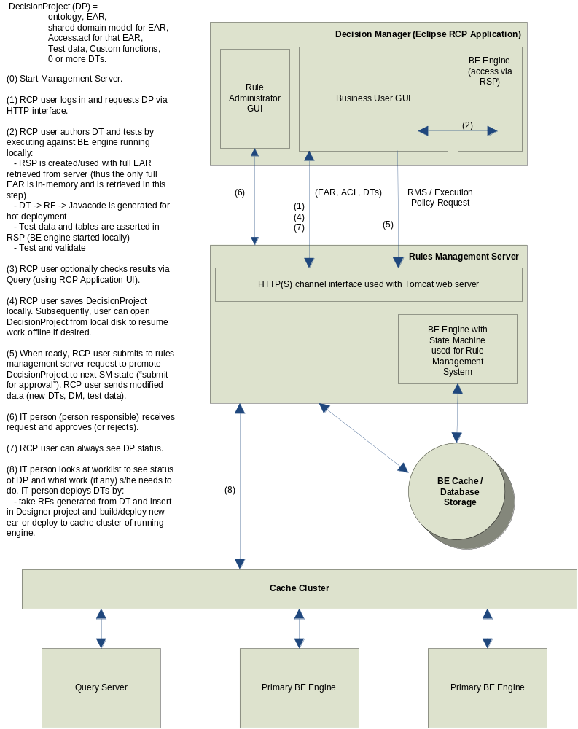

Data flow
These are the high level steps already described in the diagram in the previous section. A “DecisionProject” is defined as a set made up of the EAR file (ontology), ACL associated with that ontology, and zero or more decision tables (stored in both XMI and .rulefunction format).
The following steps are a little outdated, the diagram always shows the more accurate flow.
(0) Start Management Server manually by either the business user or the IT person although generally the business user should be able to start it easily.
(1) RCP user logs in and requests DecisionProject via HTTP interface
(2) RCP user authors DT and tests by executing against BE engine running locally:
- RSP is created/used with full EAR retrieved from server (thus the only full EAR is in-memory and is retrieved in this step)
- DT -> RF -> Javacode is generated for hot deployment
- Test data is asserted in RSP
- Test and validate (ACL/syntax validation performed)
(3) RCP user checks results via Query (using RCP Application UI). This step is optional.
(4) RCP user saves DecisionProject locally. Subsequently, user can open DecisionProject from the local disk to resume work. (Optionally, we could have the user commit to management server which stores project in “still-working” state of BE SM). This step is also optional but allows the user to save the work until submitting the project for approval.
(5) When ready, RCP user submits to management server request to promote DecisionProject to next SM state (“submit for approval”). RCP user submits execution policy request for DecisionProject. Essentially the RCP user sends the modified/new DTs.
(6) IT person (person responsible) receives request and approves.
(7) RCP user sees status of DecisionProject at all times.
(8) IT person deploys DTs by following the deployment procedure in the engine cluster. Given the class files generated, by setting properties the engine cluster can load those classes.

Execution semantics

We envision two types of decision table constructs. The two types will address two different use cases. The first use cases addresses the need of an IT person to incorporate decision table functionality into a BPM process by invoking it like a rule function. We will call this a “Decision Table Rule Function.” The second use case addresses the need of a decision table functionality in a CEP-like scenario, where such a table is modeled more like a rule. We will call this a “Decision Table Rule.”
Both types of decision table constructs will support the notion of an “Effective Date” and a “End Date” that the engine will take into account when executing. The appropriate UI will be given to the user to enter these dates.

DT Rule Function
Again, this is to address the “BPM use case” for decision tables. We will add a new resource type in TIBCO Designer to model a template for a DT rule function so that the IT person can invoke this DT by name and decide on what the input and output parameters are. For the example, a function called “MyTableFunction” located in /path/to folder could be invoked by calling:

path.to.MyDTableFunction(args);

Designer was modified to allow users to create Virtual Rule Functions (a new checkbox was added) so that if that checkbox is selected, then the body is disabled. The idea is that the DT will provide the implementation for that rule function. Then, the business user will get this virtual rule function when s/he checks out the decision project from the management server and fill it in by creating an implementation (new DT) either from scratch or by importing from a Microsoft Excel file. This means that the business user will decide which properties of the input parameters s/he needs to model the table and just modify whatever properties of the arguments that were decided in Designer. The business user will not be able to alter the signature of the function (unless they change this in Designer and then ask IT to generate the new ear and deploy it in RMS). Thus, the UI for modeling this DT rule function will look a little different. The user will have:

- A section that will list the input and output arguments. These parameters will only be entities, meaning Concepts and Events, as well as primitives. We’ll call this section “Arguments.”
- A section that will consist of a Decision Table. This will be blank and the business user will fill it in by dragging and dropping properties of input arguments. We already have this in place.
- A section that will consist of an Exception Table. This will be blank and the business user will fill it in by dragging and dropping properties of input arguments. We already have this in place. This is just another instance of a decision table.

DT Rule
Again, this is to address the “CEP use case” for decision tables. This functionality will not be available in the 3.0 release. In this scenario the business user will create a brand new decision table rule after getting the decision project from the management server. This user will decide (depending on what permissions s/he has) where to save this table, what the input and output parameters are, and the logic. This will be modeled like a rule, and because it already has a scope, the engine will know when to fire this DT rule. Thus, the UI for modeling this type of DT rule will look different than the DT rule function. The user will have:

- A section that will list the input and output parameters. These parameters could be entities (Concepts and Events) or their attributes (?). We’ll call this section “Declarations.”
- A section that will enable them to type pre-conditions that will need to be met before the decision table will get executed. We’ll call this section “Pre-conditions.” It will be a small text area that will behave like the condition area of the rule editor we now have in Designer.
- A section that will consist of a Decision Table. This will be blank and the business user will fill it in by dragging and dropping parameters from the “Declarations” section. We already have this in place.
- A section that will consist of an Exception Table. This will be blank and the business user will fill it in by dragging and dropping the parameters from the “Declarations” section. We already have this in place. This is just another instance of a decision table.

User roles

End users
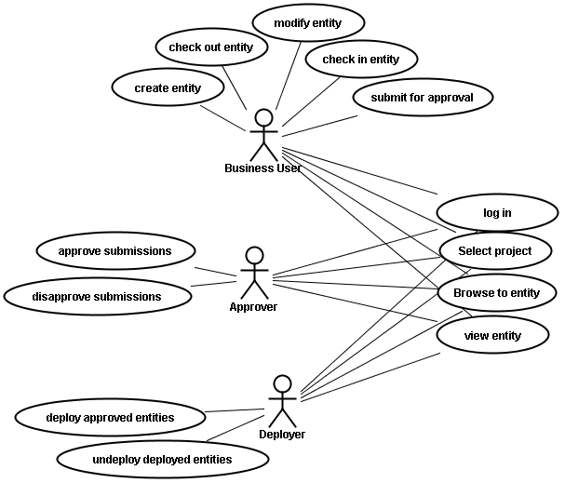

Business user: uses the client to update projects
Rule Administrator: potentially the same responsiblities of IT. In addition, user approves or denies decision projects..
IT User: setup, create project, ensure deployment process works. This user could fulfill the roles of the Approver and Deployer below as well.
Approver(s): uses the client to approve or deny changes made by business users.
Deployer: uses the client to select approved entities and deploy or undeploy them.

Developer:
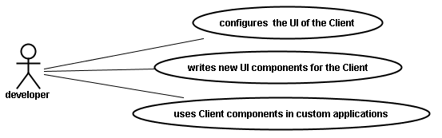
Developer: customizes the client and/or uses it as a UI component library. This user may also:
      - create project structure/class model
      - author rules (some of which may not be available to the business user)
      - create/validate deployment process
      - verify the entire system before releasing it to the rest of the organization
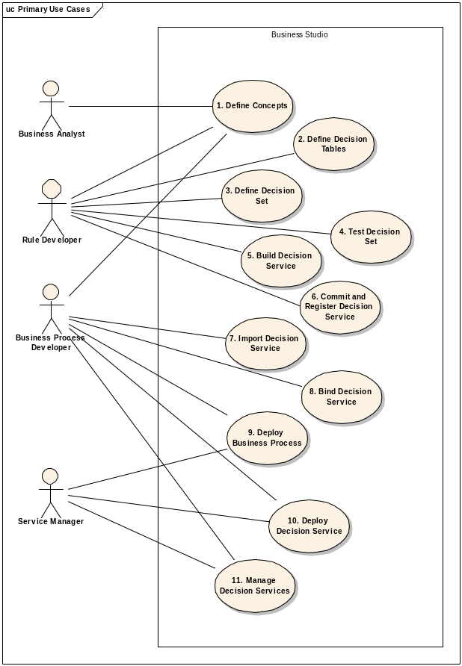

Figure 1 – Primary Use Cases

