Overview (ch1)
This chapter provides an overview of Decision Manager component, different user roles, and its workflow process.

- Introduction to Decision Manager
- User roles
- Workflow

Introduction to Decision Manager

Decision Manager, a product of TIBCO BusinessEvents family, is an eclipse-based Rich Client Platform (RCP) component. The application provides a friendly user interface to allow you to author, test, and deploy rules to the TIBCO BusinessEvents engine. Decision Manager also provides the IT personnel an easy, secure, and scripted deployment lifecycle by exposing an extensible Rules Management System (RMS). Decision Manager helps business users author rules and simplify complex rules without having to write TIBCO BusinessEvents rule language. The application allows you to simplify rules by breaking them into multiple simpler rules where each rule is mapped to a row in the decision table.
TO DECIDE: list here features as I did for RMS, or leave it as it is?
TO DECIDE: do we refer to this as “Component” or “Application” or “Decision Manager application” or what? We need to be consistent.
Different users can use this component differently. Users include
- Business User
- Developer
- Administrator
COMMENT: we have a different list a few pages later on…
Business user uses this component to write, test, and maintain decisions without having to know the underlying technical details or writing code. Business user can drag and drop the properties of entities (concepts and events) to create decision logic and simulate the rules, without understanding the rule language. Developers use this component to define, modify, deploy the configuration of a rule system, with minimal supervision, and minimal implementation overhead.
A Decision Table is an interface with rows and columns for a business user to capture threshold values and business rules in a tabular format. It comprises of one or more rows. Each row can be thought of as a rule within a table that is made up of many rules. Business user can drag and drop the properties from concepts to make a decision table. Venkata: you can look up on the web for more complete definitions of decision tables.
Decision Tables are used to provide an implementation to Virtual Rule Functions created in TIBCO Designer. The virtual rule functions by definition have no implementation and if invoked from a rule without one will throw an exception. Thus, a decision table can be used to provide implementations to such virtual rule functions.
See Appendix for more information on Events, Concepts, Channels, and other TIBCO BusinessEvents language components.

Example
Business users are not expected to understand the technicalities of complex rules. Decision Manager is an application that enables you to focus on business logic. You may have a simple set of rules, where each rule has one or more conditions and if all of them are satisfied, one or more actions are performed. For example, a more complex rule could be the following:

CONDITION:

criterion.status != "local";

transaction.AccountId == account.Id;

Temporal.Numeric.addAllHistoryDouble(account.Debits,

DateTime.getTimeInMillis(DateTime.addSecond(now(), scalars.OneDay))) + transaction.Amount > criterion.daily_limit;

ACTION:

if (criterion.status == "master") {

account.Status = "Suspended";

// other statements

System.debugOut("##### Account id <" + account.Id + " suspended");

} else if (criterion.status == "contender") {

System.debugOut("##### Account id <" + account.Id + " suggest suspension");

} else {

System.debugOut("##### Unknown criterion");

// other statements

}
The condition from the above example can be simplified into several rules. Here’s an example of a simple set of conditions:
Person.age < Max(20, Parent.age)
Person.creditscore >= Math.function(...)
Person.gender == "female"
Similarly, action can be taken depending on the entities declared in the scope as follows:
Application.status = "ACCEPTED"
Application.credit = 4000
sendNotification()
This simplified set of conditions and actions can be easily modeled in a decision table.
Decision Project
The ontology model created in TIBCO Designer (need ref here), the decision tables, domain model, test data, access control, and other decision artifacts are grouped together in what is called a Decision Project. The Decision Manager works with decision projects by checking them out from the Rules Management Server (see the next section), saving modifying, validating, testing, and committing them.

Introduction to Rules Management Server

The lightweight Rules Management Server (RMS), a product of TIBCO BusinessEvents family, serves as a rules management repository that is being built using TIBCO BusinessEvents itself. The Decision Manager application communicates with this server to retrieve rules and other artifacts, get updates, commit them, as well as approve or reject those rules and deploy them to a production system. Only one decision project can be made available to the users per RMS instance. These are some of the main features of the RMS:
- allows you to authenticate against an LDAP or file-based system
- gives you access to certain parts of a project depending on your user role
- allows you to checkout a project
- allows you to get updates to that project
- allows you to commit your project
- allows you to see the status of your project

As a Rule Administrator,
- it allows you to set up projects with domain models and test data pre-defined, as well as set project security policies
- it allows you to approve or reject committed projects and give feedback to the business users
- as a Rule Administrator, it allows you to check on the status of all projects committed and keep track of all project versions
- it allows you to deploy approved rules to a running TIBCO BusinessEvents engine of your choice
See section XXX on how to configure the RMS to enable the users to check out decision projects.

User Roles

This section presents the users of the Decision Manager component, and various tasks that they will undertake.

End Users
The Decision Manager has the following End Users:
- Business User. In this role, you use the client application to update the existing projects by creating decision tables in a decision project, modifying the tables, checking-in and checking-out the decision projects and submitting the projects for approval to the Approver.
- IT Administrator. In this role, you setup RMS. Rule Administrator can use it, approve, etc.
- Rule Administrator. In this role, you create and set up the projects, and ensure proper deployment. You decide what the business user can do using the Decision Manager. You could fulfill the roles of the Approver and Deployer as well.
- Approver. In this role, you use the client application to approve or deny decision projects committed by the Business Users.
- Deployer. In this role, you use the client application to select approved entities and deploy or undeploy them.

Developer
This user customizes the client and or uses it as a User Interface (UI) component library. This user can perform the following:
- Configuring the business users user interface
- Writing the new UI components
- Creating project structure model
- Authoring rules
- Creating and validating deployment process
- Verifying the entire system before releasing it to the rest of the organization.
The RMS is implemented using TIBCO BusinessEvents. It contains a state machine, rules, events, and catalog functions. The TIBCO Designer source code to this implementation is provided in the distribution in the <BE_HOME>/rms/project directory. If you wish to customize the default behavior, you modify this project.

Workflow

The following figure illustrates the typical deployment scenario of the TIBCO BusinessEvents Decision Manager and Rules Management Server.

Deployment scenario of the TIBCO DECISION MANAGER

Venky: I have the Visio diagram for this if you want it.
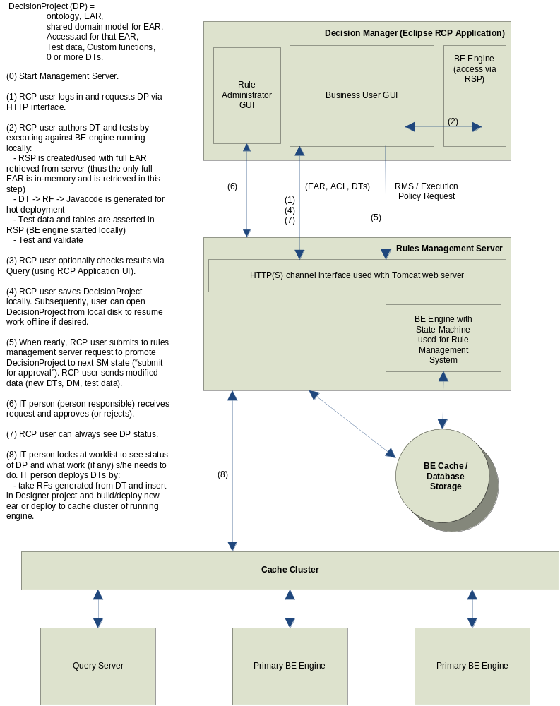

- User in your enterprise creates a TIBCO Designer project, creates an ontology, and writes rules that makes use of virtual rule functions to be implemented later by a Business User using decision tables.
- IT Administrator takes the Designer project and sets up the RMS.
- IT Administrator starts the TIBCO BusinessEvents Rules Management Server.
- Business user logs in with valid credentials and requests decision project by checking it out and saving it to the disk.
- Depending on the permissions given by the Rule Administrator, business user creates a decision table.
- Business user saves the modified decision project locally.
- Business user tests the decision tables locally with a locally running BE engine started by the Decision Manager application automatically.
- Business user submits the modified or the new decision table for approval once done with the project.
- Rule Administrator receives the request and approves or rejects the project.
- Rule Administrator takes the deployed class files generated automatically and deploys them to a production BE engine.
- Rule Administrator takes the Rule Functions generated from the decision tables and inserts in Designer project.
- Administrator builds the new EAR file and deploys it to the production.
To start the Decision Manager application:

- Run DecisionManager.exe. A splash screen followed by Welcome screen is displayed.
- Close the Welcome page to see the blank screen which is the main page of Decision Manager component before login.

Blank main page of Decision Manager component

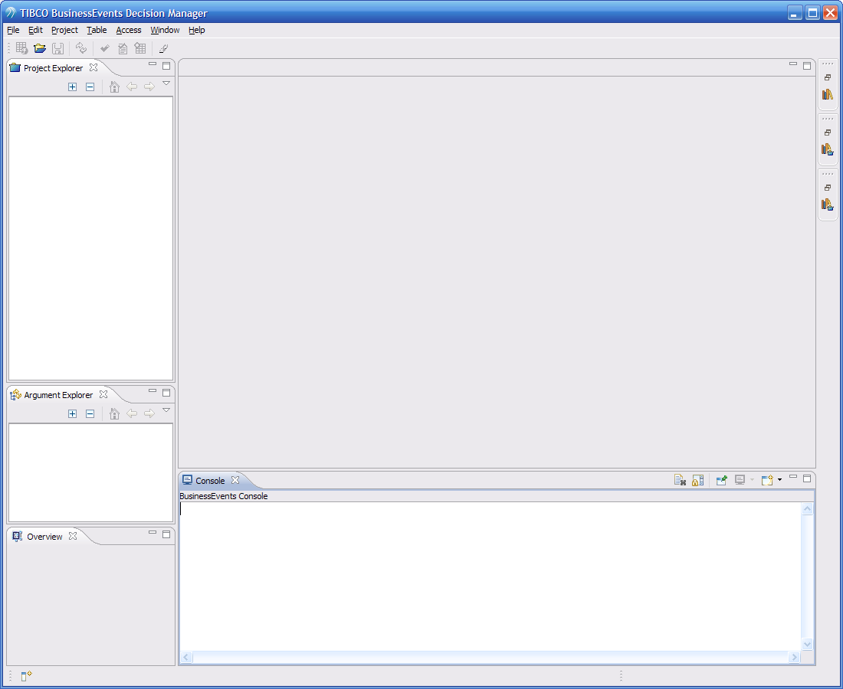

The following figure is the snapshot of Decision Manager components main page with a decision project loaded and a certain decision table opened:

Main page of TIBCO DECISION MANAGER

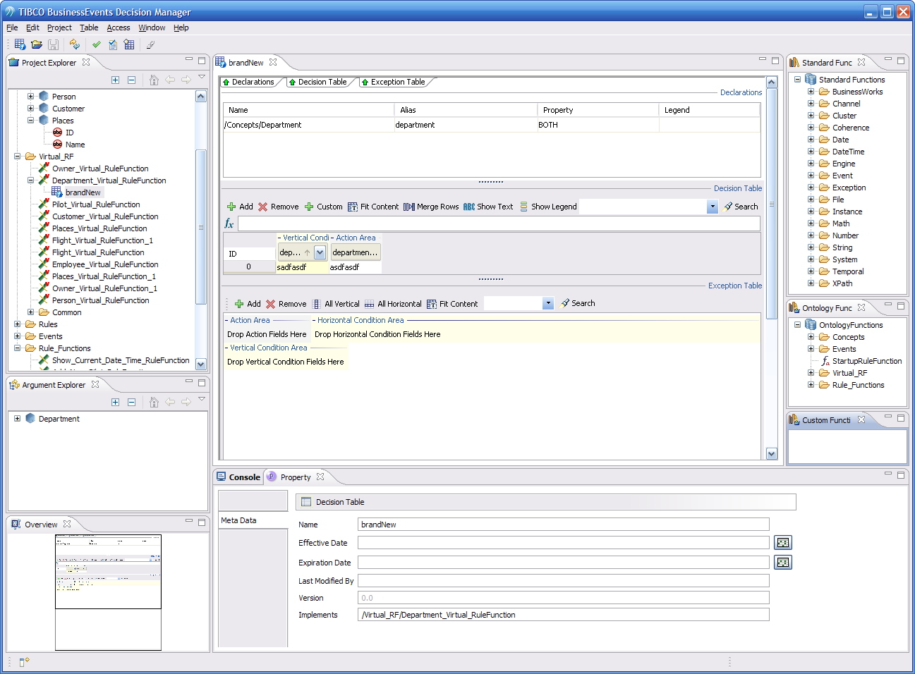
Venkata: in the screenshot, we should have arrows and show what each component is called, so when they read what’s below, they’ll know what we’re talking about.
Project Explorer: The project explorer is the user interface component of the Decision Manager application which displays the BusinessEvents ontology. This ontology is used by the business user to work with Decision Table. This is the ontology that was created in TIBCO Designer where all the model and rules were created.
Argument Explorer: Argument Explorer displays the arguments of the virtual rule function which are defined in TIBCO Designer. These are considered to be both input and output arguments. Business user can expand the entities (concepts or events) to see their properties, decide on which properties to use to make decision, and drag and drop the properties onto the Condition or Action area of the Decision Table editor to create an implementation.
Overview Explorer: This is an outline view for the decision table editor. It can be used to navigate larger tables.
Property Explorer: This window displays the meta-data of the entire Decision Table. It shows properties of Concept, Events, Implementation, and Rule Meta Data. From the Property Explorer you can only modify the Effective date and Expiration date. This view is activated when …
Console View: All engine messages are logged in this window.
Problem View: All errors or warnings are shown in this window.
Domain Model Editor: This window is displayed when you select the properties of Concepts. You can add, remove, and modify the domain entries here (if the Rule Administrator has given you permission to do so). For example, instead of typing text for a particular attribute each time, you can define a set of strings which users can simply select each time they click on a decision table cell assigned to that attribute. In figure xx below, the gender attribute has a domain model defined. In figure yy, you can see how to choose from the available list of values instead of typing it in.
TODO: anything else?
Decision Table Editor: This is the work area for defining the decision tables. This consists of three different sections.
- Declaration Table: This table displays the input and output parameters. displays read only arguments for the implementation. The arguments are defined in TIBCO Designer.
- Decision Table: This is a table you fill in by dragging and dropping properties of the the arguments .
- Exception Table: This is another instance of a decision table where you enter the conditions and actions for exceptions. Here you capture unusual situations by writing rules. For example, you could add rows that capture situations where fields are blank or contain invalid values. In such cases, you can add custom actions to send notifications or set return values in your table accordingly.

Catalog Functions: There are three catalog function views: Standard Functions, Ontology Functions, and Custom Functions. Each one of these views can be opened so you can drag and drop them to the decision table cells.
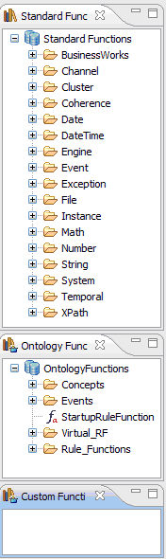

Client-Server Setup (ch 2)
This chapter provides an overview of client-server lifecycle, installation and configuration steps for client and server, project creation steps in rule management server, and the decision projects checkout process from the rule management server.

- Client Installation
- Client Configuration
- Client Startup
- RMS Installation
- RMS Configuration
- RMS Project Creation
- RMS Startup
- Checkout Decision Projects from RMS

Client Installation

Install TIBCO BusinessEvents. Make sure you include the Decision Manager application module if you choose the Custom installation option. A DecisionManager directory will be installed where the client-side program is installed.

Client Configuration

By default, all the settings for the Decision Manager desktop application are already configured to work with the RMS and no changes are necessary. However, you can make any configuration changes by modifying the configuration files.
Modify the <BE_HOME>/DecisionManager/DecisionManager.ini file to make any Java VM parameter changes. In most cases you should not need to change this.
Modify the <BE_HOME>/DecisionManager/configuration/bui-config.tra to specify several parameters. Each section in this file is described with a comment. The following are the parameters you may change:
rms.port -- this specifies the port number of the RMS. Default is 5000.
rms.baseURL -- this URL pattern need not be changed unless channel URL is changed in the RMS designer project. Default is http://localhost:<rms.port>/Transports/Channels/HTTPChannel.
TODO: Aditya will change this, check with him when done.
Venkata, other properties we can list here are:
be.trace.log.enable=true
be.trace.log.dir=../logs
be.trace.roles=infoRole,errorRole,warnRole,userRole,debugRole
be.trace.log.append=false
Engine.Log.Dir=../logs
be.trace.enable=true

# BUI Properties
# sets whether the Error Log view is visible in the BUI
bui.show.ErrorLog=false
# sets whether to redirect stdout and stderr to the Eclipse Console view
bui.redirect.stdout=true
bui.redirect.stderr=true
Just take a look at the bui-config.tra. Thanks.
The following settings should not be changed unless the IT Administrator has changed the default RMS implementation:
rms.login.destination.name – this specifies the RMS server location for authentication. Default is AuthenticationRequestDestination
rms.checkout.destination.name – this specifies the RMS server location for project checkout.Default value is CheckoutProjectDestination.
rms.checkin.destination.name – this specifies the RMS server location for project commit. Default value is SubmitProjectDestination.
rms.worklists.destination.name – this specifies the RMS server location for project worklists. Default value is AdminTasksDestination.
rms.approvals.destination.name -- this specifies the RMS server location for project approvals.Default value is RouterDestination.

Client Startup

You start the application by executing <BE_HOME>/DecisionManager/DecisionManager.exe. You will see a Splash screen and then the Welcome screen. You may close this Welcome screen to get a blank application workspace.

Server Installation

Install TIBCO BusinessEvents. Make sure you include the Rules Management Server module if you choose the Custom installation option. A rms directory will be installed where the server-side program is installed.

Server Configuration

By default, all the settings for the RMS are already configured to work one of the examples provided.
Modify the <BE_HOME>/rms/bin/be-rms.tra file to make any configuration changes to the RMS. You may use one of the existing examples to create your own project and just modify the settings below. Only the first two properties are required. The others have default values that you do not need to change.
Venkata: we should describe these in a similar manner as the client-side properties, same format.

- rms.project.location=<path of a sample project>. Change the path depending upon where the decision project artifacts are located.
- rms.project.name=<project name>. Give the name of the project. Place the ear file in the %rms.proejct.location%/%rms.project.name%/bin. The name of the EAR file to be used for checkout should be of the form <project name>.ear.
- Name the access control file for this project <project name>.acl and place it in the the %rms.project.location%/%rms.project.name%/config directory.
- Name the optional domain model file for this project <project name>.dm and and place it in the %rms.proejct.location%/%rms.project.name%/config directory.
- The optional test data for this project should be placed in a directory %rms.proejct.location%/%rms.project.name%/data/%rms.project.name%_TestData.
The following properties do not need to be changed unless you want to specify different directory names. They have the following default settings:
rms.project.workspace=<directory to store checked in projects> - default is /workspace
rms.project.decisiondata=<directory to store approved project> - default is /decisiondata
rms.project.deployment=<directory to store deployable class files> - may be same as decisiondata above.
rms.auth.type=file - can be changed to LDAP if authentication data provider is LDAP
rms.auth.file.location=users.txt-> - This is the password file. RMS reads the users.txt inside the rms/config directory by default.
The following properties need to be set if you are using LDAP instead of a file-based authentication system:
rms.auth.ldap.host=<domain name of the host for LDAP>
rms.auth.ldap.port=<port for LDAP>
rms.auth.ldap.adminDN= -> Base DN for admin login e.g: -> cn=Directory Administrators,dc=na,dc=tibco,dc=com
rms.auth.ldap.adminPassword=admin
rms.auth.ldap.baseDN=dc=na,dc=tibco,dc=com -> Base Tree in LDAP under which to search users.

Rule Management Server Project Creation

To create a project for the RMS, you follow the following steps:

- Open or create a project in TIBCO Designer.
- From the projects folder create a Virtual Rule Function. To create a Virtual Rule Function:
- Right-click in the design panel, and select Add Resource > BusinessEvents Workbench > RuleFunction.
- In the Configuration tab, select Is Virtual checkbox to mark it virtual, and then click Apply. This will disable the body area. You could then invoke the virtual rule function in your own rules, but the implementation of the virtual rule function will be provided by a decision table in the Decision Manager application.
- Build an EAR file.
- Create the Access Control List (ACL) needed for the project. See the next chapter for more information about how to create this file. Place the ACL file as specified in the previous section.
- Create the optional Domain Model model. Place this file as specified in the previous section.
- Copy to the RMS the newly built EAR file as specified in the previous section.
- Review the cep-rms.tra file and start the RMS. This will make the new project available to the users to checkout and use.

Server Startup

You start the RMS by executing <BE_HOME>/rms/bin/be-rms.exe (or be-rms.sh, depending on your operating system). You will see various log statements printed on your console (Venkata, add a screenshot of such a console). When the “BE Engine <hostname> started” statement is printed on the console, then the RMS is finished loading. You may not connect to it from the Decision Manager application.

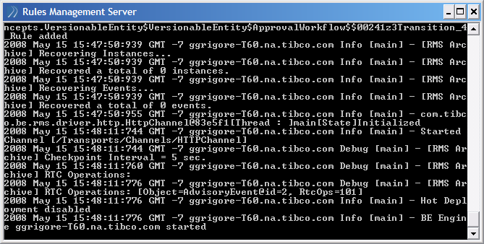

Access Control System (ch 3)
This chapter presents how the access control system works, the types of resource specifications that are permitted, and how to specify permissions to different users.

- Access control system overview
- TIBCO BusinessEvents resources
- Specifying resources
- Specifying permissions
- Guidelines

Access Control System Overview

The Access Control System manages the permissions to the users based on their roles. Using the access control system, the IT Administrator can restrict business users from accessing or modifying certain resources of a Decision Project.
Access control is role based. Thus, the users belonging to same role will have same access permissions. One user can play different roles in an organization, so the user’s permissions are a unification of the permissions that each role the user belongs to gets.
No permissions are implied. Thus, every permission has to be granted explicitly because by default all permissions are denied. Permissions do not have hierarchies. The order in which permissions are specified is irrelevant.
A Role can have zero or more permissions. Each role is represented by a name.
A Permission can have one Action and a resource for which the action applies. For example, a permission could say you have Read permission for all attributes of a particular concept.
An Action defines the most granular action the user can take on what is being controlled. For example, the action could be Read, Write, or Send for a particular entity, where that entity could be a rule, attribute, etc.
All of these ACL settings are specified in the %rms.proejct.location%/%rms.project.name%/config/%/%rms.project.name%.acl file as specified in the be-rms.tra file.

TIBCO BusinessEvents Resources

Access control is enforced for the TIBCO BusienssEvents resources. There are two types of access control modes:
BEResource: This mode is used for populating the Project Explorer view inside the Decision Manager. BEResource mode is the default mode.
Domain Model: This model is used for enforcing the Access Control in domain model editor.
For example, the following allows you to create a new domain model entry for any resource which matches the ID “AllP”

<permission resourceref="#AllP" type="DOMAINMODEL">

<action type="create">ALLOW</action>

</permission>

Specifying Resources

When you specify resources, you specify the resource ID and resource Type. The three different types of resource specifications are:
Template based resource specification: This is used wherever generic permission has to be given to the user. For example, to specify all concepts inside the project ontology, add the following to your acl file:

<resource id="C" type="CONCEPT"/>
Wildcard based resource specification: this is used wherever closer matching of resources is required such as read access to all the properties of a resource. For example, to give access to all the properties of all resources (Concepts or Events which have properties) under the /Concepts directory only, add the following to your ACL file:

<resource name="/Concepts/*"id="AllP" type="PROPERTY"/>
Absolute path specification: this is used wherever specific privileges need to be given to the user. For example, to specify access for the “FirstName” property of a “Person” concept, add the following to your ACL file:

<resource name="/Concepts/Person/FirstName" id="FN" type="PROPERTY"/>

Specifying Permissions

Permissions can be specified only for resources declared in the ACL configuration file. While specifying the permissions, resourceref has to point to a valid Id of a resource defined inside the resources section of the configuration file.
For example, to allow “read" permission for a resource defined with the Id "All" you add the following to your ACL file:

<permission resourceref="#All">

<action type="read">ALLOW</action>

</permission>
If you want to deny a certain permission you specify it as follows:

<permission resourceref="#All">

<action type="read">DENY</action>

</permission>
With this permission you do not allow any read operation for resource with Id "All".
ALLOW and DENY are the only possible permission types.
ALLOW and DENY are case sensitive.

Action Types
Action types exist based on the resource types you have in your decision project, such as concepts, events, rule sets, rule functions, Properties, domain model, catalog functions, etc. Following is the list of different action types.
Concepts
The possible action types for Concepts are:
- read
- create
- modify
- delete

Events
The possible action types for Events are:
- read
- send
- create
- assert
- reply
- delete
- modify

Rulesets
The possible action types for Rulesets are:
- read
- create
- modify
- delete

RuleFunctions
The possible action types for RuleFunctions are:
- read
- create
- delete
- add_impl (adding decision table implementation for virtual rule functions)
- del_impl (delete decision table implementation for virtual rule functions)
- invoke

Properties
The possible action types for Properties are:
- read
- create
- modify
- delete

In the Decision Manager application, you cannot create/modify/delete properties.
Domain Model
The possible action types for Domain Model are:
- read
- create
- delete
- modify

Catalog Functions
For catalog functions, the possible action types are:
- Invoke
- Read

Catalog functions can be invoked either in conditions, actions, or both.

Permission types

Possible permission types are:

- ALLOW
- DENY

Permission verification

As an example, if you define two resources as follows:

<resources>
<resource name="/Concepts/*" id="AllP" type="PROPERTY"/>
<resource name="/Concepts/Person/FirstName" id="FN" type="PROPERTY"/>
</resources>

and two permissions defined as follows:

<permissions>
<permission resourceref="#AllP">
<action type="create">ALLOW</action>
</permission>
<permission resourceref="#FN">
<action type="create">DENY</action>
</permission>
</permissions>

With these settings you give "create" permission for all resources under /Concepts directory but deny create privilege for FirstName which is also under the same directory.

Wild card based matching works as follows:

/Concepts/* is a resource defined.

Thus, /Concepts/Account would match “/Concepts/*”. However “/Conc/Account” would not match “/Concepts/*”.

For catalog functions, here’s an example of how to allow the users to send events:

<resource id="xx" type="CATALOGFUNCTION"/>
<resource name="Event.sendEvent" id="sendEvent" type="CATALOGFUNCTION"/>
<resource id="AllEventFuncs" type="CATALOGFUNCTION"/>

<permission resourceref="#sendEvent">
<action type="read">ALLOW</action>
</permission>

<permission resourceref="#sendEvent">
<action type="invoke">ALLOW</action>
</permission>

You give full permissions to all of your users by creating an ACL file as follows:

Venkata: TODO – Get smallest sample that gives full permissions to do everything with anything in a project, including property changes, domain model changes, table creation, catalog function calling… Aditya Athalye can provide you with this.

Guidelines

The template based resource specification should be used wherever generic permission has to be given e.g.: Give consume event privilege for a role for all events inside the ontology.

Wildcard based resource specification should be used wherever closer matching of resources is required, such as “read access to all properties of event A.”

Absolute path specification should be used where specific privileges need to be given. e.g: Do not allow send event privilege for event B, or do not allow modify privilege for property P of event B.

All privileges are mutually exclusive which means a create permission does not imply a modify permission or a delete permission.

If a permission is NOT specifically given, it means the role DOES NOT have the permission. This allows the Rule Administrator to ensure that if a certain privilege is not specified then accidentally unauthorized users do not get access to resources they should not have access to, or operations they should not be able to invoke.
Thus, if you require all possible permissions for a resource, you specify them individually in the configuration file.

For domain model permissions in the example above, use the following syntax:

<permission resourceref="#AllP" type="DOMAINMODEL">
<action type="create">ALLOW</action>
</permission>

In this example you allow creating a new Domain model entry for any resource which matches the AllP id (see above points for resource matching).

Rules Management Server (ch 4)
This chapter provides an overview of how to interact with the RMS by logging into it, checking out projects, getting updates, committing them, checking the decision project status, and if you are a rule administrator, how to approve and deploy decision tables.

Login

- Click File -> Login and enter valid credentials (username/password in passwd file for file authentication, or in LDAP).
- An Authentication successful message should be displayed if login was successful, else failure message will be displayed.
- Depending upon the login user's role (say Business User), some of the menu options will be enabled/disabled.

Project Checkout

- Click on Project -> Checkout menu.
- Select a directory on local file system to save the checked out directory project. Click Ok
- If a checkout is successful, the project explorer view will be populated with the ontology. This action will send the latest copy of the ontology, the ACL file, domain model file, Decision Tables that would have been approved previously, test data associated with the ontology.

Project Update

- Click on Project -> Update menu. All of the decision project files will be updated. If you have modified locally any decision tables that were updated on the RMS, you are prompted if you want to overwrite your local copy. The project permissions are updated as well. If the domain model was changed, it will also be updated. Any new decision tables that were added to the project on the server will also be added to the local project. However, if any decision tables were removed on the server, they will not be removed from your local decision project.

Project Commit

- Click on Project > Commit after authoring/modifying decision tables and after you tested them.
- RMS will create a local copy of the submitted project inside "$rms.project.workspace" directory with the name of the user who submitted it, and the version number, and with status = "pendingapprovalfordeployment".
- A task will be created for a role 'RULE_ADMINISTRATOR' to view tasks which await approval.
Once you commit, you can check the status of your project as described in the “Project Status” section.

Project Status

- These tasks can be viewed inside the application by clicking on Project > Show Worklist. This menu option will only be enabled for users belonging to role 'RULE_ADMINISTRATOR'.
- If you are not a RULE_ADMINISTATOR, you can check the status of your submitted project by going to Project > Show Status. This will show you if your project was approved, rejected, sent back to you, or whether it was reviewed at all.

Project Administration

- If your login has the RULE_ADMINISTRATOR role, you can check your worklist. Click on Access > Show Worklsit to do this. This connect to the server and show you all the projects that are checked in by other business users that are awaiting your approval. You can approve the projects checked in, reject them, or just send them back to ask them to continue to work on them. You can enter comments as well when you do this.
- The business user can always check the status of the project by clicking on Project > Show Status menu item.
- The Rule Administrator can approve projects. All decision tabless which were part of this project then become available for checkout by other users.
- The domain model file, if one was submitted and modified and approved, will be replaced. This means that the original domain model file will be overwritten by the latest domain model that was approved by the rule administrator. Domain model files are also versioned, just like all decision table files.

Note: if you modify the ontology in TIBCO Designer, you must ensure that the domain model is also updated accordingly to stay in sync.

Project Deployment

Once the decision project is approved, the IT Administrator can do the following:

- The generated class files of the decision tables become available for deployment. You can find them under <rms_project>/deployment directory.
- You can then deploy them to a multi-primary BE engine cluster through JMX console, or by shutting down the production BE engine and restarting it with the proper tra properties that will tell it where to pick up these external classes.

Venkata: get more info from Jackie about this.
Also, QA can provide you with some info on how to do this. (run “jconsole”, etc… a screenshot would be nice).

Decision Tables (ch 5)
This chapter presents the decision tables in detail. Different users can perform various activities.

- Creating Decision Tables
- Importing data form Microsoft Excel file
- Exporting Decision Table to a Microsoft Excel file
- Testing Decision Tables
- Committing Decision Table to RMS
- Interacting with RMS
- Decision Table Deployment

You login to the component by going to File > Login. After the successful authentication, some of the menu options are enabled depending on the roles your account belongs to. See the User roles section for more details on different users and user roles.
When a business user logs onto Decision Manager component, the following menu options are enabled:
- Project > Checkout/Update/Commit / Show Status
- File > Logout
- Access menu if you also have the RULE_ADMINISTATOR role

Creating a Decision Table
As a business user, you can use the Decision Manager component to create Decision Tables.
To create a Decision Table:

- Open a decision project.
- Go to File > New > Decision Table Rule Funtion menu option, and then choose a name for your implementation (Decision Table).
- Select a virtual rule function you want to implement from the project explorer.
- Click OK.

Venkata: we should be consistent about how we refer to DT/Decision Table/decision table, or Decision Project/DP/decision project, or Domain Model/domain model, DM, etc…
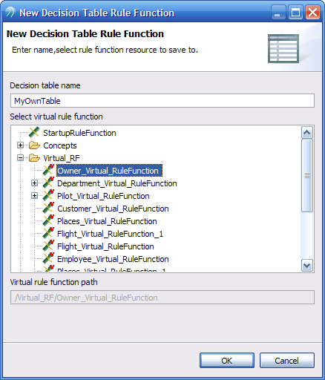
The arguments of the virtual rule function you are implementing using this new decision table will be shown in the argument explorer view. You decide on which properties you want to use to make a decision table. For example, if the arguments are two concepts called BankUser and Application, you can decide to accept the Application based on a users's age and credit score. In this case you drag and drop BankUser’s “age” and BankUser’s “creditScore” attributes from the argument explorer view to the condition area of the decision table. Then, you drag and drop the Application’s “status” attribute to the Action area. Here’s an example of a virtual rule function with 4 arguments (one event and three concepts) with all of the attributes shown:
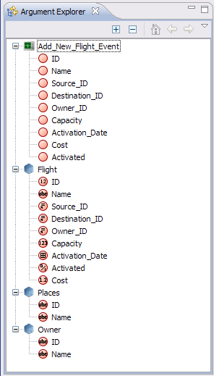
- Expand the Entities (concepts and events) to see their properties. Drag and drop those properties onto the Condition and/or Action area. You decide which properties you want to use to make your decision.
- Click on “Add” to add rows. Enter the data in the new cells.
- You click on Fit Content to resize the columns so they fit around the text.
- You click on Merged/Non-merged to separate out the rows or keep them merged. If several conditions are the same, they get merged into one cell for easier reading as it is done with pivot tables.
Venkata: get 2 screenshots of merged and non-merged view from one of us…
- You show the text alias or the graphical alias for each attribute, if one is defined. (Venkata: I think I will remove this feature in this release, check with me in a week).
- You search for certain values by entering text in the search field.
- Click on Show Text button if you want to see the full contents of the cell instead of just the values you are comparing with for the attributes you have dragged to the condition and action areas.
- You can drag and drop functions you will see collapsed by default on the right-hand side of the application. Drag and drop them to the function area (marked by the Fx icon (Venkeata, you can capture that icon here) or to the cell you are editing. For example, if you want to compare some attribute that is of type integer against the rounded value of “34.99”, you could say in one of your conditions “< Math.round(39.99)” by dragging and dropping the Math round function from the Standard Functions window and then entering the arguments of that function.
- You right-click on the condition area on the properties you dragged there to take a few actions relating to the column you have clicked on. For example, you can move the column, remove it, or change other field settings.
- If you click on the drop-down menu on the properties you dragged to either the condition or the action area, you can filter out which rows to show based on the values. For example if you want to see just the Account.AccountType where AccountType is “current” and you want to filter out all the other rows that do not have this value, select the “current” value from the drop-down list that will show you all the values you have entered so far in that column.
- If you click on the Property View, it will show you meta-data of the entire decision table. You can onlyl modify the effective date and the expiration date as described in section XXXX (VEnkata, enter name here).
When you are done creating the table, click on File > Save.

Note: If two rows end up with the same conditions after you make modifications, they will get merged into one rows. All actions will also be merged.

Column Types

There are four types of columns in decision tables. All cells in a column must be of the same type. The types are:
- non-Custom Condition
- Custom Condition
- non-Custom Action
- Custom Action
All cells that aren't Custom will apply to a single decision table argument (i.e. dragged and dropped from the argument explorer) that is associated with their column.

non-Custom Condition
There are two sub types for this cell type:
(1) Domain Model Condition: (part of a non-Custom Condition column):
You check one or more boxes in the domain model drop-down. If you edit the text of the cell, the cell is no longer considered a Domain Model Condtion and the domain model checkboxes will be unchecked the next time you click on the cell.
The access security system enforces whether you are allowed to create non-Custom functions that do not use the domain model made available to you via the drop-down menus you see when you click on a table cell.
(2) non-Domain Model Condition
You can type the following into a decision table cell of this type:
<optional operator (= is assumed if not given)> followed by <any valid BE rules language expression that can be compared with this column's argument using the operator provided>. The one divergence from BE rules language for non-Custom Conditions is that if you type an identifier (identifier is the syntax for a variable name, function name, etc) that cannot be resolved as a local variable or argument name, it will be treated as a String.
The operator itself isn't considered part of the BE rules language expression and can be one of the decision table-only operators as well as a BE operator (these are = for equality and <> for inequality).

Custom Condition
A BE rules language expression that evaluates to a boolean value.
This is one line in the Designer Rule Editor condition area without the final ';'. Thus, you can just type “Math.round(x)” More information about custom conditions is described in the next section.

non-Custom Action
A BE rules language expressions that can be assigned to this column's decision table argument. The result of the expression in this cell will always be assigned to this column's decision table argument. Assignment to other properties is not allowed in this type of cell.

Custom Action:
This is an entire Rule Editor action area in a cell. In this cell you may not make any assignments. However, if you just want to call a function that does the assignment, you may do so. Furthermore, if you want to make an assignment you have to do it explicitly. More information about custom actions is described in the next section.

Custom Conditions and Actions
As you create your decision table, if you want to add conditions not specific to any of the attributes you have dragged to the condition area, or if you want to take actions not specific to the attributes you have dragged to the action area, you can add custom conditions or actions. You click on the Custom button and choose Add Custom Condition or Add Custom Action. Then, in the column added you may enter any valid TIBCO BusinessEvents statement. The header area for each custom column is blank. An example is shown below.
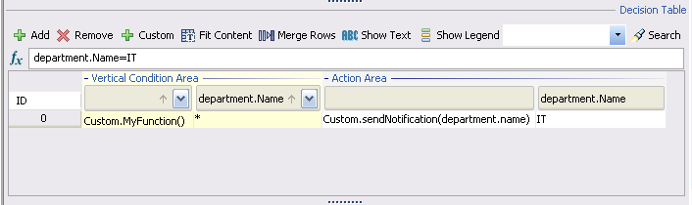

Domain Model
You may also define your own Domain Model. For example, if instead of typing text for a certain property you want to be able to choose from a list of available values, you can use the domain model to create such data. The Rule Administrator may have already created a domain model for your project. Furthermore, you may not have permissions to overwrite the domain model, in which case you will have to choose from one of the available values for that property. If you have permissions to overwrite the domain model, you may also type in the text into the decision table cell.
If you have access control permission, you define your own domain model by clicking on the property of the concept you want to define a domain model for in the argument explorer. Then, click on the Domain view. Click on Add to add a new domain model value. Click Apply to save the value. You may also add a description for that value. To remove a particular domain model value, select it, then click on Remove. When you add data to your rows, you will get a drop-down menu where you can select from “*” which means “any” or any of the values you have entered (see example screenshot below). You may select any number of the domain values. There is an implicit OR if you select multiple values.
Here is an example of what the domain looks like for a String attribute of a name for a Department concept:
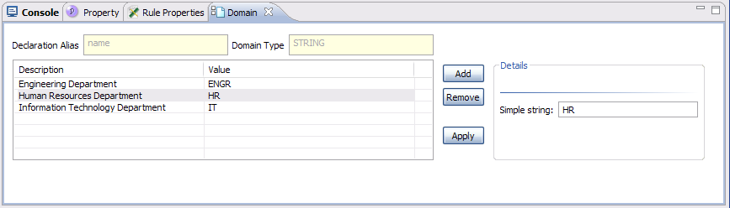
When you click on the cell, you will be able to see a list of available domain values as follows:
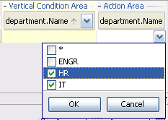
Other attribute types (such as numbers, Booleans, date/time) support different features in the domain model. For example, integers allow you to specify ranges as shown in the figure below:
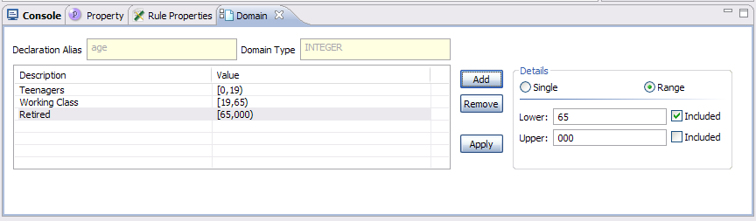

Row Priorities
The order in which rows are evaluated in a decision table is not specified. If you want to control which actions are taken first, you can set the priority of those rows to have a higher priority. Click anywhere inside that row. In the Rule Properties View, change the priority from the default value of 5 to any other value as desired. All actions with higher priorities will be executed before actions with lower priorities. 10 is the lower priority and 1 is the highest.
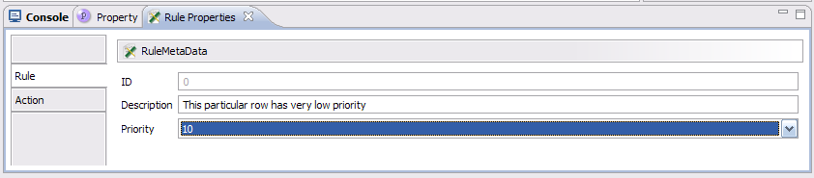

Effective Dates
To make a decision table only execute between certain rates, you can set effective and termination dates for each decision table. For example, if you have certain rules that should only take effect on a certain date, you can set the effective date and no termination date. To set the date and time, you can click on the calendar wizard available in the Property View:
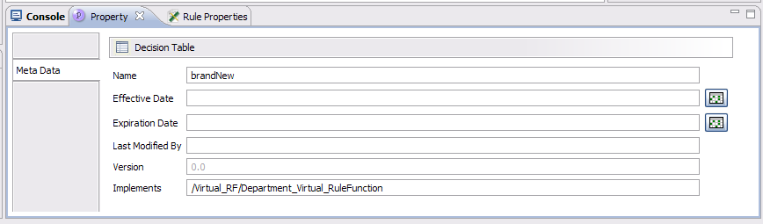
You click on the Calendar wizard to specify a date and time:
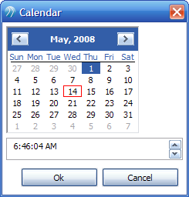
The following rules apply:
- If no effective or expiration dates are specified, the decision table is executed any time it is invoked.
- If only an effective date is specified, the decision table is executed only if the current time is on or after the effective date.
- If both effective and termination dates are specified, the decision table will only be executed if the current time is between these dates (inclusive).
- It is not valid to not have an effective date but only an expiration date. Thus if no effective date is specified, the expiration date is ignored.

Catalog Functions
For more information about how to create custom catalog functions, see ….. (Venkata, mention where it’s done). To see your own custom catalog functions, place the jar file containing your code in your classpath. Once you have done this, you will be able to see your own catalog functions in the Custom Functions view (see screenshot below).

TODO: more text here. Work with Ryan/Aditya

Importing decision tables from Microsoft Excel file
You can import data from a Microsoft Excel file to create a decision table. To do this, you take the following steps:
- Open the Decision Project.
- Click on File > Import. A browse window is displayed.
- Click Browse to select the Microsoft Excel file to import, and name your decision table.
- Select the virtual rule function you want to implement with your decision table and then click OK.
The data imported from the Microsoft Excel file is saved to the decision table and you can continue modifying the data or add new data.
Excel file template – TBD. Venkata, get the most simple example from Rohit and you can insert it here.

Exporting decision tables to Microsoft Excel file
You can export the decision table to a Microsoft Excel file. To do this, you take the following steps:

- Open the Decision Project.
- Click on File > Export.
- Click Browse.
- Select the name and path to save the file as an Excel file, and then click OK.

Opening Decision Table

You can open an existing decision table if one was checked out from the server, or if you had created it previously.
  - Open the decision project.
  - In the project explorer view find a virtual rule function. Under that, you will see a list of implementations (decision tables). Double-click on one and the DT editor will come up. The Argument Explorer will get populated as well.

Saving Decision Table
You save the decision table by clicking on File > Save. To save all the decision tables you have opened in the Decision Manager, click on File > Save All.

Validating Decision Table
Before testing your decision table or committing decision project to the RMS, you should validate your decision table. Click on Table > Validate. If there are any access control violations or syntax errors in your tables, they will be shown in the Problem View tab at the bottom of the application. Take all the corrective actions and then revalidate your table until all errors are resolved.

Language Considerations
NullPointerExceptions are silently ignored when a condition throws such an exception because you passed a null String to a function that doesn't check for null, or because you accessed a property of a null contained concept (parent.child.property and child is null).
If a condition table cell is empty, it is skipped and thus considered to be evaluated as true.

Language Considerations
While you work on your decision project, you may create multiple virtual rule function implementations by creating multiple decision tables. However, before committing your decision project to the RMS, you should only commit one decision table per virtual rule function. During testing you can have multiple tables so you can decide which ones to deploy to the engine and test. However, if you commit all implementations, only the last one will take effect if all of them are deployed.

Testing Decision Table
After creating and modifying a decision table you can test it.
To test a decision table:

- Open the Decision Project.
- From the main menu, go to Project > Test. An empty editor window is displayed.
- From the Project Explorer, click on any entity (concept or an event). The editor window displays all the instances of that entity type.
- Click Add Data to create your own instances of concepts or events.
- Enter all the attributes. Make sure you enter valid data. For example, if a certain attribute is of type Integer, enter a number and not a String. Click Save. This will save all the test data to the Decision Project, which can be used next time you open the Decision Project.
- If you have a comma delimited file, you could also Import this test data. Click on the Import button and select the comma-delimited file to import.
- Once you create your own test data, you can export this data as well so you can share it with others. It will export the test data to a comma-delimited set of files. You can do this with each concept or event test data.
- When done creating your own test data instances of concepts and events, you can start deploying your tables to a BE engine that will run inside the Decision Manager application. You can either deploy all the tables in your decision project, or just the table you have opened.
- To test just the table you have open, click on Table > Deploy.
- To test all the tables in your project, click on Project > Deploy Tables.
- At this point a BE engine will be started inside the Decision Manager application.
- Now you add the instance test objects you have created in the previous steps by clicking on Start Test in your Test Data viewer. This will load all of these objects to the engine so that the rules that are part of your project will get executed.
- You will be able to see results of your decision tables being invoked by looking at the bottom section of the Test Data viewer in the Test Result section. See sample screenshot below. Venkata, insert screenshot below.
- You see any output statements from the engine in the Console View. For example, statements such as “System.debugOut(“Executed Rule”)” will be shown in this view.

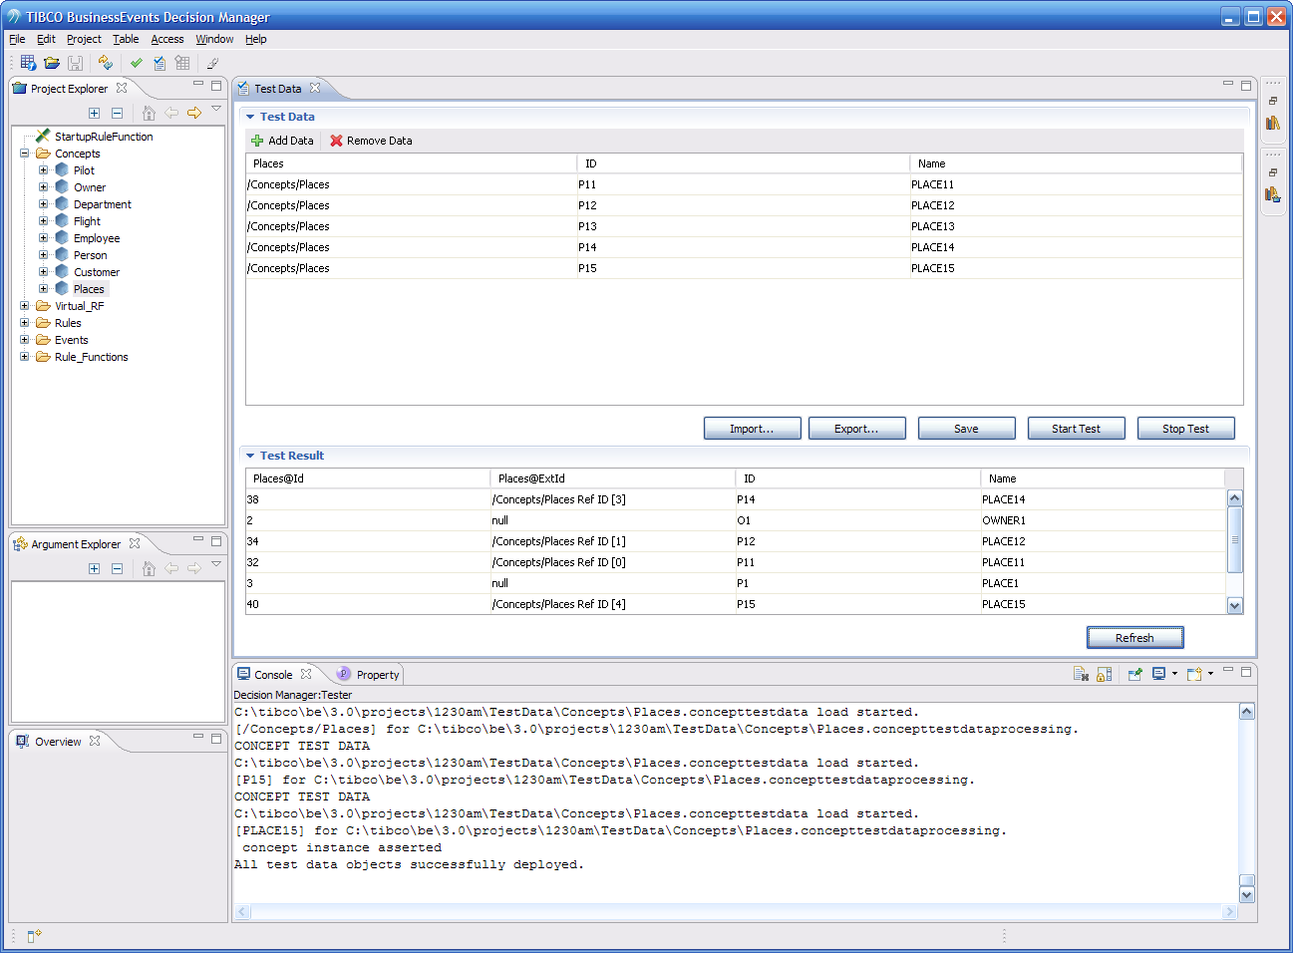

- You click on the Refresh button to ensure you have the most up to date results, in case your rules have timer events.
- You click on Stop Test button to stop the engine from running.
- If you want make more changes to your decision table, you open the decision table or switch to its editor and make the changes. Then, you can repeat all the test steps described above.
Once testing is done, you are ready to commit it to the RMS. See the RMS chapter on how to interact with the server.

Decision Project Information
You can get more information about your project.
Click on a concept in your Project Explorer. In the Property tab, you will see “Configuration” tab that will show you info about that Concept for example. In the “Property” tab you will see all the properties as defined in the TIBCO Designer project.
Window → Preferences has a few preferences you can set.
Window → Show View allows you to reopen some of the Windows if you closed them.
Window → Navigation allows you to native through various windows.

Application Preferences
You can change several aspects of the application by clicking on Window > Preferences menu option. See figure below. Similarly, you can change the appearance of the decision table by clicking on the Appearance tree option of the Preference dialog.
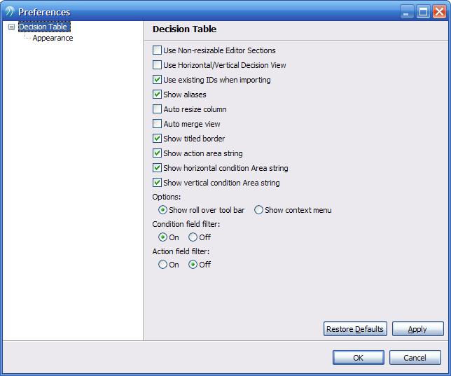

Committing Decision Tables to RMS

TBD

Interacting with RMS

What a business user can do
( This is TBD)

- From the decision table editor, click Add to add rows or rules.
- Click on Fit Content to resize the columns, so the text fits in the columns properly.
- Click on Merged/Non-merged to merge the rows or separate out the rows. If the conditions are similer, they get merged into one cell for easier reading.
- You can show the text alias for each attribute, if it is defined.
- You can drag and drop functions you will see collapsed by default on the right-hand side. DnD them to the Fx area or to your cell. So for example you could say in one of your conditions "< Math.round(34.40)" by DnD'ing the round function from the Standard Functions window.
- Right-click on the condition area on the properties dragged from the Argument Explorer, you will see a few more options of things you can do.
- If you click on the drop-down menu on the properties you dragged to either the condition or action area, you will see you can filter out which rows to show based on the values. So for example if you want to see just the Account.AccountType where AccountType is "current" just select that. It will show you all the values you have entered so far. It's just a way of filtering the views.
- You can define Domain Model. For example, instead of typing text for the gender each time, you can define male and female as domain values.
- Click on the gender property.
- Go to the Domain tab and add two values (male and female)
- Click Apply. When you go to add data to your rows, you will get a drop-down menu where you can select from "*" or "male" or "female" (or any combination of them). For integers you can specify ranges, and for dates a Calendar wizard will pop up.
- If you click on the Property tab, it will display the meta-data of the entire Decision Table. The only thing you can modify is the effective date and the expiration date. The idea is that you could deploy this table into production, but it will only be executed between those dates. The dates are optional.
- Window Preferences has a few preferences you can set.
- Window Show View allows you to reopen some of the Windows if you close them.
- Window Navigation allows you to native through various windows in different ways.

What an Administrator can do
Administrator
Administrator is the name of a user role which has control over other user roles. When an administrator logs onto the Decision Manager component, the following menu options are enabled including the above list of menu option:
- All Access menu items
As an administrator
- You can check your worklist to approve or reject the requests received from other users
- From Access menu you can create or modify the access control list using the XML editor
- You can commit the Decision Project
- Deploy it onto the server.

