ECore Model

This is how Decision Table Ecore model looks like when you open it with the Ecore Model Editor ,

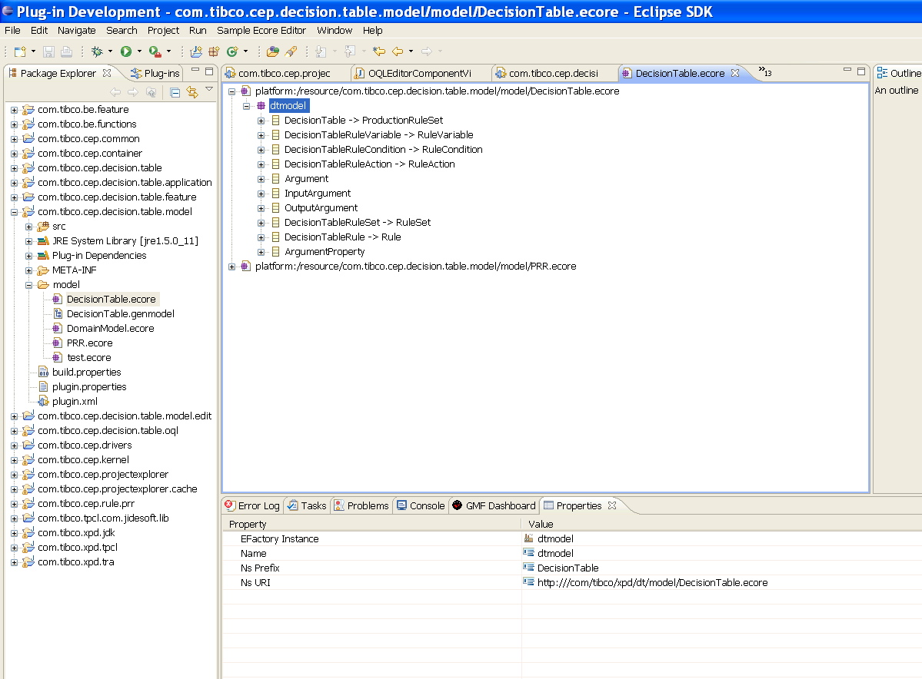

Screen :1.1

You can select any element and see it’s properties in the property view .
If you select dtmodel you can see it’s properties in the property view.

Ecore Classes needed to represent any Model :

- EClass : is used to represent a modeled class .It has a name ,zero or more attributesand zero or more references .
- EAttribute : is used to represent a modeled attribute.Attributes have a name and type .
- EReference : is used to represent one end of an association between classes. It has a name , a Boolean flag to indicate if it represents containment ,and a reference(target) type,which is another class.
- EDataType : is used to represent the type of an attribute like int or float or an object type like java.util.Date

Lets take an example ,I am going to create a simple ecore model corresponding to following UML class diagram .

Figure 2.1. UML diagram of interfaces.
PurchaseOrder

shipTo :String
billTo : String
Item

productName :String
quantity : int
price : float
PurchaseOrder can contain 0..* items.
Ecore Model corresponding to above UML model ,

PurchaseOrder will map to corresponding EClass . Similarly Item ---

Attributes shipTo,billTo ,productName,quantity and price will map to EAttribute .

PurchaseOrder contains Item so Item will map to EReference .

Lets create Ecore Model corresponding to the UML model above using sample Ecore editor ,

Create file test.ecore and open it ,

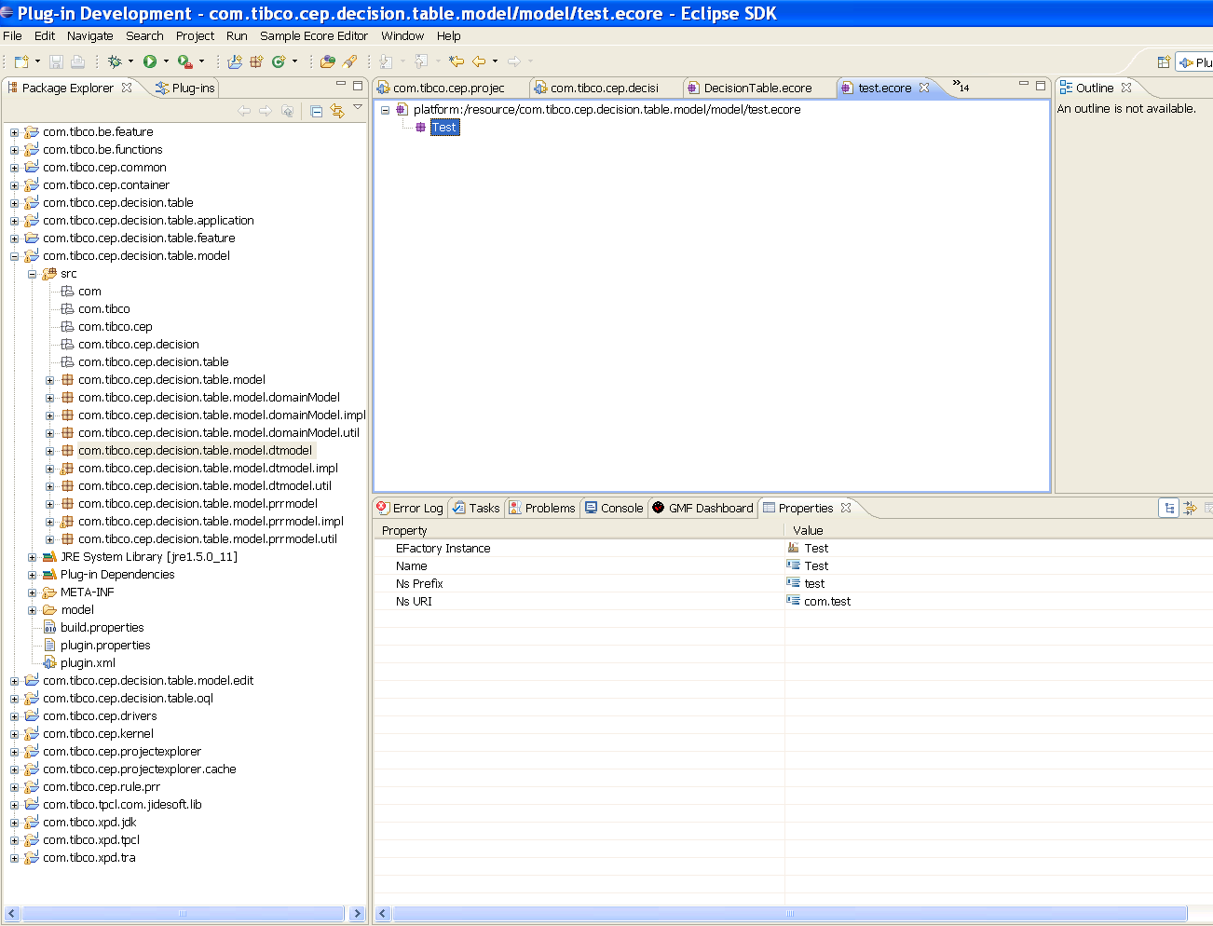
Screen :1.2

After selecting test, you will find following options ,
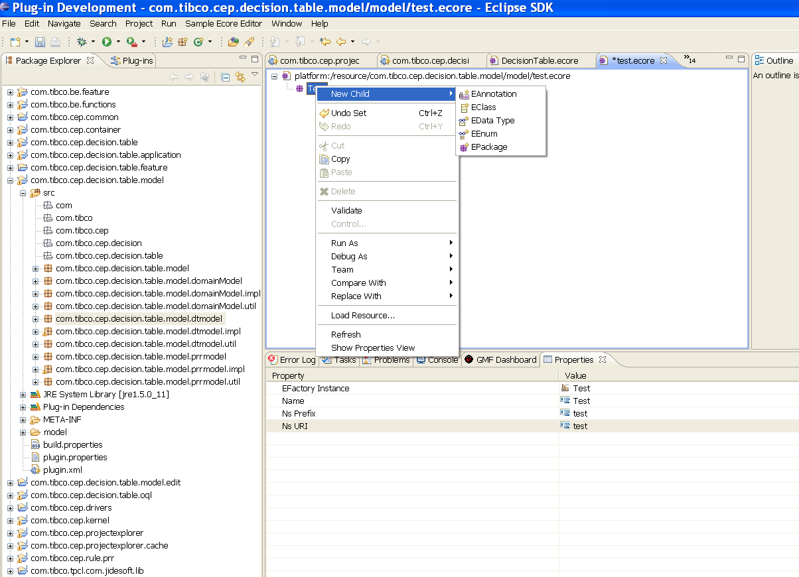
Screen :1.3

Select option EClass and modify the properties in the property view ,

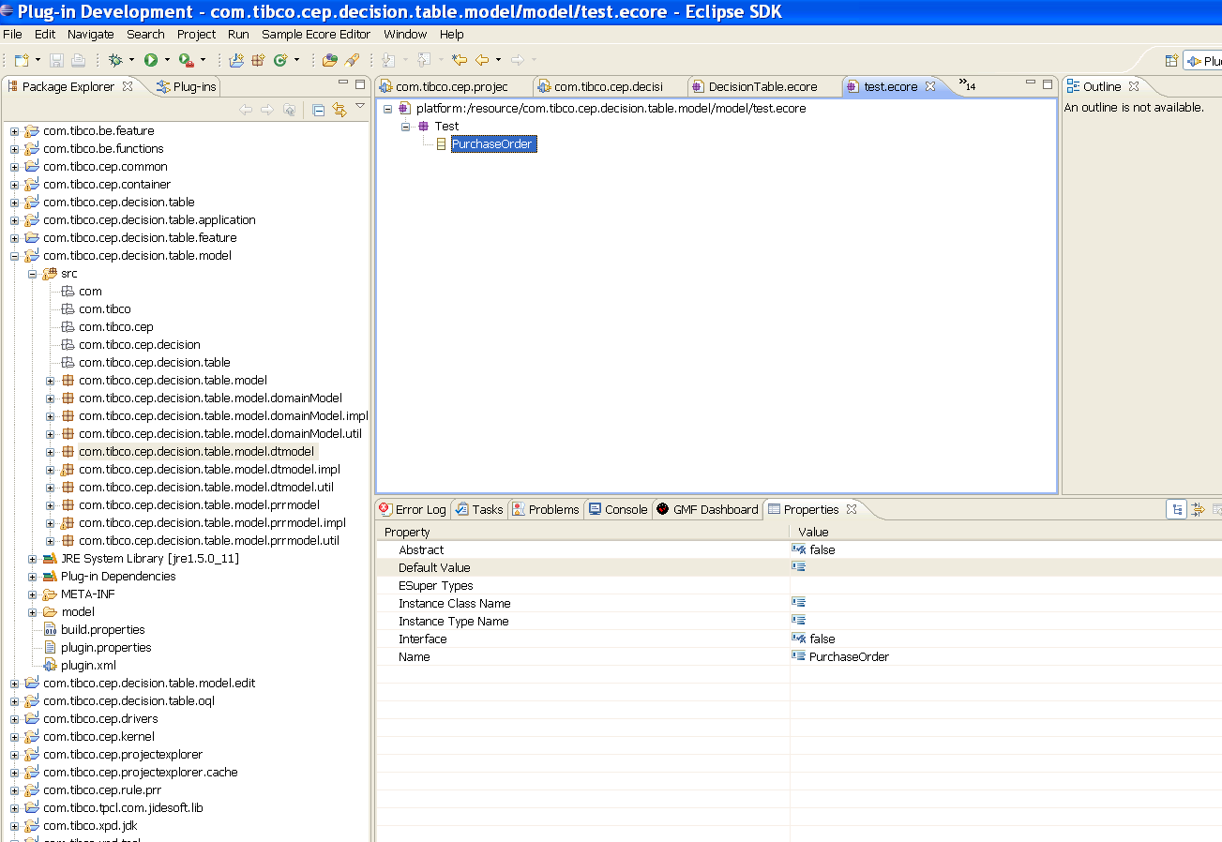

Screen :1.4

Similary create Item EClass ,

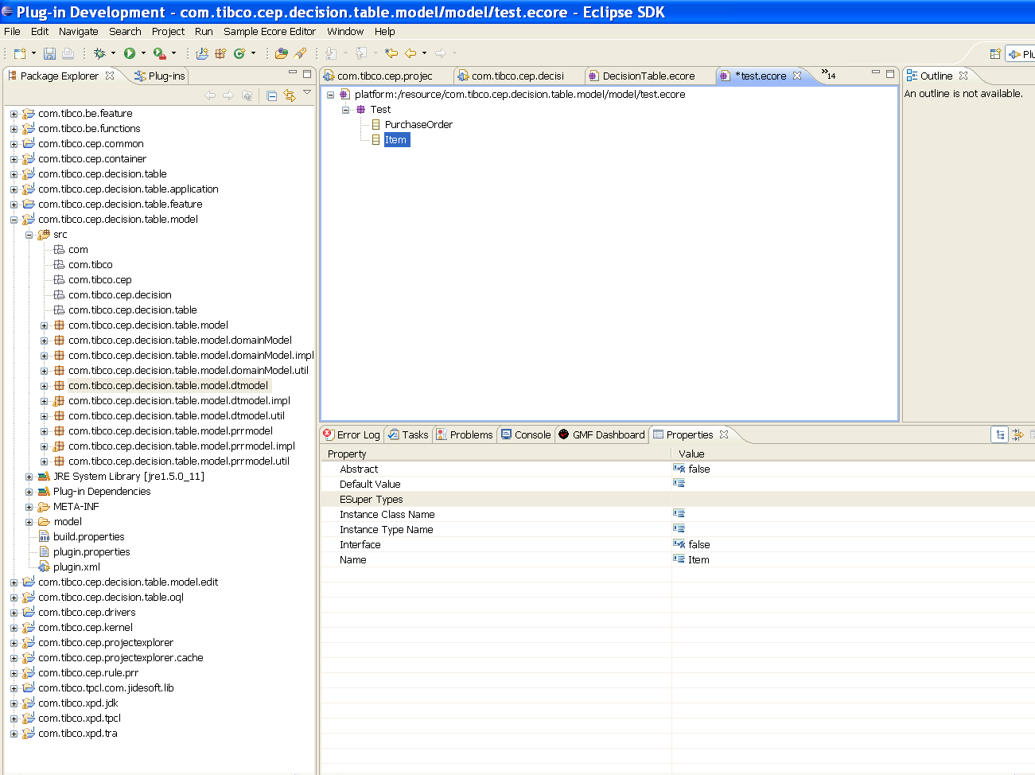

Screen :1.5

PurchaseOrder has Item as EReference ,
So select PurchaseOrder and choose New Child → EReference

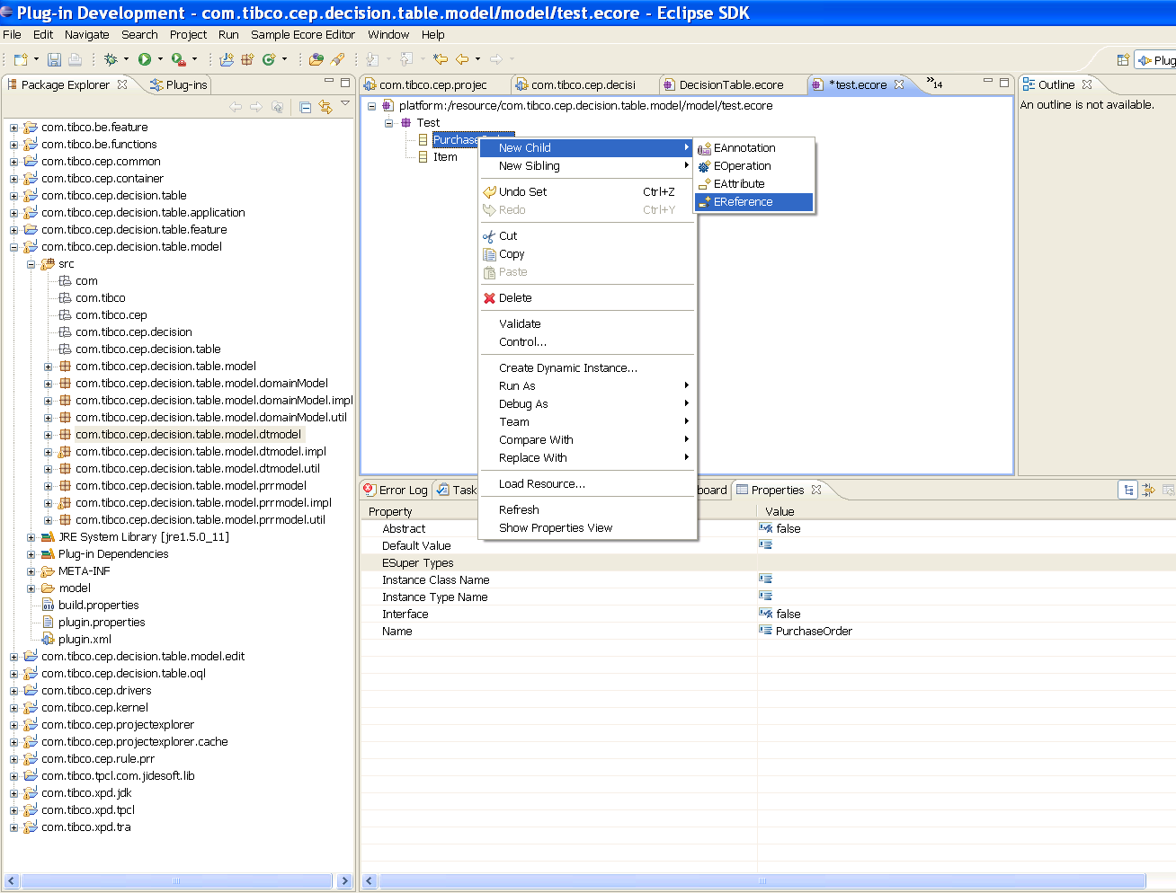

Screen :1.6

You will see the following properties in the property view ,
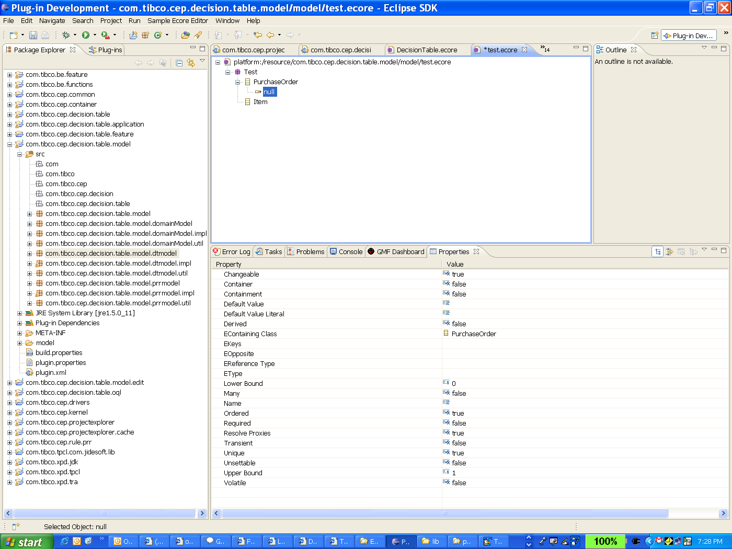
Screen : 1.7

Modify the following fields ,
Name →item
EType → Item (selectable from menu)
EReferenceType → automatically populated with EType
Containment → true in our example

Property view will look as below,

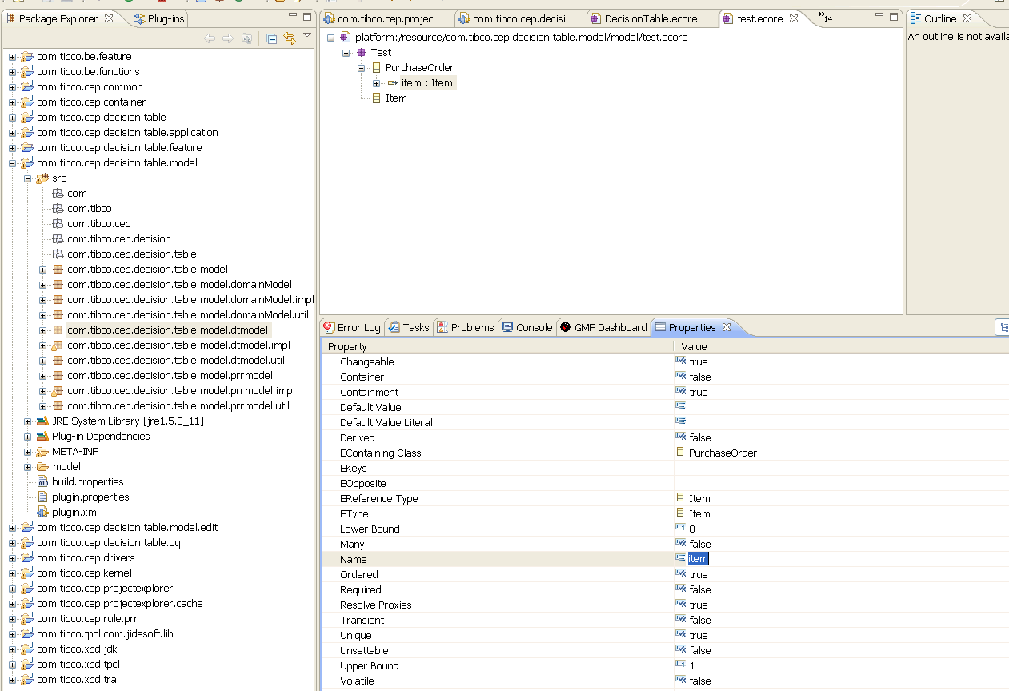

Screen : 1.8
Now create Attribute,

Select PurchaseOrder ,and choose the option New Child → EAttribute

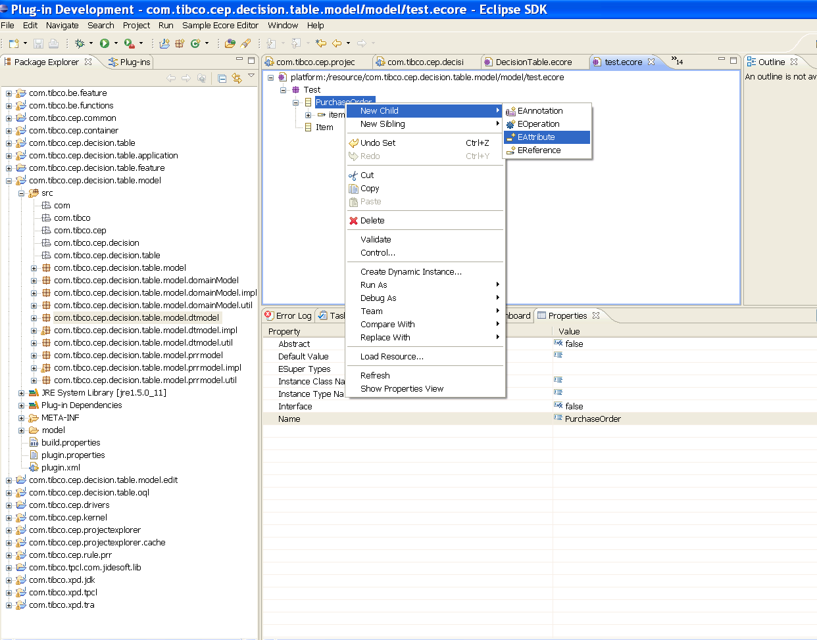

You can see the property view as below ,

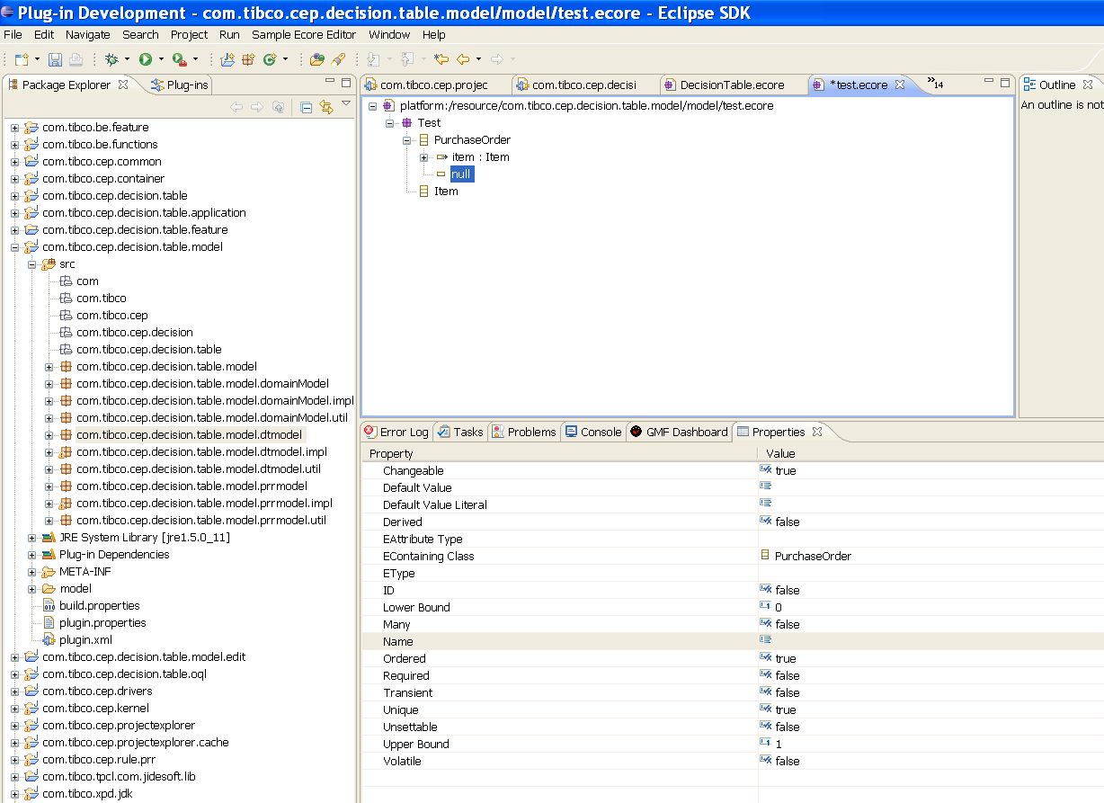

Most of the properties are understood by their name .
Set the following properties ,
Name → shipTo
EType → EString (selectable)

After setting these properties, property view will look like as below,

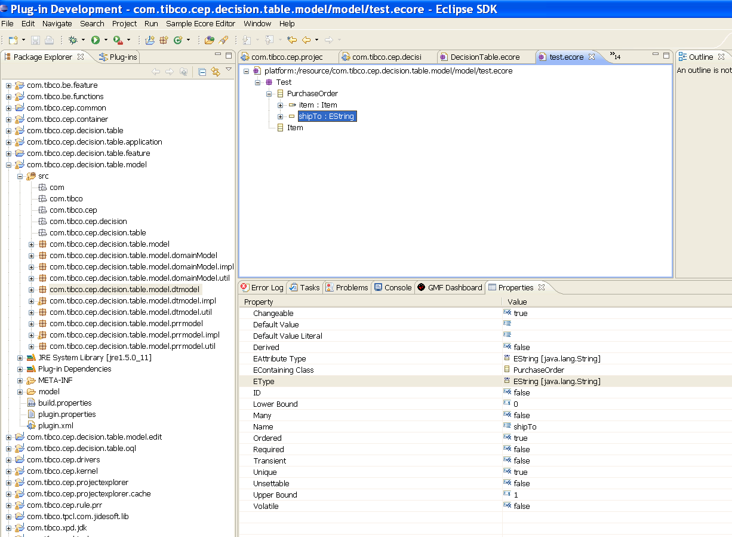

Similarly create other attributes ,the final ecore file will look some thing like this,

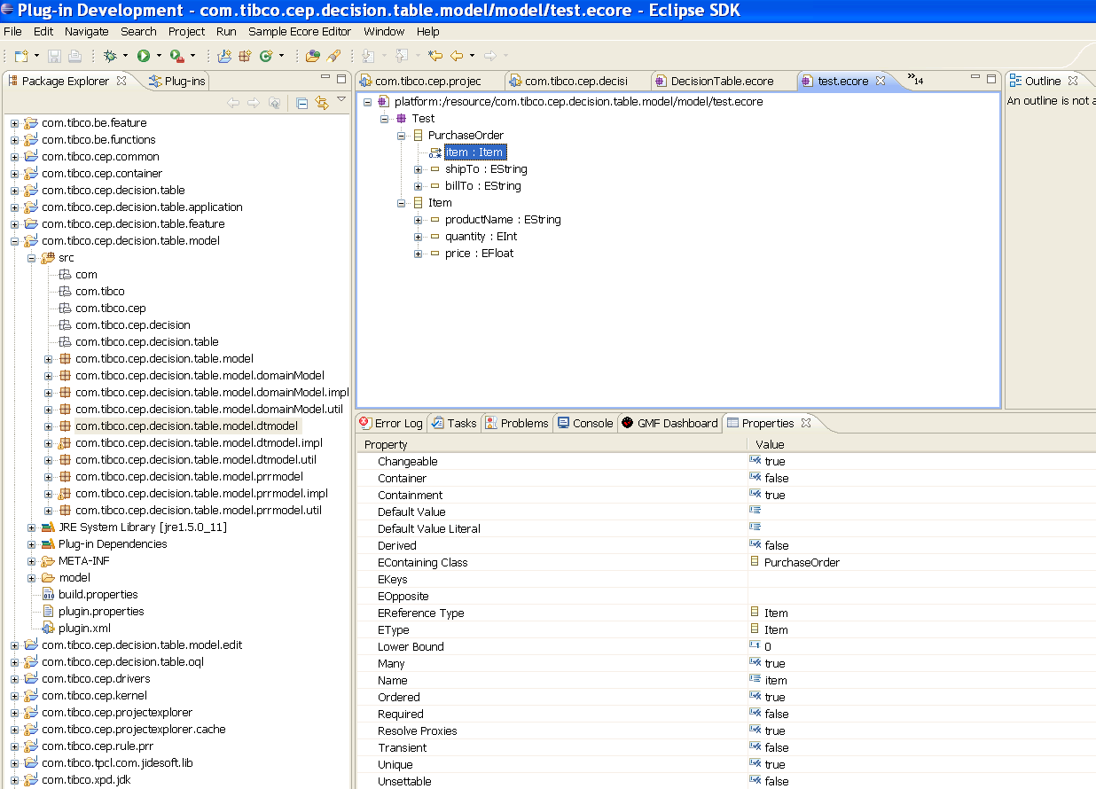

EMF uses XMI serialization to persist the model . So Serialized as XMI our PurchaseOrder model looks something like this :

<?xml version="1.0" encoding="UTF-8"?>
<ecore:EPackage xmi:version="2.0"
xmlns:xmi="http://www.omg.org/XMI" xmlns:xsi="http://www.w3.org/2001/XMLSchema-instance"
xmlns:ecore="http://www.eclipse.org/emf/2002/Ecore" name="Test"
nsURI="test" nsPrefix="test">
<eClassifiers xsi:type="ecore:EClass" name="PurchaseOrder">
<eStructuralFeatures xsi:type="ecore:EReference" name="item" upperBound="-1" eType="#//Item"
containment="true"/>
<eStructuralFeatures xsi:type="ecore:EAttribute" name="shipTo" eType="ecore:EDataType http://www.eclipse.org/emf/2002/Ecore#//EString"/>
<eStructuralFeatures xsi:type="ecore:EAttribute" name="billTo" eType="ecore:EDataType http://www.eclipse.org/emf/2002/Ecore#//EString"/>
</eClassifiers>
<eClassifiers xsi:type="ecore:EClass" name="Item">
<eStructuralFeatures xsi:type="ecore:EAttribute" name="productName" eType="ecore:EDataType http://www.eclipse.org/emf/2002/Ecore#//EString"/>
<eStructuralFeatures xsi:type="ecore:EAttribute" name="quantity" eType="ecore:EDataType http://www.eclipse.org/emf/2002/Ecore#//EInt"/>
<eStructuralFeatures xsi:type="ecore:EAttribute" name="price" eType="ecore:EDataType http://www.eclipse.org/emf/2002/Ecore#//EFloat"/>
</eClassifiers>
</ecore:EPackage>

How to generate Java classes out of this model ??

You cannot generate java classes directly for ecore model ,you need to generate gen model for some more customization and then you can generate java classes .

To generate gen model out of ecore model ,

Left click on the project explorer view and select ,
New → Other → Eclipse Modeling Framework → EMF Model

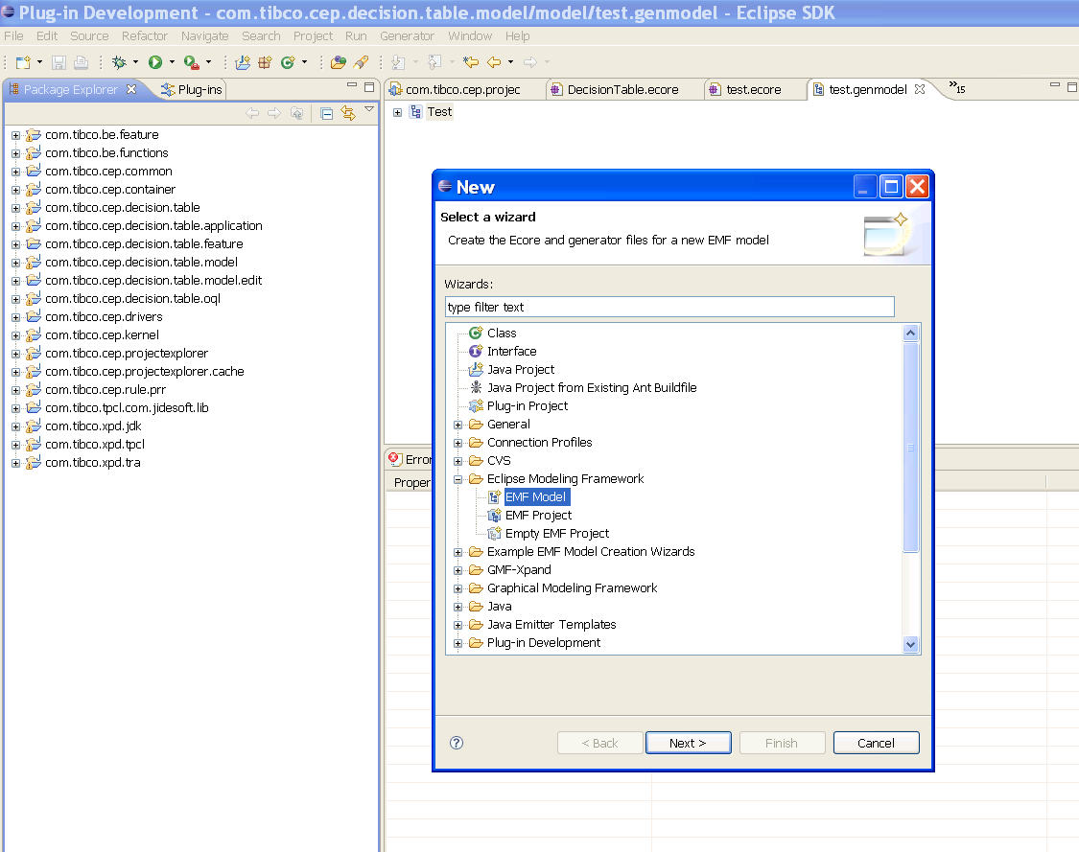

Press Next,

Select the parent folder where you want to store the gen model and give name to the gen model as test.genmodel .
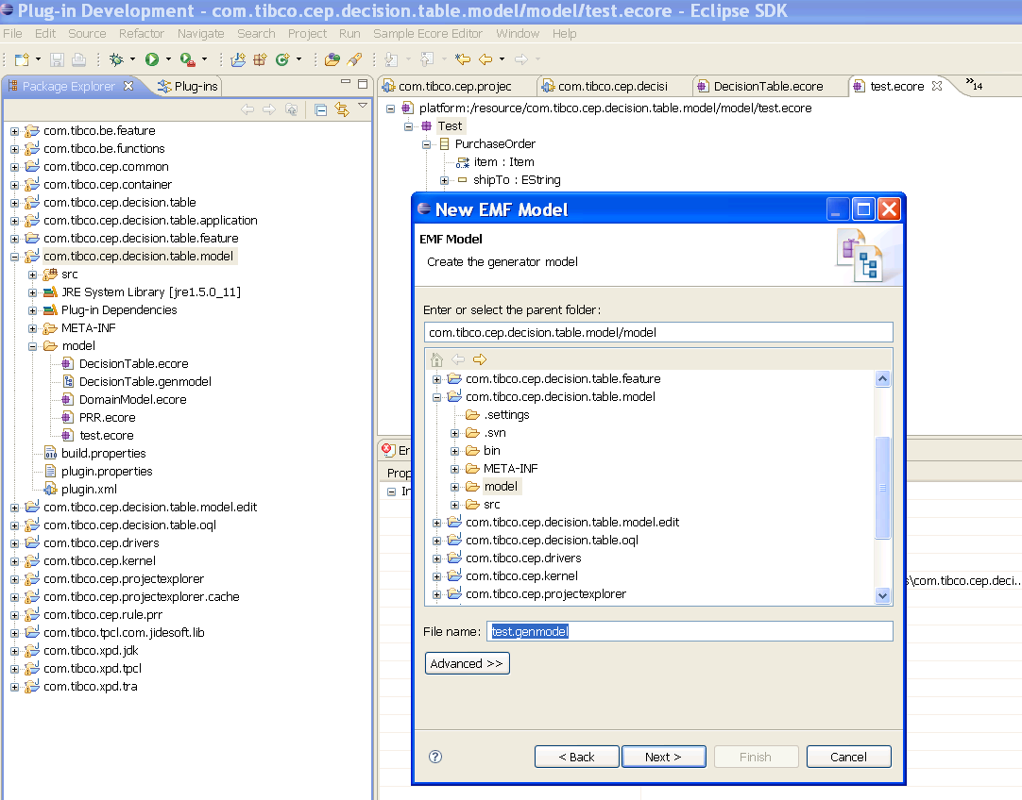

Press Next,
It will ask you the model importer (from which model you want to create gen model) in the next screen .In our case it’s ecore model . Select Ecore Model .

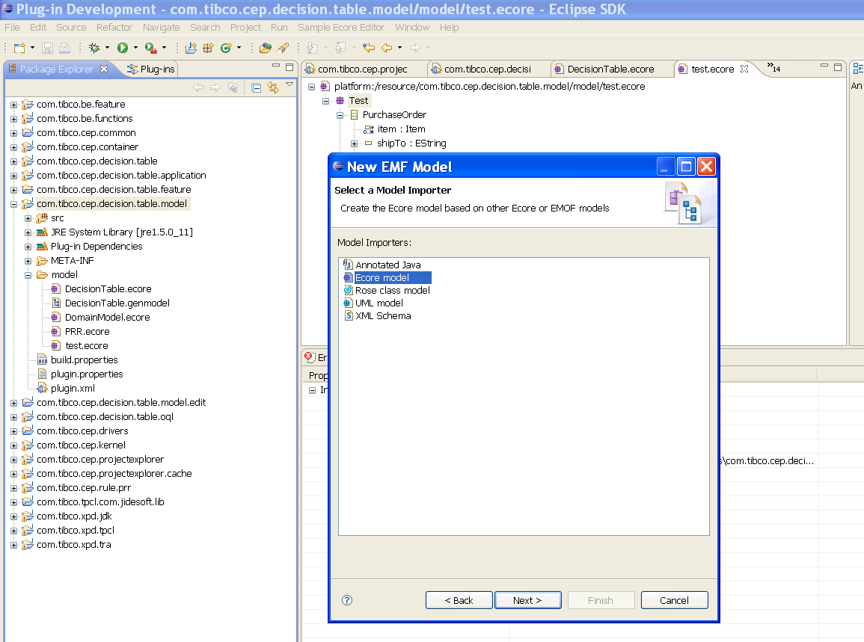

Press Next , You will see the below screen ,browse the workspace and provide test.ecore file.

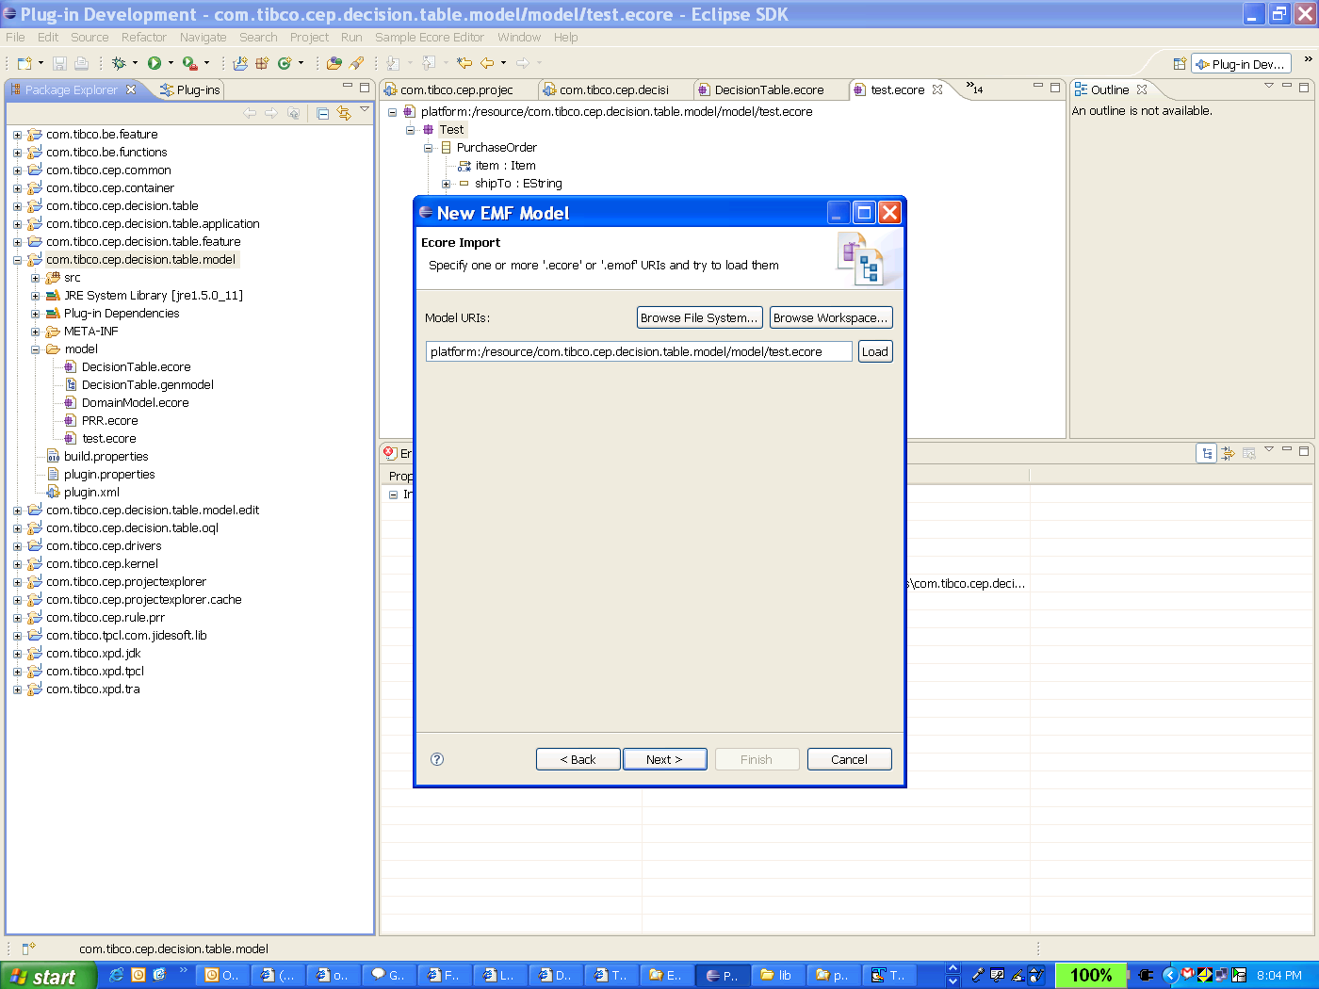

Press Next ,

You can see the package Test in the below screen .
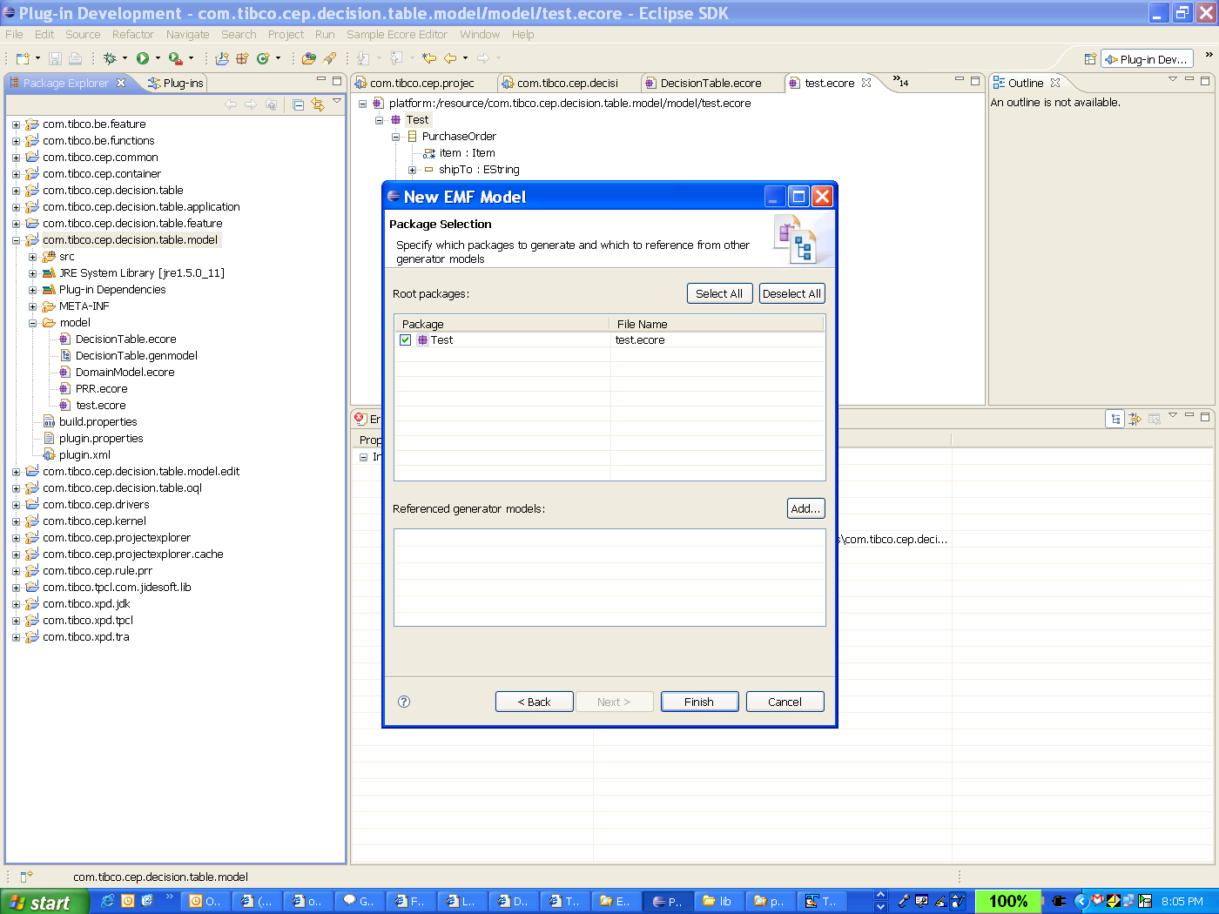

Now press finish ,and you can see the test.genmodel some thing like this .

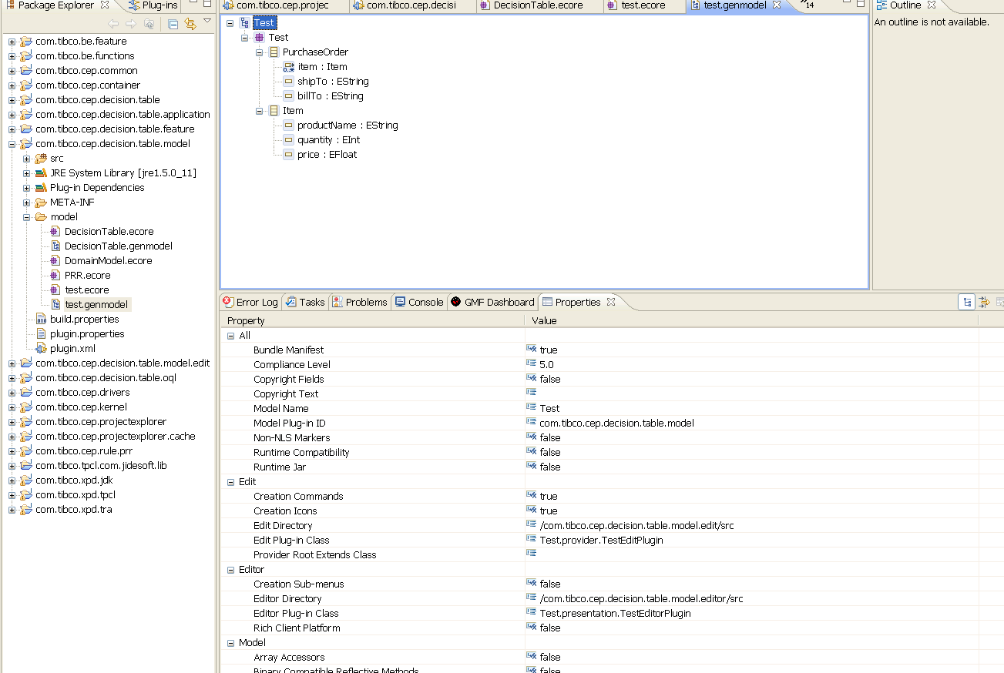

Once you have generated genmodel ,you don’t need to generate it again and again after modifying ecore model .It automatically gets synchronized with ecore model.

How to generate java code from the genmodel ????

Select gen model root and select the options according to the need ,
1) Generate model code → if u want to generate only model code
2) Generate Edit Code → if you want to generate edit code.
And other options –
But we will work with above two java codes .

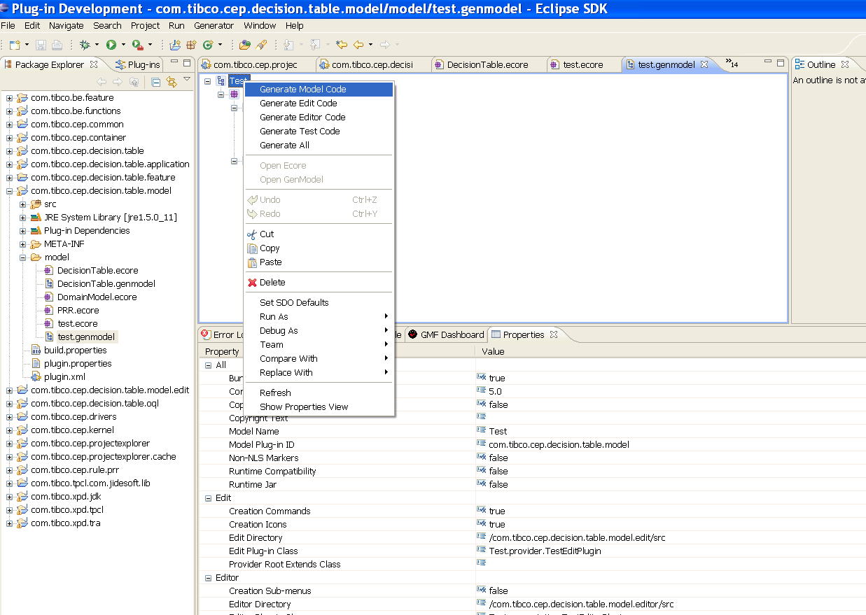

You can modify the package of java codes generated using gen model as below,
Modify the base package name as you want .
Now all the interfaces will be generated inside com.tibco.cep.decisionTable.model.Test package and all implementation classes will be generated under com.tibco.cep.decisionTable.model.Test.impl

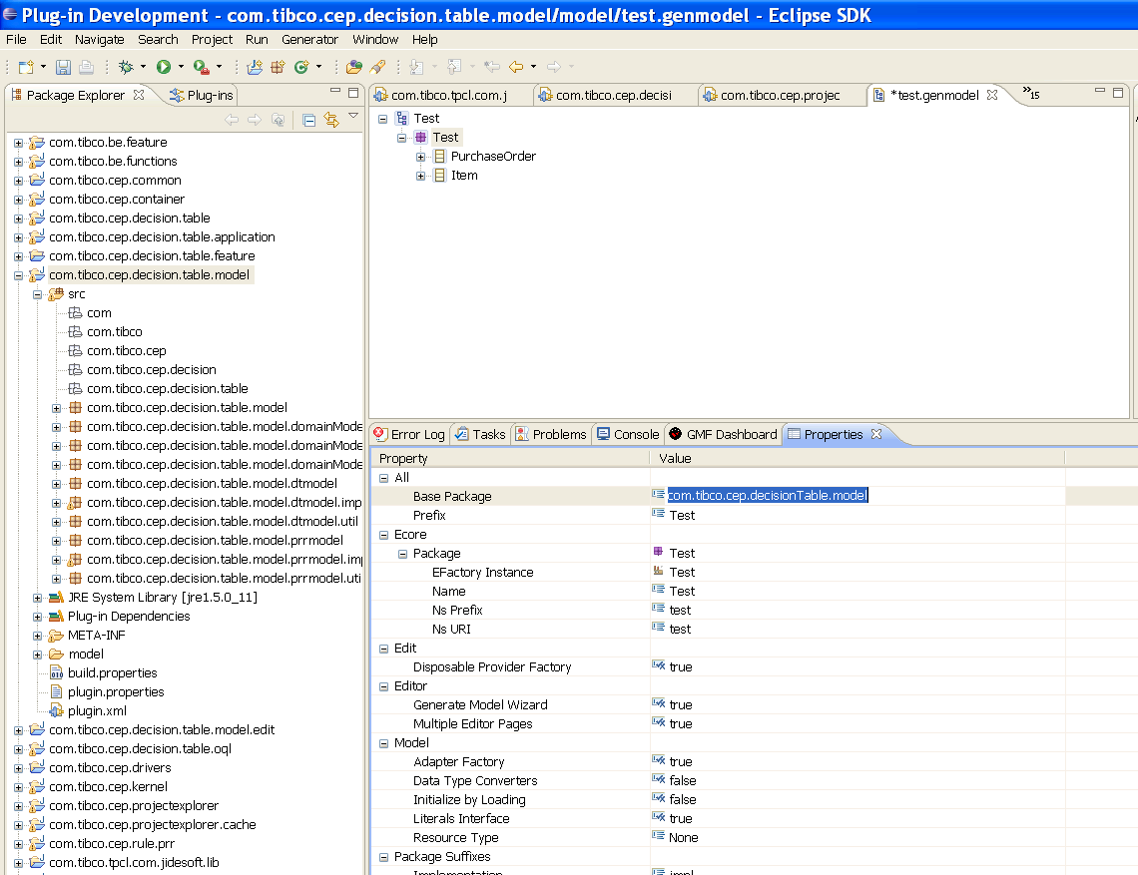

following interfaces and implementation classes are generated when you select generate Model Code ,

src\
com.tibco.cep.decisionTable.model.Test\ (interfaces)
Item.java
PurchaseOrder.java
TestFactory.java
TestPackage.java
com.tibco.cep.decisionTable.model.Test.impl\ (implementation classes)
ItemImpl.java
PurchaseOrderImpl.java
TestFactoryImpl.java
TestPackageImpl.java

com.tibco.cep.decisionTable.model.Test.util\(utility classes)
TestAdapterFactory.java
TestSwitch.java

An Ecore class (that is an ,Eclass ) actually correspondes to two things in java: an interface and a corresponding implementation in java. For example,the EClass for PurchaseOrder maps to a java interface ,

Public interface PurchaseOrder ……..

And corresponding implementation class ,

Public class PurchaseOrderImpl extends …… implements PurchaseOrder{

The next thing to notice is that each interface extends directly or indirectly base interface EObject like this ,

Public interface PurchaseOrder extends EObject {

EObject is emf equivalent of java.lang.Object ,that is it’s the base of all modeled objects.

Extending from EObject introduces three main behaviour,
- eClass() : returns the object’s meta object (an EClass)
- eContainer() and eResource() : return the object’s containing object and resource.
- eGet() ,eSet().eIsSet() and eUnSet() provides an API for accessing the objects reflectively.
The first and third items are interesting when you want to access objects generically instead of or addition to using the type safe generated accessors.

One more important thing is there to notice ; EObject extends from yet another interface ,
Public interface EObject extends Notifier {

It introduces a important characteristic to each modeled object ;model change notficatioin as in the Observer Design pattern .Like object persistence ,notification is an important feature of an EMF object.

Lets look at some of the method generated ,
For example ,the get() method generated for the shipTo attribute simply returns an instance variable like this ,
Public String getShipTo(){
return shipTo;
}

The corresponding set() method sets the same variable ,but it also sends a notification to any observers that may be interested in the same change ,

Public void setShipTo(String newShipTo){
String oldShipTo = shipTo;
shipTo = newShipTo;

if (eNotificationRequired){

eNotify(new ENotificationImpl(this,Notification.SET, TestPackage.PURCHASE_ORDER_SHIP_TO,oldShipTo,shipTo));
}

Two other important classes generated for a model; a factory and a package. The generated factory (for example,TestFactory) includes a create method for each class in the model. The EMF programming model strongly encourages ,but doesn’t require ,the use of factories for creating objects.Instead od simply using the new operator to create a PurchaseOrder ,you should do this ,

PurchaseOrder aPurchaseOrder = TestFactory.eINSTANCE.createPurchaseOrder();

The generated package( for example ,TestPackage ) provides convenient accessor for all the ecore metadata for the model. You already have noticed the use of TestPackage.PURCHASE_ORDER_SHIP_TO ,a static int constant representing the shipTo attribute.
The generated package also includes the convenient accessors for the EClasses,EAttributes and EReferences.

In additioin to the interfaces and classes described in the previous section ,the emf generator can optionally generate the following ,
- A skeleton AdaptorFactory class (for example, TestAdaptorFactory ) for the model .The convenient base class can be used to implement adapter factories that needs to create type-specific adapters .for example ,PurchaseOrderAdapter for PurchaseOrders and ItemAdapter for Items, and so on.
- A convenient switch class (for example,TestSwitch)that implements a “switch statement” like call back mechanism for dispatching based on an objects type(that is, its EClass) .The adaptor factory class ,as just described ,uses this switch class in its implementation .
- A plug-in manifest file so that model can be used as an eclipse plug-in .

Notification and Adapters :

Every generated EMF class is also a Notifier,that is it can send notification whenever an attribute or reference is changed. It is an important property which helps in updating viewsor any other dependent object.

Notification observers(or listeners) in EMF are called adapters because in addition to their observer status ,they are often used to extend the behaviour (that is support additional interfaces without subclassing)of the object they are attached to .
Adapter(observer) can be attached to any EObject like this ,

Adapter testObserver = -------
aPurchaseOrder.eAdapter().add(testObserver) ;

After doing this notifyChanged() method is called ,on testObserver whenever a state change occurs in the PurchaseOrder.(for example ,if setBillTo() methid is called).

setBillTo() adapter.notifyChanged()
----------------→PurchaseOrder-------------------------------------→ Adapter

An adapter factory is used to adapt an object with a an extension of the required type ,something like this ,

PurchaseOrder aPurchaseOrder = -------------
AdapterFactory someTestAdapterFactory = -------
Object testExtensionType = ------
If (someTestAdapterFactory.isFactoryForType(testExtensionType)){

Adapter testAdapter = someTestAdapterFactory.adapt (aPurchaseOrder ,
testExtensionType)

often the testExtensionType represents some interface supported by the adapter .
for example ,the argument could be the actual java.lang.Class for an interface of the chosen adapter .the returned adapter then can be downcast to the required interface ,like this ,

TestAdapter testAdapter = (TestAdapter) someTestAdapterFactory.adapt (someObject ,
TestAdapter.class)

If the adapter of the requested type is already attached to the object then adpt() will return the existing adapter otherwise create a new one.
In EMF adapter factory is responsible for creating adapters ,EObject has no notion of being able to adapt itself .
An adapter must be attached to each individual EObject that it wants to observe.

Sometimes you may be interested in being informed of state changes to any object in a containment hierarchy ,a resource ,or even any of set of related resources .Rather than requiring you to walk through the hierarchy and attach your observer to each object ,the EMF framework provides a very convenient adapter class ,EContentAdapter ,which can be attached to the root of a object , a resource or even a resource set ,and automatically it will attach itself to all the contents.

Object Persistence :

ECore models are serialized using XMI .EMF includes a default XMI serializer that can be used to persist object generically from any model not just Ecore. The EMF framework combined with the code generated for your model ,handles all this for you.
Above and default serialization support EMF allows you to save your object in any persistent form you like .In this case you need to write the actual serialization code by yourself.

There are two methods related to persistence : eContainer() and eResource() .Lets understand how they work with the following example ,

PurchaseOrder aPurchaseOrder = TestFactory.eINSTANCE.createPurchaseOrder();
aPurchaseOrder.setBillto( “123 Maple Street “);
Item aItem = TestFactory.eINSTANCE.createItem();
aItem.setProductName (“Apples”);
aItem.setQuantity (12) ;
aItem.setPrice (0.50) ;
aPurchaseOrder.getItems.add ( aItem );

here item object is added as a containment reference .so in our example if we call
aItem.eContainer() ,it would return the PurchaseOrder .Calling eResource() on either of the objects will return null at this point .
Now ,to persist these two objects we need to put them inside a resource.
Interface Resource is used to represent a physical storage location (for example,a file ).
To persist our object we need to add our root object to a resource like this ,

Resource testResource = ------------
testResourec.getContents().add (aPurchaseOrder);

after adding the purchase order to the resource ,calling eResource() on either object will return testResource .Now the question is how to get the Resource ,
For that we need to look at another important interface in EMF ,ResourceSet.
A ResourceSet, as its name implies ,is a set of resources that are accesed together ,inorder to allow for potential cross document references among them .it’s also the factory for its resources. So to complete our example we will create the resource and add it to the PurchaseOrder and save it ,something like this ,

ResourceSet resoirceSet = new ResourceSetImpl();
URI fileURI = URI.createFileURI(new File(“myTest.xml”).getAbsolutePath());
Resource testResource = resourceSet.createResource(fileURI);
testResource.getContents().add(aPurchaseOrder);
testResource.save(null);

after saving our resource ,we would get an XMI file myTest.xml something like this ,

<simpletest:PurchaseOrder xmi:version="2.0"
xmlns:xmi="http://www.omg.org/XMI"
xmlns:simplepo="http:///simplepo.ecore"
billTo="123 Maple Street">
<items productName="Apples" quantity="12" price="0.5"/>
</simpletest:PurchaseOrder>

Let’s look at how to load it again using resource set ,

ResourceSet resourceSet = new ResourceSetImpl();
URI fileURI = URI.createFileURI(new File(“myTest.xml”).getAbsolutePath());
Resource testResource = resourceSet.getResource(fileURI ,true);
PurchaseOrder aPurchaseOreder = (PurchaseOrder)testResource.getContents().get(0);

Because resource has single PurchaseOrder at its root ,we simply get the first element and downcast .

The Reflective EObject API :

Every generated model class implements the EMF base interface EObject .
EObject defines generic ,reflective API for manipulating instances ,

public interface EObject
{
Object eGet(EStructuralFeature feature);
void eSet(EStructuralFeature feature, Object newValue);

boolean eIsSet(EStructuralFeature feature);
void eUnset(EStructuralFeature feature);

...
}

We can use this reflective API ,instead of generated methods ,to read and write the model .
For example ,we can set the shipTo attribute of the purchase order like this ,
aPurchaseOrder.eset (shipToAttribute ,”123 Mapple Street”);

We can read it back like this ,

String shipTo = (String) aPurchaseOrder.eGet(shipToAttribute);

We can also create a purchase order reflectively ,by calling a generic create() method on the factory like this ,

EObject aPurchaseOrder = testFactory.create(purchaseOrderClass);

Now the question is how to get thes meta objects ??

You can get those using generated static accessors like this ,
TestPackage testPackage = TestPackage.eINSTANCE;
TestFactory testFactory = TestFactory.eINSTANCE;
EClass purchaseOrderClass = poPackage.getPurchaseOrder();

EAttribute shipToAttribute= poPackage.getPurchaseOrder_ShipTo();

Object Adapting :

Lets implement a simple adapter whose jab is to keep track of number of changes being made to instances of classes in the PurchaseOrder model .
There are three different way of doing this ,
- attaching a different adapter to each object in the model by simply adding it to their eAdapters list
- Using a simple adapter factory adapt() call to attach the ame adapter to the model objects.
- Using the generated purchase order adapter factory to attach type specific adapters to model object

Public class ChangeCounterAdapter extends AdapterImpl
{
Public static int purchaseOrderCount ;
Public static int itemCount ;
Public void notifyChanged( Notification notification )
{
If (notification.getNotifier() instanceof PurchaseOrder )
{
++ purchaseOrderCount ;
}
else if (notification.getNotifier() instanceof Item )
{
++ itemCount;
}

}

Public static ChangeCounterAdapter INSTANCE = new ChangeCounterAdapter();

}

Since it carries no state ,we can use a single instance for all the objects we plan to adapt .

We can add the adapter to the model object in the following way ,

aPurchaseOrder.eAdapters().add(ChangeCounterAdapter.INSTANCE);

let’s move on to the second approach ,

we can use the same ChangeCounterAdapter class but we will need to add one more method to it ,

Public class ChangeCounterAdapter extends AdapterImpl
{
Public static int purchaseOrderCount ;
Public static int itemCount ;
Public void notifyChanged( Notification notification )
{
If (notification.getNotifier() instanceof PurchaseOrder )
{
++ purchaseOrderCount ;
}
else if (notification.getNotifier() instanceof Item )
{
++ itemCount;
}

}

Public boolean isAdapterForType(Object type ) {
return type == ChangeCounterAdapter.Class ;
}
Public static ChangeCounterAdapter INSTANCE = new ChangeCounterAdapter();

}
The isAdapterForType() method will be used by adapter factories when checking if an adapter of a specified type is already attached to an object .Remember that adapter factories are used to attach adapters ,which usually represent some kind or “type ,“of behavioral extension to the object.

Now that adapter knows its type ,we need an adapter factory capable of adapting objects with adapters of this type .We can create such an adapter factory like this ,

Public class ChangeCounterAdapterFactory extends AdaptorFactoryImpl{
Public boolean isFactoryForType (Object type ){
return type == ChangeCounterAdapter.class ;
}
Protected Adapter createAdapter(){
return ChangeCounterAdapter.INSTANCE ;
public static ChangeCounterAdapterFactory INSTANCE = new ChangeCounterAdapterFactory() ;

}
Using the adapter factory approach ,we would ,now change the test program to attach the adapter like this ,

ChangeCounterAdapterFactory.INSTANCE.adapt(aPurchaseOrder ,
ChangeCounterAdapter.Class);

Let’s move on to the third approach :using type specific adapters ,

To do this we will create another adapter factory which will subclass the generated TestAdapterFactory,

Public class TypedChangeCounterAdapterFactory extends TestAdapterFactory {
Public Adapter createPurchaseOrderAdapter () {
return new ChangeCounterAdapter(){
Public void notifyChanged( Notification notification )
{

++ purchaseOrderCount ;

}

}
}

Public Adapter createItemAdapter () {
return new ChangeCounterAdapter(){
Public void notifyChanged( Notification notification )
{

++ itemCount ;

}

}
}
Public boolean isFactoryForType (Object type ){
return type == ChangeCounterAdapter.class | | super.isFactoryForType(type);
}

Public static TypedChangeCounterAdapterFactory INSTANCE = new
TypedChangeCounterAdapterFactory();

}

As you can expect we’d use this factory exactly the same way as in the previous example .

TypedChangeCounterAdapterFactory.INSTANCE.adapt(aPurchaseOrder , ChangeCounterAdapter.Class);

