T

TIBCO BusinessEvents: Catalog Functions

Product Suite | TIBCO BusinessEvents
Product | Studio
Product Version | 4.0
Initial Author | Pranab Dhar

Copyright Notice
COPYRIGHT© 2009 TIBCO Software Inc. This document is unpublished and the foregoing notice is affixed to protect TIBCO Software Inc. in the event of inadvertent publication. All rights reserved. No part of this document may be reproduced in any form, including photocopying or transmission electronically to any computer, without prior written consent of TIBCO Software Inc. The information contained in this document is confidential and proprietary to TIBCO Software Inc. and may not be used or disclosed except as expressly authorized in writing by TIBCO Software Inc. Copyright protection includes material generated from our software programs displayed on the screen, such as icons, screen displays, and the like.
Trademarks
Technologies described herein are either covered by existing patents or patent applications are in progress. All brand and product names are trademarks or registered trademarks of their respective holders and are hereby acknowledged.
Confidentiality
The information in this document is subject to change without notice. This document contains information that is confidential and proprietary to TIBCO Software Inc. and may not be copied, published, or disclosed to others, or used for any purposes other than review, without written authorization of an officer of TIBCO Software Inc. Submission of this document does not represent a commitment to implement any portion of this specification in the products of the submitters.
Content Warranty
The information in this document is subject to change without notice. THIS DOCUMENT IS PROVIDED "AS IS" AND TIBCO MAKES NO WARRANTY, EXPRESS, IMPLIED, OR STATUTORY, INCLUDING BUT NOT LIMITED TO ALL WARRANTIES OF MERCHANTABILITY OR FITNESS FOR A PARTICULAR PURPOSE. TIBCO Software Inc. shall not be liable for errors contained herein or for incidental or consequential damages in connection with the furnishing, performance or use of this material.
For more information, please contact:
TIBCO Software Inc.
3303 Hillview Avenue
Palo Alto, CA 94304
USA
Table of Contents
1 Change Log 4
1.1 Related Documents 4
2 Introduction 5
2.1 Main Objective 5
2.2 Intended Usage of Catalog Functions Error! Bookmark not defined.
2.3 Scope 5
2.4 Audience 5
3 Acronyms and Vocabulary 6
4 Design Spec 6
4.1 Old Designer Functionality 6
4.2 Design 12

Change Log
.
Date | Version | Name | Description
12/17/2009 | 1.0 | Pranab Dhar | Initial doc

Related Documents
Document Title | Revision Number | Author

Introduction

Main Objective
This document objective is to introduce the BusinessEvents debugger functionality as adapted and integrated inside the Eclipse Platfrom.

Usage of the Debugger
The debugger is used by a application developer to run the application code in an integrated development environment and test the code. The debugger enabled the user to detect and diagnose errors in the application programs running either locally or remotely.
The debugger allows the user to control the execution of the program by setting breakpoints, suspending launched programs, stepping through the code, and examining the contents of variables.
The debugger has a client/server design so the user can debug programs running remotely on other systems in the network as well as programs running locally on your workstation. The debug client runs inside the workbench on the workstation. The debugger server runs on the same system as the program the user wants to debug. This could be a program launched on the workstation (local debugging) or a program started on a computer that is accessible through a network (remote debugging).

Scope
The scope of this document is to provide both requirements and design of the BE debugger

Audience
The document is intended for Developers, Architects, QA, Product Marketing, and Manager.

Acronyms and Vocabulary

The table below describes some of the Acronyms used in this documentation
- BE – TIBCO BusinessEvents.
- XML – Extensible Markup Language
- Designer Project – A TIBCO Project build using TIBCO Designer. A Project is a VFileSystem which could typically be a Directory Node in the FileSystem.
- EAR – Enterprise Archive Resource. This is modeled from the J2EE world and contains a subset of VFiles, user defined files, properties, code, jars, etc. An Engine may choose to run against this EAR file.

Design Spec
The following section outlines the desired functionality of project libraries in Designer and which functionality we want to keep in the new BE Studio.

Old Debugger Functionality
This is documentation from the TIBCO Designer product.
Overview of Creating Custom Functions

Rule Debugger Setup Overview

You can run Rule Debugger without additional setup when you invoke it from TIBCO Designer while a BusinessEvents project is displayed. However for other uses, some additional setup is required. This section summarizes the setup and points to other sections for more details.
Creating and Managing Profiles
When you run Rule Debugger at the command line, you must select a profile after the user interface displays. Each debugger profile specifies an EAR file that contains a BusinessEvents application configuration, as well as some other information about property files and startup options. See Configuring Rule Debugger Profiles for more details.
Running Rule Debugger Against a Remote Engine
You can run rule debugger against a BusinessEvents application running on a remote BusinessEvents engine. Note the following differences when you run against a remote engine:
Remote Engine Configuration Before running debugger remotely you must ensure that the remote engine’s TRA file is configured to enable remote debugging. See Configuring a BusinessEvents Engine for Remote Debugging.
EAR File and TRA File Location If the remote application’s EAR file and TRA file are not accessible to the debugger, copy them to the local machine (or to a shared network drive) and specify that location in the debugger profile. For accurate debugging, do not change the copied files or filenames.
Console Tab is Unavailable When you use the debugger on a remote BusinessEvents engine, the debugger console tab (which shows the engine’s console output) is not available.
Providing Data to the Application
You may have to provide sample messages to trigger rules to fire. In TIBCO BusinessEvents Getting Started, the first tutorial explains how to using BusinessWorks activities and the BusinessWorks tester feature to provide input to a BusinessEvents application.

Running Rule Debugger
You can run Rule Debugger from the command line. You can also run it from TIBCO Designer, when a BusinessEvents project is open.
In both cases, once Rule Debugger is displayed, you can use the Launch Rule Debugger button or select Debug > Launch to start a new Rule Debugger session with the same or a different configuration profile. You can then switch between the application tabs to work with each application.
 | This section explains the basic procedure for running Rule Debugger. Before you can use Rule Debugger, however, you must configure a profile specifying details of the application you want to debug. The procedures in this section refer to the procedure for setting up profiles, where you can find more detailed information.  Before you can run Rule Debugger against a remote BusinessEvents engine, you must configure that engine’s TRA file to enable remote access. See Configuring a BusinessEvents Engine for Remote Debugging.
To Run Rule Debugger From the Command Line
1. | At a command prompt, execute the following:
BE_HOME/bin/be-tools
You see the Rule Analyzer user interface, which displays by default.
2. | Click the Debugger button (at the bottom left of the user interface).
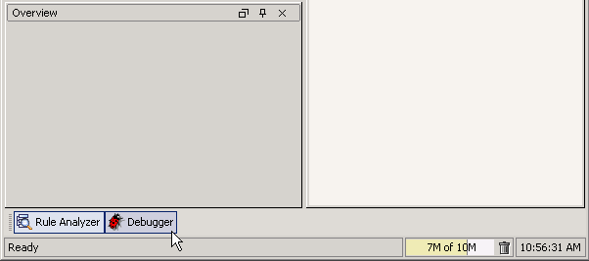
The Rule Debugger and Profiles options are now available from the menu.
The next step is to configure one or more profiles. Profiles provide information about the application you want to debug. To begin debugging, you will launch a Rule Debugger session with a profile. See Configuring Rule Debugger Profiles.
If your profile is ready to use, see To Start a Rule Debugger Session—After Configuring Profiles for the next step.
To Run Rule Debugger From TIBCO Designer
In the context of TIBCO Designer, you can always run Rule Debugger when you select the project’s EAR resource. If the focus is elsewhere in the project, you can run Rule Debugger only when there are no changes to the BusinessEvents project since the last time the EAR file was built. If the tool is unavailable from the menu, rebuild the EAR file to make it available or select the EAR file resource.
With the desired project open in TIBCO Designer, do the following.
1. | Navigate to and select the project EAR file (its icon is the blue box ).
2. | Start a Rule Debugger session in any of the following ways:

─ | Click Tools > BusinessEvents Tools and select > Rule Debugger
─ | Right-click on an EAR resource and select Tools or Multiuser > BusinessEvents Tools and select > Rule Debugger

─ | Press F12
You see the Rule Debugger user interface, displaying the application. The console window shows activity in the engine.
If you want to run additional sessions from within Rule Debugger, you must configure one or more profiles. See Configuring Rule Debugger Profiles.
If your profile is ready to use, see To Start a Rule Debugger Session—After Configuring Profiles for the next step.
To Start a Rule Debugger Session—After Configuring Profiles
You can launch Rule Debugger from a BusinessEvents application open in TIBCO Designer without specifying a profile. See To Run Rule Debugger From TIBCO Designer for details.
But for all other cases, you must start a Rule Debugger session using a profile that specifies details about the application you want to debug. For details on adding and modifying profiles, see Configuring Rule Debugger Profiles.
If the profile you want to use has been configured, then follow this procedure after you have started Rule Debugger. (See To Run Rule Debugger From the Command Line and To Run Rule Debugger From TIBCO Designer for startup details.)
1. | Do one of the following to start a Rule Debugger session.
─ | From the Rule Debugger menu, select Debug > Launch

─ | Click the Launch Rule Debugger button in the top toolbar:
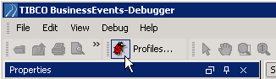

You see the Launch Debugger with Configurations dialog.
2. | Select a profile from the list on the left and do one of the following:
─ | Click Run to run the debugger without pausing between execution of each rule.

─ | Click Step to run the debugger in step mode, pausing between execution of each rule.
You see the Rule Debugger user interface, displaying the application. The console window shows activity in the engine.
Note that you can launch and run multiple debugger sessions in one BusinessEvents Tools instance. Each session is displayed on a separate tab.

Configuring Rule Debugger Profiles
When you start a Rule Debugger session, you must specify a profile that provides information about the application you want to work with and the BusinessEvents engine that runs the application. You can create multiple profiles for the same application. For example, you may want to test the effect of different startup arguments.
When you start a Rule Debugger session from the context of a project open in TIBCO Designer you don’t have to create a profile (see To Run Rule Debugger From TIBCO Designer).
To Configure Rule Debugger Profiles
This procedure assumes you are viewing the Rule Debugger user interface. See Running Rule Debugger for instructions on accessing the Rule Debugger user interface.
1. | Access the Edit Debug Configurations dialog in one of the following ways:
─ | Click the Profiles button in the top toolbar:
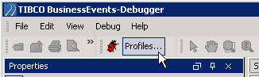
Or select Debug > Profiles from the menu.
─ | Click the Launch Rule Debugger button in the top toolbar:
Or select Debug > Launch from the menu.
When you use the Profiles option, you can work with profiles but cannot start a debugger session. When you use the Launch option, you can work with profiles, and you can also start a debugger session using a selected profile.
2. | To create or edit a profile, do one of the following:
─ | To create a new profile based on defaults, click the New Profile button .

 | Click Edit Defaults to change defaults used when creating new profiles. See Edit Default Configuration Properties Dialog for details.

─ | To create a new profile based on the currently selected profile, click the Copy Profile button .
─ | To edit an existing profile, select it from the list on the left and modify its values in the fields on the right.
See Rule Debugger Profiles Settings for details on completing the settings to enable local or remote debugging.
3. | To organize the list of profiles, you can do the following:
─ | To delete a profile, select the profile name in the left panel and click the Delete button . Delete profiles you don’t need any more to keep the list manageable.

─ | To move a profile up or down in the list, select the profile name in the left panel and click the up and down arrows. You can put frequently-used profiles near the top, or organize profiles by project, and so on.
4. |  | As appropriate, choose an option to save, apply, or cancel all changes made in all profiles since you opened the Edit Default Configuration Properties dialog:

─ | To apply changes to a profile in memory, click Apply. You can then select a different profile to work with.
─ | To save changes, additions, and deletions to disk, click Apply (to save the last changes to memory), then click OK (to save the work to disk).

─ | To cancel changes, additions, and deletions, click Cancel. None of the work done since you opened the Edit Default Configuration Properties dialog (or last clicked OK) is saved to disk.
 |  | Note that clicking the Apply button does not save changes, additions, and deletions to disk. Click Apply then click OK to save these actions to disk.

Rule Debugger Profiles Settings
This section explains how to configure profile settings for local or remote debugging. See Running Rule Debugger and Configuring Rule Debugger Profiles for related procedures.
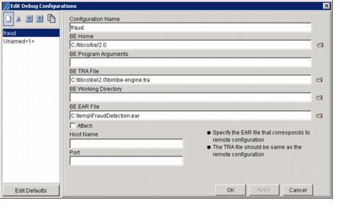
A profile specifies the EAR file whose rules you want to debug, and other supporting information. You can configure and save multiple profiles to point to different EAR files, or to the same EAR file but with a different configuration.
Remote Debugging To enable debugging against a remote BusinessEvents engine, you must specify its host name and Java Debug Interface (JDI) port number. All sections below apply to both local and remote debugging, unless specific information for remote debugging is provided in the text below. Configuration is also required. See Configuring a BusinessEvents Engine for Remote Debugging.
Configuration Name
Provide a descriptive name for the profile.
BE Home
Specify the directory in which BusinessEvents is installed, for example, C:/tibco/be/3.0.
Remote Debugging This setting is not used for remote debugging.
BE Program Arguments
Provide options and parameters as you would if you were starting the BusinessEvents engine at the command-line (see Overview of Managing TIBCO BusinessEvents Servers for details).
Remote Debugging This setting is not used for remote debugging.
BE TRA File
Identify the path and name of the property file (be-engine.tra) used when starting the engine, for example:
c:/tibco/be/3.0/bin/be-engine.tra
Remote Debugging Specify the location of the property file used to start the remote engine if it is available to the debugger session using the file system. If it is not available on the file system, specify the location of a copy of the original file that you save to an accessible location. Do not change the copy in any way.
When you manage the engine for your BusinessEvents application using TIBCO Administrator, then by default the property file used to start the engine is located here:
TIBCO_HOME/tra/domain/domain-name/application/app-name/app-name.tra
Note that a different domain home can be specified when a domain is created.
BE Working Directory (and Log File Location)
The location of the working directory for the BusinessEvents engine. The default default value is a dot (.), which means that the working directory is the directory where the BusinessEvents engine is started. The be-tools and be-engine executables are normally started in the TIBCO_HOME\be\3.0\bin directory.
Working Directory and Log File Location If you use the dot value, be aware of the following difference in the location of the working directory, and therefore engine-name.log file:
● | When you start BusinessEvents tools from the command line (and in its default location in the BusinessEvents bin directory), the working directory will be BE_HOME\bin\logs.
● | When you start BusinessEvents Tools from TIBCO Designer, the working directory will be TIBCO Designer_HOME\bin\logs.
Also see Default Location of Log Files and Other Files and Directories.
Path names that do not start with the root directory are assumed by the operating system to start from the working directory.
Remote Debugging This setting is not used for remote debugging.
BE EAR File
Location of the BusinessEvents EAR file of the project you want to debug.
Remote Debugging Specify the location of the EAR file of the project you want to debug if it is available to the debugger session using the file system. If it is not available on the file system, specify the location of a copy of the original file that you save to an accessible location. Do not change the copy in any way.
Attach
This setting is used only for remote debugging.
Remote Debugging Check this checkbox if you are configuring a profile for remote debugging.
Host Name
This setting is used only for remote debugging.
Remote Debugging Provide the name of the machine on which the remote BusinessEvents engine runs.
Port
This setting is used only for remote debugging.
Remote Debugging Provide the JDI port number, as specified in the remote engine’s property file. See Configuring a BusinessEvents Engine for Remote Debugging.
Edit Defaults
Click to display the Default Configuration Properties dialog. See Edit Default Configuration Properties Dialog, next.
Edit Default Configuration Properties Dialog
Complete the values you want to use as default properties when you click the New Profile button in the Edit Debug Configurations dialog. See above for details on the meaning of each setting.
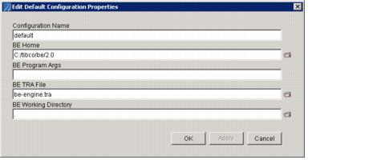
Profiles XML File
Profile settings are saved in XML format in the be-tools.debugger.config file, stored in the user’s .TIBCO directory. For example, for a Windows user called jsmith, the location would be C:\Documents and Settings\jsmith\.TIBCO.

Configuring a BusinessEvents Engine for Remote Debugging
You must configure the BusinessEvents engine property file so the engine uses Java Debug Interface (JDI) for remote debugging.
To Configure Java Debug Interface (JDI)
For each BusinessEvents engine you want to enable for remote debugging, do the following.
1. | Open the BE_HOME/bin/be-engine.tra file for editing.
2. | Specify the port on which you want the engine to listen, using the environment variable tibco.env.JDI_PORT, for example:
tibco.env.JDI_PORT 5192
Where 5192 is the default value. If multiple engines run on the same machine, ensure that each has a unique port.
3. | Uncomment the following line:
-Xrunjdwp:transport=dt_socket,address=%JDI_PORT%,suspend=na,server=y
4. | Start or restart the engine.
You specify the same JDI port number in the profile you will use to connect to the remote engine (see Port).

Studio Design (new)
The Studio debugger is an integrated debugger as opposed to an external debugger application. It runs within the Studio development environment. It enables the user to debug a compiled BE application inside the development environment as well as a remote BE application.The debugger is built upon 2 eclipse plugins.
- com.tibco.cep.studio.debug.core
- com.tibco.cep.studio.debug.ui

The Studio debugger comprises of the following components/artifacts :-
- Code Editor (Rule Editor/Rule Function Editor)
- Code Builder (Build Enterprise Archive)
- Launch Configuration Dialog
- Launch Viewer
- Breakpoint Viewer
- Console Viewer
- Variable Viewer
- Rule Input Viewer
- Agenda Viewer

Workflow
The Studio debugger integrated all these components to provide the debugger functionality. The workflow for a Debugger can be described as follows.
- Debug Local Application – This workflow consists of the following steps:
  - Save Studio project.
  - Compile Studio project into a EAR file using the Project Menu->Build Enterprise Archive. The Build Enterprise Archive menu appears when a project is selected in the project explorer view 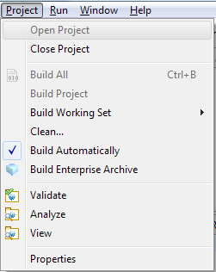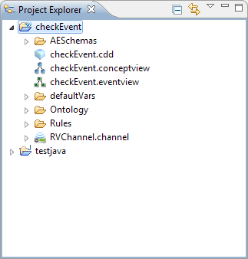
  - Set up Launch configuration using the
    - Menu Debug->Debug Configurations 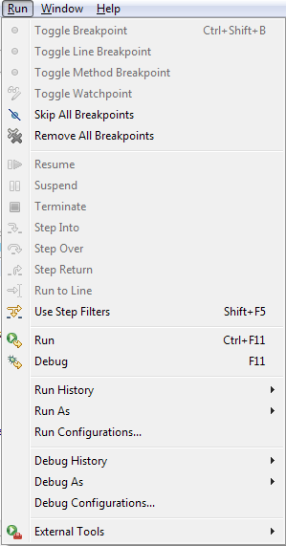
    - Tool bar icon for Debug menu -> Debug Configurations… 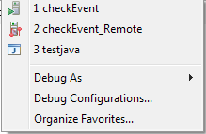
  - Set up Local Debug Launch configuration in the Launch Configuration Dialog 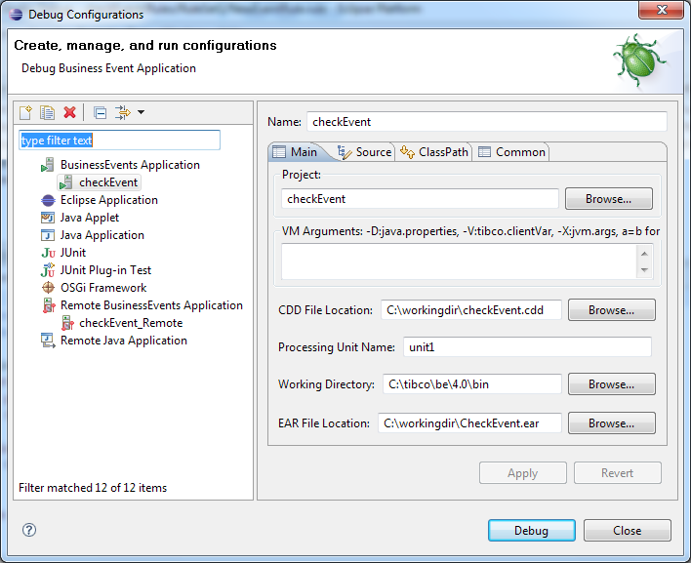
  - Start the Debug process.
- Run Local Application -This workflow consists of the following steps:
  - Save Studio project.
  - Compile Studio project into a EAR file using the Project Menu->Build Enterprise Archive. The Build Enterprise Archive menu appears when a project is selected in the project explorer view
  - Set up Launch configuration using
    - Menu Run->Run Configurations
    - Tool bar icon for Run menu -> Run Configurations… 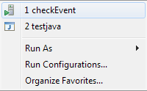
  - Set up Local Debug Launch configuration in the Launch Configuration Dialog
  - Start the Run process.
- Debug Remote Application – This workflow consists of the following steps
  - Save Studio project.
  - Compile Studio project into a EAR file using the Project Menu->Build Enterprise Archive. The Build Enterprise Archive menu appears when a project is selected in the project explorer view
  - Set up Launch configuration using the
      - Menu Debug->Debug Configurations
      - Tool bar icon for Debug menu -> Debug Configurations…
  - Set up Local Remote Debug Launch configuration in the Launch Configuration Dialog but not start it until the remote process is started or running. 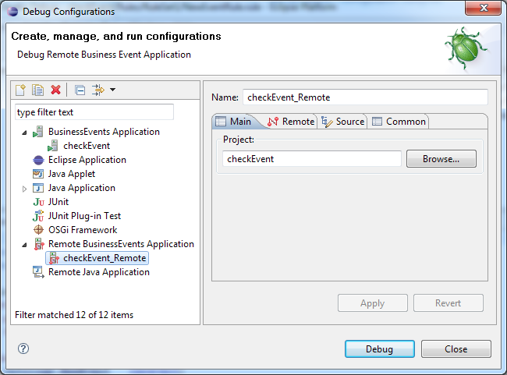
  - Start the external process as shown below. Note the -d flag for starting the debugger service thread inside the BE engine.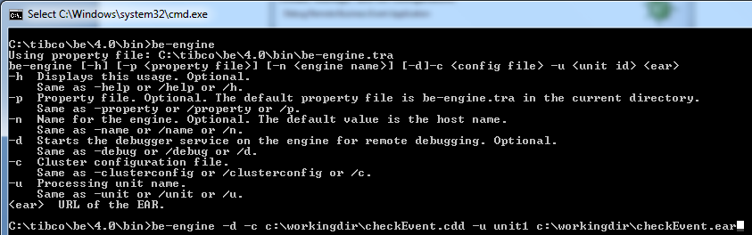
  - The TRA file for setting the remote process needs to set this as well as in the debug configuration.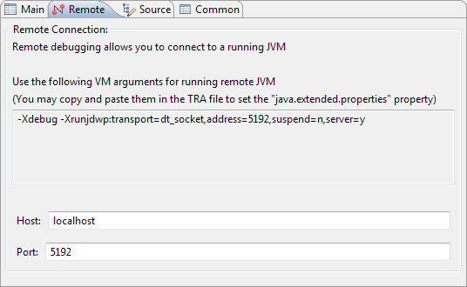
  - Start the debug.

Debugger Artifacts/Components

Code Editor (Rule Editor/Rule Function Editor)
The Code editors give allows the user to see the code, set breakpoints and while debugging highlight the line where the current execution has suspended due to breakpoint or debug step actions.
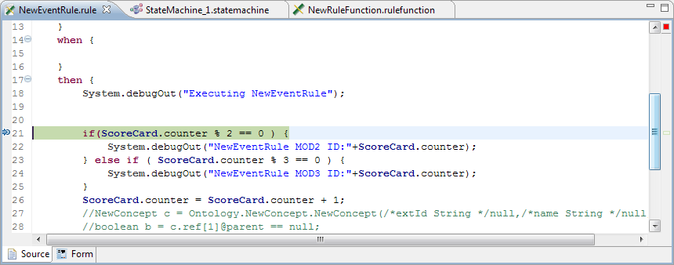

Code Builder (Build Enterprise Archive)
The code builder is responsible for building the EAR resource which contains the compiled BE application code. It is built using the the Project Menu->Build Enterprise Archive. The Build Enterprise Archive menu appears when a project is selected in the project explorer view
The Build Enterprise archive allows you to build the EAR file resource in Debug and Non Debug mode by checking in the “Generate Debug Info” check box .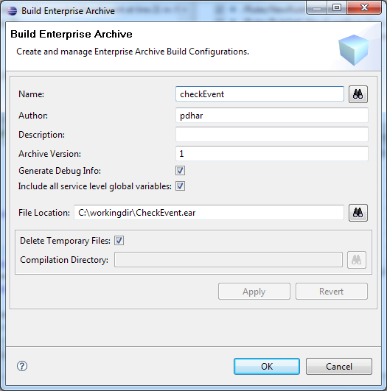

Launch Configuration Dialog
The launch configuration Dialog has the following Tabs :-
- Main Tab
For Local Debug the main tab allows you to enter the Project Name, VM arguments, CDD File location, Processing unit name, working directory and the EAR file location. 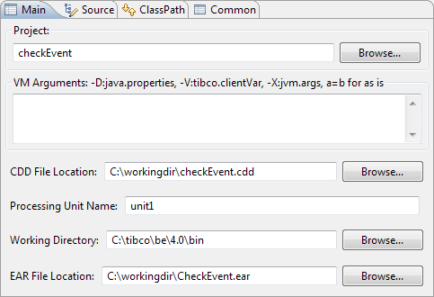
For Remote Debug the main tab allows you to select the Workspace project that you are debugging remotely. 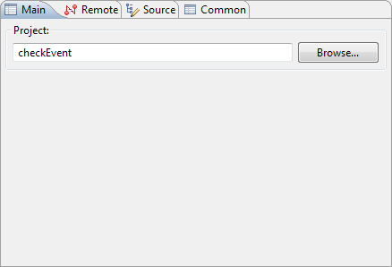
- Source Tab
For most purposes the source tab allows you to add different BE source code containers, but by default the selected project is the source container and it is being debugged. This functionality is available by default from the Eclipse Development environment. 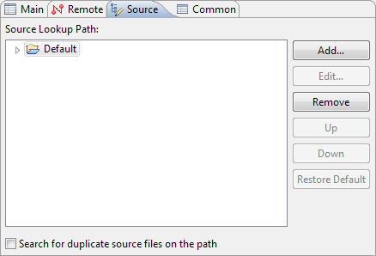
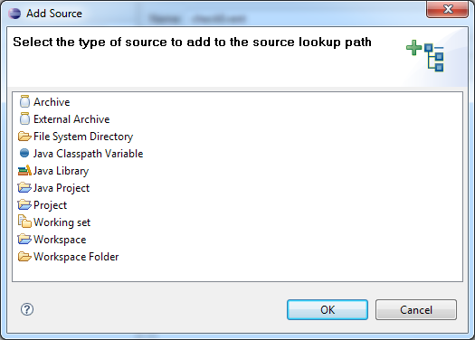
Classpath Tab
The class path tab allows you to add custom function jars and third party libraries for running the BE application inside the debugger. This tab has the same functionality as the Studio Project->Properties->Build Path Tabs 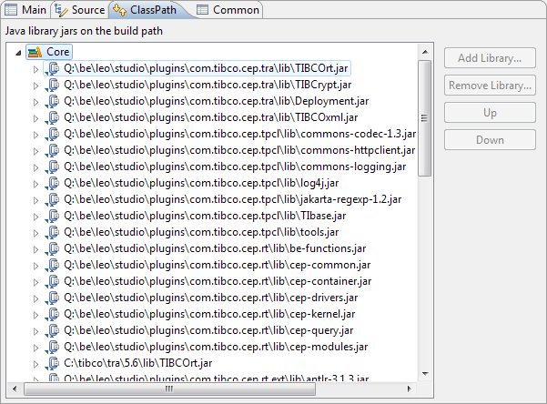
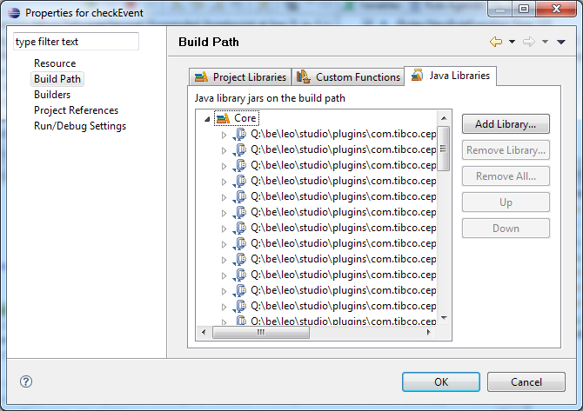
Remote Tab
The remote tab is visible when you choose Remote Business Events Application type configuration.
The remote tab allows you to set the host name and the port number where the debugee process is running. For remote debugging you have to run the BE runtime with a –d flag and also set the java.extended.properties as shown below.
Common Tab
The common tab allows you to save the configuration as local file or shared file. This functionality is available by default from Eclipse platform.
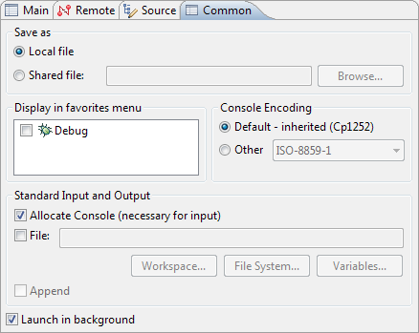

Launch Viewer
When a debug session is launch this viewer shows the debug target which consists of the launched process and its threads in a tree structure. When the debug target is suspended at breakpoint or it is stepping it shows the thread stack.
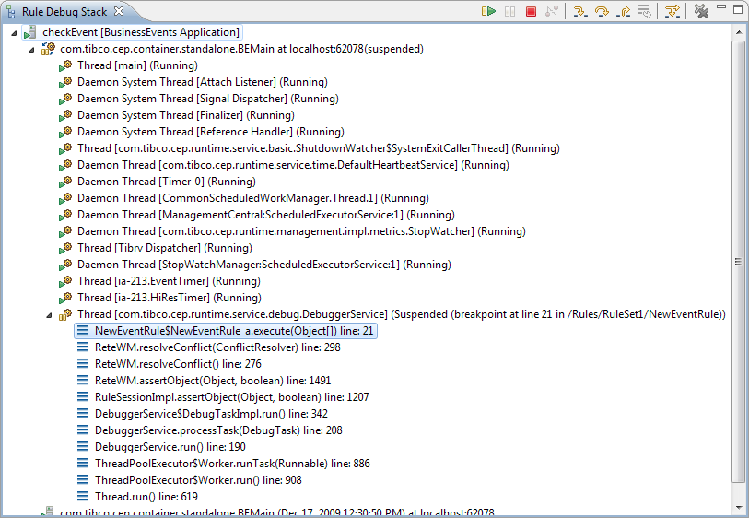
It has a tool bar which allows the following debug actions
Run/Go
Stop
Pause
Step in
Step Over
Step Out
Remove terminated Launches

Breakpoint Viewer
The break point viewer allows you to see and manage the breakpoints. In eclipse the breakpoints are common to all debug targets, it is the responsibility of each target to pick and set the relevant one internally. It may show Java as well as Studio breakpoints. This functionality is inherited from the Eclipse environment.
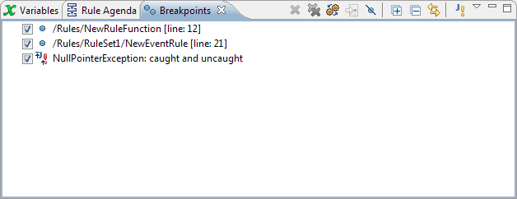

Console Viewer
The console viewer show the console output for local debug launches only.
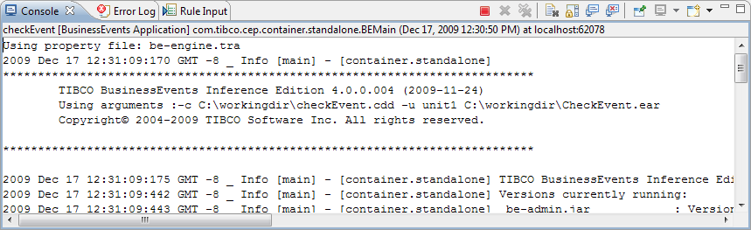

Variable Viewer
The variable viewer shows the variable values which are visible in the debug context when the debug target is suspended at a breakpoint or stepping.
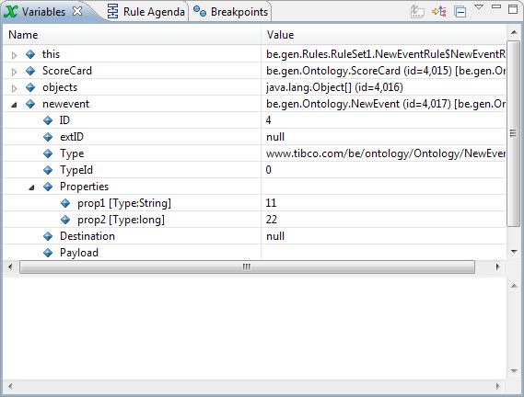

Agenda Viewer
The Rule Agenda viewer shows the remaining agenda items until the RTC. It shows what rules will be executed next and what objects and their values being passed to the rule
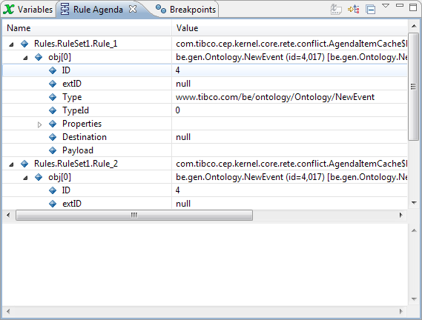

Rule Input Viewer
This view allows you to send /assert Events /Concepts to the debugged process. This view allows you to select the Rule session, Entity, Debug Target, Channel destination URI and mapping information. It also allows you to save the input data to a xml file and load from a xml file.
