T

TIBCO BusinessEvents User Interface

Product Suite | TIBCO BusinessEvents
Product | Technical User Interface
Product Version | 4.0
Initial Author | Gabe Grigorescu

Copyright Notice
COPYRIGHT© 2008 TIBCO Software Inc. This document is unpublished and the foregoing notice is affixed to protect TIBCO Software Inc. in the event of inadvertent publication. All rights reserved. No part of this document may be reproduced in any form, including photocopying or transmission electronically to any computer, without prior written consent of TIBCO Software Inc. The information contained in this document is confidential and proprietary to TIBCO Software Inc. and may not be used or disclosed except as expressly authorized in writing by TIBCO Software Inc. Copyright protection includes material generated from our software programs displayed on the screen, such as icons, screen displays, and the like.
Trademarks
Technologies described herein are either covered by existing patents or patent applications are in progress. All brand and product names are trademarks or registered trademarks of their respective holders and are hereby acknowledged.
Confidentiality
The information in this document is subject to change without notice. This document contains information that is confidential and proprietary to TIBCO Software Inc. and may not be copied, published, or disclosed to others, or used for any purposes other than review, without written authorization of an officer of TIBCO Software Inc. Submission of this document does not represent a commitment to implement any portion of this specification in the products of the submitters.
Content Warranty
The information in this document is subject to change without notice. THIS DOCUMENT IS PROVIDED "AS IS" AND TIBCO MAKES NO WARRANTY, EXPRESS, IMPLIED, OR STATUTORY, INCLUDING BUT NOT LIMITED TO ALL WARRANTIES OF MERCHANTABILITY OR FITNESS FOR A PARTICULAR PURPOSE. TIBCO Software Inc. shall not be liable for errors contained herein or for incidental or consequential damages in connection with the furnishing, performance or use of this material.
For more information, please contact:
TIBCO Software Inc.
3303 Hillview Avenue
Palo Alto, CA 94304
USA
Table of Contents
1 Change Log 6
1.1 Related Documents 6
2 Introduction 7
2.1 Main Objective 7
2.2 Component Name 7
3 Acronyms and Vocabulary 7
4 High-Level Design 8
4.1 Components 8
4.2 Menu Structure 10
4.2.1 File Menu 10
4.2.2 Edit Menu 10
4.2.3 Project 10
4.2.4 Source 10
4.2.5 Diagram 11
4.2.6 Multi User 11
4.2.7 Tools 11
4.2.8 Window 11
4.2.9 Help 11
4.3 Toolbar Structure 11
4.4 Project Explorer 12
4.4.1 Dragging Objects 13
4.4.2 Context Menus 13
4.5 Concept Editor 14
4.6 Concept Model View Editor 14
4.7 State Machine Editor 15
4.8 Event Editor 16
4.9 Scorecard Editor 17
4.10 Rule Editor 17
4.11 Rule Function Editor 18
4.12 Decision Table Editor 18
4.13 Channel Editor 18
4.14 Destination Editor 19
4.15 Domain Model Editor 19
4.16 Archive Editor 19
4.16.1 EAR editor 19
4.16.2 SAR editor 20
4.16.3 BAR editor 20
5 Persistence 21
6 Timelines 21
6.1 BE 4.0.0 21
6.2 BE 4.0.1 22
6.3 BE 4.0.2 22
7 Other Issues 22
7.1 Additional considerations 22
7.1.1 In memory vs resource based management 22
7.1.2 Multiple vs single project 23
7.1.3 Project Explorer 23
7.1.4 Wizards 23
7.1.5 Dynamic Help 23
7.1.6 Search 23
7.1.7 Refactoring 24
7.2 Old Notes (can ignore) 24

Change Log
.
Date | Version | Name | Description
11/17/2008 | 0.1 | Gabe Grigorescu | Document Creation
11/21/2008 | 0.2 | Ryan Hollom | Modifications/added sections
11/24/2008 | 0.3 | Gabe Grigorescu | Responses to Ryan’s feedback and added more info, such as fields in Properties View

Related Documents
Document Title | Revision Number | Author
Rule Editor Requirements | 0.3 | Gabe Grigorescu
BE 3.x and 4.x Planning | 0.4 | Gabe Grigorescu

Introduction

Main Objective
The objective of the new Eclipse-based Designer is to provide a more unified and more powerful design and development environment of BE. This is not meant to be a very detailed design or architecture document, but rather a starting point for our development team so we all know what direction the BE 4.0 development needs to go in.
This Designer component should be written such that almost all functionality should be done in plugins. The idea is that we should be able to drop these plugins into Eclipse and contribute new menu and toolbar items so that it will work in that Eclipse environment. For now we will create a new Designer RCP application, but the code in that application should be minimal.

Component Name
At this time we don’t know what this component will be called. Maybe TIBCO BusinessEvents Designer, maybe Decision Designer, etc. This component will be bundled with BE.

Acronyms and Vocabulary

The table below describes some of the Acronyms used in this documentation
- BUI – Business User Interface
- BE – TIBCO BusinessEvents.
- XML – Extensible Markup Language
- Designer Project – A TIBCO Project build using TIBCO Designer. A Project is a VFileSystem which could typically be a Directory Node in the FileSystem.
- EAR – Enterprise Archive Resource. This is modeled from the J2EE world and contains a subset of VFiles, user defined files, properties, code, jars, etc. An Engine may choose to run against this EAR file.
- A Rule is single Conditions/Actions pair (e.g.,. a column in the Decision Table).

- DT – Decision Table. A Spread-Sheet like interface for business user to capture threshold values, business rules (in a tabular format). It comprises of one or more rules.
- A Rule Condition is a boolean expression of logical operators and functions (which may be a rule function or another Decision Table that returns a value) acting upon one or more Terms.
- A Rule Action is one of:
  - An update to a Term represented as an Expression
  - A creation or deletion of a Term
  - An invocation of another Decision Table that may or may not return a value
  - A simple return value (to be consumed by caller)

High-Level Design

Components
This section describes the default layout of the Designer perspective. All views can be rearranged/opened/closed by the user to maximize productivity. The state of the workbench needs to be saved and restored when Designer is closed and reopened, so the modified layout of the Designer is not lost. This can be accomplished by implementing the org.eclipse.core.resources.ISaveParticipant interface.

The user should also be able to explicitly save the current layout by selecting Window->Save Perspective As… This allows users to either save over the existing Designer perspective, or create a new perspective. The user should also have the ability to reset the perspective (Window->Reset Perspective). This will reset the layout of the perspective, so that all views are restored to their default location.

This also implies that the current project that is opened will be restored when Designer is reopened, rather than forcing the user to reopen the project each time Designer starts.

The main window will by default be made up of the following:

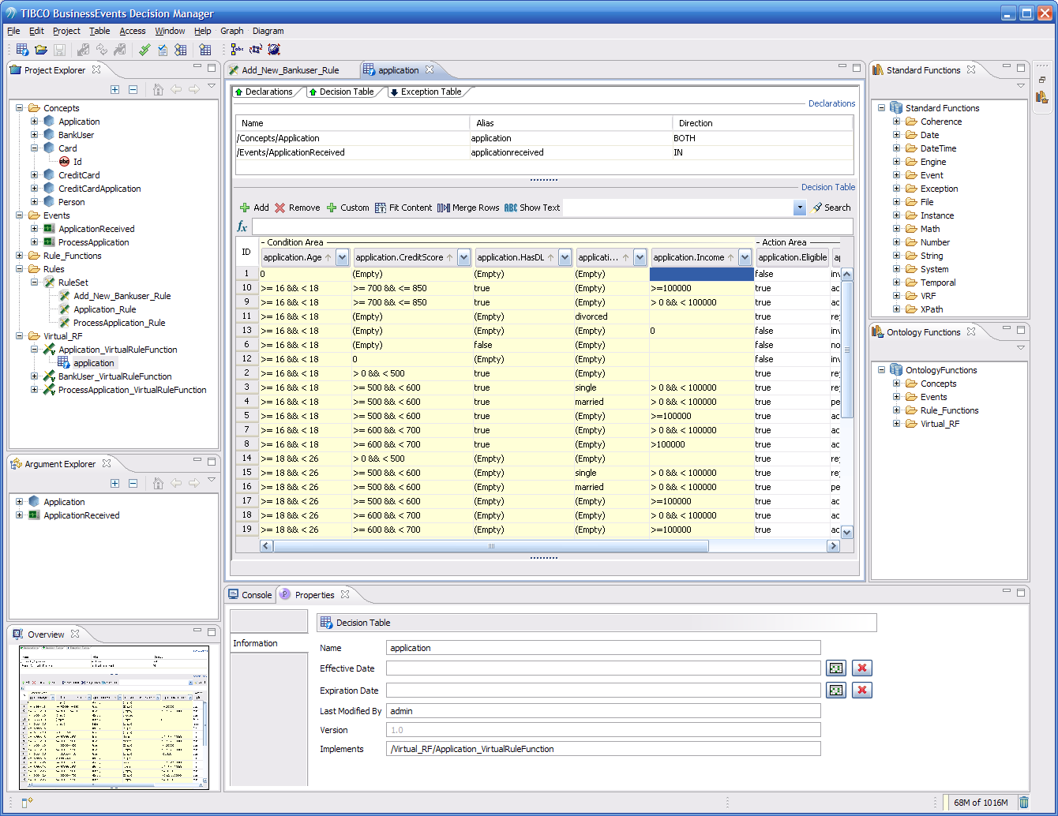

At the top we have the title bar, menu bar, toolbar (that can change depending on the context). They are self-explanatory.

On the left side we will have the project explorer. We will also have an Outline View, which generally will show outline views of what’s in the main editor area, such as diagrams (concept or state machines, decision tables).

The main area will be used by editors (tabs) that can contain whatever the user double-clicks on in the project explorer (concepts, events, rules, etc). This area may not have (and will not by default) anything open.

At the bottom of the application there will be several horizontal views (tabs), such as Console, Properties, Problems, and others depending on user actions. The Properties view is context sensitive and will be updated depending on the current selection in Designer. For instance, if an item is selected from the Project Explorer, the Properties view might show the name, description, and certain attributes of that entity.
On the right-side of the application we may have Palette Views, Catalog Functions, or other context sensitive views. This needs more design thought.

Question: Do we put Configuration stuff in “Properties View” or in this main editor tab under the first collapsible pane (like this):
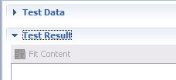

The next question is whether that even if we do, we could take it even further and not leave the other sections in the editor tab, but move them to other vertical tabs in the same Properties View:

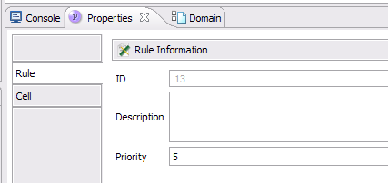

I dislike this option because it increases the number of clicks and users can no longer see all the data associated with an object. The advantage is that by doing this you avoid having to open a new tab to view/change data of the object (and avoid a double-click in the Project Explorer).

Initially the information in the properties view will be read only. In order to change this information, the appropriate editor needs to be opened and the changes need to be made there. The exception to this might be visual editors, such as the State Machine editor. In this case, the UI pattern of visual editing w/ properties is well established, and will be expected.

As the product matures, we could allow certain information to be changed in the Properties view. Careful thought must be put in to what type of information can be changed, however, as the ramifications of these changes might not be obvious. For instance, if the Concept name is changed, that could potentially change the contents of dozens, or even hundreds of resources in the designer project.

Menu Structure
Many of these menu items will only be enabled when the context makes sense. Here’s roughly what the menu structure will look like:

File Menu
New
New From Template (?)
Open
Close
Close All
Save
Save As Template
Save As Image (?)
Import/Export Resources (??)
Save All
Print
Last 4 opened projects
Exit

Edit Menu
Cut
Copy
Paste
Delete
Find/Replace
…

Project
Validate (??)
Build (??)

Source
Validate
Find References To
Find References In
Edit (bring up viewer)
Refresh (?)
…

Diagram
Interactive Tools
Labeling
Incremental Layout
Global Layout

Multi User
Nothing, may not support in 4.0.0 out of the box. We will need to investigate what it takes to make use of the source control system support Eclipse provides out of the box for BE artifacts.

Tools
Rule Analyzer
Debugger
DB Import
Generate Schema
Import Schema

Window
Show Console
New Window
Open Perspective
Show View
(Perspective related items like Eclipse if enough time):
Customize Perspective
Save Perspective As…
Reset Perspective
Navigation (and submenus)
Preferences

Help
Welcome
Help Contents
Search
Key Assist
About BE Designer

Toolbar Structure
Many of these toolbar items will only be enabled when the context makes sense. Here’s roughly what the toolbar structure will look like:

New Project
Open Project
Save
Save Project – might not be necessary
Save All (maybe)
Validate Project
Cut
Copy
Paste
Delete
Undo
Redo
Find
Rule Analyzer
Debugger
Select Tool
Pan Tool
Marquee Zoom
Interactive Zoom
Link Navigator
Fit In Window
Layout (maybe expose all layout styles)
Labeling
Grid
Show Toolbox View (show tool view specific to each editor: state machine, concept view)

Project Explorer
Upon opening a Designer project, the project will show its contents in the Project Explorer window on the left-hand side. This is very similar to what we do now in Decision Manager, except it will show more. Each item will have its own icon shown in the explorer tree. Besides the folder structure defined by the user, it will show:

Object Type | On expanding (+) | On double-click
Concept | Show state machine (if any), View and properties. Show states under SM? | Concept editor opened (new tab) in main editor area
Concept Property | Not Expandable | Open Concept Editor and highlights property in Property section.
Concept State Machine | Shows all states | Opens State Machine editor
Concept View | Not Expandable | Open diagram of Concept Model
Event | Show properties and payload | Event editor opened (new tab) in main editor area
Event Property | Not Expandable | Open Event Editor and highlights property in Property section.
Scorecard | Show properties | Scorecard editor opened (new tab) in main editor area
Channel | Show destinations | Channel editor opened (new tab) in main editor area
Destination | Not Expandable | Destination editor opened (new tab) in main editor area
Shared Resource | Not Expandable | Open JMS/RV/HTTP Connection editor
Ruleset | Show rules | Nothing (need to give way to enter ruleset description though). Maybe create ruleset editor as well.
Rules | Not expandable | Rule editor opened (new tab) in main editor area
Rule Function | Show extended properties (if any) | Rule function editor opened (new tab) in main editor area
Domain Model | All values in that model | Domain model editor opened (new tab) in main editor area. Alternatively, bottom tab can be used as it is now in Decision Manager
EAR | Show contained archives (SAR, BAR) | EAR editor opened (new tab) in main editor area
SAR | Not expandable | SAR editor opened (new tab) in main editor area
BAR | Not expandable | BAR editor opened (new tab) in main editor area

We can use existing icons from Decision Manager and add any of the new ones that we need.

Dragging Objects
Users should be able to drag and drop objects from the project explorer (provided the action is legal). For example, users should be able to drag a Destination from one Channel to another. Dragging and dropping moves the resource, holding down control key will just copy. One possible exception could be domain models. If users create domain models, they are intended to be reused, and thus maybe they should only be copied.

Context Menus
Depending on what project explorer object users right-click on, certain options will be made available. The design of what these menus show should be flexible enough. Primarily this should be driven by an “xml configuration” file where for each type of object, menu options and classes associated with them are created. We should do this the Eclipse way. This table needs to be completed more, but here is a beginning:

Tree Object Type | Context Menu Items
Folder | Cut, Copy, Paste, Delete, Rename, New Folder, Expand All, Collapse All
Concept | Cut, Copy, Paste, Delete, Rename, Add State Machine, Edit, Expand, Collapse
Concept Property | Cut, Copy, Paste, Delete, Rename, Edit
Concept State Machine | Cut, Copy, Paste, Delete, Rename, Edit, Export (to image)
Concept View | Edit, Export
Event | Cut, Copy, Paste, Delete, Rename, Edit, Expand, Collapse
Event Property | Cut, Copy, Paste, Delete, Rename, Edit
Scorecard | Cut, Copy, Paste, Delete, Rename, Edit, Expand, Collapse
Channel | Cut, Copy, Paste, Delete, Rename, Edit, Expand, Collapse
Destination | Cut, Copy, Paste, Delete, Rename, Edit
Shared Resource | Cut, Copy, Paste, Delete, Rename, Edit
Ruleset | Cut, Copy, Paste, Delete, Rename, Add Rule, Expand, Collapse
Rule | Cut, Copy, Paste, Delete, Rename, Edit
Rule Function | Cut, Copy, Paste, Delete, Rename, Edit
Decision Table | Cut, Copy, Paste, Delete, Rename, Edit
Domain Model | Cut, Copy, Paste, Delete, Rename, Edit, Expand, Collapse
EAR | Cut, Copy, Paste, Delete, Rename, Edit, Add BAR, Expand, Collapse
SAR | Cut, Copy, Paste, Delete, Rename, Edit
BAR | Cut, Copy, Paste, Delete, Rename, Edit

Concept Editor
Double-click on a Concept in the Project Explorer opens a new Editor tab. This will have 3 collapsible sections (using Eclipse collapsible pane) arranged in a top to bottom orientation (one under the other):
View
Configuration
Properties
Extended Properties

If the user double-clicks on View, a Concept View diagram will be opened with all Concepts in the diagram. The current Concept will be centered in the diagram and selected. The user will be able to further modify relationship (containment, references, inheritance) from this diagram. Alternatively, the user will be able to make the same modifications by modifying the properties not via the diagram but rather via the Properties and the Configuration.

The Properties View will show the following information when users click on the concept in the Project Explorer:
Name
Description
Inherits From

Concept Model View Editor
Double-click on a Concept Model View in the Project Explorer opens a new Editor tab. Alternatively, this could be as part of a collapsed (by default) section in the Concept Editor. Opening concept model diagram editor will also bring up the Palette View, which will contain several new tools, such as:

Nodes:
Add Note
Add Concept
Add Attribute
Links:
Inheritance
Containment
Reference

There will be two configurable modes for the Concept Model View Editor. One mode will show all of the Concepts that have been defined in the designer project. This will allow users to get a high level picture off all Concepts and their relationships, and begin modifying the relationships. However, for projects will hundreds of Concepts, this can quickly become overwhelming. Instead, we could filter the editor to show only the focused Concept and its direct relationships, and does not show unrelated Concepts. This gives the user a more focused approach to visually editing relationships. There should also be a simple way to add unrelated Concepts to the view so that they can be added to the focused Concept’s relationships.

See the section on Persistence for more information regarding the persistent state of the Concept Model View.

State Machine Editor
Double-click on a state machine in the Project Explorer opens a new Editor tab. This will have 4 collapsible sections (using Eclipse collapsible pane) arranged in a top to bottom orientation (one under the other):
State Machine (this is where the diagram is rendered)
Configuration

Opening the state machine editor will also bring up the Palette View, which will contain several new tools, such as:

Nodes:
Simple State
Composite State
Concurrent State
End State
Note
Links:
Transition

It can look something like this:
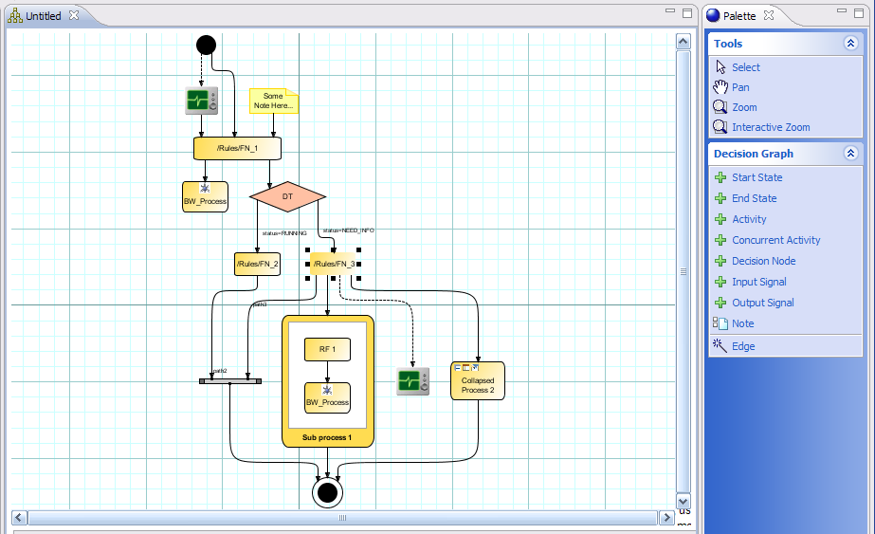

As part of Configuration section, “Timeout Expression” and “Timeout Action” may show embedded “mini” editors (Declaration and Action sections that are smaller).

To save time, let’s keep the other configuration UI as it is there and use the bridge to expose this (for now).

Although the state machine is tied to a specific Concept, the state machine model object should be persisted outside of the .concept file. This will allow users to checkout, modify, and checkin just the state machine without modifying the Concept. Moreover, the visual layout information of the state machine editor also must be persisted, in order to save layout, zoom levels, and additional metadata about the state machine. This information does not affect the model and should therefore be kept in a separate file. See the Persistence section for more information.

The Properties View will show the following information when users click on the state machine in the Project Explorer:
Name
Description
Main State Machine
Timeout Expression, Units, Timeout Action (?)

Event Editor
Double-click on an event in the Project Explorer opens a new Editor tab. This will have 4 collapsible sections (using Eclipse collapsible pane) arranged in a top to bottom orientation (one under the other):
Configuration
Payload
Properties
Extended Properties

To save time, let’s keep the UI as it is there and use the bridge to expose this (for now).

The Properties View will show the following information when users click on the event in the Project Explorer:
Name
Description
Inherits From
Time To Live
Default Destination

Scorecard Editor
Double-click on a scorecard in the Project Explorer opens a new Editor tab. This will have 3 collapsible sections (using Eclipse collapsible pane) arranged in a top to bottom orientation (one under the other):
Configuration
Properties
Extended Properties

To save time, let’s keep the UI as it is there and use the bridge to expose this (for now).

The Properties View will show the following information when users click on the scorecard in the Project Explorer:
Name
Description

Rule Editor
This in itself requires a separate document. However, we will just cover at a very high level what will be shown. Double-click on a rule in the Project Explorer opens a new Editor tab. We need 3 or 4 sections:
Declaration
Conditions
Actions
Configuration
These sections will need to be reusable because they’ll be needed in other parts of Designer, such as rule function editor, state machine transition editor, as well as State Machine timeout expression/action “mini” editors.

The Properties View will show the following information when users click on the rule in the Project Explorer:
Name
Description
Priority

Rule Function Editor
This is very similar to the Rule editor because it is a subset of it. It has 2-3 sections:
Arguments (like Declaration)
Body (like Actions)
Configuration (collapsible pane as described above)
Extended Properties (collapsible pane as described above)

To save time, let’s keep the Configuration UI as it is there and use the bridge to expose this (for now).

The Properties View will show the following information when users click on the rule function in the Project Explorer:
Name
Description
Is Virtual
Validity
Return Type

Decision Table Editor
We can use all the existing functionality to allow users to edit decision tables. This may need to come in the 4.0.1 release though.

Channel Editor
Double-click on a channel in the Project Explorer opens a new Editor tab. This will have 2 collapsible sections (using Eclipse collapsible pane):
Configuration
Destinations
This section will also list all Destinations in this channel so users can double-click on them and go to edit them. These Destinations are also shown in Project Explorer if users expand the Channel node in that tree.

The Properties View will show the following information when users click on the channel in the Project Explorer:
Name
Description
Driver
Method of Configuration
Resource

Destination Editor
Double-click on a destination in the Project Explorer opens a new Editor tab. This will have 1 collapsible section (using Eclipse collapsible pane):
Configuration

The Properties View will show the following information when users click on the destination in the Project Explorer:
Name
Description
Default Event:
Subject

Domain Model Editor
We should use the domain model editor we have developed in the Decision Manager.

Archive Editor
Use Properties View to show Configuration info, but needs to handle other tabs as well. See below.

EAR editor
Double-click on a SAR in the Project Explorer opens a new Editor tab. This will have 1 collapsible section (using Eclipse collapsible pane as shown above):
Configuration
Right-clicking on the Archive in the project explorer will give the user the ability to “Build” or a “Build” button will also be available at the bottom of the editor tab.

Optionally, above the Configuration pane, we could have a diagram view (kind of like what we have now) where users can interactively add new BAR or SAR nodes from a toolbar menu.

The Properties View will show the following information when users click on the archive in the Project Explorer:
Name
Description
Author
Version
File Location

SAR editor
Double-click on a SAR in the Project Explorer opens a new Editor tab. This will have 5 collapsible sections (using Eclipse collapsible pane as shown above):
Configuration
Resources
Files
Jars
Dependencies

The Properties View will show the following information when users click on the SAR in the Project Explorer:
Name
Description

BAR editor
Double-click on a BAR in the Project Explorer opens a new Editor tab. This will have 5 collapsible sections (using Eclipse collapsible pane as shown above):
Configuration
RuleSets
Input Destinations
Startup/Shutdown (add, remove, up/down)
Object Management

The Properties View will show the following information when users click on the BAR in the Project Explorer:
Name
Description
Author
Type

Persistence
This section will evolve more as we figure out exactly the new EMF model and such, but here is a beginning. We will need:
application specific model for preferences and such
project specific model for project-wide information
artifact specific model for artifacts

Besides the folder structure created by users, here’s what the artifacts should be stored:

Object Type | File
Concept | .concept  .sm (not part of a concept, becomes 1st class object)
Concept Model View | .cmview (??) – needs to be separate from .concept
Event | .event
Event Model View | .emview (??)
Scorecard | .scorecard
State Machine | .sm
State Machine View (layout information) | .smview (??)
Channel | .channel
Destination | .destination
Ruleset | .ruleset
Rules | .rule
Rule Function | .rulefunction
Decision Table | .rulefunctionimpl
Decision Tree | .rulefunctionimpl
EAR | .archive (ear)
SAR | .sar
BAR | .bar
Shared Resources | .sharedjmscon, .sharedrvcon, .sharedhttpcon

Timelines
Although this does not mean anything at this point, very roughly this is what we have in mind.

BE 4.0.0
Q2 2009

BE 4.0.1
Q3 2009

BE 4.0.2
Q4 2009

Other Issues
= view/editor default layout
= concept node UI (what will they look like)
= use Properties View and vertical tabs to let users edit events, etc, or allocate editor main view for that?
= where does concept model view get stored?

Additional considerations

In memory vs resource based management
Do we want to always have the entire Ontology in memory, and therefore compute all cross reference information every time the Designer project is opened? Or do we go for a resource based approach, where there is a separate, persisted “index” that serves as the cross reference index (with additional information).
There are benefits and drawbacks to each approach. Recomputing cross reference information and holding everything in memory all the time has potential performance improvements, at the cost of more memory. However, this does not solve the need to properly maintain cross reference information when things change. This option would also require us to pick appropriate times to persist the project (“Save Project” option), but what happens if the computer crashes after you have created hundreds of objects but have yet to save the project? This is counter to the eclipse project management philosophy, which is resource based. One big benefit of this option is that refactorings become simpler, since all changes are first done in memory, and only written to disk when a “Save Project” operation is run. In a resource based approach, refactorings will need to be persisted immediately when the refactoring is done. This is most apparent in renaming objects, as well as in the Concept Model View, where many changes to the structure of the project can be made.

The resource based approach has many benefits, mostly pertaining to the things we get for free from the Eclipse workbench. Many IDE features require and expect IResource objects to work. This includes navigator views, problem markers, build systems, team management (SVN, CVS, etc), “Open Resource” functionality, creation wizards, text searches, and more.

Perhaps there is a good middle ground that successfully uses both approaches. More thinking is needed here, but comments are welcome.

Multiple vs single project
Should we allow users to define multiple projects within one instance of Designer? This goes beyond just Designer projects, as it is a likely requirement that users will want to define a java project to develop manual/custom java functions and then incorporate those functions into the designer project. If we only allow one project at any given time, this will preclude users from seamlessly integrating their java projects into designer.

The initial thought here is that for the first release we will only allow one project per Designer instance. HOWEVER, WE MUST BE CAREFUL NOT TO ASSUME THAT THIS WILL ALWAYS BE THE CASE. For instance, there should be no static/singleton references to a “Designer Project” object, similar to the way DecisionProjectLoader does now.

Project Explorer
We should consider the Common Navigator Framework in Eclipse to implement our Project Explorer view. This allows us to put a logical view on top of the physical resources, which will allow us to show both the files in the project as well as structural information within the file (for instance, the attributes of a Concept).Assistive features.

Wizards
There will be a collection of wizards to assist users by simplifying multiple step processes. For instance, there should be creation wizards for all first class objects in the model (Concepts, Events, Destinations, Channels, etc). Each wizard will be specific to the entity being created, but will likely contain reusable components (name, description, etc).

There should also be a wizard for the creation and building of EAR files.

Creation wizards should be available via the File->New menu, as well as from the context menu in the Project Explorer under New->. Other wizards should be quickly accessible, and will be place in appropriate locations within the Designer perspective.

Dynamic Help
There is a framework in Eclipse to provide dynamic, context sensitive help. For instance, if the user selects a Concept in the Project Explorer, the dynamic help view could display information about Concepts, meaning, description, how they are used, etc. This could be a good way to expose the user guide in incremental doses, so that a technical and non-technical user can “play around” with Designer and discover and learn without having the user’s guide there.

Search
We should contribute a Designer search page, in which users can search for references, definitions, etc of certain entities within the decision project. This is most often useful while trying to learn the system, and to search for examples in existing implementations. This feature should also be exposed in various editors, so users can quickly find references to an existing entity (for instance, a Rule).

Refactoring
Some seemingly simple changes can have pervasive effects on the entire designer project. For instance, renaming a Concept or a Rule will require every other reference to those objects to be updated with the new name. For these types of changes, a refactoring framework should be put in place to properly update all references in a controlled fashion. This depends heavily on a strong search framework, and refactoring is just a context sensitive search and replace.

Old Notes (can ignore)

Palettes
- exposed how?
- context sensitive (can't add http channel to EAR!): channel: destination, concept: SM, Rule/RF: nothing, same with Events?
- add from resources depending on what's installed (similar to now), BW, etc...

Activities
- send/Wait for/Receive Event
- Invoke rule function
- RSP Configuration

Tester
- exposed how?
- functionality exposed how?
- BE provided it?
- process definition: provides it as well?

Global Variables
- another editor view that's accessible from a "Global Variables" tree item under project?
- can add var groups, vars, delete them, or modify them.
- can filter or show all

Must Handle Resources:
- RV Transport
- JMS, TCP, HTTP, FTP Connection
- Service
- Custom action

