T

TIBCO BusinessEvents: Shared Resources

Product Suite | TIBCO BusinessEvents
Product | Studio
Product Version | 4.0
Initial Author | Nicolas Prade, Sridhar Sailappan

Copyright Notice
COPYRIGHT© 2009 TIBCO Software Inc. This document is unpublished and the foregoing notice is affixed to protect TIBCO Software Inc. in the event of inadvertent publication. All rights reserved. No part of this document may be reproduced in any form, including photocopying or transmission electronically to any computer, without prior written consent of TIBCO Software Inc. The information contained in this document is confidential and proprietary to TIBCO Software Inc. and may not be used or disclosed except as expressly authorized in writing by TIBCO Software Inc. Copyright protection includes material generated from our software programs displayed on the screen, such as icons, screen displays, and the like.
Trademarks
Technologies described herein are either covered by existing patents or patent applications are in progress. All brand and product names are trademarks or registered trademarks of their respective holders and are hereby acknowledged.
Confidentiality
The information in this document is subject to change without notice. This document contains information that is confidential and proprietary to TIBCO Software Inc. and may not be copied, published, or disclosed to others, or used for any purposes other than review, without written authorization of an officer of TIBCO Software Inc. Submission of this document does not represent a commitment to implement any portion of this specification in the products of the submitters.
Content Warranty
The information in this document is subject to change without notice. THIS DOCUMENT IS PROVIDED "AS IS" AND TIBCO MAKES NO WARRANTY, EXPRESS, IMPLIED, OR STATUTORY, INCLUDING BUT NOT LIMITED TO ALL WARRANTIES OF MERCHANTABILITY OR FITNESS FOR A PARTICULAR PURPOSE. TIBCO Software Inc. shall not be liable for errors contained herein or for incidental or consequential damages in connection with the furnishing, performance or use of this material.
For more information, please contact:
TIBCO Software Inc.
3303 Hillview Avenue
Palo Alto, CA 94304
USA
Table of Contents
TIBCO BusinessEvents: Shared Resources 1
1 Change Log 4
1.1 Related Documents 4
2 Introduction 5
2.1 Main Objective 5
2.2 Intended Usage of Shared Resources 5
2.3 Scope 5
2.4 Audience 5
3 Acronyms and Vocabulary 6
4 Design Spec 6
4.1 Configuration in Old Designer 6
4.1.1 HTTP 6
4.1.2 JDBC 7
4.1.3 JMS 7
4.1.4 JNDI 8
4.1.5 RV 8
4.2 Proposed configuration in New BE Studio 9
4.2.1 HTTP Client / Server 9
4.2.2 JDBC 10
4.2.3 JMS 10
4.2.4 JNDI 11
4.2.5 RV 11
5 Jide schema-driven UI component 12
5.1 Input 12
5.2 Output 12
5.3 Features 12

Change Log
.
Date | Version | Name | Description
08/13/2009 | 1.0 | Sridhar Sailappan | Initial doc
08/14/2009 | 1.1 | Nicolas Prade | Linked to schema-driven editor doc.

Related Documents
Document Title | Revision Number | Author
Schema-driven editor requirements | 0.2 | Nicolas Prade, Sridhar Sailappan

Introduction

Main Objective
The objective of this document is to discuss the integration of the TIBCO Shared Resources with TIBCO BusinessEvents Studio.

Intended Usage of Shared Resources
The shared resources are used to configure properties for security features, and for various connection types such as HTTP, JDBC, TCP, JMS, JNDI etc.

Scope
The scope of this document is to provide both requirements and design of schemas, editors, and persistence formats for shared resources, that can be integrated with the TIBCO BusinessEvents Studio.

Audience
The document is intended for Developers, Architects, QA, Product Marketing, and Manager.

Acronyms and Vocabulary

The table below describes some of the Acronyms used in this documentation
- BE – TIBCO BusinessEvents.
- XML – Extensible Markup Language
- Designer Project – A TIBCO Project build using TIBCO Designer. A Project is a VFileSystem which could typically be a Directory Node in the FileSystem.
- EAR – Enterprise Archive Resource. This is modeled from the J2EE world and contains a subset of VFiles, user defined files, properties, code, jars, etc. An Engine may choose to run against this EAR file.

Design Spec
The following section outlines the desired functionality of Shared Resources in the old Designer and the representation we want to keep in the new BE Studio.

Configuration in Old Designer

HTTP
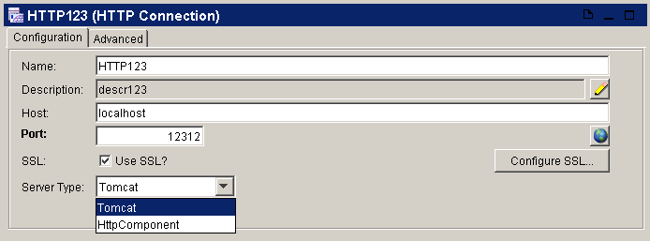

JDBC
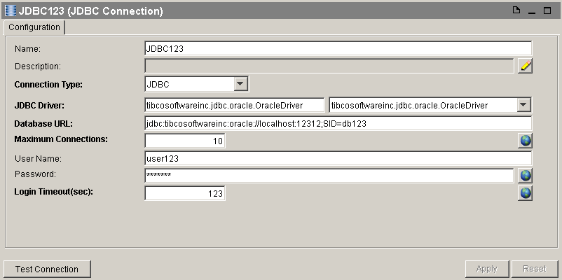

JMS
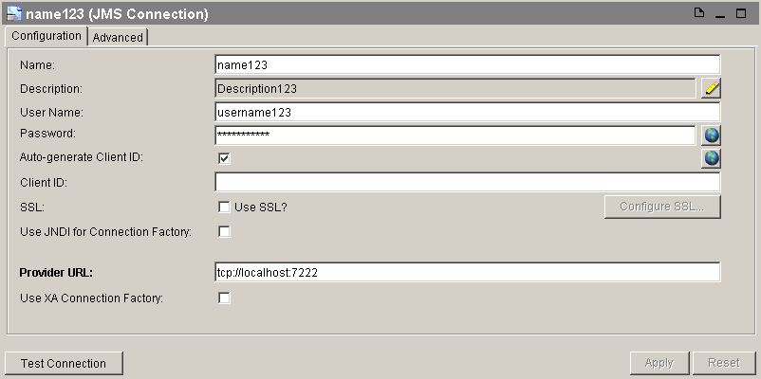

JNDI
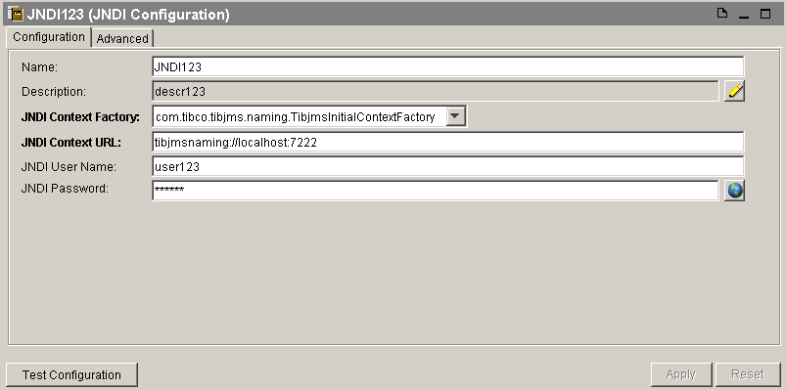

RV
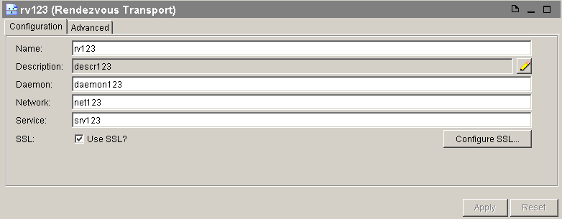

Proposed configuration in New BE Studio

HTTP Client / Server
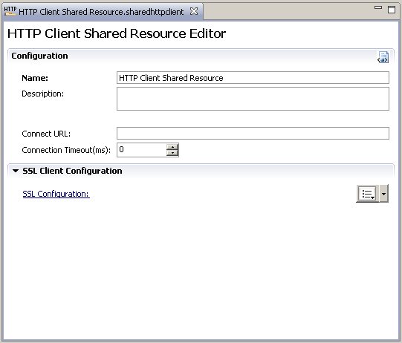
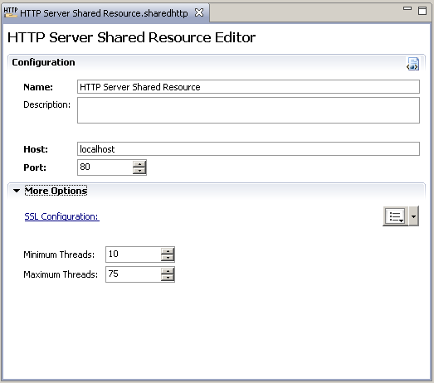

JDBC
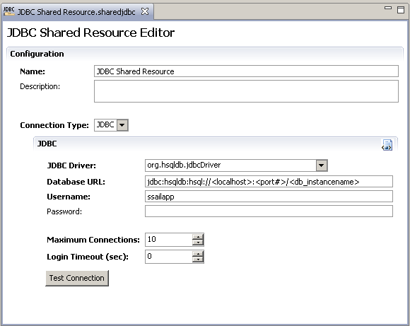

JMS
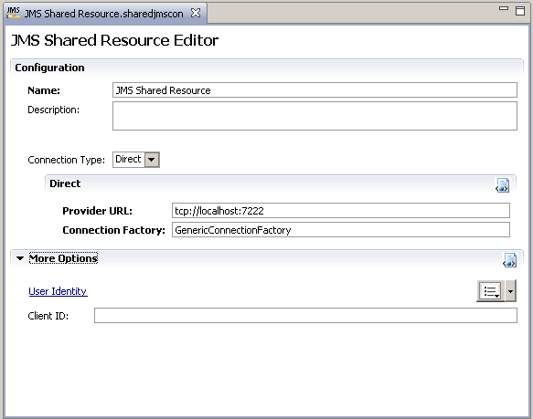

JNDI
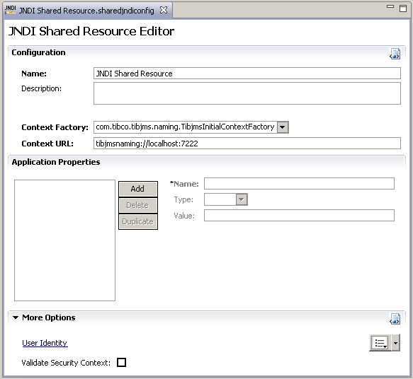

RV
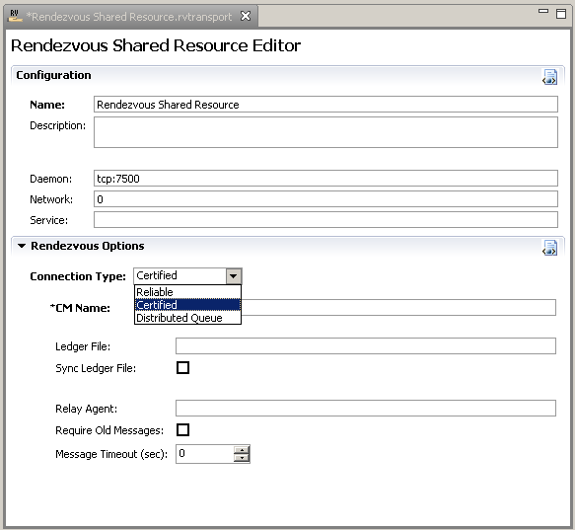

Jide schema-driven UI component

A schema-driven editor component from Jide may be developed and used to render the shared resource UIs. Please see the referred document.

