T

TIBCO BusinessEvents: WebStudio High Level Design

Product Suite | TIBCO BusinessEvents
Product | WebStudio
Product Version | 5.0
Initial Author | Gabe Grigorescu

Copyright Notice
COPYRIGHT© 2011 TIBCO Software Inc. This document is unpublished and the foregoing notice is affixed to protect TIBCO Software Inc. in the event of inadvertent publication. All rights reserved. No part of this document may be reproduced in any form, including photocopying or transmission electronically to any computer, without prior written consent of TIBCO Software Inc. The information contained in this document is confidential and proprietary to TIBCO Software Inc. and may not be used or disclosed except as expressly authorized in writing by TIBCO Software Inc. Copyright protection includes material generated from our software programs displayed on the screen, such as icons, screen displays, and the like.
Trademarks
Technologies described herein are either covered by existing patents or patent applications are in progress. All brand and product names are trademarks or registered trademarks of their respective holders and are hereby acknowledged.
Confidentiality
The information in this document is subject to change without notice. This document contains information that is confidential and proprietary to TIBCO Software Inc. and may not be copied, published, or disclosed to others, or used for any purposes other than review, without written authorization of an officer of TIBCO Software Inc. Submission of this document does not represent a commitment to implement any portion of this specification in the products of the submitters.
Content Warranty
The information in this document is subject to change without notice. THIS DOCUMENT IS PROVIDED "AS IS" AND TIBCO MAKES NO WARRANTY, EXPRESS, IMPLIED, OR STATUTORY, INCLUDING BUT NOT LIMITED TO ALL WARRANTIES OF MERCHANTABILITY OR FITNESS FOR A PARTICULAR PURPOSE. TIBCO Software Inc. shall not be liable for errors contained herein or for incidental or consequential damages in connection with the furnishing, performance or use of this material.
For more information, please contact:
TIBCO Software Inc.
3303 Hillview Avenue
Palo Alto, CA 94304
USA
Table of Contents
TIBCO BusinessEvents: WebStudio High Level Design 1
1 Change Log 4
1.1 Related Documents 4
2 Introduction 5
2.1 Main Objective 5
2.2 Intended Usage 5
2.3 Audience 5
3 Acronyms and Vocabulary 6
4 Non-Functional Requirements 6
4.1 Packaging 6
4.2 Portlet support 7
4.3 Performance 7
5 High-level Design 7
5.1 Components 7
5.2 Home Page 8
5.2.1 User Profile 8
5.3 MyGroups 9
5.3.1 MyGroup lifecycle 9
5.3.2 Instance chooser lifecycle 10
5.4 Work Area 10
5.5 Toolbox Area 10
6 Individual Component Design 10
6.1 Common Widgets and Functionality 10
6.1.1 Authentication and Authorization 10
6.1.2 Login 11
6.1.3 Project Explorer: TODO 11
6.1.4 Decision Manager: TODO 12
6.1.5 BPMN Process Editor: TODO 14
6.1.6 Instance Editor: TODO 14
6.1.7 Rule Editor: TODO 15
6.1.8 Rule Template Editor: TODO 16
6.1.9 WebStudio Portal/Initial User Experience 16
7 Webstudio Server (WSS) 17
7.1 High Level Design 17
7.1.1 Component Design 17

Change Log
.
Date | Version | Name | Description
12/29/2010 | 1.0 | Gabe Grigorescu | Initial doc
01/10/2011 | 1.0.1 | Aditya Athalye | Added more comments related to WS server.
05/25/2011 | 1.0.2 | Aditya Athalye | High level design approach WS server.
09/01/2011 | 1.0.3 | Ryan Hollom | Added WebStudio Portal design

Related Documents
Document Title | Revision Number | Author
BE 4.0 Requirements, Design, and Implementation documents | Various | various
BE BPMN Requirements/Design document | 2.4 | Gabe Grigorescu

Introduction

Main Objective
The objective of this document is to outline the high level design of the new web-based Studio component in TIBCO BusinessEvents.

Intended Usage
WebStudio (the name is not decided yet) is intended to provide end-users a lighter (web footprint) and much easier to use (business-friendly) environment to author, manage, and deploy BE artifacts and projects. More specifically, it is meant to give business users the ability to easily interact with the lifecycle of a BE application via a web browser interface. It will also enable these users to easily not only create event processing and decision metaphors (such as decision tables, trees, graphs), but also collaborate with others via the web, gain a better understanding of the BE Project, how the components interact, analyze potential problems of the project, and manipulate running instances of BE applications.
As BusinessEvents is used across many domains and client types, WebStudio will also provide a toolkit approach for developers to assemble the user interface required for an application.
The scope of this document is to provide a high level design of Web Studio.

Audience
The document is intended for Developers, Architects, QA, Product Marketing, and Managers.

Acronyms and Vocabulary

The table below describes some of the Acronyms used in this documentation
- BE – TIBCO BusinessEvents.
- WS -- WebStudio

- WSS – Webstudio Server
- RMS -- Rules Management Server. It is the existing component, which we will need to modify to support WS needs, or a completely new server component.
- PE – Project Explorer view in BE Studio
- DM -- Decision Manager
- Studio Project – A TIBCO Project build using TIBCO BusinessEvents Studio.
- ACL -- Access Control List. Security configuration file on server end to control what each user role is allowed to do.
- BUI -- Business User Interface
- GWT – Google Widget Toolkit

Non-Functional Requirements
The following section briefly covers in more details the non-functional requirements for the initial versions of BE WS. The requirements document covers these requirements in more detail.

Packaging
For now, we are planning to embed this new component as a separate addon that is meant to be sold with the core BE component. The server component, which I am currently envisioning to be built on top of the existing RMS, must also be made available.
Furthermore, the decision table functionality, which is a key component of BE WS, is currently a different addon. All of the other addons can "contribute" to the core WebStudio addon their own functionality. For example, decision table component of WebStudio addon will only exist in the Decision Manager addon, same for decision tree editing, or BE Processes (BPMN).
Thus, if someone installs WS but does not have any of the other add-ons, they will only get web-based functionality that comes with the core, such as instance editing and any kind of rule/ontology editing that is part of the core component (in Eclipse).
The core WebStudio addon will simply have rule editing, instance editing, and of course the server component.
The advantages of the latter approach are that different module users can benefit from the appropriate BUI: for example:
Core: edit concepts / BE rule parameters at runtime, create events, view reports, run / create / edit tests, deploy (eg to test)
DM: edit decision metaphors
BPMN: edit business process diagrams
Data Mgmt: edit state models, view DB data and update DBConcepts
Views: view dashboard alongside edit components, ability to edit parameters used in Views, etc
Stream Processing: create / navigate queries and event patterns

Portlet support
All widgets of BE WS should be exposed as portets (support JSR 168?) or gadgets. This will enable our customers to decide which widgets they want to expose.

Performance
We should support many concurrent users on the same server. We should ensure a minimum of 10-50 users can concurrently interact with the server on the same project. Some of our customers will want hundreds of users as well.
We should also enable our customers to deploy multiple RMS instances to support a larger number of concurrent WS users.
The server component (RMS extended) should be cache based with BS support. To handle concurrent requests and provide Load Balancing, the server component can contain multiple agents (Inference Agents in BE terminology) so as to handle the load. Also the server component will use HTTP Channels which means each Inference agent could potentially have a separate instance of a channel running (different ports) and a virtual load balancer would be needed to route a request to appropriate channel (inference agent).

High-level Design
The following section covers the high level design for the initial version of BE WS. The Requirements document covers the requirements for each of these areas in more detail.

Components
The basic architecture is typical client-server architecture with emphasis on a lightweight client and the server component doing the bulk of model work.
At a high level following 2 components are envisaged:
1.) WebStudio Client (aka Webstudio/WS) : The client side of the Webstudio product will be a browser based rich client UI which will be used by various types of users as a designtime tool for authoring BE projects.
The number of components that will be part of BE WS will increase over time. Initially, these are the components we will address. What is defined as a "component" is also up for debate. Each component will also have several widgets and probably other subcomponents as well. We list here just the high priority components we need to design and implement in the first version:
Decision Manager decision metaphors: decision tables.
BPMN Process: customized tasks, invocation of editors on a decision task, sequence flows.
Instance and Ontology Editor: concept instances.
Rule Template Editor: populate inference rule templates.
Rule Editor: very simple rule editing

Home Page
We want to avoid a developer/technical oriented home page. Thus, a standard Eclipse-like UI with the project explorer on the left, editor area, and other views will be too much for business users. Instead, an easier interface, like Facebook or other sites, would be better.
Along these lines, as can be seen from the screenshot below, we can have the following default layout.
An application bar. This will show the logo, the current project viewed which can be changed via a dropdown list, and then what you're logged in as.
Toolbar (optional). This can have the standard purpose. It's questionable whether we may even always need this.
Below this, we have the main area, which can be split up into 3 areas, where each section can be collapsed or resized. On the left side we can have the "My Groups" area. In the middle we have the main work area, and on the right side we have the Toolbox area.

User Profile
The home page is associated with a user profile. Each user gets a default profile depending on the user role they have. Thus, this user profile is made up of the following values:
- permissions (user role)
- default project (if any)
- "My Group" definitions (folder contents, names, expanded/collapsed, location)
- work area and tools location/size/expanded status
- work area tabs open..

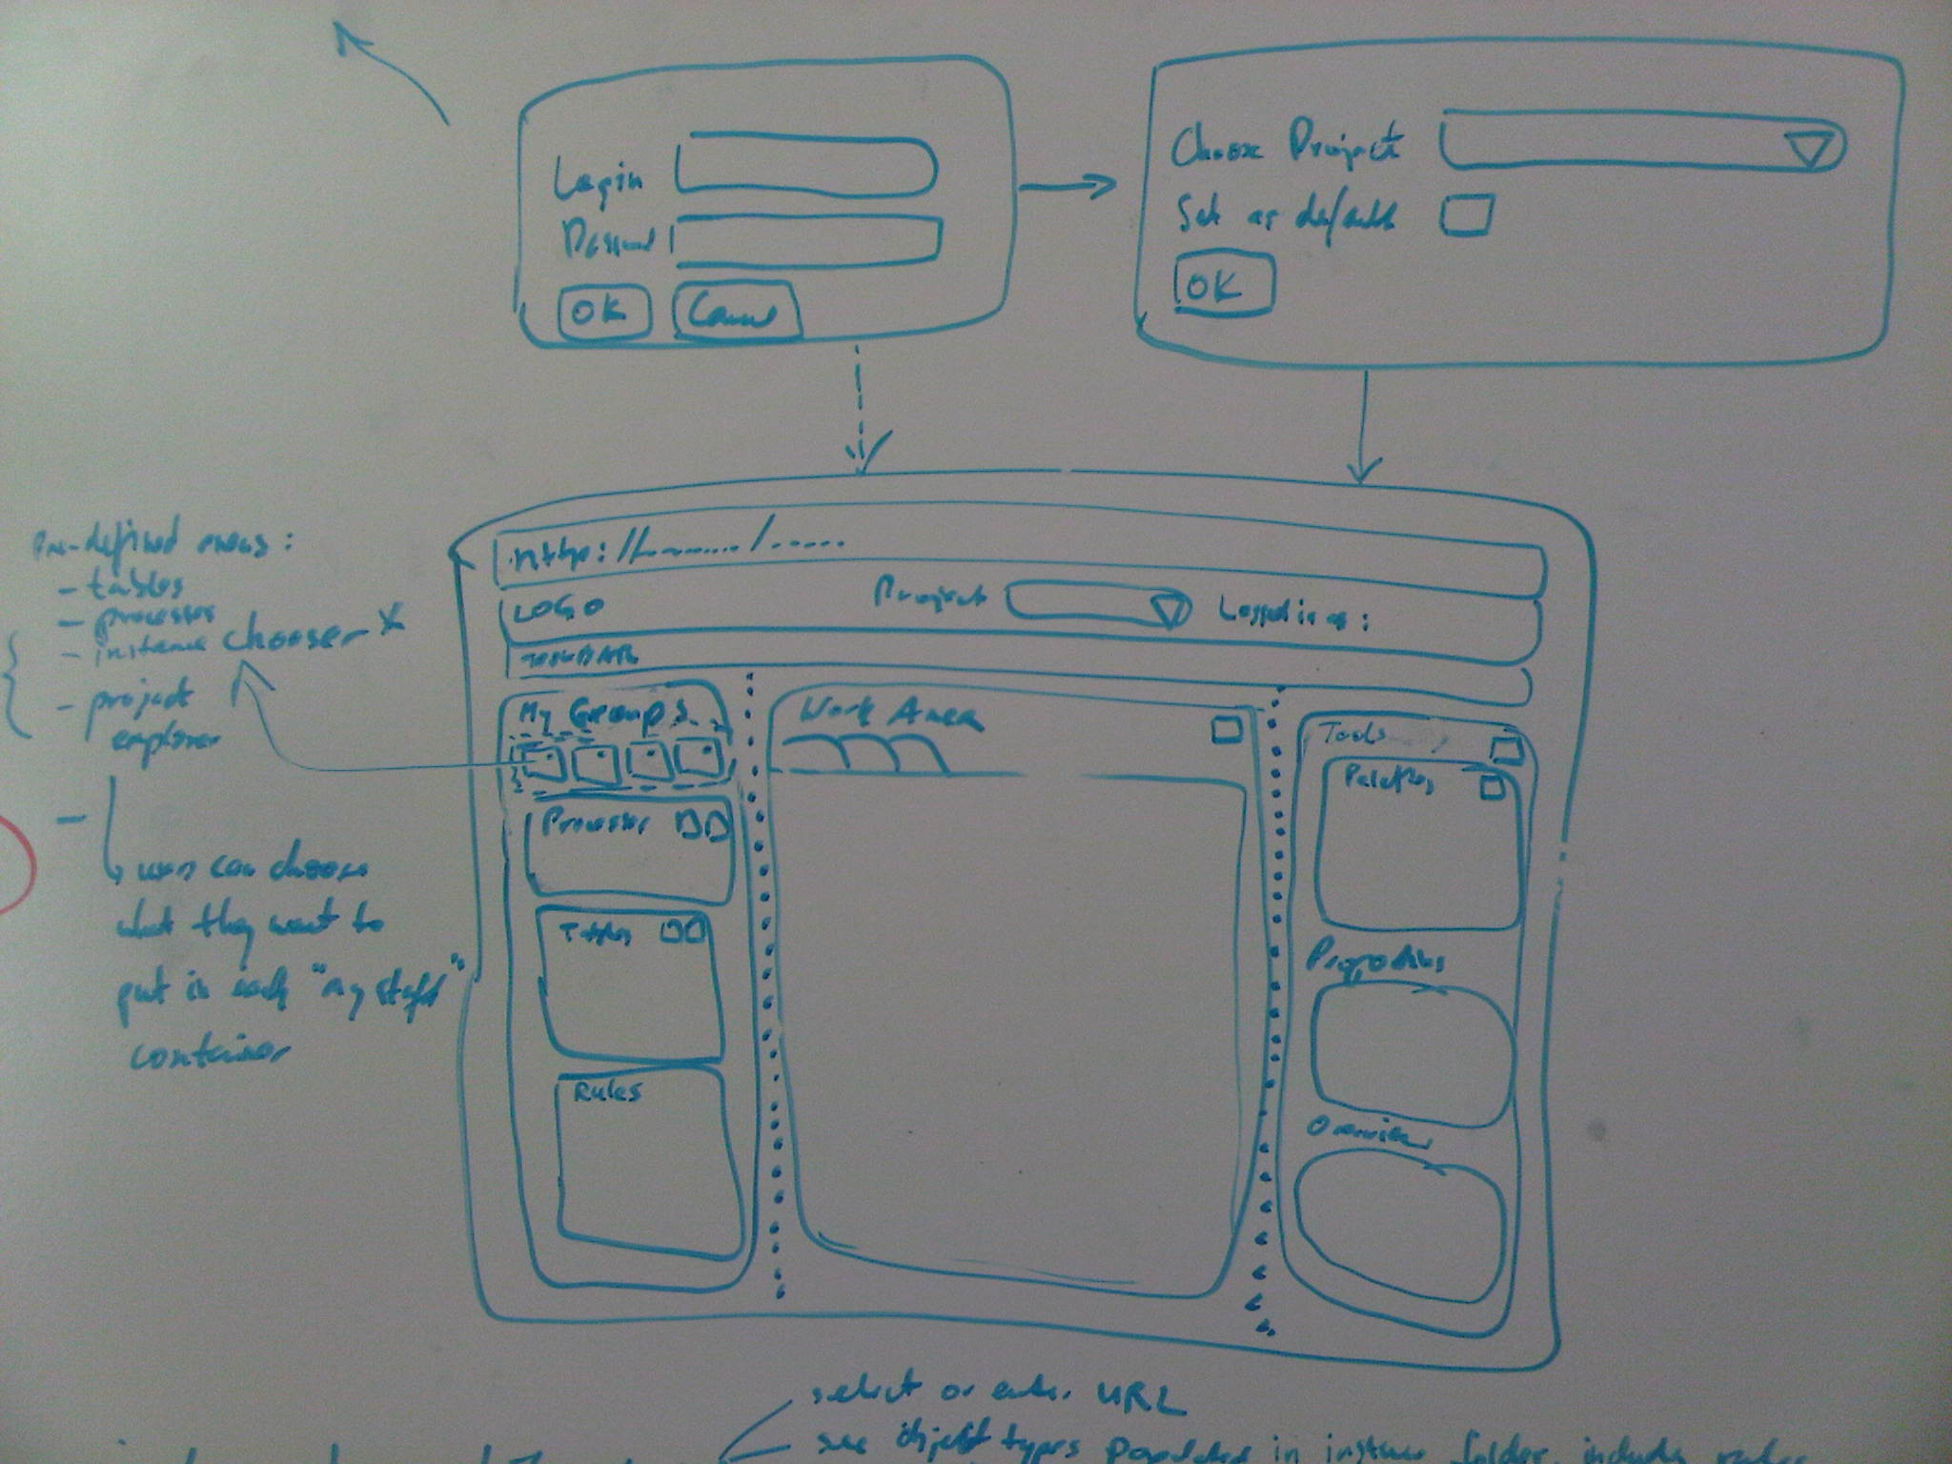Lo

MyGroups
In this section we can have some predefined groups, which users can open by clicking on them (we can just show collapsed folders):
- tables
- processes
- instance chooser. It cannot be deleted as it's a "system" group.
- project explorer (this is like the one we have now). It cannot be deleted as it's a "system" group.
Users can of course also create their own groups, where they can choose what they want to put in each group container. CRUD/minimize operations will be supported for these groups.

MyGroup lifecycle
Users can create, delete, rename, collapse, expand them. Defining what's in each group can be done via several paradigms. Users can choose what they want to add to a group by:
- type (e.g.: "all tables")
- folder (I want "/projectName/myStuff" folder)
- selecting individual files from some checkbox tree view
Then users name this group, then save it.

Instance chooser lifecycle
These are the steps users have to go through to use this.
- users select an engine or type in some URL
- they see object types populated in the instance folder, including rules
- they select what they're interested in to see instances and modify them in the work area.

Work Area
This is the main area in the browser. It can support multiple tabs. Users will be able to see diagrams, tables, do instance editing. It can be resized to "squeeze out" other areas if needed. It can also be maximized or minimized.

Toolbox Area
The toolbox area can be populated with different gadgets depending on what the user is doing in the work area. It can also be collapsed and hidden completely. This area is similar as the MyGroup area in the sense that it allows the management of whatever gadgets it has (expand, collapse). It can contain Palettes, Overview, etc.

Individual Component Design

Common Widgets and Functionality
Certain components will be needed by all components that make up BE WS. A layered web framework will be required to exploit re-use across WS UI components and uses.

Authentication and Authorization
Just like BE MM, BE Views, and BE DM/RMS (Eclipse-based), the new BE WS will use the same JAAS-based authentication and authorization system. Users will need to login to a customizable server. File-based or LDAP-based will be supported. Once a user successfully logs in, the server component will send the UIs and information that the user's role is allowed to see. Authorization should be user role-based.
What BE WS users are allowed to do (modifying rules, tables, creating, viewing) must be fully access controlled. Auditing of such access will also be supported.
Access to the server will be done only through the browser, there should be no local installations allowed on the business users' machines.
TODO: modify existing ACL file format how? Is it even needed?

Administration User Interface
There needs to be a formal UI accessible only to administrators where ACLs can be configured. This admin console can be used to specify access permissions for every project (entities in each project.)
Session Management should be left to the server (BE engine). We make WS server a clustered server with FT/LB features provided by BE it is important to let the server manage all the state/session information. Session timeouts will be handled via schedulers in BE. State Timeouts is also an option for this where a State Machine on the server actually keeps 2 states Login/Logout where the Login state has an inactivity state timeout which takes it to Logout state. Maintaining HTTPSession on server will not allow us to provide High Availability features.
TODO: details.

Login
As shown in the screenshot shown in the Home Page section, users will need to authenticate themselves first via a Login screen. Upon successful authentication, they will be presented with the option to choose a project they want to work on, and if they want to set that as the default one the next time they login. If the previous time they logged they already selected a project, the home page will be populated with that project.
Access Control checks will be made here to show only those pages (portlets?) that the logged in user’s role(s) has access to. This also applies to optional menu items that user can see.
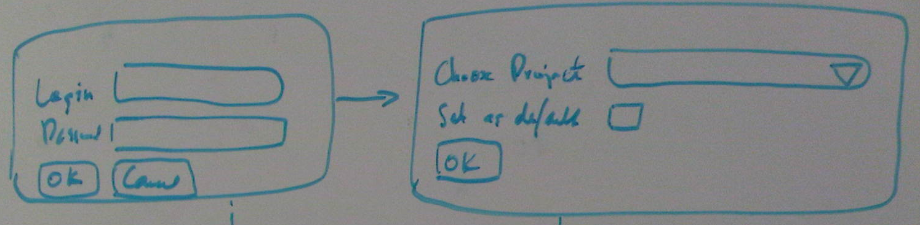

Project Explorer: TODO
BE WS is not meant to be a port of BE Studio to the web. Thus, although a "project explorer" should exist, it should most likely be collapsed by default. Instead, given that the focus is to provide a business user friendly interface that is simple and not technical, we should provide a customizable home page where users can organize the artifacts they work on. Examples include what we have now in BE Views, Facebook, Yahoo homepages, etc. They may have a window where they have BPMN Processes, Decision tables, etc. A button in those windows would allow them to have CRUD operations on those types of artifacts. Of course when they create new objects, they'll need to specify where to store those files, but that information can then be hidden and now shown.
A project explorer component should be made available to allow users to scroll through the section of their application that they are allowed to see. This does not necessarily need to be a tree control, but can be rather a button-based that automatically filters out the unwanted types of artifacts. For example, it can allow users to navigate folder by folder by clicking on buttons, and when you click on the right-most button, it shows you the artifact types you are interested in (depending on what the main component is all about).
For example, users can keep on expanding to the right as they select which folders they want to see:
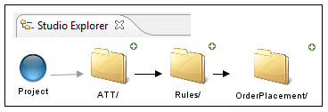
then, when they click on a folder (OrderPlacement in this case), they'd get a dropdown so they can choose which folder to see or which artifact to open:
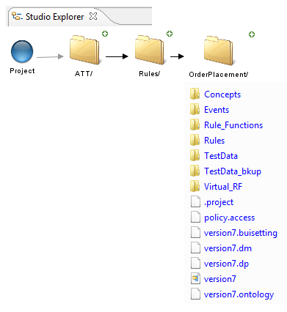

Decision Manager: TODO
At a high level, this component should support basic table editing, table analyzer.

Decision Tables
Users should be able to import from Excel, export to Excel, create new tables, edit existing tables, and run Table Analyzer functionality (functionality currently available in BE Studio).
Decision tables should support pagination to avoid loading entire large tables in the browser.
Loading DTables from Excel files should be left to the WS server component. The primary reason for this is, pagination handling is a server side responsibility and if users are allowed to do this operation locally, client side will have to manage pagination aspects making it fatter than intended. The flip side however to this is that clients may not be able to do this operation without connecting to the WS server.
We should also add utility Excel like functions which Business users are comfortable using.This has come as a requirement from some field folks.
Design-time variables need to be supported as well. These variables can be defined at table level and accessed anywhere inside the table (decision/exception). These variables can be complex expressions themselves containing other variables.
We do need to keep our Table Analyzer, so the table widgets will need to be combined with a new component:

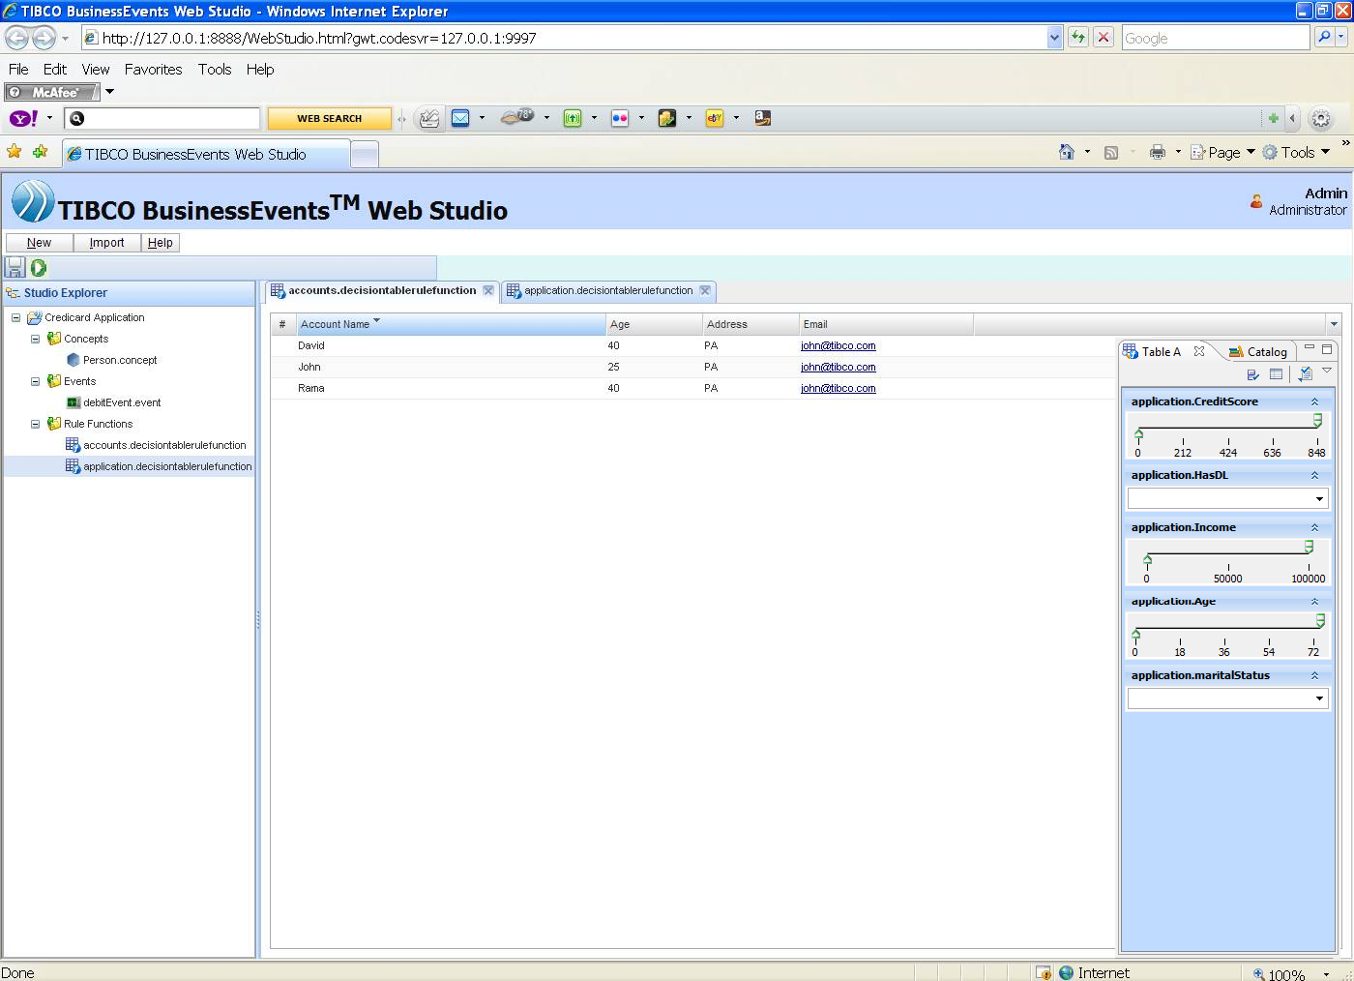

Decision Trees
We will probably not implement decision tree editing in the first version. We should be able to create decision trees fairly easily though.
TODO: how to at least let them view decision tree views from tables.

Decision Table workflows
This will be a subset of a BPMN process editor, except users will only be able to define a process made up RF and DT invocations.
TODO: in first version we will most likely not do this.

BPMN Process Editor: TODO
At a high level, this component should mimic the functionality we have available in the Eclipse-based version.

Instance Editor: TODO
There are different runtime artifacts that can be edited while the engine is running. Users may want to change concept property values after they connect to a certain engine to run "what-if' scenarios and see what would happen. They may also want to change rule parameters so they can change the behavior of a rule without going through the painful process of changing the rule in BE Studio, package the ear again, then hot deploy it. For example, if a rule's condition is to see if a person's age is between 18 and 36, web users may want to change just those two parameters.
Just like in the existing BE Studio Tester users can connect to any engine (local or remote), users can do the same via BE WS:
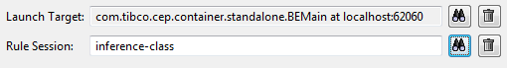
Then, they may or may not assert test data, but they should be able to see the contents of the WM in a table format, then edit the values of the object properties, click on "Post" and then see what rules may fire due to the change. After this, the users can then see the test results to see the effect of their changes.
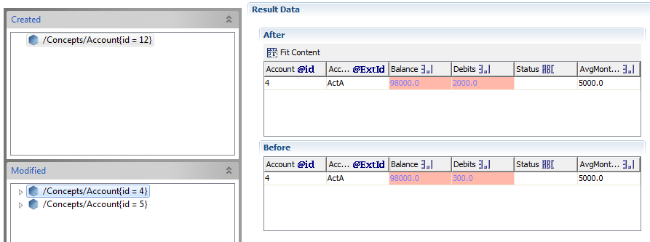

Meta-Data Server
The WS server will maintain state on its end which can be recoverable even upon restart of the server. WS server which essentially would be a BE engine running in cache mode supported by BE data grid functionality (optionally Backing store also) will handle Fault Tolerance as well as Load Balancing aspects to ensure High availability and concurrent use.

Rule Editor: TODO
Another important component is a rule editor. This component itself can have two parts.
The first can consist of a web version of a "full" rule editor (with any restrictions we may need to add due to no longer having an Eclipse framework available). A simple UI is needed, like this:
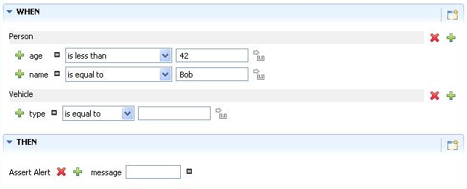
The second is the ability for users to browse an existing project, select a rule, and then be able to modify parameters of that rule and then "hot deploy" them to any instance of a BE engine running. This would require a customized UI where we show just the editable components, and the rest are shown as read-only (as a convenience). We need to figure out a way to let the users designate how to identify what is a modifiable "rule parameter." For example, if a rule condition has:
person.age > 50
then we need to decide whether they can change the operator, or just the "50" or both, and once that's decided, how do we know what they can change? We could either let developer mark the section that is changable, or we allow the user to change anything in the condition but add some restriction via web-based logic (coding).
Once decided, the engine needs to pick up the changed parameters and any future rule invocation would use those new values.
We should also allow users to call other functions, so they can create simple rules like this (received from Andreas Gerst):
WHEN:
sum(call time) where destination=international and ...> .95 * sum
> (call time) where<custom filter>

Rule Template Editor: TODO

WebStudio Portal/Initial User Experience

we should provide the user the ability to group activities via portlets onto one or more portal pages, accessible via a navigation pane on the left side:

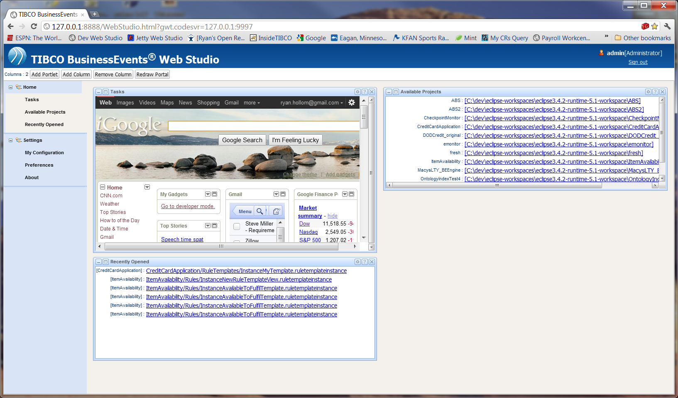

Each Portlet, then, provides a “modular” view and a “maximized” view. The modular view is a higher level view that is shown on the portal page itself. However, if the user clicks on an individual activity/portlet from the navigation pane, the other portlets on that view will be hidden and the selected portlet will be maximized, showing additional content details. For instance, if the user clicks on the “Available Projects” link, they would see something like this:
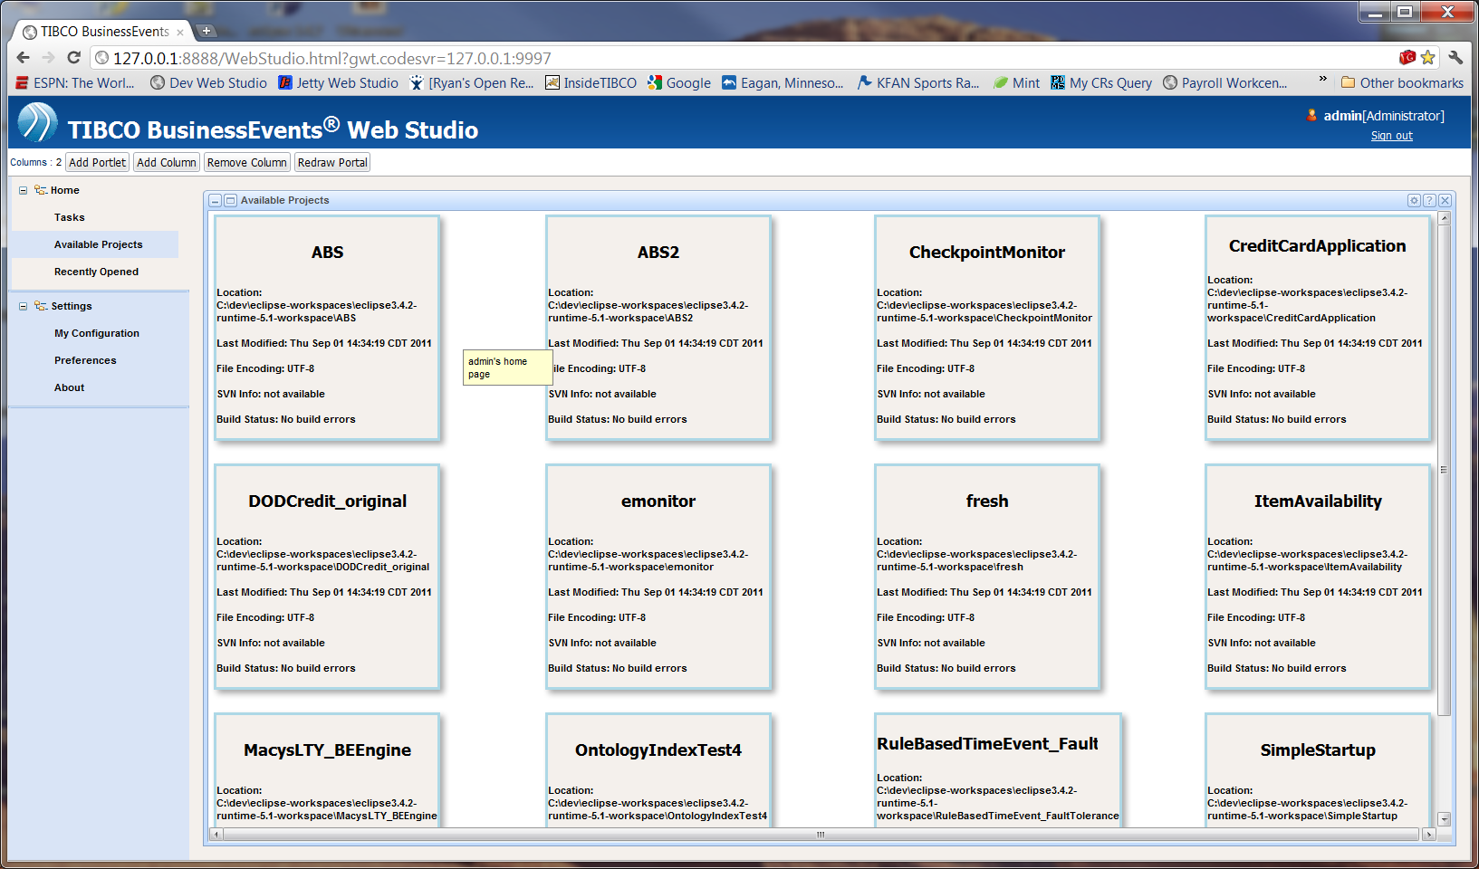

That way, we can provide a configurable approach that allows users to group their basic activities onto a single “jumping off point”, but also provide a mechanism to drill down into some of those activities. We would provide a default initial portal page, as well as several other configurable portlets (for instance, webpage portlets), so that the user can add/remove new portlets as appropriate.

Webstudio Server (WSS)
The server component will be developed using the BE platform so as to leverage certain benefits provided by BE:
HTTP channel support.
Caching infrastructure for state persistence which can be used for session management and such.
Failover/LB support if required.
State Machine support out of the box.

High Level Design
WSS will use various features provided by BE. Since it will be developed using BE platform, most of the ore server logic will be implemented in BE rules/Rule functions/Decision Tables etc. The WSS model will be represented using BE’s concept model and interactions with the WS client will be modeled as events.
WSS clients will communicate with the server component via exposed HTTP channel(s) such that standard HTTP REST style interactions will occur. Client messages will be transformed to events on the server (like any BE application) and appropriate rules will be triggered to satisfy the client request.

Component Design
Various design choices are outlined as below:
- HTTP Transport

HTTP transport will be used by client to interact with the server and this will be via HTTP channel provided by BE. It is envisaged that the client will be developed using a rich client UI tool like GWT or the like, the web application will make HTTP request to the server and get response back much the same way that RMS and RMS clients interact. Load balancing for the channel can be via a virtual load balancer like the one from apache.
- Web-app Deployment and server communication

An important design consideration to be given is deployment of the web-application containing the client code. Since it is suitable to have the client code interact with the same server on which it is deployed (see Same Origin Policy SOP http://en.wikipedia.org/wiki/Same_origin_policy), the channel can also double up as a rudimentary webserver. The BE HTTP channel would have to be augmented to support deployment of web application (WAR) on an embedded TOMCAT (BUILT-IN support Nice to have). However the major difference from deployment of WAR onto stand-alone web/J2EE server and the BE channel would be that all client requests for WSS will be routed to the same HTTP servlet with the context URI mapping to the destination being the differentiator.
GWT (Assuming GWT is the client side technology choice) facilitates developing RPC style services for the server component which can then be deployed on server, however the server being a BE application obviates usage of GWT RPC services for the WS server.
Hence we will have to solve the communication problem with AJAX style HTTP request API provided by GWT which would require specification of the URL (standard BE HTTP channel URL) and data retrieval/post via standard HTTP 1.1 methods.
Asynchronous communication will be preferred though it should not be considered as binding.
- Communication data Protocol

BE is tailor made to work with XML input/output data hence data communication to and from the server should be XML as far as possible. Non-XML data (rules/rule functions etc.) could be wrapped into XML.
- Session Management/FT/LB

Object Management used will be cache to get Failover support as well as reliability when combined with backing store.

