T

TIBCO BusinessEvents: WebStudio Rule Template Design

Product Suite | TIBCO BusinessEvents
Product | WebStudio Rule Templates
Product Version | 5.1
Initial Author | Ryan Hollom

Copyright Notice
COPYRIGHT© 2011 TIBCO Software Inc. This document is unpublished and the foregoing notice is affixed to protect TIBCO Software Inc. in the event of inadvertent publication. All rights reserved. No part of this document may be reproduced in any form, including photocopying or transmission electronically to any computer, without prior written consent of TIBCO Software Inc. The information contained in this document is confidential and proprietary to TIBCO Software Inc. and may not be used or disclosed except as expressly authorized in writing by TIBCO Software Inc. Copyright protection includes material generated from our software programs displayed on the screen, such as icons, screen displays, and the like.
Trademarks
Technologies described herein are either covered by existing patents or patent applications are in progress. All brand and product names are trademarks or registered trademarks of their respective holders and are hereby acknowledged.
Confidentiality
The information in this document is subject to change without notice. This document contains information that is confidential and proprietary to TIBCO Software Inc. and may not be copied, published, or disclosed to others, or used for any purposes other than review, without written authorization of an officer of TIBCO Software Inc. Submission of this document does not represent a commitment to implement any portion of this specification in the products of the submitters.
Content Warranty
The information in this document is subject to change without notice. THIS DOCUMENT IS PROVIDED "AS IS" AND TIBCO MAKES NO WARRANTY, EXPRESS, IMPLIED, OR STATUTORY, INCLUDING BUT NOT LIMITED TO ALL WARRANTIES OF MERCHANTABILITY OR FITNESS FOR A PARTICULAR PURPOSE. TIBCO Software Inc. shall not be liable for errors contained herein or for incidental or consequential damages in connection with the furnishing, performance or use of this material.
For more information, please contact:
TIBCO Software Inc.
3303 Hillview Avenue
Palo Alto, CA 94304
USA
Table of Contents
TIBCO BusinessEvents: WebStudio Rule Template Design 1
1 Change Log 4
1.1 Related Documents 4
2 Introduction 5
2.1 Main Objective 5
2.2 Intended Usage 5
2.3 Audience 5
3 Acronyms and Vocabulary 6
4 Non-Functional Requirements 6
4.1 Packaging 6
5 High-level Design 6
5.1 Rule Templates 6
5.1.1 Declarations section 8
5.1.2 Pre-conditions section 8
5.1.3 Action Context section 9
5.1.4 Bindings section 9
5.1.5 Views section 10
5.2 Rule Template Views 10
5.3 Rule Template Instances 12
5.3.1 When section – Condition Builder 13
5.3.2 Then section – Command Builder 14
5.3.3 Non-Builder/Views Approach 15
6 Execution 15
Largely TBD. The combination of one rule template and one rule template instance make a unique instance of a rule that can be executed. There is a one-to-many relationship from rule templates to rule template instances – one rule template can have many rule template instances. 15
The execution of this unique combination should be done in an interpreted way, rather than by generating java code as is done with traditional rules. The interpreter will introspect the rule templates pre-conditions/actions, and combine that information with the information from the rule template instance. If bindings have been defined, the rule template instance must provide the values for those bindings. 15

Change Log
.
Date | Version | Name | Description
9/9/2011 | 1.0 | Ryan Hollom | Initial doc

Related Documents
Document Title | Revision Number | Author
WebStudio-GeneralDesign.doc | Various | various

Introduction

Main Objective
The objective of this document is to outline the high level design of the new Rule Template feature in TIBCO BusinessEvents 5.1.

Intended Usage
The intended usage of Rule Templates is to provide a mechanism to define “virtual rules” that are “filled out” via a user friendly interface inside of WebStudio. Rule Templates are analogous to Virtual Rule Functions, in that they contain no (or incomplete) actions and conditions. Decision Tables are designed to implement/complete a virtual rule function definition. Similarly, “Rule Template Instances” are defined to complete the Rule Template definition, and to create an executable rule.

Audience
The document is intended for Developers, Architects, QA, Product Marketing, and Managers.

Acronyms and Vocabulary

The table below describes some of the Acronyms used in this documentation
- BE – TIBCO BusinessEvents.
- WS – WebStudio
- WSS – WebStudio Server
- RMS -- Rules Management Server. It is the existing component, which we will need to modify to support WS needs, or a completely new server component.
- PE – Project Explorer view in BE Studio
- Studio Project – A TIBCO Project build using TIBCO BusinessEvents Studio.
- ACL – Access Control List. Security configuration file on server end to control what each user role is allowed to do.
- BUI – Business User Interface
- GWT – Google Widget Toolkit

Non-Functional Requirements
The following section briefly covers in more details the non-functional requirements for the initial versions of BE WS. The requirements document covers these requirements in more detail.

Packaging
Rule Templates should be considered as part of the core/standard BE component, and Rule Template Instance support will be part of the core BE WebStudio component.

High-level Design
The following section covers the high level design for the initial version of BE Rule Templates.

Rule Templates
Rule Templates are defined inside of BE Studio, and are intended to be designed by more technical users, similar to Rule developers. A Rule Template is in fact a special type of Rule, and contains the familiar “Declaration” section as well as specialized condition and action sections. Rule Templates are first class citizens inside of a BE Studio Project, and their file extension is “.ruletemplate”.
Form Editor, main tab:
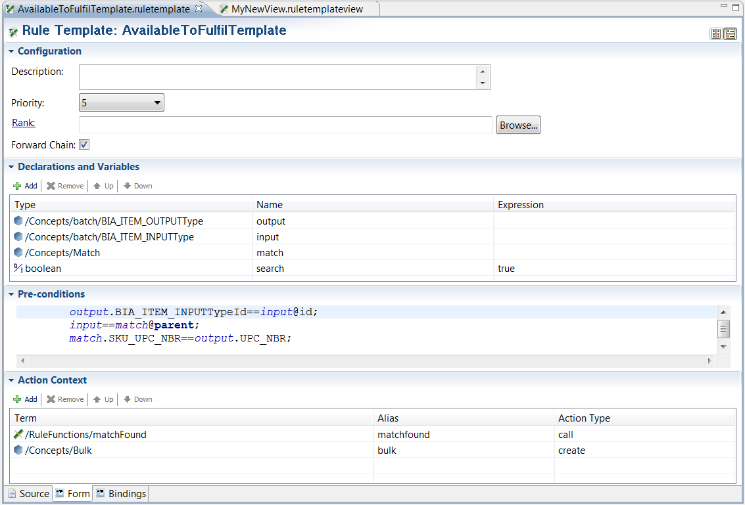
Form Editor, Bindings tab:
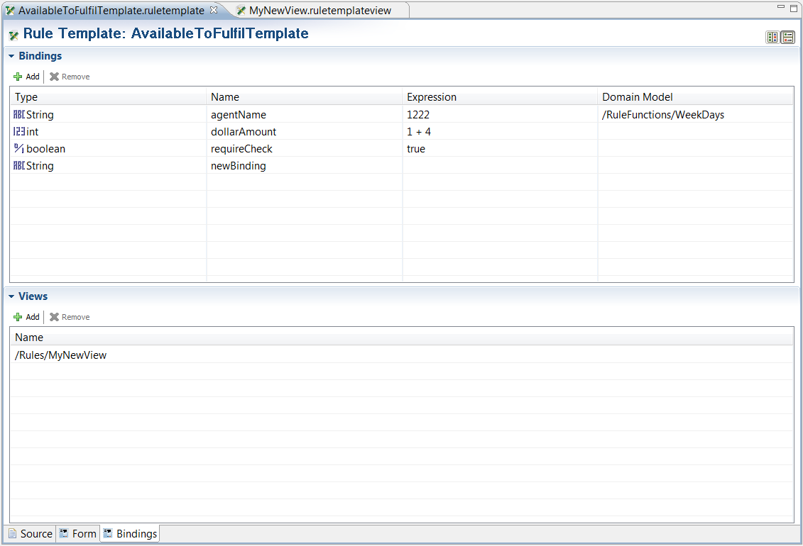
The syntax for the above rule template is as follows:
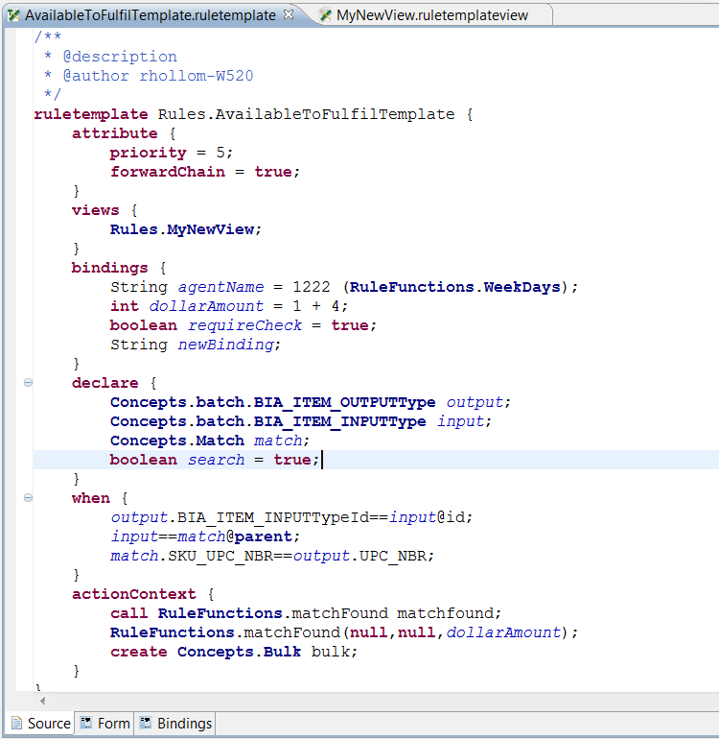

Declarations section
The declarations section (‘declare’) is similar to the declarations section of a rule. However, in rule templates you can declare primitive types (similar to rule functions), as well as define initial expressions for these types (for instance, int j = 50;).

Pre-conditions section
The pre-conditions section (‘when’) section is similar to the conditions section of a rule. These are conditions that must be met before the rule’s actions are fired. However, in rule templates, these are called “pre-conditions” as they are only first level checks, defined by the rule template developer. Additional conditions can be defined by rule template instance developers in WebStudio.
Further, the pre-conditions section inside of rule templates can contain non-conditional statements (for instance local variable declarations) in order to provide more flexible and comprehensive condition checking capabilities.
The intent of the pre-conditions section is to define conditions that must be met in all rule template instances, rather than having to redefine common conditions in every rule template instance.

Action Context section
The Action Context section (‘actionContext’) is similar to the actions section of a rule. This section defines the actions to be taken after all conditions are met. However, this section also defines which actions can be taken by rule template instances. These statements are not executed unless they are defined as commands inside of rule template instances. The purpose of this section is to restrict which actions can be taken, as defined by the rule template instance developers. This is done to simplify rule template instance editing as well as control the level of access rule template instance developers have while defining rule template instances.
At this time, there are three available action context statements types:
- ‘create’ statements
This statement allows rule template instance developers the ability to create new concepts or events. For example,
create Concepts.Bulk bulk;

The rule template instance developer is responsible for assigning the constructor values for the entity type.
- ‘modify’ statements
This statement allows rule template instance developers the ability to modify instances of concepts or events. For example,
modify Concepts.Bulk bulk;

This entity must be in the scope of the rule. The rule template instance developer is responsible for determining which properties to change, as well as assigning values to those properties.
- ‘call’ statements
This statement allows rule template instance developers the ability to call other rule functions. For example,
call RuleFunctions.matchFound matchfound;

The rule template instance developer is responsible for assigning the parameter values for the rule function.

Bindings section
The bindings section (‘bindings’) is used in conjunction with the views section to define “placeholder” variables whose value can be set by rule template instance developers. Bindings must be primitive types, and are defined like other local variables. They can be given an initial assignment, but unlike local variables, they can also be tied to a domain model. For instance,
String day = "Monday" (RuleFunctions.WeekDays);
In this example, ‘day’ is initially assigned to the value of “Monday”, and is tied to the domain model RuleFunctions.WeekDays. If a domain model is specified, the rule template view will display the input field for this binding as a drop down box, rather than a simple input field.
A binding field can be used like any other global variable, in both conditions and actions. The value of the binding is specified in the rule template instance, and is therefore treated as a “placeholder” variable whose value can be set in BE WebStudio.
Two common examples for using bindings are in condition checks and in action statements. For instance, if there is a ‘dollarAmount’ binding defined, a condition might be defined as
output.UNIT_PRICE > dollarAmount;
so that the UNIT_PRICE is checked against a specific dollar amount defined by the rule template instance developer in BE WebStudio.
Similarly, an action statement could be defined in the Action Context section that calls a rule function, but one of the parameters is specified by the dollarAmount binding:
RuleFunctions.matchFound(match,null,dollarAmount);
This will call the matchFound rule function and pass the value of dollarAmount that is specified by the rule template instance developer in BE WebStudio.

Views section
This section is used in conjunction with the ‘bindings’ section to assign the visual presentation of the rule template instance that is created from this rule template. See the “Rule Template Views” section for more information on rule template views.
Currently, more than one view can be associated with each rule template. However, it is undecided how to determine which view is displayed, or whether it will only allow one view per rule template.

Rule Template Views
Rule Template Views are defined inside of BE Studio. Rule Template Views are first class citizens inside of a BE Studio Project, and their file extension is “.ruletemplateview”.
The purpose of a rule template view is to define how rule template instances are displayed inside of BE WebStudio. If the rule template defines one or more “bindings”, then this approach is generally used to define a form-like UI to allow the rule template instance developer to assign the value of these bindings (for instance, threshold values). If no rule template view is defined, then there is a “builder-based” UI that is presented to the rule template instance developer. See the “Rule Template Instances” section for more information on rule template instances.
Rule template views are first tied to a specific rule template, at which point the available bindings are displayed in a ‘Bindings’ panel. The actual view is defined as plain text or simple html inside of the “Presentation” section. See the screenshot below for an example of using simple html to define the UI. There is also a “Preview” section that allows users to see a preview of the rule template view, as it will appear in BE WebStudio. The bindings can be dragged and dropped from the Bindings panel to the Presentation panel, or they can be typed directly into the Presentation section. The UI syntax for a binding is as follows:
<binding id="bindingName"></binding>
It is necessary to type the closing “</binding>” tag. If the binding is associated with a domain model, the UI will display the input widget as a drop down. Otherwise, an input widget of the appropriate type is displayed (for instance, a check-box for a boolean field).
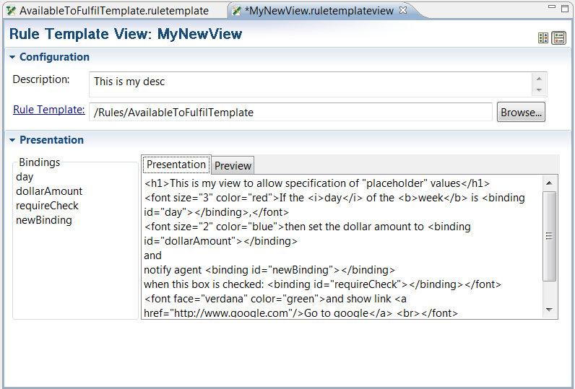
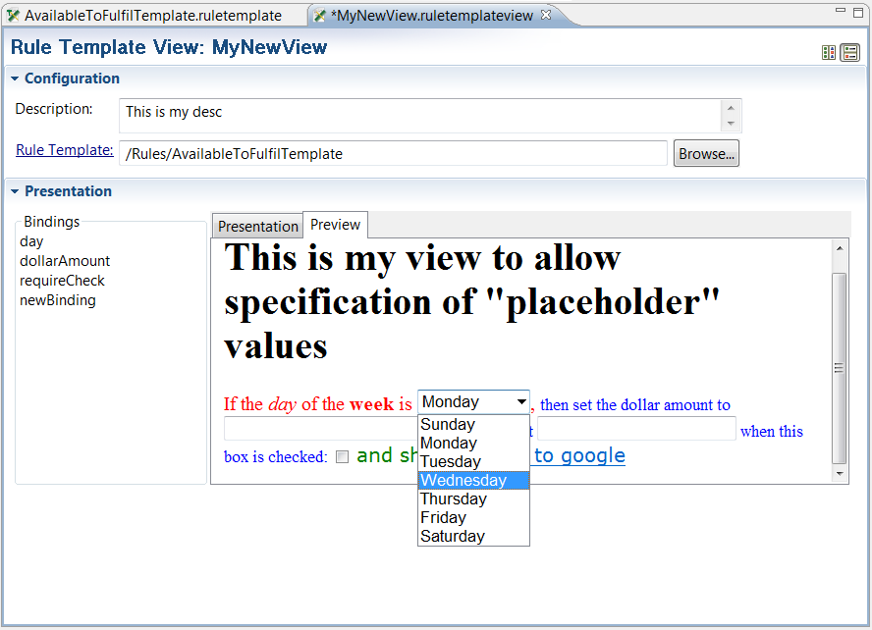
This view is displayed inside of BE WebStudio as:
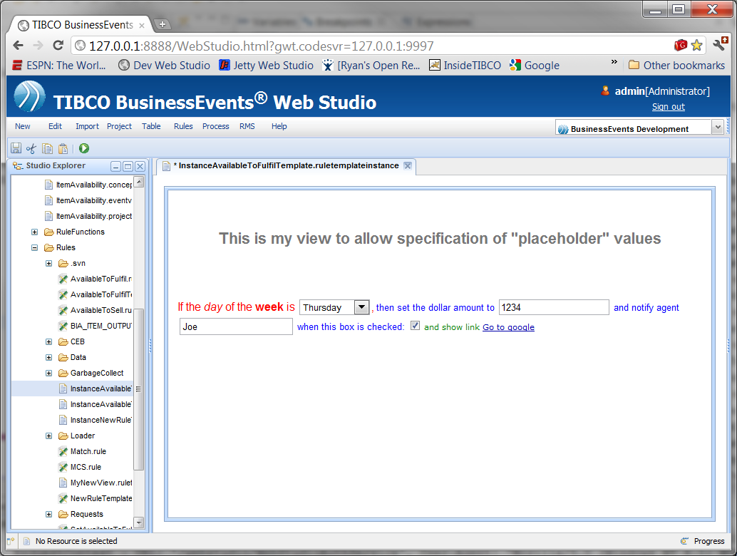

Rule Template Instances
Rule Template Instances are defined inside of BE WebStudio, and are intended to be used by non-technical users. Rule Template Instances are first class citizens inside of a BE Studio Project, and their file extension is “.ruletemplateinstance”.
A Rule Template Instance defines additional conditions that must be met before rule template’s actions can be executed. This is done by rule template instance developers in the ‘When’ section of the rule template instance editor via a “condition builder”. It also defines additional actions to be taken (if any). The available actions to be taken are specified in the Action Context section of the rule template. If there are any available actions that can be taken, they are specified by rule template instance developers in the ‘Then’ section.
Example UI:
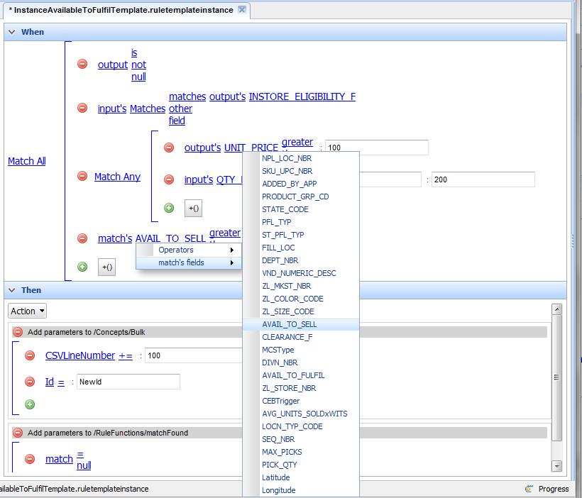

When section – Condition Builder
The ‘When’ section defines additional conditions that must be met, in addition to the pre-conditions that are defined in the rule template. This is done via a builder that determines the scope of the rule template, and allows the developer to define individual conditional clauses based on that scope. Each clause has one or more sub-clause, and the developer can select the condition/match type by clicking on the match operator link:
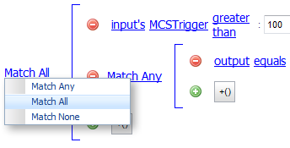
This specifies whether all sub-clauses must be met, none must be met, or any of them can be met for the clause to evaluate to true.
New sub-clauses can be added by clicking on the icon. New nested sub-clauses can be added by clicking on the  icon. Sub-clauses can be removed by clicking the icon.
Instance developers can navigate through the accessible related fields by clicking on the field links.
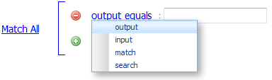
Once the initial field is selected (based on the scope of the rule template), the developer can either choose the operator for the condition by clicking on the operator link:
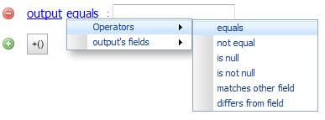
Or they can navigate to the properties and related fields by via the ‘fields’ menu (for instance, “output’s fields”):
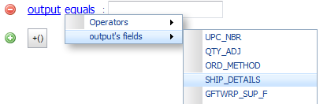
There are several operators that allow for comparison to other fields, rather than comparison to a simple value. For instance, “matches other field”. If these operators are selected, a similar link-based navigation is made available to select the field for comparison:
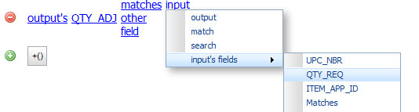

Then section – Command Builder
The ‘Then’ section allows rule template instance developers to define additional actions to be taken when all conditions are met. The available actions are restricted to the Action Context statements defined in the rule template. For instance, if the rule template defines a call action statement and a modify action statement:
actionContext {
call RuleFunctions.matchFound matchfound;
modify Concepts.Bulk bulk;
}

Then there are two available actions in the rule template instance editor:
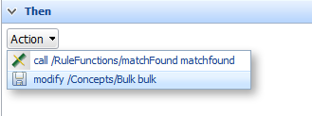
Once selected, a similar link-based mechanism is provided to fill out the appropriate information for the selected action.
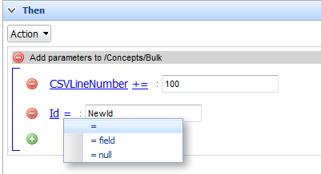

Non-Builder/Views Approach
See the section on Rule Template Views for more information on an alternative approach to pre-define the UI for rule template instances.

Execution
Largely TBD. The combination of one rule template and one rule template instance make a unique instance of a rule that can be executed. There is a one-to-many relationship from rule templates to rule template instances – one rule template can have many rule template instances.
The execution of this unique combination should be done in an interpreted way, rather than by generating java code as is done with traditional rules. The interpreter will introspect the rule templates pre-conditions/actions, and combine that information with the information from the rule template instance. If bindings have been defined, the rule template instance must provide the values for those bindings.

