T

TIBCO BusinessEvents: WebStudio Display Model Design

Product Suite | TIBCO BusinessEvents
Product | WebStudio Display Model
Product Version | 5.2
Initial Author | Ryan Hollom

Copyright Notice
COPYRIGHT© 2011 TIBCO Software Inc. This document is unpublished and the foregoing notice is affixed to protect TIBCO Software Inc. in the event of inadvertent publication. All rights reserved. No part of this document may be reproduced in any form, including photocopying or transmission electronically to any computer, without prior written consent of TIBCO Software Inc. The information contained in this document is confidential and proprietary to TIBCO Software Inc. and may not be used or disclosed except as expressly authorized in writing by TIBCO Software Inc. Copyright protection includes material generated from our software programs displayed on the screen, such as icons, screen displays, and the like.
Trademarks
Technologies described herein are either covered by existing patents or patent applications are in progress. All brand and product names are trademarks or registered trademarks of their respective holders and are hereby acknowledged.
Confidentiality
The information in this document is subject to change without notice. This document contains information that is confidential and proprietary to TIBCO Software Inc. and may not be copied, published, or disclosed to others, or used for any purposes other than review, without written authorization of an officer of TIBCO Software Inc. Submission of this document does not represent a commitment to implement any portion of this specification in the products of the submitters.
Content Warranty
The information in this document is subject to change without notice. THIS DOCUMENT IS PROVIDED "AS IS" AND TIBCO MAKES NO WARRANTY, EXPRESS, IMPLIED, OR STATUTORY, INCLUDING BUT NOT LIMITED TO ALL WARRANTIES OF MERCHANTABILITY OR FITNESS FOR A PARTICULAR PURPOSE. TIBCO Software Inc. shall not be liable for errors contained herein or for incidental or consequential damages in connection with the furnishing, performance or use of this material.
For more information, please contact:
TIBCO Software Inc.
3303 Hillview Avenue
Palo Alto, CA 94304
USA
Table of Contents
TIBCO BusinessEvents: WebStudio Display Model Design 1
1 Change Log 4
1.1 Related Documents 4
2 Introduction 5
2.1 Main Objective 5
2.2 Intended Usage 5
2.3 Audience 5
3 Acronyms and Vocabulary 6
4 Non-Functional Requirements 6
4.1 Packaging 6
5 High-level Design 6
5.1 Display Models 6
5.1.1 Naming 7
5.1.2 Syntax 7
5.1.3 User Interface 7
5.1.4 Internationalization 8
5.1.5 Overriding behaviors 8
5.1.6 Refactoring 8
5.1.7 Search 8
5.1.8 Validation 8
5.2 WebStudio 9
5.2.1 Runtime 9
For the base Entity name itself, the display text should be shown inside of the Group Contents window, portlet, and any RMS related dialog (commit, checkout, etc): 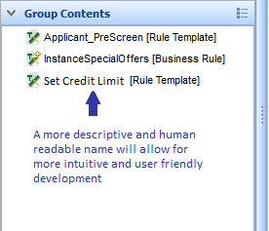 10

Change Log
.
Date | Version | Name | Description
12/5/2012 | 1.0 | Ryan Hollom | Initial doc

Related Documents
Document Title | Revision Number | Author
WebStudio-GeneralDesign.doc | Various | various
WebStudio-RuleTemplate-Design.doc | Various | Ryan Hollom

Introduction

Main Objective
The objective of this document is to outline the high level design of the new Display Model artifact in TIBCO BusinessEvents 5.2.

Intended Usage
The intended usage of Display Models is to provide a mechanism to define the display text for elements inside of the WebStudio UI, for instance properties. Rather than using the default element name, a human readable should be displayed instead.

Audience
The document is intended for Developers, Architects, QA, Product Marketing, and Managers.

Acronyms and Vocabulary

The table below describes some of the Acronyms used in this documentation
- BE – TIBCO BusinessEvents.
- WS – WebStudio
- WSS – WebStudio Server
- RMS -- Rules Management Server. It is the existing component, which we will need to modify to support WS needs, or a completely new server component.
- PE – Project Explorer view in BE Studio
- Studio Project – A TIBCO Project build using TIBCO BusinessEvents Studio.
- ACL – Access Control List. Security configuration file on server end to control what each user role is allowed to do.
- BUI – Business User Interface
- GWT – Google Widget Toolkit

Non-Functional Requirements
The following section briefly covers in more details the non-functional requirements for the initial version of Display Models.

Packaging
Display Models should be considered as part of the core/standard BE component, and will exist as a first class citizen inside of TIBCO BE Projects.

High-level Design
The following section covers the high level design for the initial version of BE Display Models.

Display Models
Display Models are defined inside of BE Studio, similar to Concepts, Events, and Rules. A Display Model is ultimately a specialized type of property file, and follows the familiar name/value pair syntax for property files in Java. Display Models are first class citizens inside of a BE Studio Project, and their proposed file extension is “.display”. Alternatively, the file extension could be the more familiar “.properties” used in Java. However, there are some benefits in defining a new file extension inside of BE Studio, for instance the creation of Display Model specific editor, refactoring support, etc.

Naming
The Display Model should follow a well-known naming convention. The name should match the associated BE Project artifact (Concept or Event). For instance, for the Concept named “Person.concept”, the corresponding Display Model artifact would be named “Person.display”. This will simplify the syntax and allow for a loose coupling of the artifacts.

Syntax
The syntax for Display Model files follows the standard Java property file syntax, specifying name/value pairs corresponding to the display attributes for individual elements. For each artifact property, there should be an optional property to specify the text that is displayed in the WebStudio UI, specifically the builder based Business Rule editor. The simple syntax is as follows:
<property name>=<display text>
For instance
Name=User Name
Additionally, there should be an optional property that allows properties to be hidden entirely from the WebStudio UI, so that they are not accessible from the builder based Business Rule editor.
<property name>.hidden=true | false
For instance
Name.hidden=true
Finally, there should be one optional property to specify the text to be displayed wherever the artifact itself is shown in the WebStudio UI, for instance inside of the Group Contents window. The proposed syntax for this setting is
Artifact.text=<display text>

User Interface
A wizard should be added to create new Display Models, similar to the existing ‘New’ wizards for other BE Project artifacts. There should be a context menu option to quickly create a new Display Model for a given Concept or Event, accessible by right clicking on the Entity from the Studio Explorer and related views.
In the first version, it is likely sufficient to use a simple text editor to edit the display model, as it is a simple property file. If time permits, a standalone editor could be created that allows the user to select from the Entity’s properties and to specify the display text for each one.
An alternative approach would be to add additional columns to the Properties section in the Concept/Event editor itself:
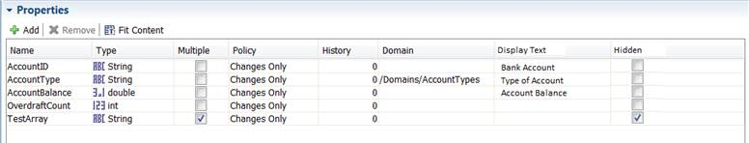
This approach would read the corresponding .display file and write back to that file as the user changes the Display Text or Hidden attribute. This approach has the benefit of added convenience, as the user does not need to open a separate file to specify the Display Text. However, the limitation is that there is no simple way to provide display text for separate locales (see the section on Internationalization).

Internationalization
Should follow standard Java I18N conventions.

Overriding behaviors
As Concepts and Events can inherit properties from parent Concepts/Events, it is important to allow any visible property from the Entity’s hierarchy to the Display Model. For instance, if the Concept ‘Employee’ inherits a property called ‘Name’ from the Concept ‘Person’, it is valid to specify the display text for the ‘Name’ property inside of the Display Model for the ‘Employee’ Concept. This is, in fact, a very common use case, as ‘Name’ can have very different meanings depending on the context.
Additionally, there should be a way to override the default display text inside individual Rule Templates. This would provide another level of meaningful, context-aware specification of properties. A new ‘display’ section could be added to the Rule Template source, and the context-sensitive display text for each accessible property can be specified by using dot notation, for instance:
display {
account.AccountID = "Personal Checking Account ID";
}

Refactoring
A new refactoring participant should be created to react to element modifications. Specifically, the refactoring participant should support renaming of properties as well as the associated Entity itself. Upon Entity renaming, the filename of the Display Model must change as well.

Search
A new search participant should be created to show references to property names inside of the Display Model.

Validation
A new validator should be added to check for invalid properties. This should result in a warning only, as it should not cause any runtime error.

WebStudio

Runtime
The localized display text, if specified in the Display Model, should be displayed in lieu of the standard element name. For properties, the display text will be shown inside of the “builder-based” Business Rule editor:
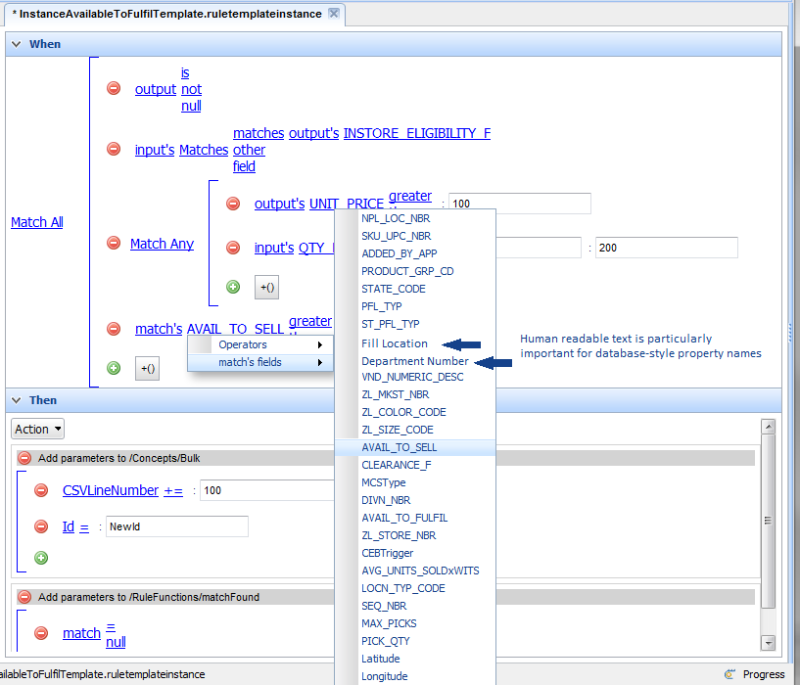
If left unspecified, the property name itself will be shown.
For the base Entity name itself, the display text should be shown inside of the Group Contents window, portlet, and any RMS related dialog (commit, checkout, etc):

