T

TIBCO BusinessEvents: Catalog Functions

Product Suite | TIBCO BusinessEvents
Product | Studio
Product Version | 4.0
Initial Author | Ryan Hollom

Copyright Notice
COPYRIGHT© 2009 TIBCO Software Inc. This document is unpublished and the foregoing notice is affixed to protect TIBCO Software Inc. in the event of inadvertent publication. All rights reserved. No part of this document may be reproduced in any form, including photocopying or transmission electronically to any computer, without prior written consent of TIBCO Software Inc. The information contained in this document is confidential and proprietary to TIBCO Software Inc. and may not be used or disclosed except as expressly authorized in writing by TIBCO Software Inc. Copyright protection includes material generated from our software programs displayed on the screen, such as icons, screen displays, and the like.
Trademarks
Technologies described herein are either covered by existing patents or patent applications are in progress. All brand and product names are trademarks or registered trademarks of their respective holders and are hereby acknowledged.
Confidentiality
The information in this document is subject to change without notice. This document contains information that is confidential and proprietary to TIBCO Software Inc. and may not be copied, published, or disclosed to others, or used for any purposes other than review, without written authorization of an officer of TIBCO Software Inc. Submission of this document does not represent a commitment to implement any portion of this specification in the products of the submitters.
Content Warranty
The information in this document is subject to change without notice. THIS DOCUMENT IS PROVIDED "AS IS" AND TIBCO MAKES NO WARRANTY, EXPRESS, IMPLIED, OR STATUTORY, INCLUDING BUT NOT LIMITED TO ALL WARRANTIES OF MERCHANTABILITY OR FITNESS FOR A PARTICULAR PURPOSE. TIBCO Software Inc. shall not be liable for errors contained herein or for incidental or consequential damages in connection with the furnishing, performance or use of this material.
For more information, please contact:
TIBCO Software Inc.
3303 Hillview Avenue
Palo Alto, CA 94304
USA
Table of Contents
TIBCO BusinessEvents: Catalog Functions 1
1 Change Log 4
1.1 Related Documents 4
2 Introduction 5
2.1 Main Objective 5
2.2 Intended Usage of Catalog Functions 5
2.3 Scope 5
2.4 Audience 5
3 Acronyms and Vocabulary 6
4 User Experience 6
4.1 Creating Custom Functions 6
4.2 Custom Functions in BusinessEvents Studio 8
4.2.1 Adding custom function jars to Studio project 8
4.2.2 Third party libraries 9
4.2.3 Accessing Catalog Functions in Studio 10

Change Log
.
Date | Version | Name | Description
09/21/2009 | 1.0 | Ryan Hollom | Initial doc

Related Documents
Document Title | Revision Number | Author

Introduction

Main Objective
The objective of this document is out discuss what catalog functions are, the needs of BE Studio to provide similar functionality, and what migration path we will provide for existing users of catalog functions (most BE users).

Intended Usage of Catalog Functions
The catalog functions allow BE developers and users to use their own java functions or other libraries inside BE. See the section 4 for more information.

Scope
The scope of this document is to provide both requirements and design of migration path for catalog functions.

Audience
The document is intended for Developers, Architects, QA, Product Marketing, and Manager.

Acronyms and Vocabulary

The table below describes some of the Acronyms used in this documentation
- BE – TIBCO BusinessEvents.
- XML – Extensible Markup Language
- Designer Project – A TIBCO Project build using TIBCO Designer. A Project is a VFileSystem which could typically be a Directory Node in the FileSystem.
- EAR – Enterprise Archive Resource. This is modeled from the J2EE world and contains a subset of VFiles, user defined files, properties, code, jars, etc. An Engine may choose to run against this EAR file.

User Experience
The following section outlines the functionality of custom catalog functions BE Studio.

Creating Custom Functions
This is documentation from the TIBCO Designer product.
Overview of Creating Custom Functions
This chapter does not contain detailed instructions for creating custom functions
or programming in Java. It is assumed that you are comfortable programming in
Java, and have at a minimum already implemented a class and a static function.
Restrictions
Note the following restrictions that pertain to using custom functions.
Static and Non-Static Functions
Custom functions must be written in Java and have public static modifiers.
As a workaround, encapsulate a non-static function in a static function and
compile the encapsulating class to get the .class file.
Return Types
BusinessEvents custom functions support the following return types:
• Java types supported are: Object, String, Calendar (which displays in
BusinessEvents as DateTime), Integer, Long, Double, Boolean, int, long,
double, and boolean (but not byte, short, float, or char).
• Entity model object, for example, concept or event. Also any well defined
entities in the model of that type.
• Arrays are not supported return types, with this exception: One-dimensional
Java arrays of any supported type are supported.
Name Overloading
The functions.catalog file makes functions available for use in TIBCO
Designer. The structure of the file requires each function within a class to have a
unique name. Because of this structure, you cannot refer to an overloaded
function in functions.catalog.
For example, the standard Java library has several String.valueOf() functions
overloaded for each primitive type (String.valueOf(int i),
String.valueOf(double d) and so on). However, the BusinessEvents standard
function catalog has a separate function name for each data type:
valueOfBoolean(), valueOfDouble(), valueOfInt(), and valueOfLong().
See Structure of a Function Catalog on page 32, for more about the
functions.catalog file.

Task Summary
TIBCO BusinessEvents allows you to write your own custom functions in Java
and add them to the function registry, making them available from within the
function registry along with the prepackaged functions in the rule editor.
The steps below summarize the tasks required to integrate your own custom
functions with TIBCO BusinessEvents:
1. Write your custom static function in Java and compile it.
2. Create a file called functions.catalog, an XML file that makes it possible to
access your custom functions from the functions registry within the rule
editor. The XML can also include information for a tool tip for each function.
3. Create a .jar file that includes your .class file and functions.catalog.
4. Add the location of the .jar file to the class path for the BusinessEvents
Server and Workbench. Also add locations for any dependent classes.
The following pages provide more information about each of these tasks.
Structure of a Function Catalog
A function catalog is an XML file that conforms to function_catalog.xsd — a
schema. This allows BusinessEvents to integrate your custom functions with the
function registry in the rule editor. The function catalog must be in the XML
format described in Table 7 to map properly to the schema.
Elements
Table 7 lists and describes the elements used in the function catalog. Each
element’s horizontal position within the Element Name column indicates the
correct nesting position within the XML file.
• Name the function catalog functions.catalog.
• Place functions.catalog in the root folder of the required Java archive
resource (.jar) file.
Name Sub-Elements Description
<catalog name="name "> The root element. Attribute: name="name"
where name is a name you provide for this functions catalog.
Example: <catalog name="custom">
<category> This is a sub-element of <catalog>. <category> is a nesting
container for a set of related functions within this functions
catalog.
<name> A name you provide for this category.
<function> A container for the information about a single function.
<name> The name of the function.
<class> The java class that implements the function.
<desc> Optional. A description of the function.
<args> A comma separated list of descriptive names for the function’s
arguments. BusinessEvents takes the argument type from the
function itself.
<isActionOnly> Valid values: true, false
Optional.

If this function has side effects, for example, if it can modify
values, you can only use it in action rules. Set this parameter to
true to alert BusinessEvents that this function has side effects.
<tooltip> This is a sub-element of <function>. This element contains the
elements of a tool tip. A tool tip provides information about a
function when the user floats the curser over the name of the
function in the functions catalog in the rule editor.
<synopsis> A brief description of the function for display within the tool
tip.
Example:
<synopsis>Takes value of "amount" and returns item
name.
<args> A container for descriptive information about the function’s
arguments. The information you provide will be displayed in
the function’s tool tip.
<paramdesc> A sub-element of <args>. Provides descriptive information for
one argument. Use this tag once for each argument. Attributes:
• name=’arg_name’
• type=’arg_type’
Example:
<paramdesc name=’amount’ type=’int’>arg1</paramdesc>
<returns> Describes the return value.
Attribute: type=’return_type’
Example:
<returns type=’string’>item name</returns>

Custom Functions in BusinessEvents Studio
Custom java functions are an integral part of Designer, as it allows users to invoke manual java functions, call third party java libraries, etc. The current solution requires users to write the java functions, and then manually create entries in a “functions.catalog” file to describe these functions. This file must then be placed in the classpath so that the classloader can locate and inspect the file in order to perform validation, text hover, etc. This process, as well as the structure of the functions.catalog file, is described in the previous section.

Adding custom function jars to Studio project

The user is presented with a project property page wherein custom function jars can be added and removed. This property page will look and behave similar to the ‘Java Build Path’ in Eclipse, where the user can add and remove jar files. The property page can be viewed by right clicking on the Studio project and selecting Properties:

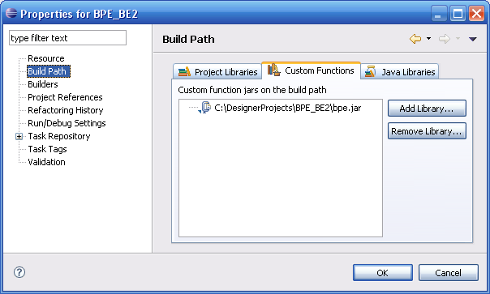
Each of the jar files added here must contain a functions.catalog file. This will allow the Studio infrastructure to mine the information in each jar file. Moreover, this will allow users to dynamically add new custom function jars without restarting Studio, and have the custom functions available for use in the rule editor. This cannot be done if we rely on the existing ‘classpath’ functionality.
The locations of the custom function jars are stored in the .beconfig configuration file inside the Studio project. This will allow the user to check in this configuration file into a version control system so that it can be shared among other developers of that project. It is located at the root level of the project. This file contains other information as well, for instance the location of project libraries, etc.

Third party libraries
Some custom function jar files depend on additional third party java archives. In this case, the user will be presented with a dialog stating that it was unable to load a class if they attempt to apply changes in the Project Properties page:
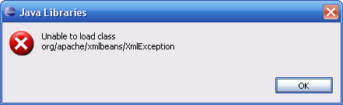
In these cases, the user must add the additional third party jar files to the “Java Libraries” tab in the Build Path page:
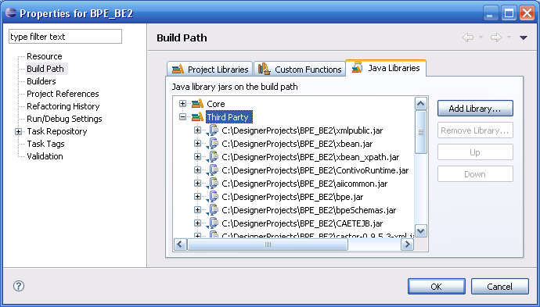
This page will contain built-in Core libraries, for instance tra libraries. The user can add additional third party libraries here so that all custom function classes can be loaded and resolved. This information is also used to build the classpath for code generation, so the user is no longer required to change the additional classpath settings in the .tra.
If the third party jar contains a functions.catalog file, the user will be notified and prompted to add the jar as a custom function jar rather than as a third party library:
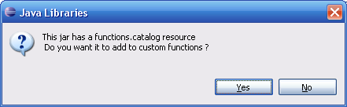
If the jar is added as a third party jar, the custom functions in this jar are not made available to the user.
Similarly, if the user attempts to add a non-custom function jar to the Custom Functions page, the user will be notified and prompted to add the jar to the Java Libraries tab:
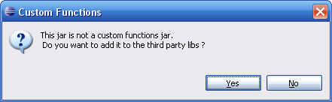

Accessing Catalog Functions in Studio
To access the available catalog functions in BE Studio, open the Catalog Functions view by selecting Window->Show View->Other->TIBCO BusinessEvents->Catalog Functions:
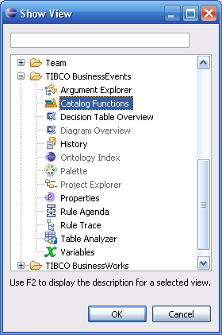
The Catalog Functions view contains all of the available Built-in, Custom, and Ontology functions for the current context. The context is defined by the currently active editor. That is, the project that owns the file currently being edited.
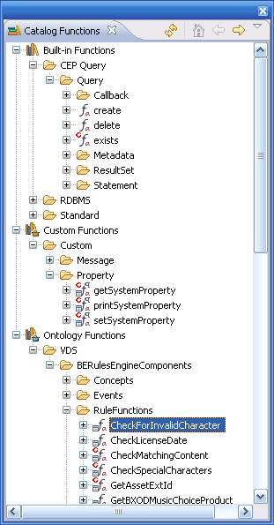
From this view, the user can drag and drop catalog functions into the rule editor source, or the user can right click on the catalog function, select Copy, and paste the name into the rule. In additional, hovering over a catalog function will provide the user with additional information about the function, for instance the parameters, synopsis, etc.

