T

TIBCO BusinessEvents: Project Analyzer

Product Suite | TIBCO BusinessEvents
Product | Studio
Product Version | 4.0
Initial Author | Gabe Grigorescu

Copyright Notice
COPYRIGHT© 2009 TIBCO Software Inc. This document is unpublished and the foregoing notice is affixed to protect TIBCO Software Inc. in the event of inadvertent publication. All rights reserved. No part of this document may be reproduced in any form, including photocopying or transmission electronically to any computer, without prior written consent of TIBCO Software Inc. The information contained in this document is confidential and proprietary to TIBCO Software Inc. and may not be used or disclosed except as expressly authorized in writing by TIBCO Software Inc. Copyright protection includes material generated from our software programs displayed on the screen, such as icons, screen displays, and the like.
Trademarks
Technologies described herein are either covered by existing patents or patent applications are in progress. All brand and product names are trademarks or registered trademarks of their respective holders and are hereby acknowledged.
Confidentiality
The information in this document is subject to change without notice. This document contains information that is confidential and proprietary to TIBCO Software Inc. and may not be copied, published, or disclosed to others, or used for any purposes other than review, without written authorization of an officer of TIBCO Software Inc. Submission of this document does not represent a commitment to implement any portion of this specification in the products of the submitters.
Content Warranty
The information in this document is subject to change without notice. THIS DOCUMENT IS PROVIDED "AS IS" AND TIBCO MAKES NO WARRANTY, EXPRESS, IMPLIED, OR STATUTORY, INCLUDING BUT NOT LIMITED TO ALL WARRANTIES OF MERCHANTABILITY OR FITNESS FOR A PARTICULAR PURPOSE. TIBCO Software Inc. shall not be liable for errors contained herein or for incidental or consequential damages in connection with the furnishing, performance or use of this material.
For more information, please contact:
TIBCO Software Inc.
3303 Hillview Avenue
Palo Alto, CA 94304
USA
Table of Contents
TIBCO BusinessEvents: Project Analyzer 1
1 Change Log 4
1.1 Related Documents 4
2 Introduction 5
2.1 Main Objective 5
2.2 Intended Usage 5
2.3 Scope 5
2.4 Audience 5
3 Acronyms and Vocabulary 6
4 Design Spec 6
4.1 Rule Analyzer Functionality 6
4.1.1 Rule Analyzer Benefits 7
4.2 New Desired Functionality 7
4.2.1 Analysis Functionality 7
4.3 Design – BusinessEvents Studio 8
4.3.1 Overview 8
4.3.2 Invoking Project Analyzer 9
4.3.3 Filtering 9
4.3.4 Searching 10
4.3.5 Preferences 10
4.3.6 Diagramming 11
4.3.7 Project Diagram Elements 11
4.3.8 Project Diagram Relationships 12
4.3.9 Simplifying Project Diagrams 12

Change Log
.
Date | Version | Name | Description
10/06/2009 | 1.0 | Gabe Grigorescu | Initial doc
01/20/2010 | 1.1 | Gabe Grigorescu | Added info on links shown

Related Documents
Document Title | Revision Number | Author

Introduction

Main Objective
The objective of this document is to outline the features of the new Project Analyzer component in TIBCO BusinessEvents Studio 4.0, as well as a “migration path” from the old Rule Analyzer.

Intended Usage
Project Analyzer is intended to provide developers a better understanding of the BE Project, how the components interact, analyze potential problems of the project, and also provide a way for developers to document and share the project with others through other means, such as web pages or through images (jpg, pdf, etc).

Scope
The scope of this document is to provide both requirements and design of Project Analyzer.

Audience
The document is intended for Developers, Architects, QA, Product Marketing, and Managers.

Acronyms and Vocabulary

The table below describes some of the Acronyms used in this documentation
- BE – TIBCO BusinessEvents.
- PE – Project Explorer view in BE Studio
- Designer Project – A TIBCO Project build using TIBCO Designer. A Project is a VFileSystem which could typically be a Directory Node in the FileSystem.
- Studio Project – A TIBCO Project build using TIBCO BusinessEvents Studio.

Design Spec
The following section outlines the original functionality of Rule Analyzer in Designer and new and modified functionality in new BE Studio.

Rule Analyzer Functionality
This section discusses the old functionality available in BE 3.0 through TIBCO Designer. This is relevant documentation from our existing BE documentation.
Two tools help you analyze and troubleshoot your BusinessEvents projects: Rule Analyzer and Rule Debugger. These tools are provided in an application called BusinessEvents Tools, which runs independently. You can start the application from within TIBCO Designer or at the command line. You can switch between Rule Debugger and Rule Analyzer when you are using the BusinessEvents tools application.

Rule Analyzer lets you check the structure of a project before you build its EAR and deploy it. You can examine several projects in Rule Analyzer simultaneously, using a tabbed interface. Unlike Rule Debugger, Rule Analyzer does not work with facts, just with the ontology.

Central to the Rule Analyzer and Rule Debugger tools are the graphs generated for each BusinessEvents project that you open. Each graph summarizes possible rule evaluation paths based on assertion of facts into working memory.

The graphs show the relationships between ontology entities (concepts, events, scorecards, and rules) using color-coded shapes and various kinds of linking lines. You can click each object in a graph to view its properties and other information in different panels of the user interface.

In Rule Analyzer (but not Rule Debugger), you can also display (or hide) class diagram relationships between entities in the graph, and you can display state machine graphs. You can filter the graph to focus on a subset of entities.

Many layout styles are available for graphs. It is recommended that you try different layouts until you find the ones that render the structure of your BusinessEvents projects most clearly.

Rule Analyzer Benefits
Users who are familiar with BusinessEvents rules can use the graphs (and associated information) to follow the logic of rule execution and find areas for improvement. Users who are less familiar with the product can learn more by close examination of the graphs.

Using Rule Analyzer, you can make changes in the project and view the results before deploying the project. Working with Rule Analyzer can reveal useful information such as the following:

● | How changes to the project might affect object interdependencies. For example, how a rule firing would cause rule conditions to be re-evaluated.
● | How changes in inheritance, property types, conditions, and dependencies may affect existing rule execution.

● | Which rules are independent from one another. This information is helpful for partitioning your projects into independent rule sets for better scaling, and for better load balancing, in the case of multiple rule sessions (agents) in one EAR.
● | Where there are inefficiencies in conditions and overall design such as unused identifiers or properties, most-frequently-used objects, and bottleneck rules.

New Desired Functionality
The purpose of the Project Analyzer is to not only replace the old Rule Analyzer, but also add more features to help the developer understand and improve the project. This analyzer should not focus just on rules, but the entire project. This is also the reason for the name change. At a high level, we want the new Project Analyzer to:
- help users understand how all project components are connected and they interact
- analyze rules and how they modify ontology (see features of the old Rule Analyzer)
- view UML class diagrams (for concepts and events)
- easily edit artifacts of interest and create dependency diagrams of just those artifacts
- be able to search for entities in the diagram
- see statistics of project components (# of concepts, events, state machines, etc).
- share project design, logic, deployments with others in a format they can read without having to have BE Studio, as well as print the entire project according to page setup settings
- keep all diagramming functionality of the old Rule Analyzer and add new navigation tools to make it easier to navigate through large diagrams

Analysis Functionality
The analyzer has the following functionality:
- find rules that can never fire
- find rule functions that are never used
- find events that are never used/may never fire
- find destinations with no default events
- find domain models that are never used (are not associated with entity properties)
- find state machines that are orphaned (are not associated with any concepts)

Design – BusinessEvents Studio

Overview
The project analyzer consists of 2 main components: the diagram, and the report it generates (analysis results). It is a living document that can be refreshed whenever the project changes by clicking a button:
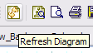
To ensure an accurate representation of the project, the project analyzer diagram is always generated from the existing project and its contents are not stored on the disk. Users may see a .projectview file in the PE, but that is an empty file. It can be used to double-click on it so it can create the project view, instead of clicking on the menu. Here’s a sample screenshot of a project analyzer diagram:
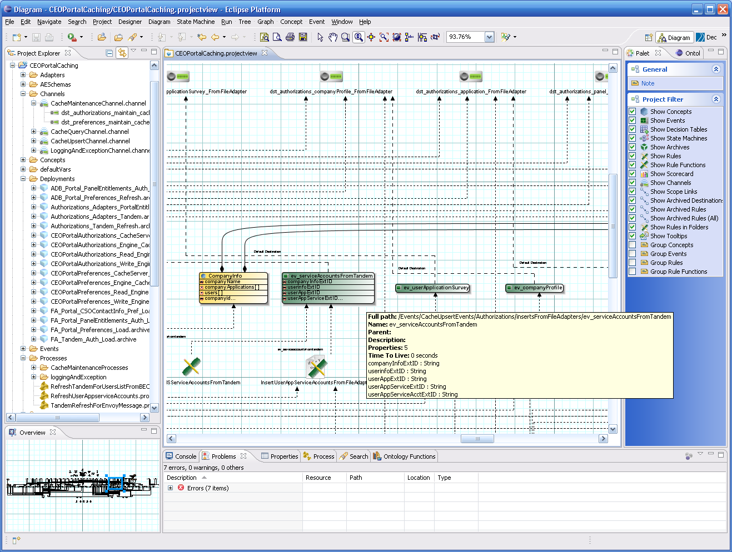

Invoking Project Analyzer
There are multiple ways of invoking this. Users can double-click on the .projectview file in the root of their project. Alternatively, users can right-click on the top level folder of their project and click on “Show Project View“, or once the top level folder is selected, click on Project menu, and then either click on the “View” or “Analyze” menu option. The difference between “View” and “Analyze” is that “View” will only generate the diagram and not run the analysis, whereas “Analyze” will only run the analysis and show you the results in the Problems View.
The reason for this distinction is that in some cases users may not want to see the complicated diagram, but rather just see if there are any problems with their project. In that case, they would only run the analysis. Creating the diagram can take quite a bit of time if the project is large. Similarly, running the analysis can also take quite some time if there are a lot of artifacts in the project, and in some cases the users may want to create only the diagram and not the analysis. This can be done by selecting only the “View” option.
However, this behavior can be changed through preferences! See section below.

Filtering
Since these project diagrams can quickly get very large and hard to understand, the Project Analyzer also has a palette that allows the users to filter out components that are not of interest. The screenshot below is self-explanatory. Once the user makes the appropriate changes (select or unselect options), click on “Apply” to have the diagram be regenerated. Click on “Defaults” to restore the filtering settings back to what is stored in preferences.

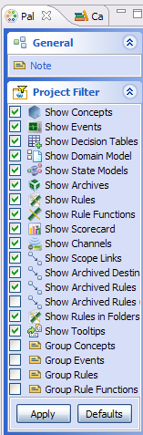

Searching
You can search for objects in the diagram via the search button:
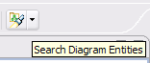
This will bring up a dialog box like this:
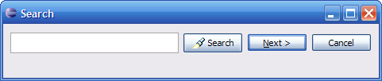
Once it finds such an object, it will select it, and center it in the diagram.

Preferences
Most of the Project Analyzer preferences are around how to control the diagram. There are two areas worth mentioning in this document. The “Create View When Analyzing” and “Run Analysis When Creating View” are important ones to bring out. They do what the text says…
Furthermore, the “Filter Options” are the options you see in the Palette discussed in the section above. If users want to change the defaults, they can change them here, so that the next time they run the Project Analyzer, the diagrams will be created according to these settings.
If users change these settings in the palette view, those changes are not reflected in the preferences here, and they are lost when the project diagram is closed.
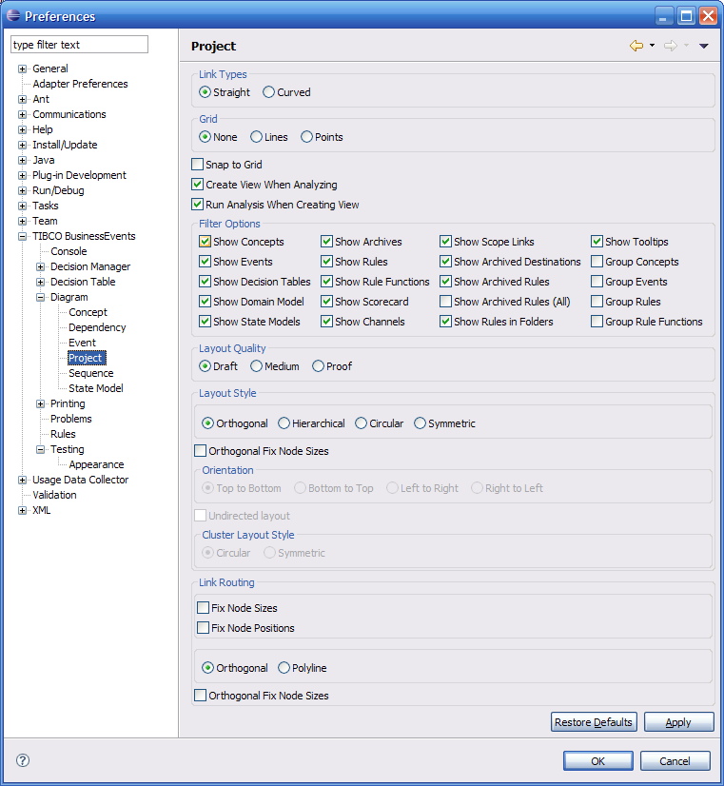

Diagramming
All diagramming features available in all other diagrams in Studio are also available in the Project Analyzer diagram. They are not repeated here: tools, page setups, image export, layout styles, etc.

Project Diagram Elements
The following elements are currently shown in the diagram:
- Concepts
- Events (Simple and Time)
- Scorecards
- Channels
- Destinations
- State Machines
- Decision Tables
- Domain Models
- Rules
- Rule Functions (Normal and Virtual)

Project Diagram Relationships
The project diagram shows how project components interact with each other, what their relationships are, and how they may use/update other components at runtime.
At a high level the idea behind this diagram is to:
- Understand complete message flow through BE
- Find potential problems, understand dependencies
- Share with others with no access to BE (web, graphics, printing)
Generally the links also have labels to further describe what they mean. They are also drawn differently. Continuous lines mean inheritance/containment, dashed mean in the scope, and dashed with dots mean used.
Channels have links to destinations they contain.
Destinations have links to events that are triggered when messages arrive on those destinations.
Rules point to entities (Concepts, Events, Scorecards) that are in its scope. They also point to other entities that it uses inside (either accesses or creates, including events). They also point to Rule Functions invoked. Notice that such links only indicate potential usage, because only at runtime can it be determined if a certain path of code is followed.
Rule Functions also point to entities (Concepts, Events, Scorcards) that are in its arguments. They also point to other entities and other rule functions it may call itself.
Concepts and Events point to parent entities (inheritance structure). They also point to any domain models that may be associated with their properties. Concepts also point to state machines they own.

Simplifying Project Diagrams

Scope and usage links may be optionally filtered out (independently), in case the diagram gets too large. Furthermore, this step is done automatically before displaying the diagram if so set up in the project diagram preferences.
Furthermore, if project diagrams are too large, or if the user wants to understand just a part of the project, a partial project diagram can be created. The users have 2 options. First, you can either select any number of elements in the Studio Explorer (selecting a folder will include all elements inside that folder recursively), then right-click, and create the project diagram. This will create a project diagram of just the selected objects and their immediate dependencies (currently just 1 level away, although this can also be changed via a preference).
Alternatively, once you have a project diagram created, you can select which objects you are interested in the diagram, right-click anywhere inside the diagram (not on any object), create the project diagram, and you will see the same behavior.

