T

TIBCO BusinessEvents: Project Libraries

Product Suite | TIBCO BusinessEvents
Product | Studio
Product Version | 4.0
Initial Author | Ryan Hollom

Copyright Notice
COPYRIGHT© 2009 TIBCO Software Inc. This document is unpublished and the foregoing notice is affixed to protect TIBCO Software Inc. in the event of inadvertent publication. All rights reserved. No part of this document may be reproduced in any form, including photocopying or transmission electronically to any computer, without prior written consent of TIBCO Software Inc. The information contained in this document is confidential and proprietary to TIBCO Software Inc. and may not be used or disclosed except as expressly authorized in writing by TIBCO Software Inc. Copyright protection includes material generated from our software programs displayed on the screen, such as icons, screen displays, and the like.
Trademarks
Technologies described herein are either covered by existing patents or patent applications are in progress. All brand and product names are trademarks or registered trademarks of their respective holders and are hereby acknowledged.
Confidentiality
The information in this document is subject to change without notice. This document contains information that is confidential and proprietary to TIBCO Software Inc. and may not be copied, published, or disclosed to others, or used for any purposes other than review, without written authorization of an officer of TIBCO Software Inc. Submission of this document does not represent a commitment to implement any portion of this specification in the products of the submitters.
Content Warranty
The information in this document is subject to change without notice. THIS DOCUMENT IS PROVIDED "AS IS" AND TIBCO MAKES NO WARRANTY, EXPRESS, IMPLIED, OR STATUTORY, INCLUDING BUT NOT LIMITED TO ALL WARRANTIES OF MERCHANTABILITY OR FITNESS FOR A PARTICULAR PURPOSE. TIBCO Software Inc. shall not be liable for errors contained herein or for incidental or consequential damages in connection with the furnishing, performance or use of this material.
For more information, please contact:
TIBCO Software Inc.
3303 Hillview Avenue
Palo Alto, CA 94304
USA
Table of Contents
TIBCO BusinessEvents: Project Libraries 1
1 Change Log 4
1.1 Related Documents 4
2 Introduction 5
2.1 Main Objective 5
2.2 Intended Usage of Project Libraries 5
2.3 Scope 5
2.4 Audience 5
3 Acronyms and Vocabulary 6
4 Design Spec 6
4.1 Designer Functionality (old) 6
4.2 Design – BusinessEvents Studio (new) 9
4.2.1 Overview 9
4.2.2 Project library creation 9
4.2.3 Import/inclusion 10
4.2.4 Build/packaging 14

Change Log
.
Date | Version | Name | Description
10/06/2009 | 1.0 | Ryan Hollom | Initial doc

Related Documents
Document Title | Revision Number | Author

Introduction

Main Objective
The objective of this document is out discuss what TIBCO Designer project libraries are, the needs of BE Studio to provide similar functionality, and what migration path we will provide for existing users of project libraries.

Intended Usage of Project Libraries
The project libraries are meant to be used to share certain components of a project with other projects. See the section 4 for more information.

Scope
The scope of this document is to provide both requirements and design of migration path for project libraries.

Audience
The document is intended for Developers, Architects, QA, Product Marketing, and Manager.

Acronyms and Vocabulary

The table below describes some of the Acronyms used in this documentation
- BE – TIBCO BusinessEvents.
- XML – Extensible Markup Language
- Designer Project – A TIBCO Project build using TIBCO Designer. A Project is a VFileSystem which could typically be a Directory Node in the FileSystem.
- EAR – Enterprise Archive Resource. This is modeled from the J2EE world and contains a subset of VFiles, user defined files, properties, code, jars, etc. An Engine may choose to run against this EAR file.

Design Spec
The following section outlines the desired functionality of project libraries in Designer and which functionality we want to keep in the new BE Studio.

Designer Functionality (old)
This is documentation from the TIBCO Designer product.
A LibraryBuilder resource is the basis for a design-time library. Before creating a design-time library, you must have access to a LibraryBuilder resource alias.
Aliases are used to manage access to LibraryBuilder resources. The aliases you create are saved in your user profile and available to all projects you create on your machine. Other developers can export aliases to LibraryBuilder resources, so they can be imported into other projects.
When you add a LibraryBuilder resource to a project you can create an alias to it when loading the library, or pick an alias and load the corresponding library.
- If you are working on a different machine, or are not the user who created the alias, you can import an alias to your alias list.
- Clicking New when adding a LibraryBuilder resource allows you to define an alias and load the LibraryBuilder resource in one operation. The alias is then added to your alias list.
- To update a LibraryBuilder resource, delete the alias to it, then add it back.
- To delete a LibraryBuilder resource from a project, delete the alias to it.
To Create a Design-time Library
- Open the project to which the LibraryBuilder resource will be added.
- Click Project > Save.
- Select the project’s root folder.
- Click the Design Time Libraries tab.
- Click Pick or New.
Click Pick if you have an alias defined for the library. Select the file alias for the design time library.
Click New and navigate to the location of the design-time library. After you click Apply, a new alias for the library is added to your alias list.
- Click OK.
- Click Apply.
To Update a Design-time Library
- Open the project in which the design-time library will be updated.
- Select the project’s root folder.
- Click the Design Time Libraries tab.
- Select the File Alias for the design-time library to update.
- Click Delete.
- Click Apply.
- Click Pick.
- Select the file alias for the design time library to update.
- Click OK.
- Click Apply.
To Delete a Design-time Library
- Open the project in which the design-time library will be deleted.
- Select the project’s root folder.
- Click the Design Time Libraries tab.
- Select the File Alias for the design-time library to remove.
- Click Delete.
- Click Apply.
Using a Resource in the Design-time Library
After you have added a LibraryBuilder resource to your project, you can use the resources defined in it. The resources display in the project view like other resources but, because they cannot be modified, they are greyed out and not editable.
The next diagram shows a process that calls a process definition in the design-time library. The Process Name field points to the process definition in the design-time library.
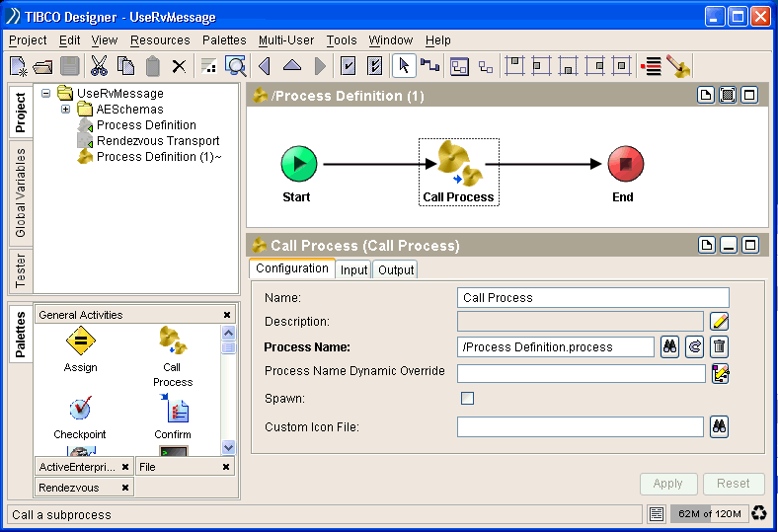
Showing or Hiding Design-time Libraries
You can hide the design-time libraries that you have added to a project. When you hide the design-time libraries, the resources in the libraries are not available to your project. If you are using a resource in a design-time library and have hidden the library, when you build an enterprise archive file, that resource will not be part of the archive.
To Toggle Showing and Hiding Design-time Libraries
- Click Project > Hide Library Resources.
- Click Project > Show Library Resources.

Design – BusinessEvents Studio (new)

Overview
Project libraries (i.e. design-time libraries) are simple archives that allow users to share resources with other projects/developers. Project libraries have a file extension of .projlib and can contain any resources inside of a Studio project, so that they can be created once and shared with other projects. For example, a project library might contain a handful of Concepts that are standard, such as Person, so that multiple projects do not need to redefine these Concepts.

In order to properly integrate project libraries into Studio, three main features must be added:
- Project library creation
- Project library import/inclusion into existing Studio projects
- Build/packaging of projects with project libraries

Project library creation
Since project libraries are simple archives, project library creation can be treated as a resource export. As such, a wizard is provided that allows the user to select one or more resources inside of the workspace to include in the exported .projlib archive. This wizard is available in the File->Export dialog, or in the right click->Export menu from the Project Explorer:

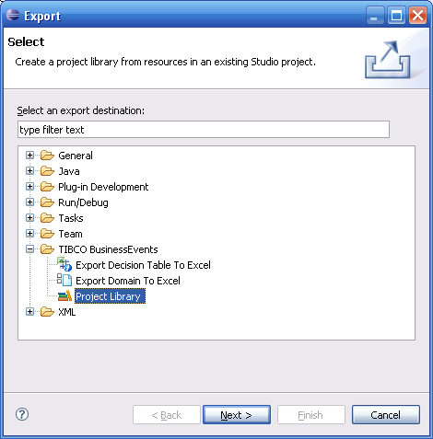

The wizard has a tree based view of the resources in the workspace, and allows the user to check one or more resources to include in the project library. The user is required to name the library and provide an export location:
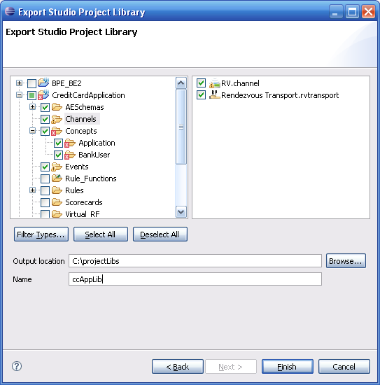

Import/inclusion
There are two potential solutions for including a project library into an existing Studio project. As the creation of a project library is done through an export wizard, there is an analogous import wizard that allows a user to import a project library into a Studio project.
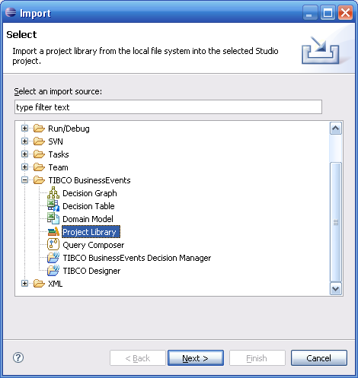
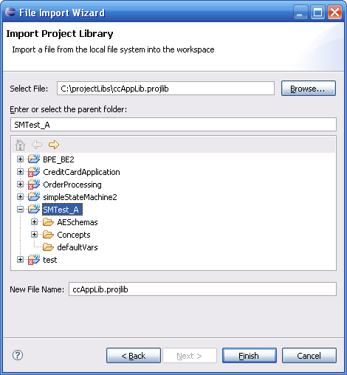

Rather than physically moving the imported project library into the selected Studio project, “importing” a project library is equivalent to pointing to the location of the specified project library and including its contents into the Studio project. The location of the project library might be external to the Studio project, but could also be contained within the project’s directory structure. The physical location of the project library should be unimportant, as long as the user has access to the location (if it is on a shared drive, for instance).
The locations of the project libraries are stored in the .beproject file in the Studio project. This will allow the user to check in this configuration file into a version control system so that it can be shared among other developers of that project.
The import wizard satisfies a logical symmetry with the export wizard, but there is an additional method of maintaining project libraries in a Studio project. Specifically, the user can add/remove project libraries in the project properties page for the Studio project, which is invoked by right clicking on the Studio project and selecting “Properties”. This solution will allow multiple projects to point to one external location:
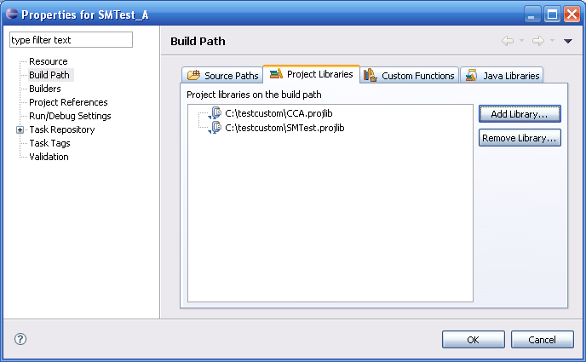

Once the project library is imported/included, the contents of the project library are displayed in the Project Explorer view under a “Project Dependencies” node. The user is able to open the resources contained in the library, in read-only editors. For non-Studio resources (xml, aeschema, etc), these resources are open in a simple text editor, as we do not control the default editors for these resources.
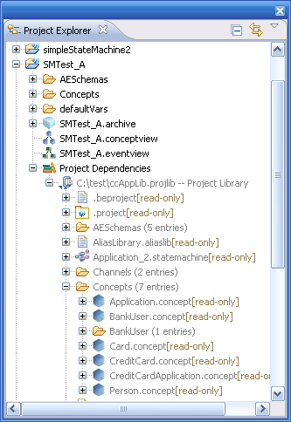

Build/packaging
As the archives are built, and the java code is generated, the resources inside the project library are included in the project archive so that the project library resources are available during runtime.

Migration
Since the format of the BusinessEvents objects has changed, any existing project libraries will need to be recreated using the new tooling in BE Studio. In other words, there is no migration available for designer project libraries that contain BE entities (Concepts, Events, etc). However, it should be valid to use project libraries created by designer that contain only non-BE objects (xml files, schemas, etc). This may or may not be officially supported.

