T

TIBCO BusinessEvents: Refactoring

Product Suite | TIBCO BusinessEvents
Product | Studio
Product Version | 4.0
Initial Author | Ryan Hollom

Copyright Notice
COPYRIGHT© 2009 TIBCO Software Inc. This document is unpublished and the foregoing notice is affixed to protect TIBCO Software Inc. in the event of inadvertent publication. All rights reserved. No part of this document may be reproduced in any form, including photocopying or transmission electronically to any computer, without prior written consent of TIBCO Software Inc. The information contained in this document is confidential and proprietary to TIBCO Software Inc. and may not be used or disclosed except as expressly authorized in writing by TIBCO Software Inc. Copyright protection includes material generated from our software programs displayed on the screen, such as icons, screen displays, and the like.
Trademarks
Technologies described herein are either covered by existing patents or patent applications are in progress. All brand and product names are trademarks or registered trademarks of their respective holders and are hereby acknowledged.
Confidentiality
The information in this document is subject to change without notice. This document contains information that is confidential and proprietary to TIBCO Software Inc. and may not be copied, published, or disclosed to others, or used for any purposes other than review, without written authorization of an officer of TIBCO Software Inc. Submission of this document does not represent a commitment to implement any portion of this specification in the products of the submitters.
Content Warranty
The information in this document is subject to change without notice. THIS DOCUMENT IS PROVIDED "AS IS" AND TIBCO MAKES NO WARRANTY, EXPRESS, IMPLIED, OR STATUTORY, INCLUDING BUT NOT LIMITED TO ALL WARRANTIES OF MERCHANTABILITY OR FITNESS FOR A PARTICULAR PURPOSE. TIBCO Software Inc. shall not be liable for errors contained herein or for incidental or consequential damages in connection with the furnishing, performance or use of this material.
For more information, please contact:
TIBCO Software Inc.
3303 Hillview Avenue
Palo Alto, CA 94304
USA
Table of Contents
TIBCO BusinessEvents: Project Libraries 1
1 Change Log 4
1.1 Related Documents 4
2 Introduction 5
2.1 Main Objective 5
2.2 Intended Usage of Project Libraries 5
2.3 Scope 5
2.4 Audience 5
3 Acronyms and Vocabulary 6
4 Design Spec 6
4.1 Designer Functionality (old) 6
4.2 Design – BusinessEvents Studio (new) 9
4.2.1 Overview 9
4.2.2 Project library creation 9
4.2.3 Import/inclusion 10
4.2.4 Build/packaging 14

Change Log
.
Date | Version | Name | Description
11/18/2009 | 1.0 | Ryan Hollom | Initial doc

Related Documents
Document Title | Revision Number | Author

Introduction

Main Objective
The objective of this document is to discuss “refactoring” operations in BE Studio, how they are done, and the affects they have on BE Studio projects.

Intended Usage of Refactoring operations
Refactoring operations are intended to restructure the elements in a BE Studio project without changing the behavior of the project. For instance, renaming an entity or moving an entity should not affect the behavior of the project.

Scope
The scope of this document is to provide both requirements and design of migration path for project libraries.

Audience
The document is intended for Developers, Architects, QA, Product Marketing, and Manager.

Acronyms and Vocabulary

The table below describes some of the Acronyms used in this documentation
- BE – TIBCO BusinessEvents.
- XML – Extensible Markup Language
- Designer Project – A TIBCO Project build using TIBCO Designer. A Project is a VFileSystem which could typically be a Directory Node in the FileSystem.
- EAR – Enterprise Archive Resource. This is modeled from the J2EE world and contains a subset of VFiles, user defined files, properties, code, jars, etc. An Engine may choose to run against this EAR file.

Design Spec
The following section outlines the functionality of the refactoring operations in BE Studio, how they are invoked, and the expected behavior.

General
Refactoring operations alter the structure of a BE Studio project without changing the behavior of the project. For instance, renaming or moving a Concept should not affect the behavior of the project, only its name or fully qualified path should change.

An exception to this rule is deleting an element. This will potentially change the behavior of the project. However, as deletion of an element could affect other elements, it is covered in this framework as well.

Invocation
Refactoring operations can be invoked in several ways:
- Right clicking on an element in the Project Explorer and selecting a menu item in the “Refactoring” menu.
- Clicking on an element in the Project Explorer and selecting File->Move or File->Rename
- Dragging and dropping an element in the Project Explorer from one location to another is equivalent to File->Move or right click->Refactor->Move
- NOTE: Some operations are not supported outside of the BE Project Explorer view (for instance, the java Package Explorer view). It is imperative that these refactoring operations take place from within this context.

Rename Refactorings

Renaming an element will first prompt the user to type in the new name of the element to be renamed, similar to the following:
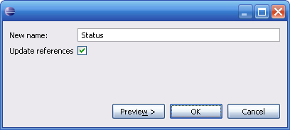

Some validation is done to ensure that the new name is a valid BE identifier:
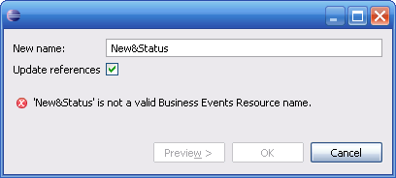

It is recommended that the user Previews the changes that will be made by clicking on ‘Preview’. This will outline the workspace changes that will take place for this refactoring operation.
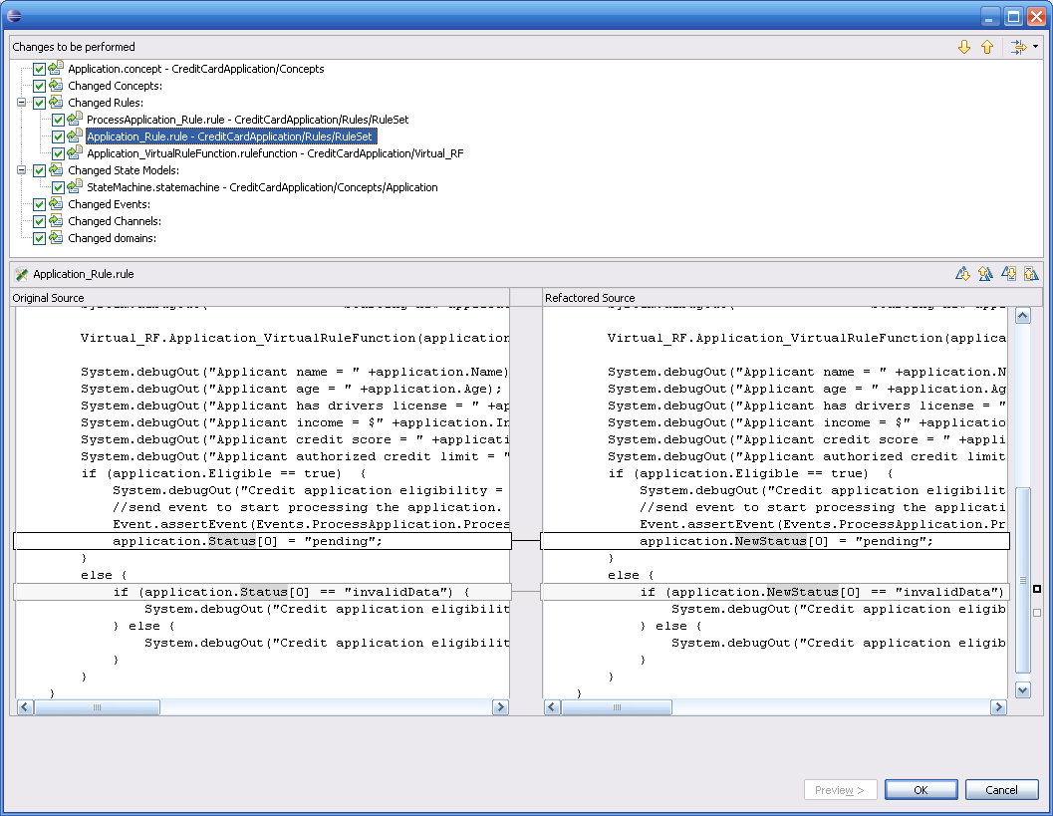

This page allows the user to review the changes to be performed, and also gives the user the chance to cancel this operation, as well as deselect certain changes if it is deemed they should not be changed.

Note that, unlike Designer, refactoring operations in Studio will change the source of the rules and rule functions. This includes the rules in State Models (entry/exit actions, guard rules, etc), as well as Expiry Actions in Events.

The following rename operations are supported, as well as the default behavior of each (not fully inclusive, but this is to provide a general idea):
- Concept rename (the same applies to Scorecards)
  - Renames the Concept file itself
  - Renames the Concept entity
  - Updates references in any sub Concept (Inherits from)
  - Updates references in any Event (Expiry Action)
  - Updates references in any Property Definition
  - Updates references in any State Models
  - Updates references in any Rules/Rule Functions
- Event rename
  - Renames the Event file itself
  - Renames the Event entity
  - Updates references in any sub Event (Inherits from)
  - Updates references in any Event (Expiry Action)
  - Updates references in any Destination (Default Event)
  - Updates references in any State Models
  - Updates references in any Rules/Rule Functions
- Concept/Event property definition rename
  - Renames the Property Definition in the owner Concept/Event
  - Updates references in any Event (Expiry Action)
  - Updates references in any State Models
  - Updates references in any Rules/Rule Functions
- Channel rename
  - Renames the Channel file itself
  - Renames the Channel entity
  - Updates references in any Event (Default Destination path)
- Destination rename
  - Renames the Destination in the owner Channel
  - Updates references in any Event (Default Destination)
- Rule/Rule Function rename
  - Renames the Rule/Rule Function file itself
  - Updates the Rule/Rule Function source to reflect the new name
  - Updates references in any Event (Expiry Action)
  - Updates references in any State Models
  - Updates references in any Rules/Rule Functions
- Folder rename (NOTE: partially supported as of this writing)
  - Renames the Folder itself
  - Updates references in any sub Event
  - Updates references in any Destination (Default Event)
  - Updates references in any State Models
  - Updates references in any Rules/Rule Functions

The following elements cannot currently be renamed:
- State Models
- BE Studio projects

Move Refactorings
Moving an element will first prompt the user to select the new location of the element to be moved, similar to the following:

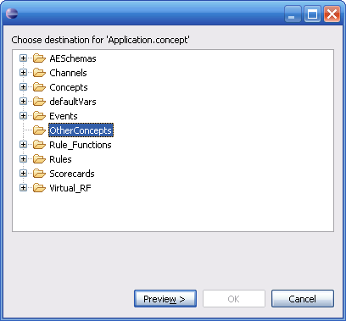

It is required that the user Previews the changes that will be made by clicking on ‘Preview’. This will outline the workspace changes that will take place for this refactoring operation.
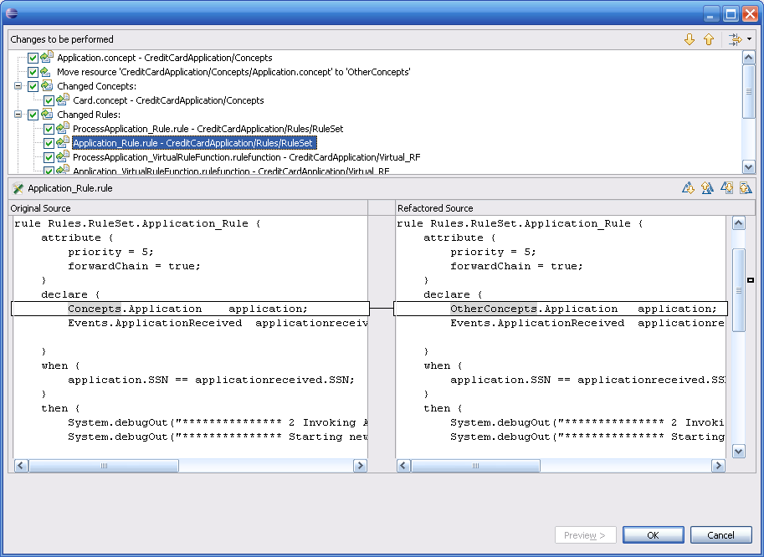

This page allows the user to review the changes to be performed, and also gives the user the chance to cancel this operation, as well as deselect certain changes if it is deemed they should not be changed.

Note that, unlike Designer, refactoring operations in Studio will change the source of the rules and rule functions. This includes the rules in State Models (entry/exit actions, guard rules, etc), as well as Expiry Actions in Events.

The following move operations are supported, as well as the default behavior of each (not fully inclusive, but this is to provide a general idea):
- Concept move (the same applies to Scorecards)
  - Moves the Concept file itself
  - Updates the Concept’s folder
  - Updates references in any sub Concept (Inherits from)
  - Updates references in any Event (Expiry Action)
  - Updates references in any Property Definition
  - Updates references in any State Models
  - Updates references in any Rules/Rule Functions
- Event move
  - Moves the Event file itself
  - Updates the Event’s folder
  - Updates references in any sub Event (Inherits from)
  - Updates references in any Event (Expiry Action)
  - Updates references in any Destination (Default Event)
  - Updates references in any State Models
  - Updates references in any Rules/Rule Functions
- Channel move
  - Moves the Channel file itself
  - Updates the Channel’s folder
  - Updates references in any Event (Default Destination path)
- Rule/Rule Function move
  - Moves the Rule/Rule Function file itself
  - Updates the Rule/Rule Function source to reflect the new location
  - Updates references in any Event (Expiry Action)
  - Updates references in any State Models
  - Updates references in any Rules/Rule Functions
- Folder move (NOTE: partially supported as of this writing)
  - Moves the Folder itself
  - Updates references in any sub Event
  - Updates references in any Destination (Default Event)
  - Updates references in any State Models
  - Updates references in any Rules/Rule Functions

The following elements cannot currently be moved:
- State Models
- BE Studio projects
- Destinations
- Property Definitions

Delete Refactorings (under development)
In some situations, deleting a BE element could cause other elements in the project to change. For instance, if a State Model is deleted, any Concept with which has that State Model associated should be updated to remove this association. This is currently being done, but not through the refactoring framework, so no preview is available. It is desirable to add this as a supported refactoring operation so the user can see any side effects of deleting a BE element.

Limitations
See above for a list of unsupported refactoring operations. This section describes current limitations of the refactoring framework, and addresses whether these limitations are intended to be supported in the future.

Global Variables/Shared Resources
As Global Variables can be used in various locations/text fields/etc in BE Entities, it is desirable to update these references if the Global Variable/shared resource changes. Currently this is not supported, and would require tighter integration with the Global Variable/Shared Resource editors. This is a goal for a future release.

XSLT Strings
Inside of XSLT Strings in BE Rules/Rule Functions, for example in Instance.createInstance(…) calls (or other mapper functions), it is possible to reference BE elements. For instance, Concepts/Events/etc can be referenced. It is desirable to update these references as those BE elements are refactored. This is not currently done, but it is a goal in the future.

Copy/Paste
Copy/Paste is not a true refactoring operation, as it changes the behavior of the Studio project. However, some interaction is needed for these operations, as performing a simple file copy (as in Windows Explorer) will cause issues inside of a Studio project. For example, the definition of a Rule or Rule Function begins with the fully qualified name of that Rule/RF:
rule Rules.RuleSet.Application_Rule {
…
}

If this Rule is copied and then pasted into the folder ‘OtherRules’, the definition of the rule must be changed to:
rule OtherRules.Application_Rule {
…
}

Similarly, if an Event is copied/pasted from one folder to another, the “fullPath” of that Event needs to change to the target path.

This is currently supported by Studio for all Entities and Rules/Rule Functions. However, this is not currently supported for Folders. For Folders, all BE elements contained within that Folder need to be updated properly when the paste takes place. This is not done today, but it is a goal to provide this functionality for the 4.0 release.

