T

TIBCO BusinessEvents: NatTable based Decision Table Editor

Product Suite | TIBCO BusinessEvents
Product | Decision Manager
Product Version | 5.2
Initial Author | Ryan Hollom

Copyright Notice
COPYRIGHT© 2009 TIBCO Software Inc. This document is unpublished and the foregoing notice is affixed to protect TIBCO Software Inc. in the event of inadvertent publication. All rights reserved. No part of this document may be reproduced in any form, including photocopying or transmission electronically to any computer, without prior written consent of TIBCO Software Inc. The information contained in this document is confidential and proprietary to TIBCO Software Inc. and may not be used or disclosed except as expressly authorized in writing by TIBCO Software Inc. Copyright protection includes material generated from our software programs displayed on the screen, such as icons, screen displays, and the like.
Trademarks
Technologies described herein are either covered by existing patents or patent applications are in progress. All brand and product names are trademarks or registered trademarks of their respective holders and are hereby acknowledged.
Confidentiality
The information in this document is subject to change without notice. This document contains information that is confidential and proprietary to TIBCO Software Inc. and may not be copied, published, or disclosed to others, or used for any purposes other than review, without written authorization of an officer of TIBCO Software Inc. Submission of this document does not represent a commitment to implement any portion of this specification in the products of the submitters.
Content Warranty
The information in this document is subject to change without notice. THIS DOCUMENT IS PROVIDED "AS IS" AND TIBCO MAKES NO WARRANTY, EXPRESS, IMPLIED, OR STATUTORY, INCLUDING BUT NOT LIMITED TO ALL WARRANTIES OF MERCHANTABILITY OR FITNESS FOR A PARTICULAR PURPOSE. TIBCO Software Inc. shall not be liable for errors contained herein or for incidental or consequential damages in connection with the furnishing, performance or use of this material.
For more information, please contact:
TIBCO Software Inc.
3303 Hillview Avenue
Palo Alto, CA 94304
USA
Table of Contents
TIBCO BusinessEvents: NatTable based Decision Table Editor 1
1 Change Log 4
1.1 Related Documents 4
2 Introduction 5
2.1 Main Objective 5
2.2 Scope 5
2.3 Audience 5
3 Acronyms and Vocabulary 6
4 Third Party integration 6
4.1 NatTable 6
4.2 GlazedLists 6
5 Decision Table Editor UI 7
5.1 Editor 7
5.1.1 DecisionTableSWTFormViewer 7
5.1.2 DTBodyLayerStack 8
5.1.3 DTColumnHeaderLayerStack 8
5.2 UI Components 8
5.3 General Section 8
5.4 Declarations Section 8
5.5 Decision Table Section 9
5.5.1 Corner Layer 9
5.5.2 Column Header Layer 9
5.5.3 Row Header Layer 10
5.5.4 Body Layer 11
5.6 Exception Table Section 11
6 Data Providers 11
7 Editing 12
8 Validation 12
9 Styling/Configuration 13
10 Notes/TODOs 14
10.1 TODOs 14

Change Log
.
Date | Version | Name | Description
2/28/2013 | 1.0 | Ryan Hollom | Initial doc creation

Related Documents
Document Title | Revision Number | Author
Studio5.2-SWT-DecisionTables.doc

Introduction

Main Objective
The objective of this document is to describe the implementation of the NatTable/SWT based Decision Table editor, which replaces the JIDE based editor.

Scope
The scope of this document is to describe in detail the NatTable based Decision Table editor implementation.

Audience
The document is intended for Developers, Architects, QA, Product Marketing, and Manager.

Acronyms and Vocabulary

The table below describes some of the Acronyms used in this documentation
- BE – TIBCO BusinessEvents.
- DT – Decision Table
- DM – Decision Manager
- RMS -- Rules Management Server. It is the existing component, which we will need to modify to support WS needs, or a completely new server component.
- PE – Project Explorer view in BE Studio
- Studio Project – A TIBCO Project build using TIBCO BusinessEvents Studio.
- BUI – Business User Interface

Third Party integration
The following section outlines the various third party software used in the new decision table editor implementation.

NatTable
NatTable is a custom table/grid widget which is based on the SWT library. It is focused on handling high volume, real-time data updates. It also features dynamic styling, integration with GlazedLists, and more (see http://www.eclipse.org/nattable/index.php for more information).
NatTable is a custom painted table widget that does not use default SWT composites for rendering. Only those elements that are visible to the user are calculated and rendered. Therefore NatTable acts as a virtual table.
The central idea behind NatTable is the notion of “layers”. A layer is the mechanism for adding functionality to a NatTable, and layers can be arranged in “stacks”. At the bottom of each layer stack is a DataLayer which serves as a data source for all the other layers.

GlazedLists
GlazedLists are event driven lists for dynamically filtered and sorted tables (see http://www.glazedlists.com/ for more information).

Integration with GlazedLists allows for the dynamic sorting and concurrency benefits that GlazedLists provides. Specifically, NatTable + GlazedLists integration provides efficient sorting and filtering in the Decision Table, thus it was considered beneficial enough to incorporate into the final solution.

Decision Table Editor UI
The following section describes the new Decision Table user interface and its various sections/components.

Editor
The new editor user interface can be in Figure 1 below:
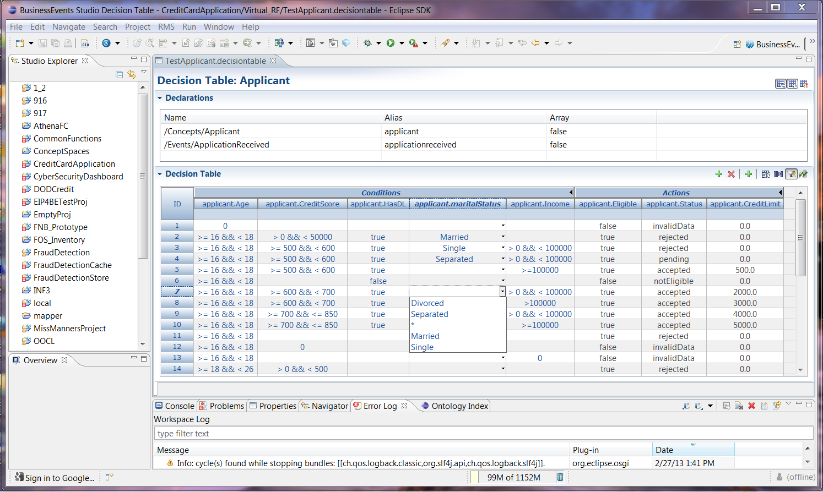

Figure 1 - Decision Table UI
The new decision table editor follows the familiar form-based approach that is used by the Concept editor, Event editor, Rule/RF (form-based) editor, etc. It contains 3 collapsible sections, a Declarations section, a Decision Table section, and an Exception Table section (hidden in the above screenshot).
Note: The relevant decision table editor classes are:
- com.tibco.cep.studio.decision.table.editor.DecisionTableSWTEditor
- com.tibco.cep.studio.decision.table.editor.DecisionTableSWTFormViewer
- com.tibco.cep.studio.decision.table.editor.DTBodyLayerStack<TableRule>
- com.tibco.cep.studio.decision.table.editor.DTColumnHeaderLayerStack<TableRule>

DecisionTableSWTFormViewer
This is the main entry point for creating and configuring the NatTable.

DTBodyLayerStack
See the section on the Body Layer for more information.

DTColumnHeaderLayerStack
See the section on the Column Header Layer for more information.

UI Components

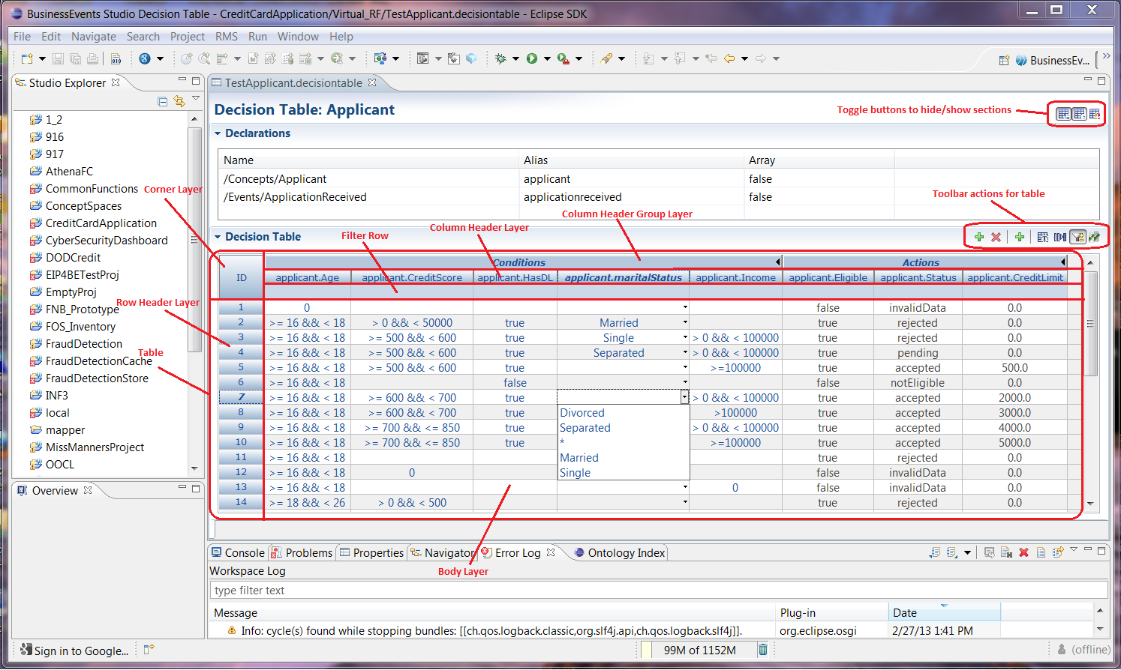

General Section
The general/header section contains the name of the Decision Table as well as buttons to show/hide each section of the editor. These sections include the Declarations Section, the Decision Table section, and the Exception Table section.

Declarations Section
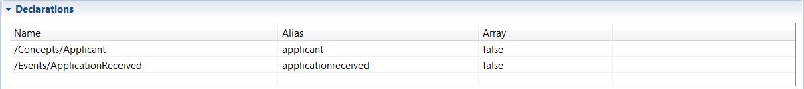
The Declarations section is the same it was in the original editor and needs no further explanation.

Decision Table Section
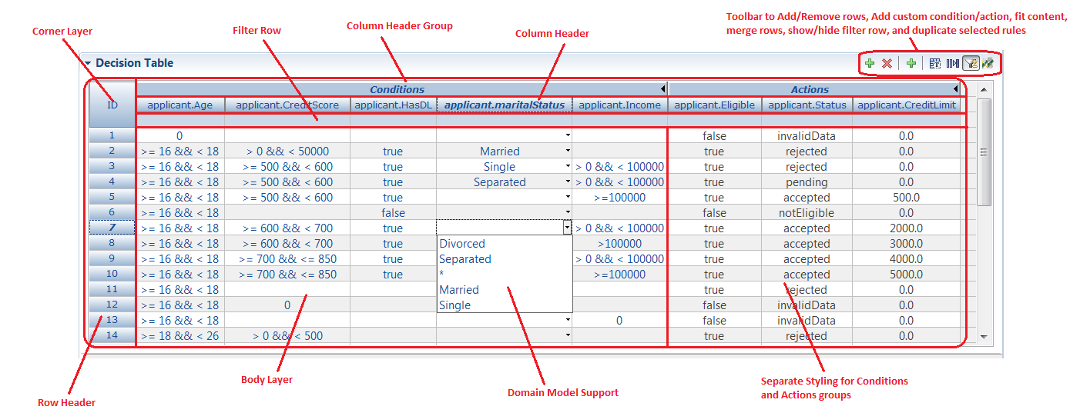

Corner Layer
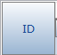
The corner layer simply shows “ID” as a static value to indicate the row header layer is showing the rule IDs.

Column Header Layer
The column header layer consists of three separate rows, as described below.
Note: The relevant column header layer class is:
- com.tibco.cep.studio.decision.table.editor.DTColumnHeaderLayerStack<TableRule>
This class combines each of the three column header rows into a composite layer to show all three.

- Column Header Group
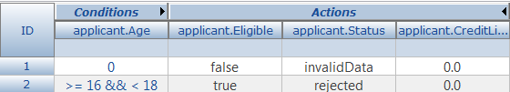
The top row of the column header layer is a Column Group consisting of 2 groups – one for the conditions of the table and one for the actions. These sections can be collapsed by double clicking, which will hide all but one column, useful when there are many columns and the user wants to work with the actions section.
Note: The column group is created by creating a ColumnGroupHeaderLayer, and adding individual column indexes to that layer. As such, whenever a new column is added, care must be taken to ensure that the column is properly inserted and added to the respective column group.

- Column Header
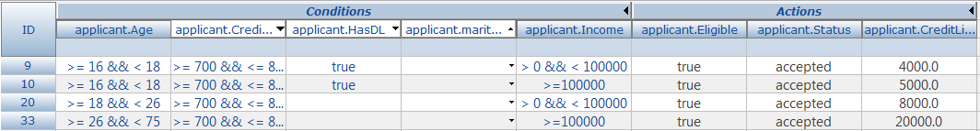
The middle row is the column header layer, which shows the columns for the decision table. This row supports sorting, including multi-column sort. Single column sorting can be accomplished by clicking on the target column. Multi-column sort can be done by holding down Alt-Shift while clicking on multiple columns.
Columns can be reordered by dragging and dropping to the appropriate index.
Note: Sorting is accomplished by creating a SortModel, and we use a GlazedListsSortModel with the GlazedLists integration. A SortHeaderLayer is then created, and it is provided the SortModel. See DTColumnHeaderLayerStack for more information.

- Filter Row
The bottom row of the column header layer is a filter row that can be used to quickly filter values in the table on one or more columns. The filter row can be conditionally hidden/shown via a toggle button on the toolbar. By default the filter row is shown.
Note: Filtering is made available by creating a FilterRowHeaderComposite, and providing a FilterStrategy. With GlazedLists integration we use a DefaultGlazedListsFilterStrategy. See DTColumnHeaderLayerStack for more information.

Row Header Layer
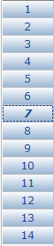
The row header is a static row that is always visible, and is created by creating a RowHeaderLayer.

Body Layer
The central area of the decision table is the “Body Layer”. This layer shows all of the conditions and actions of the TableRules.
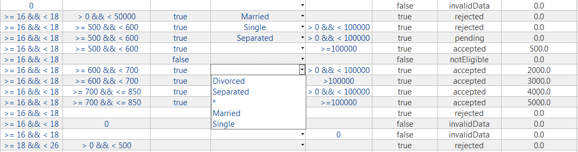
The body layer supports cell merging via a push button on the toolbar:
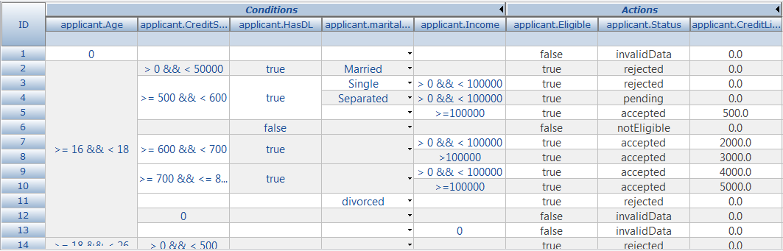

Exception Table Section
The Exception Table is analogous to the Decision Table section, no further detail is needed.

Data Providers
All information that is displayed inside of the above layers is provided via “Data Layers”, and each data layer is associated with an IDataProvider. This is a key concept for a NatTable based table. See the table below, which describes the relationship between the layers and their corresponding data providers:
Layer | DataLayer | IDataProvider
CornerLayer | DataLayer | DefaultCornerDataProvider
RowHeaderLayer | DataLayer | DTRowHeaderDataProvider
DTColumnHeaderLayerStack | DefaultColumnHeaderDataLayer | DTHeaderDataProvider
DTBodyLayerStack | SpanningDataLayer | SpanningGlazedListsDataProvider

See the IDataProvider classes to see how data is accessed.

Editing
To make cells editable, a configuration attribute must be set while configuring the table. To make all cells editable, the following attribute is set:
configRegistry.registerConfigAttribute(EditConfigAttributes.CELL_EDITABLE_RULE,
IEditableRule.ALWAYS_EDITABLE,
DisplayMode.EDIT);

See the section on styling for more information on configuration.
DataProviders are also responsible for setting the underlying model’s values. Once an expression is changed, the IDataProvider.setDataValue method is called. This method is given the column and row index, and the new value.
The corner and row headers are immutable. For the body layer, the SpanningGlazedListsDataProvider delegates the setDataValue call to the DTColumnPropertyAccessor that is given to the data provider.

Validation
Validating is enabled by setting a DataValidator in the configuration registry

DecisionTableDataValidator validator = getTableValidator(bodyDataProvider, ruleSet);
configRegistry.registerConfigAttribute(EditConfigAttributes.DATA_VALIDATOR, validator, DisplayMode.EDIT);

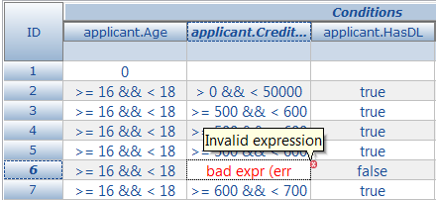

This validator is responsible for checking whether the expression is valid. If not, it should throw a validation exception, and the UI will style the cell to display the error. The problem with this approach, though, is that NatTable will not allow the cell to be committed (i.e. the value cannot be set in the underlying model) if the cell contains a validation error. The editor should, in fact, allow invalid expressions to be committed to the cell, so that they can be corrected at a later point.

Therefore it is recommended that validation is not used in this manner. Instead, if validation must be done, separate styling could be applied to invalid cells programmatically. Alternatively, the validation could simply check the syntax of the expression, not the semantics, and disallow invalid syntax from being committed to the cell.

Styling/Configuration
Styling is enabled on the table by adding IConfigurations to the NatTable. These configurations provide more than just styling (for instance SingleClickSortConfiguration is added to allow sorting via clicking on the header column), but for the purposes of this document the styling settings are of particular interest.

The following chart contains the various classes used to configure/style the decision table, with a brief description of the functionality each one provides:

IConfiguration | Purpose
DTSelectionStyleConfiguration | Sets up the default selection styling for any selected element in the decision table. This includes the selection font, background/foreground colors, etc. This is overridden for layer specific configurations.
DTRowHeaderStyleConfiguration | Styles the row header layer (i.e. the rule IDs).
DTColumnHeaderStyleConfiguration | Styles the column header layer (the column group, column header, and filter row)
DTBodyStyleConfiguration | Styles the body layer of the decision table. Responsible for registering alternative cell editors (checkbox for Booleans, combo box for domain models, etc).

By default, global styling is applied across all cells in the layer. However, styling of individual cells can be accomplished by adding “labels” to individual cells. The style configuration is then set for a specific label, and any cells that have that label will be styled appropriately. One such configuration is the CELL_EDITOR for the cell, which by default is a TextEditor but can be overridden for boolean properties or properties that have an associated domain model.

Further, styling can be done for all cells in a column by registering a column overrides (see DTBodyStyleConfiguration for an example). This is done, for instance, to display Actions cells differently than Conditions cells, or to set a checkbox or drop down editor for all cells in the column:
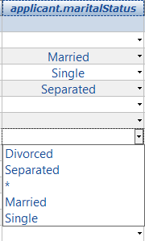

To provide multiple values in a combo box, the data provider must implement IComboBoxDataProvider, which contains a “getValues” method that returns a List of objects.

Notes/TODOs
The following section contains some relevant observations and some TODOs.

TODOs
- Drag N Drop – Currently DND is not supported from Studio Explorer. Users can create new custom condition/action columns, but not from properties. See DecisionTableSWTFormViewer::addCustom() as a template for dynamically adding columns to the table. Further, DND must be supported for catalog functions as well.

Also note that the current add custom code does not properly create the new column, so adding a custom condition column and then editing that column will result in an error. The proper column ID must be set, and perhaps other attributes as well.

- Checkbox Editor for boolean types – any column corresponding to a boolean type should have a checkbox rather than a text field. The hooks are already in place in DTBodyStyleConfiguration::registerColumnOverrides(). See the TODO in that method.

- Proper Domain Model support – currently users cannot select multiple domain model values from the drop down. This could require a custom cell editor, but is a requirement. Further, code should be added to display the domain model descriptions, based on a user preference.

- Exception Table support – no testing has been done on exception tables. Ensure this is working properly

- Initial creation of the table – no testing has been done on creating an empty table and building the table from scratch. Ensure this is working properly

- Table Analyzer integration – no work has been done to integrate the Table Analyzer into this solution. Ensure this is done

- Array property support – no work has been done to support array properties

- SWT leak analysis – no work has been done to ensure there are no SWT leaks (likely there are, as Images and Fonts are created programmatically).

- Properties View – no work has been done to integrate the Properties view. Ensure this is done.

- Search – Search is supported via Ctrl+F, but there is no dedicated search field. This could (optionally) be added to the Section header, though is not imperative as there is both a filter row as well as a Ctrl+F option.

- Validation – The existing validation framework can be used to validate an entire table, but proper hooks should be put in place to allow navigation from the problem in the Problems view to the corresponding rule in the editor.

- Undo/redo support – Currently the implementation does not use any EMF command stack infrastructure, and thus does not support undo. This should be added.

