T

TIBCO BusinessEvents: SWT Decision Table Editor

Product Suite | TIBCO BusinessEvents
Product | BE Studio Decision Tables
Product Version | 5.2
Initial Author | Ryan Hollom

Copyright Notice
COPYRIGHT© 2011 TIBCO Software Inc. This document is unpublished and the foregoing notice is affixed to protect TIBCO Software Inc. in the event of inadvertent publication. All rights reserved. No part of this document may be reproduced in any form, including photocopying or transmission electronically to any computer, without prior written consent of TIBCO Software Inc. The information contained in this document is confidential and proprietary to TIBCO Software Inc. and may not be used or disclosed except as expressly authorized in writing by TIBCO Software Inc. Copyright protection includes material generated from our software programs displayed on the screen, such as icons, screen displays, and the like.
Trademarks
Technologies described herein are either covered by existing patents or patent applications are in progress. All brand and product names are trademarks or registered trademarks of their respective holders and are hereby acknowledged.
Confidentiality
The information in this document is subject to change without notice. This document contains information that is confidential and proprietary to TIBCO Software Inc. and may not be copied, published, or disclosed to others, or used for any purposes other than review, without written authorization of an officer of TIBCO Software Inc. Submission of this document does not represent a commitment to implement any portion of this specification in the products of the submitters.
Content Warranty
The information in this document is subject to change without notice. THIS DOCUMENT IS PROVIDED "AS IS" AND TIBCO MAKES NO WARRANTY, EXPRESS, IMPLIED, OR STATUTORY, INCLUDING BUT NOT LIMITED TO ALL WARRANTIES OF MERCHANTABILITY OR FITNESS FOR A PARTICULAR PURPOSE. TIBCO Software Inc. shall not be liable for errors contained herein or for incidental or consequential damages in connection with the furnishing, performance or use of this material.
For more information, please contact:
TIBCO Software Inc.
3303 Hillview Avenue
Palo Alto, CA 94304
USA
Table of Contents
TIBCO BusinessEvents: SWT Decision Table Editor 1
1 Change Log 4
1.1 Related Documents 4
2 Introduction 5
2.1 Main Objective 5
2.2 Intended Usage 5
2.3 Audience 5
3 Acronyms and Vocabulary 6
4 Non-Functional Requirements 6
4.1 Format 6
4.2 Packaging 6
5 SWT Based Tables 6
5.1 Background 7
5.1.1 Existing JIDE based editor 7
5.1.2 Basic Features 7
5.1.3 Advanced Features 8
5.1.4 New Features 8
5.2 SWT based Tables 9
5.2.1 Pure SWT 9
5.2.2 KTable 10
5.2.3 Glazed Lists 11
5.2.4 NatTable 12
5.2.5 Grid 13
5.2.6 XViewer 14
5.2.7 KTable with GlazedLists 15
5.2.8 NatTable with GlazedLists 16
5.3 Performance 17
6 Summary 18
6.1.1 Pure SWT 18
6.1.2 KTable 18
6.1.3 Glazed Lists 18
6.1.4 NatTable 18
6.1.5 Grid 18
6.1.6 XViewer 19
6.1.7 KTable with GlazedLists 19
6.1.8 NatTable with GlazedLists 19
7 Conclusion 19

Change Log
.
Date | Version | Name | Description
1/11/2012 | 1.0 | Ryan Hollom | Initial doc

Related Documents
Document Title | Revision Number | Author

Introduction

Main Objective
The objective of this document is to discuss several options to replace the existing JIDE/Swing based Decision Tables with a pure SWT based implementation in TIBCO BusinessEvents 5.2.

Intended Usage
The new SWT based Decision Table editor is intended to be a drop in replacement for the existing JIDE based editor, and, where appropriate, should provide the same functionality that the existing editor provides.

Audience
The document is intended for Developers, Architects, QA, Product Marketing, and Managers.

Acronyms and Vocabulary

The table below describes some of the Acronyms used in this documentation
- BE – TIBCO BusinessEvents.
- DT – Decision Table
- DM – Decision Manager
- RMS -- Rules Management Server. It is the existing component, which we will need to modify to support WS needs, or a completely new server component.
- PE – Project Explorer view in BE Studio
- Studio Project – A TIBCO Project build using TIBCO BusinessEvents Studio.
- BUI – Business User Interface

Non-Functional Requirements
The following section briefly covers in more details the non-functional requirements for the initial version of Display Models.

Format
The format for existing Decision Tables should not change purely due to the replacement of the JIDE based editor. Any format changes should be done as a separate effort to increase efficiency and decrease the size of the persisted files.

Packaging
The replacement editor can either exist as an entirely new plugin or can be put into the existing com.tibco.cep.decision.table.ui. If a new plugin is created, it should be delivered as part of the Decision Manager add-on. Initially, it might be beneficial to have a separate plugin for maintenance purposes, but ultimately the plugin should be merged into the existing set of plugins.

SWT Based Tables
The following section discusses various options to replace the existing JIDE/Swing based Decision Table editor with a pure SWT based implementation.

Background
The current Decision Table editor uses a Swing based table widget from the 3rd party provider JIDE Software. As it is a Swing based widget, it must be placed in an embedded java.awt.Frame widget using the SWT_AWT bridge. This causes BE Studio to crash intermittently on GTK due to a SWT_AWT bridge + Java bug (see bugs http://bugs.sun.com/bugdatabase/view_bug.do?bug_id=6386791 and https://bugs.eclipse.org/bugs/show_bug.cgi?id=126931 for more information).
These issues render BE Studio largely unusable on Linux with several GTK versions. As such, a pure SWT based implementation must be developed to replace the Swing based implementation and avoid the SWT_AWT bridge.

Existing JIDE based editor
The existing editor can be seen below in Figure 1. It contains a Declarations section, a Decision Table section, and an Exception Table section. Within the tables, there is a conditions area and an actions area.
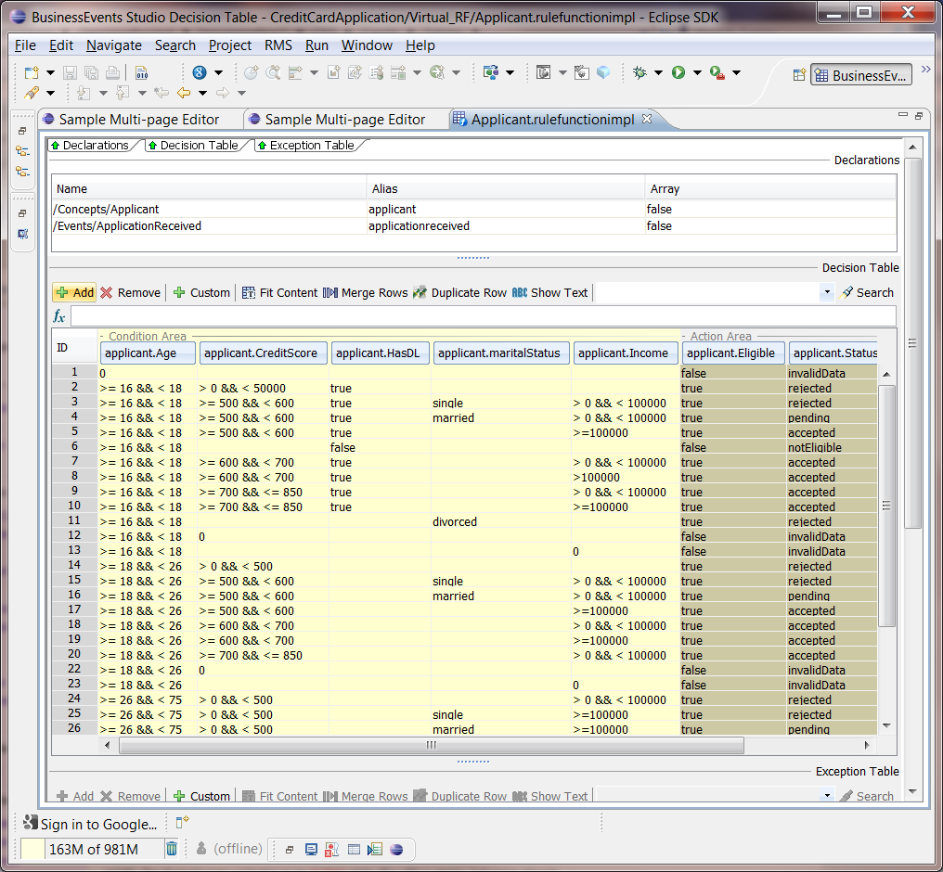
Figure 1

Basic Features
The replacement solution should contain a minimum set of functionality that is available in the existing Swing based editor:
- Show rule IDs on the LHS of the table
- Adding/removing columns via drag n drop
- Adding/removing rows
- Editing cell values
- Sorting
- Duplicating rows
- Searching for cell values
- Domain Model support
- Validation

Advanced Features
Beyond the basic features, a number of more advanced features should be considered while evaluating a replacement solution. These features include, but are not limited to:
- Row merging
- Performance/Efficiency (though the current table is not terribly efficient for large tables)
- Array support/wildcard support by renaming column headers
- Fit content
- Show Text
- Comments

New Features
Creating a replacement solution also affords the opportunity to explore new features that currently do not exist in the Swing based editor. These features include, but are not limited to:
- Validation during cell-editing (currently done only at the table level)
- Filtering (Currently only Search is available)
- Collapsing/Hiding columns (to show more relevant columns to the user)
- Advanced/Multi-column sorting
- Paging (for large tables)

SWT based Tables
The following sections discuss various SWT based tables that are candidates to replace the Swing based table in the Decision Table editor. Each section will discuss the underlying component, as well as show a simple implementation of the table. The screenshots mostly reflect the default implementation of the table. That is, no styling has been added. Many of the components can be further customized to varying levels. The level of customization will be discussed in each section.

Pure SWT
One solution is to develop an entirely custom solution by using the existing SWT Table widget. This would allow for full control over the behavior and the styling, and it would not introduce any new 3rd party libraries as the SWT Table widget exists and is used extensively in the current product. There is also a flag to create a “Virtual” table that would allow for large datasets (see the section on Performance for more information). An example SWT based implementation can be seen in Figure 2 below:
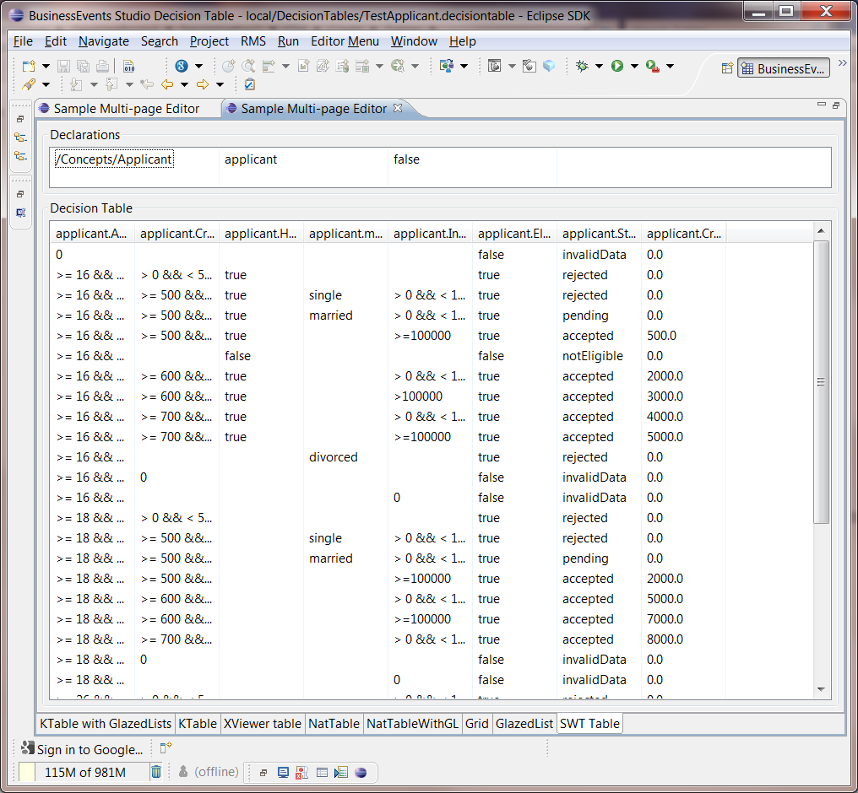
Figure 2 – SWT Table example
Although it is beneficial to use a custom built widget for maintenance and control of the code, it also requires the highest level of effort as nothing has been built in. This includes management of the table model, creation of the table items, enabling sorting, etc. All features would need to be added manually. Further, the base SWT Table widget does not have the concept of “Row Headers”. That is, it is not simple to add the Row ID on the left hand side of the table. For these reasons and more, implementation a solution based on the core SWT widget is not attractive.

KTable
KTable is a custom SWT table widget that provides a flexible grid of cells to display data. Since it is custom-drawn, it does not have the restrictions of the native SWT Table control. Information regarding KTable can be found at http://sourceforge.net/projects/ktable/. The basic premise behind KTable is that you provide a KTableModel to the table, which is responsible for both providing the data (i.e. doGetContentAt(row, col)) as well as providing the cell editor, cell renderer, column count, row count, etc. An example KTable implementation can be seen in Figure 3 below:
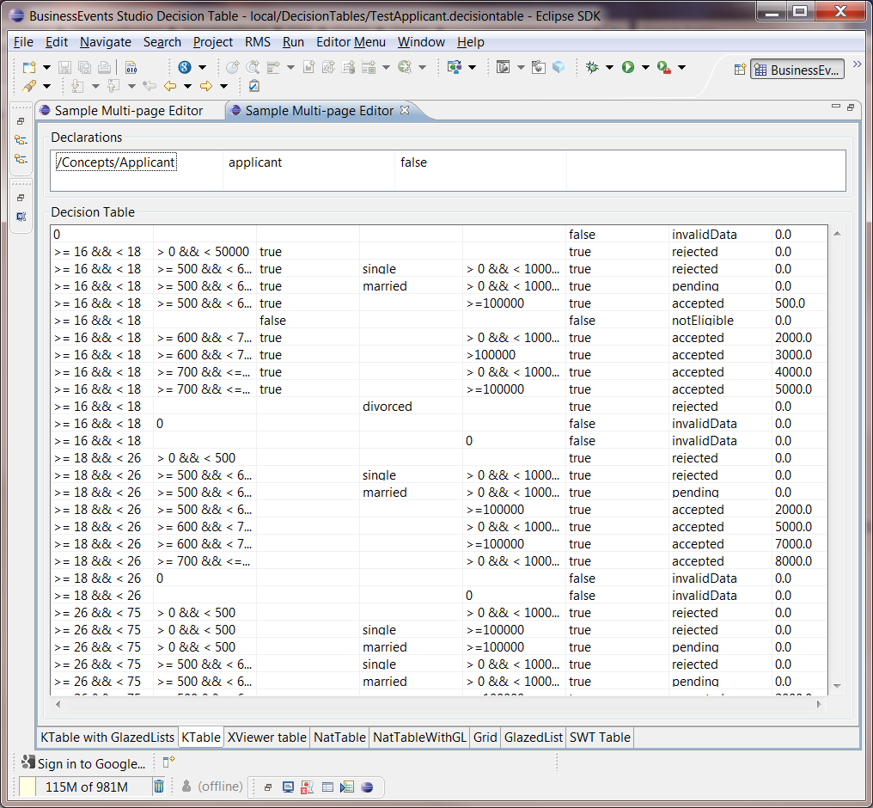
Figure 3 – KTable example
Although not shown here, KTable does support the notion of “Fixed” rows and columns, which would suffice for displaying the row IDs for the rules in the table. It also supports sorting, although it is the responsibility of the implementer to create the comparator.
KTable does maintain some of the table model (row mappings, etc), so it is not necessary to maintain that mapping manually, which is beneficial to avoid data corruption. KTable also attempts to request and render only visible data, rather than asking for all information, which is necessary for very large tables (see the section on Performance for more information).
KTable supports both cell and row spanning in a relatively straightforward (though perhaps inefficient) way. There is a method on the KTableModel (‘doBelongsToCell’) to test whether a certain cell belongs to a separate cell. This method must be overridden to calculate whether the column/row belongs to a different cell, therefore it is up to the implementer to decide how to calculate this. In other words, the “merge” functionality that exists in the current Swing based Table is not built-in, though it is supported from the KTable component itself.
The biggest significant drawback with KTable is that it does not support column reordering by default. Because KTable is a custom-drawn widget, it extends from Canvas directly rather than the default SWT Table widget, so the reordering functionality that exists in the SWT Table is not present with KTable. It would likely be possible to implement this functionality with explicit actions to move columns right/left similar to the existing JIDE Table, though it would be preferable to allow drag-and-drop reordering for better usability.
KTable is fairly extensive, although it is unclear how active the project is as of this writing. The last update was nearly 2 years ago, and it is difficult to find much documentation on the product. Further, there does not appear to be any active forum for this project.

Glazed Lists
Glazed Lists is an event-driven list for dynamically filtered and sorted tables. It is not a UI component in itself, however it can be used by other UI components. KTable, NatTable, and pure SWT all support integration with Glazed Lists. EventList implements the same List interface as ArrayList and Vector, and so it is simple to use. The EventList can be used for the rows of the table (via the EventTableModel). It supports dynamic, granular sorting, and is designed for high performance. For instance, if 5 elements are inserted into a SortedList containing 10,000 elements, only the new elements get sorted.
Glazed Lists is also designed for concurrency, where the EventList can be populated on a background thread while the user interface thread remains responsive. This is beneficial for large tables.
Figure 4 below shows a basic SWT Table widget with Glazed List integration. As can be seen, the UI is exactly like the basic SWT Table in Section 5.2.1.
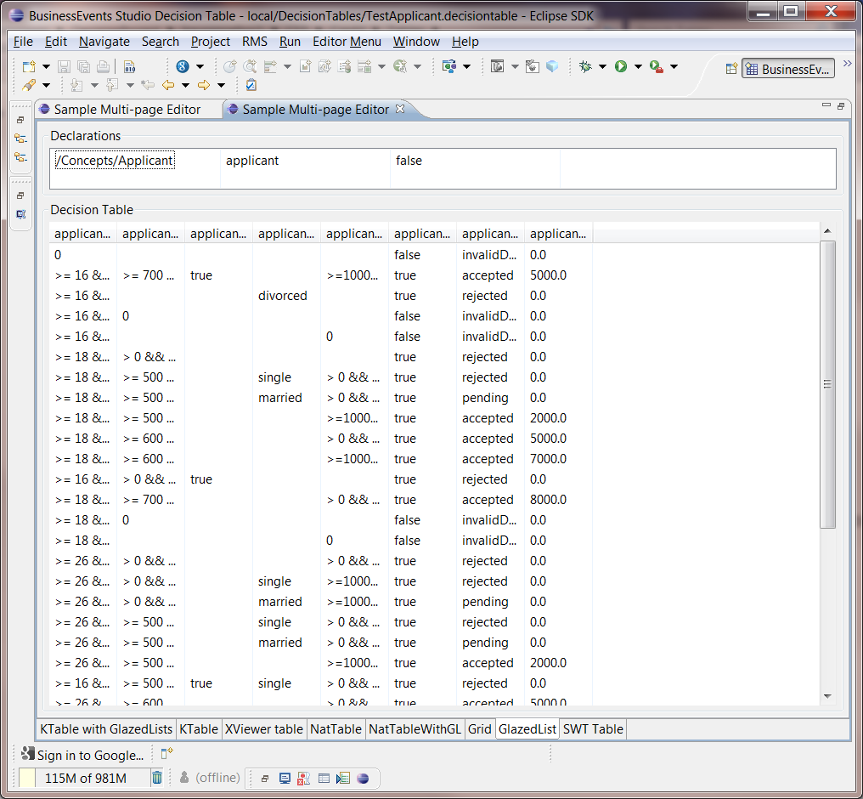
Figure 4 – Glazed List example
The limitations of this implementation are similar to those for base SWT Table widget. Specifically there is still no concept of row headers, and all other functionality would need to be manually developed.

NatTable
NatTable is a custom table/grid widget which is based on the SWT library. It is focused on handling high volume, real-time data updates. It also features dynamic styling, integration with GlazedLists, and more (see http://www.eclipse.org/nattable/index.php for more information).
NatTable is a custom painted table widget that does not use default SWT composites for rendering. Only those elements that are visible to the user are calculated and rendered. Therefore NatTable acts as a virtual table.
The central idea behind NatTable is the notion of “layers”. A layer is the mechanism for adding functionality to a NatTable, and layers can be arranged in “stacks”. At the bottom of each layer stack is a DataLayer which serves as a data source for all the other layers.
An example of a NatTable implementation can be seen in Figure 5 below.
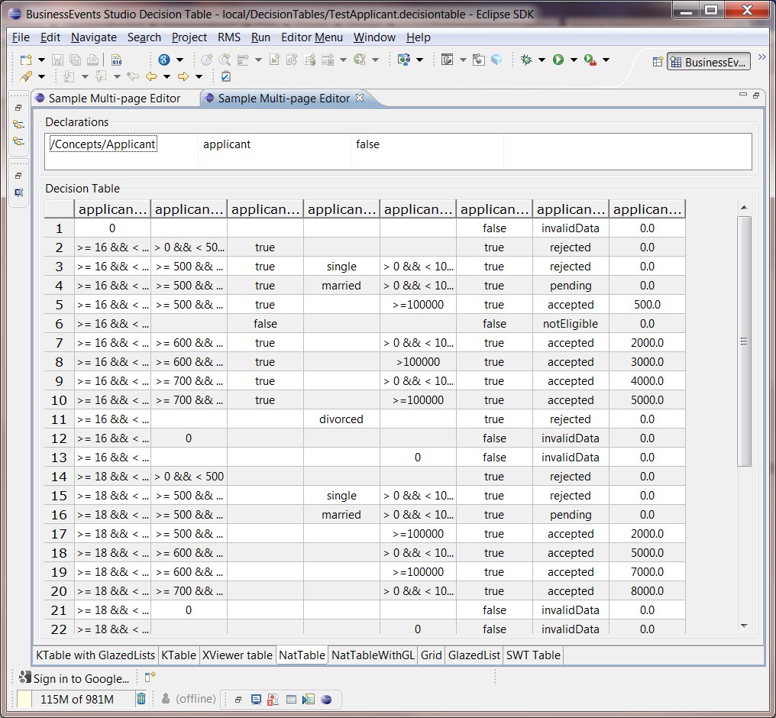
Figure 5 – NatTable example
NatTable supports a high level of data, UI, and functionality customization. Each layer has its own style configuration to customize how the data is rendered. The above example shows the basic, default UI rendering with little or no customizations.
NatTable is now under the parent Eclipse Nebula project, and so falls under the Eclipse Public License. It has a fairly active user group/forum page, which is encouraging from an implementation standpoint.
Unfortunately NatTable is relatively complex compared to the other solutions, and so it has the highest learning curve out of any of the other options discussed in this document. However, the functionality, extensibility, and performance of this table make it an attractive option to replace the Swing based Decision Table.

Grid
The Grid widget is a spreadsheet/table component that offers features not currently found in the base SWT Table. Features include cell selection, column grouping, column spanning, row headers, and more.
An example of a simple Grid implementation can be seen in Figure 6 below.
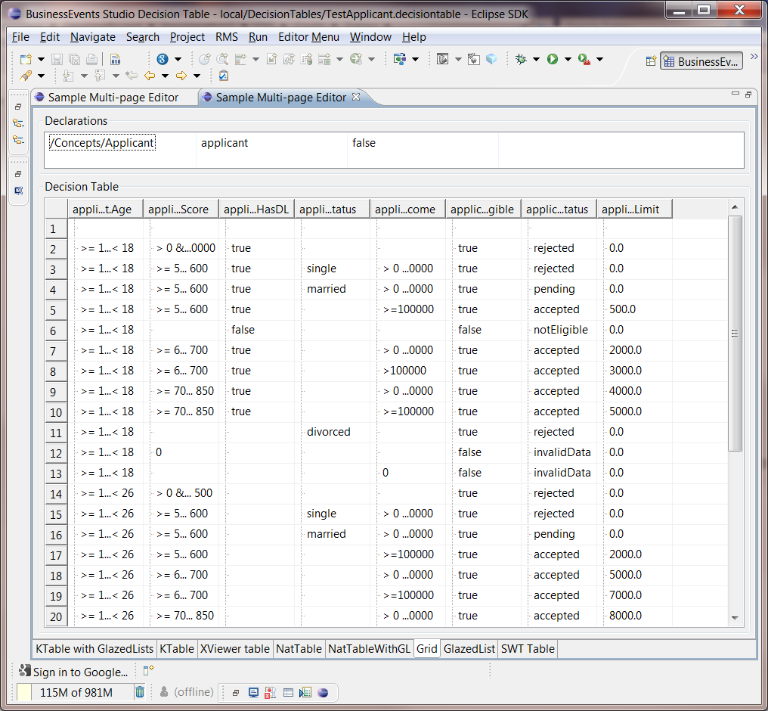
Figure 6 – Grid example
The Grid widget removes many of the limitations that exist in the standard SWT widget, however it is still up to the developer to manually develop all of the feature functionality of the table itself. This includes creation of the “GridItems”, enabling editing, sorting, maintaining the table model, etc.

XViewer
The purpose of XViewer is to provide a more advanced and dynamic TreeViewer that has the filtering and sorting capabilities of a spreadsheet while providing the users the ability to customize their table to suit their current needs. More information on XViewer can be found at http://www.eclipse.org/nebula/widgets/xviewer/xviewer.php.
XViewer extends from the core SWT TreeViewer widget, but provides several nice built-in features. These features include column reordering, sorting, filtering, and simple metrics. It also provides advanced editing features such as copying rows and columns, multi-column editing, html rendering of the table, export functionality (i.e. to an Excel spreadsheet), and more.
The basic idea behind XViewer is to provide a standard ITreeContentProvider as well as an XViewerLabelProvider to the XViewer control. These two classes are responsible for telling the XViewer what data to show, and how to show it. This is a simple approach that is used by many Eclipse widgets.
An example of an XViewer implementation can be seen in Figure 7.
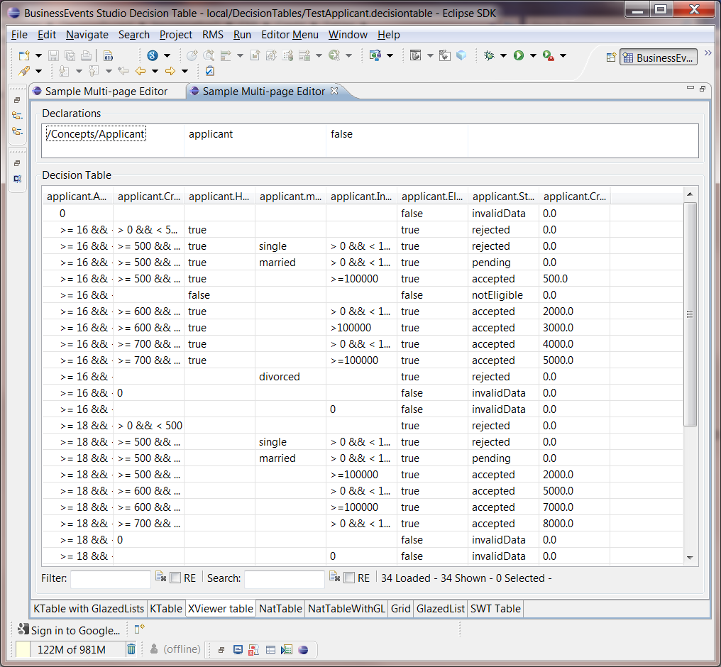
Figure 7 – XViewer example
XViewer provides an attractive, functional table that contains many built in features. However there are significant drawbacks to the implementation that make it less ideal as a solution. Specifically, while rendering the table, the LabelProvider is asked for the text of every cell in the table, regardless of whether the cell is visible or not. So if the table has 100,000 rows, it will calculate labels for every single cell. This results in a significant delay in the initial table population (see the section on Performance for more information). It is unclear whether there is any way to avoid this. There is an ILazyTreeContentProvider that allows for lazy retrieval of children, however since a Decision Table “tree” is flat, this does not add any performance gain.
Ultimately XViewer is better suited for tree controls, and although it could be used for a flat, table-like control, it falls short for the needs of decision table.

KTable with GlazedLists
To integrate KTables with GlazedLists the user must create an EventKTableModel at the model for the KTable, rather than a custom KTableModel. The responsibility for UI styling/editing is then delegated to a TableFormat rather than to the KTableModel.
Integrating KTable with GlazedLists removes the need to provide some of the manual steps related to managing the table model. An example of a KTable integrated with GlazedLists can be seen in Figure 8.
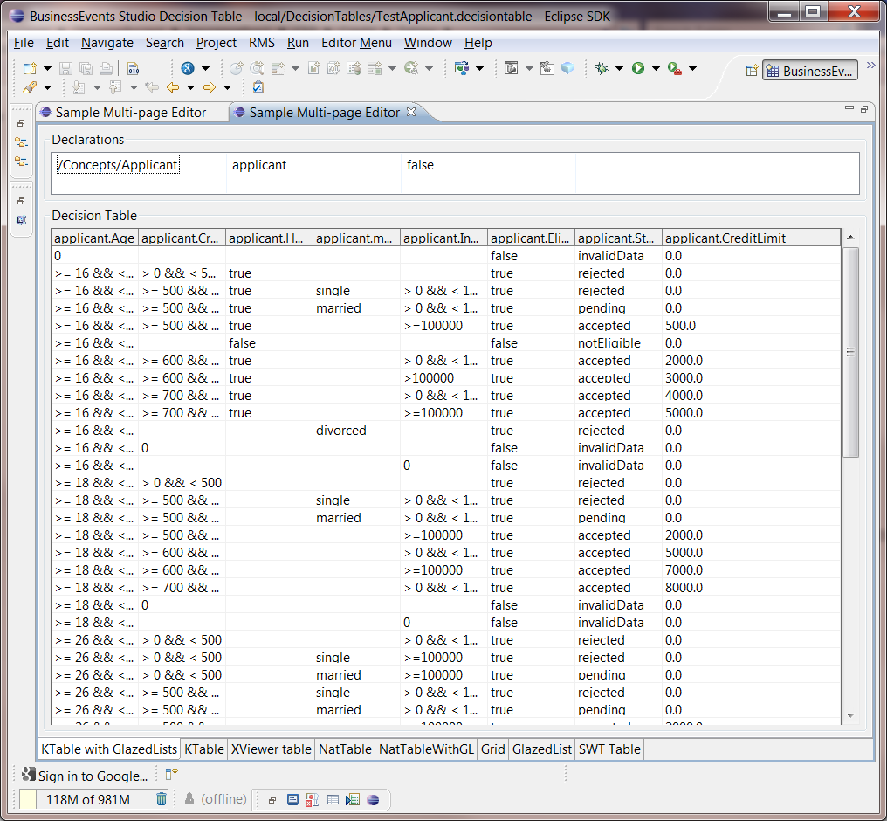
Figure 8 – KTable with GlazedLists
Integration with GlazedLists provides some convenient functionality, however the same limitations of KTable still exist as GlazedLists do not provide any UI related enhancements.

NatTable with GlazedLists
To integrate GlazedLists with NatTable, one must create a GlazedListsEventLayer that wraps an EventList, and this becomes the body data provider rather than a custom data provider.
An example of a NatTable integrated with GlazedLists can be seen in Figure 9 below.
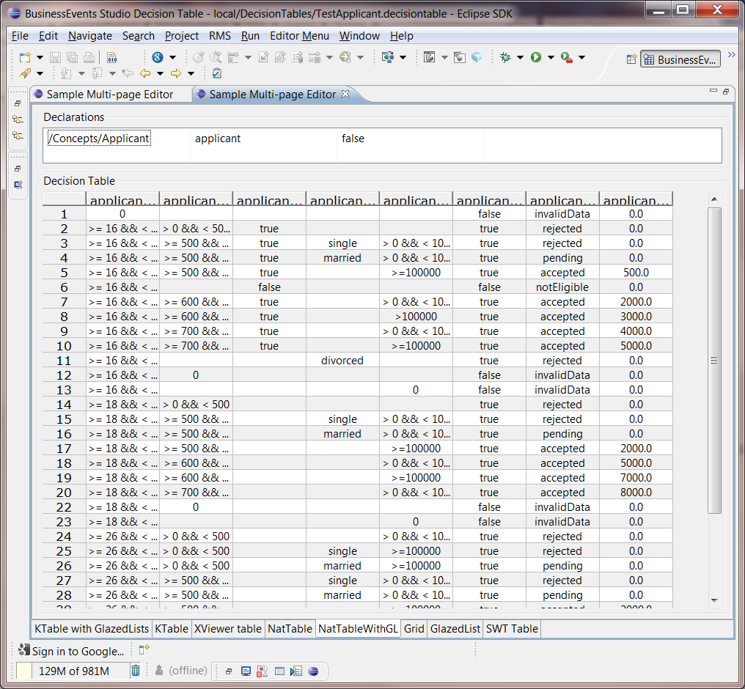
Figure 9 – NatTable with GlazedLists
Integration with GlazedLists allows for the dynamic sorting and currency benefits that GlazedLists provides. Specifically, the ability to lock the input model for writing is important for live data or multi-threaded manipulation of the data. However it is unclear whether this functionality is absolutely necessary for Decision Table editing.

Performance
Following table shows some initial performance testing for each of the components described in Section 5.2.
 | SWT | KTable | NatTable | XViewer | Grid | SWT w/ GlazedList | KTable w/ GlazedList | NatTable w/ GlazedList | JIDE Table
License | EPL | EPL | EPL | EPL | EPL | LGPL-2.1, MPL-1.1 | EPL + LGPL-2.1, MPL-1.1 | EPL + LGPL-2.1, MPL-1.1 | Commercial
Load time (30 rows) | 46 ms | 15 ms | 12 ms | 101 ms | 12 ms | 36 ms | 13 ms | 26 ms | 138 ms
Load time (40,000 rows) | 21933 ms | 14 ms | 15 ms | 115430 ms | 859 ms | 21232 ms | 14 ms | 75 ms | 9703 ms
Load time (100,000 rows) | 58234 ms | 17 ms | 15 ms | 930113 ms | 4419 ms | 58424 ms | 14 ms | 235 ms | 23601 ms
Table paint time (100,000 rows) | 4 ms | 4 ms | 4 ms | 46 ms | 4 ms | 5 ms | 3 ms | 2 ms

Summary

Pure SWT
Although attractive as a custom solution to avoid any 3rd party libraries, there are too many limitations with the core SWT Table widget to make it a viable solution for Decision Tables.

KTable
KTable provides many of the required features needed in a Decision Table replacement. A full-featured table can be created quickly, though any styling changes would need to be done manually. There is a limitation with the column reordering, though there is a valid workaround.
Ultimately the long term viability of KTable as a project is the most concerning. There have been few updates to this project in recent years, the documentation is limited, and there are no active forums for this project. Therefore, although KTable would be a viable solution, it is recommended to avoid this component due to potential support related issues.

Glazed Lists
Ultimately Glazed List integration provides some good functionality for very large datasets, however it seems that Glazed Lists are really more geared toward live data so that the data can be constantly and dynamically updated. As such the integration of Glazed Lists should be considered optional.

NatTable
NatTable is a rich table widget, and is under the Eclipse Nebula project (see http://www.eclipse.org/nebula/). It allows for a high level of extensibility and customization. There is an active forum for this project, and the fact that it is under the Eclipse umbrella is encouraging for the long term viability of this component as a solution. The drawback for NatTable is that it is the most complex solution under consideration with the highest learning curve.

Grid
The Grid widget removes many of the limitations that exist in the standard SWT widget, however it is still up to the developer to manually develop all of the feature functionality of the table itself. This includes creation of the “GridItems”, enabling editing, sorting, maintaining the table model, etc. Further, the webpage for the Grid widget states that “The Grid widget is still under active development. The code is made available in an ALPHA state. User should expect changes in future versions”. As such, the Grid widget should not be considered as a viable replacement for Decision Tables.

XViewer
Ultimately XViewer is better suited for tree controls, and although it could be used for a flat, table-like control, it falls short for the needs of decision table.

KTable with GlazedLists
See Section 6.1.3 for more information.

NatTable with GlazedLists
See Section 6.1.3 for more information.

Conclusion
Ultimately the choice depends on the requirements and the long term vision for an Eclipse based Decision Table solution. As of BE 5.1, BE WebStudio provides support for editing Decision Tables, and so it is possible that an Eclipse based Decision Table editor will be phased out moving forward. It would therefore be unnecessary to commit a lot of time/large number of resources toward the creation of a new SWT based Decision Table product.
That said, it is recommended that NatTable is used as the replacement component for the Swing based Decision Table editor. It provides very rich functionality that would allow for relatively quick development of a replacement Decision Table editor. There is the concern that the learning curve for this solution is steep, however it is not insurmountable and, once crossed, development and maintenance of this solution should be straightforward. Further, because this component falls under the Eclipse Nebula project, support for the component should be long(er)-lived.
Ultimately the inclusion of GlazedLists into the solution would add complexity, as well as adding two new licenses (LGPL and MPL) to the product. Although GlazedLists provides some nice functionality, it is not a requirement for this solution and should therefore be omitted.

