T

TIBCO BusinessEvents: WebStudio Display Models

Product Suite | TIBCO BusinessEvents
Product | WebStudio Display Models
Product Version | 5.2
Initial Author | Ryan Hollom

Copyright Notice
COPYRIGHT© 2011 TIBCO Software Inc. This document is unpublished and the foregoing notice is affixed to protect TIBCO Software Inc. in the event of inadvertent publication. All rights reserved. No part of this document may be reproduced in any form, including photocopying or transmission electronically to any computer, without prior written consent of TIBCO Software Inc. The information contained in this document is confidential and proprietary to TIBCO Software Inc. and may not be used or disclosed except as expressly authorized in writing by TIBCO Software Inc. Copyright protection includes material generated from our software programs displayed on the screen, such as icons, screen displays, and the like.
Trademarks
Technologies described herein are either covered by existing patents or patent applications are in progress. All brand and product names are trademarks or registered trademarks of their respective holders and are hereby acknowledged.
Confidentiality
The information in this document is subject to change without notice. This document contains information that is confidential and proprietary to TIBCO Software Inc. and may not be copied, published, or disclosed to others, or used for any purposes other than review, without written authorization of an officer of TIBCO Software Inc. Submission of this document does not represent a commitment to implement any portion of this specification in the products of the submitters.
Content Warranty
The information in this document is subject to change without notice. THIS DOCUMENT IS PROVIDED "AS IS" AND TIBCO MAKES NO WARRANTY, EXPRESS, IMPLIED, OR STATUTORY, INCLUDING BUT NOT LIMITED TO ALL WARRANTIES OF MERCHANTABILITY OR FITNESS FOR A PARTICULAR PURPOSE. TIBCO Software Inc. shall not be liable for errors contained herein or for incidental or consequential damages in connection with the furnishing, performance or use of this material.
For more information, please contact:
TIBCO Software Inc.
3303 Hillview Avenue
Palo Alto, CA 94304
USA
Table of Contents
TIBCO BusinessEvents: WebStudio Display Models 1
1 Change Log 5
1.1 Related Documents 5
2 Introduction 6
2.1 Main Objective 6
2.2 Intended Usage 6
2.3 Audience 6
3 Acronyms and Vocabulary 7
4 Non-Functional Requirements 7
4.1 Packaging 7
5 High-level Design 7
5.1 Display Models 7
5.1.1 Naming 8
5.1.2 Syntax 8
5.1.3 Display Model Wizard 8
5.1.4 Display Model Editor 9
5.1.5 Internationalization 10
5.1.6 Overriding behaviors 10
5.1.7 Refactoring 10
5.1.8 Search 10
5.1.9 Validation 10
5.2 WebStudio 10
5.2.1 Runtime 10
For the base Entity name itself, the display text should be shown inside of the Group Contents window, portlet, and any RMS related dialog (commit, checkout, etc): 12
If the Display Model is given a non-default language, and the locale is set to that language (i.e. 12

Change Log
.
Date | Version | Name | Description
6/4/2014 | 1.0 | Ryan Hollom | Initial doc

Related Documents
Document Title | Revision Number | Author
WebStudio-GeneralDesign.doc | Various | various
WebStudio-RuleTemplate-Design.doc | Various | Ryan Hollom
WebStudio5.2-DisplayModel-Design.doc | Various | Ryan Hollom

Introduction

Main Objective
The objective of this document is to outline the implementation of the new Display Model artifact in TIBCO BusinessEvents 5.2.

Intended Usage
The intended usage of Display Models is to provide a mechanism to define the display text for elements inside of the WebStudio UI, for instance properties. Rather than using the default element name, a human readable should be displayed instead.

Audience
The document is intended for Developers, Architects, QA, Product Marketing, and Managers.

Acronyms and Vocabulary

The table below describes some of the Acronyms used in this documentation
- BE – TIBCO BusinessEvents.
- WS – WebStudio
- WSS – WebStudio Server
- RMS -- Rules Management Server. It is the existing component, which we will need to modify to support WS needs, or a completely new server component.
- PE – Project Explorer view in BE Studio
- Studio Project – A TIBCO Project build using TIBCO BusinessEvents Studio.
- ACL – Access Control List. Security configuration file on server end to control what each user role is allowed to do.
- BUI – Business User Interface
- GWT – Google Widget Toolkit

Non-Functional Requirements
The following section briefly covers in more details the non-functional requirements for the initial version of Display Models.

Packaging
Display Models should be considered as part of the core/standard BE component, and will exist as a first class citizen inside of TIBCO BE Projects.

High-level Design
The following section covers the high level design for the initial version of BE Display Models.

Display Models
Display Models are defined inside of BE Studio, similar to Concepts, Events, and Rules. A Display Model is ultimately a specialized type of property file, and follows the familiar name/value pair syntax for property files in Java. Display Models are first class citizens inside of a BE Studio Project, and their proposed file extension is “.display”.

Naming
The Display Model should follow a well-known naming convention. The name should match the associated BE Project artifact (Concept or Event). For instance, for the Concept named “Person.concept”, the corresponding Display Model artifact would be named “Person.display”. This will simplify the syntax and allow for a loose coupling of the artifacts.

Syntax
The syntax for Display Model files follows the standard Java property file syntax, specifying name/value pairs corresponding to the display attributes for individual elements. For each artifact property, there is an optional property to specify the text that is displayed in the WebStudio UI. The simple syntax is as follows:
<property name>=<display text>
For instance
Name.displayText=User Name
Additionally, there should be an optional property that allows properties to be hidden entirely from the WebStudio UI, so that they are not accessible from the builder based Business Rule editor or Decision Table editor.
<property name>.hidden=true | false
For instance
Name.hidden=true
Finally, there should be one optional property to specify the text to be displayed wherever the artifact itself is shown in the WebStudio UI, for instance inside of the Group Contents window. The syntax for this setting is
displayText=<display text>
For instance, for an ‘Applicant’ Concept
displayText=Credit Card Applicant

Display Model Wizard
A wizard should be added to create new Display Models, similar to the existing ‘New’ wizards for other BE Project artifacts. The wizard optionally allows the user to choose a language and a country for the Display Model. If no language/country is chosen, a file with the default name of <Artifact Name>.display is created. If those values are selected, the name of the file created follows the standard Java I18N naming conventions, namely <Artifact Name>_<Language code>_<Country code>. For instance, for the Concept named ‘Applicant’, with ‘English’ selected as the language, and ‘United States’ selected as the country, the file name becomes Applicant_en_US.display.
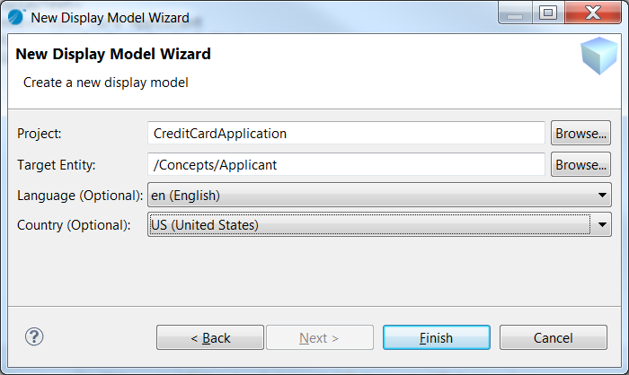
Display Model Wizard

Display Model Editor

A form editor is provided as the default editor for all Display Model artifacts:
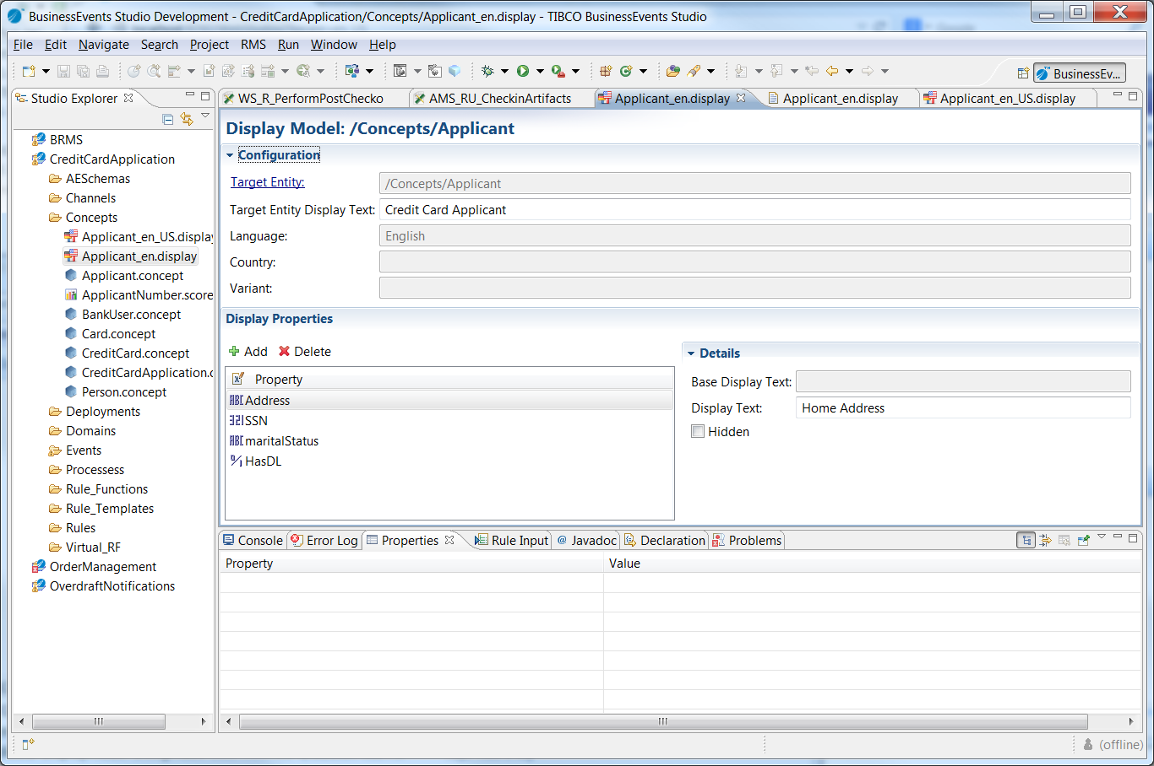

The user can optionally add one or more properties to translate/hide. Clicking on the ‘Add’ button will display all available properties for this target entity. Once added, the user can change the display text for that property, or hide that property from WebStudio by checked the ‘Hidden’ box.

Internationalization
Should follow standard Java I18N conventions.

Overriding behaviors
As Concepts and Events can inherit properties from parent Concepts/Events, it is important to allow any visible property from the Entity’s hierarchy to the Display Model. For instance, if the Concept ‘Employee’ inherits a property called ‘Name’ from the Concept ‘Person’, it is valid to specify the display text for the ‘Name’ property inside of the Display Model for the ‘Employee’ Concept. This is, in fact, a very common use case, as ‘Name’ can have very different meanings depending on the context.
Additionally, there is a way to override the default display text inside individual Rule Templates. This would provide another level of meaningful, context-aware specification of properties. A new ‘display’ section could be added to the Rule Template source, and the context-sensitive display text for each accessible property can be specified by using dot notation, for instance:
display {
account.AccountID = "Personal Checking Account ID";
}

Refactoring
A new refactoring is added to react to element modifications. Specifically, the refactoring participant should support renaming of properties as well as the associated Entity itself. Upon Entity renaming, the filename of the Display Model must change as well.

Search
A new search participant should be created to show references to property names inside of the Display Model.

Validation
A new validator should be added to check for invalid properties. This should result in a warning only, as it should not cause any runtime error.

WebStudio

Runtime
The localized display text, if specified in the Display Model, should be displayed in lieu of the standard element name. For properties, the display text will be shown inside of the “builder-based” Business Rule editor as follows:
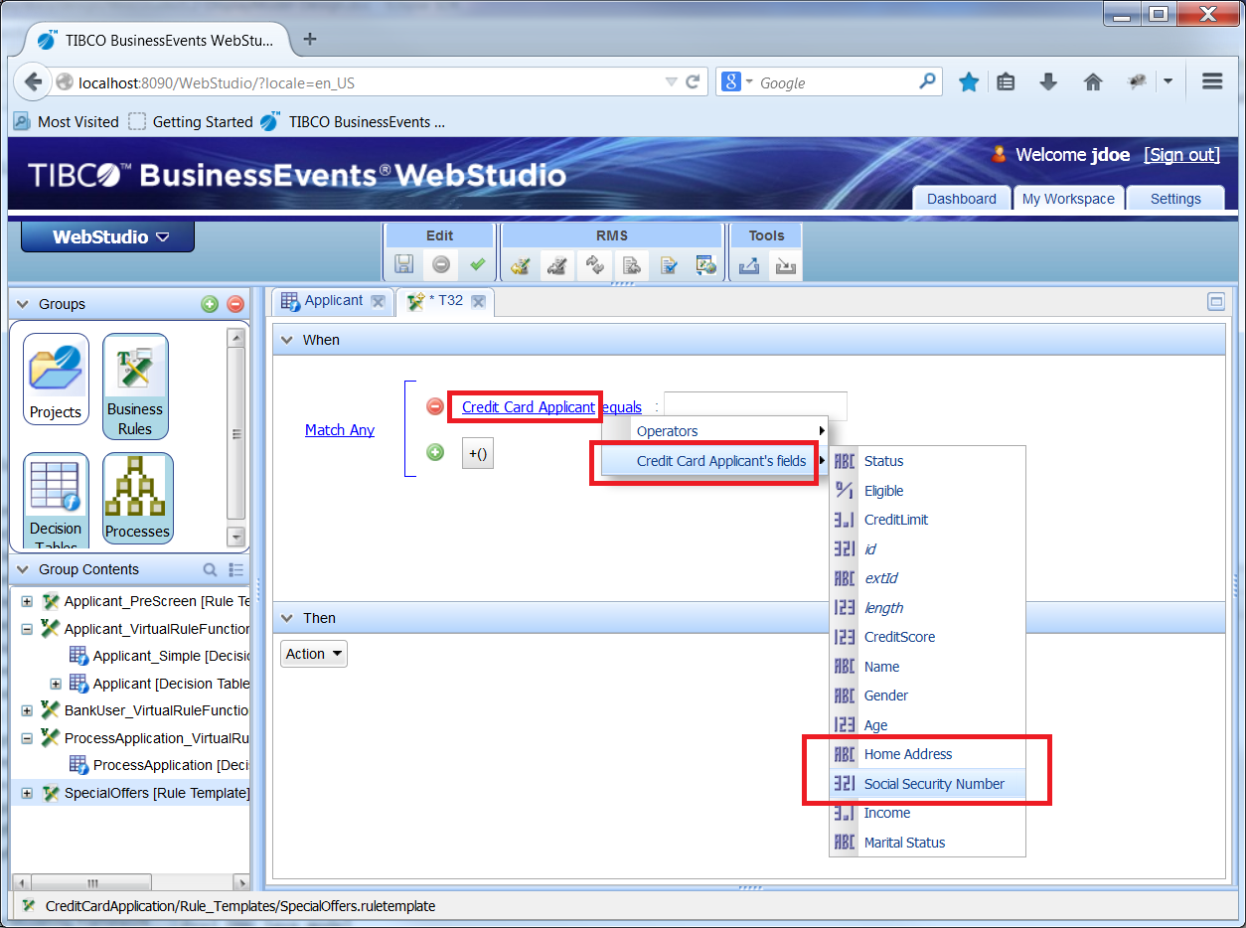
If left unspecified, the property name itself will be shown. If the property is marked as “Hidden”, then it is not accessible via the fields drop down menu.
In the Decision Table editor, the names will be shown in the column text as well as the arguments under the Decision Table in the Group Contents window:
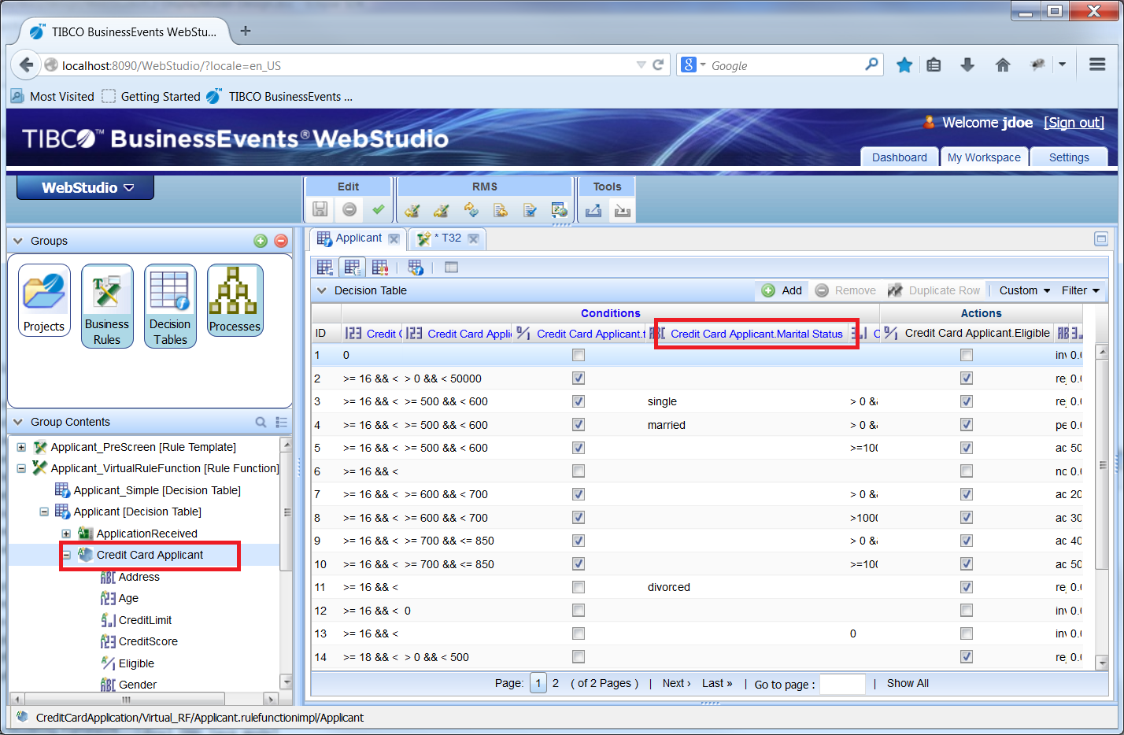
Similarly, if marked as “Hidden”, then the property should not be displayed under the Decision Table’s arguments.
For the base Entity name itself, the display text should be shown inside of the Group Contents window, portlet, and any RMS related dialog (commit, checkout, etc): 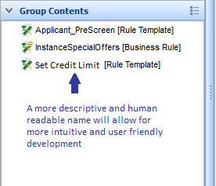

If the Display Model is given a non-default language, and the locale is set to that language (i.e. http://localhost:8090/WebStudio/?locale=de for German), then the German Display Model is picked up and used, for instance:
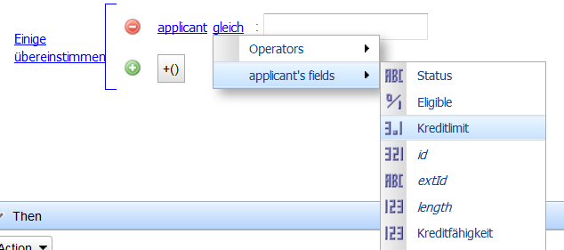

Known Issues
As of this writing, there are a few known issues to be logged (via CRs) and addressed:
- “Hidden” fields still show up under the Decision Table arguments.
- If no base entity text is given, then ‘null’ is displayed for the Decision Table
- The base entity text is not displayed in the Group Contents window
- A translated Display Model (i.e. German) does not include the base text of any default Display Models. For instance, Applicant_de.display does not inherit the display text from Applicant.display.
- In the Display Model editor, the “base display text” is never populated
- The Country code is ignored at this time in WebStudio (GWT limitation).
- Display text is not displayed in RMS dialogs

