T

TIBCO BusinessEvents Business User Interface: Decision Tables

Product Suite | TIBCO BusinessEvents
Product | Business User Interface
Product Version | 1.0
Initial Author | Gabe Grigorescu

Copyright Notice
COPYRIGHT© 2007 TIBCO Software Inc. This document is unpublished and the foregoing notice is affixed to protect TIBCO Software Inc. in the event of inadvertent publication. All rights reserved. No part of this document may be reproduced in any form, including photocopying or transmission electronically to any computer, without prior written consent of TIBCO Software Inc. The information contained in this document is confidential and proprietary to TIBCO Software Inc. and may not be used or disclosed except as expressly authorized in writing by TIBCO Software Inc. Copyright protection includes material generated from our software programs displayed on the screen, such as icons, screen displays, and the like.
Trademarks
Technologies described herein are either covered by existing patents or patent applications are in progress. All brand and product names are trademarks or registered trademarks of their respective holders and are hereby acknowledged.
Confidentiality
The information in this document is subject to change without notice. This document contains information that is confidential and proprietary to TIBCO Software Inc. and may not be copied, published, or disclosed to others, or used for any purposes other than review, without written authorization of an officer of TIBCO Software Inc. Submission of this document does not represent a commitment to implement any portion of this specification in the products of the submitters.
Content Warranty
The information in this document is subject to change without notice. THIS DOCUMENT IS PROVIDED "AS IS" AND TIBCO MAKES NO WARRANTY, EXPRESS, IMPLIED, OR STATUTORY, INCLUDING BUT NOT LIMITED TO ALL WARRANTIES OF MERCHANTABILITY OR FITNESS FOR A PARTICULAR PURPOSE. TIBCO Software Inc. shall not be liable for errors contained herein or for incidental or consequential damages in connection with the furnishing, performance or use of this material.
For more information, please contact:
TIBCO Software Inc.
3303 Hillview Avenue
Palo Alto, CA 94304
USA
Table of Contents
Change Log 5
1.1 Related Documents 5
2 Introduction 6
2.1 Main Objective 6
2.2 Purpose 6
2.3 Scope 6
2.4 Audience 6
2.5 References 6
3 Acronyms and Vocabulary 7
4 Architecture 8
4.1 Existing Deployment Process 8
4.2 New Deployment Process 9
4.3 User roles 11
4.3.1 End users 11
4.3.2 Developer: 11
5 Functional Requirements 12
5.1 Vocabulary/Concept Modeling 12
5.2 Decision Table Editing 12
5.3 Decision Table Validation 14
5.4 Decision Set Editing 15
5.5 Decision Set Testing 15
5.6 Decision Service Building 16
5.7 Decision Service Deployment and Management 16
5.8 Design-time Versioning of Decisioning Artifacts 16
5.9 Deployed Service Versioning 16
5.10 Data and Metadata Management 16
5.11 Rule Management 16
5.11.1 CRUD 16
5.11.2 Rule Analysis 17
5.11.3 Rule Verification 17
5.12 Authentication and Authorization 17
5.13 UI Components 17
5.13.1 Main form 18
5.13.2 Explorers 19
5.13.3 Decision table View 21
6 Technical Requirements 23
6.1 General 23
6.1.1 Run-time and Test Environments 23
6.1.2 Flexibility 23
6.2 Platform Support 23
6.2.1 Java 23
6.2.2 Application Servers 23
6.3 Framework Support 23
6.4 Performance 23
6.5 Security 23
6.6 Logging and Auditing Requirements 23
6.7 Configuration and Deployment Requirements 24
6.8 Installation Requirements 24
6.9 Interoperability Requirements 24
7 Use Case 25
7.1 Overview 25
8 Appendix: Expression Support 29
8.1 Introduction 29
8.2 Type Support 29
8.3 Literal Support 29
8.4 Common Operators 30
8.5 Additional Integer and Decimal Operators and Operations 30
8.6 Additional Decimal Operations 30
8.7 Additional String Operators and Operations 30
8.8 Additional DateTime, Date and Time Operations 31
8.9 Additional Concept Operations 31
8.10 Additional Collection Operations 31
8.11 Iterator Operations 32
8.12 Run-time Messaging Operations 32

Change Log
.
Date | Version | Name | Description
09/21/2007 | 0.1 | Gabe Grigorescu | Document Creation
09/27/2007 | 0.2 | Gabe Grigorescu | Incorporated John Cribbs’ feedback.

Related Documents
Document Title | Revision Number | Author
TIBCO Business Rules: System Requirements | 0.3 | Justin Brunt
TIBCO BusinessEvents Business User Interface | 1.0 | Nicolas Prade

Introduction

Main Objective
The TIBCO Business User Interface (BUI), a product of the TIBCO BusinessEvents family, will allow developers and business users to define / modify / hot-deploy the configuration of a Production Rule System (decisioning logic), with minimal supervision, and minimal implementation overhead. It will also be able to provide a “What-If” behavior to end-user queries.
The BUI contains several components, such as decision tables, decision graphs, decision trees, template-based rule editors, score models, runtime dashboards.

Purpose
The Purpose of this document is to capture the Decision Table Requirements that is part of the BUI. The related documents mentioned above discuss in more detail other requirements and related issues around the BUI, but this document will only cover Decision Tables and some areas closely related to them.

Scope
The scope of this document is to provide
- Functional requirements of decision tables
- Technical requirements for decision tables and/or individual components within the framework of BUI
- Design and implementation constraints
- Decision table context

Audience
The document is intended for Developers, Architects, QA, Product Marketing, and Manager.

References
- TIBCO BusinessEvents document set.
- TIBCO BusinessEvents road map

Acronyms and Vocabulary

The table below describes some of the Acronyms used in this documentation
- BUI – Business User Interface
- BE – TIBCO BusinessEvents.
- XML – Extensible Markup Language
- HTML – Hyper Text Markup Language
- TTL – Time To Live
- VFiles – Virtual FileSystem is a TIBCO Repository which is used as storage for MetaData, Configuration XML, Properties files, Process Diagram, StateDiagram, and others. TIBCO provides a Repository Client API for CRUD, Query, Search. An individual entity is referred to as a VFILE.
- Project – A TIBCO Project build using TIBCO Designer. A Project is a VFileSystem which could typically be a Directory Node in the FileSystem.
- EAR – Enterprise Archive Resource. This is modeled from the J2EE world and contains a subset of VFiles, user defined files, properties, code, jars, etc. An Engine may choose to run against this EAR file.
- REPO Instance – A Deployed EAR by a TIBCO Administrator is served by REPOSITORY Server. The Repository Client API provides a transparent mechanism to access the instance.
- A Rule is single Conditions/Actions pair (e.g.,. a column in the Decision Table).

- DT – Decision Table. A Spread-Sheet like interface for business user to capture threshold values, business rules (in a tabular format). It comprises of one or more rules.
- A Decision Set is an modeled orchestration (e.g. BPMN) of one or more Decision Tables and/or Decision Sets, equivalent of a Corticon Rule Set.

- A Decision Service is the deployable and invokable embodiment of a Decision Set.
- A Service is independently managed, black-box functionality invoked either as a Web Service or as a Matrix service- which may well be a Decision Service but called remotely as a black-box (web) service.

- A Rule Condition is a boolean expression of logical operators and functions (which may be a rule function or another Decision Table that returns a value) acting upon one or more Terms.
- A Rule Action is one of:
  - An update to a Term represented as an Expression
  - A creation or deletion of a Term
  - An invocation of another Decision Table that may or may not return a value
  - A simple return value (to be consumed by caller)

Architecture
The following section is mostly for background knowledge purposes. It is meant to provide the reader with a basic understanding of the context in which the decision tables are to be used. Although this section covers the deployment process and a high level introduction to the use cases, an end-to-end use case in section 7 will provide an even better understanding of the entire process.

Existing Deployment Process
Currently, a BE application is deployed as follows:

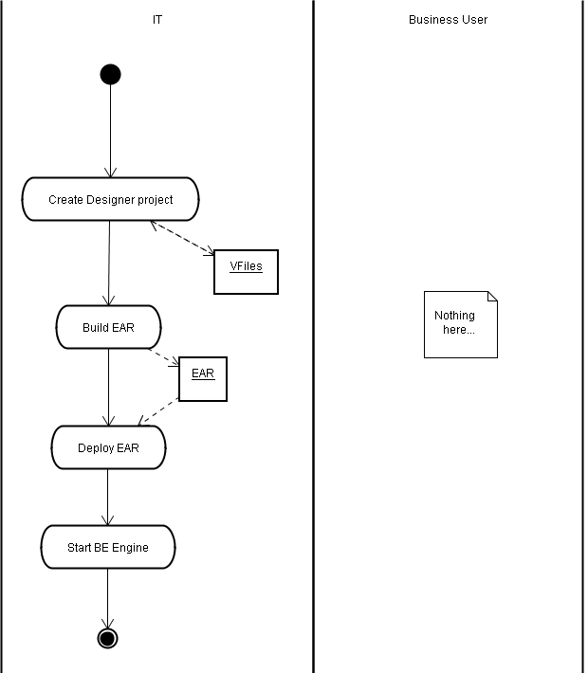

Here’s a diagram with more details:
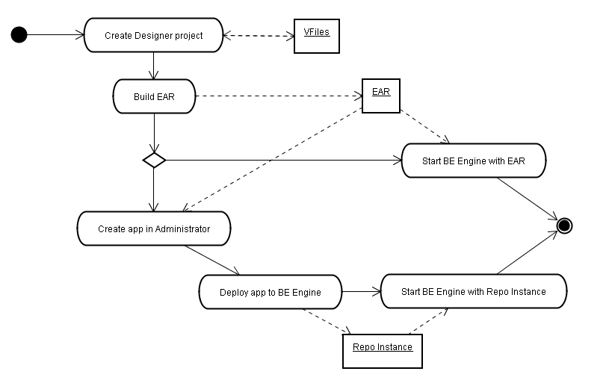
The VFiles (TIBCO Designer Repository) contain BE Model (metadata) which includes:
- Concept definitions, scorecard definitions, event definitions, “rule functions”, functions.
- Rules. Rules are contained in rule sets, and can appear as decision tables, decision trees, or simple rules.
The BE engine is a background process with no UI.

New Deployment Process
The following is a possible (maybe even typical) deployment scenario and our customers may need to customize it for fit their organizational needs. For example, some organizations may not want to allow the business user to deploy the project, but may give that responsibility to the IT user.
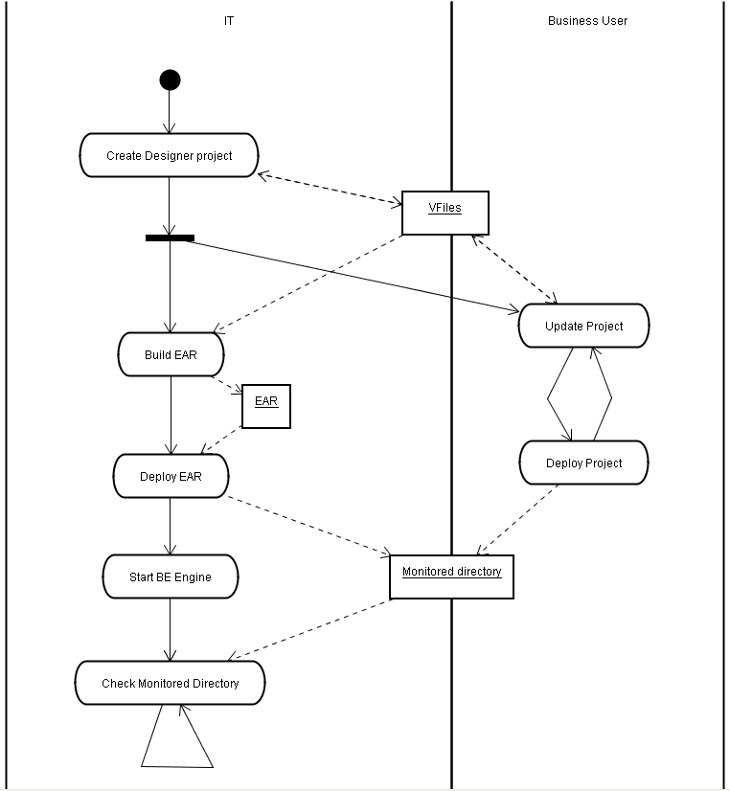
The BUI receives CRUD / approve / deploy requests from the end-user.
The BUI retrieves information from the project repository (file system or Version Control System).
The BUI displays information to the end-user.
The BUI saves changes from the end-user to the project repository.
The BUI sends approval and deployment requests from the end-user to the process(es) in charge of approval and deployment.

User roles

End users
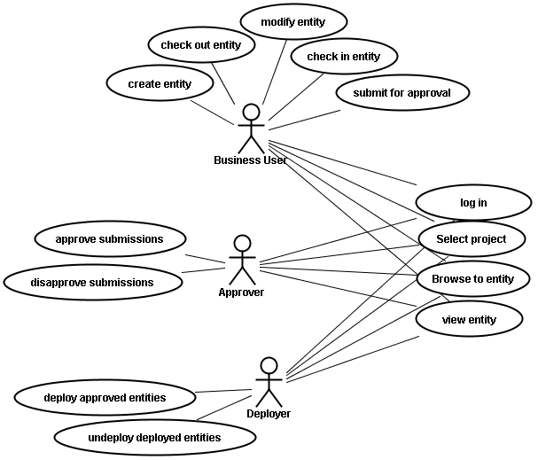

Business user: uses the client to update projects
IT User: setup, create project, ensure deployment process works. This user could fulfill the roles of the Approver and Deployer below as well.
Approver(s): uses the client to approve or deny changes made by business users.
Deployer: uses the client to select approved entities and deploy or undeploy them.

Developer:
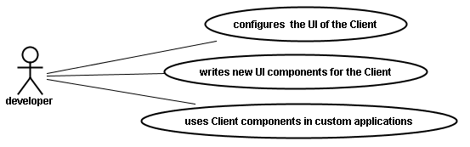
Developer: customizes the client and/or uses it as a UI component library. This user may also:
      - create project structure/class model
      - author rules (some of which may not be available to the business user)
      - create/validate deployment process
      - verify the entire system before releasing it to the rest of the organization

Functional Requirements

Vocabulary/Concept Modeling
It shall be possible to define ranges for domain values within the concept model using standard range expressions. It should be possible to enter these as a simple list within the concept model.

Examples: [<100, 100..1000, >1000], [<=100,>100], [gold, silver, bronze]

Other modeling requirements are covered in the referenced documents. More details to be added here (TBD).

Decision Table Editing
The following table lists priorities for each of the requirements:
1 – Required in next release
2 – Can be deferred until subsequent version if time does not permit
3 – Lowest priority
Here’s a sample screenshot of split cells and various conditions and actions:
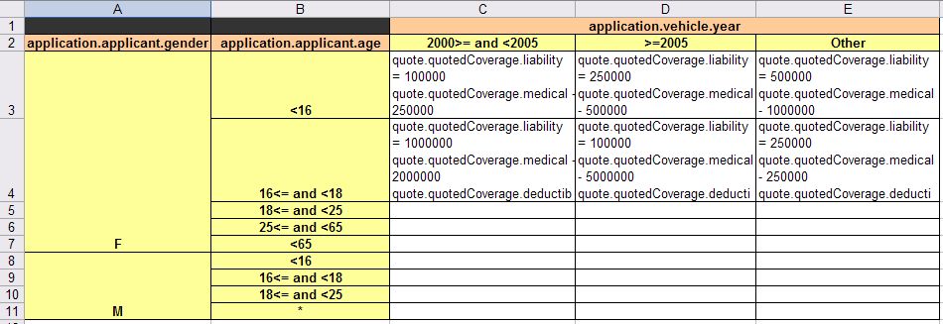

No. | Description | Priority
 | Rule modeling shall be via a familiar decision table form. (http://en.wikipedia.org/wiki/Decision_table) | 1
 | The user should be able to transpose the columns and rows (swap row and column data). | 1
 | Rules should be easy to create and flexible using the vocabulary/concept model. It should be possible for Business User to own the rule creation activity. Therefore, it should be intuitive for Business User to do so.  User will be able to drag concepts and concept.attribute(s) from a concept model onto the decision table as rule terms. These should be added to the table as headers. | 1
 | It shall be possible for the user to add new valid property values to header cells, building complex conditions. Cells should merge or split as necessary, following the pivot grid principles. | 1
 | The condition and action expression language shall be based upon the OO object.operation (object.method) style wherever appropriate.  This is due to this left-to-right style being more suited to both the rule developers thought processes during the condition definition and the drag and drop building of the expression from concepts, operations and operators. We may optionally allow the use of aliases in the user interface to make displaying of information easier (the more concise, the better). | 1
 | The decision table editor will support an “auto-complete” term editing capability for concept models and rule expressions and functions.  Eg. Customer.{show attribute list} or Customer.orders.{show functions list} | 2
 | In cases where “auto-complete” and Wizards are not appropriate mechanisms for assisting with the correctness of Rule definition, syntax checking and error reporting shall be employed to advise the users of syntax errors etc. | 1
 | Provide terms that are used to create temporary or transient concepts (such as the outcome of intermediate derivations). These entities and attributes usually have a business meaning or context, but do not need to be persisted in a database or communicated to other applications external to iProcess. | 2
 | It shall be possible to define plain text (English?) equivalents of rules. Each plain text rule shall be assigned an identifier that can be associated with a rule and used as a means to identify the rules that evaluated to TRUE during an invocation of a decision set in the data set returned by the decision set to the calling client who may then include it in an audit trail. | 2
 | It shall be possible to clone or alias inbound concepts received via the calling interface so that they can be  - Used to define simplified/shortened rule terms  - Modified “in-flight” and used inputs to other rules and returned as output data | 3
 | It shall be possible to perform the following:  copy rows (conditions), domain values and column values within the decision table. | 1
 | It shall be possible to copy decision tables:  - To create new versions of the same decision table  - To create new decision tables | 1
 | It shall be possible to ensure that attribute domain ranges are mutually exclusive and complete. | 2
 | It shall be possible to compress/simplify Decisions Tables through DON'T CARE usage for rule terms. The DON”T CARE symbol is * | 1
 | It shall be possible for the user from within the decision table editor to over-ride and/or extend the domain values defined within the concept model. These over-rides should only apply to the decision table within which the over-ride occurs.  It should NOT be necessary to have domain values set-up in the concept model in order to define rules in the decision table editor.  Also the over-ride values do not need to be restricted to being a sub-set of the domain values set up in the concept model. | 1
 | It shall be possible to use Expressions and Functions as part of the rule definition. A list of prioritized expressions is included in Appendix A below. | 1
 | Expressions and Functions shall to include attribute, concept and concept and attribute array level functions.  Refer to Appendix A for more details on rule expression language. | 1
 | Provide a built-in library of literal terms and operators that can be applied to rule terms. It provides many of the verbs (the “operators”) needed in business rules. Include any standard operators such as the mathematical functions { +, -, *, /} and comparator functions {<, >, =} as well as more specialized.  Refer to Appendix A for more details on rule expression language. | 1
 | It shall be possible to define conditions applied as functions applied to child concept arrays  Example: flight.destinations[].containany [“boston”, “nyc”, “sfo”]  Refer to Appendix A for more details on rule expression language. | 2
 | It shall be possible for (developer persona) users to be able to extend the default BE rule language through the creation of their own rule Functions/operations that can be applied to attribute, concepts and concept and attribute arrays. | 1
 | It shall be possible for the user to define ACTIONs to be performed when rules evaluate to true using the expression language and built-in functions that modify the in-memory concept model (thus triggering other rules) and modify the data (concept model) returned to the calling client of the decision service | 1
 | It shall be possible to perform Verification tests on a decision table.  These are covered in more detail in the Validation section below. | 2
 | It shall be possible for the user to create a new version of the Decision Table. See section below for more information on Versioning of business rules related artifacts. | 2
 | Ability at design time to pull the domain values for a concept model or for a given Decision Table from a separately maintained database.  The solution should support TIBCO’s CIM Master Data Management solution as a source of domain values. This is a rather complex task and a more basic functionality (TBD?) should be provided earlier. | 3
 | The Rule Modeling capability shall include Wizards to assist users understand when they might be defining poor rules, e.g. in Corticon, the object model can actually make it quite confusing to create rules. It would be an advantage if the user interface was able to provide advice such as “You are about to apply this to a child entity, where all of the rest of your rules are applying to the parent” or something to help foster proper rule creation. | 3
 | Ability to import decision table data from Microsoft Excel. | 2
 | It shall be possible for the user to undo/redo all of their actions. | 1

Decision Table Validation
 | The Decision Table editor will provide the following capabilities for Validating the decision table:  - Check for and address any overlapping or inconsistent rules  - Check for and apply any missing rules  - Check for and correct any loops | 2
 | The Decision Set editor will provide the following capabilities for Validating the decision set:  - Check for and address any overlapping or inconsistent rules  - Check for and warn about orchestration tasks without bound in decision tables  - Check for and correct non-termination conditions | 2

Decision Set Editing
 | It shall be possible for users to create a named decision set by adding decision tables into the decision set. (TIBCO will be implementing this functionality given a Decision Table implementation provided by Jide). | 1
 | The users shall define the decision table members of a decision set through the definition an orchestration of decision tables in the decision set using graphical flow modeling tool (existing BPMN editor?). | 1
 | It shall be possible for the user to define decision table orchestration tasks by applying the relevant decision tables in sequence either:  - through gestures that drag the decision table onto the flow and explicitly create a rules orchestration task and assign the decision table as the callee and automatically connects it to the previous orchestration task  - by dragging a (decision table) task onto the flow (as per regular process modeling) and assigning the required decision table to be called as a parameter. | 3.a 2  3.b 1
 | It shall be possible to define preconditions on a task in the decision set flow that will control whether the decision table is executed.  For example, in the case where a rule is concerned with 50 states and there are corresponding 50 policies each covered by its own decision table it should be possible to have a task condition which filters by state so that the decision table is only executed if the provided concept model contains the defined state. | 3
 | User shall be able to specify the concept mapping where this cannot be achieved automatically.  For example, in the case where inheritance has been used within the Concept model, e.g. Applicant is a type of Person and a decision table has been created based upon the general concept Person. In this case Application.applicant needs to be mapped to the Person parameter of the decision table | 2
 | It shall be possible for the user to create a new version of the Decision Set. See section below for more information on Versioning of business rules related artifacts. | 2
 | It shall be possible for the user to copy a decision set in order to create a new decision set definition. | 1

Decision Set Testing
These requirements will not be discussed in this document.

Decision Service Building
The user should be able to “build” a DecisionSet into DecisionService. These requirements are currently not being discussed in this document. TBD.

Decision Service Deployment and Management
It shall be possible to subject deployment packages to version control. Full requirements are not being discussed in this document. TBD.

Design-time Versioning of Decisioning Artifacts
The system shall support versioning of decisioning artifacts including decision tables. These requirements will not be discussed in this document. However, the decision tables should be designed and implemented such that decision tables (but not the individual rules that make up said table) should be possible to get versioned within the SCS. Also, the system should support references between decision tables and concepts.

Deployed Service Versioning
The system shall support Business Versioning at the Decision Service level. These requirements will not be discussed in this document.

Data and Metadata Management
Object Type | C | R | U | D | A | Y | Comments
Rule set | √ | √ | √ | √ | √ | √
Rule | √ | √ | √ | √ | √ | √
Decision Table | √ | √ | √ | √ | √ | √
Decision Tree | √ | √ | √ | √ | √ | √ | ?
C.R.U.D., A – Approve, Y – Deploy
Concept, Event, Scorecards represent fact types in BE. Aliases are named monikers for Instances, Expressions, Rules, or any resource in the BE Model.

Rule Management

CRUD

The BUI shall provide a way to create, read, update and delete rules using terms, while the BE engine is running. Thus, decision tables should provide proper notification to the system of any relevant changes the user may make to it. Rule/Ruleset editors should include:
- Decision tables
- Decision trees
- Templates
- Rule language editors

Rule Analysis

System shall provide Rule Analysis. This can be implemented in a later release.

Rule Verification

System shall provide Rule Consistency Checks and Rule Validation. This can be implemented in a later release.

Authentication and Authorization
The authenticated user shall be subject to the authorization and access control mechanism provided by the system when determining the vocabulary available to the user, whether the user can create/update/delete/submit model objects.

UI Components
This section provides more information on the various components that need to be created to support decision tables. The screenshots and the various components described in this section were taken from a prototype we have built. These components do not need to be implemented exactly as they are shown. Rather, they are meant to provide a list of functionality that needs to be implemented and to serve as a possible example. More specifically, the decision table view shown below will need to be more sophisticated and show an interactive table with a graphical interface that is intuitive.

Main form

The UI is articulated around a main form.
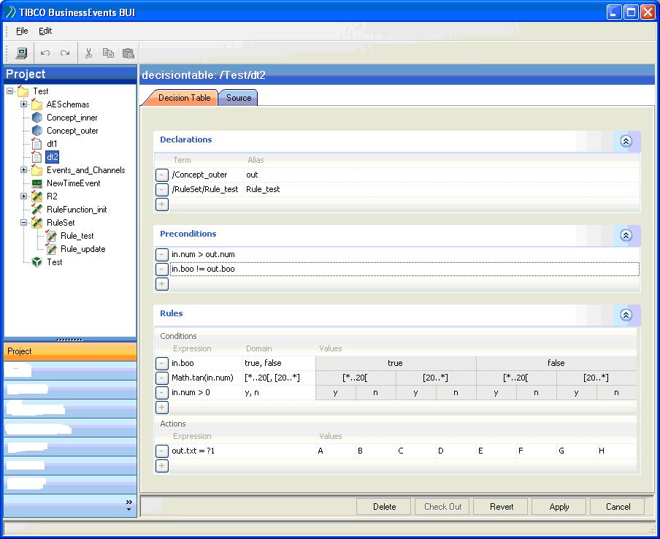

The main form includes a Title bar.

The main form includes a Browser pane.

The main form includes an Editor pane.

The main form includes a Status bar.

The main form may include an Inspector pane (?).

The main form may include a Tools pane (?).

The main form includes a button to copy.

The main form includes a button to cut.

The main form includes a button to paste.

The main form includes a button to undo.

The main form includes a button to redo.

The main form includes a menu bar with menu-items that match the buttons listed above.

Explorers

This component includes a ExplorerGroup component and a series of explorers: Project explorer, Functions explorer, Global Variables explorer.

Most explorers present data in the form of a selection tree.

Explorers may be configured using filters.

An optional Project List Explorer could show all projects accessible to the user.

The Project Explorer shows all entities in a single project that are accessible to the user.
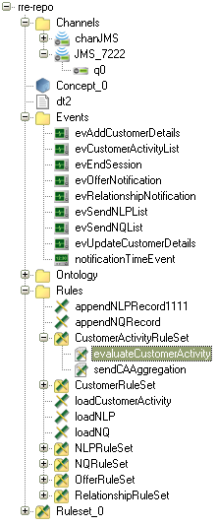

Each Function Explorer shows a set of functions to the Business User. These can be user-defined rule functions or the function library that is used in the context of authoring rules/rule functions.

The Submitted Explorer shows all items (entities or deletions) that have been submitted.

The Approved Explorer shows all items (entities or deletions) that have been approved.

The Deployed Explorer shows all entities of a project that are currently deployed.

TBD: optionally show the user what’s been submitted, approved, deployed as part of one explorer. Yet another option would be to not give this functionality at all in the Explorer.

Decision table View
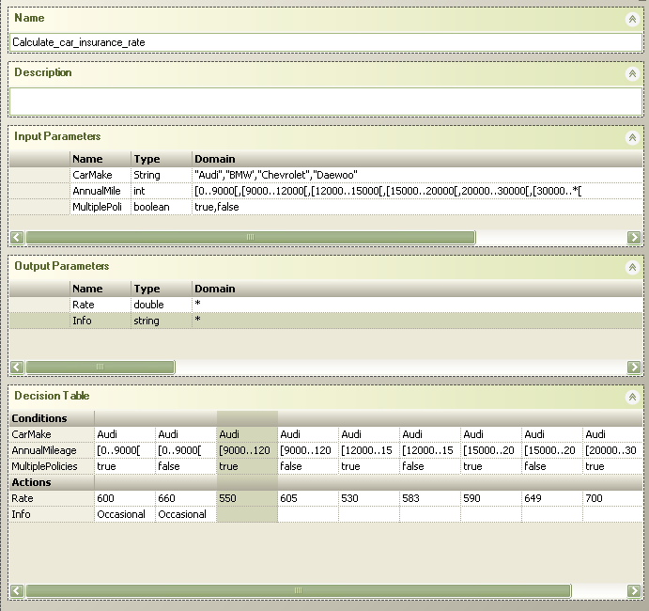
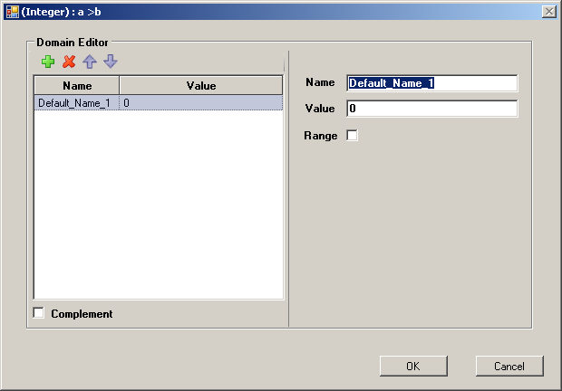

Input/Output parameter name: rule language entity name.

Input/Output parameter Type: rule language primitive type or path to a scopable entity.

Input/Output parameter Domain: list of exclusive single values and/or intervals, editable through a domain editor form.

In the Decision Table, each condition value is either empty or an item selected from the Condition Domain of the condition specified at the beginning of the same row.

The grid of condition values contains all the combinations of input parameter values that will be evaluated by the Decision Table.

Each Action value is a rule language expression whose type, if it has one, is determined by the output parameter specified at the beginning of the same row.

A comment/text string may be associated with each decision table rule..

Hovering over / selecting any cell in the Decision Table grid should highlight the column, and (later) display the matching comment. Complementary to this, we will also like to give the user the option to add this information in a properties pane.

The domain editor form shows the list of current name/value pairs that constitutes the domain.

The domain editor form includes a name/value editor specific to the type of the domain (String, Boolean, int, long, double string, datetime).

In the domain editor form, the name/value editor for numeric types allows the specification of intervals.

The domain editor has Ok and Cancel buttons.

Technical Requirements

General

Run-time and Test Environments
The run-time and test (validation) environments should provide the rule developer the ability to turn on a tracing capability which will trace the Decision service, decision table and rule evaluation in detail to a log file and to the Eclipse UI. Thus, the decision table should provide such logging capability.

Flexibility
The BUI, and thus the decision table as well should be extensible, flexible and configurable by application developer.

Platform Support

Java
The Decision Tables UI as well as the underlying code shall be fully compatible with JDK 1.5 and implemented in Java.

Application Servers
TOMCAT, WebLogic, WebSphere, and Matrix will be supported as run-time environment for calling Decision Services via web services. However, in the first release we must support the application servers our initial customers use.

Framework Support
The BUI, and thus the decision table should also be provided as a library for use in other applications. A documented and programmatic interface that can be added later will allow us to “productize” this functionality.

Performance
The BUI, and thus the decision table should be able to manipulate a very large number of entities. More precise performance numbers will be identified later, but initially the equivalent of 1000 rules that manipulate 100 properties should not slow down the response of the decision table by a significant amount (not more than 2-3 seconds).

Security
TBD.

Logging and Auditing Requirements
There should be a configurable amount of logging done when making changes to the rules using the decision tables. A certain amount of this functionality may be moved later on to a versioning service.

Configuration and Deployment Requirements
TBD.

Installation Requirements
The system should integrate with TIBCO Installation. The system should also integrate well with the build process we have.

Interoperability Requirements
Once BE 2.0 (BUI) is installed, all the other TIBCO products should work and should not be affected.
TBD: Proper co-existance with TIBCO BusinessStudio needs to be worked out.

Use Case

Overview
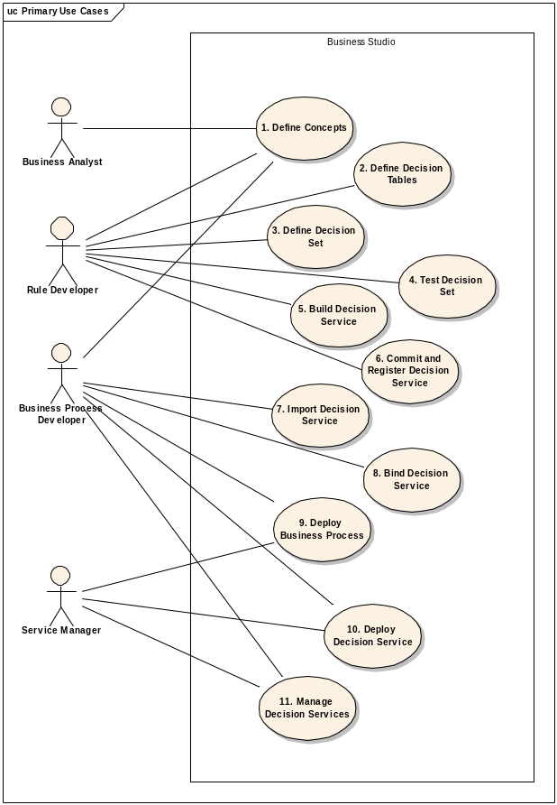

Figure 1 – Primary Use Cases

The end-to-end Use Case illustrated and described below assumes a bottom-up approach to the development, testing and deployment of Decision Services. The use cases described here are to provide the context in which the decision tables will be used.

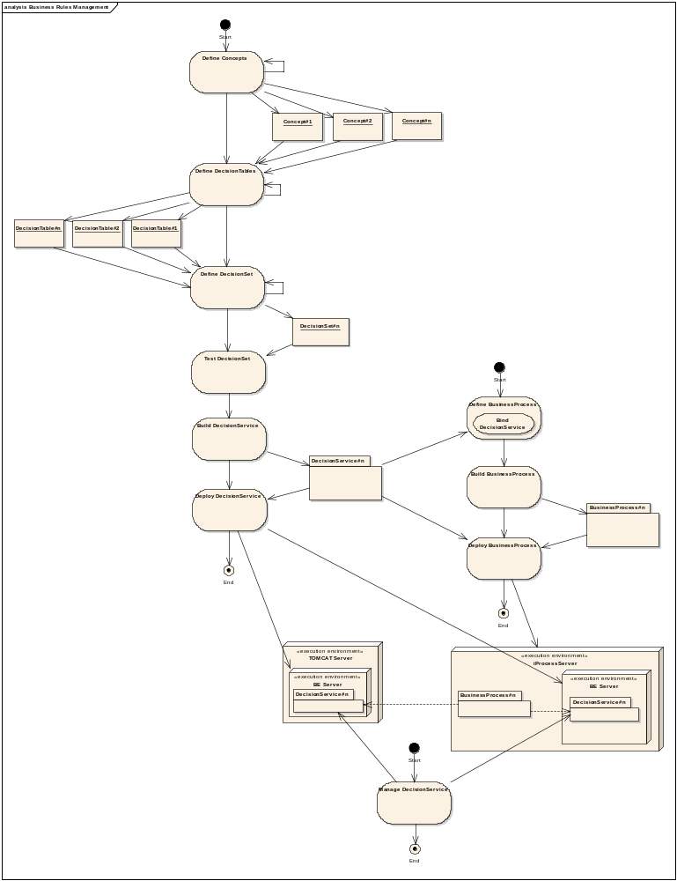

Figure 2 – End-to-End Use Case

- Rule Developer defines one or more business concepts/entities (using Concept Modeler) that will define the terms of the business rules. This is an iterative process and the user may iterate back to this phase from any of the three subsequent activities of DefineDecisionTables, DefineDecisionSet and TestDecisionSet.

  - Rule Developer defines containment relationships between concepts/entities

  - Rule Developer defines Domain Values for Concept Attributes

- Rule Developer defines one or more decision tables (using Decision Table editor) that contain one or more business rules, the terms of which are generated from the concepts during the previous activity. This is an iterative process and the user may iterate back to this phase from any of the two subsequent activities of DefineDecisionSet and TestDecisionSet.

  - Rule developer defines the Concept model scope as required by the Decision Table
    - e.g. Order or Customer.order (where order may be an array)

  - Rule developer defines rule conditions by applying relevant parts of the Concept model (e.g. through gestures that drag parts of the Concept model into the condition or typing + auto-complete)

  - (optional) Rules Developer overrides any supplied Domain Values for Concept Attributes used in each Decision Table.

  - For each Condition, Rule developer assigns applicable Domain Values (as inherited from domain model or from over-ride) for every rule (column in decision value). Rule developer can elect to choose a special don’t care domain value.

  - Rule developer can verify the decision table for ambiguity and completeness

- Rule Developer defines a Decision Set by collecting one or more of the decision tables defined during step 2 into a modeled orchestration (Using DecisionSet editor – eg. Propose usage of existing BPMN editor).

Rule developer defines decision table orchestration tasks by applying the relevant decision table in sequence either:
  - through gestures that drag the decision table onto the flow and explicitly create a rules orchestration task and assign the decision table as the callee and automatically connects it to the previous orchestration task

  - by dragging a (decision table) task onto the flow (as per regular process modeling) and assigning the required decision table to be called as a parameter.

In both of the above cases any required parameter/concept mapping should be hidden and performed automatically for the rules developer

  - (optional) Rules developer will use a wizard to specify the concept mapping where this cannot be achieved automatically. For example, in the case where inheritance has been used within the Concept model, e.g. Applicant is a type of Person and a decision table has been created based upon the general concept Person. In this case Application.applicant needs to be mapped to the Person parameter of the decision table

  - Rule developer can verify the decision set for continuous loops

- Rule Developer performs validation of the DecisionSet by dynamically exercising the Decision Set with a number of datasets derived from the Concept model, either manually or through importing run-time rule execution data or through automated generation. More information about this step is provided in documents referenced above in the “Related Documents” section.

- Rule Developer “builds” DecisionSet into DecisionService. Output is DecisionService run-time artifact and run-time contract definition (WSDL). Decision Service is available within Services folder of the Rule Developers workspace. More information about this step is provided in documents referenced above in the “Related Documents” section.

- Rule Developer commits the Decision Service and associated artifacts into Source Control System (SCS). The Rule Developer can optionally elect to manually register the Decision Service within a UDDI registry. More information about this step is provided in documents referenced above in the “Related Documents” section.

- Business Process Developer imports Decision Service definition (WSDL) into the Decision Services folder of their workspace from either: SCS, file system or UDDI registry.

- Business Process Developer binds Decision Service to a business process activity. More information about this step is provided in documents referenced above in the “Related Documents” section.

- BPM Developer/Service Deployer deploys package of business processes. Any “embedded” decision services referenced by the processes contained within the process package are deployed at the same time as the process models to the requisite location in the defined iProcess Server instance. Rules services that are defined as “remote” are not deployed along with the process. Deployment of a “remote” Decision Service is a separate activity. More information about this step is provided in documents referenced above in the “Related Documents” section.

- BPM Developer/Service Manager selects one or more Decision Services for deployment selects Decision Server to which services should be deployed, services are deployed to selected Decision Server. More information about this step is provided in documents referenced above in the “Related Documents” section.

BPM Developer/Service Manager perform lifecycle management of the decision services deployed on an iProcess or TOMCAT node. More information about this step is provided in documents referenced above in the “Related Documents” section.

Appendix: Expression Support

Introduction
The requirements for the Decision Table editor state that the condition and action expression language should be based upon the OO object.operation (object.method) style wherever appropriate. This is due to this left-to-right style being more suited to both the rule developers thought processes during the condition definition and the drag and drop building of the expression from concepts, operations and operators.
The Business Events rule language however is functional in nature. The tables below describe the expression support primarily in terms of operations.
However, when comparing BE run-time support with the operations requirements defined below BE is considered to support the required operation if a comparative BE function is available. This is because the PIM/PSM approach utilized between Studio and the run-times it supports enables a transformation from the OO approach to be utilized in Studio to the functional approach utilized by the BE run-time.
The BE run-time supports many functions not included in this list below. Where appropriate to the persona of the Rules Developer these unlisted functions should also be made available to the Rules Developer.
Key:
1 – Required in next release of Business Rules System (BRS)
2 – Can be deferred until subsequent version of BRS as it can be derived
3 – Lowest priority
Y – BE Supports this feature

Type Support
Type | ID | Required | BE Supported
Boolean | B | 1 | Y
DateTime | DT | 1 | Y
Date | Da | 1 | ?
Time | T | 1 | ?
Decimal | De | 1
Integer | I | 1 | Y
String | S | 1 | Y
Concept | Ct | 1 | Y
Collection (of any of the above types) | Cn | 1

Literal Support
Expression | Required | BE Supported
Null | 1 | Y
True | 1 | Y
T | 1
False | 1 | Y
F | 1
~ (Don’t care) | 1

Common Operators
Expression | Description | Types Supported | Required | BE Supported
== | Comparison for equality | All | 1 | Y
= | Assignment | All |  | Y
<> | Not Equal | All except Ct | 1
< | Less Than | All except Ct and Cn | 1 | Y
> | Greater Than | All except Ct and Cn | 1 | Y
<= | Less than or equal to | All except Ct and Cn | 1 | Y
>= | Greater than or equal to | All except Ct and Cn | 1 | Y
! | Not | All | 1 | Y
&& | And | All | 1 | Y
|| | Or | All | 1 | Y
. | Property (get/set) | All | 1 | Y
instanceof | Concept type check | Ct | 1 | Y (concept only)

Additional Integer and Decimal Operators and Operations
Expression | Description | Required | BE Supported
+ | Add | 1 | P (int only)
- | Subtract | 1 | P (int only)
* | Multiply | 1 | P (int only)
/ | Divide | 1 | P (int only)
** | Exponential by | 1 | P (int only)
+= | Increment by | 2
-= | Decrement by | 2
Max | Max of value | 1 | P (int only)
Min | Min of value | 1 | P (int only)
 | Absolute value | 2 | P (int only)
 | Convert to decimal | 1
 | Convert to string | 1 | P (int only)
mod | Get modulus | 1
div | Get divisor | 1
Log10 | Log to base 10 | 3
Log | Log of value to logbase | 3
In | Natural log | 1 | P (int only)

Additional Decimal Operations
Expression | Description | Required | BE Supported
 | Convert to integer | 1
 | Floor | 1 | P (for double)
 | Round | 1 | P (for double)
 | Round to decimal digits | 1 | ?

Additional String Operators and Operations
Expression | Description | Required | BE Supported
&& | Concatenate | 1 | Y
len | Length | 1 | Y
upper | Uppercase | 1 | Y
lower | Lowercase | 1 | Y
 | Convert to decimal | 1
 | Convert to integer | 1 | Y
 | Convert to datetime | 1 | Y
 | Substring | 1 | Y
 | Contains substring | 1 | Y
 | Starts with substring | 1 | Y
 | Ends with substring | 1 | Y
 | Index of substring | 1 | Y

Additional DateTime, Date and Time Operations
Expression | Description | Required | BE Supported
 | Get System DateTime | 1 | Y
 | Datetime to Time | 1 | Y
 | DateTime to Date | 1 | ?
 | DateTime to String | 1 | Y
 | Time to datetime | 1
 | Date to datetime using TimeZone offset | 1
 | Datetime to datetime using TimeZone offset | 1 | Y
Year | DateTime to Year (integer) | 1 | Y
Month | DateTime to Month (integer) | 1
Day | DateTime to Day (integer) | 1
Hour | DateTime to Hour (integer) | 1
Min | DateTime to Minutes (integer) | 1
Sec | DateTime to Seconds (integer) | 1
 | Add years to datetime | 2 | Y
 | Add months to datetime | 2 | Y
 | Add weeks to datetime | 2 | Y
 | Add days to datetime | 2 | Y
 | Add hours to datetime | 2 | Y
 | Add mins to datetime | 2 | Y
 | Add secs to datetime | 2 | Y
 | Years between this datetime and a datetime | 1
 | Months between this datetime and a datetime | 1
 | Days between this datetime and a datetime | 1
 | Hours between this datetime and a datetime | 1
 | Mins between this datetime and a datetime | 2
 | Seconds between this datetime and a datetime | 2
 | Day of year | 2
 | Week of year | 1
 | Month of year | 1 | Y
 | Day of month | 1 | Y
 | Week of month | 2
 | Day of week | 1

Additional Concept Operations
Expression | Description | Required | BE Supported
 | New instance of concept | 1
 | New instance if not in expression | 3
 | Remove concept from parent | 1
 | Add concept to parent | 1

Additional Collection Operations
Expression | Description | Required | BE Supported
+= | Add collection | 2
-= | Remove collection | 2
 | First element | 2
 | Last element | 2
 | Element at index | 1 | Y
 | Contains (evaluation of expression) | 1
 | Contains all of supplied collection | 1
 | Contains any of supplied collection | 1
 | Is Empty | 2
 | Not Empty | 2
 | Sort by (ascending) | 1
 | Sort by descending | 1
len | Length | 1
 | Sum (on attribute determined by expression) | 2
 | Average (on attribute determined by expression) | 2
 | Min (on attribute determined by expression) | 1
 | Max (on attribute determined by expression) | 1

Iterator Operations
Expression | Description | Required | BE Supported
[] | Iterate evaluation of expression from this point (return a collection)  flight.destinations[].airport.code.containany [“LHR”, “JFK”, “SFO”] | 1

Run-time Messaging Operations
Expression | Description | Required | BE Supported
 | Post Message to Concept | 1
 | Post Message to data payload | 1

