T

TIBCO BusinessEvents Business User Interface

Product Suite | TIBCO BusinessEvents
Product | Eclipse Workbench
Product Version | 2.0
Initial Author | Suresh Subramani

Copyright Notice
COPYRIGHT© 2005 TIBCO Software Inc. This document is unpublished and the foregoing notice is affixed to protect TIBCO Software Inc. in the event of inadvertent publication. All rights reserved. No part of this document may be reproduced in any form, including photocopying or transmission electronically to any computer, without prior written consent of TIBCO Software Inc. The information contained in this document is confidential and proprietary to TIBCO Software Inc. and may not be used or disclosed except as expressly authorized in writing by TIBCO Software Inc. Copyright protection includes material generated from our software programs displayed on the screen, such as icons, screen displays, and the like.
Trademarks
Technologies described herein are either covered by existing patents or patent applications are in progress. All brand and product names are trademarks or registered trademarks of their respective holders and are hereby acknowledged.
Confidentiality
The information in this document is subject to change without notice. This document contains information that is confidential and proprietary to TIBCO Software Inc. and may not be copied, published, or disclosed to others, or used for any purposes other than review, without written authorization of an officer of TIBCO Software Inc. Submission of this document does not represent a commitment to implement any portion of this specification in the products of the submitters.
Content Warranty
The information in this document is subject to change without notice. THIS DOCUMENT IS PROVIDED "AS IS" AND TIBCO MAKES NO WARRANTY, EXPRESS, IMPLIED, OR STATUTORY, INCLUDING BUT NOT LIMITED TO ALL WARRANTIES OF MERCHANTABILITY OR FITNESS FOR A PARTICULAR PURPOSE. TIBCO Software Inc. shall not be liable for errors contained herein or for incidental or consequential damages in connection with the furnishing, performance or use of this material.
For more information, please contact:
TIBCO Software Inc.
3303 Hillview Avenue
Palo Alto, CA 94304
USA
Table of Contents
Change Log 5
1.1 Related Documents 5
2 Introduction 6
2.1 Objective 6
2.2 Purpose 6
2.3 Scope 6
2.4 Audience 6
2.5 References 6
3 Acronyms and Vocabulary 7
4 Requirements 8
4.1 Existing BusinessEvents Workbench 8
4.2 Functional Requirement 10
4.2.1 General Requirements 10
4.2.2 Model Management 11
4.2.3 Packaging and Runtime Management 11
4.2.4 User Preferences 11
4.3 Eclipse - UI Requirements 11
4.3.1 General Requirements 11
4.4 Eclipse – UI Editors 14
4.4.1 Concept Editor 14
4.4.2 ScoreCard Editor 17
4.4.3 Event Editor 17
4.4.4 Time Event Editor 21
4.4.5 Channel & Destination Editor 21
4.4.6 Rule Editor 22
4.4.7 Ruleset Editor 22
4.5 State Diagram Editor 23
4.5.1 General Requirements 23
4.5.2 State Diagram Properties 24
4.5.3 Simple State and Properties 24
4.5.4 Composite State and Properties 24
4.5.5 Concurrent State and Properties 25
4.5.6 SubMachine State and Properties 25
4.5.7 Transition Rules and Properties 25
4.5.8 Transition Rules 26
4.5.9 Concept Diagram Editor 27
4.5.10 Packaging Editor 27
4.5.11 RuleFunction Editor Error! Bookmark not defined.
4.6 Debugger Requirements 27
4.7 Rule Analyzer Requirements 27
5 Technical Requirements 28
5.1 Platform Support 28
5.2 Framework Support 28
5.3 Authentication 28
5.4 Performance 28
5.5 Security 28
5.6 Logging and Auditing Requirements 28
5.7 Configuration and Deployment Requirements 28
5.8 Installation Requirements 28
5.9 Interoperability Requirements 28
6 Use Cases 29
7 Appendices 30

Change Log
.
Date | Version | Name | Description
12/28/05 | 0.1 | Suresh Subramani | Document Creation
01/03/06 | 0.2 | Nikunj Bansal | Update Requirement spec for Concept, Event etc
01/10/06 | 0.3 | Suresh Subramani | Attached the UI, and statemachine Requirements
01/12/06 | 0.4 | Nikunj Bansal | Updated with screenshots and descriptions for Concept, Event and Hierarchy view

Related Documents
Document Title | Revision Number | Author
BusinessEvents UserGuide | 1.2 | Product Set

Introduction

Objective
The Objective is to port /redo the existing BusinessEvents Workbench palette in TIBCO Designer to Eclipse Workbench.

Purpose
The Purpose of this document is to formalize the BusinessEvents Palette Requirements in Eclipse. The document also provides the interdependency of BE Workbench with other TIBCO Products.

Scope
The scope of this document is to provide
- Functional Requirements of BusinessEvents Workbench for Eclipse
- Technical Requirements of BusinessEvents Workbench for Eclipse
- Design and Implementation Constraints if any

Audience
The document is intended for Developers, Architects, QA, and Product Marketing, and Manager to verify the requirements are met and scoped.

References
- TIBCO BusinessEvents Document Set
- TIBCO BusinessEvents road map
- TIBCO Administrator Document Set

Acronyms and Vocabulary

The table below describes some of the Acronyms used in this documentation
- BUI – Business User Interface
- BE – TIBCO BusinessEvents.
- XML – Extensible Markup Language
- HTML – Hyper Text Markup Language
- TTL – Time To Live
- VFiles – Virtual FileSystem is a TIBCO Repository which is used as storage for MetaData, Configuration XML, Properties files, Process Diagram, StateDiagram, and others. TIBCO provides a Repository Client API for CRUD, Query, Search. An individual entity is referred to as a VFILE.
- Project – A TIBCO Project build using TIBCO Designer. A Project is a VFileSystem which could typically be a Directory Node in the FileSystem.
- EAR – Enterprise Archive Resource. This is modeled from the J2EE world and contains a subset of VFiles, user defined files, properties, code, jars, etc. An Engine may choose to run against this EAR file.
- REPO Instance – A Deployed EAR by a TIBCO Administrator is served by REPOSITORY Server. The Repository Client API provides a transparent mechanism to access the instance
- DT – Decision Table. A Spread-Sheet like interface for business user to capture threshold values, and

Requirements

Existing BusinessEvents Workbench
The current components of a deployed BE application are:

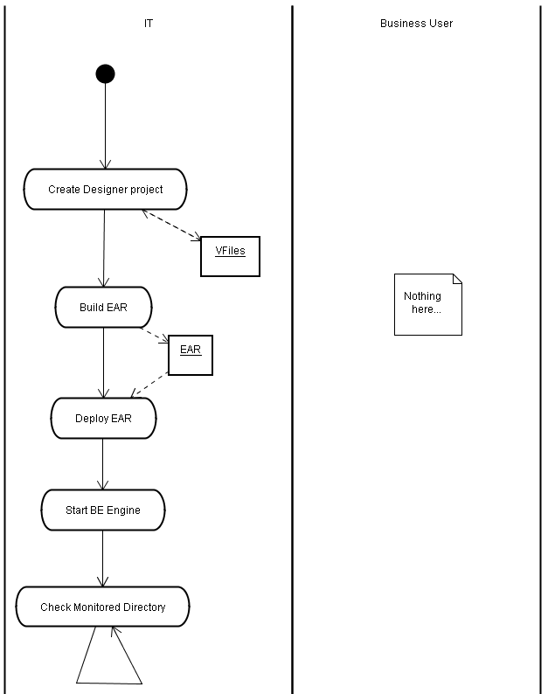

FYI, in more details:
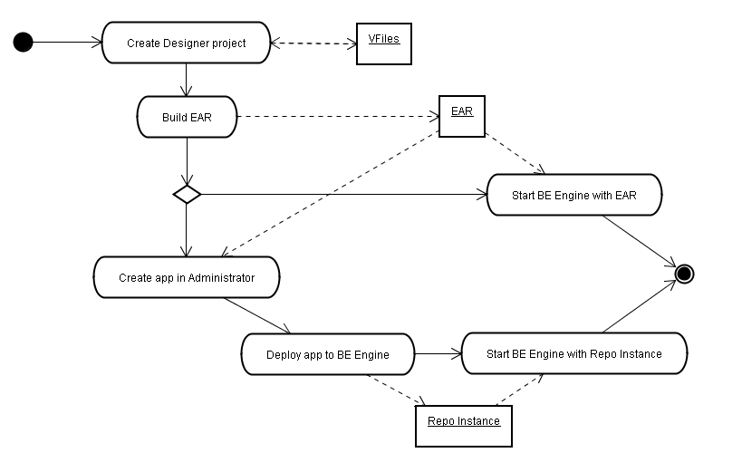

The VFiles (TIBCO Designer Repository) contain BE Model (metadata) which includes:
- Concept, Property definitions,
- Scorecard definitions,
- Event definitions,
- Rule functions,
- Function Registry
- Rules. Rules are contained in rule sets, and can appear as decision tables, decision trees, or simple rules.
- State Diagram for a Concept, and its sub palette.
- Concept View Class Diagram
- Business Events Archive

The BE engine is a background process with no UI.

Functional Requirement

General Requirements

The Workbench should be able to provide all the necessary user interaction for model management. The below table describes the requirement.

Object Type | C | R | U | D | P | V | F | H | E | G | Comments
Concept(.concept) | √ | √ | √ | √ |  | √ | √ | √ | √
Event(.event) | √ | √ | √ | √ |  | √ | √ | √ | √
Scorecard (.card) | √ | √ | √ | √ |  | √ | √ | √ | √
Rule set(.rset) | √ | √ | √ | √ | √ | √ | √ | √ | √
Rule(.rul) | √ | √ | √ | √ | √ | √ | √ | √ | √ | √ | Support for debugging, placing break-point
Decision Table (.dt) |  |  |  |  |  |  |  |  |  |  | Not yet Scoped
Decision Tree
Concept Instance
Event Instance
Scorecard Instance
Channel | √ | √ | √ | √ | √ | √ | √ | √ | √
Folder | √ | √ | √ | √ | √ | √ | √ | √ | √
Rule Function | √ | √ | √ | √ | √ | √ | √ | √ | √ | √ | Support for debugging, placing break-points
State Machine | √ | √ | √ | √ |  | √ | √ | √ | √ | √ | Can also be exported as an Image
Concept View | √ | √ | √ | √ |  | √ | √ | √ | √ |  | Can also be exported as an Image
Archive | √ | √ | √ | √ | √ | √ | √ | √ | √ | √ | Deployer only
Alias
RuleDebugger |  |  |  |  |  |  |  |  |  | √ | Runtime UI for debugging an rule execution
RuleBrowser

- C – Create an Instance of the Model
- R – Re factoring (Ability to Rename, move to different folder, package, or split into multiple subsets)
- U – Update the model entity
- D – Delete the model entity
- P – Special Packaging requirements for archiving. The ability to chose an instance of model for an archive is a Special Packaging requirement and
- V – Version control availability on the instance of model entity
- F – Ability to find a resource within a Project (s) per model type
- H – Replace (More on it)
- E – Export
- G - Debugging

The Eclipse Workbench provides an Editor per model type. For example a Concept Editor to manage the perspective of a Model Concept

The Workbench provides cut, copy and paste of model entity within a Folder, Project, Cross Projects, and Cross Multiple Workbench. It supports Copy to Clipboard functionality

The Workbench provides Undo-Redo facility.

The Workbench provides the Project Save, Save-As, functionality

The Workbench provides an Import and Export mechanism. A developer should be able to Import a UML1.2 compliant XMI model and vice-a-versa.

The Workbench provides a File->New mechanism for creating instances of Model Type

The Workbench provides a CheckIn and -CheckOut mechanism for instances of Model Type. It integrates with the VCS system provided with eclipse.

The Workbench provides Debug perspective for Rule Debugging

Model Management

The System data model is a representation of UML2.0 model

The System model is extensible. It provides a flexible and generic mechanism to plug-in external model entities. For V2.0, the following are expected to be available as part of extensible model framework – Java, XML Schemas (XSD), Database(JDBC), WSDL(Soap Svcs)

The System provides consistent API for Model access.

The System provides Serialization and De-Serialization of Model Entities into XML(XMI) representation.

The System provides (optionally) a mechanism to persist the Model into a File-System, Database, or VFile appropriately.

The System provides (optionally) a mechanism to migrate from a prior version.
The System provides a XML schema for the model itself.

Packaging and Runtime Management
As per current TIBCO BE Designer

User Preferences

Eclipse - UI Requirements

General Requirements

Eclipse 3.0 and above will be used as the current UI Framework for modeling BE model entities

TIBCO BusinessEvents Palettes is provided as a plugin to an already existing Eclipse installation.

The BE Palette is build using the Plugin-Development kit in Eclipse.
The BE Palette utilizes the Luna Framework for various Form building and other standard widgets

The BE Palette in Eclipse exposes the model entities described in 4.2.1 as Resources

The BE Palette is visible whenever an Eclipse based TIBCO project is created in a Workspace. See Java Visual Editor as an Example. The BE Palette should also be seen as a Folder

The BE Resources are also available under File->New->BusinessEvents. They are context sensitive.

The top level ‘New’ menu item has a BusinessEvents sub-item that contains the various BusinessEvents resource types such as Concept, Event etc.. These are context-sensitive. For example, A state machine resource is only available to be picked if the main editor is viewing a Concept.

The System shall provide editor for all TIBCO BusinessEvents resource. The subsequent section describes the Eclipse Editor requirement for each resources.

Use the TIBCO Eclipse UI framework wherever possible. That framework provides some Refactoring, validation, and saving/restoring etc.

Fully Qualified Names for all resources are unique.

The file name associated with a resource is same as the resource name appended with the appropriate extension. The UI will take care of this seamlessly. It does not mandate the user to type in the extension.

File extensions (.concept for example)not to be shown in the tree, navigator and inherits from fields.

All resource names including Folder names are restricted to Java compatible names. Nothing that is allowed by Java compiler will be allowed.

In addition, resource names cannot be a BusinessEvents reserved keyword. The list of BE reserved keywords can be found in the document ‘BusinessEvents Language Reference’ under Chapter 1, Section titled ‘Keywords and Other Reserved Words’.

The name restrictions also apply to Drag&Drop as well as ‘Cut/Copy/Paste’ operations.

Icon Reference fields are provided for all resource types except for the BusinessEvents Archive resource type.

Icon Reference Fields for all the resources are used to provide a reference to a Luna Icon Resource. This Icon will be displayed at various places in the UI pertaining to this particular resource e.g. in the resource tree view etc.

Every resource has a set of fileproperties which are the path of the resource, date it was created, last modified date, current revision nos, and last modified by

Every resource may or may not have Advanced Property

Every resource shall have a create wizard dialog box

Hierarchy View

The Hierarchy View is displayed on the left pane in place of the Package Explorer when the user selects Hierarchy in the list of tabs.

The Hierarchy View shows the entire hierarchy for the Concepts and Events defined for the current project.

Each Concept and Event is named as <folder>.<folder>…<Entity Name>

The Concept and Events can be expanded to show the following details:
For a Concept its Properties, State Machines and Methods are shown.
For an Event its Properties, Methods and payload if any are shown.

The user can select any Concept or an Event in the hierarchy and the corresponding Editor is displayed on the right. The outline view below also changes accordingly.

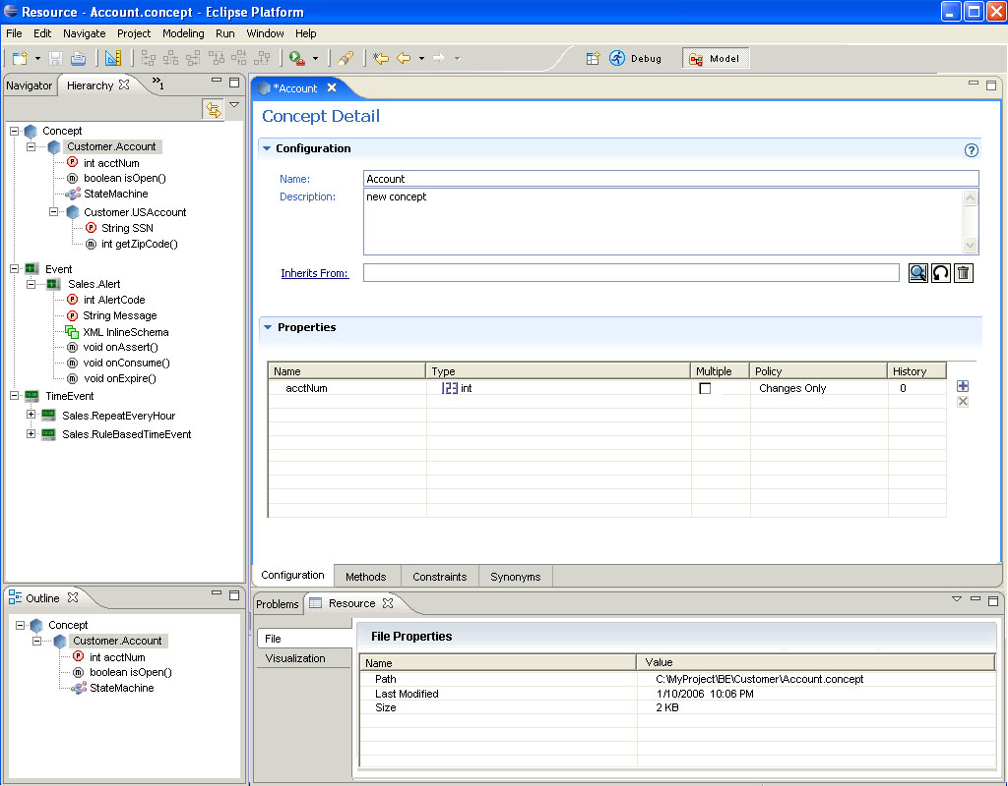

Eclipse – UI Editors

Concept Editor

When editing a concept, the Outline pane will show the hierarchy and currently selected concept’s properties and methods.

Any concepts in the Concept hierarchy can be selected from the Outline pane and the right side panes are updated to display details for the newly selected concept. The Package Explorer at the top also highlights the name of the newly selected concept.

The Concept Editor has 4 tabs. Each tab is described below. Please refer to the sample screen shots at the end of each subsection.
Configuration

Concept Name is a unique fully qualified resource name. It should follows the rules for a valid java class name

The Description is a free form text field.

The ‘Inherits From’ field shows the Fully Qualified Path if any of the super concept.

The Inherits From field’s chooser shows the concept list for the current project. It should not show any concepts that might create circular inheritence.

Validations for Inherits From field will check for Property Definition Conflicts. This validation is performed when the user tries to select a super concept with such a conflict and displays an error message in the chooser window.

Properties Definitions: The property names are validated to be unique across the Concept hierarchy.

When creating a new property, the name of the property is auto-generated as <conceptname>_property_<index>

A contained concept can have only one container concept. When choosing contained concept as the type of a property and choosing the Concept, validation is performed to make sure that the target concept isnt already contained by some other container concept.

Containment circles are not allowed. That is A contains B and B contains A is not allowed

Reference Concepts don’t have any restrictions. Self references are also allowed.

The History Field has a spinner as well as the value can be typed in directly.

Defaults for Property Definitions are ‘Multiple : false’, ‘Type: String’, ‘Policy: Changes Only’ and ‘History Size: 0’

Validate the history size to be between 0 to 1024. This should be a configuration parameter in a resource/property file.

The Property Definitions Table is sortable by its various columns. The Property definition table has the following columns
  - Name : <conceptname>_property_<index>
  - Type : String
  - Multiple : false
  - Policy : Changes Only
  - History Size : 0
  - Default value : null
  - Formatting (Currency, Date, number, etc) : null
  - Range : null

The Property definition UI shows the ability to add or remove columns from the visible list.

In the package explorer view of the Project, StateDiagram(s) can be added to the Concept.

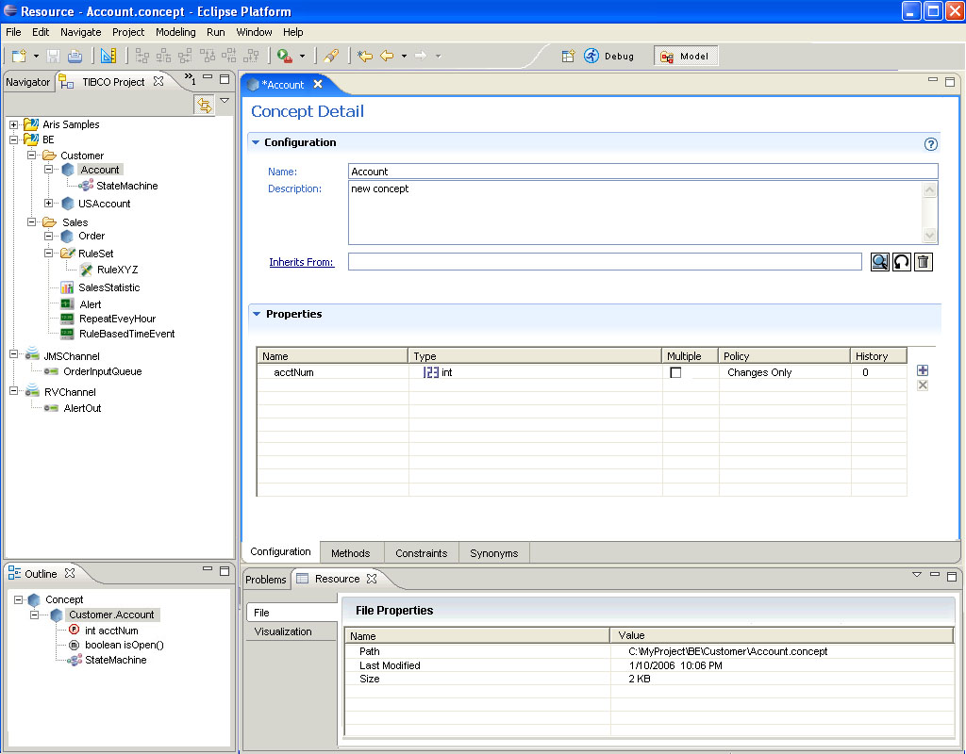

Methods

The Methods tab displays an editor window.

There are no Declare, When or Then sections for this editor.

Stubs for the following methods are auto generated – void onAssert() and void onDelete() that call super.onAssert() and super.onDelete() respectively.

The user types in the Concept methods. Syntax and semantic errors are highlighted as in the rule editor.

The editor has a second vertical pane from where the user can drag and drop Functions just like the rule editor. Help is displayed for functions on hovering the pointer.

The function catalog pane can be configured to be displayed on either the left or the right side of the editor pane.

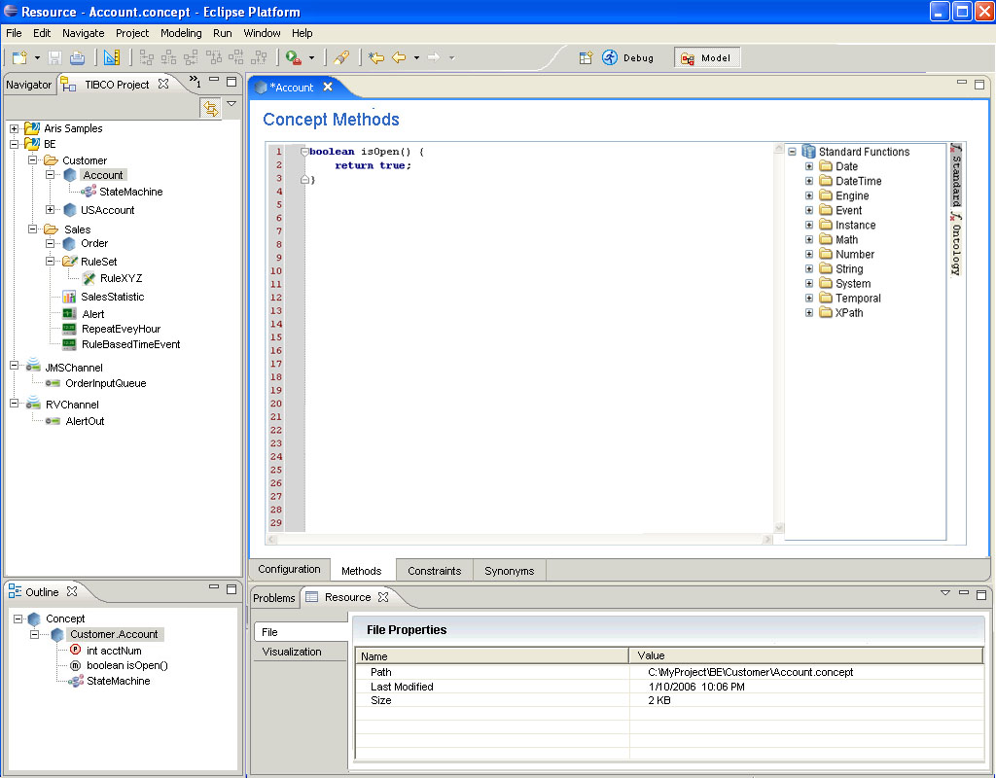

Constraints
This section will be described later.

Synonyms
This section will be described later.

ScoreCard Editor

The Scorecard Editor is largely similar to the Concept Editor except the following differences:
- No ‘Inherits From’ field.
- Contained Concept and Concept Reference types are not shown in the possible Property Types in the Property Table. Only primitive type
- No State Machine defintion allowed.
- Add a check box for Global

Event Editor

When editing an event, the Outline pane will show the hierarchy and currently selected event’s properties, payload and methods.

Any events in the Event hierarchy can be selected from the Outline pane and the right side panes are updated to display details for the newly selected event. The Package Explorer at the top also highlights the name of the newly selected event.

The Event Editor has 3 tabs. Each tab is described below. Please refer to the sample screen shots at the end of each subsection.

Configuration

The ‘Description’ is a free form text field.

The ‘Inherits From’ field shows the Fully Qualified Path if any of the super Event.

The Inherits From field’s chooser shows the Event list for the current project. It should not show any Events that might create circular inheritence.

Validations for Inherits From field will check for Property Definition Conflicts. This validation is performed when the user tries to select a super Event with such a conflict and displays an error message in the chooser window.

The ‘Serialize As:’ field is removed from the Eclipse designer vs. the old Designer.

‘Time to Live’ has 2 sub fields. One is a numeric value with a spinner. The other is a drop down with various units i.e. Milliseconds, Seconds, Minutes, Hours and Days.

The Expiry Action field shows a Expiry Action editor window. This is similar to a Rule Editor Window except the following:

Only the Action portion of this window is editable.

Attribute and Condition sections are not displayed.

The Declare section is shown with one entry that is the name of the Event but is not editable.

Properties Definitions: The property names are validated to be unique across the Concept hierarchy.

When creating a new property, the name of the property is auto-generated as <Eventname>_property_<index>

In the Properties defintion, only Name/Type are allowed. The Types allowed are only the Primitive Types. The Default type is String.

The Property Definitions Table is sortable by its various columns.

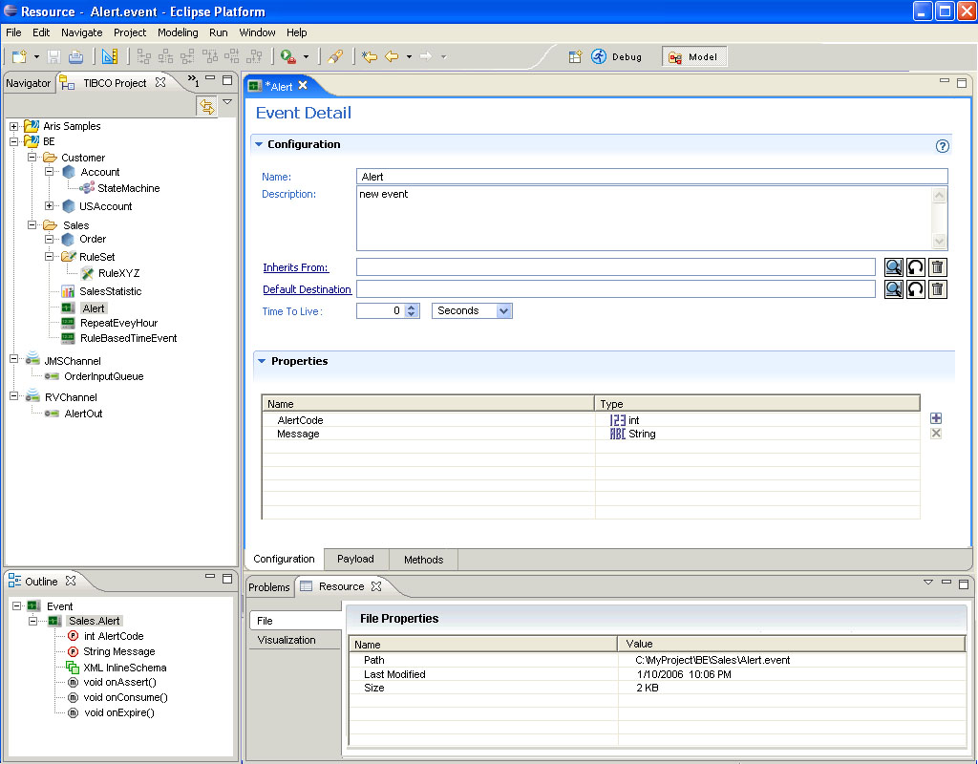

Payload

The Payload editor uses the standard Luna Inline Schema Editor.

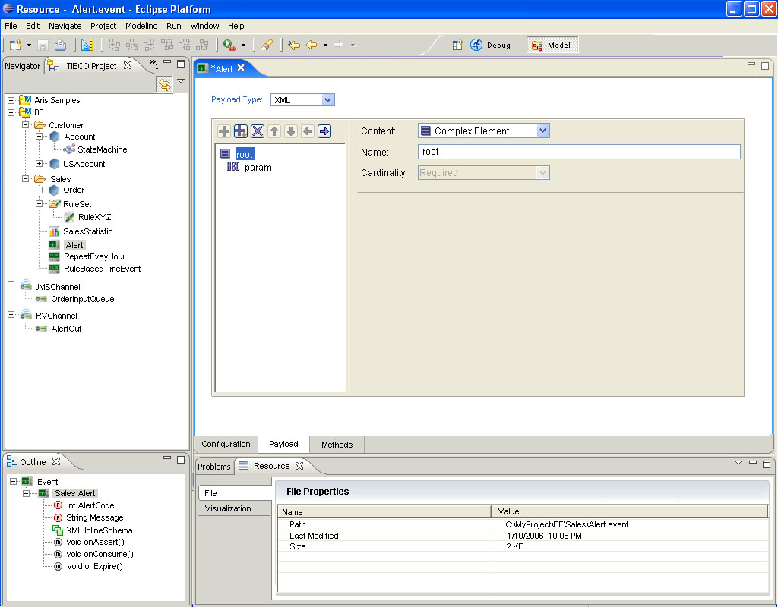

Methods

The Methods tab displays an editor window.

There are no Declare, When or Then sections for this editor.

Stubs for the following methods are auto generated – void onAssert(), void onExpire() and void onConsume() that call their super methods respectively.

The user types in the Event’s methods. Syntax and semantic errors are highlighted as in the rule editor.

The editor has a second vertical pane from where the user can drag and drop Functions just like the rule editor. Help is displayed for functions on hovering the pointer.

The function catalog pane can be configured to be displayed on either the left or the right side of the editor pane.

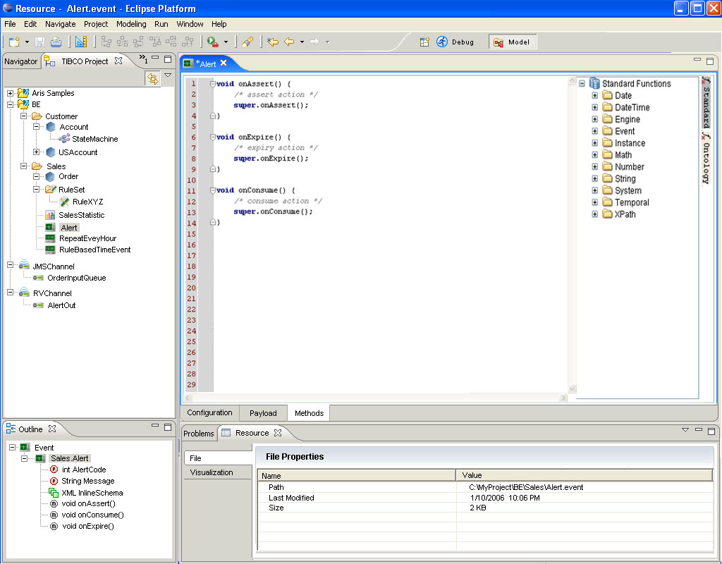

Time Event Editor

The ‘Description’ is a free form text field.

The Type field is a drop down box with 2 types: ‘Rule based’ and ‘Repeat Every’.

The ‘Rule based’ selection does not have any further configuration.

The ‘Repeat Every’ selection causes further configuration options to be displayed. These are as follows:
- A form field called ‘Repeat Every’ has time specification with two sub fields. One is a numeric value with a spinner. The other is a drop down with various units i.e. Milliseconds, Seconds, Minutes, Hours and Days. The default here is ‘1 second’. The numerical range is 1 to INT_MAX.
- Events/Interval is a numerical field with range of 1 to 10000.

Channel & Destination Editor

Rule Editor

General Requirements

Rule editor has 4 editable sections: ‘declare’, ‘attribute’, ‘when’ and ‘then’.

Declare section

User can declare multiple terms, each in the following format:
<Fully Qualified Type name> <alias name>;
- User can drag and drop the types from the Project tree on the left.
- If any types are renamed or moved in the project tree, the fully qualified name in declare sections will be refactored automatically for all rules.

When section
- User can specify multiple condition expressions in the BE rules language e.g.
order.amount > 1000;
- Content assist and code completion is provided for expressions typed here.

Then section
- User can specify multiple actions to be performed in the BE rules language here. E.g.
order.status = “Big Order”;
- Content assist and code completion is provided for expressions typed here.

Content assist is provided for expressions in the ‘when’ and ‘then’ sections (evaluate expression and check its type).

The Rule Editor will highlight any syntax and semantic errors in the rule being edited.

Hyperlink support (ex. When you type XPath it should be able to provide hyperlinks and bring up another dialog dynamically)

Code completion support for Concept and Event types in the Rule editor.

Some regions in the editor may be locked. Ex: rule name may not be editable, declare might be locked

Below the Maximize button on the left side, display Compilation Hints
Function Catalog Browsing
Ontology Functions, Custom Functions, and displaying tooltip help on functions

Ruleset Editor

The ‘Description’ is a free form text field.

Rule Set" right click menu item will allow user to create a rule set folder with following functionality:

Allows user to create only .rul files within the rule set folder

Provides a way to mark folders during packaging where rules needs to be picked up

User should be able to create multiple rule set folders

State Diagram Editor

General Requirements

The State Diagram Editor can only be created under Concept type resources.

There can be N State Diagrams per Concept. The name must follow the java identifier naming rules.

For a concept, there can be only one Main State machine if present

The State Diagram Editor has its own canvas where a UML 1.2 state diagram can be rendered.

The editor has its own palette. The palette has sections
  - Select
  - Marquee
  - Components
    - Psuedo States
      - Start
      - End
      - History
    - State Types
      - Simple
      - Composite
      - Concurrent
      - SubMachine
    - Transition
    - Comments / Notes

Upon creation of State Diagram, a drawing canvas with Start and End States filled in are shown in the canvas.

For any Rule editior (Action included), the concept to which the StateDiagram is associated is the first entry in the declaration scope, and cannot be changed.

The Outline views shows the current rectangle of the graph being edited

State Diagram Properties

The StateDiagram has its own properties. These are categorized as Config Properties, UI Properties, and System Properties

The Config Properties are { Name , Description, Main State Machine, Timeout Expression, Units, and Timeout Action}

The rules for these config properties are same as the current designer properties.

The UI properties are applied to all of the drawing elements within the diagram. They could be State icons, transition line rendering options, fonts to use

Simple State and Properties

User can drag a Simple state and place it any where on the canvas

Once the state is created, it can be named on the canvas by providing a named region for edit or specify the state properties.

From a State, on hovering, should have the ability to create other state(s), for faster state creation. (See Visual Paradigm State Diagram for usability)

Every State has a name. The State name is unique with in its immediate parent. A State can be owned by the diagram or by Composite State. It follows the java rules for identifying a name

Has a free form description

Has an Entry Action and an Exit Action. The exception is a Start State has an exit action, and an End State has an entry Action.

Each State has a Timeout section in the form of a tab. This is same as the timeout tab in the designer

Each State has an internal transition rule. When enabled, shows the rule editor for internal transition. The State decorates itself with an internal transition icon.

Composite State and Properties

Composite State can contain other states including a composite and concurrent.

Composite State can minimized and restored back to it original estate size

Composite State can be resized using rubber band techniques. That is its dimensions can increased or decreased from stretching or compressing at the edges of right bottom side of the state. See any window.

Composite State when created has a Start and an End State

The config properties are same as the Simple State config properties

The UI properties of the Composite State may have a LayoutManager option such as FlowManager, GridManager, or GridBayLayout Manager

Concurrent State and Properties

A Concurrent state has 2 or more regions. Each region is a composite state in itself.

The Concurrent state has the ability to add new region thru right click context sensitive menu, or a plus/minus button on the top right corner of the Concurrent state.

Each region occupies exactly the same dimensions, and is stacked one above the other. There might be an option of stacking horizontally also.

Each region may or may not have a border around it, and is configurable in the region layout property sheet.

The Concurrent state inherits its property sheet from the Composite State.

SubMachine State and Properties

The SubMachine state is calling other StateDiagram within the Concept Hierarchy.

The SubMachine state has a Name, and Reference Diagram. The Reference Diagram looks valid StateDiagram within the Concept Hierarchy. It always searches the super concepts.

A check box for Calling explicity the statemachine or to find the state diagram with that name in the concept hierarchy at runtime.

There is no Entry and Exit Action for the SubMachine State.

Transition Properties

Transition connects any two states within a diagram.

Transition Properties are Config Propertie {Name, Label, Lambda, and Rule } and UI properties { Color (Error, CompletedRule, InvalidRule. Lambda), Font, Style (bend, rectilinear, curved, straight), MaxCharsToDisplay

The Name follows java identifier syntax rules.

Label is descriptive information of the transition. Max Chars 512. The label is rendered just above the line

Lambda is a no-op rule, if Checked, the Rule field is disabled, if unchecked, then the rule can be edited. The line colors are matched to the color rules. The Styles are also matched according

A Rule Editor is invoked when a Rule field is clicked.

Hovering on the transition provides the Rule text

Transition Rules

The Transition always includes a From and To

The From and To can be the Same State, It is called Self Transition

There are 4 Exclusion Rules

There can be no Transitions to the Start State

There can be no Transitions from the End State

There can be no Transitions between any two Regions of a Concurrent State. There can be no Transition into a State whose Least Common Ancestor is a Concurrent State. i.e. The transition and State Ancestors intersection should not include a Concurrent State. This excludes if the From State and To State

There can be any Transition between any two State if the above 4 rules are met.

Refactoring Rules

Select Rule
- User can select a state/transition. This is indicated by a rectangular border around the state, and for transition, it applies the line style for the selected transition
- User can select multiple states/transition using a Combination of Shift/Ctrl key with mouse clicks
- User can use the marquee brush from the palette to draw a region around states and transition. For state to selected, it should be contained completed within the rectangular region drawn by the marquee, for a transition to be selected both the From and To States must be inside the marquee region.
- If a composite state or a concurrent state is minimized and a marquee region is drawn around it, then the states are selected as wholly.
- No Partial States can be selected while using a marquee.

Copy Rule
- The copy rule is to copy the State in entirety and excluding transition originating from it or its children, and excluding the transition it is the target of or any of its children is target
- The copy will serialize the State into an XML, and put into a ClipBoard
- In case of a region being selected, all the states and transition wholly inside the regions are copied.
- Copy might introduce orphaned States

Paste Rule
- Pasting would paste the new State or Region with its in-memory copy. It will decorate a new name with a suffix <<_index>> in case of duplicate name. Follow the unique constraints for State name.
- Once pasted all the states/transition must be in a select state, readily available for delete or undo
- In case of a marquee region

Delete Rule
Select a State and Delete should follow a confirmation dialog. Upon confirmation, delete the state, and its children, any transition originating from (include its children) or is a target of any transition.
Copy the Action in an Undo Buffer
Region Delete – same follow with a confirmation dialog, and repeat for each of the selected resources. Copy the Action in an Undo Buffer
Transition Delete – same as above.

Cut Rule
Cut would mean that State is copied into a buffer using the Copy Syntax, and then followed by the Delete Rule.

Move Rule
User can move a transition. He can retarget the destination or re-orginate from the source. This can be done by holding on any of
User can move a state and change its parent. A state can be moved from one composite to another and to any region. This can be done as a Drag of State and Release (Drop) of the State
The transitions are also moved along with state validating the Transition rules at all time.

Concept Diagram Editor

Packaging Editor

Debugger Requirements

Rule Analyzer Requirements

Technical Requirements

Platform Support

Framework Support

Authentication

Performance

Security

Logging and Auditing Requirements
Configurable.

Configuration and Deployment Requirements

Installation Requirements
Integrates with TIBCO Installation
Build Process

Interoperability Requirements
Once BE 2.0 (BUI) is installed, all the other TIBCO products should work and should not be affected.

Use Cases

Appendices

