T

TIBCO BusinessEvents: WebStudio

Product Suite | TIBCO BusinessEvents
Product | WebStudio
Product Version | 5.x
Initial Author | Gabe Grigorescu

Copyright Notice
COPYRIGHT© 2011 TIBCO Software Inc. This document is unpublished and the foregoing notice is affixed to protect TIBCO Software Inc. in the event of inadvertent publication. All rights reserved. No part of this document may be reproduced in any form, including photocopying or transmission electronically to any computer, without prior written consent of TIBCO Software Inc. The information contained in this document is confidential and proprietary to TIBCO Software Inc. and may not be used or disclosed except as expressly authorized in writing by TIBCO Software Inc. Copyright protection includes material generated from our software programs displayed on the screen, such as icons, screen displays, and the like.
Trademarks
Technologies described herein are either covered by existing patents or patent applications are in progress. All brand and product names are trademarks or registered trademarks of their respective holders and are hereby acknowledged.
Confidentiality
The information in this document is subject to change without notice. This document contains information that is confidential and proprietary to TIBCO Software Inc. and may not be copied, published, or disclosed to others, or used for any purposes other than review, without written authorization of an officer of TIBCO Software Inc. Submission of this document does not represent a commitment to implement any portion of this specification in the products of the submitters.
Content Warranty
The information in this document is subject to change without notice. THIS DOCUMENT IS PROVIDED "AS IS" AND TIBCO MAKES NO WARRANTY, EXPRESS, IMPLIED, OR STATUTORY, INCLUDING BUT NOT LIMITED TO ALL WARRANTIES OF MERCHANTABILITY OR FITNESS FOR A PARTICULAR PURPOSE. TIBCO Software Inc. shall not be liable for errors contained herein or for incidental or consequential damages in connection with the furnishing, performance or use of this material.
For more information, please contact:
TIBCO Software Inc.
3303 Hillview Avenue
Palo Alto, CA 94304
USA
Table of Contents
TIBCO BusinessEvents: WebStudio 1
1 Change Log 4
1.1 Related Documents 4
2 Introduction 5
2.1 Main Objective 5
2.2 Intended Usage 5
2.3 Scope 5
2.4 Audience 5
3 Acronyms and Vocabulary 6
4 General Requirements 6
4.1 Naming 6
4.2 Packaging 7
4.3 Pricing 7
5 Non-Functional Requirements 7
5.1 Web browser support 8
5.2 Server support 8
5.3 Portlet support 8
5.4 Ease of use and customization 8
5.5 Performance 8
6 Functional Requirements 9
6.1 Components 9
6.2 Common Widgets and Functionality 9
6.2.1 Authentication and Authorization 9
6.2.2 Project Explorer 11
6.3 WS operations should optionally also be under the control of the RMS workflow: users can navigate around (free flow) and at the same time view a worklist with direct links to appropriate content for workflow operations.Main Use Cases by BE Component 12
6.3.1 Decision Manager 12
6.3.2 BPMN Process Editor 15
6.3.3 Instance Editor 16
6.3.4 Rule Editor 17
6.3.5 ESP Viewer 19
6.3.6 Rule Template Editor 19
7 High Level Design 19
8 Technology Overview 19
8.1 Client/Server Presentation Model: EMF 19
8.2 Web form editing: GWT vs Flex 20
8.3 Diagramming 23

Change Log
.
Date | Version | Name | Description
11/22/2010 | 1.0 | Gabe Grigorescu | Initial doc
11/30/2010 | 1.1 | Gabe Grigorescu | Added more information on packaging and rule editor/instance editor (new section for rule editor), including screenshots.
12/01/2010 | 1.1.1 | Gabe Grigorescu | Incorporated some feedback from Aditya Athalye.
12/01/2010 | 1.2 | Gabe Grigorescu | Incorporated feedback from Paul Vincent
12/01/2010 | 1.2.1 | Gabe Grigorescu | More contents from Paul Vincent (manual merge from his copy of the document)
12/10/2010 | 1.3 | Gabe Grigorescu | Added technology discussion section. Added GWT vs Flex, EMF, diagramming. Incorporated some info from Sandip.
12/13/2010 | 1.4 | Ryan Hollom | Added additional info on technology discussion.
12/17/2010 | 1.5 | Gabe Grigorescu | Added info on authorization, auditing, simplicity of rule editing, home page/UI info in place of a standard "project explorer"
21/12/2010 | 1.6 | Aditya Athalye | Added some content for server implementation (state anagement and such).

Related Documents
Document Title | Revision Number | Author
BE 4.0 Requirements, Design, and Implementation documents | Various | various
BE BPMN Requirements/Design document | 2.4 | Gabe Grigorescu

Introduction

Main Objective
The objective of this document is to outline the features of the new web-based Studio component in TIBCO BusinessEvents.

Intended Usage
WebStudio (the name is not decided yet) is intended to provide end-users a lighter (web footprint) and much easier to use (business-friendly) environment to author, manage, and deploy BE artifacts and projects. More specifically, it is meant to give business users the ability to easily interact with the lifecycle of a BE application via a web browser interface. It will also enable these users to easily not only create event processing and decision metaphors (such as decision tables, trees, graphs), but also collaborate with others via the web, gain a better understanding of the BE Project, how the components interact, analyze potential problems of the project, and manipulate running instances of BE applications.
As BusinessEvents is used across many domains and client types, WebStudio will also provide a toolkit approach for developers to assemble the user interface required for an application.

Scope
The scope of this document is to provide both requirements and a high level design of Web Studio.

Audience
The document is intended for Developers, Architects, QA, Product Marketing, and Managers.

Acronyms and Vocabulary

The table below describes some of the Acronyms used in this documentation
- BE – TIBCO BusinessEvents.
- WS -- WebStudio
- RMS -- Rules Management Server. It is the existing component, which we will need to modify to support WS needs, or a completely new server component.
- PE – Project Explorer view in BE Studio
- DM -- Decision Manager
- Studio Project – A TIBCO Project build using TIBCO BusinessEvents Studio.
- ACL -- Access Control List. Security configuration file on server end to control what each user role is allowed to do.
- BUI -- Business User Interface
- GWT – Google Widget Toolkit

General Requirements
The following section outlines general requirements for the initial versions of BE WS.

Naming
We need to find a proper name for this component. Product Management will work on this. For now, I am calling it WebStudio, more specifically TIBCO BusinessEvents WebStudio. Any trademark requirements and such will be worked on by Product Management along with our Legal team.
Example product names could include WebStudio, BusinessDesigner, WebDesigner, WebManager, WebDecisions, etc.

Packaging
For now, we are planning to embed this new component as a separate addon that is meant to be sold with the core BE component. The server component, which I am currently envisioning to be built on top of the existing RMS, must also be made available. Furthermore, the decision table functionality, which is a key component of BE WS, is currently a different addon. Thus, we may need to rethink our packaging, or place the WebStudio (client and server) into a different core WebStudio addon. All of the other addons can "contribute" to the core WebStudio addon their own functionality. For example, decision table component of WebStudio addon will only exist in the Decision Manager addon, same for decision tree editing, or BE Processes (BPMN).
The core WebStudio addon can simply have rule editing, instance editing, and of course the server component.
Alternatively, all of these components (decision table, graph, tree, etc) can be "contributed" to the WS component only if the respective add-ons are installed. Thus, if someone installs WS but does not have any of the other add-ons, they will only get web-based functionality that comes with the core, such as instance editing and any kind of rule/ontology editing that is part of the core component (in Eclipse).
We may release this as part of BE 5.1.
The advantages of the latter approach are that different module users can benefit from the appropriate BUI: for example:
Core: edit concepts / BE rule parameters at runtime, create events, view reports, run / create / edit tests, deploy (eg to test)
DM: edit decision metaphors
BPMN: edit business process diagrams
Data Mgmt: edit state models, view DB data and update DBConcepts
Views: view dashboard alongside edit components, ability to edit parameters used in Views, etc
Stream Processing: create / navigate queries and event patterns

Pricing
This topic is beyond the scope of this document. This topic will of course also depend on how we package this new component.

Non-Functional Requirements
The following section covers in more details the non-functional requirements for the initial versions of BE WS.

Web browser support
On Win32/64: recent versions of IE (7, 8, 9?) should be supported, as well as recent version of Firefox (3.5+).
Optionally: Google Chrome
Mac: Safari browser may also be supported (TBD).

Server support
Supported platforms for our server component should be the same as what we support for the core BE engine, as the "back end" server for WS will be another BE application.

Portlet support
All widgets of BE WS should be exposed as portets (support JSR 168?) or gadgets (QL Engineering to synchronise with TIBCO Portal team on a compatible approach). This will enable our customers to decide which widgets they want to expose. It will enable them to expose them wherever they want in their enterprise web sites, and it will also enable them to potentially have different back end servers to serve different users.
If we do not support portlets or gadgets in the first version, design must allow us to easily add this support later.
Ideally WS portlets should be compatible with TIBCO Portal and capable of being run alongside a BE Views frame.

Ease of use and customization
We must give our customers the ability to customize which functionality they want to expose to their end users. They should also be able to plug in their own color schemes, logos, and such.
This implies some kind of WS configuration approach, ACL for WS components against BE project entities (ie MVC).

Performance
We should support many concurrent users on the same server. We should ensure a minimum of 10 users can concurrently interact with the server on the same project. Some of our customers will want hundreds of users as well.
We should also enable our customers to deploy multiple RMS instances to support a larger number of concurrent WS users.
The server component (RMS extended) should be cache based with BS support. To handle concurrent requests and provide Load Balancing, the server component could contain multiple agents (Inference Agents in BE terminology) so as to handle the load. Also the server component will use HTTP Channels which means each Inf agent could potentially have a separate instance of a channel running (different ports) and a virtual load balancer would be needed to route a request to appropriate channel (inf agent).

Functional Requirements
The following section covers in more details the functional requirements for the initial versions of BE WS.

Components
The number of components that will be part of BE WS will increase over time. Initially, these are some of the components we need to consider. What is defined as a "component" is also up for debate. Each component will also have several widgets and probably other subcomponents as well.
Decision Manager decision metaphors
Priority: decision tables
Optional: decision trees, score models, "decision models"
BPMN Process
Priority: customized tasks, invocation of DM editor on a decision task
Optional: constrained routes and branches
Instance and Ontology Editor
Priority: concept instances
Optional: concept class editing (with constraints e.g. adding properties to a class)
Optional: constraints on classes
Rule Template Editor
Priority: populating inference rule templates
Optional: specifying rule inheritance (eg shared actions/service libraries, etc).

Common Widgets and Functionality
Certain components will be needed by all components that make up BE WS. A layered web framework will be required to exploit re-use across WS UI components and uses.

Authentication and Authorization
Just like BE MM, BE Views, and BE DM/RMS (Eclipse-based), the new BE WS should also use the same JAAS-based authentication and authorization system. Users will need to login to a customizable server. File-based or LDAP-based should be supported. Once a user successfully logs in, the server component should send the UIs and information that the user's role is allowed to see. Authorization should be user role-based.
What BE WS users are allowed to do (modifying rules, tables, creating, viewing) must be fully access controlled. Auding of such access is also an important requirement, as fraud and data privacy is very sensitive.
Access to the server should be done only through the browser, there should be no local installations allowed on the business users' machines.

Administration User Interface
There needs to be a formal UI accessible only to administrators where ACLs can be configured. This admin console can be used to specify access permissions for every project (entities in each project.)
A similar behavior should exist as what BE DM 3.0 (and 4.0) has when it comes to ACL. Depending on the ACL specified WS server, users will only be shown a subset of their project. Users will also only be allowed to read or modify artifacts (designtime or runtime) that they are allowed to change, as specified in the WS server ACL.
IT users should be able to specify inactivity timeout periods. This can be added in a server-config descriptor file for the WS server (RMS or other component acting as server) where inactivity timeouts are specified. Inactivity will lead to session information being lost (including unsaved local changes) and prompt user for login.
Session Management should be left to the server (BE engine). If we want to make this a clustered server with FT/LB features provided by BE it is important to let the server manage all the state/session information.Session timeouts will be handled via schedulers in BE. State Timeouts is also an option for this where a State Machine on the server actually keeps 2 states Login/Logout where the Login state has an inactivity state timeout which takes it to Logout state. Maintaing HTTPSession on server will not allow us to provide High Availability features.

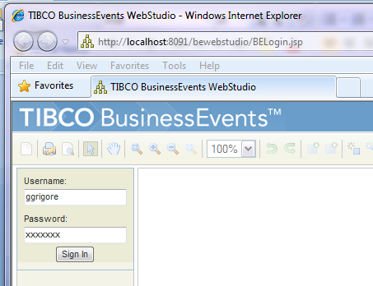

Project Explorer
BE WS is not meant to be a port of BE Studio to the web. Thus, although a "project explorer" should exist, it should most likely be collapsed by default. Instead, given that the focus is to provide a business user friendly interface that is simple and not technical, we should provide a customizable home page where users can organize the artifacts they work on. Examples include what we have now in BE Views, Facebook, Yahoo homepages, etc. They may have a window where they have BPMN Processes, Decision tables, etc. A button in those windows would allow them to have CRUD operations on those types of artifacts. Of course when they create new objects, they'll need to specify where to store those files, but that information can then be hidden and now shown.
A project explorer component should be made available to allow users to scroll through the section of their application that they are allowed to see. This does not necessarily need to be a tree control, but can be rather a button-based that automatically filters out the unwanted types of artifacts. For example, it can allow users to navigate folder by folder by clicking on buttons, and when you click on the right-most button, it shows you the artifact types you are interested in (depending on what the main component is all about).
For example, users can keep on expanding to the right as they select which folders they want to see:
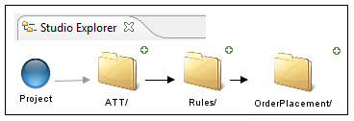
then, when they click on a folder (OrderPlacement in this case), they'd get a dropdown so they can choose which folder to see or which artifact to open:
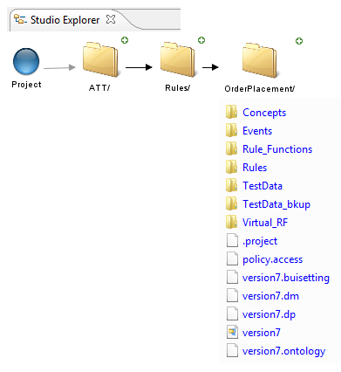

WS operations should optionally also be under the control of the RMS workflow: users can navigate around (free flow) and at the same time view a worklist with direct links to appropriate content for workflow operations.Main Use Cases by BE Component
Just like BE 4.0 has independent add-ons, these various BE WS components should also work independently.

Decision Manager
At a high level, this component should mimic the functionality we have available in the Eclipse-based version.

Decision Tables
Users should be able to import from Excel, export to Excel, create new tables, edit existing tables, and run Table Analyzer functionality (functionality currently available in BE Studio).
Decision tables should support pagination to avoid loading entire large tables in the browser.
We should also add utility Excel like functions which Business users are comfortable using.This has come as a requirement from some field folks.
Designtime variables need to be supported as well. These variables can be defined at table level and accessed anywhere inside the table (decision/exception). These variables can be complex expressions themselves containing other variables.
We do need to keep our Table Analyzer, so the table widgets will need to be combined with a new component:

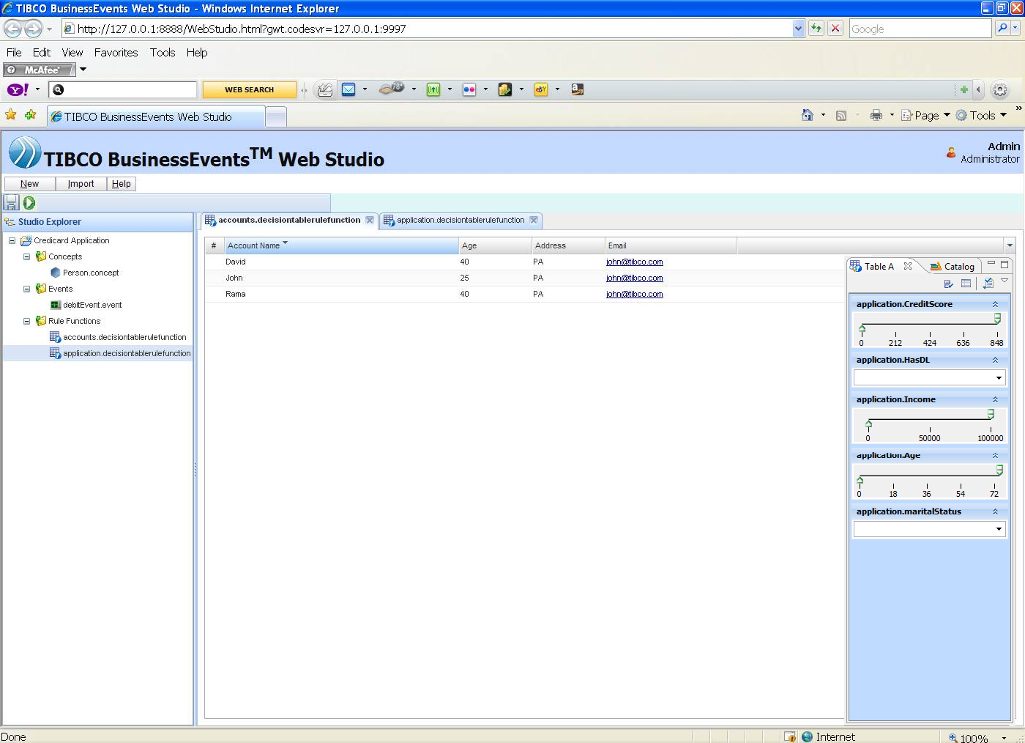

Decision Trees
Users should be able to do the same CRUD operations on decision trees as well. Users should also be able to run the same Table Analyzer functionality, in addition to being able to fold/unfold various components of the tree.
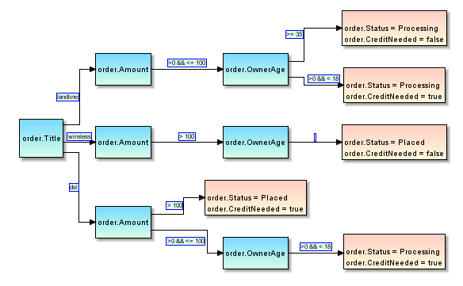

Decision Tree workflows
This will be a subset of a BPMN process editor, except users will only be able to define a process made up RF and DT invocations.
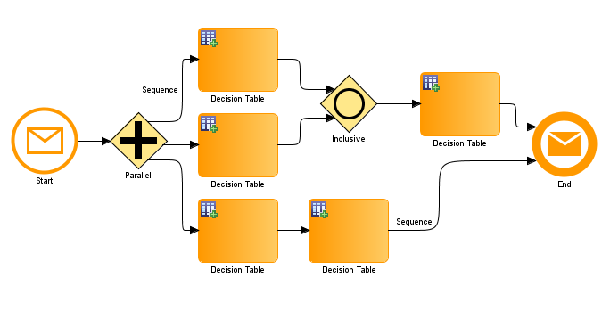
Users shall also be able to compare similar entities (diff), ideally in a visual format, view verification test results (logical tests for duplicate rules, etc), run unit tests (CRUD operations on test cases and results), and run and review system component tests (CRUD operations on test cases and results).

BPMN Process Editor
At a high level, this component should mimic the functionality we have available in the Eclipse-based version. Here's a screenshot of a prototype built already:
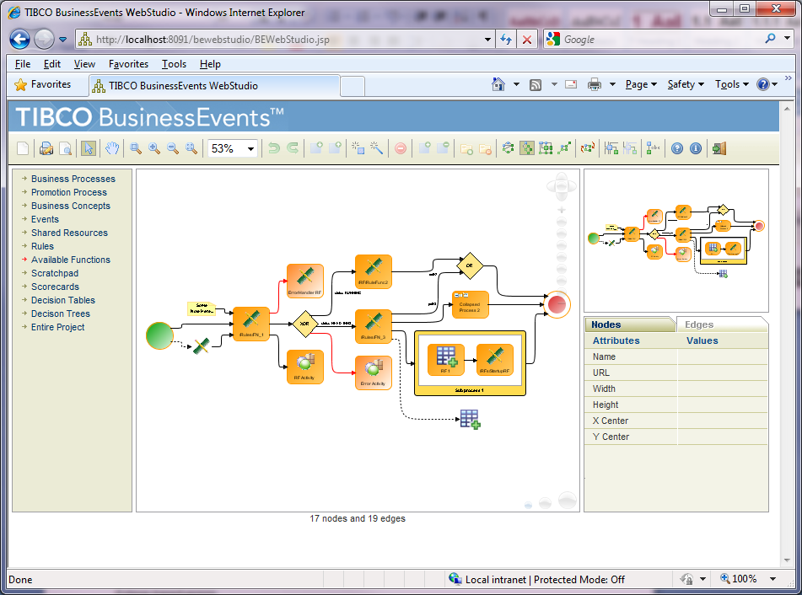
Just like we should have for all diagram-based components, besides the main canvas area, we should expose the overview window, property sheet(s) that can be used for viewing properties of selected components and also change them.
Users should be able to pan, zoom, print preview, print, export to various image formats, and of course edit the diagrams. Do/undo/redo functionality should also be available.
Note that navigation amongst visual editors in a web environment may be more modal (ie with fixed navigation options) compared to the BEStudio IDE. The BPMN model could be used to model user navigation, within or outside the context of the RMS.

Instance Editor
There are different runtime artifacts that can be edited while the engine is running. Users may want to change concept property values after they connect to a certain engine to run "what-if' scenarios and see what would happen. They may also want to change rule parameters so they can change the behavior of a rule without going through the painful process of changing the rule in BE Studio, package the ear again, then hot deploy it. For example, if a rule's condition is to see if a person's age is between 18 and 36, web users may want to change just those two parameters.
Just like in the existing BE Studio Tester users can connect to any engine (local or remote), users can do the same via BE WS:
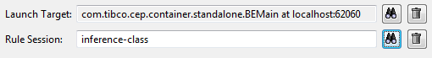
Then, they may or may not assert test data, but they should be able to see the contents of the WM in a table format, then edit the values of the object properties, click on "Post" and then see what rules may fire due to the change. After this, the users can then see the test results to see the effect of their changes.
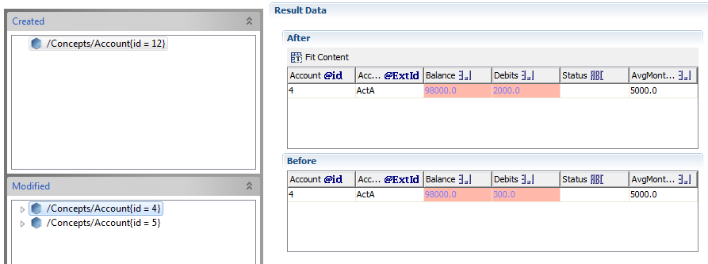
Similarly, if users want to change rule parameters, users should be able to navigate through the rules they have, select them, and then on the main screen area be able to see the rule conditions, and be allowed to change the parameters, click on "Post" and then allow the modified rule to execute if triggered.
We need to have the WS server manage a running engine, and each logged in user gets a session to work with in the engine (TesterSession exists already and will have to be augmented). User will then send data to be asserted into the running engine similar to current way of doing this. Results view also can be improved. It is even more important now to have session concept for tester as well as multiple users would test their data simultaneously. Need to see whether one engine instance can be shared or separate engines have to be started for each user.

Meta-Data Server
An important question is what happens to the changes made once the engine shuts down. These changes should be optionally saved and stored by the RMS on the server side, such as a change log or change entity that can be re-run on project (starts etc).

Rule Editor
Another important component is a rule editor. This component itself can have two parts.
The first can consist of a web version of our existing rule editor (with any restrictions we may need to add due to no longer having an Eclipse framework available).
The second is the ability for users to browse an existing project, select a rule, and then be able to modify parameters of that rule and then "hot deploy" them to any instance of a BE engine running. This would require a customized UI where we show just the editable components, and the rest are shown as read-only (as a convenience). We need to figure out a way to let the users designate how to identify what is a modifiable "rule parameter." For example, if a rule condition has:
person.age > 50
then we need to decide whether they can change the operator, or just the "50" or both, and once that's decided, how do we know what they can change? We could either let developer mark the section that is changable, or we allow the user to change anything in the condition but add some restriction via web-based logic (coding).
Once decided, the engine needs to pick up the changed parameters and any future rule invocation would use those new values. Here's a screenshot of what a simple port from BE Studio of our form-based rule editor would look like in a browser, which is not exactly what we want:
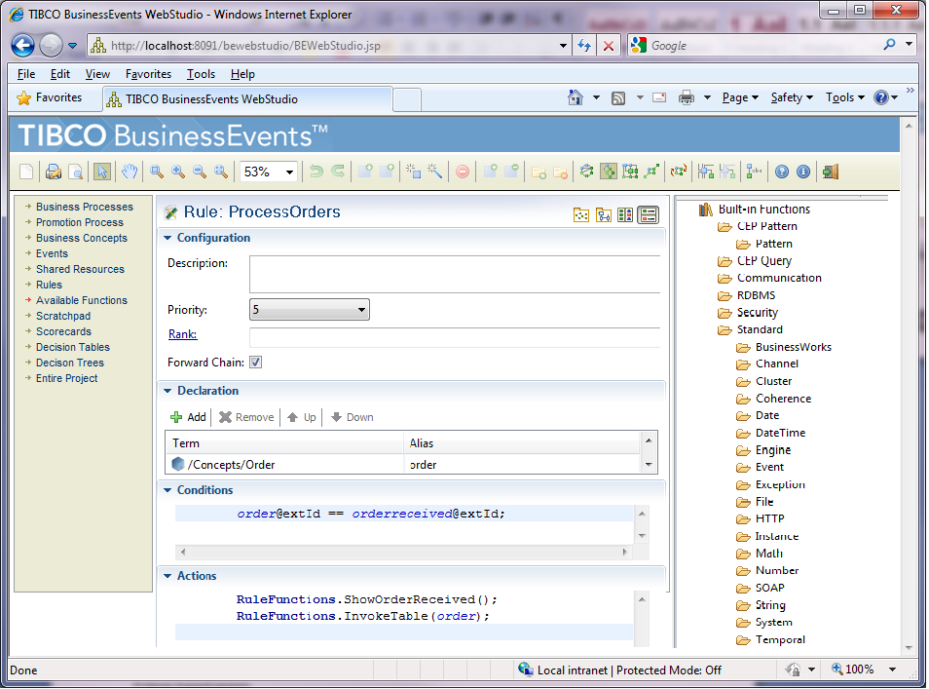
We do however want a much simpler user interface, maybe something along these lines:
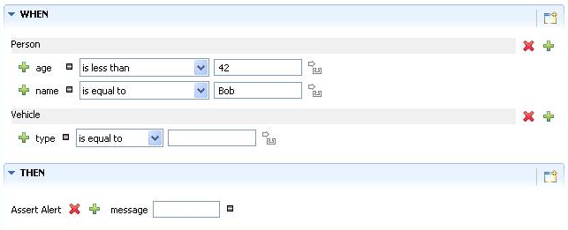
We should also allow users to call other functions, so they can create simple rules like this (received from Andreas Gerst):
WHEN:
sum(call time) where destination=international and ...> .95 * sum
> (call time) where<custom filter>

ESP Viewer
Users should be able to type a pattern and deploy it to an engine, and see the results.
Similarly, users should be able to type continuous queries and see the results. This is similar to a web-based version of the BQL example we have:
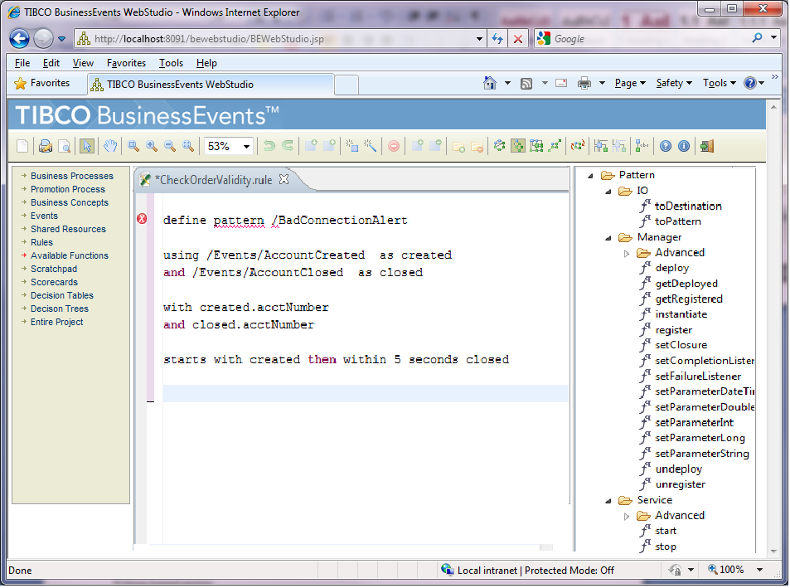

Rule Template Editor
TBD

High Level Design
TBD

Technology Overview
This section covers discussions around what technologies to use for each component.

Client/Server Presentation Model: EMF
One of the decisions that needs to be made is what model we use for client/server presentation and communication. We need to be able to:
- load (studio) projects from server
- support EMF for data model management
- be capable of loading/saving artifacts from/to server project
A very strong candidate is EMF, given that our BE Studio model is already in EMF. Unfortunately GWT doesn't support EMF out of the box yet, although the upcoming EMF 2.7 will. That will work with Eclipse 3.6, which I'm planning to switch to for BE 5.1 release. Here's a link about EMF support for GWT:
http://wiki.eclipse.org/EMF/New_and_Noteworthy/Helios#Support_for_Google_Web_Toolkit_.28GWT.29
The big benefit is that we can code directly with the Entity objects (Concept, Event, etc) without worrying about binding every field to some backend piece of info, etc. It does make coding for the client easier from that perspective. We can also leverage some built in functionality that EMF 2.7 is providing to perform CRUD operations on our model objects, however it remains to be seen how sophisticated that framework will be. For instance, performance (sending only the information that has changed, rather than the entire EMF object), concurrent users, etc.

A very big concern is that EMF 2.7 is not released yet, so it is possible that this implementation will be changed before it is release, or not release at all. I would consider this unlikely, as EMF has a very strong following in the Eclipse community and will likely want to support the GWT platform
In order to generate EMF model code that is compatible with the client side of GWT, the “GWT” platform must be selected as the target runtime platform. This generates “lightweight” code without references to unsupported EMF and java jre packages, such as java.io or org.eclipse.core.resources. The concern with this approach is that there is a separately generated code base for the Ontology EMF model in the com.tibco.cep.studio.common plugin, where the target platform is “IDE”. This generated code has been modified, sometimes heavily, and would not work on the client side currently. This means that there would be two sets of generated code for a single model, which could potentially result in synchronization issues as the model changes.
I would add, however, that this concern also applies to other data binding strategies, where the client side needs to “bind” to the server side domain objects, either via xml (declaratively), programmatically, or some other means. If the model changes, the binding would also need to change.

Web form editing: GWT vs Flex
There are quite a few discussions around which is better for what. I believe that for more form-based kind of UIs, such as rule editor, instance editor, decision tables, GWT would be better.
The most interesting and short discussion I found about GWT vs Flex is here:
http://stackoverflow.com/questions/424895/gwt-vs-flex-vs

Other sites include:
http://www.linkedin.com/answers/technology/software-development/TCH_SFT/216281-3264546
http://www.slideshare.net/mraible/flex-vs-gwt-smackdown (Small presentation, little intuitive though)
http://aarendar.wordpress.com/2010/03/03/flex-vs-gwt-comparison-part-1/#comment-409

Other third party advanced widgets to be researched include:
- SmartGWT
- EXTGWT
- GWT Mosaic
- GWT-DND
- GWT-Log (for logging)
- GWT-Cal (Calendar)

Here's a screenshot of a GWT form-based editor (prototype):
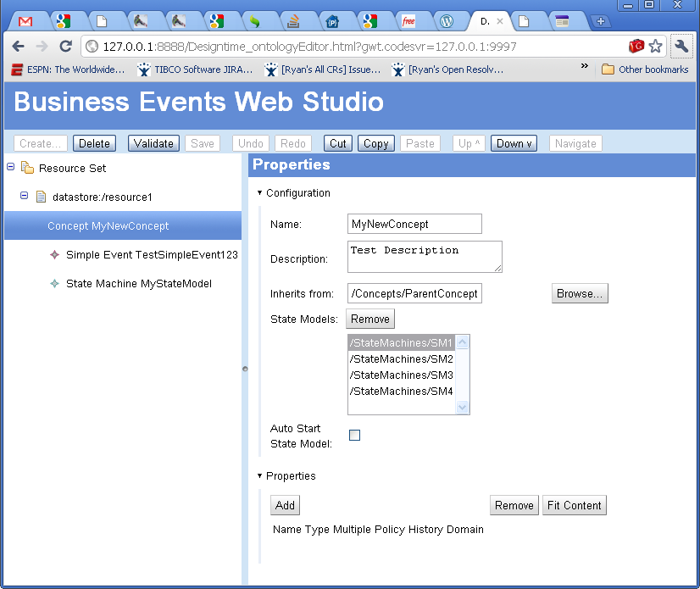
Out of the box, GWT does not have an elegant solution for tables. There is a FlexTable widget, which is basically an HTMLTable with varying numbers of columns per row. There are several widget libraries that have better table solutions, so we would want to use one of those. As mentioned above, for decision tables, we would certainly want to use data paging in the table so that we don’t send 10,000 records to/from the server. The best solution would have some support for paging on-demand as well. SmartGWT might be a good solution here.

Here is an example of a table in gwt-ext:

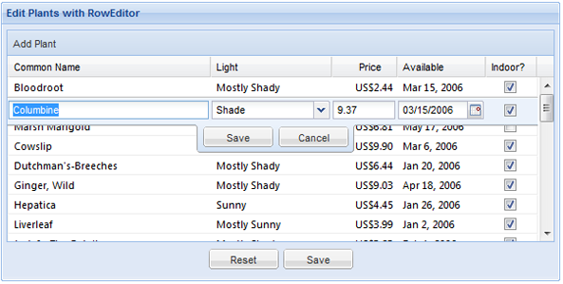

or with SmartGWT:
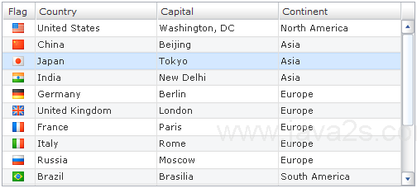

See http://www.smartclient.com/smartgwt/showcase/#featured_grid_live as an example of SmartGWT using pagination. The example fetches new rows as the user scrolls, which would be required for a large Decision Table with thousands of rows.
It is very important to keep the data binding aspects in mind while choosing a technology solution.

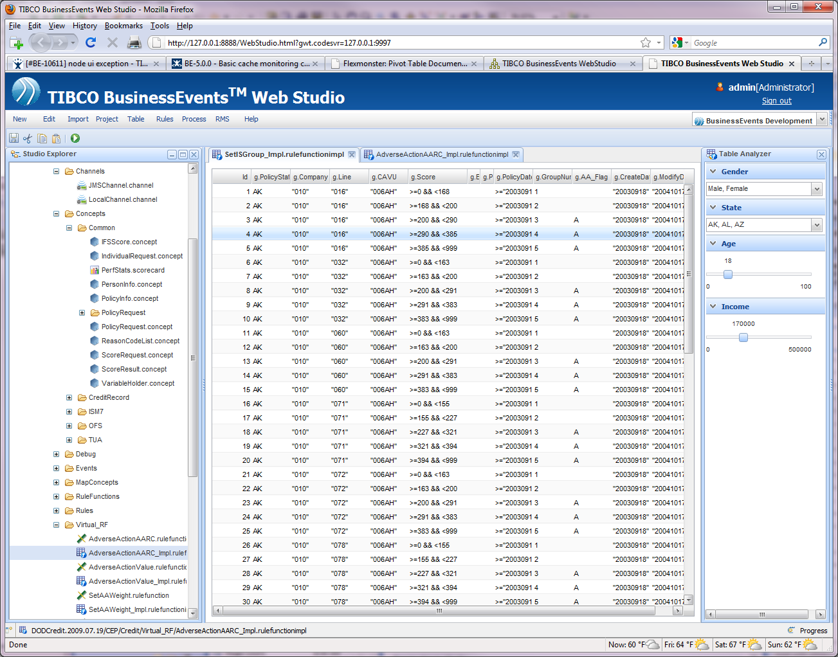

Diagramming
For our diagrams, such as project views, BPMN Processes, Decision trees, site topology, using the Tom Sawyer-based web technology would be the easiest and give us most of the features already available in BE Studio, including usability and performance, not to mention same look and feel.
Unfortunately, only a JSP edition is available from Tom Sawyer Software. They started working on an HTML5 edition which would be a good fit for us, but that won't be available until some time in the second half of 2011 (at least that's the current plan). Thus, with JSP, unfortunately we'd need a JSP container on the back end to serve diagramming components to web browsers.
Another advantage would be that because we are already using TS model in our BE Studio, integration with back end model would be much easier. We have already developed a prototype to show BPMN processes (see screenshot in document above).

