Instructions for 4.0 Example Builders

Overview
This document explains how to set up 4.0 examples and how to prepare the readme.html file. The readme file has javascript smarts and it is also the input to an http channel for testing.
- You must use only HTTP channels in examples (unless there is a good reason not to).
- Do not use the word example or sample or repo or project in the project name (i.e. project directory). Try to give a name that is descriptive of the example topic. HTTPChannel for example.
- If the name isn’t specified in the tracking document, please check with me about the name before you start!

The following sections explain the folder structure, and how to set up your 4.x example and readme.html.

Example Folders and Names
In the product as shipped, we need this kind of structure for each example. The standard folder is expanded to show the structure of one example.
BE_HOME/examples/
/_resource
/data_modeling
/decision_manager
/event_stream_processing
/standard
/YourExampleName –The EAR file and the readme.html file.
/YourExampleName/YourExampleName – The project, and CDD.
/views
Don’t change anything in the folder called _resources. You must, however, copy this directory to your sand box if you use one, to provide test data to the example’s runtime. _resources contains the HTTP input smarts. It needs to be two directories above your actual project to simulate the installed environment, and to make the readme.html forms work and look pretty.

What You Must Do in the Studio Project
We must use an HTTP channel for sending events to the running engine. We must handle the reply to the request. Use FraudDetection as a model and the instructions below.

Create the HTTP.channel HTTP Channel
Please copy the FraudDetection example resources exactly. Keep everything the same that can be the same.
- Create the HTTP.channel with AllOps destination exactly as in the FraudDetection project unless the example requires something different. Create an HTTPConnection.connection resource and reference it.
- Use Caller in the HTTP channel’s destination Threading Model CDD property.
In the FraudDetection CDD the destination is inserted directly here:
Agent Classes > FraudDetection (Inference) > Destination Groups > AllOps
Note: Use the default agent class name for a single-agent example.

Create the PreProcessor() Rule Function
1. Add this rule function and call it PreProcessor:

/**
* @description Closes requests from the HTTP server
*/
void rulefunction RuleFunctions.PreProcessor {

attribute {
validity = ACTION;
}
scope {
Event request;

}
body {
// Replies to the request event, in order to close the HTTP request.
// To keep it simple, uses the request event as the response.
Event.replyEvent(request, request);
}

}

2. Add it as the AllOps destination event preprocessor.

What You Must Do In the Readme.HTML
Don’t change the filename – just keep it in its appropriate example directory.

Head Section: Title
Set the project name in the title, changing nothing else.
For example, change this:
<title> Fraud Detection - TIBCO BusinessEvents&trade; 4.0.0 Examples

to this:

<title> One Event and Two Concepts - TIBCO BusinessEvents&trade; 4.0.0 Examples

Head Section: buildForms()
This is where you configure the input forms that you later reference in the body section.
Two forms are provided. Add or remove forms and customize them as needed.
Each form must have a unique name, of course:

form = SendEventForm.get("YOURFORMNAMEHERE");

(You’ll reference this name in the body section.)
In each form, set the event name in the first line, as shown.

form = SendEventForm.get("debitCheckAccountForm");

In the form.addproperty() lines, set event property names and property values, as needed. For example, for the OneExternalEventAndTwoconcepts example you might change the provided example form like this – changes shown in bold:

form = SendEventForm.get("debitCheckAccountForm");
form.setDestinationPath("/Channels/HTTP/AllOps");
form.setEventPath("/Events/Payment");
form.addProperty("TransactionType", "CHECKING");
form.addProperty("CheckingAccountId", "checking1");
form.addProperty("Amount", "1000");
form.build();

Add more form.addProperty() lines as needed for the event properties you’ll need in the form, and provide name-value pairs as shown above
form.addProperty("NAME", "VALUE");

Note: the order of the form.addProperty() lines determines their display order in the form when it appears in the body section. Don’t change the order of any other kinds of lines in the form definition.

Body Sections

Name of Example
In the h1 element, put the name of the example, using regular English, for example:
<h1>One Event and Two Concepts</h1>

Purpose
Below the h2 element “Purpose of This Example” replace the example paragraphs with some appropriate content explaining why this example is interesting – what useful features is it demonstrating? Use only simple HTML formatting as needed, such as list bullets. Keep it short and simple. I’ll review and edit all these so don’t agonize over the language.

It’s a good idea to give a brief flow– events enter – rules fire – concepts are altered – other rules fire – things display on the console – world peace is established – the end.

How to Run the Example
Below the h2 element “How to Run the Example” provide steps as needed, using the provided HTML ordered list formatting. Do the following to the provided model:
Modify the command line: Edit only the actual commands and don’t disturb the formatting. Use the default installation directories. Use forward slashes.
Note: The provided commands start the example in the examples/standard/myexample directory. It has the convenience that the logs are with the example and not under in the engine bin folder. Let me know what you think.
Add More Steps As Needed: Steps are generally just about providing input. Here is an example:
<ol>
. . .
<li>
<p>Create an account and give it a balance and an average monthly balance. Enter a name in the Account ID field. Enter, for example, 10000 in the Balance, and 20000 in the AvgMonthlyBalance fields. Repeat this step to create multiple accounts, as desired.</p>
<form id="createAccountForm"></form>
<p>In the command window you see a message like this: #### Created account Bob. </p>
</li>
. . .
</ol>

Show and Tell Users What They’ll See – But NO screenshots (as a rule)
If at all possible explain what they’ll see by trying different things. I tried to make the FraudDetection example readme.html a model for you to follow and adapt as needed. Avoid screenshots – they are high-maintenance. Users can look at the example in Studio.

If Users Must Do some Project Configuration
- Add a “Project Configuration” h3 section with instructions to configure the example if it needs configuration before it can run.
- Add an h3 section “Steps to Run the Example” Then put the steps to run the example in that section.

Sending Event Payloads in Forms

General Info about HTTP Channel and Payloads
To send an HTTP GET request to the REST Serializer so that it deserializes into an event with a payload, the user must include a request parameter named "_payload_".
The string value of that _payload_ parameter will always be used as payload in the event.
To use an HTML form as an example:
<form action="http://myserver:8989/ChannelName/DestinationName" method="GET">
<input name="property1" value="foo" />
<input name="property2" value="bar" />
<input name="property3" value="true" />
<input name="property4" value="12.34" />
<input name="_payload_" value="&lt;p:mypayload xmlns:p=... ... ... ... &lt;/p:mypayload&gt;" />
<input type="submit/>
</form>
A word of warning: GET requests are limited by server-side implementations. Users should avoid sending long requests in a GET request (use POST instead, if you can, which is not always possible --for example because of compatibility issue with HTML forms).

Info for Readme Form Builders Only: @payload
If you want to send a message that will be turned into an event payload in the project, use the following format:

form.addProperty(“@payload”, text, numrows)

Here’s an example:

form = SendEventForm.get("f");
form.setDestinationPath("/Channels/Http/AllOperations");
form.setEventPath("/Events/OrderEvent");form.addProperty("@payload",
'<p:order xmlns:p="http://www.tibco.com/be/collection">\n'
+' <p:orderId>4001</p:orderId>\n'
+' <p:custId>1234</p:custId>\n'
+' <p:orderline>\n'
+' <p:lineId>1</p:lineId>\n'
+' <p:productId>prod-abc</p:productId>\n'
+' <p:qty>1000</p:qty>\n'
+' </p:orderline>\n'
+' <p:orderline>\n'
+' <p:lineId>2</p:lineId>\n'
+' <p:productId>prod-xyz</p:productId>\n'
+' <p:qty>200</p:qty>\n'
+' </p:orderline>\n'
+'</p:order>',
15);
form.build();

This will result in something close to the following where you insert the form in the instructions: 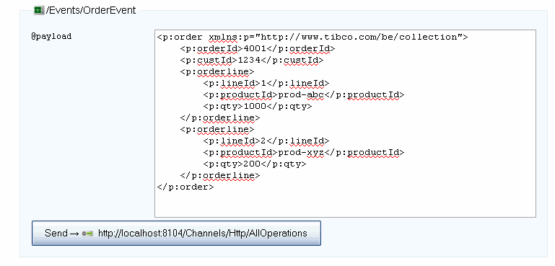

Note that you can now set the number of rows in the text field in the form (rows=”15” in the example above)
On the server side, the REST deserializer will find the_payload_ field when it processes the GET request, and use its value as a payload string.

Happy Exampling!

