Functional Design Specification for BE ActiveSpaces Channel,
Version 0.7
Feb 16, 2012
Table of Contents
Revision History 4
1 Introduction 5
1.1 Purpose 5
1.2 Document Scope 5
2 Overview 6
2.1 Feature Descriptions 6
2.2 Assumptions 6
Functional Design Description 7
2.3 Shared Resource 7
2.3.1 Metaspace 7
2.4 Channel 7
2.4.1 Destination 7
2.5 Catalog Functions 8
2.5.1 getEventConsumptionMode() 8
2.5.2 getEventType() 8
2.5.3 beginTransaction() 8
2.5.4 commitTransaction() 9
2.5.5 rollbackTransaction() 9
2.5.6 releaseTransaction() 9
2.5.7 takeTransaction() 10
2.5.8 putTuple() 10
2.5.9 getTuple() 10
2.5.10 takeTuple() 11
2.5.11 query() 11
2.5.12 takeSnapshot() 12
2.6 Rule and Event 12
2.6.1 Translate an ActiveSpaces Tuple into BE Event 13
2.6.2 Translate a BE Event into ActiveSpaces Tuple 14
2.6.3 Define a Rule to put Tuple to AS by using method sendEvent(…) 15
2.6.4 ActiveSpaces Transactions 15
2.6.5 Transaction Across Different Rules 15
3 Interfaces 16
3.1 Metaspace 16
3.2 Destination 17
3.3 Catalog Functions 17
4 Impact Analysis 20
4.1 Changes to Internal Interfaces 20
4.2 Migration and Backward Compatibility Issues and Solutions 20
4.3 Impact on Other TIBCO Products 20
4.4 Dependencies on Other Components or Products 20
4.5 Impact on Documentation 20
5 Resolved Issues 21
6 QA Guidelines 22
APPENDIX A. Related Documents 23
APPENDIX B. Functional Design Spec Distribution and Approval 23

Revision History
Version | Date | Author | Department | Description
0.1 | 1/10/2012 | Huabin Zhang | Solution | Create document.
0.2 | 1/12/2012 | Michael Qian | Solution | Modified.
0.3 | 1/13/2012 | Huabin | Solution | Modified the description of Catalog Functions and the usage of Event Consumption Mode.
0.4 | 1/19/2012 | Huabin | Solution | Update Shared Resource section.
0.5 | 2/10/2012 | Huabin | Solution | Add Catalog Functions.
0.6 | 2/15/2012 | Michael | Solution | Reviewed with some comments and modified.
0.7 | 2/16/2012 | Huabin | Solution | Add release and take transaction catalog function.
- Introduction
  - Purpose
TIBCO BusinessEvents is complex event processing (CEP) software that enables organizations to identify meaningful patterns among the countless events that occur across their business. By doing so the software helps organizations recognize and proactively address problems and opportunities sooner than would otherwise be possible.
TIBCO ActiveSpaces is a distributed peer-to peer in-memory data grid, a form of virtual shared memory that leverages a distributed hash table with configurable replication. It simplifies enterprise application development by providing an easy-to-use interface for data storage and retrieval (data grid) and process coordination (messaging grid).
ActiveSpaces provides a set of API for developers to write ActiveSpaces applications. The purpose of BE ActiveSpaces Channel is to allow BE customers to monitor the activities on metaspace of the AS and receive AS events and transform them to BE events. At the same time we provide some catalog functions which used to control the type of the AS events.
This Functional Design Specification document focuses on the functional requirements for each major feature of the product and describes the design of each component.
The engineering teams who will benefit from having this document at their disposal for development and testing tasks are:
- Development Engineering Team
- QA Engineering Team
- Technical Publication Team
- Product Support Team
  - Document Scope

We will address following features in this document:
- Create AS Shared Resource
- Configure Destination
- Serializer/Deserializer to transform between AS Event and BE Event.
- Use Catalog functions
- Overview
  - Feature Descriptions
BE ActiveSpaces Channel will implement some ActiveSpaces operations in BE. Then users manipulate some activities and functions of ActiveSpacesin BE process.
Feature | Content
Shared Resource | Create Metaspace
Channel | Create Destination
Catalog Functions | Get Consumption-Mode and Type of Event and other functions
Rule and Event | Translate BE Event and AS Tuple

  - Assumptions
The audients of this document are assumed to understand the basic concepts in ActiveSpaces. Please refer to ActiveSpaces documentations for more details of each operation and API.

Functional Design Description
  - Shared Resource
    - Metaspace
Metaspace is an instance of a cluster of applications processes (typically, but not necessarily, deployed on multiple hosts interconnected by a network) using ActiveSpaces. It is an administrative container for a set of spaces (system spaces and user spaces). In BE ActiveSpaces Channel, Metaspace is a BE shared resource representing a Metaspace of ActiveSpaces.
      - Configuration
- Metaspace Name
  - Default: ms
  - Required: Yes
- Discovery URL (Multicast URL)
  - Default: <Empty>
  - Required: No
- Listening URL (Unicast URL)
  - Default: <Empty>
  - Required: No

  - Channel
    - Destination
Messages enter and leave the BE system through channels. The destinations will be created within a channel to define the message sources and sinks. Typically, events are created using data in incoming messages; outgoing messages are created using data from events.
      - Serializer/Deserializer
  - Deserialize ActiveSpaces Tuple to BE Event and Serialize BE Event to ActiveSpaces Tuple.
  - Type: Enumeration
  - Required: Yes
  - Default: ASSerializer
      - Space Name
  - The name of Space.
  - Type: String
  - Required: Yes
  - Default: <Empty>
      - Filter
  - The Filter of Event Listener.
  - Type: String
  - Required: No
  - Default: <Empty>

Samples of Filer:
“id > 100 AND id <= 500”
“name LIKE \”.*John.*\””
      - Consumption Mode
  - The ActiveSpaces Event Consumption Mode.
  - Type: Enumeration (Taker and Monitor)
  - Required: Yes
  - Default: Monitor
  - Warning: The implementation of Taker Mode uses such an approach to handle the Take Event: When AS Channel detects a new Take Event occurs, it will get the tuple from the Take Event unless it takes tuple directly from the Space successfully,
      - Event Type
  - The ActiveSpaces Event Type.
  - Type: Multiple-Selections (PutEvent, TakeEvent and ExpireEvent) with check box.
  - Required: Yes
  - Default: PutEvent
  - Warning: Only the PutEvent is effectual if users select the Taker consumption mode.
  - Catalog Functions
The BE functions registry includes various catalogs of functions provided with the product, and each catalog organizes functions into various related categories. Users can use functions in rule conditions and actions and in rule function bodies.
    - getEventConsumptionMode()
Just as its name implies, it retrieves consumption mode of Event.
Warning: To use this function, users must define a String type property of BE Event with the name k_consumption_mode.
      - API Definition

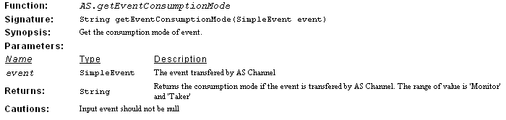
    - getEventType()
It retrieves the consumption mode of Event.
Warning: To use this function, users must define a String type property of BE Event with the name k_event_type.
      - API Definition

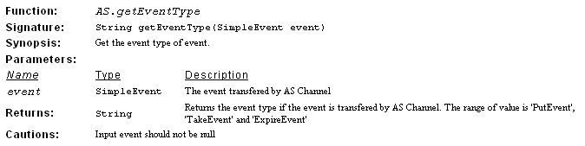
    - beginTransaction()
Begin Transaction is used to start a transaction.
      - API Definition

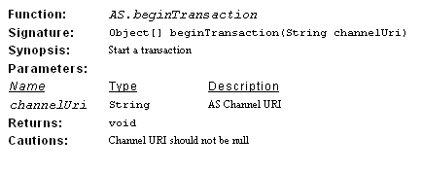
    - commitTransaction()
Commits all of the space operations invoked since Begin Transaction is called.
      - API Definition

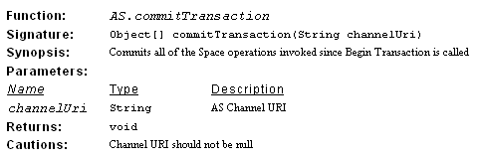
    - rollbackTransaction()
Reverts all of the space operations invoked since Begin Transaction is called.
      - API Definition

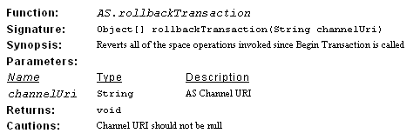
    - releaseTransaction()
Return TransationId if the thread is in a transaction. TransactionId can then be given to another thread to continue transaction.
      - API Definition

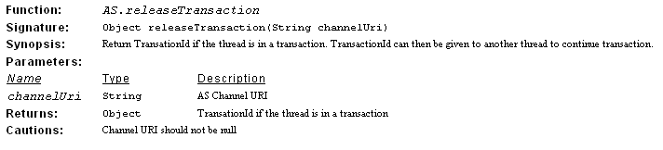
    - takeTransaction()
Take TransactionId to continue transaction.
      - API Definition

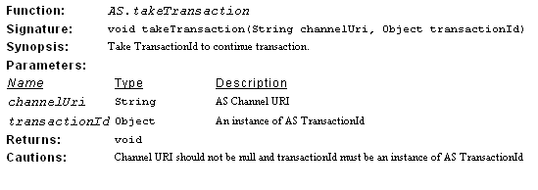
    - putTuple()
Store a tuple in a space.
      - API Definition

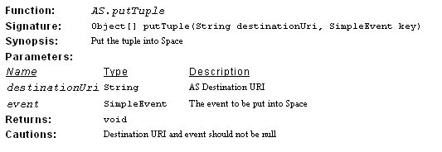
    - getTuple()
Query a tuple from a space.
      - API Definition

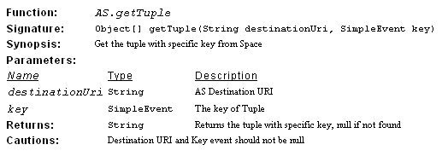
    - takeTuple()
Get and remove a tuple from a space.
      - API Definition

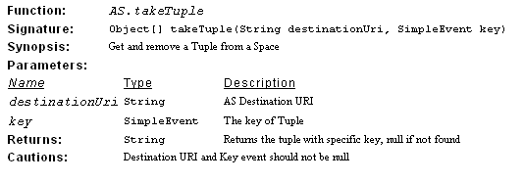
    - query()
Retrieves the entries that match the conditions you specified in the associated space.
      - API Definition

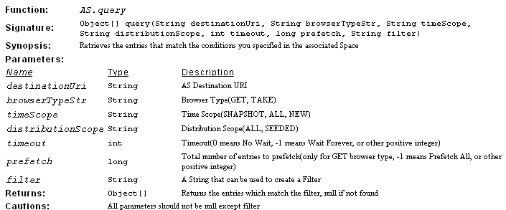
    - takeSnapshot()
Take snapshot of the entries that match the conditions you specified in the associated space.
      - API Definition

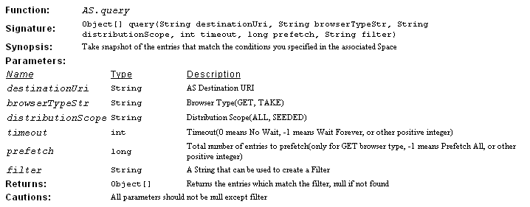

  - Rule and Event
Rules define actions to take when certain conditions are met. Rules are written in the TIBCO BusinessEvents rule language, which is similar to the Java language. Rules are declarative and are generally narrow in scope. A rule has three parts: the declaration (declare), the conditions (when), and the actions (then). As with rule functions, you can work in a source view, which displays the Java-like code, or in a form view.

The term event is overloaded: it means an activity that happens, and the definition of an object that represents the activity in TIBCO BusinessEvents (an event type), and an instance of that event type definition.
    - Translate an ActiveSpaces Tuple into BE Event
      - Define an Event
First of all, users need to define a BE Event with EMPTY Default Destination property. Please see the figure as below:
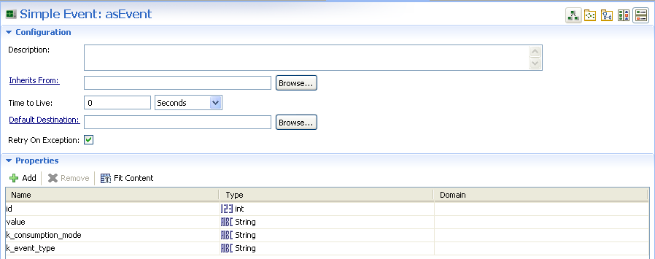

      - Define a Destination
And then, they need to define a Destination of AS Channel and specify Default Event with the name as above. Please see the figure:
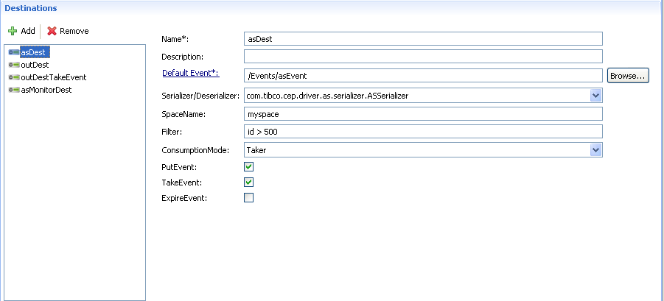

      - Configure CDD (Cluster Deployment Descriptor)
Finally, users must specify the URI of Input Destination. Please see the following figure:
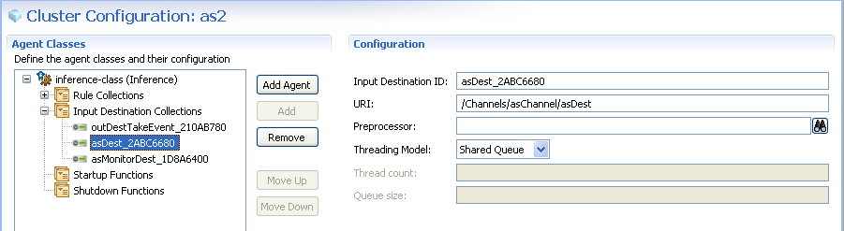

    - Translate a BE Event into ActiveSpaces Tuple
      - Define a Destination
Users must define a Destination of AS Channel with EMPTY Default Event property If they want to reply event to AS.
Warning: The only one useful property of this destination is SpaceName, the others will be ignored by the translation module in run-time. Please see the figure as below:
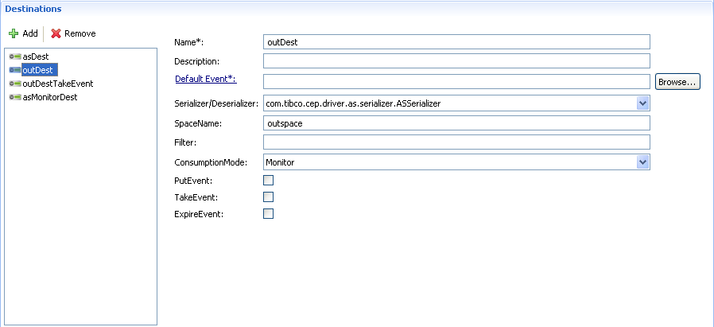

      - Define an Event
At the same time, users must define a BE Event and specify Default Destination with the name as above. Please see the figure as below:
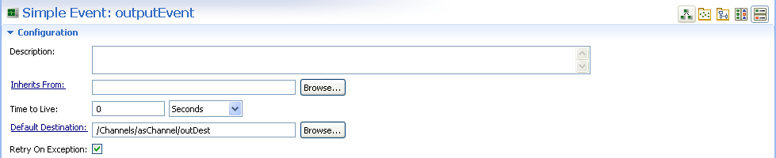

    - Define a Rule to put Tuple to AS by using method sendEvent(…)
Finally, users use function Event.sendEvent() to reply event. Please see the following figure as a sample:
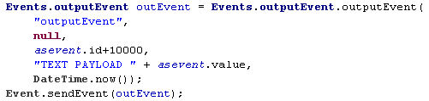
    - ActiveSpaces Transactions
ActiveSpaces offers the ability to atomically perform sets of space operations using transactions. Transactions can span multiple spaces, but not multiple Metaspaces. A transaction starts when an individual thread in an application creates a transaction, and terminates when either commit or rollback are invoked, at which point all space operations performed by that thread are either validated or canceled.
    - Transaction Across Different Rules
ActiveSpaces does support transaction across different threads through releaseTransaction() and takeTransaction() API. It basically says that if you are in a transaction, take a transaction ID, perform your work, and then release it. By doing this, you wouldn’t need to worry if BE Rule Engine switches thread in between each Rule. AS will handle thread context switching for you. However users must manage transaction with Catalog Functions releaseTransaction() and takeTransaction() by themselves.

Here is the sample that users should do in a BE Rule:

- For Begin Transaction function
AS.beginTransaction(“channelUri”);
Object tid = AS.releaseTransaction(“channelUri”);
Util.HashMap.createMap(“asCtx”);
Util.HashMap.putObject(“asCtx”, “CONTEXT_KEY_TID”, tid);

- For Get/Put/Take function
Util.HashMap.createMap(“asCtx”); // This function won’t create a new HashMap if it has already existed with specific name.
Object tid = Util.HashMap.getObject(“asCtx”, “CONTEXT_KEY_TID”);
If (tid != null) {
AS.takeTransaction(“channelUri”, tid);
// call Get/Put/Take tuple function
// Get/Take tuple function needs to handle transaction so that one can read un-committed tuples
tid = AS.releaseTransaction(“channelUri”);
Util.HashMap.putObject(“asCtx”, “CONTEXT_KEY_TID”, tid); // update tid

}

- For Commit and Rollback Transaction function
Util.HashMap.createMap(“asCtx”);
Object tid = Util.HashMap.getObject(“asCtx”, “CONTEXT_KEY_TID”);
If (tid != null) {
// call commit or rollback transaction function
Util.HashMap.remove(“asCtx”, “CONTEXT_KEY_TID”); // remove tid from context
}
- Interfaces
  - Metaspace
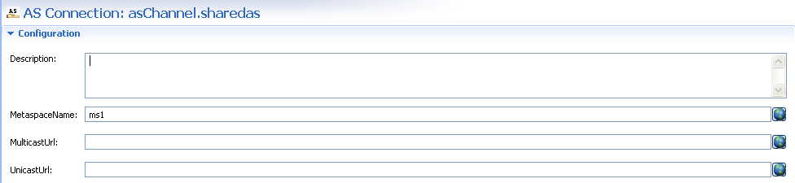
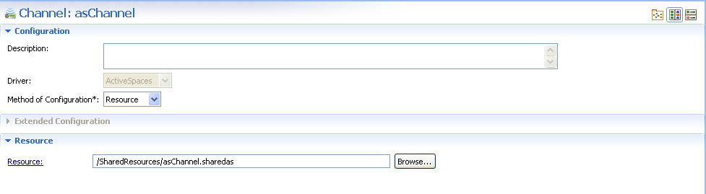
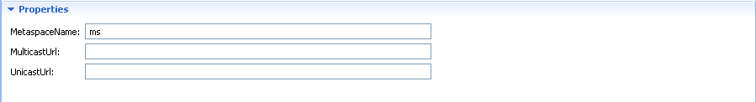
  - Destination
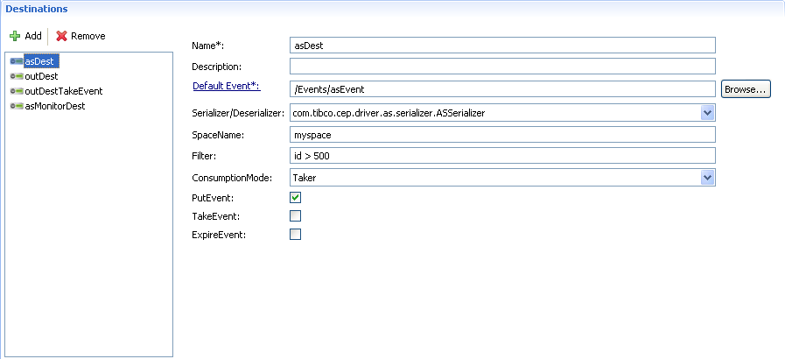
  - Catalog Functions
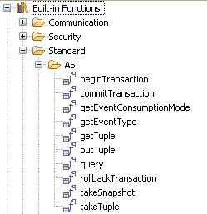
Sample 1. , Qquery some tuples, create a new transaction and put a new tuple, commit current transaction if there isexist a tuple with IDid less than 450, else rollback:
rule Rules.asRule {
attribute {
priority = 5;
forwardChain = true;
}
declare {
Events.asEvent asevent;
}
when {
}
then {
System.debugOut("TAKER MODE: EVENT ID: " + asevent.id);
System.debugOut("TAKER MODE: EVENT VALUE: " + asevent.value);
System.debugOut("TAKER MODE: CONSUMPTION MODE: " + AS.getEventConsumptionMode(asevent));
System.debugOut("TAKER MODE: EVENT TYPE: " + AS.getEventType(asevent));

String asChannel = System.getGlobalVariableAsString("asChannel", "");
String asDest = System.getGlobalVariableAsString("asChannel.asDest", "");
String outDest = System.getGlobalVariableAsString("asChannel.outDest", "");

// query
Object[] result = AS.query(asDest, "get", "snapshot", "all", 0, 1000, "id < 500");
if (result != null) {
for (int i=0; i<result@length; i++) {
Object[] temp = result[i];
for (int j=0; j<temp@length; j++) {
Object[] tuple = temp[j];
System.debugOut("ResultX "+i+","+j+" is "+tuple[0]);
System.debugOut("ResultX "+i+","+j+" is "+tuple[1]);
}
}
}

// take snapshot
result = AS.takeSnapshot(outDest, "get", "all", 0, 1000, "id <= 10500");
if (result != null) {
for (int i=0; i<result@length; i++) {
Object[] temp = result[i];
for (int j=0; j<temp@length; j++) {
Object[] tuple = temp[j];
System.debugOut("ResultY "+i+","+j+" is "+tuple[0]);
System.debugOut("ResultY "+i+","+j+" is "+tuple[1]);
}
}
}

// begin transaction
AS.beginTransaction(asChannel);

// put tuple
Events.outputEvent newOutputEvent = Events.outputEvent.outputEvent(
"newOutputEvent",
null,
asevent.id+20000,
"New Output Event TEXT PAYLOAD " + asevent.value,
DateTime.now());
AS.putTuple(outDest, newOutputEvent);

// get tuple
asEvent asEventKey = Events.asEvent.asEvent("asEventKey", null, 499, null, null, null);
Object[] tupleEvent = AS.getTuple(asDest, asEventKey);

if (tupleEvent == null) {
// commit transaction
AS.commitTransaction(asChannel);
} else {
// take tuple
tupleEvent = AS.takeTuple(asDest, asEventKey);
System.debugOut("Take Tuple before rolling back transaction");
boolean lt450 = false;
// take snapshot
result = AS.takeSnapshot(asDest, "get", "all", 0, 1000, "id <= 450");
if (result != null && result@length > 0) {
lt450 = true;
}
if (lt450) {
// rollback transaction
AS.rollbackTransaction(asChannel);
} else {
// commit transaction
AS.commitTransaction(asChannel);
}
}
Events.outputEvent outEvent = Events.outputEvent.outputEvent(
"outputEvent",
null,
asevent.id+10000,
"TEXT PAYLOAD " + asevent.value,
DateTime.now());
Event.sendEvent(outEvent);
System.debugOut("ENDENDENDENDENDENDENDENDENDENDENDENDENDENDENDENDENDENDENDEND");
}
}

Sample 2., Ccreate a new transaction in rule#1, and then put a new tuple, finally release current transaction and store the Transaction IDd to context:
rule Rules.outTakeRule {
attribute {
priority = 5;
forwardChain = true;
}
declare {
Events.outTakeEvent outtakeevent;
}
when {
}
then {
System.debugOut("OUT-TAKE EVENT ID: " + outtakeevent.id);
System.debugOut("OUT-TAKE EVENT VALUE: " + outtakeevent.datetime);
System.debugOut("OUT-TAKE: CONSUMPTION MODE: " + AS.getEventConsumptionMode(outtakeevent));
System.debugOut("OUT-TAKE: EVENT TYPE: " + AS.getEventType(outtakeevent));

String asChannel = System.getGlobalVariableAsString("asChannel", "");
String outDest = System.getGlobalVariableAsString("asChannel.outDest", "");

// query
Object[] result = AS.query(outDest, "get", "snapshot", "all", 0, 1000, "id > 1000");
if (result != null) {
for (int i=0; i<result@length; i++) {
Object[] temp = result[i];
for (int j=0; j<temp@length; j++) {
Object[] tuple = temp[j];
System.debugOut("ResultA "+i+","+j+"[0] is "+tuple[0]);
System.debugOut("ResultA "+i+","+j+"[1] is "+tuple[1]);
}
}
}

// begin transaction
AS.beginTransaction(asChannel);

// put tuple
if (outtakeevent.id > 11000) {
Events.outputEvent newOutputEvent2 = Events.outputEvent.outputEvent(
"newOutputEvent2",
null,
outtakeevent.id+10000,
"New Output Event 2222222 TEXT PAYLOAD " + outtakeevent.value,
DateTime.now());
AS.putTuple(outDest, newOutputEvent2);
System.debugOut("OUT-TAKE: New Output Event 2: ID = " + (outtakeevent.id+10000));
} else {
Events.outputEvent newOutputEvent2 = Events.outputEvent.outputEvent(
"newOutputEvent2",
null,
outtakeevent.id+1111,
"New Output Event 2222222 TEXT PAYLOAD " + outtakeevent.value,
DateTime.now());
AS.putTuple(outDest, newOutputEvent2);
System.debugOut("OUT-TAKE: New Output Event 2: ID = " + (outtakeevent.id+1111));
}
// release transaction
Object tid = AS.releaseTransaction(asChannel);
Util.HashMap.createMap("asContext");
Util.HashMap.putObject("asContext", "tid1", tid);
}
}
Sample 3., Gget Transaction IDd from context and take transaction with it, and then commit this transaction if exist there is a tuple with IDid between (15000, 20000], else rollback :
rule Rules.asMonitorRule {
attribute {
priority = 5;
forwardChain = true;
}
declare {
Events.asMonitorEvent asmoniotrevent;
}
when {
}
then {
System.debugOut("MONITOR MODE: EVENT ID: " + asmoniotrevent.id);
System.debugOut("MONITOR MODE: EVENT VALUE: " + asmoniotrevent.value);
System.debugOut("MONITOR MODE: CONSUMPTION MODE: " + AS.getEventConsumptionMode(asmoniotrevent));
System.debugOut("MONITOR MODE: EVENT TYPE: " + AS.getEventType(asmoniotrevent));

String asChannel = System.getGlobalVariableAsString("asChannel", "");
String outDest = System.getGlobalVariableAsString("asChannel.outDest", "");

// take snapshot
Object[] result = AS.takeSnapshot(outDest, "get", "all", 0, 1000, "id > 15000 AND id <=20000");
boolean gt15000 = false;
if (result != null && result@length > 0) {
gt15000 = true;
}
System.debugOut("MONITOR MODE: GT15000: " + gt15000);
Util.HashMap.createMap("asContext");
Object tid = Util.HashMap.getObject("asContext", "tid1");
if (tid != null) {
AS.takeTransaction(asChannel, tid);
if (gt15000) {
// commit transaction
AS.commitTransaction(asChannel);
System.debugOut("MONITOR MODE: Commit Transaction");
} else {
// rollback transaction
AS.rollbackTransaction(asChannel);
System.debugOut("MONITOR MODE: Rollback Transaction");
}
Util.HashMap.remove("asContext", "tid1");
}
}
}
- Impact Analysis
  - Changes to Internal Interfaces
…
  - Migration and Backward Compatibility Issues and Solutions
…
  - Impact on Other TIBCO Products
…
  - Dependencies on Other Components or Products
…
  - Impact on Documentation
…
- Resolved Issues
This section describes the issues that will be resolved with the feature implementations covered in this document. …
Identifier | Description | Resolution

Note: project and technical issues should be covered in the project plan and other project activity deliverables (e.g. status reports, etc.).
- QA Guidelines
This section provides guidelines on the level of test coverage (e.g. integration, performance, etc.), any specific test scenarios that needs to be covered. …

  - Related Documents
The sources used when creating this document and other related documents, such as the PRD, that might be prerequisites or contain useful information regarding this design are listed in the table:
Document Title | Author | Link or Description
  - Functional Design Spec Distribution and Approval
The functional design specification review and approval should normally include the following groups/people.
Organization | Name of Representative | Sign-Off Signature | Sign-Off Date
Product Manager
Development Manager
QA Manager
Program Management
Integration QA
Globalization / Localization
Technical Publications
Support
Educational Services
Legal
Author

