Functional Design Specification for BE Hawk Channel
Version 0.5
Feb 24, 2012
Table of Contents
Revision History 3
1 Introduction 4
1.1 Purpose 4
1.2 Document Scope 4
2 Overview 5
2.1 Feature Descriptions 5
2.2 Assumptions 5
3 Functional Design Description 5
3.1 Channel 5
3.1.1 Hawk-RV 5
3.1.2 Hawk-EMS 5
3.2 Destination 6
3.3 Serializer 6
3.3.1 HawkAlertSerializer 6
3.3.2 HawkRuleBaseSerializer 7
3.4 Catalog Functions 7
3.4.1 Hawk Initialization Method 7
3.4.2 Generic Method Invocation 7
3.4.3 Common Microagent Methods 7
4 Interfaces 9
4.1 Hawk Channel 9
4.1.1 Hawk-RV 9
4.1.2 Hawk-EMS 9
4.2 Destination 10
4.3 Catalog Functions 10
5 Impact Analysis 12
5.1 Changes to Internal Interfaces 12
5.2 Migration and Backward Compatibility Issues and Solutions 12
5.3 Impact on Other TIBCO Products 12
5.4 Dependencies on Other Components or Products 12
5.5 Impact on Documentation 12
6 Resolved Issues 13
7 QA Guidelines 14
APPENDIX A. Related Documents 15
APPENDIX B. Functional Design Spec Distribution and Approval 15

Revision History
Version | Date | Author | Department | Description
0.1 | 1/10/2012 | Neng Wang | TOOLS | First version.
0.2 | 1/12/2012 | Michael Qian | TOOLS | modified
0.3 | 1/19/2012 | Neng Wang | TOOLS | Separate hawk-rv and hawk-ems
0.4 | 2/13/2012 | Neng Wang | TOOLS | Add catalog functions
0.5 | 2/22/2012 | Neng Wang | TOOLS | Add monitor type of destination, update catalog functions, add 2 sample rules
- Introduction
  - Purpose
TIBCO BusinessEvents is complex event processing (CEP) software that enables organizations to identify meaningful patterns among the countless events that occur across their business. By doing so the software helps organizations recognize and proactively address problems and opportunities sooner than would otherwise be possible.
TIBCO Hawk is a tool for monitoring and managing distributed applications and operating systems. Unlike other monitoring solutions, TIBCO Hawk software uses TIBCO Messaging software for communication and inherits many of its benefits. These benefits include a flexible architecture, enterprise-wide scalability, and location- transparent product components that are simple to configure.
TIBCO Hawk is an event-based system built around the concept of a distributed, autonomous smart agent that operates on each managed machine in the network. The software is designed specifically for monitoring distributed systems, so there is no centralized console or frequent polling across the network. With this structure, TIBCO Hawk is able to scale to multi-thousand node global networks without the use of hierarchical managers and has the flexibility to allow individual managed entities to be added or modified without the need to re-configure or re-start any other parts of the system.
The purpose of Hawk Channel for BE is to enable BE to receive hawk monitor events and transform them to BE events. At the same time we provide some catalog functions which used to control Microagent through hawk API.
This Functional Design Specification document focuses on the functional requirements for each major feature of the product and describes the design of each component.
The engineering teams who will benefit from having this document at their disposal for development and testing tasks are:
- Development Engineering Team
- QA Engineering Team
- Technical Publication Team
- Product Support Team
  - Document Scope

We will address following features in this document:
New BE Channel Type --- Hawk Channel( including Hawk-RV Channel and Hawk-EMS channel)
Destination for Hawk Channel.
Serializer/Deserializer to transform between Hawk Event and BE Event.
Catalog function for Hawk Channel
- Overview
  - Feature Descriptions
Hawk Channel for BE can receive the events of the hawk monitor and transform them to BE events. And in BE rules, users can use catalog functions to invoke Microagent Methods.
Channel: Need to set transport properties (RV properties or EMS properties) and Hawk domain. Then listen on Hawk Channel using Hawk Console API.
Destination: Listen on a certain type of Hawk Events(Such as AlertMonitorEvent and RuleBaseMonitorEvent)
Serializer/Deserializer: HawkSerializer
Catalog Functions: Query agent or Microagent information, Invoke Microagent Methods
  - Assumptions
The audients of this document is assumed to understand the basic concepts in Hawk. Please refer to Hawk documentations for more details of each operation and API.
- Functional Design Description
  - Channel
    - Transport
      - Hawk-RV
Rendezvous software makes it easy to create distributed applications that exchange data across a network. You get software support for network data transport and network data representation. Rendezvous software supports many hardware and software platforms, so programs running on many different kinds of computers on a network can communicate seamlessly.
In BE Hawk-RV Channel, Rendezvous is the underlying communication protocol, we need to configure channel as following:
- hawkDomain
  - Default: default
  - Required: Yes
- rvService
  - Default: 7474
  - Required: Yes
- rvNetwork
  - Default: <Empty>
  - Required: Yes
- rvDaemon
  - Default: tcp:7474
  - Required: Yes
      - Hawk-EMS
The JMS framework (an interface specification, not an implementation) is designed to supply a basis for MOM development. TIBCO Enterprise Message Service implements JMS and integrates support for connecting other message services, such as TIBCO Rendezvous and TIBCO SmartSockets.

In BE Hawk-EMS Channel, EMS is the underlying transport type. So we need to configure channel as following:
- hawkDomain
  - Default: default
  - Required: Yes
- serverURL
  - Default: tcp://localhost:7222
  - Required: Yes
- userName
  - Default: null
  - Required: No
- password
  - Default: null
  - Required: No

    - Destination
Destinations represents to different types of monitors listening on different hawk events. Currently monitor type contains: AlterMonitor, RuleBaseListMonitor, AgentMonitor, MicroAgentListMonitor, ErrorMonitor and WarningMonitor.
AlterMonitor is used to listen on the events of the alert posted, if there are some alerts posted, we can get the information from a AlertMonitorEvent and transform to a BE event.
RuleBaseMonitor is used to listen on the events for rulebase changed. If some rulebases are added or removed, we will receive a RuleBaseMonitorEvent, and then transform it to a BE event.
AgentMonitor is used to listen on the events for agents status changed(alive or expired).
MicroAgentListMonitor is used to listen on the events for Microagent added or removed.
ErrorMonitor is used to listen on the event for error occurring.
WarningMonitor is used to listen on the event for warning occurring.
    - Serializer
We provide a generic serializer HawkSerializer to handler all the transformation between Hawk monitor event and BE event.
  - Catalog Functions
A rule function is a function you write in the TIBCO BusinessEvents rule language. TIBCO BusinessEvents provides a large library of functions for various purposes. In addition, an ontology function is automatically created for each concept and event in your project. These are constructor functions. Another type of ontology function enables you to create and schedule a time event. You can also add custom Java functions.
For Hawk Channel, we provide a “setHawkConsole(channel URI)” method to initialize hawkConsole before we invoke Microagent Methods. Then we provide some catalog functions which can be used to invoke Microagent methods in BE rule. We also provide a generic method for user to invoke Microagent methods which are not listed in common Microagent Methods list.
    - Hawk Initialization Method
Before we invoke Micoragent methods, we need to initialize HawkConsole, We provide a catalog function “ setDefaultHawkChannel” to set up a HawkConsoleBase using BE channel URI.
E.g.: Hawk.Initialization. setDefaultHawkChannel ("/Channels/hawkChannel");
Warning: we must use setDefaultHawkChannel to initialize HawkConsoleBase before we use any other hawk catalog function
    - Generic Method Invocation
Generic method is used to list agents or Microagent information, or invoke Microagent methods
      - invokeHawkMethod
This method is used to invoke Microagent method by agent name, Microagent name, method name and method parameters. Use need to create a simple event to transport parameters.
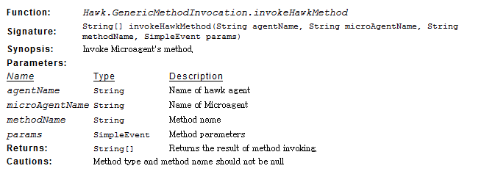
      - getAllAgentNames

This method is used to get all hawk agent names.
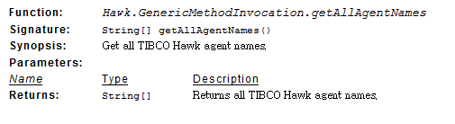
      - getAllMicroAgentInfo
This method is used to get all TIBCO Hawk method info for a specified MicroAgent.
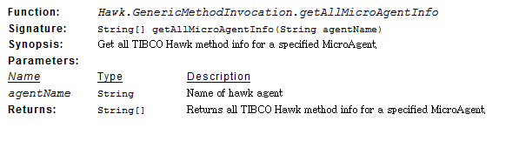
      - getAllMicroAgentMethodInfo
This method is used to get all TIBCO Hawk method info for a specified MicroAgent
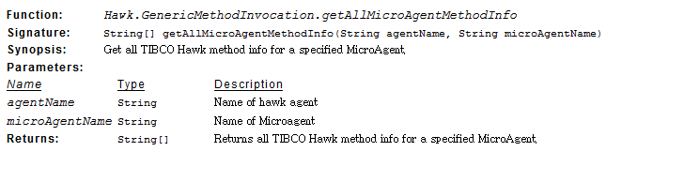

      - describeHawkMicroAgentsMethod
This method is used to get the description of a specified MicroAgent method.
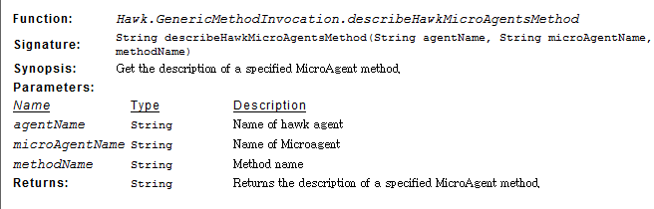

    - Common Microagent Methods
We also provide some common Microagent method in catalog function list, to make user invoke them directly and easy.
      - Self
Returns information from and takes actions that affect the TIBCO Hawk agent itself.
- getUptime
- getReleaseVersion
- getReleaseVersion
- getMicroAgentInfo
- getComponentInfo
- turnDiagnosticsOn
- turnDiagnosticsOff
- doAMIDiscovery
- onMicroAgentEvent
      - RuleBaseEngine
Returns information from rulebases and takes actions on rulebases that affect the TIBCO Hawk agent itself.
- getRuleBaseNames
- getScheduleNames
- getExternalVariables
- updateExternalVariables
- loadRuleBase(RuleBaseName)
- loadRuleBaseFromFile(File)
- unloadRuleBase(RuleBaseName)
- getConfigInfo
- sendMail(To,From,CC,Subject,Mail Server,Content)
- deleteRuleBase(RuleBaseName)
- getCommands
- onAlertCount
- suspendAlert(AlertID,Time,Reason)
- suspendAllAlerts（RuleBaseName,Time,Reason）
- resumeSuspendedAlerts

      - Custom
Runs executable programs and scripts from within the TIBCO Hawk system.
- executeForString(command)
- executeForNumber(command)
- execute(command)
      - SysInfo
Returns information on a network host: its name, address, type of computer and operating system.
- getOperatingSystem
- getArchitecture
- getHostName
- getNetworkAddress

  - Rule and Event
Rules define actions to take when certain conditions are met. Rules are written in the TIBCO BusinessEvents rule language, which is similar to the Java language. Rules are declarative and are generally narrow in scope. A rule has three parts: the declaration (declare), the conditions (when), and the actions (then). As with rule functions, you can work in a source view, which displays the Java-like code, or in a form view.
The term event is overloaded: it means an activity that happens, and the definition of an object that represents the activity in TIBCO BusinessEvents (an event type), and an instance of that event type definition
    - Transform a Hawk monitor event to BE event
      - Define an Event
First of all, users need to define a BE Event with EMPTY Default Destination property. Please see the figure as below:
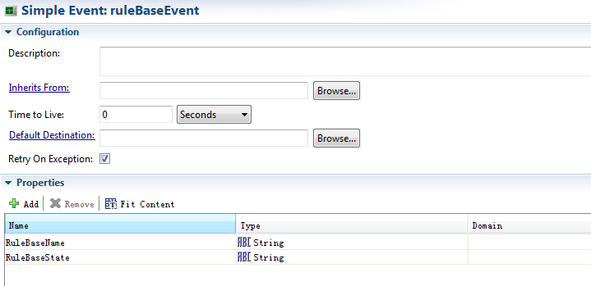
      - Define a Destination
And then, we need to define a Destination of Hawk Channel and specify Default Event with the name as above. Please see the figure:
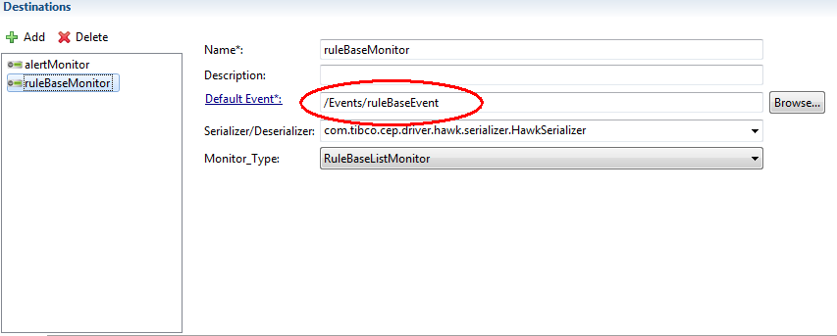
      - Configure CDD (Cluster Deployment Descriptor)
Finally, users must specify the URI of Input Destination. Please see the following figure:
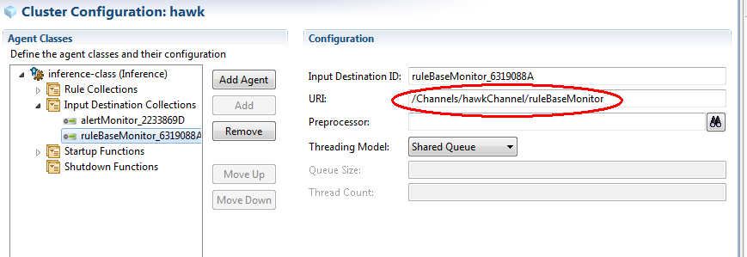

    - Use BE Event to carry parameters
When we use catalog function to invoke Microagent methods, we may need to input parameters dynamiclly. We can define a simpleEvent to carry multiply parameters.
      - Create a simpleEvent

For example we create a simpleEvent which name is “getComponentInfo_params”. It contains one property “Component”. 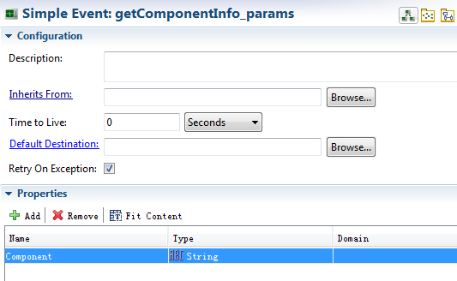

      - Use event in the rule

We can use this event to set the property and pass to the invoke method:

String[] result = Hawk.GenericMethodInvocation.invokeHawkMethod("wangneng-lt","Self","getComponentInfo",Parameters.getComponentInfo_params.getComponentInfo_params(null,null,"Agent"));

The above code set the “Component” to “Agent”.
- Interfaces
  - Hawk Channel
    - Hawk-RV
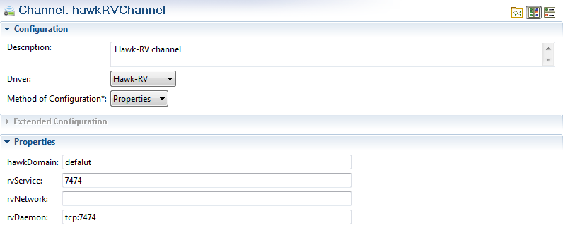
    - Hawk-EMS
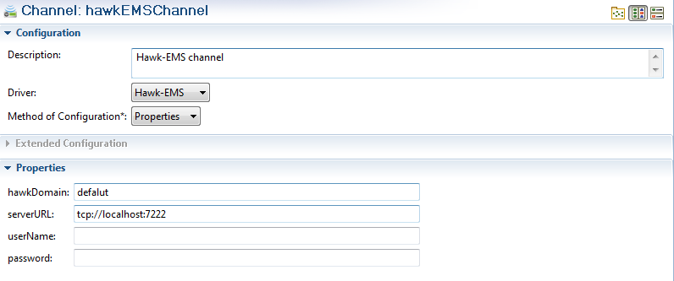
  - Destination
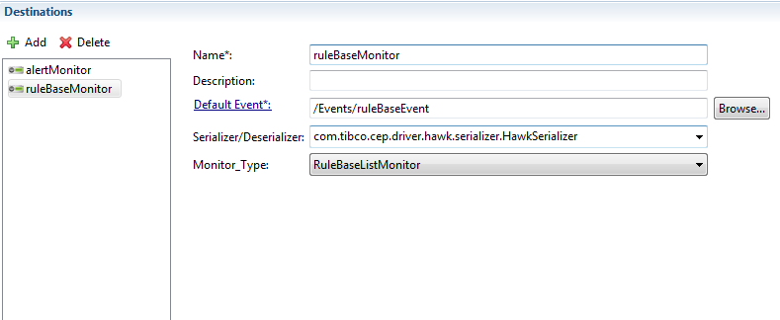
Need to choose “MonitorType”.
  - Catalog Functions
To use catalog functions, we need to open the “Catalog Functions” view in the BE studio. The step is “Window”->”Show View”->”Other”->”TIBCO BusinessEvent”->”Catalog Functions”. Then we can see the function bar on the right side of the studio as following:
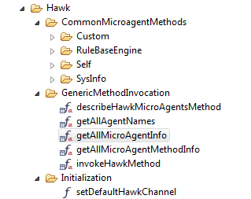

Sample1
If the alertMonitor detected any hawk alert message, print out the alert text and the corresponding rule base. At the same time, using common microagent method to get the agent’s opreation system infomation, using generic method to invoke microagent method to get agent uptime.
rule Rules.alertRule {
attribute {
priority = 5;
forwardChain = true;
}
declare {

Events.alertEvent alertevent;
}
when {

}
then {
System.debugOut("Alert text: " + alertevent.AlertString);
System.debugOut("Rule Base: " + alertevent.RuleBase);

String[] result1 = Hawk.CommonMicroagentMethods.SysInfo.getOperatingSystem("wangneng-lt");
System.debugOut("getOperatingSystem:"+result1[0]);

String[] result2 = Hawk.GenericMethodInvocation.invokeHawkMethod("wangneng-lt","Self","getUpTime",null);
System.debugOut("getUptime:"+result2[0]);

}
}

Sample2
If the ruleBaseMonitor dectect any rulebase changed event, print out rulebase name and rulebase status. At the same time use generic method to invoke microagent method with event parameters
rule Rules.ruleBaseRule {
attribute {
priority = 5;
forwardChain = true;
}
declare {

Events.ruleBaseEvent rulebaseevent;
}
when {

}
then {
System.debugOut("RuleBase Name is: " + rulebaseevent.RuleBaseName);
System.debugOut("Rule Base State: " + rulebaseevent.RuleBaseState);

String[] result = Hawk.GenericMethodInvocation.invokeHawkMethod("wangneng-lt",
"Self","getMicroAgentInfo",Parameters.getMicroAgentInfo_params.getMicroAgentInfo_params(null,null,"COM.TIBCO.hawk.microagent.HawkEventService"));
System.debugOut(result[0]);
}
}
The definition of event “getMicroAgentInfo_params” is as below:
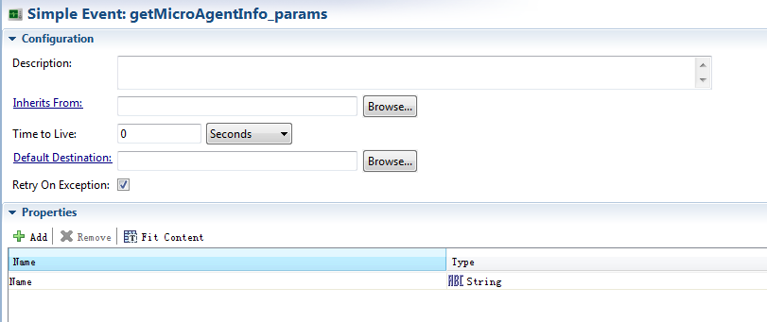

- Impact Analysis
  - Changes to Internal Interfaces
…
  - Migration and Backward Compatibility Issues and Solutions
…
  - Impact on Other TIBCO Products
…
  - Dependencies on Other Components or Products
…
  - Impact on Documentation
…
- Resolved Issues
This section describes the issues that will be resolved with the feature implementations covered in this document. …
Identifier | Description | Resolution

Note: project and technical issues should be covered in the project plan and other project activity deliverables (e.g. status reports, etc.).
- QA Guidelines
This section provides guidelines on the level of test coverage (e.g. integration, performance, etc.), any specific test scenarios that needs to be covered. …

  - Related Documents
The sources used when creating this document and other related documents, such as the PRD, that might be prerequisites or contain useful information regarding this design are listed in the table:
Document Title | Author | Link or Description
  - Functional Design Spec Distribution and Approval
The functional design specification review and approval should normally include the following groups/people.
Organization | Name of Representative | Sign-Off Signature | Sign-Off Date
Product Manager
Development Manager
QA Manager
Program Management
Integration QA
Globalization / Localization
Technical Publications
Support
Educational Services
Legal
Author

