Event Stream Processing – Design Notes

Version | Date | Author(s) | Comments
0.1 | Sep 10, 2007 | Ashwin Jayaprakash
Table of Contents
Event Stream Processing – Design Notes 1
Intent 3
State of the Machine (BE 2.1.1) 3
Salient Features of ESP on BE 2.1.1 3
Diagrams 3
Figure – 1 4
Figure – 2 5

Intent

- Enumerate the characteristics of an Event Stream Processor
- Address the features missing in the existing System that are required to perform Event Stream Processing (ESP)
- Describe the Design and Working of the ESP features that will be implemented

Characteristics of an Event Stream Processor
- Processes large volumes of Raw Events/Data Streams, continuously
- Performs simple operations on fast moving Data
- Functional
- Filtering
- Windowing (Buffering)
- Aggregation
- Lookup and/or Comparison against other Streams
- Multi-Stream Correlation (Pattern Matching and/or Detection)
- Technical
- Low Latency
- High Throughput
- Handle large numbers of simple, related Queries on Streams (High degree of Parallelism)
- Domain Specific Language (DSL) to specify Queries (Ref: Language Spec)

State of the Machine (BE 2.1.1)
- No explicit Windowing facilities
- Simple Queries that involve Windows, Aggregates, Correlations have to be written as a combination of multiple Rules
  - No DSL to specify simple Query behavior
- When required, parallel processing of Streams has to be done explicitly
- Queries that do not require Inference cycles are still forced to go through the Working Memory

Salient Features of ESP on BE 2.1.1
- Provide a Language to specify Queries
- Allow a single Stream to be consumed by multiple Queries
- Allow the results of one Query to be pipelined to another Query
  - Do not distinguish between External Input Stream and Query Output Stream
  - Allow complex Query to be split into several re-usable, smaller Queries
- Implement Windowing, Aggregation, Pre and Post Filtering on Streams
- Leverage the existing Pre-Processors, Channels and Rete N/w
  - Rete – where incremental Joins are required across multiple Streams
  - Channels and Pre-processors
    - Threading and Scheduling
    - Event Source and Sink infrastructure
    - Result pipelining

Diagrams

Figure – 1
The Diagram below shows how multiple Queries can be created on a set of Streams. The results of Queries can also be pipelined into other Queries.

<Enlarge page for better view>

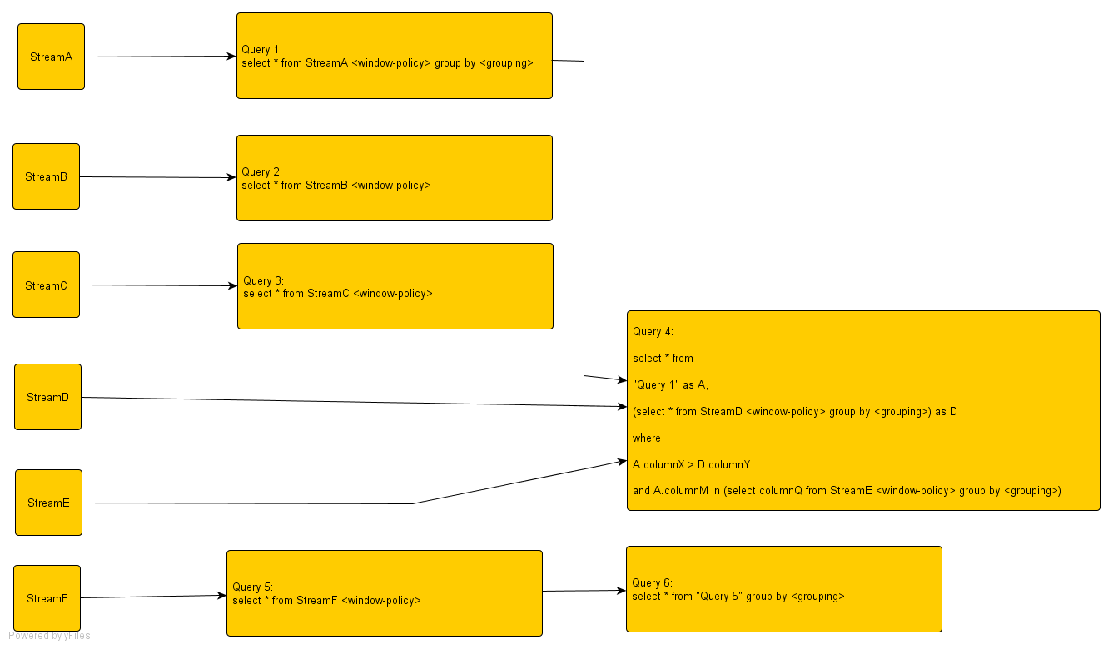

Figure – 2
The Diagram below shows how ESP Queries will be deployed on an BE Engine instance.
<Enlarge page for better view>




