Query Agent Overview

Queries can only be executed by specialized agents called query agents. One engine (node) can have multiple query agents or a mixture of inference agents and query agents. Query agents have channels and destinations. They can execute rule functions, but not rules. Query agents have no Rete network for inferencing.

When a query agent is deployed as part of a TIBCO BusinessEvents application that uses cache object management, data in the cache can be queried.
Query features provide view-only access into the cache. Query language cannot be used to do any updates to data in the cache.

Queries are executed in query agents on cache content (requires Cache OM)

Block Diagram

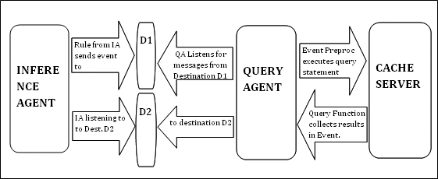

*Hardware Configuration: Linux 64bit RHEL 5.6, 12 Core CPU, 32GB RAM.

Index Configuration

Configuring Index in Coherence

- Write Startup.rulefunction to mention property field to be indexed.

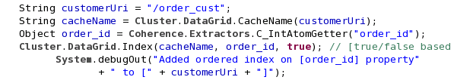

- Add this Startup.rulefunction to inference Agent Startup Functions.
- Set below property to true in Query Agent properties in cdd.
“be.agent.query.enable.filter.optimizer=true”

Configuring Index in ActiveSpaces

- Enable index check box in Cluster property in cdd to apply indexing on individual properties.

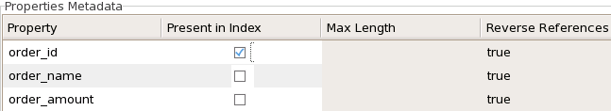

- Set below property to true in all Agents in cdd.
“be.engine.cluster.as.tuple.explicit=true”

How to confirm Index is applied?

Coherence

- Properties holding index appears in Engine console log when set to info level.

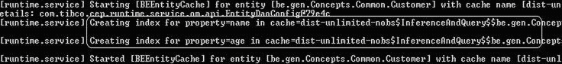

- MBean displays index applied on supposed properties.

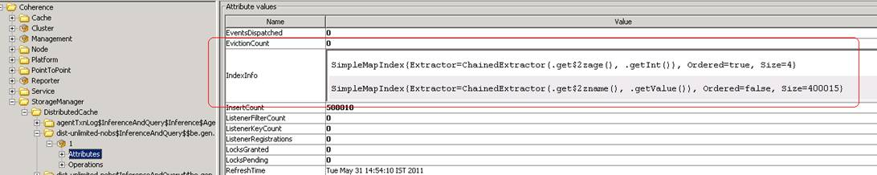

- Query fired on index enabled data, fills entries in optimized Query parameters.
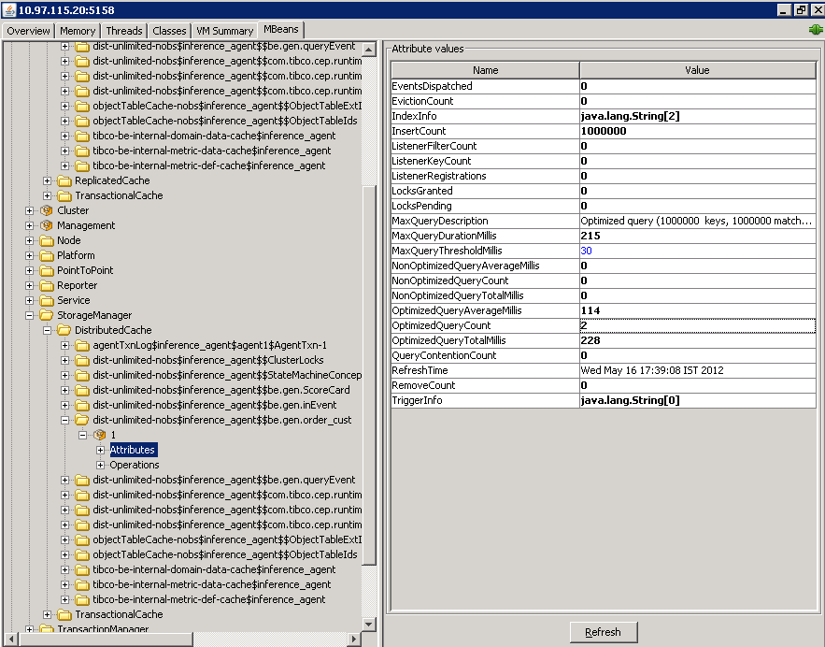

- Whereas Query fired on non-indexed data, fills entries in Non-optimized Query parameters.
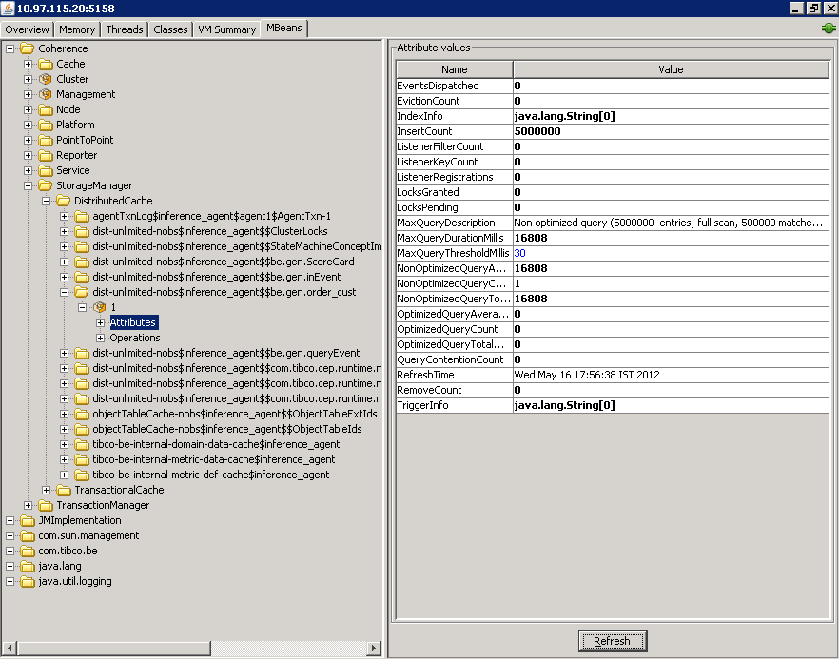
ActiveSpaces

- Properties holding index appears in Inference Engine console log when set to debug level.

2012 Jun 08 12:19:38:314 GMT +5 linbms664-1 Debug [$default.be.mt$.Thread.1] - [com.tibco.cep.query.as.filter] [query1] Using filter string [order_id < 1000] on [be.gen.order_cust]

- Second way is to browse the appropriate space for IndexDef used.

Index: {IndexDef name=dist-unlimited-nobs-inference_agent_AS--be_gen_order_cust_idx_0, index_type=TREE, fields=[order_id]}

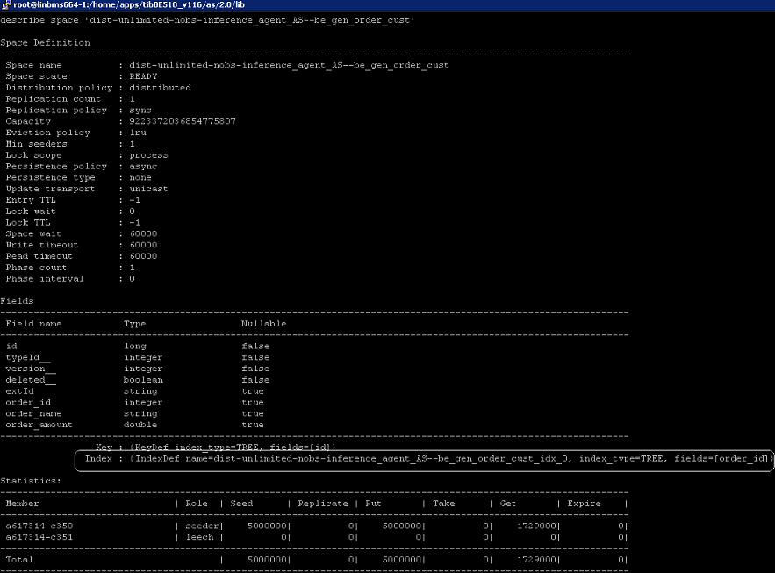

Performance Test Case 1

The impact of increasing the number of concepts created is verified by understanding the impact on the time required to query selected objects (Selectivity %)*. Object Management is Cache Only without Backing Store.

Selectivity %:
Index S (I) = d/n * 100%

Where d is cardinality or the number or distinct elements in the cache for that specific indexed property
n is total number of elements in the cache for that property.

This can be controlled by varying the number of distinct elements in the cache for an indexed property.

Workload Description & Query Executed

Single cache server is used to store large number of concepts. E.g.,1 million and 5 million.
Query: select * from /order_cust cust where cust.order_id < 1000;
Fields: (3)- order_id(int), order_name(string), order_amount(double)
Index applied on: (1) order_id(int)
Performance Comparison

- Coherence Numbers
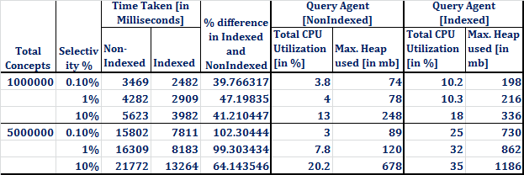

- Comparison of Coherence Indexed numbers with Non-Indexed for 1 million and 5 million data points with CPU Usage.

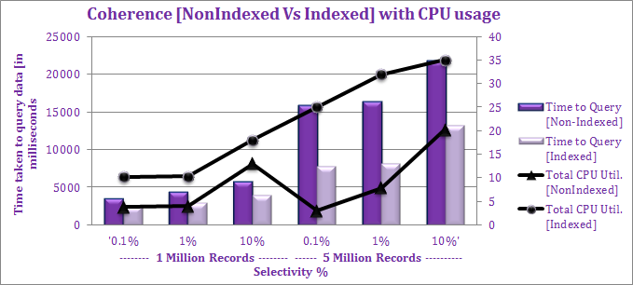

- Comparison of Coherence Indexed numbers with Non-Indexed for 1 million and 5 million data points with Heap Usage.

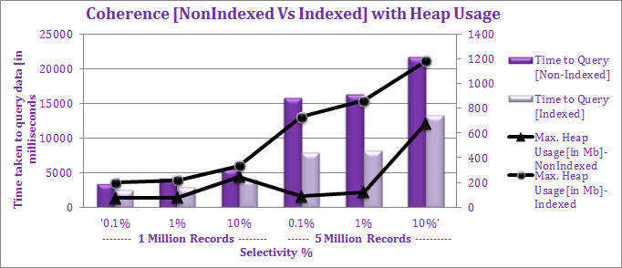

- ActiveSpaces Numbers
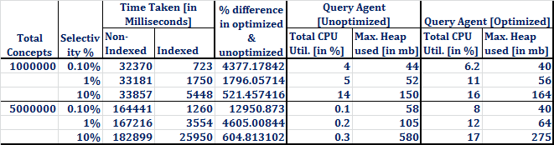

- Comparison of AS Indexed numbers with Non-Indexed with 1 million and 5
Million data points with CPU usage.

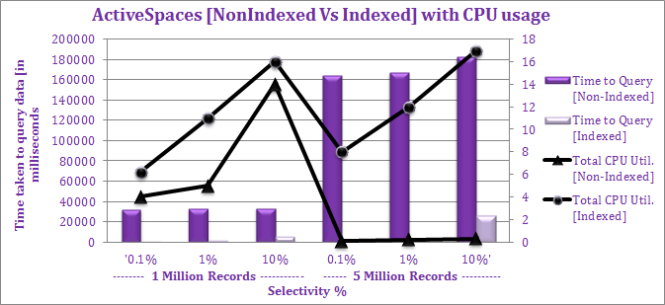

- Comparison of AS Indexed numbers with Non-Indexed with 1 million and 5
Million data points with Heap usage.

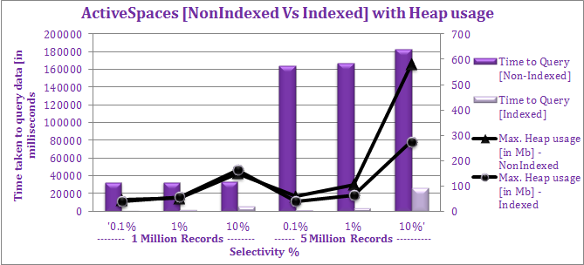

Performance Test Case 2

The impact of increasing number of Cache server instances is observed with different Replication Count by understanding the impact on the time required to query selected objects (Selectivity %)*. Test conducted on ActiveSpaces cache.

Workload Description & Query Executed

Cache servers together loaded with large number of concepts. E.g.,1 million

Query: select * from /order_cust cust where cust.order_id < 1000;
Fields: (3)- order_id(int), order_name(string), order_amount(double)
Index applied on: (1) order_id(int)

Performance Comparison

- Increasing Cache Servers with Replication count=0

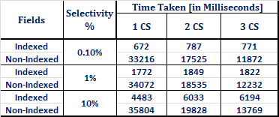

- Increasing Cache Servers with Replication count=1

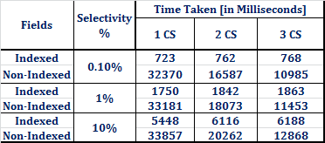

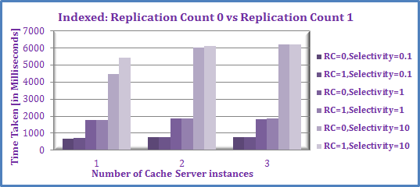

Performance Test Case 3

The impact on Throughput is observed for querying single record by increasing number of Query Agent instances on varying load keeping few parameters constant. Test conducted on ActiveSpaces cache.

Threading Model used: Workers Threads
Selectivity: Single Record
Concurrent Users = 20

Workload Description & Query Executed

Cache servers together loaded with large number of concepts. E.g.,1 million

Query: select * from /order_cust cust where cust.order_id = 88;
Fields: (3)- order_id(int), order_name(string), order_amount(double)
Index applied on: (1) order_id(int)

Performance Comparison

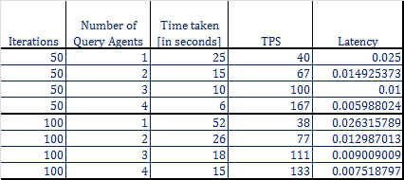

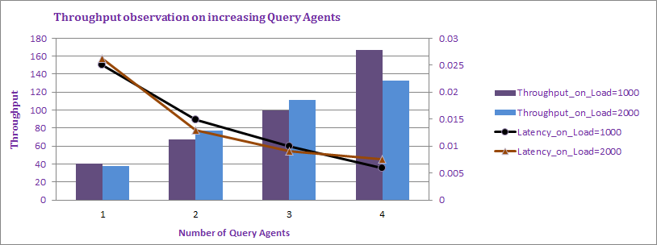
Note: Average CPU utilization is around 2% and Heap usage is around 100mb per Query Agent

