T

TIBCO BusinessEvents: BPMN Process Codegen Mappings

Product Suite | TIBCO BusinessEvents
Product | BPMN Processes Codegen Mappings
Product Version | 1.0
Initial Author | Pranab Dhar

Copyright Notice
COPYRIGHT© 2011 TIBCO Software Inc. This document is unpublished and the foregoing notice is affixed to protect TIBCO Software Inc. in the event of inadvertent publication. All rights reserved. No part of this document may be reproduced in any form, including photocopying or transmission electronically to any computer, without prior written consent of TIBCO Software Inc. The information contained in this document is confidential and proprietary to TIBCO Software Inc. and may not be used or disclosed except as expressly authorized in writing by TIBCO Software Inc. Copyright protection includes material generated from our software programs displayed on the screen, such as icons, screen displays, and the like.
Trademarks
Technologies described herein are either covered by existing patents or patent applications are in progress. All brand and product names are trademarks or registered trademarks of their respective holders and are hereby acknowledged.
Confidentiality
The information in this document is subject to change without notice. This document contains information that is confidential and proprietary to TIBCO Software Inc. and may not be copied, published, or disclosed to others, or used for any purposes other than review, without written authorization of an officer of TIBCO Software Inc. Submission of this document does not represent a commitment to implement any portion of this specification in the products of the submitters.
Content Warranty
The information in this document is subject to change without notice. THIS DOCUMENT IS PROVIDED "AS IS" AND TIBCO MAKES NO WARRANTY, EXPRESS, IMPLIED, OR STATUTORY, INCLUDING BUT NOT LIMITED TO ALL WARRANTIES OF MERCHANTABILITY OR FITNESS FOR A PARTICULAR PURPOSE. TIBCO Software Inc. shall not be liable for errors contained herein or for incidental or consequential damages in connection with the furnishing, performance or use of this material.
For more information, please contact:
TIBCO Software Inc.
3307 Hillview Avenue
Palo Alto, CA 94304
USA
Table of Contents
- Table of Contents
TIBCO BusinessEvents: BPMN Process Codegen Mappings 1
1 Table of Contents 3
2 Change Log 7
2.1 Related Documents 7
3 Introduction 8
3.1 Main Objective 8
3.2 Intended Usage 8
3.3 Scope 8
3.4 Naming 8
3.5 Audience 8
4 Acronyms and Vocabulary 9
5 Service Architecture 10
10
5.1 Naming 11
5.1.1 Message Id 11
5.1.2 Flow element 11
5.1.3 Job 11
5.2 ScoreCard constants 11
5.3 Bpmn Message 12
5.4 BpmnJobContext 13
5.5 BpmnJobConcept 13
5.6 Process MessageProc RuleFunction 13
5.7 HandlerFunctions 14
5.8 SequenceFlow eval function 15
6 Activity/Tasks 15
6.1 LoopActivity 16
6.2 MultiInstanceActivity 17
6.3 RuleFunction Task 20
6.4 Web Service Task 20
6.4.1 BusinessEvents WS server 20
6.4.2 BusinessEvents WS Client 21
6.4.3 BusinessWorks 22
6.5 BusinessRule Task 23
6.6 Decision Table 24
6.7 Sub-Process 25
6.7.1 Standard 26
6.7.2 Event Sub-Process 26
6.7.3 Call Activity 26
7 Events 26
7.1 Start Event (Throw) 28
7.1.1 Triggers 29
7.1.1.1 None 29
7.1.1.2 Message 29
7.1.1.3 Timer 30
7.1.1.4 Signal 30
7.2 End Event (Catch) 30
7.2.1 Triggers 32
7.2.1.1 None 32
7.2.1.2 Message 32
7.2.1.3 Error 33
7.2.1.4 Signal 33
7.2.1.5 Terminate 33
7.3 Intermediate Event 33
7.3.1 Triggers 34
7.3.1.1 Message 34
7.3.1.2 Timer 34
7.3.1.3 Error 34
7.3.1.4 Signal 34
8 Gateways 34
8.1 Parallel Gateway 34
8.1.1 Merging 34
8.1.2 Branching 35
8.2 Exclusive Gateway 35
8.2.1 Merging 35
8.2.2 Branching 36
8.3 Inclusive Gateway 37
8.3.1 Merging 37
8.3.2 Branching 38
8.4 Event Based Gateway 39
8.4.1 Merging 39
8.4.2 Branching 39
8.5 Complex Gateway 39
8.5.1 Merging 39
8.5.2 Branching 39
9 Dynamic BPMN 39
9.1 Itinerary 39
9.2 Global Definitions 39
9.3 Versioning 40
9.4 Business Rule Tasks 40

Change Log
.
Date | Version | Name | Description
12/28/2010 | 1.0 | Pranab Dhar | Initial doc
12/29/2010 | 1.1 | Gabe Grigorescu | Incorporated into TIBCO template, reorganized, and made other changes/fixes.

Related Documents
Document Title | Revision Number | Author
BPMN 2.0 Specification
BE 4.1 BPMN Project Plan
BE BPMN Requirements document |  | Gabe Grigorescu

Introduction

Main Objective
The objective of this document is to outline the code generation mappings implementation details of the BE BPMN Process Add-on functionality.

Intended Usage
BE BPMN Decision Graphs will be used by different types of users. These users include: Business Owners, Business Analysts, Developers, IT Engineers.

Scope
The scope of this document is to provide most of the execution documentation needed to describe how the codegen is created and how processes are executed.

Naming
We have not decided yet how to refer to this new type of a process. Candidates include:
Decision Graph
(BPMN) Decision Process
BE (BPMN) Process

Audience
The document is intended for Developers, Architects, QA, Product Marketing, and Managers.

Acronyms and Vocabulary

The table below describes some of the Acronyms used in this documentation
- BE – TIBCO BusinessEvents.
- Studio Project – A TIBCO Project build using TIBCO BusinessEvents Studio.
- BPM – Business Process Model
- BPMN – Business Process Model Notation

Service Architecture
Dispatcher
MsgProc
Queue
Msg
sg
Msg
sg
Msg
sg
MsgProc
Process Instance(Job)
ReteWM
Process Instance(Job)
Process Instance(Job)
Process Instance(Job)
External Event

Naming

Message Id
Every FlowNode(graph node) and SequenceFlow(graph edge) is identified based on the following rule.
Message Id := { Flow element id , Job id }

Flow element
Flow node id := <flow container id>.<type prefix>.<number>
Flow container id = <parent flow container name>.<child flow container name>

Job
Job id := <parent job id>.<child job id>

ScoreCard constants
Every FlowNode(node) is given a constant name generated from the node identifier which represents a field in the scorecard. A corresponding init function is also generated to initialize the scorecard with the fields.
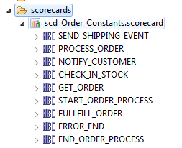
/**
* @description
*/
void rulefunction codegen.ruleFunctions.initrul_Order {
attribute {
validity = ACTION;
}
scope {

}
body {
codegen.scorecards.scd_Order_Constants.SEND_SHIPPING_EVENT = "Order.SEND_SHIPPING_EVENT";
codegen.scorecards.scd_Order_Constants.PROCESS_ORDER = "Order.PROCESS_ORDER";
codegen.scorecards.scd_Order_Constants.NOTIFY_CUSTOMER = "Order.NOTIFY_CUSTOMER";
codegen.scorecards.scd_Order_Constants.CHECK_IN_STOCK = "Order.CHECK_IN_STOCK";
codegen.scorecards.scd_Order_Constants.GET_ORDER = "Order.GET_ORDER";
codegen.scorecards.scd_Order_Constants.START_ORDER_PROCESS = "Order.START_ORDER_PROCESS";
codegen.scorecards.scd_Order_Constants.FULLFILL_ORDER = "Order.FULLFILL_ORDER";
codegen.scorecards.scd_Order_Constants.ERROR_END = "Order.ERROR_END";
codegen.scorecards.scd_Order_Constants.END_ORDER_PROCESS = "Order.END_ORDER_PROCESS";
}
}

Bpmn Message
This is notification object which encapsulates the context information and the message id corresponding to a FlowNode.

public class BpmnMessage {
/*
* This is a regular execution flow token type
*/
public static final int BPMN_MESSAGE_TYPE_TOKEN = 1;
/*
* This is a external/internal point-to-point event notification token type
*/
public static final int BPMN_MESSAGE_TYPE_EVENT = 2;
/*
* This is a external/interal broadcast event notification token type
*/
public static final int BPMN_MESSAGE_TYPE_SIGNAL = 3;
/*
* This is a exception notification token type
*/
public static final int BPMN_MESSAGE_TYPE_EXCEPTION = 2;

String msgId;
int msgType;
BpmnJobContext context;

public BpmnMessage(String msgId, BpmnJobContext context) {
super();
this.msgId = msgId;
this.context = context;
}

public String getProcessId() {
return msgId.substring(0,msgId.indexOf("."));
}

public String getMsgId() {
return msgId;
}

public Object getContext() {
return context;
}

}

BpmnJobContext
This is a opaque container to hold context data i.e JobConcept to be used during Message procedure handling. The Job concept holds the stateful information of a process instance.

public class BpmnJobContext {

Concept job;

public BpmnJobContext(Concept job) {
this.job = job;
}

public Concept getJob() {
return job;
}

public void setJob(Concept job) {
this.job = job;
}

}

BpmnJobConcept
This is Job information repository where it can hold the current state, previous states, user data and it is available for the user to get the stored information. The job data concept holds the users data in a Data concept. The job id identifies the process/sub-process this job is associated to. Each Job can have a hierarchy of children Jobs which are spawned during concurrent execution flows. Each child Job inherits structure and data from the Parent Job. The job Id naming will follow a <parent Job Id>.<child job id>. The last Flow node Id and the last sequence Flow Id keeps a configurable history of the steps followed by the executing job as it moves from one state to another.
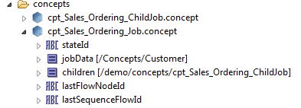

Process MessageProc RuleFunction
This is the bpmn message handling procedure(callback) for the given process and it needs to be registered before use. By matching the message Id with a particular scorecard constant the code flow is directed to a specific handler function for the particular node
/**
* @description
*/
void rulefunction codegen.ruleFunctions.msgProcrul_Order {
attribute {
validity = ACTION;
}
scope {
String msgId;
Object context;
}
body {
if(msgId == codegen.scorecards.scd_Order_Constants.SEND_SHIPPING_EVENT) {
codegen.ruleFunctions.handlerul_Order_Send_Shipping_Event(/*context Object */context);
System.debugOut("Order.SEND_SHIPPING_EVENT");
}
else if(
……
……
}
}

HandlerFunctions
Due to the limit of a rulefunction to hold more than 64k of String data. Therefore the MsgProc control flow is distributed to individual handler function to which the Message context is passed as a parameter. Each Flow node is assigned a handler function. Further generated code is inserted in the body of the handler function to execute the flow node task and then propagate execution flow.
/**
* @description
*/
void rulefunction OrderDemo.ruleFunctions.handlerfn_Proc_Notify_Customer {
attribute {
validity = ACTION;
}
scope {
Object context;
}
body {
/**
** @START - Do not edit between START and END comment blocks.
*/
try {
/**
** @END - Do not edit between START and END comment blocks.
*/

Demo.Customer customer = BPMN.context.getBpmnJobData(context);

System.debugOut("Notifying Customer:"+customer.name);
rulefunctions.NotifyCustomer();

/**
** @START - Do not edit between START and END comment blocks.
*/
if(OrderDemo.ruleFunctions.evalrfn_Proc_Call_Shipping(context)) {
BPMN.service.postMessage(OrderDemo.scorecards.scd_Proc_Constants.END_ORDER_PROCESS,context);
}
/**
** @END - Do not edit between START and END comment blocks.
*/

/**
** @START - Do not edit between START and END comment blocks.
*/

} catch( Exception e) {
BPMN.service.postMessage(OrderDemo.scorecards.scd_Proc_Constants.ERROR_END,context);
}

/**
**@END - Do not edit between START and END comment blocks.
*/

}
}

SequenceFlow eval function
The sequence flow indicates the direction of the processing state movement and it can also have an optional Boolean condition. To handle this during execution a sequence flow handler is represented as a eval rule function with a Boolean return value. The message context is passed as a parameter to the function from which the execution context information can be retrieved using catalog helper functions
/**
* @description
*/
boolean rulefunction codegen.ruleFunctions.evalrfn_Order_Call_Fullfill_Order {
attribute {
validity = ACTION;
}
scope {
Object context;
}
body {
return true;
}
}

Activity/Tasks
Acitvities are usually handled by their respective handler functions. However each activity has some execution attributes which determine how the activity is executed. Activities are of two types in terms of their execution semantics :-
- Atomic – Usually involves executing a single Task and its life cycle.
- Decomposable – This involves executing a set of atomic task where each task has its own life cycle.
Each atomic activity has a life cycle where it transitions from one state to another and allows both internal and external events to alter the execution outcome. The activity life-cycle states are as follows
public static final int ACTIVITY_STATE_INACTIVE = -1;
public static final int ACTIVITY_STATE_READY = 0;
public static final int ACTIVITY_STATE_ACTIVE = 1;
public static final int ACTIVITY_STATE_COMPLETING = 2;
public static final int ACTIVITY_STATE_COMPLETED = 3;
public static final int ACTIVITY_STATE_WITHDRAWN = 4;
public static final int ACTIVITY_STATE_FAILED = 5;
public static final int ACTIVITY_STATE_COMPENSATING = 6;
public static final int ACTIVITY_STATE_COMPENSATED = 7;
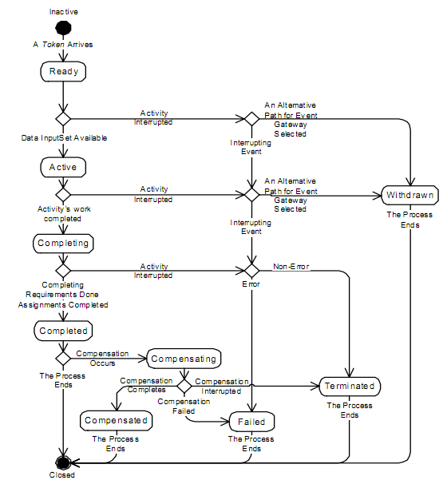
xx

LoopActivity
To execute a loop activity a catalog function by the name LoopActivity will be available which will be used by the code generation to use inside the main activity handler code, while hiding the execution semantics from the user. The execution attributes for a loop activity are
- loopMaximum - int count representing the number of times the inner activity is executed.
- testCondition – Boolean expression is exposes as a generated callback rulefunction enclosure to which the BpmnJobContext is passed to break the loop executing the inner activity.
boolean rulefunction codegen.ruleFunctions.evalrfn_XXX_LoopCondition {
attribute {
validity = ACTION;
}
scope {
Object context;
}
body {
return true;
}
}

- testBefore – Determines whether the test is done at the beginning of the loop or at the end.
The loop Activity interface runtime semantics are as follows :-

public interface LoopActivity extends OuterActivity {

int getLoopCount();

boolean testBefore();

public Condition getLoopCondition();

public interface LoopCondition extends Condition {

}

}

MultiInstanceActivity
To execute a multi-instance activity a catalog function by the name MultiInstanceActity will be available which be used by the code generation to use inside the main activity handler code, while hiding the intricate execution semantics from the user. The execution attributes for a multi instance activity are
- isSequential – Boolean flag to determine if each instance of the inner activity is executed in sequence or in parallel. Parallel execution is not supported in the initial release.
- loopCardinality - The number of instances to be generated is either specified by the integer-valued expression loopCardinality or as the cardinality of a specific collection-valued data item of the data input of the MI Activity. The latter is described in detail below. The number of instances to be generated is evaluated once. Subsequently the number of instances are generated. If the instances are generated sequentially, a new instance is generated only after the previous has been completed. Otherwise, multiple instances to be executed in parallel are generated. Currently the cardinality will be exposed as a generated callback rulefunction returning an integer value with the expression code embedded during code generation.
Collection<Object> rulefunction codegen.ruleFunctions.evalrfn_XXX_Cardinality {
attribute {
validity = ACTION;
}
scope {
Object context;
}
body {
return true;
}
}
completionCondition - The completionCondition Expression is a Boolean predicate that is evaluated every time an instance completes. When evaluated to true, the remaining instances are cancelled, a token is produced for the outgoing Sequence Flow, and the MI Activity completes. The completionCondition will be exposed as a generated callback rulefunction returning a Boolean value with the condition expression embedded during code generation.
boolean rulefunction codegen.ruleFunctions.evalrfn_XXX_CompletionCondition {
attribute {
validity = ACTION;
}
scope {
Object context;
}
body {
return true;
}
}

- behavior - The attribute behavior defines if and when an Event is thrown from an Activity instance that is about to complete. It has values of none, one, all, and complex, assuming the following behavior:
  - none: an EventDefinition is thrown for all instances completing.
  - one: an EventDefinition is thrown upon the first instance completing.
  - all: no Event is ever thrown.
  - complex: the complexBehaviorDefinitions are consulted to determine if and which Events to throw.
For the behaviors of none and one, an EventDefinition (which is referenced from MultipleInstanceLoopCharacteristics through the noneEvent and oneEvent associations, respectively) is thrown which automatically carries the current runtime attributes of the MI Activity. That is, the ItemDefinition of these SignalEventDefinitions is implicitly given by the specific runtime attributes of the MI Activity.

The complexBehaviorDefinition association references multiple ComplexBehaviorDefinition entities which each point to a Boolean condition being a FormalExpression and an Event which is an ImplicitThrowEvent. Whenever an Activity instance completes, the conditions of all ComplexBehaviorDefinitions are evaluated. For each ComplexBehaviorDefinition whose condition is evaluated to true, the associated Event is automatically thrown. That is, a single Activity completion may lead to multiple different Events that are thrown. The Events may then be caught on the boundary of the MI Activity. Multiple ComplexBehaviorDefinitions offer an easy way of implicitly spawning different flow at the MI Activity boundary for different situations indicating different states of progress in the course of executing the MI Activity.
The completionCondition, the condition in the ComplexBehaviorDefinition, and the DataInputAssociation of the Event in the ComplexBehaviorDefinition can refer to the MI Activity instance attributes and the loopDataInput, loopDataOutput, inputDataItem, and outputDataItem that are referenced from the MultiInstanceLoopCharacteristics.

In practice, an MI Activity is executed over a data collection, processing as input the data values in the collection and producing as output data values in a collection. The input data collection is passed to the MI outer Activity’s loopDataInput from a Data Object in the Process scope of the MI Activity. Under BPMN data flow constraints, the Data Object is linked to MI activity’s loopDataInput through a DataInputAssociation. To indicate that the Data Object is a collection, its respective symbol is marked with the MI indicator (three-bar). The items of the loopDataInput collection are used to determine the number of instances required to be executed (whether sequentially or in parallel). Accordingly, the inner instances are created and data values from the loopDataInput are extracted and assigned to the respective instances. Specifically, the values from the loopDataInput items are passed to an inputDataItem, created in the scope of the outer Activity. The value in the inputDataItem can be passed to the loopDataInput of each inner instance, where a DataInputAssociation links both. The process of extraction is left under-specified. In practice, it would entail a special-purpose mediator which not only provides the extraction and data assignment, but also any required data transformation.
Each instance processes the data value of its DataInput. It produces a value in its DataOutput if it completes successfully. The DataOutPut value of the instance is passed to a corresponding outputDataItem in the outer Activity, where a DataOutputAssociation links both. Each outputDataItem value is updated in the loopDataOutput collection, in the corresponding item. The mechanism of this update is left underspecified, and again would be implemented through a special purpose mediator. The loopDataOutput is passed to the MI Activity’s Process scope through a Data Object that has a DataOutputAssociation linking both. It should be noted that the collection in the Process scope should not be accessible until all its items have been written to. This is because, it could be accessed by an Activity running concurrently, and therefore control flow through token passing cannot guarantee that the collection is fully written before it is accessed.The MI Activity is compensated only if all its instances have completed successfully.
For the current implementation of the Multi-instance activity the functionality of the data input/output associations are left to the user to provide the cardinality collection via a generated callback returning a collection of Objects. The completion condition is also a generated call back for the user. The behavior definitions which essentially captures the type and the corresponding throw event will be used to broadcast(asserted to all process Rete’s) or queued to a single process.

public interface MultiInstanceActivity extends Activity {

boolean isSequential();

Collection<Object> getLoopCardinality(BpmnJobContext context);

Condition getCompletionCondition(BpmnJobContext context);

public interface CompletionCondition extends Condition {

}

int getBehaviorType();

Collection<Behavior> getBehaviors();

public interface Behavior extends Condition {

Event getThrowEvent();
}

public interface NoneEventBehavior extends Behavior {

}

public interface OneEventBehavior extends Behavior {

}

public interface ComplexEventBehavior extends Behavior {

}
}

RuleFunction Task
This is the most commonly used task in a process where the user can link to a predefined rule function and execute it inside the handler function. E.g. see Handler Functions example. The rule function takes arguments and returns results using data types supported by the BE ontology. It is the users responsibility to match the input data coming via the message context and map it to the right argument as required by the rule function and also transfer the result to the message context to be used by the next recipient of the execution control flow.

Web Service Task
The web service task allows the user to execute a remote service and return the results to be used inside BPMN process flow. During design time the user can choose a web service from a UDDI registry from which a WSDL definition is extracted and stored as project resource, or the user can directly add a wsdl resource to the project and store its resource uri in the model. During code generation depending on the WSDL information the proper channel and destinations will be created however the mapping of the input data to the WSDL payload needs to be done .

BusinessEvents WS server
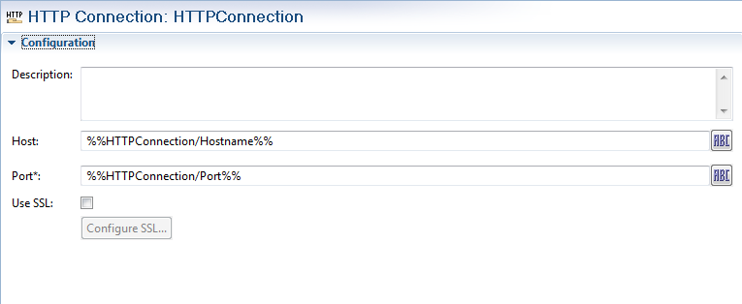
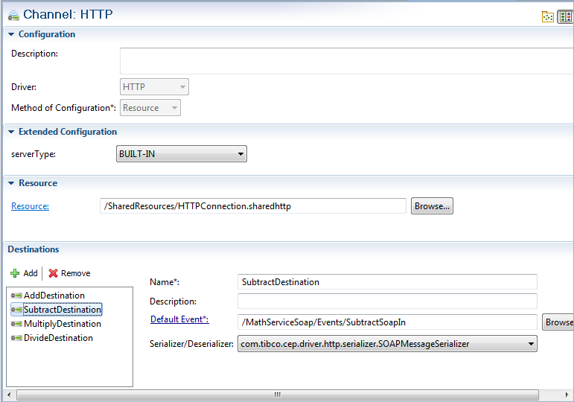

BusinessEvents WS Client
BusinessEvents studio uses the mapper to provide the designtime and the Tibco XML provides the runtime mapping services.

/** @.name sendEvent
* @.synopsis Send a synchronous HTTP request. The requestEvent's default destination URI is appended to the URL. The requestEvent properties and payload are converted to HTTP headers and POST data respectively.
* If event payload is null, HTTP GET will be used, else HTTP POST will be used.
* This will return an event of type responseEventURI as a response encapsulating response headers as properties and post data if any as event payload.
* This function can also be used to send SOAP requests. For SOAP requests, the SOAPAction will be taken from a corresponding event property or if not present,
* the default destination of the request event will be used.
* @.signature Event sendEvent(SimpleEvent requestEvent, String responseEventURI, long timeoutMillis, String url)
* @param requestEvent SimpleEvent The input event to send
* @param responseEventURI String URI of event to be created once response received
* @param timeoutMillis long time out for the operation, -1 signifies wait forever.
* @param url String The endpoint URL to send the request. The default destination of the requestEvent would be appended to the URL to form the final endpoint URL.
* @return Event event The response event
*/

BusinessEvents sends WS request using catalog function ” HTTP.sendRequest(String url,SimpleEvent requestEvent, String responseEventURI, long timeoutMillis)”
e.g., HTTP.sendRequest("https://localhost:9797/QueryBooksByAuthor",soapeventin, "", 1000)
where soapeventin is a soap event having the schema for soap message envelope as payload schema. This data has to be filled before sending WS request as shown below in screen shot.Before sending the SOAP request SoapMessageSerializer serialize the soap event’s payload to soap message.

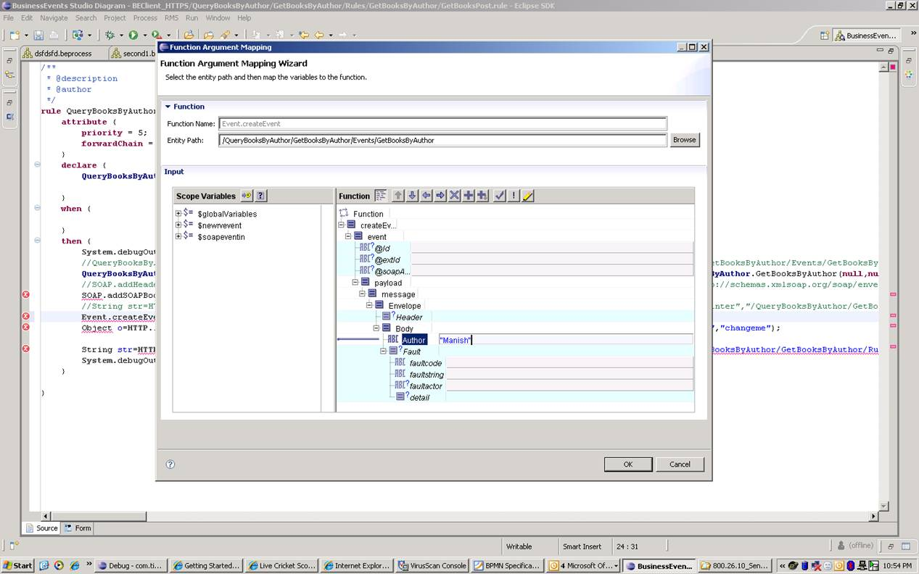

BusinessWorks
To send WS request in BusinessWorks. We need to place wsdl inside project. Then service url, end point details, soap envelope data are specified.

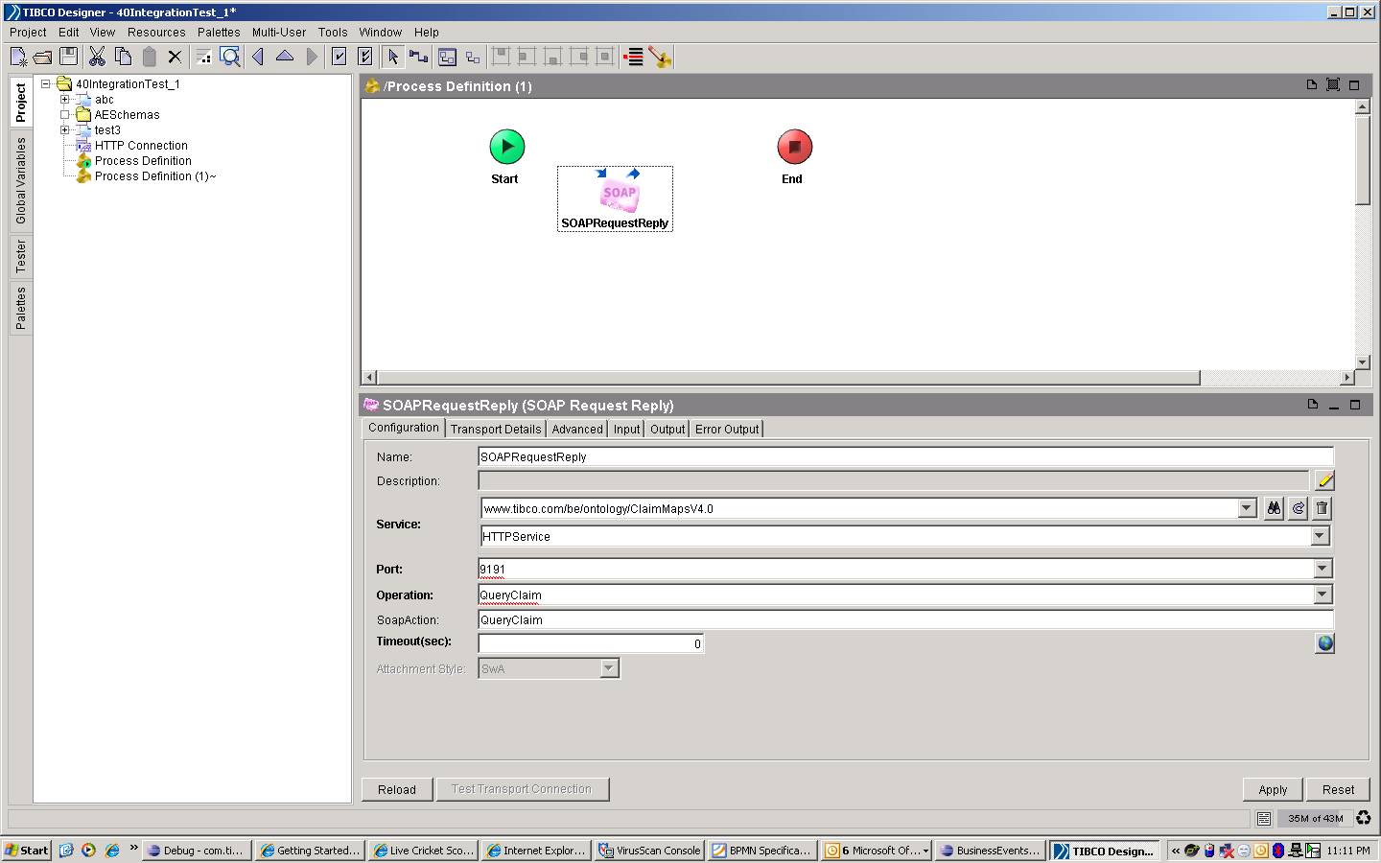

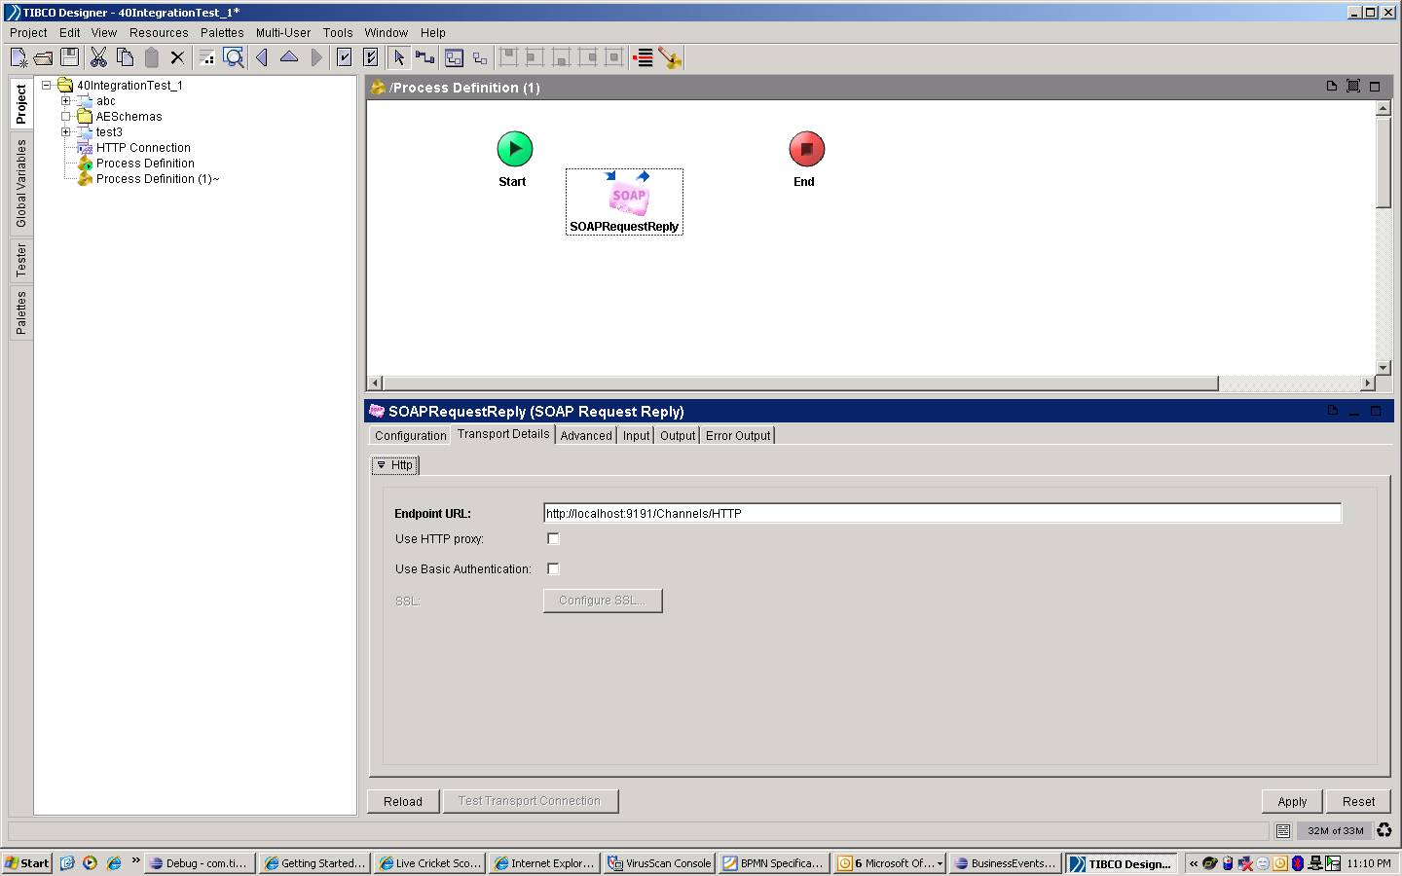

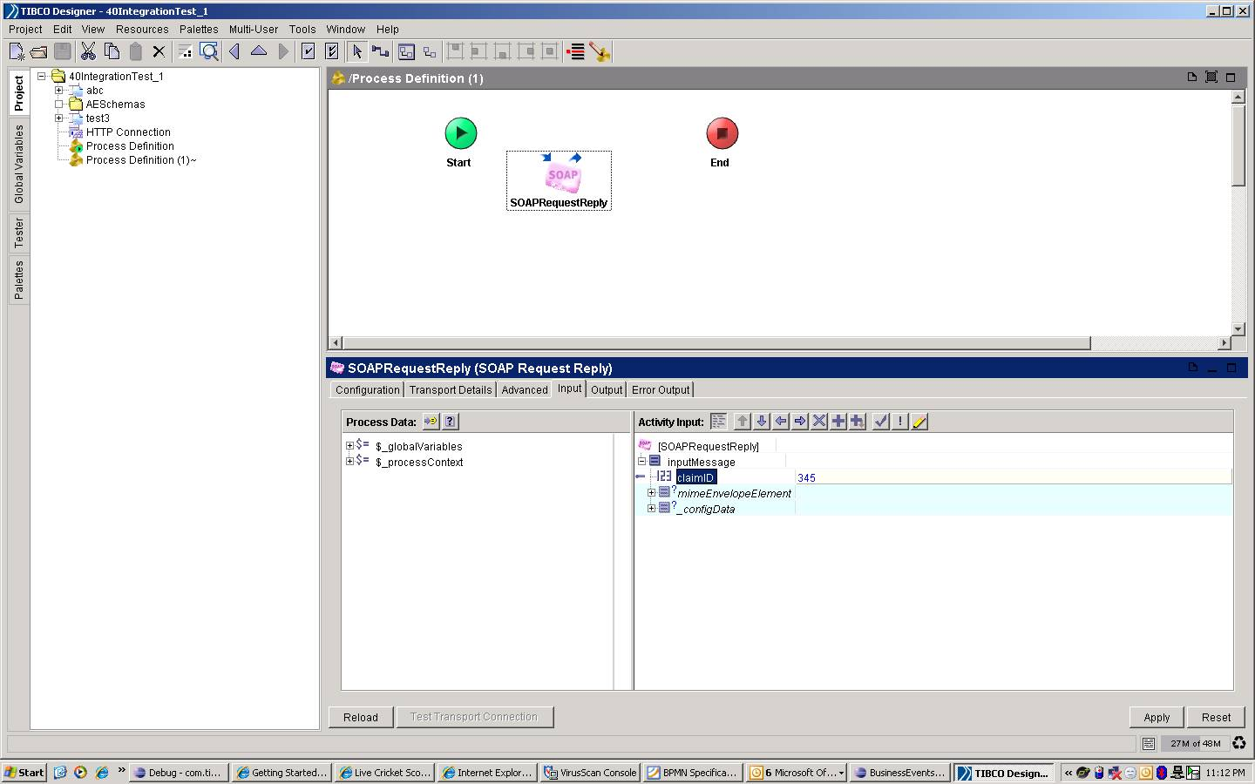

The UDDI registry lookup can be done using UDDI4J API, the other alternative is to use the eclipse WS client infrastructure. The UDDI4J is open-sourced under IBM Public license.

BusinessRule Task
The business rule task involves running a set of rules against a given set of input data. The Input data being extracted from the BpmnContext will be asserted in to the Rete and any deployed rule which matches the scope and condition will get executed. Each individual Rule action can change the data upon execution. The rules will run on a separate Rete for a single RTC cycle. This Rete is separate from the Process Rete which is responsible for handling waits and out of order events. When the task has Loop characteristics and Multi-Instance characteristics the Rete will be executed multiple times with changing input data and actions being fired accordingly. The multi-instance task can have different behaviors in addition to the rule actions themselves. i.e the Business Rule task handler function

/**
* @description
*/
void rulefunction OrderDemo.ruleFunctions.handlerfn_Proc_Notify_Customer {
attribute {
validity = ACTION;
}
scope {
Object context;
}
body {
// codegen generates the ruleset from the task properties in the model
String ruleSet[] = String [] x = {"/x/y/z","/a/b/c"};

/**
** @START - Do not edit between START and END comment blocks.
*/
try {
/**
** @END - Do not edit between START and END comment blocks.
*/

Demo.Customer customer = BPMN.context.getBpmnJobData(context);

// user determines the data set that goes in and is hand coded
Object[] dataset = { customer , customer.order[1] };

Object[] matches = BPMN.tasks.executeRules(ruleSet,dataset)

/**
** @START - Do not edit between START and END comment blocks.
*/
if(OrderDemo.ruleFunctions.evalrfn_Proc_Call_Shipping(context)) {
BPMN.service.postMessage(OrderDemo.scorecards.scd_Proc_Constants.END_ORDER_PROCESS,context);
}
/**
** @END - Do not edit between START and END comment blocks.
*/

/**
** @START - Do not edit between START and END comment blocks.
*/

} catch( Exception e) {
BPMN.service.postMessage(OrderDemo.scorecards.scd_Proc_Constants.ERROR_END,context);
}

/**
**@END - Do not edit between START and END comment blocks.
*/

}
}

The rule themselves can change the course of BPMN execution path by execution a BPMN.service.postMessage() in the rule action however the BPMN execution being a queue based, the new message will get executed after the current business rule task is finished but at the same time the default message routing based on the process model will queue the default post message after the rule action post. This needs to be avoided and it can be done by different methods, get a return status flag from the execute Rule API function where the user returns whether a post is done from a rule action , the other mechanism can be that every post message needs to record the information about the originating task(message id) and there cannot be two consecutive post messages from the same origin, if it happens only the first message is handled and the second one ignored. E.g Msg₁(Task₁),Msg₂(Task₁) => only Msg₁(Task₁) get picked up and the Msg₂(Task₂) get removed from the queue.

Decision Table
The decision table task invocation is similar to the RuleFunction task in which a virtual rulefunction is invoked via catalog function APIs and the scope data extracted from the context and its associations are passed to the invocation as a parameter. For loop and multi-instance invocations are passed different inputs for each iteration.

/**
* @description
*/
void rulefunction OrderDemo.ruleFunctions.handlerfn_Proc_Process_Order {
attribute {
validity = ACTION;
}
scope {
Object context;
}
body {
try {
Demo.Customer customer = BPMN.context.getBpmnJobData(context);
VRF.invokeVRFImplByName("/rulefunctions/ProcessOrder","ProcessOrderDT",Object[] {customer});
if(OrderDemo.ruleFunctions.evalrfn_Proc_Inventory_Check_Exclusive(context)) {
BPMN.service.postMessage(OrderDemo.scorecards.scd_Proc_Constants.CHECK_IN_STOCK,context);
}
} catch( Exception e) {
BPMN.service.postMessage(OrderDemo.scorecards.scd_Proc_Constants.ERROR_END,context);
}
}
}

Sub-Process
An Event Sub-Process is a specialized Sub-Process that used within a Process (or Sub-Process). A Sub-Process is an Activity which encapsulates a Process which is in turn modeled by Activities, Gateways,
Events, and Sequence Flow. Once a Sub-Process is instantiated, its elements behave as in a normal Process. The instantiation and completion of a Sub-Process is defined as follows.
• A Sub-Process is instantiated when it is reached by a Sequence Flow token. The Sub-Process has either a unique empty Start Event, which gets a token upon instantiation, or it has no Start Event but Activities and Gateways without incoming Sequence Flow. In the latter case all such Activities and Gateways get a token. A Sub-Process must not have any non-empty Start Events.
• If the Sub-Process does not have incoming Sequence Flow but Start Events(Event Subprocess) that are target of Sequence Flow from outside the Sub-Process, the Sub-Process is instantiated when one of these Start Events is reached by a token. Multiple such Start Events are alternative, i.e., each such Start Event that is reached by a token generates a new instance.
• A Sub-Process instance completes when there are no more tokens in the Sub-Process and none of its Activities is still active.
• If a “terminate” End Event is reached, the Sub-Process is abnormally terminated. For a “cancel” End Event, the Sub-Process is abnormally terminated and the associated Transaction is aborted. Control leaves the Sub-Process through a cancel intermediate boundary Event. For all other End Events, the behavior associated with the Event type is performed, e.g., the associated Message is sent for a Message End Event, the associated signal is sent for a signal End Event, and so on.
• If a global Process is called through a Call Activity, then the Call Activity has the same instantiation and termination semantics as a Sub-Process. However, in contrast to a Sub-Process, the global Process that is called may also have non-empty Start Events. These non-empty Start Events are alternative to the empty Start Event and hence they are ignored when the Process is called from another Process.

Standard
The standard subprocess behaves like any other process except that it can only be reached by the parent process and it inherits the scope variables and context. For code generation purposes a subprocess is treated like a process i.e. it has its own message handler and it is instantiated by the parent when the subprocess task is reached and it posts a message to the subprocess message handler to start its life cycle. The sub-process handler functions should not post messages outside the sub process boundary.

Event Sub-Process
A Sub-Process is defined as an Event Sub-Process when its triggeredByEvent attribute is set to true. An Event Sub-Process is not part of the normal flow of its parent Process—there are no incoming or outgoing Sequence Flows. An Event Sub-Process MUST NOT have any incoming or outgoing Sequence Flows. Unlike a standard Sub-Process, which uses the flow of the parent Process as a trigger, an Event Sub-Process has a Start Event with a trigger. Each time the Start Event is triggered while the parent Process is active, then the Event Sub-Process will start.
- The Start Event of an Event Sub-Process MUST have a defined trigger.
- The Start Event trigger (EventDefinition) MUST be from the following types: Message, Error, Escalation, Compensation, Conditional, Signal, and Multiple .
- An Event Sub-Process MUST have one and only one Start Event.
There are two (2) possible consequences to the parent Process when an Event Sub-Process is triggered: 1) the parent Process can be interrupted, and 2) the parent Process can continue its work (not interrupted). This is determined by thetype of Start Event that is used.

Call Activity
The reusable Sub-Process of BPMN 1.2 corresponds to the Call Activity that calls a pre-defined Process. A Call Activity identifies a point in the Process where a global Process or a Global Task is used. The Call Activity acts as a ‘wrapper’ for the invocation of a global Process or Global Task within the execution. The activation of a call Activity results in the transfer of control to the called global Process or Global Task. The current release will only support global process which means a call activity task should be able to start a process. The called process uri is captured during design time in the process model . To implement this at runtime we already have a centralized message loop running for all deployed processes which have implemented their own message handlers. The call activity task can call a separate process by executing a post Message with the destination start task. It is known during code generation which process is being called therefore the message routing can be generated.
BPMN.service.postMessage(OrderDemo.scorecards.scd_Proc_Constants.ERROR_END,context);

Events
Events are mapped to the BusinessEvents Simple Events, Timer Events. The source of the events can be a Channel/Destination , Timer , Rule Action. When it comes to the action due to an event in BPMN, A generated rule is the event catcher which gets invoked by the Process Rete. BPMN Events are flow nodes like tasks and activities but they do not have loop and multi-instance characteristics. The rule catches the BE event and posts a start message to BPMN message handler to start the corresponding process which is known during code generation.

/**
* @description
* @author pdhar-dt
*/
rule Rules.StartRule {
attribute {
priority = 5;
forwardChain = true;
}
declare {

Events.DemoEvent demoevent;
}
when {

}
then {
BPMN.service.postMessage(
demo.scorecards.scd_Sales_Ordering_Constants.START,
null);
}
}
BPMN Message handler function then takes over and creates processes or other sequenced activities.

/**
* @description
*/
void rulefunction demo.ruleFunctions.handlerfn_Start {
attribute {
validity = ACTION;
}
scope {
Object context;
}
body {
Object ctx = null;
if(context == null) {

String id = String.valueOfLong(System.ID.nextId("userdata"));
Concepts.Customer customer = Instance.createInstance("xslt://{{/Concepts/Customer}}<?xml version=\"1.0\" encoding=\"UTF-8\"?>\n<xsl:stylesheet xmlns:xsd=\"http://www.w3.org/2001/XMLSchema\" xmlns:xsl=\"http://www.w3.org/1999/XSL/Transform\" version=\"1.0\" exclude-result-prefixes=\"xsl xsd\">\n <xsl:output method=\"xml\"/>\n <xsl:param name=\"id\"/>\n <xsl:template match=\"/\">\n <createObject>\n <object>\n <name>\n <xsl:value-of select=\"concat(\'Customer-\',$id)\"/>\n </name>\n </object>\n </createObject>\n </xsl:template>\n</xsl:stylesheet>");
System.debugOut("Creating userdata:"+customer);

demo.concepts.cpt_Sales_Ordering_Job job = demo.concepts.cpt_Sales_Ordering_Job.cpt_Sales_Ordering_Job(
/*extId String */ "JobId"+id,
/*msgId String*/demo.scorecards.scd_Sales_Ordering_Constants.START,
/*jobData Concepts.Customer */customer,
/*children demo.concepts.cpt_Sales_Ordering_ChildJob[] */null,
/*lastFlowNodeId String */demo.scorecards.scd_Sales_Ordering_Constants.START,
/*lastSequenceFlowId String */null
);

ctx = BPMN.context.getBpmnContext(job);

} else {
System.debugOut("using null context");
ctx = context;
}
if(demo.ruleFunctions.evalrfn_Call_Store_Request(ctx)) {
BPMN.service.postMessage(demo.scorecards.scd_Sales_Ordering_Constants.STORE_REQUEST,ctx);
} else {
BPMN.service.postMessage(demo.scorecards.scd_Sales_Ordering_Constants.STORE_REQUEST,ctx);
}
}
}

Start Event (Throw)
As the name implies, the Start Event indicates where a particular Process will start. In terms of Sequence Flow, the Start Event starts the flow of the Process, and thus, will not have any incoming Sequence Flow—no Sequence Flow can connect to a Start Event.
- A Process may have more than one Process level (i.e., it can include Expanded Sub-Processes). The use of Start and End Events is independent for each level of the Diagram.
- If a Process is complex and/or the starting conditions are not obvious, then it is RECOMMENDED that a Start Event be used
- If a Start Event is not used, then the implicit Start Event for the Process SHALL NOT have a Trigger.
- If there is an End Event, then there MUST be at least one Start Event.
- If the Start Event is used, then there MUST NOT be other flow elements that do not have incoming Sequence Flow—all other Flow Objects MUST be a target of at least one Sequence Flow.
  - Exceptions to this are Activities that are defined as being Compensation Activities (have the Compensation Marker). Compensation Activities MUST NOT have any incoming Sequence Flow, even if there is a Start Event in the Process level. See page 314 for more information on Compensation Activities.(Not supported as of now)
  - An exception to this is the Intermediate Event, which MAY be without an incoming Sequence Flow (when attached to an Activity boundary).
If the Start Event is not used, then all Flow Objects that do not have an incoming Sequence Flow (i.e., are not a target of a Sequence Flow) SHALL be instantiated when the Process is instantiated. There is an assumption that there is only one implicit Start Event, meaning that all the starting Flow Objects will start at the same time.
  - Exceptions to this are Activities that are defined as being Compensation Activities (have the Compensation marker). Compensation Activities are not considered a part of the normal flow and MUST NOT be instantiated when the Process is instantiated. See page 314 for more information on Compensation Activities.
- There MAY be multiple Start Events for a given Process level.
  - Each Start Event is an independent Event. That is, a Process instance SHALL be generated when the Start Event is triggered.

Triggers

None
This is also known as the implicit Start Event. The generated trigger rule is replaced by a trigger rule function.
/**
* @description
*/
void rulefunction demo.ruleFunctions.triggerfn_Start {
attribute {
validity = ACTION;
}
scope {
Object context;
}
body {
BPMN.service.postMessage(
demo.scorecards.scd_Sales_Ordering_Constants.START,
null);
}
}

Message
This trigger involves occurrence of a BE SimpleEvent to trigger the BPMN event. This is achieved by generating a trigger rule.
/**
* @description
* @author pdhar-dt
*/
rule Rules.StartRule {
attribute {
priority = 5;
forwardChain = true;
}
declare {

Events.DemoEvent demoevent;
}
when {
process.key == demoevent@extId;
}
then {
BPMN.service.postMessage(
demo.scorecards.scd_Sales_Ordering_Constants.START,
null);
}
}

Timer
This trigger involves occurrence of a BE timer event to trigger the BPMN event. This is achieved by generating a trigger rule. There is one issue with time events that they do not have any affinity towards any process by means of a process id key. It is possible that by user error in BPMN-BE mapping a time event may be reused for two different triggers.
/**
* @description
* @author pdhar-dt
*/
rule Rules.StartRule {
attribute {
priority = 5;
forwardChain = true;
}
declare {

Events.DemoEvent demoevent;
}
when {
process.key == demoevent@extId;
}
then {
BPMN.service.postMessage(
demo.scorecards.scd_Sales_Ordering_Constants.START,
null);
}
}

Signal
This trigger is similar to the message trigger except that the source of the message may be another process which is broadcasting the event so other processes can act upon it. The code generation of this trigger type is similar to the message type. The difference will be in throwing a Signal event where it needs to be asserted in to each individual process Rete correlation to act upon it.

End Event (Catch)
As the name implies, the End Event indicates where a Process will end. In terms of Sequence Flow, the End Event ends the flow of the Process, and thus, will not have any outgoing Sequence Flow—no Sequence Flow can connect from an End Event.
To continue discussing how flow proceeds throughout the Process, an End Event consumes a token that had been generated from a Start Event within the same level of Process. If parallel Sequence Flow targets the End Event, then the tokens will be consumed as they arrive. All the tokens that were generated within the Process must be consumed by an End Event before the Process has been completed. In other circumstances, if the Process is a Sub- Process, it can be stopped prior to normal completion through interrupting Intermediate Events. In this situation the tokens will be consumed by an Intermediate Event attached to the boundary of the Sub-Process.

        - Semantics of the End Event include:
        - There MAY be multiple End Events within a single level of a Process.
        - An End Event is OPTIONAL: a given Process level—a top-level Process or an expanded Sub-Process—MAY (is not required to) have this shape:
If an End Event is not used, then the implicit End Event for the Process SHALL NOT have a Result.
If there is a Start Event, then there MUST be at least one End Event.
If an End Event is used, then there MUST NOT be other flow elements that do not have any outgoing Sequence Flow—all other Flow Objects MUST be a source of at least one Sequence Flow.
Exceptions to this are Activities that are defined as being Compensation Activities (have the Compensation marker). Compensation Activities MUST NOT have any outgoing Sequence Flow, even if there is an End Event in the Process level. See page 314 for more information on Compensation Activities.
If the End Event is not used, then all Flow Objects that do not have any outgoing Sequence Flow (i.e., are not a source of a Sequence Flow) mark the end of a path in the Process. However, the Process MUST NOT end until all parallel paths have completed.
Exceptions to this are Activities that are defined as being Compensation Activities (have the Compensation marker). Compensation Activities are not considered a part of the normal flow and MUST NOT mark the end of the Process.
Note – A Process may have more than one Process level (i.e., it can include Expanded Sub-Processes). The use of Start and End Events is independent for each level of the Diagram.
For Processes without an End Event, a token entering a path-ending Flow Object will be consumed when the processing performed by the object is completed (i.e., when the path has completed), as if the token had then gone on to reach an End Event. When all tokens for a given instance of the Process are consumed, then the Process will reach a state of being completed.
Process level end events
For a “terminate” End Event, the Process is abnormally terminated.
For all other End Events, the behavior associated with the Event type is performed, e.g., the associated Message is sent for a Message End Event, the associated signal is sent for a Signal End Event, and so on. The Process instance is then completed, if and only if the following two conditions hold:
        - All start nodes of the Process have been visited. More precisely, all Start Events have been triggered, and for all starting Event-Based Gateways, one of the associated Events has been triggered.
        - There is no token remaining within the Process instance.
Sub-process level end events
For a “terminate” End Event, the Sub-Process is abnormally terminated. In case of a multi-instance Activity, only the affected instance is terminated.
For a “cancel” End Event, the Sub-Process is abnormally terminated and the associated transaction is aborted. Control leaves the Sub-Process through a cancel intermediate boundary Event. (Not supported)
For all other End Events, the behavior associated with the Event type is performed, e.g., the associated Message is sent for a Message End Event, the associated signal is sent for a signal End Event, and so on. The Sub-Process instance is then completed, if and only if the following two conditions hold:
        - All start nodes of the Sub-Process have been visited. More precisely, all Start Events have been triggered, and for all starting Event-Based Gateways, one of the associated Events has been triggered.
        - There is no token remaining within the Sub-Process instance.

Triggers

None
The None End Event does not have a defined result. From code generation side it is a no op in the handler function for the end event node, however it has bearing on the state of the process as the instance is taken off the message token dispatch destination so no message tokens can be posted to it to change its state.

Message
This type of End indicates that a Message is sent to a Participant at the conclusion of the Process. This is easily mapped to the BE event where the event is sent/routed to a configured channel and destination specified during design time.

Error
This type of End indicates that a named Error should be generated. All currently active threads in the particular Sub-Process are terminated as a result. The Error will be caught by a Catch Error Intermediate Event with the same errorCode or no errorCode which is on the boundary of the nearest enclosing parent activity (hierarchically). The behavior of the Process is unspecified if no Activity in the hierarchy has such an Error Intermediate Event. The system executing the process may define additional Error handling in this case, a common one being termination of the Process instance.

Signal
This type of End indicates that a Signal will be broadcasted when the End has been reached. Note that the Signal, which is broadcast to any Process that can receive the Signal, can be sent across Process levels or Pools, but is not a Message (which has a specific Source and Target).

Terminate
The process is abnormally terminated. This will involve terminating the thread on which the process is being executed and performing cleanup of the message tokens in the message queue for this process which may have been scheduled by other parallel paths. If there are parallel threads of execution for this process then those threads also need to be terminated and their message tokens cleaned up from the queue.
For a single instance sub process it also behaves like the process, but in case of a multi-instance sub-process only the affected instance is terminated.

Intermediate Event
As the name implies, the Intermediate Event indicates where something happens (an Event) somewhere between the start and end of a Process. It will affect the flow of the Process, but will not start or (directly) terminate the Process.
- Intermediate Events can be used to:
- Show where Messages are expected or sent within the Process,
- Show delays are expected within the Process,
- Disrupt the normal flow through exception handling, or show the extra work required for compensation.
For Intermediate Events, the handling consists of waiting for the Event to occur. Waiting starts when the Intermediate Event is reached. Once the Event occurs, it is consumed. Sequence flow leaving the Event is followed as usual.
One use of Intermediate Events is to represent exception or compensation handling. This will be shown by placing the Intermediate Event on the boundary of a Task or Sub-Process (either collapsed or expanded). The Intermediate Event can be attached to any location of the Activity boundary and the outgoing Sequence Flow can flow in any direction. However, in the interest of clarity of the Diagram, we recommend that the modeler choose a consistent location on the boundary. For example, if the Diagram orientation is horizontal, then the Intermediate Events can be attached to the bottom of the Activity and the Sequence Flow directed down, then to the right. If the Diagram orientation is vertical, then the Intermediate Events can be attached to the left or right side of the Activity and the Sequence Flow directed to the left or right, then down.

Normal Flow - Triggers
An Intermediate Event that is placed within the normal flow of a Process can be used for one of two purposes. The Event can respond to (“catch”) the Event Trigger or the Event can be used to set off (“throw”) the Event Trigger.
The code generation for a catch intermediate event is done by a rule implementation in which the associated BE Simple Event is used in the scope ,condition and action. The associated simple event can have correlation with the target process . E.g.
Rule handleIntermediateCatchEventX {
Scope {
EventX x;
}
Condition {
}
Action {
String processKey = x@extId;
API.postMessage(processKey,EVENT_X);
}
}
The code generation for a throw intermediate event is done inside the handler rule function e.g.
/**
* @description
*/
void rulefunction OrderDemo.ruleFunctions.handlerfn_Throw_Intermediate_EventX {
attribute {
validity = ACTION;
}
scope {
Object context;
EventX x;
}
body {
/**
** @START - Do not edit between START and END comment blocks.
*/
try {
/**
** @END - Do not edit between START and END comment blocks.
*/

Demo.Customer customer = BPMN.context.getBpmnJobData(context);

Event.sendEvent(x);

/**
** @START - Do not edit between START and END comment blocks.
*/
if(OrderDemo.ruleFunctions.evalrfn_Proc_Call_Shipping(context)) {
BPMN.service.postMessage(OrderDemo.scorecards.scd_Proc_Constants.END_ORDER_PROCESS,context);
}
/**
** @END - Do not edit between START and END comment blocks.
*/

/**
** @START - Do not edit between START and END comment blocks.
*/

} catch( Exception e) {
BPMN.service.postMessage(OrderDemo.scorecards.scd_Proc_Constants.ERROR_END,context);
}

/**
**@END - Do not edit between START and END comment blocks.
*/

}
}

None
The None Intermediate Event is only valid in Normal Flow, i.e., it may not be used on the boundary of an Activity. Although there is no specific trigger for this Event, it is defined as throw Event. It is used for modeling methodologies that use Events to indicate some change of state in the Process.

Message
A Message Intermediate Event can be used to either send a Message or receive a Message.

Timer
In Normal Flow the Timer Intermediate Event acts as a delay mechanism based on a specific time-date or a specific cycle (e.g., every Monday at 9am) can be set that will trigger the Event.

Signal
This type of event is used for sending or receiving Signals. A Signal is for general communication within and across Process Levels, across Pools, and between Business Process Diagrams. A BPMN Signal is similar to a signal flare that shot into the sky for anyone who might be interested to notice and then react. Thus, there is a source of the Signal, but no specific intended target. This type of Intermediate Event can send or receive a Signal if the Event is part of a Normal Flow.

Boundary Event - Triggers
An Intermediate Event that is attached to the boundary of an Activity can only be used to “catch” the Event Trigger.
The intermediate event attached to the boundary of a Activity is implemented using a try-catch block where the trigger will generate and exception from the activity processing and code execution will follow the exception path.

Message
A Message arrives from a participant and triggers the Event. If a Message Event is attached to the boundary of an Activity, it will change the Normal Flow into an Exception Flow upon being triggered.

Timer
A specific time-date or a specific cycle (e.g., every Monday at 9am) can be set that will trigger the Event. If a Timer Event is attached to the boundary of an Activity, it will change the Normal Flow into an Exception Flow upon being triggered.

Error
An Intermediate Error Catch Event can only be attached to the boundary of an activity, i.e., it may not be used in Normal Flow. If used in this context, it reacts to (catches) a named error, or to any error if a name is not specified. Note that an Error Event always interrupts the Activity to which it is attached

Signal
The Event can only receive(catch) a Signal when attached to the boundary of an activity. In this context, it will change the Normal Flow into an Exception Flow upon being triggered. The Signal Event differs from an Error Event in that the Signal defines a more general, non-error condition for interrupting activities

Gateways

Parallel Gateway

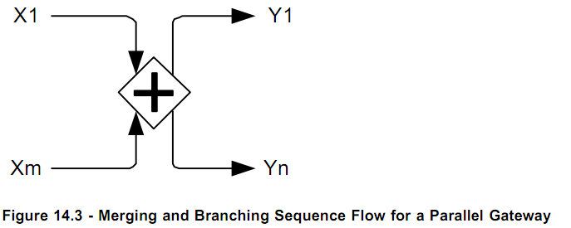

Merging
Parallel gateway merge is used to synchronize concurrent branches or threads of execution. The gateway is activated if it receives a execution token from each incoming sequence flow and the token is consumed. To model this behavior in BE a rule is required whose condition would require incoming messages from each incoming sequence flow to be asserted to the Process Rete and each message context providing identification of the sequence path travelled and the last flow node it originated from.
If there are excess Tokens at an incoming sequence flow, these Tokens remain at this sequence flow after execution of the gateway. This could mean that the out of context msg has arrived and it needs to be correlated there it should also get asserted.
Function ParallelGatewayMsgHandler(MsgContext m) {
Rete.Assert(m);
}
Rule {
Scope {
Msg₁ m₁;
Msg_{n} m_{n};
}
Condition {
M₁.origin = ‘X’
M_{n}.origin = ‘Y’
}
Action {
}
}

Branching
Parallel gateway branching is used to spawn concurrent threads or branches. This will involve creating a Job hierarchy i.e. Parent job spawns child jobs and each job keeps progressing on the assigned sequence flow. If the sequence flow activities have no outgoing Sequence Flow and there are no End Events in the containing Process or Sub-Process, the Activities will terminate and termination semantics for the container applied. The parent job can have multiple child jobs but a child job can have only one parent job. Each job can be identified by <parent job id>.<child job id> and it can have its own job Context. All the concurrent job are scheduled to be executed immediately once the gateway synchronization happens in the rule action.

Exclusive Gateway
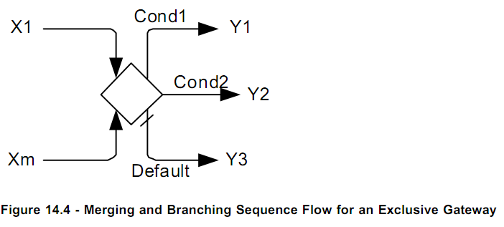

Merging
A converging Exclusive Gateway is used to merge alternative paths. Each incoming control flow token is routed to the outgoing Sequence Flow without synchronization. Each Token arriving at any incoming sequence flow activates the gateway and is routed to exactly one of the outgoing sequence flow. The Exclusive Gateway has pass-through semantics for a set of incoming branches (merging behavior). This will behave like the parallel gateway merging except that each incoming sequence will require a individual rule and the rule will be satisfied with the message token coming via the sequence flow .
ExclusiveHandlerFunction(MsgContext msg) {
Rete.assert(msg);
}
Rule X₁ {
Scope {
Msg₁ m;
}
Condition {
m.origin = ‘X₁’;
}
Action {
}
}
Rule X_{n} {
Scope {
Msg_{n} m;
}
Condition {
m.origin = ‘X_{n}’;
}
Action {
}
}

Branching
The gateway activation leads to the activation of exactly one out of the set of outgoing branches. This can be implemented by generating a if-then-else conditional logic where the evaluation conditions are available from the sequence flows . In order to determine the outgoing sequence flow that receives the Token, the conditions are evaluated in order. The first condition that evaluates to true determines the sequence flow the Token is sent to. No more conditions are henceforth evaluated. If and only if none of the conditions evaluates to true, the Token is passed on the default sequence flow. In case all conditions evaluate to false and a default flow has not been specified, an exception is thrown. The exclusive gateway throws an exception in case all conditions evaluate to false and a default flow has not been specified. To implement this each merging rule condition will need identical if-then-else logic gates . The if-then-else logic gates can be generated inside a rulefunction to be call be different merge rule.
ExclusiveHandlerFunction(MsgContext msg) {
Rete.assert(msg);
}
Rule X1 {
Scope {
MsgContext₁ m;
}
Condition {
m.origin = ‘X₁’;
}
Action {
BPMN.api.callGatewayBranch(m, <ProcessName>.scorecards.scd_<ProcessName>_Constants.<process activity id>);

}
}
Rule Xn {
Scope {
Msg_{n} m;
}
Condition {
m.origin = ‘X_{n}’;
}
Action {
BPMN.api.callGatewayBranch(m, <ProcessName>.scorecards.scd_<ProcessName>_Constants.<process activity id>);
}
}

Inclusive Gateway
The Inclusive Gateway synchronizes a certain subset of branches out of the set of concurrent incoming branches (merging behavior). Further on, each firing leads to the creation of threads on a certain subset out of the set of outgoing branches (branching behavior).
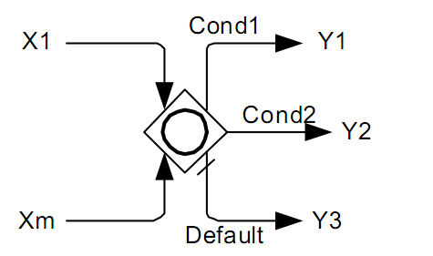

Merging
A converging Inclusive Gateway is used to merge a combination of alternative and parallel paths. A control flow Token arriving at an Inclusive Gateway may be synchronized with some other Tokens that arrive later at this Gateway.
The Inclusive Gateway is activated if
- At least one incoming sequence flow has at least one Token and
- for each empty incoming sequence flow, there is no Token in the graph anywhere upstream of this sequence flow, i.e., there is no directed path (formed by Sequence Flow) from a Token to this sequence flow unless
- the path visits the inclusive gateway or
- the path visits a node that has a directed path to a non-empty incoming sequence flow of the inclusive gateway.
Upon execution, a Token is consumed from each incoming sequence flow that has a Token. A Token will be produced on some of the outgoing sequence flows.
This means that the activation of the gateway becomes active when it gets a execution token from any of the incoming sequence flows. In case of a single incoming flow it is simple , when it comes to multiple parallel flows, it needs to be checked whethen there are parallel jobs running and the job’s state is on upstream flow node and is connected to this gateway directly or indirectly. The synchronization part involves consuming incoming tokens from each incoming sequence flow. The implementation looks similar to the parallel gateway merge.
Function InclusiveGatewayMsgHandler(MsgContext m) {
Rete.Assert(m);
}
Rule {
Scope {
Msg₁ m₁;
Msg_{n} m_{n};
}
Condition {
M1.origin = ‘X’
Mn.origin = ‘Y’
}
Action {
}
}

Branching
A diverging Inclusive Gateway (Inclusive Decision) can be used to create alternative but also parallel paths within a Process flow. Unlike the Exclusive Gateway, all condition expressions are evaluated. The true evaluation of one condition expression does not exclude the evaluation of other condition expressions. All Sequence Flow with a true evaluation will be traversed by a Token. Since each path is considered to be independent, all combinations of the paths may be taken, from zero to all. However, it should be designed so that at least one path is taken.
A default path can optionally be identified, to be taken in the event that none of the conditional expressions evaluate to true. If a default path is not specified and the Process is executed such that none of the conditional expressions evaluates to true, a runtime exception occurs.
In order to determine the outgoing sequence flows that receive a Token, all conditions are evaluated. The evaluation does not have to respect a certain order. For every condition, which evaluates to true, a Token must be passed on the respective sequence flow. If and only if none of the conditions evaluates to true, the Token is passed on the default sequence flow. In case all conditions evaluate to false and a default flow has not been specified, the inclusive gateway throws an exception.
Inclusive gateway branching is used to spawn concurrent threads or branches after each branch sequence flow condition is evaluated and the result is true. This will involve creating a Job hierarchy i.e. Parent job spawns child jobs and each job keeps progressing on the assigned sequence flow. If the sequence flow activities have no outgoing Sequence Flow and there are no End Events in the containing Process or Sub-Process, the Activities will terminate and termination semantics for the container applied. The parent job can have multiple child jobs but a child job can have only one parent job. Each job can be identified by <parent job id>.<child job id> and it can have its own job Context. While evaluating each outgoing flow condition a concurrent flow execution is started when the condition is satisfied. This can be done using a if-then-else conditional expression inside the gateway rule action for every outgoing condition and spawning a child thread for each satisfied condition.

Function ParallelGatewayMsgHandler(MsgContext m) {
Rete.Assert(m);
}
Function MergeFunction(MessageContext [] childJobContext)
Rule {
Scope {
Msg₁ m₁;
Msg_{n} m_{n};
}
Condition {
M₁.origin = ‘X’
M_{n}.origin = ‘Y’
}
Action {
MsgContext parentCtx = BPMN.api.MergeContext(
”/codegen/MergeFunction”,m₁,...m_{n});
If (evalConditionY1(ctx)) {
MsgContext childJobContext =
BPMN.api.spawnConcurrentJob(parentCtx, <ProcessName>.scorecards.scd_<ProcessName>_Constants.<process activity id>);
}
}
}

Event Based Gateway
The Event-Based Gateway represents a branching point in the Process where the alternative paths that follow the Gateway are based on Events that occur, rather than the evaluation of Expressions using Process data (as with an Exclusive or Inclusive Gateway). A specific Event, usually the receipt of a Message, determines the path that will be taken. Basically, the decision is made by another Participant, based on data that is not visible to Process, thus, requiring the use of the Event-Based Gateway.

Merging

Branching

Complex Gateway

Merging

Branching

Dynamic BPMN

Itinerary
Dynamic BPMN involves a facility to change the process flow(Itinerary) using the same process task elements by the introduction of a modified Itinerary on a predefined schema. The default Itinerary is the modeled process diagram, where as a modified itinerary which may be a xml file is loaded at runtime and deployed on the process agent. The process agent then creates new process instances using the new Itinerary and executes accordingly. This is useful for abstracting out common tasks and reuse them for different contexts. Existing process instances continue to run with the old itinerary until they finish.
An Itinerary consists of a number of steps and each step has a entry condition, condition ,action and a next step pointer as shown below in a concept diagram.
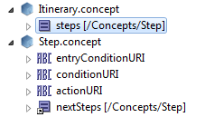

Global Definitions
During process execution each individual Step or Action needs to access relevant data and there will be scenarios when multiple processes may act on the same data. BE provides granular object level locking across multiple running bpmn process instances , bpmn process agents and virtual machines. Every executable Step in the BPMN process is afforded the job context which is a opaque object holding the base input data for the running instance. Any extraneous data that is needed during process can be retrieved using rich BE catalog function API which is related to the input context.

Versioning
The process definitions and Itineraries can be versioned in the same principle as Decision Tables where the business analyst can change the decision logic and deploy it at runtime after approval checks and versioning.

Business Rule Tasks
The Business Rule task also add a dimension to dynamic execution, here a set of rules act on a set of data and based on their execution the rule actions can drive the process flow.

