T

TIBCO BusinessEvents: BPMN Processes

Product Suite | TIBCO BusinessEvents
Product | BPMN Processes
Product Version | 1.0
Initial Author | Gabe Grigorescu

Copyright Notice
COPYRIGHT© 2010 TIBCO Software Inc. This document is unpublished and the foregoing notice is affixed to protect TIBCO Software Inc. in the event of inadvertent publication. All rights reserved. No part of this document may be reproduced in any form, including photocopying or transmission electronically to any computer, without prior written consent of TIBCO Software Inc. The information contained in this document is confidential and proprietary to TIBCO Software Inc. and may not be used or disclosed except as expressly authorized in writing by TIBCO Software Inc. Copyright protection includes material generated from our software programs displayed on the screen, such as icons, screen displays, and the like.
Trademarks
Technologies described herein are either covered by existing patents or patent applications are in progress. All brand and product names are trademarks or registered trademarks of their respective holders and are hereby acknowledged.
Confidentiality
The information in this document is subject to change without notice. This document contains information that is confidential and proprietary to TIBCO Software Inc. and may not be copied, published, or disclosed to others, or used for any purposes other than review, without written authorization of an officer of TIBCO Software Inc. Submission of this document does not represent a commitment to implement any portion of this specification in the products of the submitters.
Content Warranty
The information in this document is subject to change without notice. THIS DOCUMENT IS PROVIDED "AS IS" AND TIBCO MAKES NO WARRANTY, EXPRESS, IMPLIED, OR STATUTORY, INCLUDING BUT NOT LIMITED TO ALL WARRANTIES OF MERCHANTABILITY OR FITNESS FOR A PARTICULAR PURPOSE. TIBCO Software Inc. shall not be liable for errors contained herein or for incidental or consequential damages in connection with the furnishing, performance or use of this material.
For more information, please contact:
TIBCO Software Inc.
3307 Hillview Avenue
Palo Alto, CA 94304
USA
Table of Contents
TIBCO BusinessEvents: BPMN Processes 1
1 Change Log 5
1.1 Related Documents 5
2 Introduction 6
2.1 Main Objective 6
2.2 Intended Usage 6
2.3 Scope 6
2.4 Naming 6
2.5 Audience 6
3 Acronyms and Vocabulary 7
4 Release Notes 7
4.1 New Features 7
4.1.1 Release 5.1 7
4.2 Changes in Functionality 7
4.2.1 Release 5.1 7
4.3 Deprecated Features 7
4.3.1 Release 5.1 7
4.4 Migration and Compatibility 7
4.4.1 Release 5.1 7
4.5 Closed Issues 7
4.6 Known Issues 7
5 Installation Guide 8
5.1 Installation Overview 8
5.1.1 Required and Optional Products 8
5.1.2 Extracting Archive Files 8
5.1.3 Installing in GUI Mode 8
5.1.4 Installing in Console Mode 8
5.1.5 Installing in Silent Mode 8
5.2 Post-Installation Tasks 8
5.3 Uninstalling BusinessEvents Processes 8
6 Getting Started Guide 8
6.1 Getting Started with TIBCO BusinessEvents Processes 8
6.1.1 Overview 8
6.1.2 Create Studio Project 8
6.1.3 Create Processes with their Tasks and Default Flow 9
6.1.4 Link Tasks to Studio Resources 9
6.1.5 Validate Process 9
6.1.6 Generate Process Code 9
6.1.7 Review and Extend Process Code 9
6.1.8 Configure TIBCO BusinessEvents for Process Deployment 9
6.1.9 Run the Project 9
6.1.10 Overview 9
6.1.11 Order Processing Scenario 9
7 User's Guide 9
7.1 Introduction to Processes 9
7.2 Process Service Architecture 9
7.2.1 Naming 9
7.3 Configuring Processes 9
7.3.1 Process Message 10
7.3.2 Job Context 10
7.3.3 Job Concept 10
7.3.4 MessageProc Rule Function 10
7.3.5 Handler Functions 10
7.3.6 SequenceFlow Evaluation Function 10
7.4 Working With Processes 10
7.4.1 Diagramming 10
7.4.2 Lanes 10
7.4.3 Tasks 10
7.4.4 Loops 11
7.4.5 Events 11
7.4.6 Gateways 11
7.4.7 Sequence Flows 12
7.4.8 Sub-Processes 12
7.4.9 Notes 13
7.5 Validating Processes 13
7.6 Building Processes for Execution 13
7.7 Extending Generated Process Code 14
7.8 Debugging Processes 14
7.9 Working with Dynamic Processes 14
7.10 Accessing External Data 14
7.11 Hot Deployment 14
7.11.1 Process Versioning 14
7.11.2 Business Rule Tasks 14
7.12 Configuring Process Agents 14
7.13 Setting Process Preferences 14
7.13.1 Process Diagram 15
7.13.2 Code Generation 15
7.14 Using Custom Palettes 18

Change Log
.
Date | Version | Name | Description
12/20/2010 | 1.0 | Gabe Grigorescu | Initial doc
12/27/2010 | 1.1 | Gabe Grigorescu | Added more sections. All Guide TOCs should be more complete.
12/29/2010 | 1.2 | Gabe Grigorescu | Added some sub-sections based on Pranab's BPMN codgen mapping document
01/05/2011 | 1.3 | Gabe Grigorescu | Added Release Notes guide and screenshots and icons for various process artifacts in each section (tasks, etc).

Related Documents
Document Title | Revision Number | Author
BPMN 2.0 Specification
BE 4.1 BPMN Project Plan
BE BPMN Requirements document |  | Gabe Grigorescu
BE BPMN Codegen Mapping document | 1.1 | Pranab Dhar

Introduction

Main Objective
The objective of this document is to outline the implementation details of the BE BPMN Process Add-on functionality.

Intended Usage
BE BPMN Decision Graphs will be used by different types of users. These users include: Business Owners, Business Analysts, Developers, IT Engineers.

Scope
The scope of this document is to provide most of the documentation needed to describe what this functionality is about. Most of the contents of this document will be moved to a FrameMaker document to be used in the documentation we plan to release with this new addon.

Naming
We have not decided yet how to refer to this new type of a process. Candidates include:
Decision Graph
(BPMN) Decision Process
BE (BPMN) Process

Audience
The document is intended for Developers, Architects, QA, Product Marketing, and Managers.

Acronyms and Vocabulary

The table below describes some of the Acronyms used in this documentation
- BE – TIBCO BusinessEvents.
- Studio Project – A TIBCO Project build using TIBCO BusinessEvents Studio.
- BPM – Business Process Model
- BPMN – Business Process Model Notation

Release Notes
Minimal changes need to be made to any of the other Release Notes that we did in version 4.0.

New Features
Modified text from ESP 4.0 guide as needed. See FrameMaker document.

Release 5.1
Modified text from ESP 4.0 guide as needed. See FrameMaker document.

Changes in Functionality

Release 5.1
Modified text from ESP 4.0 guide as needed. See FrameMaker document.

Deprecated Features

Release 5.1
Modified text from ESP 4.0 guide as needed. See FrameMaker document.

Migration and Compatibility

Release 5.1
Modified text from ESP 4.0 guide as needed. See FrameMaker document.

Closed Issues

Known Issues

Installation Guide
Very minimal changes need to be made to any of the other Installation Guides. Thus, we can copy the Installation Guide from Decision Manager and make small changes.

Installation Overview
Modified text from DM guide as needed. See FrameMaker document.

Required and Optional Products
Modified text from DM guide as needed. See FrameMaker document.

Extracting Archive Files
Modified text from DM guide as needed. See FrameMaker document.

Installing in GUI Mode
Modified text from DM guide as needed. See FrameMaker document.

Installing in Console Mode
Modified text from DM guide as needed. See FrameMaker document.

Installing in Silent Mode
Modified text from DM guide as needed. See FrameMaker document.

Post-Installation Tasks
Modified text from DM guide as needed. See FrameMaker document.

Uninstalling BusinessEvents Processes
Modified text from DM guide as needed. See FrameMaker document.

Getting Started Guide
Before chapter 1, reuse same Figures, Tables, Examples, and Preface as we have for other guides.

Getting Started with TIBCO BusinessEvents Processes
This guide is a tutorial that demonstrates the major steps in using TIBCO BusinessEvents processes. It begins with creating a BE Studio project and ends with
exercising the BPMN processes in a running TIBCO BusinessEvents engine.

Overview
xxx

Create Studio Project
xxx

Create Processes with their Tasks and Default Flow
xxx

Link Tasks to Studio Resources
xxx

Validate Process
xxx

Generate Process Code
xxx

Review and Extend Process Code
xxx

Configure TIBCO BusinessEvents for Process Deployment
xxx

Run the Project
xxx

Overview
xxx

Order Processing Scenario
xxx

User's Guide
This section covers the text we will move to the separate User's Guide FrameMaker document.

Introduction to Processes
intro...

Process Service Architecture
quick intro

Naming

Configuring Processes
intro...

Process Message

Job Context

Job Concept

MessageProc Rule Function

Handler Functions

SequenceFlow Evaluation Function

Working With Processes
intro...

Diagramming
Brief mention of what they can do, copy/paste, undo/redo, etc. Point to main doc. Export to PDF, etc.

Lanes
Currently, there is just one lane, the default one, which is part of a default pool...

Tasks

Rule Function

xxxx

Business Rule


Decision Table
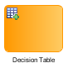
xxxx

Loops

Standard


Multi-Instance


Events

Send Event


Receive Event


Start Event
 and and 

End Event
and and 

Gateways

Parallel


Exclusive


Inclusive


Event-based

Complex


Sequence Flows
talk about edges...


Sub-Processes

Standard
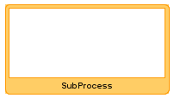

Event-based


Call Activity
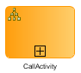

Notes
talk about notes (for doc purposes only)
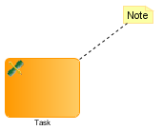

Validating Processes
intro...

Building Processes for Execution
intro...
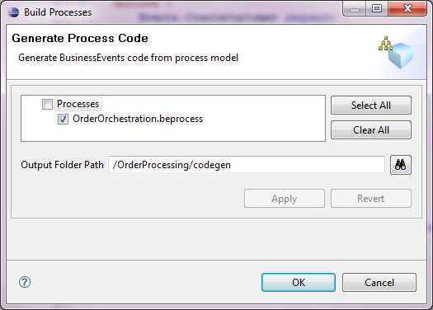

Extending Generated Process Code
document how users can add their own logic in generated code, as long as they add their code outside of the clearly marked blocks:
/**
** @START - Do not edit between START and END comment blocks.
*/
and
/**
** @END - Do not edit between START and END comment blocks.
*/

Debugging Processes
In addition to standard BE debugging techniques, you can also use the Debugger to debug the generated code and see the execution path of the processes. When the debugger stops at a particular task, the diagram will highlight that task:


Working with Dynamic Processes
Talk about Itinerary object.

Accessing External Data
talk about how multiple processes may act on the same data.

Hot Deployment
talk about how processes can be changed at runtime.

Process Versioning
processes can be deployed at runtime...

Business Rule Tasks
support multiple rules...

Configuring Process Agents
CDD stuff...

Setting Process Preferences
intro...

Process Diagram
User interface changes...
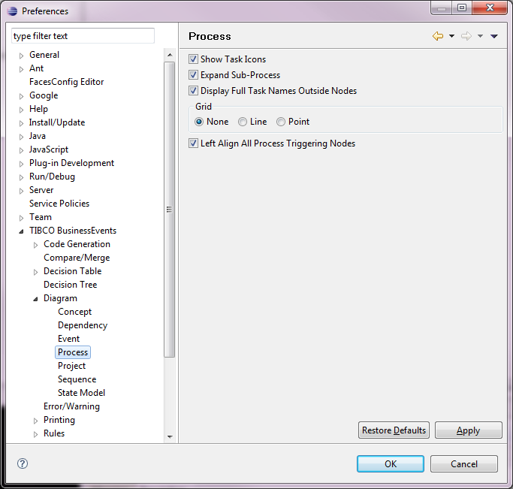

Code Generation
intro...
You can customize the prefixes for ...
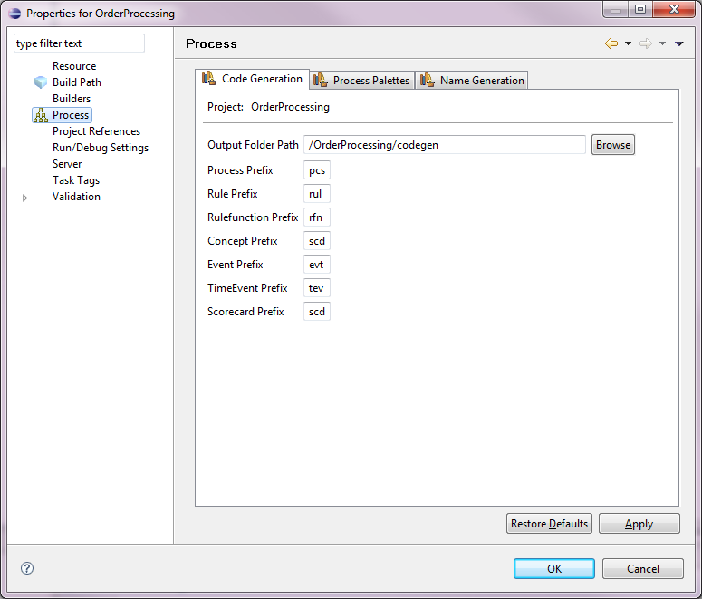
You can also customize the unique names used for objects...
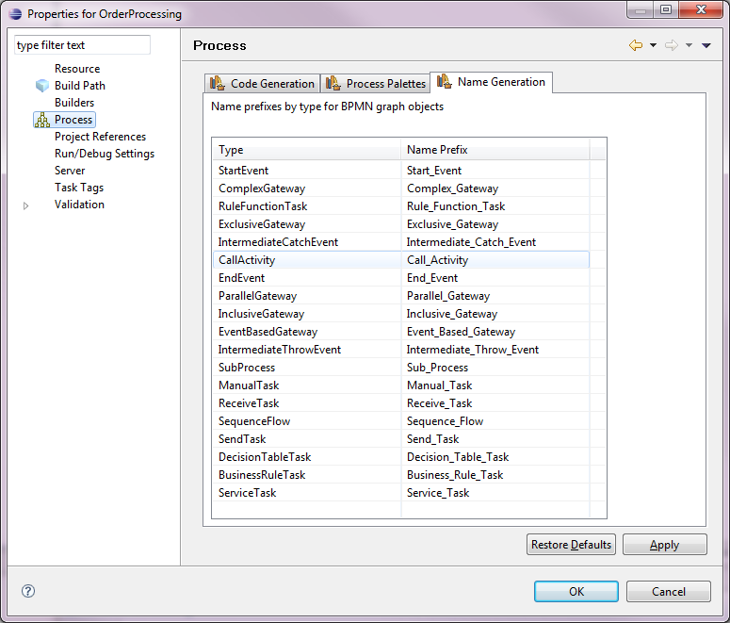

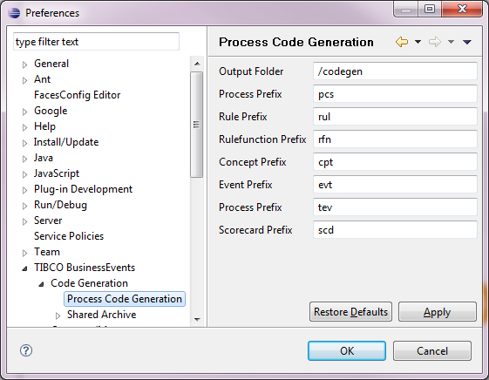

Using Custom Palettes
how users can create their own, plug them in, and also modify default ones... Go to project Properties, click on Process, click on Palette tab:
