T

TIBCO BusinessEvents: BPMN Processes

Product Suite | TIBCO BusinessEvents
Product | Process Orchestration
Product Version | 1.0
Initial Author | Gabe Grigorescu

Copyright Notice
COPYRIGHT© 2011 TIBCO Software Inc. This document is unpublished and the foregoing notice is affixed to protect TIBCO Software Inc. in the event of inadvertent publication. All rights reserved. No part of this document may be reproduced in any form, including photocopying or transmission electronically to any computer, without prior written consent of TIBCO Software Inc. The information contained in this document is confidential and proprietary to TIBCO Software Inc. and may not be used or disclosed except as expressly authorized in writing by TIBCO Software Inc. Copyright protection includes material generated from our software programs displayed on the screen, such as icons, screen displays, and the like.
Trademarks
Technologies described herein are either covered by existing patents or patent applications are in progress. All brand and product names are trademarks or registered trademarks of their respective holders and are hereby acknowledged.
Confidentiality
The information in this document is subject to change without notice. This document contains information that is confidential and proprietary to TIBCO Software Inc. and may not be copied, published, or disclosed to others, or used for any purposes other than review, without written authorization of an officer of TIBCO Software Inc. Submission of this document does not represent a commitment to implement any portion of this specification in the products of the submitters.
Content Warranty
The information in this document is subject to change without notice. THIS DOCUMENT IS PROVIDED "AS IS" AND TIBCO MAKES NO WARRANTY, EXPRESS, IMPLIED, OR STATUTORY, INCLUDING BUT NOT LIMITED TO ALL WARRANTIES OF MERCHANTABILITY OR FITNESS FOR A PARTICULAR PURPOSE. TIBCO Software Inc. shall not be liable for errors contained herein or for incidental or consequential damages in connection with the furnishing, performance or use of this material.
For more information, please contact:
TIBCO Software Inc.
3303 Hillview Avenue
Palo Alto, CA 94304
USA
Table of Contents
TIBCO BusinessEvents: BPMN Processes 1
1 Change Log 5
1.1 Related Documents 5
2 Introduction 6
2.1 Main Objective 6
2.2 Intended Usage 6
2.3 Scope 6
2.4 Naming 6
2.5 Audience 6
3 Acronyms and Vocabulary 7
4 Add-on Definition 7
4.1 What is the BE BPMN add-on 7
4.2 What BE BPMN add-on is not 7
4.3 Difference from State Machines 8
5 Requirements 8
5.1 Users 10
5.2 Palette 11
5.3 Project Analyzer 11
5.4 Modeling requirements 12
5.4.1 Events 12
5.4.2 Tasks 12
5.4.3 Gateways 13
5.4.4 Annotations 13
5.5 Simulation requirements 13
5.6 Debugging requirements 13
5.7 Import/export requirements 13
5.8 Persistence requirements 14
5.9 Analysis requirements 14
5.10 Documentation requirements 14
5.11 Analysis requirements 14
5.12 Deployment requirements 14
5.13 Runtime requirements 14
5.13.1 Profiler 14
6 Customer Requirements 15
6.1 AT&T Use Case 15
6.2 Phillips Use Case 19
6.3 Swisscom / Active Fulfillment Framework (AF&AC) Use Case 20
6.4 OOCL Use Case 20
6.5 Barclays (MOTIF) Use Case 21
7 Barclays MOTIF 22
7.1 Barclays Capital 22
7.2 MOTIF Project 22
7.3 Management Service 22
7.4 MOTIF lifecycle 22
7.4.1 Complexity of process dependencies 23
7.5 BPM Requirements Summary 23
7.6 New Management Service Architecture Proposal 24
7.7 MA / MR Initiative 24
7.8 Context in which the BPM product will be used 25
7.8.1 MEM/BPM interface 25
7.8.2 BPM Component Coverage 26
7.8.3 BPM Terminology 26
7.9 Short vs. long running processes 26
7.10 Statement of need 27
7.11 Detailed requirements 27
7.12 BPMN 2.0 support 27
7.12.1 Process activity execution 28
7.13 Operational visibility 28
7.13.1 Process categorization 28
7.13.2 Process visibility 29
7.14 Operational Control 30
7.14.1 Front-end UI 30
7.14.2 Threshold alerts 31
7.15 BPM engine runtime environment 31
7.16 Performance and scalability 31
7.16.1 Situation 31
7.16.2 BPM Engine performance 31
7.16.3 BPM UI performance 32
7.16.4 Scalability 32
7.17 Development and customization 32
7.18 Testing and debugging 32
7.18.1 Unit testing and integration testing 32
7.18.2 Debugging 34
7.18.3 Process repository 34
7.19 Reporting, auditing 34
7.20 Support, documentation 34

Change Log
.
Date | Version | Name | Description
09/09/2009 | 1.0 | Gabe Grigorescu | Initial doc
07/02/2010 | 2.0 | Gabe Grigorescu | Added more information
07/06/2010 | 2.1 | Gabe Grigorescu | Added palette customization information
08/02/2010 | 2.2 | Gabe Grigorescu | Added SM vs DG info and Phillips use case (from Paul Vincent)
08/03/2010 | 2.3 | Gabe Grigorescu | Added AFF use case info (from Mark Descallar)
08/04/2010 | 2.4 | Gabe Grigorescu | Added Project Analyzer section
12/15/2011 | 2.5 | Gabe Grigorescu | Minor changes and added Barclays requirements

Related Documents
Document Title | Revision Number | Author
Existing Decision Manager 3.0 Documentation
BPMN 2.0 Specification
BE 5.1 BPMN Project Plan
AT&T.BPM-Platform-Requirements | 1.0
Barclays.MOTIF_BPMTool_Requirements_v1.0 | 1.0

Introduction

Main Objective
The objective of this document is to outline the requirements of the BE BPMN Add-on functionality.

Intended Usage
BE BPMN Decision Graphs will be used by different types of users. These users include: Business Owners, Business Analysts, Developers, IT Engineers.

Scope
The scope of this document is to provide an overview of what we would like to achieve in the initial BE BPMN Decision Graph add-on release.

Naming
We have not decided yet how to refer to this new type of a process. Candidates include:
Decision Graph
(BPMN) Decision Process
BE (BPMN) Process

Audience
The document is intended for Developers, Architects, QA, Product Marketing, and Managers.

Acronyms and Vocabulary

The table below describes some of the Acronyms used in this documentation
- BE – TIBCO BusinessEvents.
- Studio Project – A TIBCO Project build using TIBCO BusinessEvents Studio.
- BPM – Business Process Model
- BPMN – Business Process Model Notation

Add-on Definition
In order to avoid confusion, it is important to identify what problem we are trying to solve and what this add-on is meant to do. The space of the functionality provided has some limited overlap with other TIBCO and external products and thus we want to clearly define the overall scope of the product.

What is the BE BPMN add-on
The BE BPMN add-on provides a BPMN-based modeling capability along with execution in BE. It is an event-driven process execution with BPMN-based modeling semantics. At a high level, it will provide:
- Eclipse, BPMN based modeling, even though only a subset will be supported that makes sense for BE execution
- processes that operate on BE artifacts (concepts, events, rule, rule functions, scorecards) and that can trigger other processes
- tight integration with BE Studio modeling
- orchestration engine through the existing BE engine which will stay unchanged for BPMN execution purposes

What BE BPMN add-on is not
The BE BPMN add-on is not a BPM (process modeling) tool or substitute for N2 (AMX BPM). More specifically it does not provide:
- human workflow capabilities
- workforce allocation features
- document or form management capabilities
- page flow capabilities
- out of the box reporting capabilities
- asset management capabilities
- organizational model capabilities
However, given that BE has built-in state machine capabilities, it does not restrict an end-user/developer/field engineer from building such capabilities.

Difference from State Machines
State diagram describes lifecycles of entities typically over a long period of time.
Process diagrams describe sequences of activities typically over the course of a single “transaction”.

State diagrams describe only state: behaviors are the rules used in state changes.
Process diagrams describe activities: behaviors are the process activities (eg rule functions, decision tables) themselves.

Requirements
We want to provide BE customers the ability to model processes using a familiar and easy to use standard (BPMN) and yet still leverage the performance and scalability BE provides by executing those processes using the same BE runtime engine available today.

We envision two modeling environments, an Eclipse-based one, and a web-based one. They would both work off the same BE project and modify the same artifacts.

This is an Eclipse-based modeling environment:

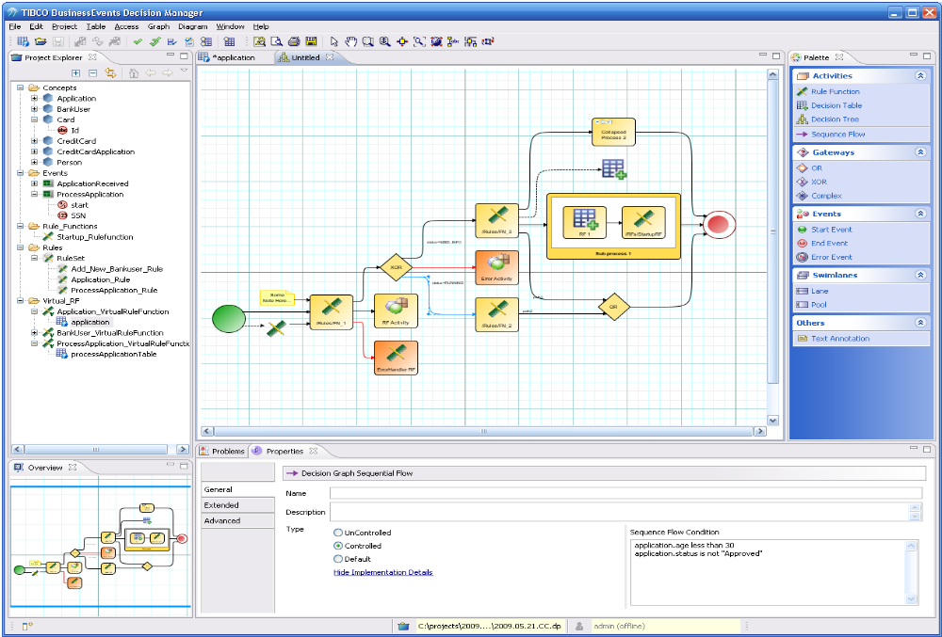

There are several sections:

- standard project explorer
- overview window
- main editor area
- context sensitive property sheets that can be used to view and edit artifacts
- palette that is extensible so users can plug in their own activity tasks with well defined actions

This is a web-based modeling example:

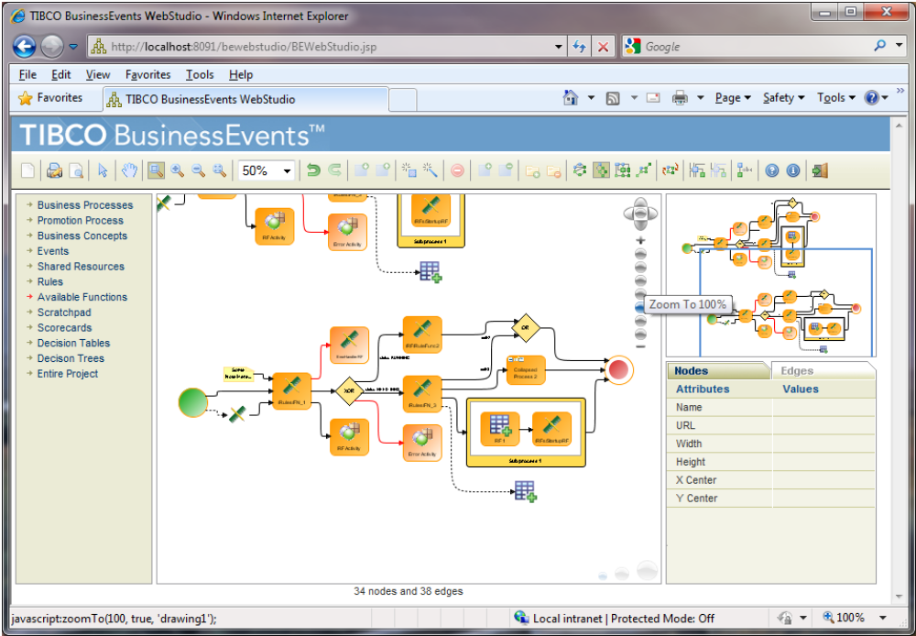

Users
We envision three different types of users of this functionality.
User | Role | Responsibility
Web-user | business | Define business process at very high level with annotations
Web/eclipse | Analyst | Update model and add enough information to existing model from business user so developer can implement fully. Cycles updated process so business user can review (using web-based interface) the updated process.
Eclipse | Architect/developer | Adds necessary functions, java code, and all other artifacts needed to fully implement the process so it can be executed by BE engine.

Palette
The palette for the BPMN modeling should be customizable. More specifically, there should be two different types of palettes: built-in and user palettes.
The built-in palettes should be configurable to enable users to decide the following:
- title of palette section
- whether the entire palette section is visible or not
- which of the palette section items are visible
This should be made possible via a GUI (although maybe not in the first release), similar to how users can customize perspectives now (functionality provided by Eclipse).
Users should also be able to define their own palettes. Users should be able to do this through a GUI (although in first release it may be just an XML file) in which they can specify the following:
name of palette section
For each palette section item, users should be able to specify the following:
- name
- tooltip
- palette icon (a 16x16 icon)
- diagram icon (usually larger version, like a 48x48 image)
- all task information, such as type, looping, actual BE artifact to invoke (event, rule, rule function, etc), description, etc. Actual persistence XML format is to be determined as part of design.
Users should be able to right-click on a particular task or subprocess, and export it to a custom palette. This will enable other users to easily reuse that part of a graph in other graphs.

Project Analyzer
The Project Analyzer should be updated to show processes. By default they can be expanded to show all components (tasks, gateways, events, etc). Then, links should be added from the tasks to the corresponding BE artifacts (rule functions, rules, events) that they invoke so users can see what artifacts these processes operate with. We can also add links to concepts these subprocesses modify as well. The palette should give the users the option to collapse these subprocesses and also filter out these links from the process.
Similarly, the analysis component should warn users if they have any empty processes or subprocesses, empty lanes, or other situations that may be legal but may not be intended (such as a task that is not connected to anything else). More of this functionality will be added as we figure out what else we can warn users about.

Modeling requirements
We provide the ability to model the following high level types of BPMN categories:
- Events
- Tasks (activities which can call various other BE functions)
- Gateways
- Connections
- swim lanes and pools
- ability to annotate objects
We will provide different types of templates that can be used to start modeling. If a simple template is used, no pools and swimlanes will be created, but rather just a simple process. This will mean that the entire process is inside one swimlane, which is inside one pool.
All of these artifacts should have the ability to have extended properties associated with them, which should be imported and exported in XPDL format as well.

Events
We will support the following types of events:
Start Events
- Message
- Timer
Intermediate Events
- Message
- Timer
- Rule
End Events
- Error
- Message

Tasks
We will support the following types of tasks:
- Simple Task
- Sub Process Task
Each type of a task can be:
- Normal
- Looping
- Parallel

Gateways
We will support the following types of gateways:
- OR
- XOR
- AND
- Complex

Annotations
We will support the ability to attach any textual data to any objects which will be displayed as a label on the diagram, where the label can have any text.
We will also support the ability to attach a URI to any object, which can be any file location or standard URL. This URI can be accessed via @uri tags (TBD).

Simulation requirements
We will not provide any BPMN specific simulation capabilities (at least not in the first version), other than what BE 4.0 already provides (in terms of having a tester with test results shown in BE Studio).

Debugging requirements
Eventually we want to provide a visual debugger with interfaces right on the BPMN diagram. Users should be able to set up break points, see flow of data and overall state of objects right in the diagram and accompanying views. This functionality will not be provided in the first version of this add-on though.

Import/export requirements
We will provide various export facilities of these processes:
- XPDL
- PDF
- JPG
- PNG
- GIF
We will also provide the ability to import from XPDL, although the user will need to further annotate and describe the process that is imported, because presumably that will not have all the BE specific info BE will need to fully execute that process.

Persistence requirements
We will store each process in one file, in an EMF format for which we will share the .ecore so others can generate such processes without using our GUI.

Analysis requirements
We will not provide the following capabilities in the first release, but eventually we'd like to add ability to add analysis of the designtime model for:
- conflicts
- consistency
- overlaps
- completeness

Documentation requirements
Process documentation details, process documentation summary and other process reports will be requirements in subsequent releases but no in the first release.

Analysis requirements
We will not provide the following capabilities in the first release, but eventually we'd like to add ability

Deployment requirements
These processes should be treated as first class BE artifacts, and thus stored in one file and be bundled with the .ear file when project is built. Thus, changing a process and rebuilding the ear file should cause the new process to be hot deployed. Semantics of what will happen to existing processes are driven by existing rule hot deployment behavior in BE.

Runtime requirements

The designtime process should be fully executed by BE inference engines in the same way as the existing BE applications are.

We must be able to suspend, resume, shutdown processes.

We must be able to suspend, resume, shutdown process components (tasks) (?).

We must be able to do various "hot deployment" activities. For example, if a process is changed, hot deployment should work for that process.

Profiler

In the first release very limited process profiling information will be available, but eventually we want to be able to report on various profiling metrics, such as:

- execution times of each individual process task, gateway, subprocesses.

Customer Requirements
We present here some more specific use cases.

AT&T Use Case
Here is an example of a process AT&T would like to model and execute inside BE:

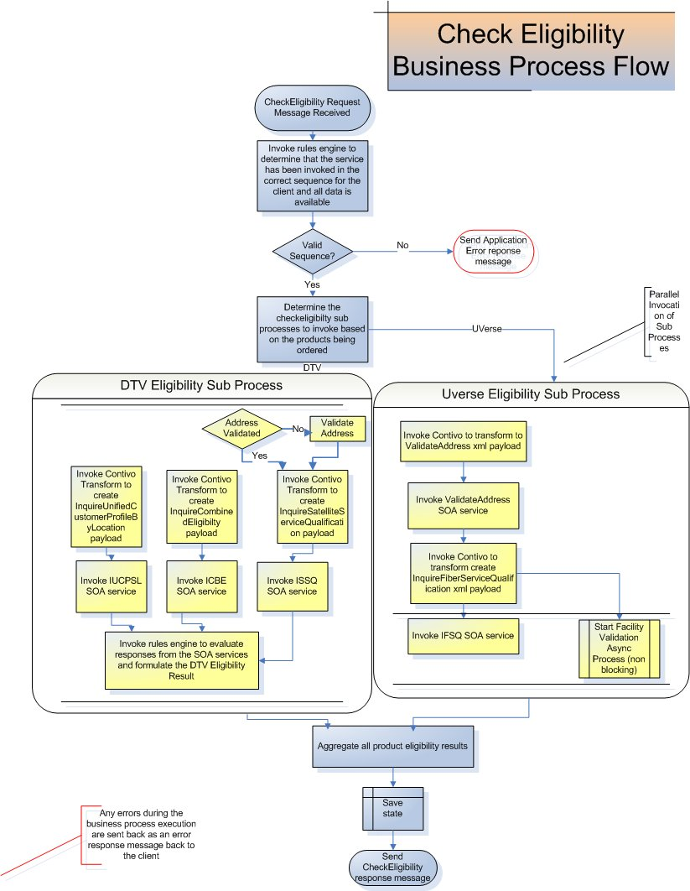

USE CASE # 1 |  | Check Availability and Ordering Eligibility of ATT Services for a customer location
Goal in Context |  | Create a cross entity order that enables a customer to order one or more ATT services (like UVerse, DSL, Direct TV, wireless etc)
Scope |  | BPM
Preconditions |  | The client has browsed the collateral provided and has decided to order one or more ATT services  The 360 degrees view of the customer has already been provided for an existing ATT customer.  All information needed to invoke the BPM service has been obtained from the client.
Success End Condition |  | The availability and eligibility for the ATT services requested by the customer has been determined.
Failed End Condition |  | One or more steps fail causing the entire Business Process to terminate
Primary,  Secondary Actors |  | AT&T Sales systems initiate a request to BPM, and BPM submits the appropriate requests to the Backend systems through SOA service calls.
Trigger |  | Clients initiate the ordering flow for ATT products
MAIN SCENARIO
Implementation Layer |  |  | Step | Action – |  | Traced From
Trigger |  |  | 1 | Clients initiate the ordering flow for ATT products
Client |  |  | 2 | Client invokes the CheckEligibility Web Service
 |  |  | 3 | The “partner link” terminates at the Service Gateway (Gateway) via a SOAP message over JMS
 |  |  | 4 | Gateway performs authentication , authorization and versioning services and initiates the Business Process over a JMS private channel
 |  |  | 5 | Business Process: The CheckEligibility Business process receives the message and performs validation. If a correlation ID has not been created for the order, the correlation ID sent by the gateway will be persisted and used to tie together all the business processes for the order.
 |  |  | 6 | Business Process runs the payload through a rules engine to determine if the service has been called in the correct sequence for that client. Assumption - Different clients can have their ordering sequence preconfigured in the rules engine including the ability to skip certain steps in the ordering flow
 |  |  | 7 | The rules engine also checks the payload to determine the appropriate sub processes/overloaded process to be executed based on the products that the customer wants to order. For example if ordering Uverse and DTV – go though the Uverse and DTV check eligibility sub flows
 |  |  | 8a | Sub process - Check DTV Eligibility – This is executed in parallel with all other sub processes that check eligibility for other ATT services
 |  |  | 8b | Call a transform to create the InquireCustomerProfileRequest payload
 |  |  | 8c | Invoke the InquireCustomerProfile Service over JMS
 |  |  | 8d | For existing ATT customer, invoke the InquireCombinedBillEligibility Service over JMS by first calling a transform to create the payload.
 |  |  | 8e | Call the InquireSatelliteServiceQualification service over JMS by first calling a transform to create the payload.
 |  |  | 8f | Send appropriate elements from the responses of all the SOA services that have executed in parallel to the rules engine to determine the final eligibility
 |  |  | 8g | Create the response by calling a transform
 |  |  | 8h | Persist appropriate data elements that will be required later on in the ordering flow
 |  |  | 9 | Aggregate the responses from all sub processes to compose the eligibility for all ATT products being ordered and create the response
 |  |  | 10 | Return the SOAP response to the gateway over JMS
SUB-VARIATIONS
Description of Change |  |  | Step | Alternative Action - | Traced From
EXTENSIONS
Description of Change |  |  | Step | Action – Error Flows | Traced From
 |  |  | 1 | The request XML fails to validate against defined port interface – A SOAP fault is sent back to the client
 |  |  | 2 | Any critical activity fails - A SOAP fault is sent back to the client
 |  |  | 3 | Unrecoverable errors from the Stateless service invocation are sent back to the client as SOAP Faults.
NOTES
ID | Description
1 | The CheckEligibility BPM process is one of the steps executed in the overall business process flow for cross entity ordering. Similar steps (required or optional depending on the calling client) will be executed to complete the order processing. This could include Business processes for credit check, retrieving products from multiple catalogs, checking product compatibility, Retrieving order summary and Quote, scheduling installation and finally submitting the order.

Phillips Use Case
Compared to the medical graphs Philips have, these process diagrams will probably better represent decision graphs than state models or pure decision trees. The main aspect is the complexity of the decision rules: if simple then they can be simple gateways, but if more complex can be delegated to a custom decision table. I would guess Philips would be looking for a combined decision and process graph (if only as an output) to show all decisions and processes in detail...

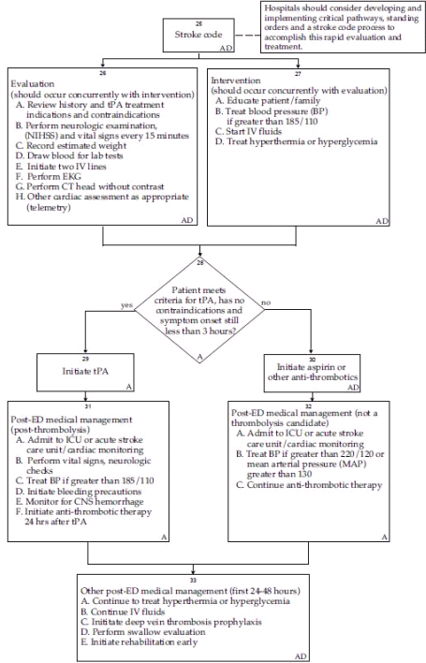

Swisscom / Active Fulfillment Framework (AF&AC) Use Case
This is information provided by Mark Descallar.
There are two levels of fulfillment process/process modeling.
- PROCESS FLOW: A High level Process flow. We see this as the domain of BE and the value-add of AFF.
  - Some traditional processs flow (step a to step b)
  - But aside from traditional BPM many steps will be based on rules and pre/post conditions (step is performed if orderline.classtype=router. Requires that “ProvisionInternet” Step has been completed)
  - Because of this most of the process flow is rules-based and dynamic (e.g. which route taken will depend on data at run time)
    - The rules reference a standard Product Model, Customer Model, Order Model
  - each high-level step is associated with a low-level ACTIVITIY(or Activities)
- ACTIVITIES FLOW: Each high level step is decomposed into a lower-level, traditional BPMN-type process flow. We see this as potentially AMX BPM or BE or any engine.
  - hard-coded process flow dealing with specific tasks (e.g. call webservice to query install scheduling system)
  - may use data from the standard data objects (Process,Product, Customer, Order data models)
  - These low level process flows may include human-based workflow activities
  - There is no requirement to model these process flows in the same tool as the high level flow. The intention is that a “library” of Activities is created by the customer for each of their specific low level activities (e.g. CreateNewCustomerInSiebel” or UpdateSalesforce”. This library would be referenced in the High Level Process modeling.
  - Because of this AFF would be agnostic to what engine is used to model these activities (BW, AMX BPM, iProcess, or other)

BE would perform the higher level process modeling and management of the process. We envision this to be the model for any of our customers. The difference in today’s AFF vs the proposed AFF is: Today AFF only does high-level orchestration for Product Decomposition Use Cases. What we need to add is the ability to generate the high-level plan for any fulfillment Use Case, which does not always start with product decomposition.

AMX Platform vs AMX BPM: Aside from the BPM question, the future AFF solution will need a unified gui, logging, scaling, cache, debugger, etc. Depending on capabilities we have to determine the value of AMX platform in this regard. We will still be using TIBCO CIM to power the ActiveCAtalog-side, and whether the Fulfillment side is BE only or BE + other TIBCO products, we may need a common platform to run on.

We want the BE Engine to perform the higher level. We want BE to orchestrate and manage the fulfillment processes

OOCL Use Case
This section covers some of the requirements we received from OOCL.
TBD…

Barclays (MOTIF) Use Case
Here is an example of a process Barclays would like to model and execute inside BE:

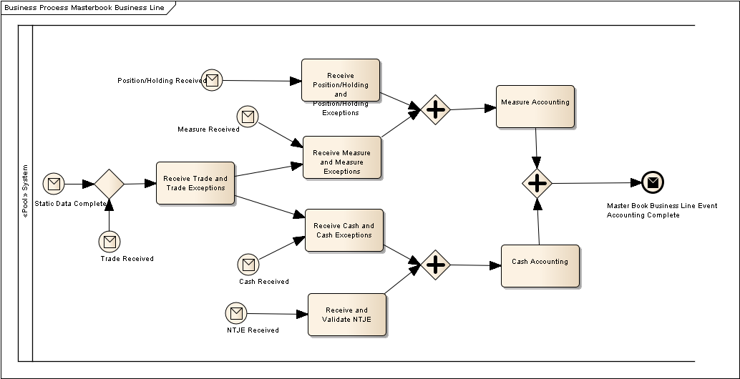

The next Section will cover the Barclays MOTIF requirements in more detail.

Barclays MOTIF

Barclays Capital
Barclays Capital is the investment banking division of Barclays Bank PLC. With a distinctive business model, Barclays Capital provides large corporate, government and institutional clients with a full spectrum of solutions to their strategic advisory, financing and risk management needs.
Barclays Capital has offices around the world, employs over 23,000 people and has the global reach, advisory services and distribution power to meet the needs of issuers and investors worldwide. For further information about Barclays Capital, please visit our website www.barclayscapital.com.

MOTIF Project
From business perspective MOTIF is a bespoke Finance initiative with the primary objectives of integrating the Financial Control (FC) and Product Control (PC) process, facilitating the compilation of a daily balance sheet and providing a single source of balance sheet and P&L data across Barclays Capital.
From technical perspective MOTIF is a key green-field project within Enterprise Solutions IT / Finance IT to replace a large number of disparate product control systems with a single, strategic application; a single bank-wide Sub Ledger. Based on Service Oriented Architecture (SOA) and stream processing principles MOTIF is providing an extremely scalable and extensible solution to better enable the banks increasingly rapid growth.

Management Service
Within MOTIF, the Management Service is responsible for the high-level process dependency management, processing resource workload management, process orchestration and choreography, technical exception handling and process performance monitoring.
Currently the Management Service is a bespoke project implemented partially in Tibco Business Events, partially as database logic in PL/SQL procedures and partially in Java code linking these two worlds together. The current solution suffers from indeterminism, insufficient operational control and unclear visibility. Also in general the Management Service is not understood across the RTB as well as BTB teams.
The new suggested solution based on Business Process Management tool, BPMN 2.0 processes and cluster principles should address all these issues. The new proposed Management Service architecture (MEM, WLM and BPM components) is explained in section below.

MOTIF lifecycle
MOTIF is an overnight automated event based system which builds up the general ledger. It also allows an UI driven reporting and adjustments (.NET based desktop application).
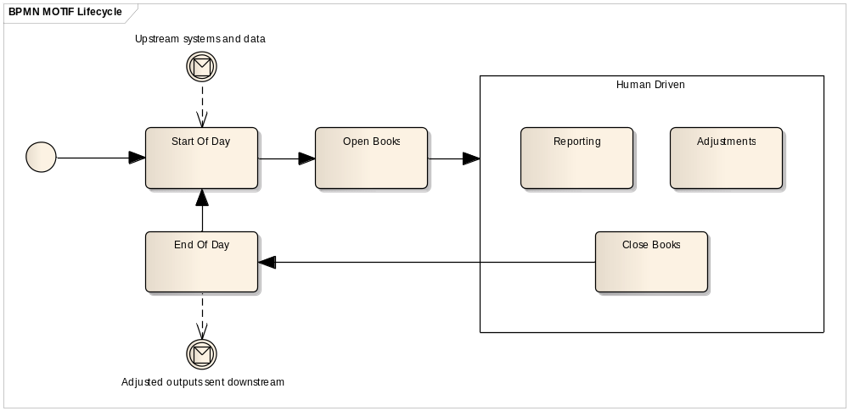
Figure 1 - MOTIF High-level lifecycle
Three main batch phases in MOTIF:
- SOD Static – Start of day, static batch (static data load and replication, market data load, technical day setup – prepare for balance sheet and P&L generation, etc.).
- SOD Transactional – Start of day, transactional batch (loads all the transactional data, i.e. trades, cash and measures, etc.).
- EOD – End of day process (prepare adjusted entity, calculate and post netting, roll business day, etc.).

Complexity of process dependencies
The MOTIF processes are executed with a certain granularity. Processes can be executed on global level (course grained, highest granularity), legal entity level or masterbook level (finest granularity).
The process dependencies are the most complex part of the inter-process section of the current (old) Management Service. Dependencies can be the same granularity, but also cross granularity (for example global process depending on n masterbook level processes). Implementation of the cross granularity handling the respective process execution was integral part of the old Management Service.
The new proposed Management Service architecture moves this difficult process dependency related logic to the MOTIF Event Manager (MEM) component so that the proposed BPM component will not need to deal with these difficulties at all. The BPM engine will simply execute the defined process based on the incoming message (see details in section below).

BPM Requirements Summary
Main requirements for the BPM tool are as follows:
[F] – functional requirements
[NF] – nonfunctional requirements
- Ability to execute BPMN 2.0 modeled processes [F]
(see paragraph below)
- Ability to execute sub-flows within a process ‘activity’ as well as ‘simple API invocation’ [F]
(see paragraph below)
- Categorization of the runtime processes in a hierarchy (historic / active) [F]
(see paragraph below)
- Real-time illustration of the runtime process diagrams [F]
(see paragraph below)
- Operational control (re-run, suspend, resume) functionality, robust and easy to use UI [F]
(see paragraph below)
- Producing threshold alerts to external systems [F]
(see paragraph below)
- Runtime environment which is easy to install, use and maintain; managing both work load management as well as instance load balancing [NF]
(see paragraph below)
- High performance and scalability [NF]
(see paragraph below)
- Easy development and customization [NF]
(see paragraph below)
- Testability of the processes [F]
(see paragraph below)
- Process reporting and statistics, detailed audit log [F]
(see paragraph below)
- Support, documentation, training [NF]
(see paragraph below)

New Management Service Architecture Proposal

MA / MR Initiative
The current MOTIF architecture comprised of functionality from two different areas, serving both SOD/EOD batch processing (accounting) as well as intra-day human interaction based processing (reporting).
The purpose of the MA/MR initiative is to decouple these two distinct system parts, split the current MOTIF into two parts and build de facto two products – MOTIF Accounting and MOTIF Reporting.

Context in which the BPM product will be used
The requested BPM Tool will be running on MOTIF cluster nodes, receiving input notifications from the MEM/WLM components. This architecture means that the BPM engine is intrinsically clustered.
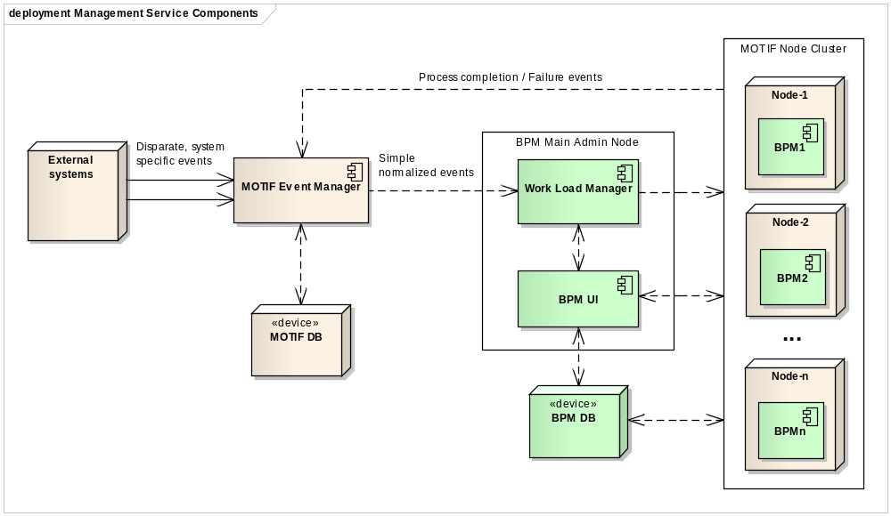
Figure 2 - BPM Component context
The MOTIF Event Manager (MEM) component holds Events (short-term) and Entities (long-term) and drives process creation aiming to do it “as soon as possible”. The component will consume business events from a number of sources; externally from the Enterprise Service Bus and RFDW (Risk and Finance Data Warehouse), internally from MOTIF in the form of process completion events.
The MEM aggregates (e.g. all Masterbooks for a Legal Entity) and correlates (e.g. Cash and Trades for a Masterbook) the business events in order to generate new simple normalized MOTIF triggering events (e.g. Accountable Cash available) which have 1-to-1 triggering rate to the BPM processes and contain details and shared state information for the entire process workflow. Hereby the MEM component entirely takes responsibility for the business process dependency handling and cross-granularity dependencies.

MEM/BPM interface
The MEM and BPM components will be two loosely coupled components communicating using messaging. BPM receives messages (process triggers) sent by MEM. The MEM component as well as MEM/BPM interface will be implemented by Barcap.
Despite the MEM/BPM factual independence, the BPM UI application should serve as an unified UI to the entire platform. Therefore it should support common view to both MEM as well as BPM components. Means the UI should be customizable to such an extent so that MEM events can be viewed and browsed in the BPM UI. See section 7.14.1 for additional details.

BPM Component Coverage
From the BPM Tool we expect not only covering the actual BPM engine and BPMN execution, but also a comprehensive User Interface and Workload management.
The Workload Manager (WLM) is a load balancing and scheduling component (expected to exist within the BPM solution) that ensures efficient and stable process execution on the cluster nodes. The workflow is assigned to a single server instance where it will actually run. Data notifications would also be routed to the running instance. The priority queue implementation in WLM will not only intelligently takes the task weighting into consideration, but also considers the historical executions. Also any SLA breaches for the event delivery should factor into the prioritization process.
The BPM execution engines will be running on the cluster nodes, executing the BPMN 2.0 based processes. Logic is executed locally underneath the instance.

BPM Terminology
Process definition – Collection of activities and logic assembled as a BPMN 2.0 model. It can be instantiated given a triggering source event.
Process – Process definition instance. These are idempotent by design, whereby 2nd+ runs start by running the logical reversal compensation for any accounting generated from the first run by the same granularity.
Activity – An executable action (task) within the Process.

Short vs. long running processes
The processes running within the BPM engine are of two types – short-living and long-living.
Short-living processes are part of the MOTIF Accounting (MA) part, implement the SOD and EOD batch processing. These conduct a set of quickly running end-to-end activities (minutes).
Long-living processes are part of the MOTIF Reporting (MR) part, de-facto implement state machines and hold state of entities. Example of such a long-running process might be the Masterbook state model (processes holding the state for respective masterbook and period). This book state model is used for instance within the MOTIF UI where it allows the user to act upon the book, move the book to different status. The long-living processes can be running for a very long time (days to months in some rare/extreme cases). We expect ~30,000 of such a long-running processes per day (corresponds to number of Masterbooks in the system).
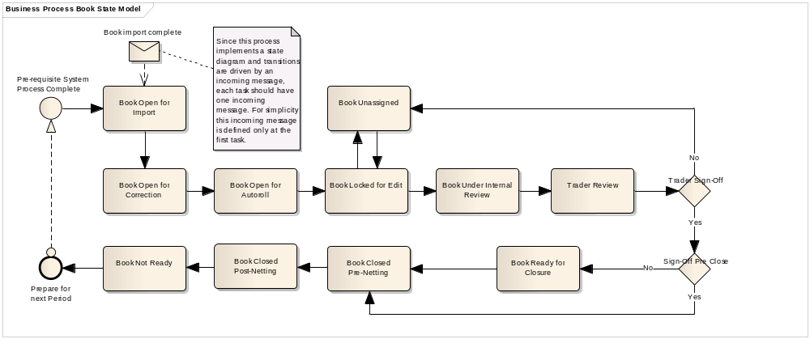
Figure 3 - Example of a long running process (book state model)

Statement of need
The essential purpose of Management Service is orchestration of the distributed processes. The BPM engine should constitute an essential part of the Management Service, executing the processes based on the incoming event messages. The processes are modeled using the BPMN 2.0 language. The BPM Tool needs to accommodate the current business processes (by mean of their import) and align them with the “as-built” model.
The processes orchestrated by Management Service need to be easy to monitor, understand quickly whether a process has been running too long or has failed. This is closely coupled with the ability to quickly and efficiently handle the rerun / retry actions for the RTB team. Ideally the RTB team need to understand quickly what is the problem within the processing, go to detail if necessary and contact the team responsible for the respective component executed by the process.

Detailed requirements

BPMN 2.0 support
The Tool needs to fully support BPMN 2.0 which will be a core business process modeling language used within MOTIF on both business as well as implementation sides.
The processes on L2 (higher business) level are created by business analysts in Sparx Enterprise Architect CASE tool. The BPM Tool needs to support the BPMN to such an extent that the Process Team is able to design the same processes on L3 (executable / implementation) level.
This means the BPM tool needs to support BPMN 2.0 import of models and any associated diagrams exported from other tools (EA 9 in our case).
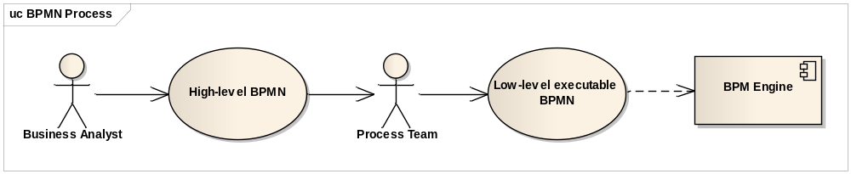
Figure 4 - BPMN Support

Process activity execution
The BPM tool should be able to execute each activity (task) in a process as:
- Simple API invocation
- Nested activity sub-flow for complex activities (one activity need to execute more services in the same process context as one atomic operation)
The BPM tool should possess proper event and exception handling capabilities.

Operational visibility

Process categorization
The BPM Tool should be able to provide an exact and illustrative picture about the active as well as historical processes. We expect ~10⁶ of process instances being executed/instantiated in the system every day. The UI therefore needs to be capable of handling a very large number of processes with reasonable response times (gradual loading on demand).
The processes need to be categorized in a tree structure, user can browse the processes, expand and collapse the tree, see the execution history, see the entire course grained picture, open the sub-processes, etc. (see Figure 5 - Process Tree depicting the nested processes).
Ideally the granularity (Masterbook vs. Business Line) should be able to be presented as a Pivot Table rather than a sub-tree.
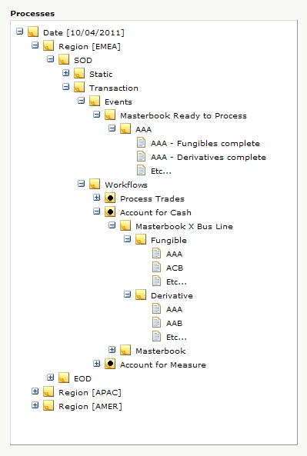
Top level categorization by Date and Region
Group of processes (SOD Transaction)
Events generated by the MEM component are also part of the BPM UI as mentioned in paragraph 5.3.1.
Process Account For Cash under the SOD Transaction category
Process instance executed in the given granularity (asset class Fungible, book AAA)
Figure 5 - Process Tree depicting the nested processes

Process visibility
The Tool needs to be able to depict visually the processes in the current processing stage including the status of the respective processes and tasks (see Figure 6 - BPM process in progress).
The status of process instances is reflected in the tree and after drilling down the hierarchy the user can open the respective process instance and see the process status in real time, what activities fail
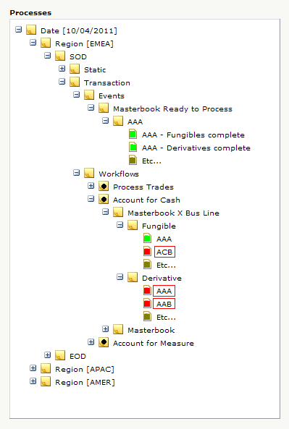

Process instance which failed
(failed activity floating hint describes details)
Figure 6 - BPM process in progress

Operational Control
The support team will be able to use the UI application to monitor the processing status. The Tool needs to support the functions for accurate operational control of the processes.
The user will be able to start / stop, suspend / resume and rerun the process. Ideally, if technically possible, these operations should work on the entire process as well as on the particular activity/task within the process.
Apart from pure re-run, the tool should be capable of running and manage “version 2” of the process flow (for example caused by an intra-day data delivery).

Front-end UI
User-friendly UI allows users to see the process repository and review the current processing stage. The UI needs to possess powerful and robust user access permissions settings including user groups with different permissions and access rights.
Ideally the UI application should be customizable in terms of the authorization process with the internal company authorization Single-Sign-On solutions.
Extension points for custom improvements in the Tool will be important part of the assessment process as well as possibilities for easy look and feel customization. It should be easy to implement custom parts in the UI, therefore the UI needs to be implemented using an UI framework which will be part of the BPM product documentation.
Example of such an UI extension: The BPM UI should be able to list the events sent from MEM to BPM as described in section above and depicted on Figure 5 above (MEM triggering events are part of a single tree structure together with workflows). This assumes therefore a custom UI extension allowing to display custom data from database in the UI.
With each activity/process there should be a possibility to save meta-data related to the particular entity indicating some further information about the process. This meta-data can be displayed on ‘Mouse Over’, for instance in order to guide the operating team as to how to handle such a failure (see Figure 6 - BPM process in progress for an example of floating hint on a failed activity.

Threshold alerts
The BPM tool should allow defining SLA criteria on the processes. The engine should generate threshold alerts to external systems in case of SLA breach.

BPM engine runtime environment
The BPM Tool needs to be capable of running on one of the widely used application servers or needs to be shipped with a runtime environment which ensures easy administration, deployment and scalability. The ability to handle growing amounts of processes in a graceful manner should be presented illustratively including the failover handling.
As described in the section above, the BPM tool should be capable of managing the cluster workload and act as load balancer in the cluster (WLM component). This feature should be shown as part of the PoC solution together with its management.
Related to the cluster management capabilities, the PoC should also clearly describe the HA (High Availability) and DR (Disaster Recovery) strategies.

Performance and scalability
Because of the high number of processes executed in the cluster simultaneously we expect the BPM engine to perform extremely well with low latency. Both BPM engine as well as BPM UI front-end will be in scope for the performance tests. A performance and scalability analysis is also expected to be delivered as part of the answer to this document.

Situation
We are anticipating 30,000 masterbooks and 5 business lines (asset classes) meaning we are looking at ~10⁶ process instances per day, meaning ~10⁷ tasks / transitions / interactions (~10 tasks per process) per day.
It is also noted that this is not spread out evenly across the day but rather in three 2-hour processing slots (one for each regional close).

BPM Engine performance
The BPM engine performance should be measured in these aspects:
- Process execution performance: how many of short lived execution cycles per JVM/CPU can the BPM engine perform (demo / stress test); we expect a simple process with 10 dummy activities to be executed sequentially in a loop (1, 10, 100, 1000 times), the process should be kicked in by a message/event (ideally JMS). Execution times should grow in linear manner and a single execution of such a simple process should not take more than 1s. This should prove that the processing engine overhead costs are reasonable.
- Performance vs. process instances: the previously mentioned dummy process should be executed in various number of instances in parallel (various number of concurrently running process instances within a single BPM engine); the output should be a graph describing performance of one process (execution time). This should prove that increasing number of concurrently running instances do not exponentially deteriorate the performance.

BPM UI performance
- High UI responsiveness (90% of regular requests <2s response, 10% of high-demanding requests in <5s)
- Responsivness of the UI under a stress test simulating a defined number of concurrent users (1, 5, 10)
- Ability to handle/display the high number of process instances (high-level picture, on-demand partial load when drilling down to details)

Scalability
The scalability requirements must be clearly proven in the PoC from the following aspects:
Horizontal scalability: prove the ability to gain throughput in a linear manner as extra instances are added to the cluster.
State scalability: state scalability should be flat, i.e. historic number of processes does not adversely effect throughput of cluster.
Concurrency scalability: given threads available give the ‘yield graph’ – i.e. peak TPS concurrent operations Vs physical available cores in cluster – and ‘break’ point and coefficient of descaling performance post break.

Development and customization
The BPM Tool and all its components and modules should to be “API oriented” and open for customizations (extension points and internal API are required). The actual BPM runtime engine should be accessible using JMX, REST web-services or any other reasonable interface for other internal firm’s applications, tools and systems if these want to cooperate in any way.
Developers should be able to quickly understand the BPM engine development environment and implement the customizations. Therefore the Tool should be supported by plug-ins and development tools (ideally integrated with the major IDEs like Eclipse or IntelliJ IDEA).
The installation of the BPM development supporting tools should be easy enough, the development environment should be executable on a regular developer’s machine (Xeon 3.4 GHz, 2GB RAM).

Testing and debugging

Unit testing and integration testing
The processes within the BPM repository need to be easily testable. The degree to which the BPM tool supports testing in a given test context will be an important part of the assessment.
Any testing framework to test the processes entirely and partially is highly required. The processes will be subject to both unit tests as well as integration tests.
Unit test framework should allow to test:
- the state of a process instance
- which node instances are currently active
- which nodes have been triggered (to check the path that has been followed)
- get the value of process variables, etc.
The testing framework should be integrated with major platform standards (JUnit in case of Java). Also, easy integration with major Continuous Integration servers (namely TeamCity) should be supported.
Testing integration with external services, invocation of external services and domain specific services should be simple, straightforward and should not mean to change the actual processes. Often testing or mock services are used for testing and these need to be “pluggable” in a declarative way (configuration, no code change). For this purpose we expect a support for “registered handlers” which define how to execute the nodes. These handlers may be different depending on the context, allowing using testing handlers for unit testing the processes.
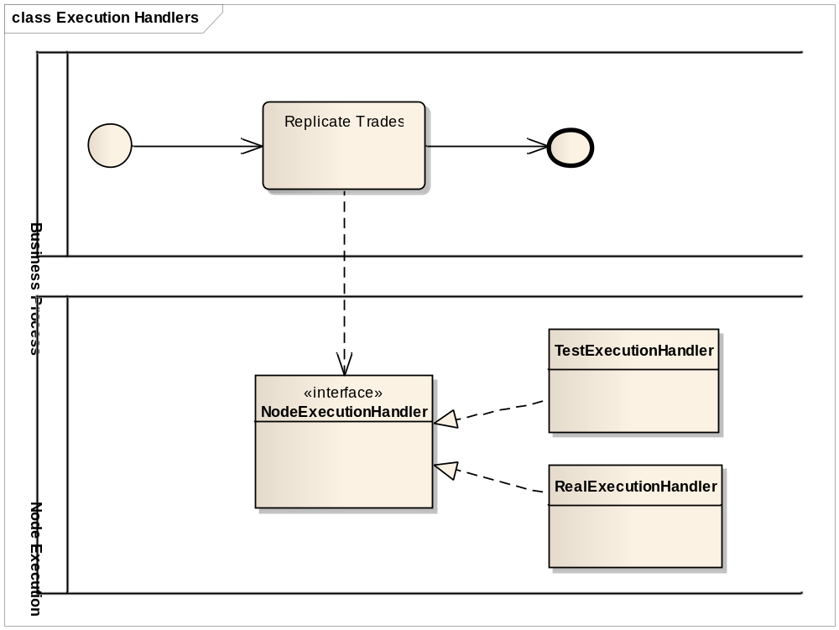
Figure 7 - Unit testing and Execution Handlers

Debugging
Ideally the developers implementing processes should be able to debug the processes easily, for example using a plugin in a major IDE (Eclipse, IntelliJ IDEA). The current state of the running processes can be inspected and visualized during execution, ideally with possibility to put breakpoints inside the process. At these breakpoints developers can then inspect the internal state of all process instances.

Process repository
Processes need to be stored in a Process repository. Each process is a versioned entity; users can update the process whereby the old versions still need to be available for review in the process history.
Preferred way to store the processes is database. Even though the database will be Oracle (strategic database in Barclays Capital, used also for other parts within MOTIF), the database agnostic solution is highly preferred in order to be able to switch to a different database (in-memory) in case of local unit testing for example.

Reporting, auditing
Part of the BPM Tool needs to be a powerful reporting solution allowing the users to generate various reports summarizing the daily runs, execution times (fine grained, course grained), review the percentage statistics of processes, etc.
All activities conducted within the system, either automatically or manually, needs to be logged properly and the UI application should provide a reasonable interface to browse through the logs for auditing purposes

Support, documentation
The vendor should be able to support the Barcap team at the initial stage of the product installation, configuration and customization. We look for comprehensive documentation, example solutions, advice on implementation best-practices, training for developers and process designers, etc.

