
BPM Tool for MOTIF
Requirements
MOTIF Management Services
Finance IT, Barclays Capital

October 11, 2011
Version 1.0

Contents
Table of Figures 3
Confidentiality 4
1 Introduction 5
1.1 Purpose of the document 5
1.2 Abbreviation and terminology 5
1.3 What is expected 5
1.4 Contacts 6
2 About MOTIF 7
2.1 Barclays Capital 7
2.2 MOTIF Project 7
2.3 Management Service 7
2.4 MOTIF lifecycle 7
3 BPM Requirements Summary 9
4 New Management Service Architecture Proposal 10
4.1 MA / MR Initiative 10
4.2 Context in which the BPM product will be used 10
4.3 Short vs. long running processes 11
4.4 Statement of need 12
5 Detailed requirements 13
5.1 BPMN 2.0 support 13
5.2 Operational visibility 13
5.3 Operational Control 15
5.4 BPM engine runtime environment 16
5.5 Performance and scalability 16
5.6 Development and customization 17
5.7 Testing and debugging 18
5.8 Reporting, auditing 19
5.9 Support, documentation 20

Table of Figures
Figure 1 - MOTIF High-level lifecycle 8
Figure 2 - BPM Component context 10
Figure 3 - Example of a long running process (book state model) 12
Figure 4 - BPMN Support 13
Figure 5 - Process Tree depicting the nested processes 14
Figure 6 - BPM process in progress 15
Figure 7 - Unit testing and Execution Handlers 19

Confidentiality
All information included in this document is confidential and only for the recipient knowledge. No information included in this document or in discussions connected to it may be disclosed to any other party.

Introduction

Purpose of the document
With this document we request information regarding your company and your BPM products. The document explains basic requirements we have for the BPM tool.

Abbreviation and terminology
Term | Description
BPM | Business Process Management
BPMN 2.0 | Business Process Model and Notation v2.0, supporting BPMN execution
BS | Balance Sheet
P&L | Profit and Loss
MEM | MOTIF Event Manager
WLM | Work Load Management
EA | Sparx Enterprise Architect CASE tool
BTB | Build The Bank team (development)
RTB | Run The Bank team (support)
SOD | Start of the day
EOD | End of the day
FC | Financial Control
PC | Product Control
MA | MOTIF Accounting
MR | MOTIF Reporting

What is expected
The answer to this document is expected to be delivered as:
- MS PowerPoint presentation slides describing your company, the BPM tool and the PoC solution built (both high-level architecture as well as implementation details).
- Supporting product documentation in PDF, MS Word or HTML format.
- Working demo/PoC of the BPM tool in context of the given business domain.
- Performance and scalability analysis as per the section below.
- Information about product licensing and pricing.
The PoC should be implemented and presented on vendor’s cost.

Contacts
Kieran Beltran
MOTIF Director and Technical Leader
Email: kieran.beltran@barclayscapital.com
Office: +1 212 320 6693
Tim Griffith
Management Service Team Lead
Email: tim.griffith@barclayscapital.com
Office: +1 212 320 9915
Adam Healey
MOTIF Architect
Email: adam.healey@barclayscapital.com
Office: +44 20-777 33105
Lukas Kubasek
Management Service Developer
Email: lukas.kubasek@barclayscapital.com
Office: +1 212 412 2804

About MOTIF

Barclays Capital
Barclays Capital is the investment banking division of Barclays Bank PLC. With a distinctive business model, Barclays Capital provides large corporate, government and institutional clients with a full spectrum of solutions to their strategic advisory, financing and risk management needs.
Barclays Capital has offices around the world, employs over 23,000 people and has the global reach, advisory services and distribution power to meet the needs of issuers and investors worldwide. For further information about Barclays Capital, please visit our website www.barclayscapital.com.

MOTIF Project
From business perspective MOTIF is a bespoke Finance initiative with the primary objectives of integrating the Financial Control (FC) and Product Control (PC) process, facilitating the compilation of a daily balance sheet and providing a single source of balance sheet and P&L data across Barclays Capital.
From technical perspective MOTIF is a key green-field project within Enterprise Solutions IT / Finance IT to replace a large number of disparate product control systems with a single, strategic application; a single bank-wide Sub Ledger. Based on Service Oriented Architecture (SOA) and stream processing principles MOTIF is providing an extremely scalable and extensible solution to better enable the banks increasingly rapid growth.

Management Service
Within MOTIF, the Management Service is responsible for the high-level process dependency management, processing resource workload management, process orchestration and choreography, technical exception handling and process performance monitoring.
Currently the Management Service is a bespoke project implemented partially in Tibco Business Events, partially as database logic in PL/SQL procedures and partially in Java code linking these two worlds together. The current solution suffers from indeterminism, insufficient operational control and unclear visibility. Also in general the Management Service is not understood across the RTB as well as BTB teams.
The new suggested solution based on Business Process Management tool, BPMN 2.0 processes and cluster principles should address all these issues. The new proposed Management Service architecture (MEM, WLM and BPM components) is explained in section below.

MOTIF lifecycle
MOTIF is an overnight automated event based system which builds up the general ledger. It also allows an UI driven reporting and adjustments (.NET based desktop application).
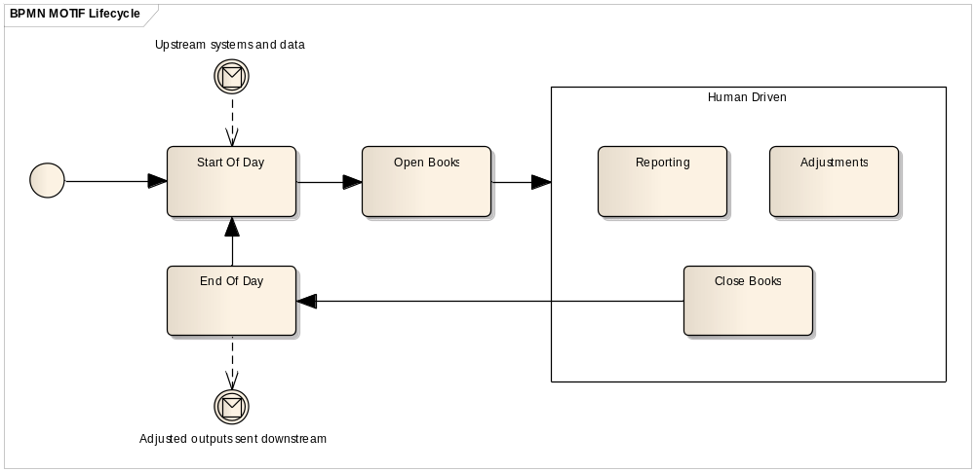
Figure 1 - MOTIF High-level lifecycle
Three main batch phases in MOTIF:
- SOD Static – Start of day, static batch (static data load and replication, market data load, technical day setup – prepare for balance sheet and P&L generation, etc.).
- SOD Transactional – Start of day, transactional batch (loads all the transactional data, i.e. trades, cash and measures, etc.).
- EOD – End of day process (prepare adjusted entity, calculate and post netting, roll business day, etc.).

Complexity of process dependencies
The MOTIF processes are executed with a certain granularity. Processes can be executed on global level (course grained, highest granularity), legal entity level or masterbook level (finest granularity).
The process dependencies are the most complex part of the inter-process section of the current (old) Management Service. Dependencies can be the same granularity, but also cross granularity (for example global process depending on n masterbook level processes). Implementation of the cross granularity handling the respective process execution was integral part of the old Management Service.
The new proposed Management Service architecture moves this difficult process dependency related logic to the MOTIF Event Manager (MEM) component so that the proposed BPM component will not need to deal with these difficulties at all. The BPM engine will simply execute the defined process based on the incoming message (see details in section below).

BPM Requirements Summary
Main requirements for the BPM tool are as follows:
[F] – functional requirements
[NF] – nonfunctional requirements
- Ability to execute BPMN 2.0 modeled processes [F]
(see paragraph below)
- Ability to execute sub-flows within a process ‘activity’ as well as ‘simple API invocation’ [F]
(see paragraph below)
- Categorization of the runtime processes in a hierarchy (historic / active) [F]
(see paragraph below)
- Real-time illustration of the runtime process diagrams [F]
(see paragraph below)
- Operational control (re-run, suspend, resume) functionality, robust and easy to use UI [F]
(see paragraph below)
- Producing threshold alerts to external systems [F]
(see paragraph below)
- Runtime environment which is easy to install, use and maintain; managing both work load management as well as instance load balancing [NF]
(see paragraph below)
- High performance and scalability [NF]
(see paragraph below)
- Easy development and customization [NF]
(see paragraph below)
- Testability of the processes [F]
(see paragraph below)
- Process reporting and statistics, detailed audit log [F]
(see paragraph below)
- Support, documentation, training [NF]
(see paragraph below)

New Management Service Architecture Proposal

MA / MR Initiative
The current MOTIF architecture comprised of functionality from two different areas, serving both SOD/EOD batch processing (accounting) as well as intra-day human interaction based processing (reporting).
The purpose of the MA/MR initiative is to decouple these two distinct system parts, split the current MOTIF into two parts and build de facto two products – MOTIF Accounting and MOTIF Reporting.

Context in which the BPM product will be used
The requested BPM Tool will be running on MOTIF cluster nodes, receiving input notifications from the MEM/WLM components. This architecture means that the BPM engine is intrinsically clustered.
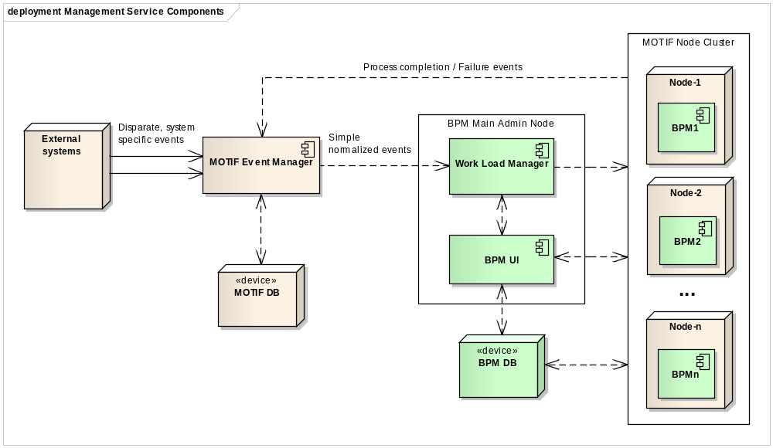
Figure 2 - BPM Component context
The MOTIF Event Manager (MEM) component holds Events (short-term) and Entities (long-term) and drives process creation aiming to do it “as soon as possible”. The component will consume business events from a number of sources; externally from the Enterprise Service Bus and RFDW (Risk and Finance Data Warehouse), internally from MOTIF in the form of process completion events.
The MEM aggregates (e.g. all Masterbooks for a Legal Entity) and correlates (e.g. Cash and Trades for a Masterbook) the business events in order to generate new simple normalized MOTIF triggering events (e.g. Accountable Cash available) which have 1-to-1 triggering rate to the BPM processes and contain details and shared state information for the entire process workflow. Hereby the MEM component entirely takes responsibility for the business process dependency handling and cross-granularity dependencies.

MEM/BPM interface
The MEM and BPM components will be two loosely coupled components communicating using messaging. BPM receives messages (process triggers) sent by MEM. The MEM component as well as MEM/BPM interface will be implemented by Barcap.
Despite the MEM/BPM factual independence, the BPM UI application should serve as an unified UI to the entire platform. Therefore it should support common view to both MEM as well as BPM components. Means the UI should be customizable to such an extent so that MEM events can be viewed and browsed in the BPM UI. See section 5.3.1 for additional details.

BPM Component Coverage
From the BPM Tool we expect not only covering the actual BPM engine and BPMN execution, but also a comprehensive User Interface and Workload management.
The Workload Manager (WLM) is a load balancing and scheduling component (expected to exist within the BPM solution) that ensures efficient and stable process execution on the cluster nodes. The workflow is assigned to a single server instance where it will actually run. Data notifications would also be routed to the running instance. The priority queue implementation in WLM will not only intelligently takes the task weighting into consideration, but also considers the historical executions. Also any SLA breaches for the event delivery should factor into the prioritization process.
The BPM execution engines will be running on the cluster nodes, executing the BPMN 2.0 based processes. Logic is executed locally underneath the instance.

BPM Terminology
Process definition – Collection of activities and logic assembled as a BPMN 2.0 model. It can be instantiated given a triggering source event.
Process – Process definition instance. These are idempotent by design, whereby 2nd+ runs start by running the logical reversal compensation for any accounting generated from the first run by the same granularity.
Activity – An executable action (task) within the Process.

Short vs. long running processes
The processes running within the BPM engine are of two types – short-living and long-living.
Short-living processes are part of the MOTIF Accounting (MA) part, implement the SOD and EOD batch processing. These conduct a set of quickly running end-to-end activities (minutes).
Long-living processes are part of the MOTIF Reporting (MR) part, de-facto implement state machines and hold state of entities. Example of such a long-running process might be the Masterbook state model (processes holding the state for respective masterbook and period). This book state model is used for instance within the MOTIF UI where it allows the user to act upon the book, move the book to different status. The long-living processes can be running for a very long time (days to months in some rare/extreme cases). We expect ~30,000 of such a long-running processes per day (corresponds to number of Masterbooks in the system).
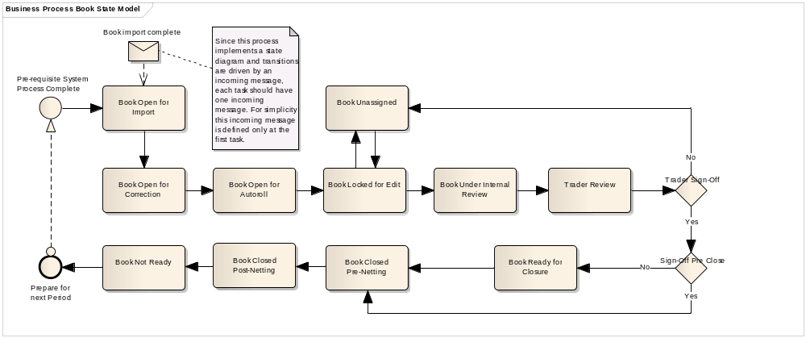
Figure 3 - Example of a long running process (book state model)

Statement of need
The essential purpose of Management Service is orchestration of the distributed processes. The BPM engine should constitute an essential part of the Management Service, executing the processes based on the incoming event messages. The processes are modeled using the BPMN 2.0 language. The BPM Tool needs to accommodate the current business processes (by mean of their import) and align them with the “as-built” model.
The processes orchestrated by Management Service need to be easy to monitor, understand quickly whether a process has been running too long or has failed. This is closely coupled with the ability to quickly and efficiently handle the rerun / retry actions for the RTB team. Ideally the RTB team need to understand quickly what is the problem within the processing, go to detail if necessary and contact the team responsible for the respective component executed by the process.

Detailed requirements

BPMN 2.0 support
The Tool needs to fully support BPMN 2.0 which will be a core business process modeling language used within MOTIF on both business as well as implementation sides.
The processes on L2 (higher business) level are created by business analysts in Sparx Enterprise Architect CASE tool. The BPM Tool needs to support the BPMN to such an extent that the Process Team is able to design the same processes on L3 (executable / implementation) level.
This means the BPM tool needs to support BPMN 2.0 import of models and any associated diagrams exported from other tools (EA 9 in our case).
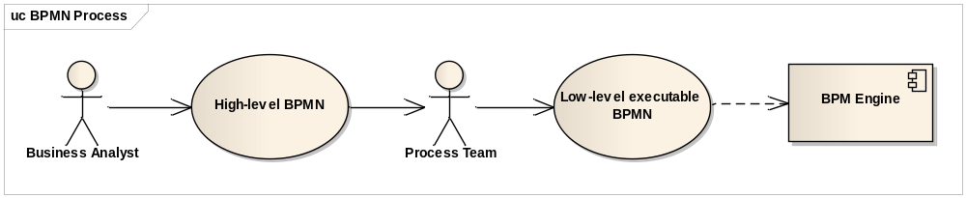
Figure 4 - BPMN Support

Process activity execution
The BPM tool should be able to execute each activity (task) in a process as:
- Simple API invocation
- Nested activity sub-flow for complex activities (one activity need to execute more services in the same process context as one atomic operation)
The BPM tool should possess proper event and exception handling capabilities.

Operational visibility

Process categorization
The BPM Tool should be able to provide an exact and illustrative picture about the active as well as historical processes. We expect ~10⁶ of process instances being executed/instantiated in the system every day. The UI therefore needs to be capable of handling a very large number of processes with reasonable response times (gradual loading on demand).
The processes need to be categorized in a tree structure, user can browse the processes, expand and collapse the tree, see the execution history, see the entire course grained picture, open the sub-processes, etc. (see Figure 5 - Process Tree depicting the nested processes).
Ideally the granularity (Masterbook vs. Business Line) should be able to be presented as a Pivot Table rather than a sub-tree.
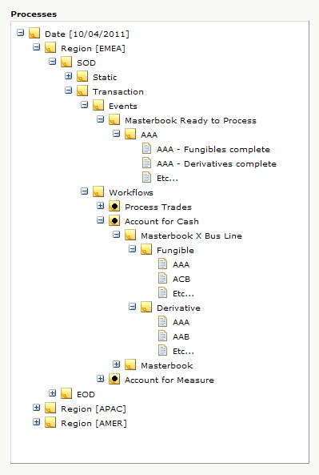
Top level categorization by Date and Region
Group of processes (SOD Transaction)
Events generated by the MEM component are also part of the BPM UI as mentioned in paragraph 5.3.1.
Process Account For Cash under the SOD Transaction category
Process instance executed in the given granularity (asset class Fungible, book AAA)
Figure 5 - Process Tree depicting the nested processes

Process visibility
The Tool needs to be able to depict visually the processes in the current processing stage including the status of the respective processes and tasks (see Figure 6 - BPM process in progress).
The status of process instances is reflected in the tree and after drilling down the hierarchy the user can open the respective process instance and see the process status in real time, what activities fail
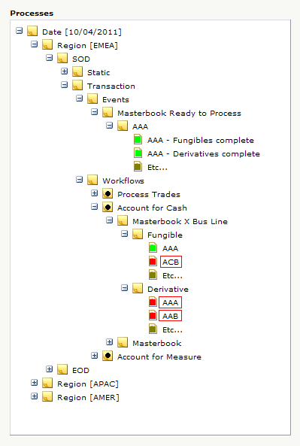

Process instance which failed
(failed activity floating hint describes details)
Figure 6 - BPM process in progress

Operational Control
The support team will be able to use the UI application to monitor the processing status. The Tool needs to support the functions for accurate operational control of the processes.
The user will be able to start / stop, suspend / resume and rerun the process. Ideally, if technically possible, these operations should work on the entire process as well as on the particular activity/task within the process.
Apart from pure re-run, the tool should be capable of running and manage “version 2” of the process flow (for example caused by an intra-day data delivery).

Front-end UI
User-friendly UI allows users to see the process repository and review the current processing stage. The UI needs to possess powerful and robust user access permissions settings including user groups with different permissions and access rights.
Ideally the UI application should be customizable in terms of the authorization process with the internal company authorization Single-Sign-On solutions.
Extension points for custom improvements in the Tool will be important part of the assessment process as well as possibilities for easy look and feel customization. It should be easy to implement custom parts in the UI, therefore the UI needs to be implemented using an UI framework which will be part of the BPM product documentation.
Example of such an UI extension: The BPM UI should be able to list the events sent from MEM to BPM as described in section above and depicted on Figure 5 above (MEM triggering events are part of a single tree structure together with workflows). This assumes therefore a custom UI extension allowing to display custom data from database in the UI.
With each activity/process there should be a possibility to save meta-data related to the particular entity indicating some further information about the process. This meta-data can be displayed on ‘Mouse Over’, for instance in order to guide the operating team as to how to handle such a failure (see Figure 6 - BPM process in progress for an example of floating hint on a failed activity.

Threshold alerts
The BPM tool should allow defining SLA criteria on the processes. The engine should generate threshold alerts to external systems in case of SLA breach.

BPM engine runtime environment
The BPM Tool needs to be capable of running on one of the widely used application servers or needs to be shipped with a runtime environment which ensures easy administration, deployment and scalability. The ability to handle growing amounts of processes in a graceful manner should be presented illustratively including the failover handling.
As described in the section above, the BPM tool should be capable of managing the cluster workload and act as load balancer in the cluster (WLM component). This feature should be shown as part of the PoC solution together with its management.
Related to the cluster management capabilities, the PoC should also clearly describe the HA (High Availability) and DR (Disaster Recovery) strategies.

Performance and scalability
Because of the high number of processes executed in the cluster simultaneously we expect the BPM engine to perform extremely well with low latency. Both BPM engine as well as BPM UI front-end will be in scope for the performance tests. A performance and scalability analysis is also expected to be delivered as part of the answer to this document.

Situation
We are anticipating 30,000 masterbooks and 5 business lines (asset classes) meaning we are looking at ~10⁶ process instances per day, meaning ~10⁷ tasks / transitions / interactions (~10 tasks per process) per day.
It is also noted that this is not spread out evenly across the day but rather in three 2-hour processing slots (one for each regional close).

BPM Engine performance
The BPM engine performance should be measured in these aspects:
- Process execution performance: how many of short lived execution cycles per JVM/CPU can the BPM engine perform (demo / stress test); we expect a simple process with 10 dummy activities to be executed sequentially in a loop (1, 10, 100, 1000 times), the process should be kicked in by a message/event (ideally JMS). Execution times should grow in linear manner and a single execution of such a simple process should not take more than 1s. This should prove that the processing engine overhead costs are reasonable.
- Performance vs. process instances: the previously mentioned dummy process should be executed in various number of instances in parallel (various number of concurrently running process instances within a single BPM engine); the output should be a graph describing performance of one process (execution time). This should prove that increasing number of concurrently running instances do not exponentially deteriorate the performance.

BPM UI performance
- High UI responsiveness (90% of regular requests <2s response, 10% of high-demanding requests in <5s)
- Responsivness of the UI under a stress test simulating a defined number of concurrent users (1, 5, 10)
- Ability to handle/display the high number of process instances (high-level picture, on-demand partial load when drilling down to details)

Scalability
The scalability requirements must be clearly proven in the PoC from the following aspects:
Horizontal scalability: prove the ability to gain throughput in a linear manner as extra instances are added to the cluster.
State scalability: state scalability should be flat, i.e. historic number of processes does not adversely effect throughput of cluster.
Concurrency scalability: given threads available give the ‘yield graph’ – i.e. peak TPS concurrent operations Vs physical available cores in cluster – and ‘break’ point and coefficient of descaling performance post break.

Development and customization
The BPM Tool and all its components and modules should to be “API oriented” and open for customizations (extension points and internal API are required). The actual BPM runtime engine should be accessible using JMX, REST web-services or any other reasonable interface for other internal firm’s applications, tools and systems if these want to cooperate in any way.
Developers should be able to quickly understand the BPM engine development environment and implement the customizations. Therefore the Tool should be supported by plug-ins and development tools (ideally integrated with the major IDEs like Eclipse or IntelliJ IDEA).
The installation of the BPM development supporting tools should be easy enough, the development environment should be executable on a regular developer’s machine (Xeon 3.4 GHz, 2GB RAM).

Testing and debugging

Unit testing and integration testing
The processes within the BPM repository need to be easily testable. The degree to which the BPM tool supports testing in a given test context will be an important part of the assessment.
Any testing framework to test the processes entirely and partially is highly required. The processes will be subject to both unit tests as well as integration tests.
Unit test framework should allow to test:
- the state of a process instance
- which node instances are currently active
- which nodes have been triggered (to check the path that has been followed)
- get the value of process variables, etc.
The testing framework should be integrated with major platform standards (JUnit in case of Java). Also, easy integration with major Continuous Integration servers (namely TeamCity) should be supported.
Testing integration with external services, invocation of external services and domain specific services should be simple, straightforward and should not mean to change the actual processes. Often testing or mock services are used for testing and these need to be “pluggable” in a declarative way (configuration, no code change). For this purpose we expect a support for “registered handlers” which define how to execute the nodes. These handlers may be different depending on the context, allowing using testing handlers for unit testing the processes.
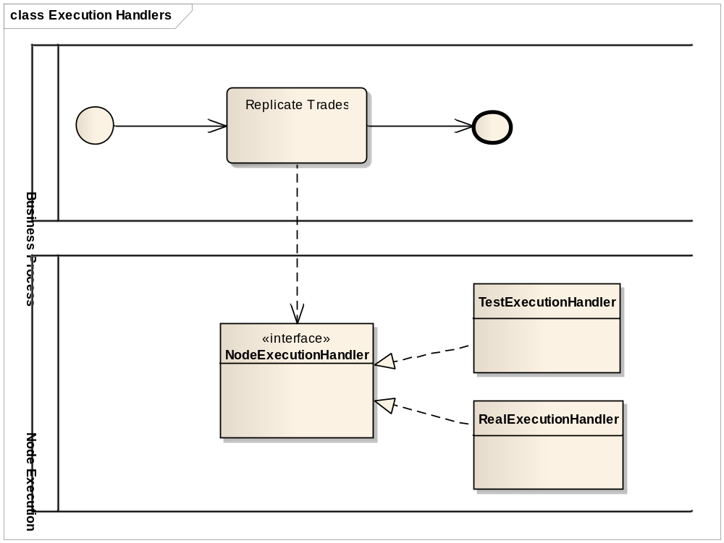
Figure 7 - Unit testing and Execution Handlers

Debugging
Ideally the developers implementing processes should be able to debug the processes easily, for example using a plugin in a major IDE (Eclipse, IntelliJ IDEA). The current state of the running processes can be inspected and visualized during execution, ideally with possibility to put breakpoints inside the process. At these breakpoints developers can then inspect the internal state of all process instances.

Process repository
Processes need to be stored in a Process repository. Each process is a versioned entity; users can update the process whereby the old versions still need to be available for review in the process history.
Preferred way to store the processes is database. Even though the database will be Oracle (strategic database in Barclays Capital, used also for other parts within MOTIF), the database agnostic solution is highly preferred in order to be able to switch to a different database (in-memory) in case of local unit testing for example.

Reporting, auditing
Part of the BPM Tool needs to be a powerful reporting solution allowing the users to generate various reports summarizing the daily runs, execution times (fine grained, course grained), review the percentage statistics of processes, etc.
All activities conducted within the system, either automatically or manually, needs to be logged properly and the UI application should provide a reasonable interface to browse through the logs for auditing purposes

Support, documentation
The vendor should be able to support the Barcap team at the initial stage of the product installation, configuration and customization. We look for comprehensive documentation, example solutions, advice on implementation best-practices, training for developers and process designers, etc.

