TIBCO BusinessEvents™
Enterprise Monitoring Example
Contents
Summary 3
The Nodes Explorer Hierarchy 3
EMM Metrics 5
Cluster Level Metrics 5
Machine Level Metrics 6
Process Level Metrics 6
Agent Level Metrics 7
Monitored Object Metrics 9
Configuration 10
Provided Files 10
Configuring the Monitored BusinessEvents Application Properties Files 10
Configuring the EMM Application Properties File 11
Configuring the Password (User Authentication) File 14
Configuring Preferences for Chart Display 14
Configuring Thresholds for Health Metrics 14
Configuring for EMM Project Customization 15
Running and Using the EMM Console 17
Running the EMM Console 17
Using the Enterprise Monitoring Console 17

Summary
This example demonstrates the use of a cluster monitoring application built using BusinessEvents. With the Enterprise Monitoring application you can monitor the health of running BusinessEvents applications that use Cache object management.
All cache cluster agents and nodes generate system metrics and make them available over the network for use by EMM. After configuring properties files, you startthe EMM engine and connect to the cluster using a web browser. At each level of the cluster hierarchy, various panes display the metrics graphically. You can rearrange the panes, and easily promote panes of special interest to the cluster overview to create a custom dashboard.

The Nodes Explorer Hierarchy
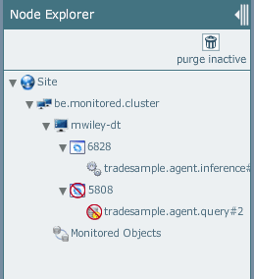
The Nodes Explorer screenshot above shows two processes (JVM nodes) on one machine, one of which is inactive. You can click the Purge Inactive button to remove inactive nodes from the display.
Site
Cluster
Machine
Process (that is JVM, Node)
Agent (inference, query, or cache
where:
- Site is the root and has no purpose in this release.
- Cluster shows the name of the cluster being monitored.
- Machine shows one or more machines within the cluster. They host the cluster nodes.
- Process shows each of the cluster nodes (JVM processes) deployed on a machine. The label is the process ID.
- Agent lists all agents of each type deployed in one EAR (one EAR instance deploys to one JVM process). Multiple inference agents and query agents can be deployed in one EAR. Cache servers show only one item at the agent level, that is, the cache server itself.

EMM Metrics
The various metrics shown at each level are briefly described in this section.
Charting Period: All charts display data for the previous ten minutes (or less if, for example EMM or a JVM has been running less than ten minutes).
Updates: EMM polls for updates and refreshes the display periodically. The interval is configurable (see Update Interval Properties on page 11).

Cluster Level Metrics
TO BE UPDATED WHEN NEW METRICS ETC IN PLACE
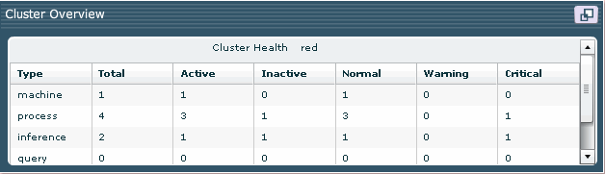
At the cluster level, the cluster overview displays summary information about the health of the cluster. For each type of item in the cluster (machines, processes, inference agents, query agents, and cache nodes), the following information displays:
- Total: total number of items (of this type).
- Active: total number of active items.
- Inactive: Total number of inactive items.
- Normal (green): Total number of items whose health falls above the threshold set for Warning.
- Warning (yellow): Total number of items whose health falls below the threshold set for Warning.
- Critical (red) : Total number of items whose health falls below the threshold set for Critical.
The thresholds for Normal, Warning, and Critical are set in the BE_HOME/emm/config/rulesconfig.xml file. See Configuring Thresholds for Health Metrics on page 14 for details.

Machine Level Metrics
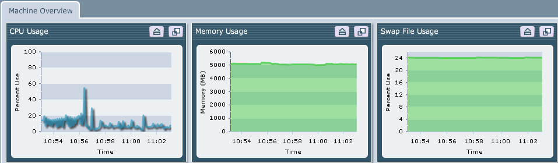
Note: Machine level metrics are visible only if a TIBCO Hawk domain has been configured. See TIBCO Hawk Domain Property on page 10 for details.
Machine level metrics shown are as follows:
- CPU Usage: CPU utilization, shown as a percentage.
- Memory Usage: Available memory, in megabytes.
- Swap File Usage: Available swap file (page file) usage , in megabytes.

Process Level Metrics
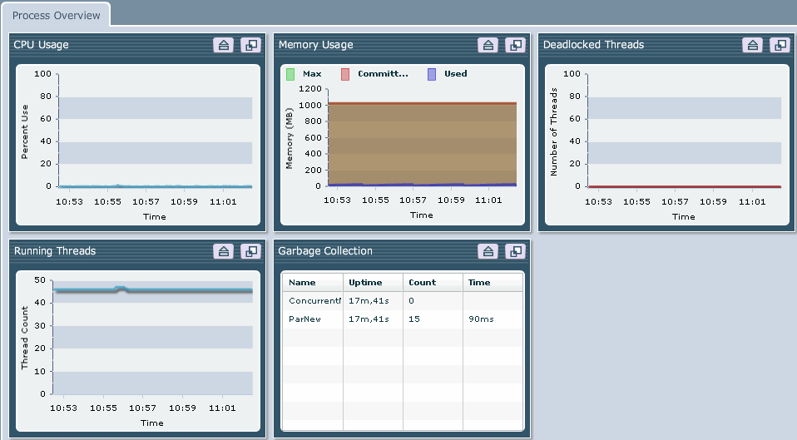
Process level metrics shown are as follows:
- CPU Usage: CPU utilization percentage for the process.
- Memory Usage: Max, Committed, and Used memory, in megabytes.
- Running Threads: The number of threads in the process, including system threads.
- Deadlocked Threads: The number of deadlocked threads in the process.
- Garbage Collection: For each garbage collector running in the process, metrics shown are: the total up time of the process, the number of objects garbage collected, and the cumulative time spent in garbage collection overall.

Agent Level Metrics
At the agent level, two tabs are shown for inference agents and query agents, and one tab is shown for cache nodes.

Agent Overview
The common tab shows the agent overview:
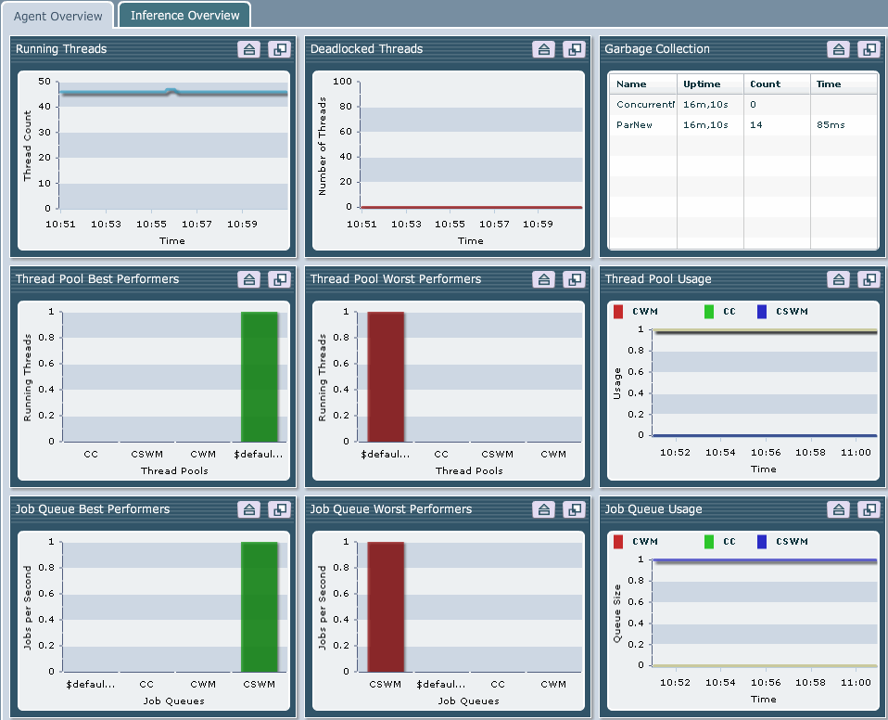
Note that the Running Threads, Deadlocked Threads, and Garbage Collection metrics are at the process level, provided here for a convenient overall view.
- Running Threads: The number of threads in the process, including system threads.
- Deadlocked Threads: The number of deadlocked threads in the process.
- Garbage Collection: For each garbage collector running in the process, metrics shown are: the total up time of the process, the number of objects garbage collected, and the cumulative time spent in garbage collection overall.
- Thread Pool Best Performers: The BusinessEvents-specific thread pools in the agent, sorted by number of active threads. The fewer running threads in a pool, the better its performance.
- Thread Pool Worst Performers: The BusinessEvents-specific thread pools in the agent, sorted by number of active threads. The more running threads in a pool, the worse its performance. (If there are only a few thread pools running in an agent. the best and worst performer charts are simply a mirror image of each other.)
- Thread Pool Usage: The active thread count for each BusinessEvents-specific thread pool.
- Job Queue Best performers: The BusinessEvents-specific job queues in the agent, sorted by number of jobs in the queue. The fewer jobs in a queue, the better its performance.
- Job Queue Worst Performers: The BusinessEvents-specific job queues in the agent, sorted by number of jobs in the queue. The more jobs in a queue, the worse its performance. (If there are only a few job queues running in an agent. the best and worst performer charts are simply a mirror image of each other.)
- Job Queue Usage: The count of active jobs in the BusinessEvents-specific job queues

Inference Agent Overview
For inference agents, the Inference Agent Overview tab shows the following metrics:
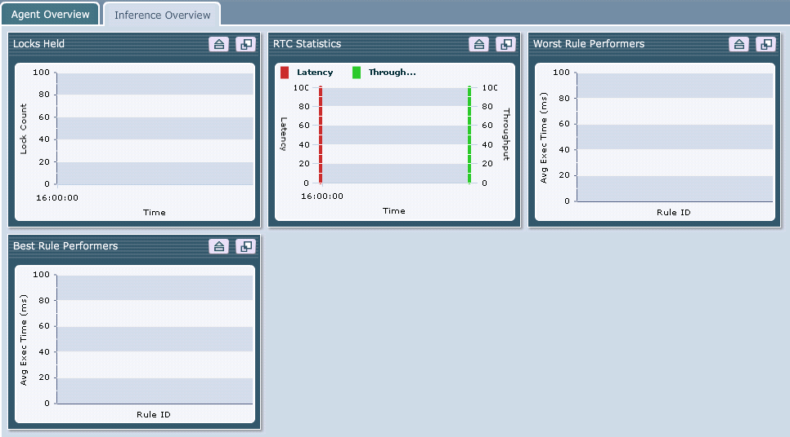
- Locks Held: The number of locks held by the agent.
- RTC Statistics: RTC performance in terms of latency and throughput
  - Latency: The average time to complete an RTC.
  - Throughput: Number of RTCs completed.
- Worst Rule Performers: Rules sorted by average execution time. The longer the execution time, the worse the rule performance.
- Best Rule Performers: Rules sorted by average execution time. The shorter the execution time, the better the rule performance.

Query Agent Overview
For query agents, the Query Agent Overview tab shows the following metrics:
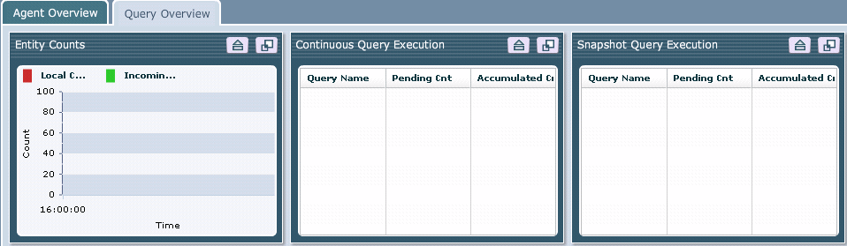
- Entity Counts
  - Local Cache Entity Count: The number of entities in the query agent local cache.
  - Incoming Entity Count: The number of entities arriving into the local cache
- Continuous Query Execution: Metrics for the first ten continuous queries to be registered (Only the first ten are shown, for performance reasons):
  - Pending: Number of cluster messages received by the query that are pending processing.
  - Accumulated: The number of real-time cache changes that are pending while the query is still processing continuous query messages
- Snapshot Query Execution: Metrics for the first ten snapshot queries to be registered (Only the first ten are shown, for performance reasons):
  - Pending: Number of cluster messages received by the query that are pending processing.
  - Accumulated: The number of real-time cache changes that are pending while the query is still processing snapshot messages

Cache Node Overview
TBD

Monitored Object Metrics
TBD when available.

Configuration
Note: All agents and nodes to be monitored must belong to the same cache cluster. See TIBCO BusinessEvents User’s Guide for full details on cache object management.

Provided Files
The EMM application is provided in BE_HOME/EMM The EMM directory contains these subdirectories:
- bin contains be-emm.exe/sh, be-emm.tra, and be-emm.ear.
- config contains jaas.config, users.pwd, and ruleconfig.xml files.
- webroot contains files relating to the web server.
Before you run the EMM application, you must specify a few properties both in the EMM application’s TRA file and in the TRA files of the cluster nodes you are monitoring.

Configuring the Monitored BusinessEvents Application Properties Files
Ensure that TRA files for all nodes of the monitored BusinessEvents application contain correctly configured JMX properties.
Note: Assign each JVM (node) a unique port number. All other values are the same in each node’s TRA file. See the TIBCO BusinessEvents Decision Manager guide for more details on JMX.

JMX Properties
The properties you must configure are as follows:
java.property.com.sun.management.jmxremote=true
java.property.com.sun.management.jmxremote.ssl=false
java.property.com.sun.management.jmxremote.port=5562 [must be unique within one machine]
java.property.com.sun.management.jmxremote.authenticate=false
When multiple instrumented JVMs exist on one machine, each must have a unique port number.
You must also specify these properties to enable cluster statistics to appear in the monitored objects table:
java.property.tangosol.coherence.management all
java.property.tangosol.coherence.management.remote true

TIBCO Hawk Domain Property
You must also specify the following TIBCO Hawk® properties to enable metrics that are made available by Hawk® microagents:
tibco.clientVar.Domain HawkDomain=<Hawk or TIBCO Administrator Domain>
Use the same domain name value in all TRA files, for the monitored application and for the EMM application.
Note that if you do not provide this property, the enterprise monitor won’t show the machine-level metrics, but it will show all other levels of metrics.
A Hawk domain specifies a group of TIBCO Hawk agents that acts as a monitoring set. Each machine has a Hawk agent and various microagents (HMA) that provide useful machine-level metrics to the enterprise monitor. The tibco.clientVar.Domain property specifies a TIBCO Hawk domain name. This section explains what value to use for this property.
If you deploy through TIBCO Administrator, the Hawk domain name is the same as the TIBCO Administrator administration domain name. You don’t have to install the full TIBCO Hawk product in this case. The limited version provided with TIBCO Runtime Agent software is sufficient.
If you do not deploy to a TIBCO Administrator domain, you must install the full TIBCO Hawk product in order to see the machine-level metrics. In this case, use the TIBCO Hawk Configuration Utility to create a Hawk domain and use the domain name as the value of the tibco.clientVar.Domain property. See the TIBCO Hawk Installation and Configuration guide for details.

Configuring the EMM Application Properties File
The EMM application runs in its own cluster. It makes a connection to the cluster of the BusinessEvents application that you want to monitor. The emm.tra file has entries for both the EMM cluster, known as the monitoring cluster, and the target BusinessEvents application, known as the monitored cluster.
Configuration of each section in the EMM application TRA file is explained next.

Properties Relating to the Monitored (BusinessEvents Application) Cluster
The properties for connecting to monitored cluster begin be.metric.cluster.property.tangosol.coherence:
# Cluster Properties for the BusinessEvents cluster to be monitored

be.metric.cluster.property.tangosol.coherence.cluster be.monitored.cluster
be.metric.cluster.property.tangosol.coherence.clusteraddress 224.3.3.1
Replace be.monitored.cluster with the actual cluster name. Other values shown are the default values.
Ensure that all other values are accurate for the monitored cluster. (Look at one of the TRA files for the monitored cluster to get the correct values.)
Note If the monitored cluster used default multicast property values, you only have to specify the cluster name and address. If the monitored cluster uses non-default multicast property values or well-known address properties, you must specify them. See TIBCO BusinessEvents User’s Guide for details.

Update Interval Properties

#
# The time interval between two topology updates (in milliseconds).
# Default is 30 seconds
#
tibco.clientVar.TopologyUpdateFreq 30000

#
# The time interval between two JMX updates (in milliseconds).
# Default is 30 seconds
#
tibco.clientVar.JMXUpdateFreq 30000

#
# The time interval between two health check pings to nodes in the monitored cluster (in milliseconds).
# Default is 5 seconds
#
tibco.clientVar.HealthCheckFreq 5000

#
# The time interval between two sweep checks to physically delete inactive purged nodes in the topology.
# Default is 5 seconds
# Do not change unless advised by TIBCO
#
tibco.clientVar.SweepFreq 10000

#
# The time interval for inactivity for a purged node to be qualified for physical deletion.
# Default is 5 seconds
# Do not change unless advised by TIBCO
#
tibco.clientVar.SweepThreshold 5000
Adjust the intervals as needed. For example, if the requests are affecting performance, increase the time interval. If you want more immediate notifications of failed nodes, decrease that time interval.
- The TopologyUpdateFreq property specifies how long to wait between two consecutive calls to the monitored cluster to fetch the latest (current) topology.
- The JMXUpdateFreq property specifies how long to wait between two consecutive calls to each JVM process in the cluster. Adjust as needed. For example, if the requests are affecting performance, increase the time interval. If you want more immediate notifications, decrease the time interval.
- The HealthCheckFreq property specifies how long to wait between two health pings to each node in the monitored cluster.
Note: The SweepFreq and SweepThreshold properties do not need to be changed for normal use. If a user is viewing an inactive node that another user has purged, the node remains visible until the user has finished viewing the node. The SweepFreq determines how often the system checks for inactive nodes to be purged, and the SweepThreshold property determines for how long a node must remain inactive before it is eligible for purging.
Note You can also specify an updateInterval property in the file: BE_HOME/EMM/web-root/app_config.xml. The updateInterval property specifies the delay between two consecutive calls from EMM Console to the BusinessEvents EMM engine process.

File-based and LDAP-based Authentication Properties

# Properties to configure file based authentication
#
java.property.be.auth.type=file
java.property.be.auth.file.location= C:/tibco/be/3.0/emm/config/users.pwd

#
# Properties to configure LDAP based authentication
#
#java.property.be.auth.type=ldap
#java.property.be.auth.ldap.host=host-machine.tibco.com
#java.property.be.auth.ldap.port=37008
#java.property.be.auth.ldap.adminDN=uid=admin,ou=administrators,ou=topologymanagement,o=netscaperoot
#java.property.be.auth.ldap.adminPassword=admin
#Base Tree under which to search
#java.property.be.auth.ldap.baseDN=dc=apac,dc=tibco,dc=com
#java.property.be.auth.ldap.roleAttr=nsroledn
Replace host-machine.tibco.com with your host machine details.
By default file-based authentication is used. See Configuring the Password (User Authentication) File on page 14 for additional configuration steps required. You can also configure and use LDAP authentication as needed.
EMM authentication configuration uses the same set of properties as RMS authentication configuration, but with appropriate values for EMM. For details on setting these properties, see the TIBCO BusinessEvents Decision Manager guide.

EMM HTTP Channel (and EMM Console) Properties

# Properties for configuring the HTTP Channel
tibco.clientVar.HTTPHostname localhost
tibco.clientVar.HTTPPort 9000
The HTTP channel is used to access the EMM Console. Default values are shown above. The format for the monitoring console URL is: http://hostname:port/index.html.

EMM (Internal) Cluster Properties

# Cluster Properties for the (internal) EMM BusinessEvents cluster

clusterjava.property.tangosol.coherence.cluster be.internal.emm
java.property.tangosol.coherence.ttl 0
java.property.tangosol.coherence.clusteraddress 224.16.3.10
Adjust values needed for multicast discovery to work correctly. Otherwise, there is no need to change the settings. Ensure that the cluster address does not conflict with another address in the network. Also ensure that the cluster port does not conflict with another port on the host. (The EMM cluster uses the default value (33389) and so omits this property in the properties file as shipped).

Other Properties Seldom or Never Changed
Do not change the following settings unless advised by TIBCO. They are required by the EMM application.
# The directory from which static HTML content is served
# Do not change unless advised by TIBCO
java.property.com.tibco.be.http.docRoot=c:/tibco/be/3.0/emm/web-root

#
# JAAS Authentication Configuration
# Do not change unless advised by TIBCO
#
java.property.java.security.auth.login.config=C:/tibco/be/3.0/emm/config/jaas-config.config

#
# Internal properties. Do not change unless advised by TIBCO
#
be.agent.query.querydataprovider.classname=com.tibco.cep.query.stream.impl.rete.integ.metrics.CoherenceMetricDataListener
be.agent.query.querydataprovider.metricobjecttransformer.classname=com.tibco.cep.query.stream.impl.rete.integ.metrics.DefaultMetricObjectTransformer

#
# The directory from which EMM configuration files are loaded
# Do not chage unless advised by TIBCO
java.property.emm.config.dir.location %TIBCO_BE_HOME_ESC%/emm/config

Configuring the Password (User Authentication) File
User authentication is performed using a JAAS login module. Java Authentication and Authorization Service (JAAS) is a pluggable part of the Java security framework.
By default, user authentication is done using a password file. This is known as file based authentication. See File-based and LDAP-based Authentication Properties on page 12 for additional configuration steps required.
The following user credentials are provided: admin/admin and jdoe/jdoe. You can add more as needed.
Note: It is recommended that you encrypt each password with MD5 (Message-Digest 5) hashing algorithm. Free hashing utilities can be found on the Internet.
To add or change entries in the password file
- Open the password file. The file is located in BE_HOME/EMM/config/users.pwd.
- Add each user on a separate line using this format:
Username:password:role,role,role;
For example:
Mark:A31405D272B94E5D12E9A52A665D3BFE:BUSINESS_USER,APPROVER;
James:21232f297a57a5a743894a0e4a801fc3:RULE_ADMINISTRATOR;
Note: Do not use spaces.
Authentication is configured the same way for Enterprise Monitoring and for RMS (except for the location of the configuration files themselves). See the TIBCO DecisionManager guide for more details.

Configuring Preferences for Chart Display
You can configure some application preferences by editing the following XML file. For example, you can define colors for chart elements:
BE_HOME/EMM/config/webroot/app_config.xml

Configuring Thresholds for Health Metrics
Various charts provide a quick health summary view showing one of three states:
- Normal (green)
- Warning (yellow)
- Critical (red)
You can configure the thresholds for different metrics to control how cluster health is computed. To do so you edit the following file:
BE_HOME/EMM/config/rulesconfig.xml
One entity element is provided. You can add more by copying and modifying the provided entity element:
<Ruleconfig>
<entity type=”site/cluster”>
<!--set the healthLevel to critical even if a single inference agent goes down-->
<setproperty name="healthLevel" value="critical">
<childentity type="site/cluster/machine/process/inference" tolerance="0">
<property name="active" value="false"/>
</childentity>
</setproperty>
<!-- set the healthLevel to critical even if a all agents are down-->
<setproperty name="healthLevel" value="critical">
<childentity type="site/cluster/machine/process/*" tolerance="100">
<property name="active" value="false"/>
</childentity>
</setproperty>
<!-- set the healthLevel to warning if 50% of agents go down-->
<setproperty name="healthLevel" value="warning">
<childentity type="site/cluster/machine/process/*" tolerance="50">
<property name="active" value="false"/>
</childentity>
</setproperty>
<!-- set the healthLevel to normal if 100% of agents are up-->
<setproperty name="healthLevel" value="normal">
<childentity type="site/cluster/machine/process/*" tolerance="100">
<property name="active" value="true"/>
</childentity>
</setproperty>
</entity>
</ruleconfig>
You can add new entity elements for the following entity types:
- site/cluster/machine
- site/cluster/machine/process
Within each entity, create the thresholds and displays as follows
- setproperty: This element determines which health state you are defining – critical (red), warning (yellow), normal (green). For each entity you would set up three setproperty elements, one for each state.
  - Name must be “healthLevel”
  - Value must be one of “critical” “warning” or “normal”
- childentity: This element defines the child entities for which this health metric is being set up. The health is defined as a percentage of all child entities that are active.
  - type: Defines the entity type whose state is used as the health metric. Specify an entity type lower in the hierarchy from the one used in the entity type.
  - tolerance: expressed as a percentage. Enter a value between 0 and 100 as desired. When the number of child entity items that satisfy the criterion meets or exceeds the percentage, the corresponding health indicator displays.
- Property
  - name: “active”
  - value: either “true” or “false”

Configuring for EMM Project Customization
Advanced users can customize the BusinessEvents project for EMM, which is located here:
BE_HOME/emm/project/emonitor
Before you can modify the EMM project you must append the following to the TIBCO Designer class path (substitute your actual path for BE_HOME):
BE_HOME/rms/lib/cep-rms.jar
BE_HOME/rms/lib/ext
BE_HOME/emm/lib/be-emm.jar
Example appended path:
tibco.env.CUSTOM_CP_EXT C:/tibco/be/3.0/rms/lib/cep-rms.jar;C:/tibco/be/3.0/rms/lib/ext (and rest of path);C:/tibco/be/3.0/emm/lib/be-emm.jar
Note Only advanced users should attempt customization. As with all data modification, back up the project before you begin any customization.

Running and Using the EMM Console
Note: The machine running EMM must be accessible to the monitored cluster. It must be in the same network or directly accessible using multicast to the monitored cluster. The machine running EMM can’t be outside the firewall.
First configure the TRA files as explained in Configuring the Monitored BusinessEvents Application Properties Files and Configuring the EMM Application Properties File on page 11.

Running the EMM Console
- Start the cluster to be monitored in the usual way.
- Start EMM as follows (on Windows): Click Start > All Programs > TIBCO > TIBCO BusinessEvents version details > Start Enterprise Monitoring and Management Server.
- In a web browser, enter the URL for the console. By default the URL is
http://localhost:9000/index.html
The hostname and port must be specified in the emm.tra file. See EMM HTTP Channel on page 13.

Using the Enterprise Monitoring Console
You can do any of the following:
- Expand Node Explorer and select the level whose metrics you want to see.
  - Active and inactive nodes are shown in Node Explorer for a quick view of system health.
  - Click Purge Inactive to remove inactive nodes from the display.
  - Click the minimize button in the Node Explorer title bar to minimize this pane.
- Click the Expand button in the title bar of any pane to get a larger view.
- Click the Promote button in the title bar of any pane to copy the pane the Cluster Overview level. In this way you can create a custom dashboard.
The following sections provide details on the metrics shown for each level.

