G11N Support in BE Studio

The default file encoding for all BusinessEvents resources has been set to UTF-8 in order to support double-byte characters inside of BusinessEvents Studio. This is done by creating BusinessEvents “Content Types” and setting the default encoding to UTF-8:

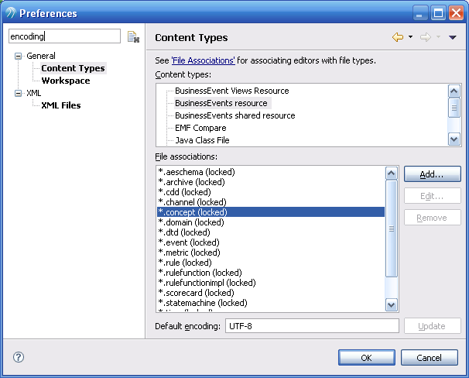

The BusinessEvents Studio editors then support the UTF-8 charset:

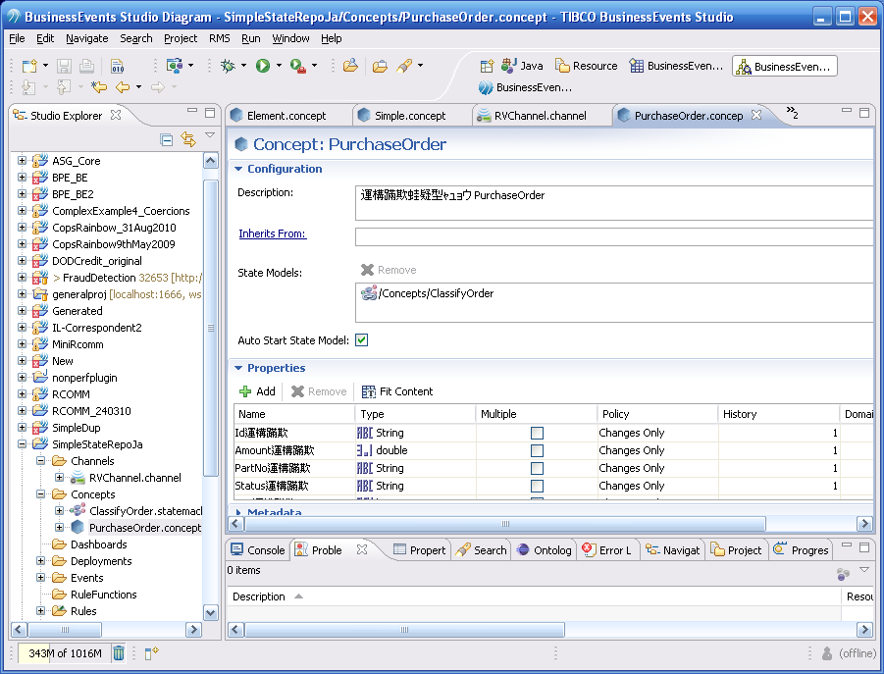

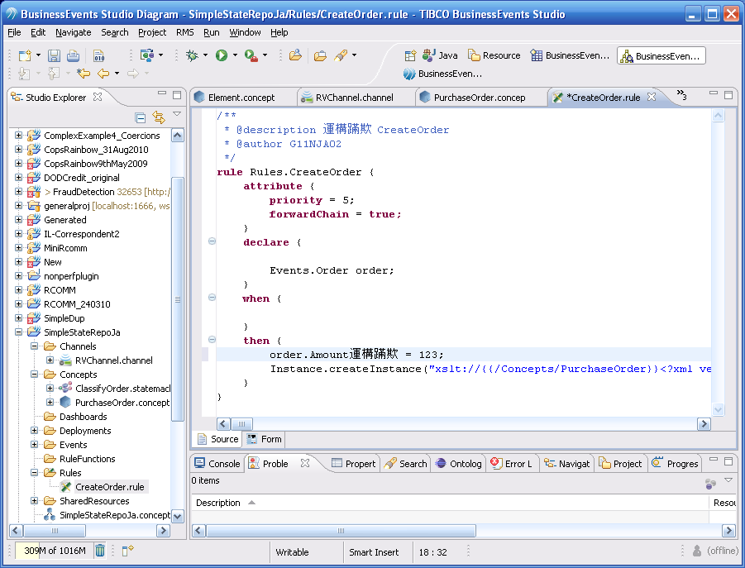

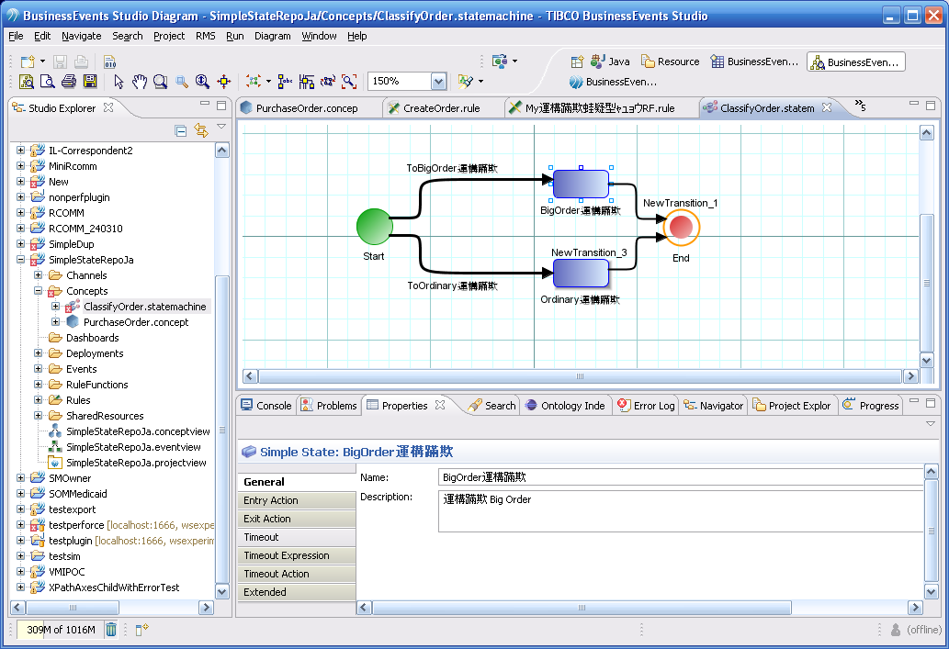

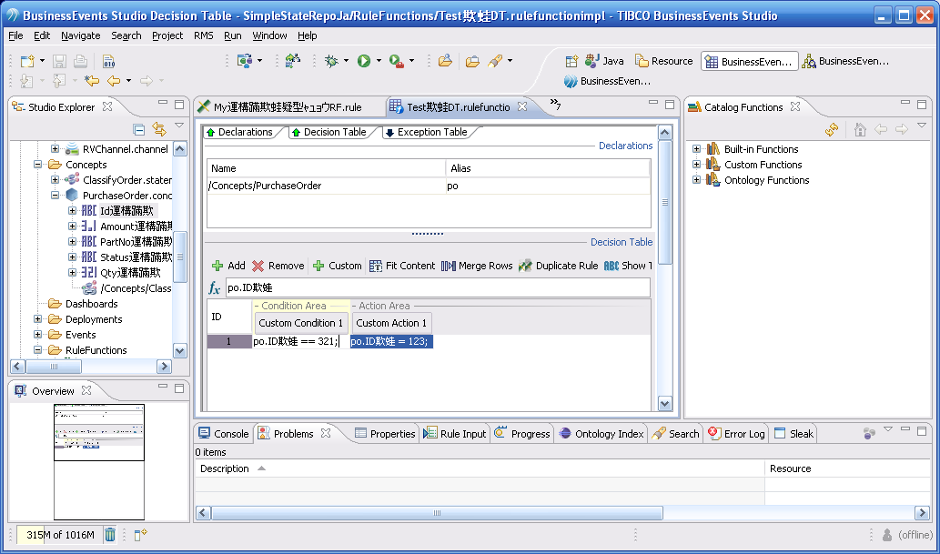

The serialized EMF objects properly store in UTF-8 format as well:

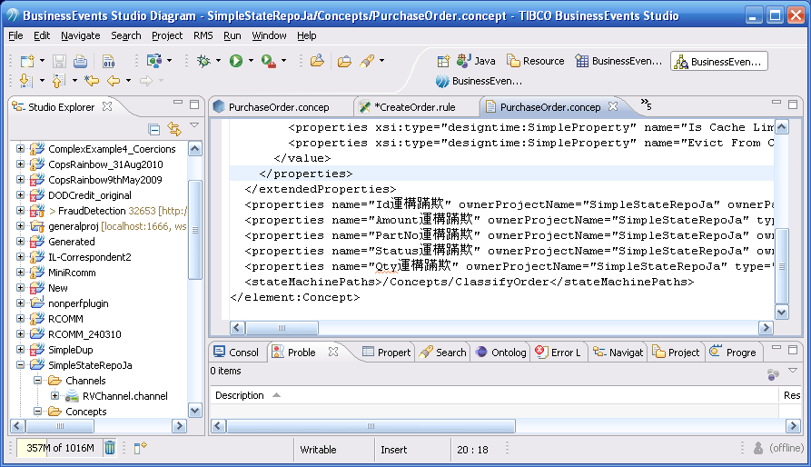

File/entity names can also contain UTF-8 chars:

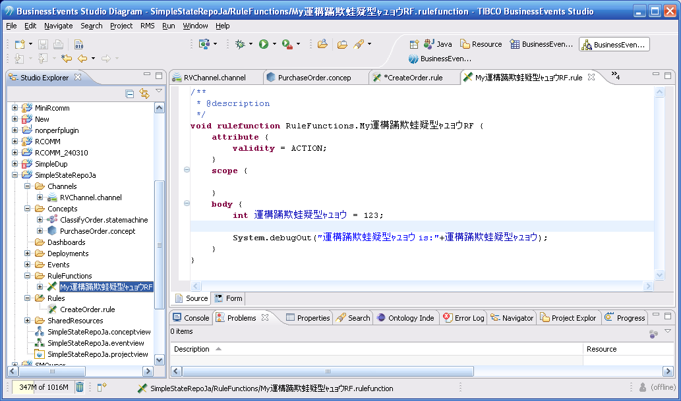

The code generation process has also been changed to support the UTF-8 charset.

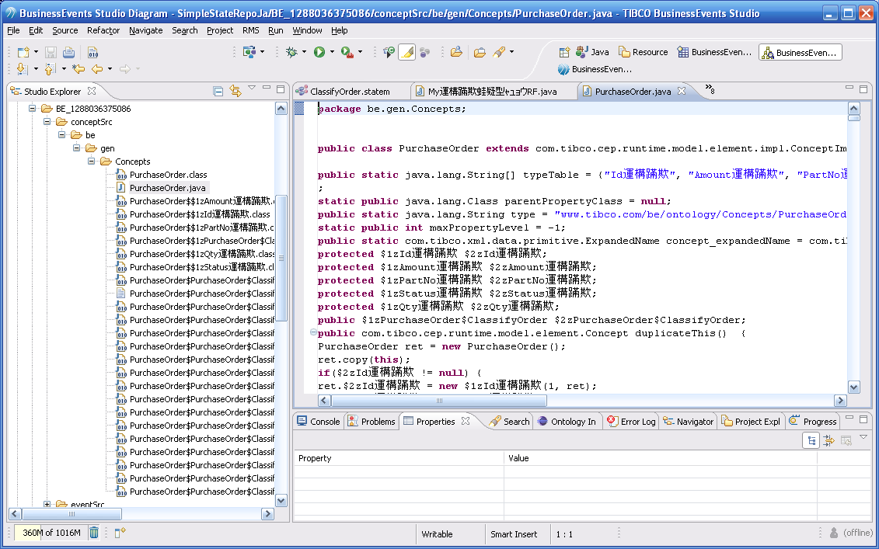

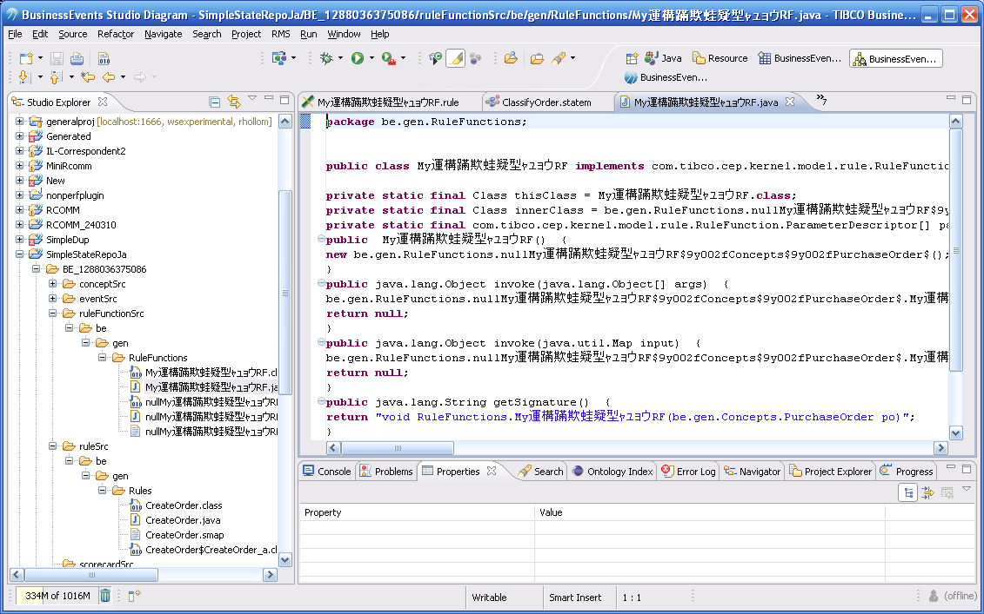

There was a strong focus by QA to test this functionality, which resulted in several CRs. A quick jira search for “G11N” shows 29 results. Of those, 13 are unresolved. David Yoon is the reporter for all of these CRs, and they are assigned to various individuals, spanning several areas (RMS, CDD, Debugger, State Machines, etc).

Here is the list of the currently open CRs:

|  |  |
| --- | --- |
| [BE-7844](http://jira.tibco.com/browse/BE-7844) | [[G11N] For Japanese BE project whose all the names are Japanese, the state machine didn't work. Refer to the attached documentation to reproduce the issue](http://jira.tibco.com/browse/BE-7844) |
| [BE-8441](http://jira.tibco.com/browse/BE-8441) | [[G11N] The Japanese approver comments of audit trail in worklist were garbled. Refer to the attached screen shots](http://jira.tibco.com/browse/BE-8441) |
| [BE-7526](http://jira.tibco.com/browse/BE-7526) | [[G11N] All the Japanese ouputs in debugger console were garbled. Refer to the attached project and doc to reproduce the issue.](http://jira.tibco.com/browse/BE-7526) |
| [BE-8262](http://jira.tibco.com/browse/BE-8262) | [[G11N] The Japanese chart titles were garbled. Refer to the attached screen shots and BE project](http://jira.tibco.com/browse/BE-8262) |
| [BE-7904](http://jira.tibco.com/browse/BE-7904) | [[G11N] The event properties (HTTP Channel) mapped from HTTP Request Headers are garbled. Refer to the attached test project and document to reproduce the issue.](http://jira.tibco.com/browse/BE-7904) |
| [BE-7509](http://jira.tibco.com/browse/BE-7509) | [[G11N] If BE project includes Japanese concept name and Japanese concept properties name, be engine throws the exception and can't be started. See attached doc to reproduce the issue.](http://jira.tibco.com/browse/BE-7509) |
| [BE-7513](http://jira.tibco.com/browse/BE-7513) | [[G11N] BE engine can't read Japanese Cluster Configuration File (Cdd) Name on command line and can't be started for Japanese CDD file name. See the attached doc to reproduce the issue.](http://jira.tibco.com/browse/BE-7513) |
| [BE-8440](http://jira.tibco.com/browse/BE-8440) | [[G11N] Decision Manager can't commit/checkout the project into RMS server that contains non-ASCII characters in decistion tables and rules. Refer to the attached webex, decision table(xls) and how to reproduce the issue](http://jira.tibco.com/browse/BE-8440) |
| [BE-7845](http://jira.tibco.com/browse/BE-7845) | [[G11N] For Japanese BE project whose all the names are Japanese,theBE Debugger throws the exception when we send event using Rule Input. (org.xml.sax.SAXParseException). Refer to the attached documents and webex recording](http://jira.tibco.com/browse/BE-7845) |
| [BE-7362](http://jira.tibco.com/browse/BE-7362) | [[G11N] When we export the state diagram into pdf format, all the Japanese characters are disappeared in the exported pdf flie. Refer to the attached project and exported pdf file.](http://jira.tibco.com/browse/BE-7362) |
| [BE-7843](http://jira.tibco.com/browse/BE-7843) | [[G11N] If the destination id in CDD file includes Japanese text, be-engine throws the exception (com.tibco.xml.validation.exception.ValueParseException). Refer to the test project and screen shots](http://jira.tibco.com/browse/BE-7843) |
| [BE-8220](http://jira.tibco.com/browse/BE-8220) | [[G11N] The global variable values from tra file (tibco.clientVar.<gvName>=<gvValue>) were garbled during runtime for both UTF-8 encoding and native encoding of tra file. See the webex, project files and tra file](http://jira.tibco.com/browse/BE-8220) |
| [BE-8384](http://jira.tibco.com/browse/BE-8384) | [[G11N] When Studio exports the concepts/events to XSD files, studio throws the error if concept names and property names contains non-ASCII characters. (error while generating schema Invalid byte 2 0f 3-byte UTF-8 sequence). Refer to the screen capture a](http://jira.tibco.com/browse/BE-8384) |
| [BE-10047](http://jira.tibco.com/browse/BE-10047) | [G11N: Event Stream Processing Query didn't work for non-ASCII characters in query condition.](http://jira.tibco.com/browse/BE-10047) |
| [BE-10148](http://jira.tibco.com/browse/BE-10148) | [G11N: Japanese characters corruption when Query engine retrieve data from Cache server.](http://jira.tibco.com/browse/BE-10148) |

On the whole, I believe that Studio is in good shape to support UFT-8/G11N. Although it has gone through some testing by David Yoon and QA, of course testing additional use cases will further stabilize this functionality.