LoadBalancer Adhoc Routing Example

Ashwin Jayaprakash, Feb 2012

# What?

To do consistent, but ad hoc routing of events between engines. Consistent means events with the same routing key will be delivered to the same engine.

# How?

An engine that wishes to participate in receiving events in a load balanced environment should register a local channel with the load balancer service using the catalog functions. Any engine can send an event to the load balanced system by using catalog functions. The name of the local channel is used as the topic by the senders and receivers to identify this ad hoc network.

This feature is meant to compliment the channel based (EMS), transparent routing of messages via a dedicated routing engine.

This can essentially behave like peer-to-peer messaging. However in the example to keep things simple, there is a dedicated router which sends events based on a timer.

Sending does not require the presence of a local channel in the engine. Local channel is required only to receive events.

# Code

## Sender

In the startup function of the router/sender, the following has to be done in a startup function:

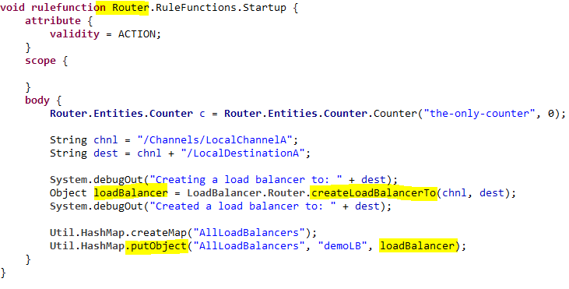

In the rules or pre-processors, it’s a simple send call:

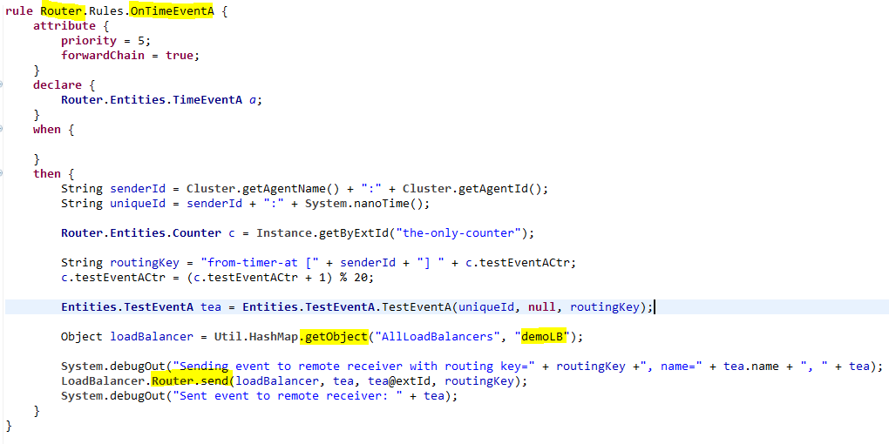

## Receiver

On the receiver side, in addition to enabling the local channel the following has to be done in a startup function:

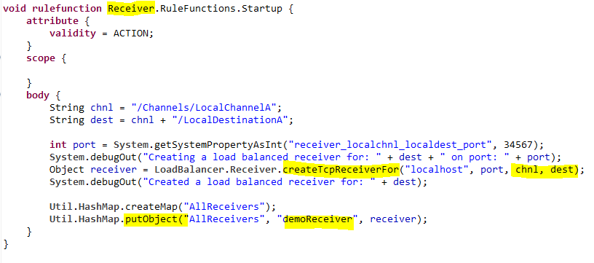

Since events arrive over the local channel at the receiver side, rules will get triggered if the event is in the scope of the rules.

### --@@--