Software Design Document (SDD) Template

Software design is a process by which the software requirements are translated into a representation of software components, interfaces, and data necessary for the implementation phase. The SDD shows how the software system will be structured to satisfy the requirements. It is the primary reference for code development and, therefore, it must contain all the information required by a programmer to write code. The SDD is performed in two stages. The first is a preliminary design in which the overall system architecture and data architecture is defined. In the second stage, i.e. the detailed design stage, more detailed data structures are defined and algorithms are developed for the defined architecture.

This template is an annotated outline for a software design document adapted from the IEEE Recommended Practice for Software Design Descriptions. The IEEE Recommended Practice for Software Design Descriptions have been reduced in order to simplify this assignment while still retaining the main components and providing a general idea of a project definition report. For your own information, please refer to [IEEE Std 1016­1998](http://www.cs.concordia.ca/~ormandj/comp354/2003/Project/ieee-SDD.pdf)[[1]](#footnote-1) for the full IEEE

Recommended Practice for Software Design Descriptions.

(Team Name)

**(Project Title)**

Software Design Document

Name (s):

Lab Section: Workstation:

Date: (mm/dd/yyyy)

**TABLE OF CONTENTS**

[1. INTRODUCTION 1](#_Toc519683396)

[1.1 Purpose 1](#_Toc519683397)

[1.2 Scope 2](#_Toc519683398)

[1.3 Overview 3](#_Toc519683399)

[1.4 Definitions and Acronyms 3](#_Toc519683400)

[2. SYSTEM OVERVIEW 4](#_Toc519683401)

[3. SYSTEM ARCHITECTURE 5](#_Toc519683402)

[3.1 Architectural Design 5](#_Toc519683403)

[3.2 Decomposition Description 6](#_Toc519683404)

[3.3 Design Rationale 8](#_Toc519683405)

[4. DATA DESIGN 9](#_Toc519683406)

[4.1 Data Description 9](#_Toc519683407)

[4.2 Data Dictionary 9](#_Toc519683408)

[5. COMPONENT DESIGN 9](#_Toc519683409)

[6. HUMAN INTERFACE DESIGN 10](#_Toc519683410)

[6.1 Overview of User Interface 10](#_Toc519683411)

[6.2 Screen Images 11](#_Toc519683412)

[6.1 Reference Material 16](#_Toc519683413)

# INTRODUCTION

## Purpose

This SDD describes the architecture and design of YSA application. The design description defined in this document is significant in the following ways;

* It will be used to assess the impact of Youtube Statistical analysis application on the Youtube channel owners.
* It describes the modular structure, data and diagrams involved with in the application.
* It identifies the required system resources.
* It will be used in case of carrying out maintenance activities on the application.

### **1.1.1 Its intended audience include:**

* YouTube data analysists and these have the highest priority over the others.
* Top level managers of an organization who are interested in layout of the project (Youtube channel owners).
* Software developers who are interested in understanding the design of the YSA application as well as make some changes in the future

.

## Scope

This Software Design Description (SDD) describes the detailed structure of the components of YouTube Statistics Analysis (YSA) and the precise implementation details required to satisfy the requirements as speciﬁed in the Software Requirements Speciﬁcation (SRS). It is assumed that the reader has read the SRS, since this document also deﬁnes the implementation details of the desired behavior given the requirements within it. This document will build heavily on the YSA and so knowledge of the general system architecture is recommended prior to commencing this document

YouTube data analysis software is one that people can use to analyze YouTube data. It contains shiny app which feature is R based and it will be helpful during the visualization stage using many different techniques. The software also has a data visualization feature that will be of use to the analyst to understand the relationships between the different variables under consideration.

This document covers the shiny web feature, which is the interface in this case, all users will have access to this app but after authentication, and the authorized user shall have full rights to the app and will be able to manipulate the data the way he/she wants

Upon completion of this software, these are some of the benefits that this software will provide to the end users.

### **1.2.1 Some of the benefits of this product are**

* Proper Market research.
* Easy Decision making.
* Provide a company with an edge over their competitors.
* Provide an insight of the user’s suggestions and reactions about the product or video.

### **1.2.2 Some of the goals of this software**

* The main goal of this software is to ease the analysis process for the YouTube analysts and those who are interested in data science particularly in the field of YouTube.
* The other goal is limiting the hardships involved during data analysis thereby saving time when visualizing the relationship between variables of interest.

## Overview

In this document, detailed design of the system with user interfaces will be described. In section 3; decomposition of the system with module. Decomposition, concurrent process decomposition and data decomposition is given, in section 4; Data design with data descriptions is given, in section 5; there is description of the component design. In section 6, there are user interfaces; screen objects, images and actions. In section 8; Requirements matrix is provided and finally in section 8; there is the appendix which has the abbreviations and their in full and the reference materials.

## Definitions and Acronyms

|  |
| --- |
| **SDD** – System Design Description/document. |
| **YSA** – YouTube Statistics Analysis. |
| **YouTube Analyst** – a person with prior knowledge about data analysis and the functionalities of the YouTube analysis. |
| **Developer** – a person who designs software for either commercial or individual purposes. |
| **Component** – a module that is part of the system. |

.

# SYSTEM OVERVIEW

YSA is a software being designed to ease the work of the person doing the analysis by bringing all the separate components into one application where he/she can easily load the required dataset that he wants to do analysis on and then choose the best visualization technique to use. These different components have been merged in one place and that is in the shiny app.

The user will have to choose from among the datasets with in the app or extract and load his own. However, before doing all these, he is supposed to be first authenticated as a user. This app has three basic components, which are going to be explained in details.

### 2.1. **Development Methods**

A software development methodology is a way of managing a software development project. This typically address issues like selecting features for inclusion in the current version, when software will be released, who works on what, and what testing is done.

For YouTube statistics analysis software, we shall use scrum, because, this method enables us (developers) to add features to our system in form of short sprints (usually 7-30 days), during our short frequent meetings thus keeping people focused. Tasks are usually tracked on a scrum board. The group is self-organizing and collaboratively managed, although there is a scrum master tasked with enforcing the rules and buffering the team from outside distractions.

We shall as well use the Unified Modeling Language (UML) for visualizing and documenting the systems design.

We considered using UML because it uses object-oriented design concepts, and it is independent of any specific programming language and can be used to describe business processes and requirements generally. This enables developers to use the same design to implement the system using various programming languages rather than being constrained to one language. [2]

# SYSTEM ARCHITECTURE

## Architectural Design

The design of this YSA application will follow the client/server architecture where by the client is represented by user Interface which is used to send requests to the server, which then services the requests of the client.



In this YSA application, the UI.r gets data from the user and sends it to the server. The server manipulates the data and sends the results in form of visual diagrams such as bar graphs, pie charts, sentiment analysis and word cloud which are displayed to the user on the user interface.

## Decomposition Description

This section decomposes each use-case feature into its data flow processes by examining its data flow diagram and process. These assist in determining the preliminary members and methods of the modules that need to be implemented, or the modifications to existing modules to implement the feature. This document uses the names of the use cases in the SRS document as the names of the features. This section includes the description of the intended design to meet the requirements. When appropriate, the use cases will be expanded to include system requirements. This section also incorporates a decomposition diagram providing the segments involved in each process.

### 3.2.1 Context Diagram for YSA application



### 3.2.2 Login Subsystem.

### This subsystem will provide authentication security to the system. Any user of the system will need to input the username and password to get access to the system.

### Below is a sequence diagram that describe the step involved in this sub system.



**Figure 4.1.1. showing a sequence diagram that describe the step involved in this sub system.**

### 3.3.3 User Interface component

The user interface enables the users to access different functions of the system. The user will be able to load any required dataset into the system which is to be visualized and analyzed to come up with what is trending and the different categories of videos.



**1. Analyze data**

1.1 Select an analysis tool

1.2 Analyze data

**2. Visualize data**

2.1 Select an analysis tool

2.2 Analyze data

2.3 Visualize analyzed data

## Design Rationale

Client/server architecture is preferred in designing YSA application because of the need to provide the user with an interactive interface. Most of the manipulations will be done in the server and this makes the user/operator’s interaction with the application easier since he/she will only have to send requests to which the server will respond to that request.

# DATA DESIGN

## Data Description

This YSA application uses Youtube data about viewers’ opinions about the Youtube videos. This data is obtained from the interaction between Youtube platform and the viewers which are stored in the Youtube database and later extracted using the Youtube api, saved as a csv file(s) for analysis using RStudio.

## Data Dictionary

Alphabetically list the system entities or major data along with their types and descriptions. If you provided a functional description in Section 3.2, list all the functions and function parameters. If you provided an OO description, list the objects and its attributes, methods and method parameters.

# COMPONENT DESIGN

**File Upload**

**Algorithm**

1. Run the app

2. Select a file

3. Upload the file

**Analyze data**

**Algorithm**

2.1 Select an analysis tool

2.2 Analyze data

**3. Visualize data**

3.1 Select an analysis tool

3.2 Analyze data

3.3 Visualize analyzed data

1. Choose the x and y variable in case of the need to create a bar graph and pie chart.

# HUMAN INTERFACE DESIGN

## Overview of User Interface

The user interface is necessary for the users as it enables the use of the different functions of the system. The user will be able to interact with the system. The user will be able to load any required dataset into the system, which are to be visualized and analyzed to come up with various trends of videos and categories of videos.



## Screen Images

These screen images are user interfaces that provides a user a platform for them to perform different tasks with YSA application.

6.2.1 **Home page**

When the user loads YSA application, the page below will be shown on their browser.

The left-hand tabs include the home page, barcharts for analysis, trending for determining trending videos, upload, for uploading personal dataset, category for the different categories of the videos and the sentiment, for identifying users’ reactions on the video

The right-hand has a select suitable dataset option, these include Canada, Great Britain, USA, Germany and France

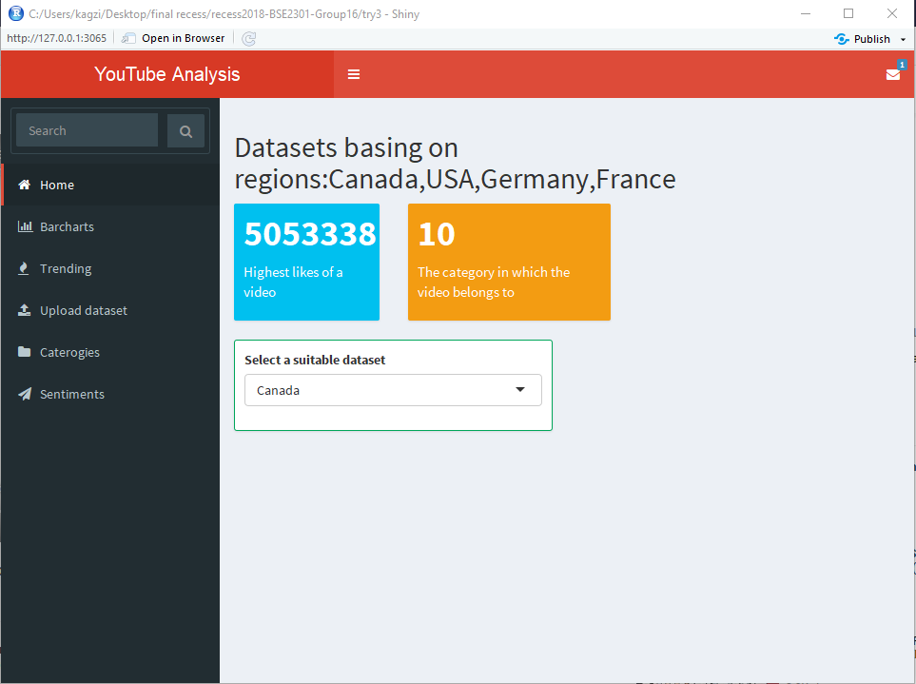

### 6.2.2. **Barchats**

This tab is used for visualizing data by selecting the x and y variables, for this case, a bar plot of views against category ID as shown

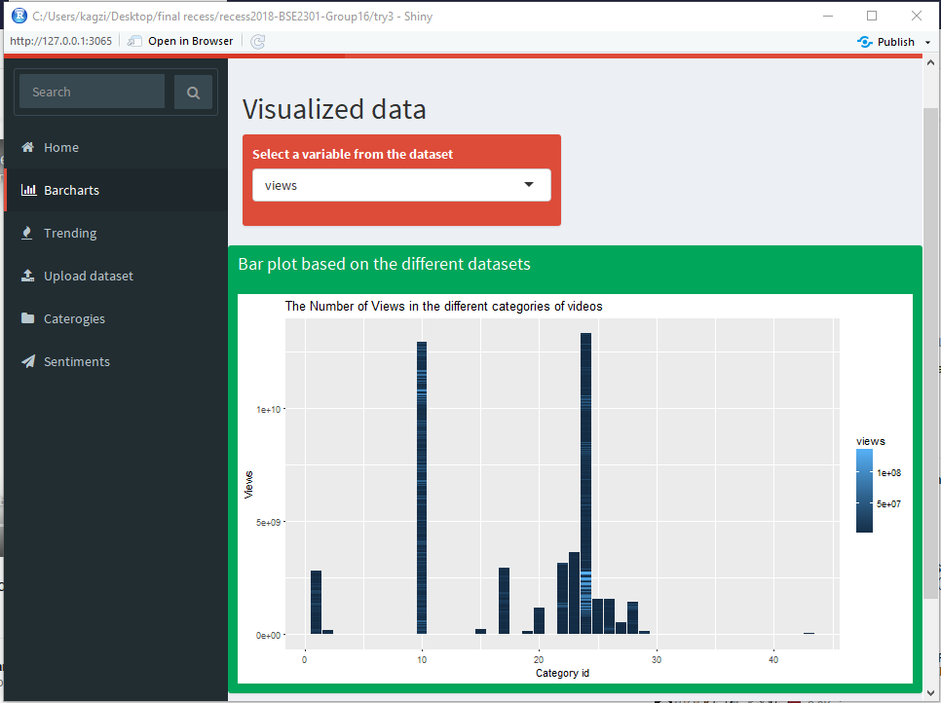

6.2.3. **Sentiment analysis**

In this section, the user enters the api key and the video they intend to carry sentiment analysis for. Sentiment analysis helps the analysis to determine the viewers’ reaction about the video as shown

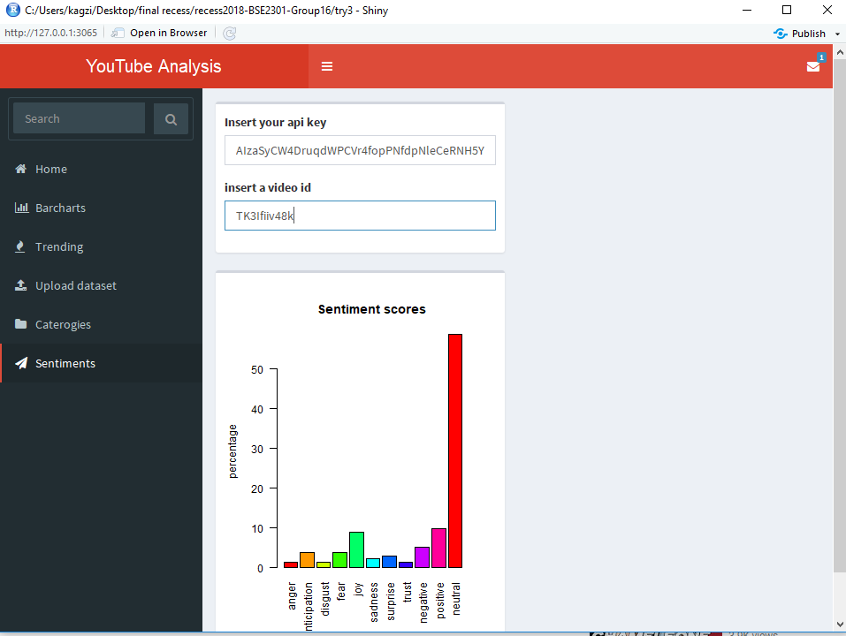

### 6.3.4 **Upload dataset**

Here, the user after selecting the upload option, they then click on browse which will ask them to select the location where their dataset is, after which its complete and its ready for analysis. The image below shows Book1.csv dataset and the data in contains.

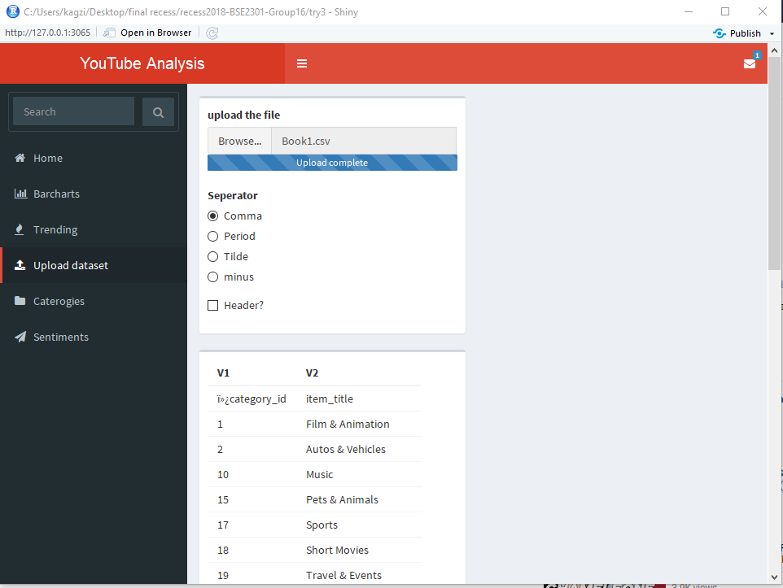

### **6.3.5 Trending**

This is used to determine the most trending videos by using the video ID against views, likes or comments as shown below

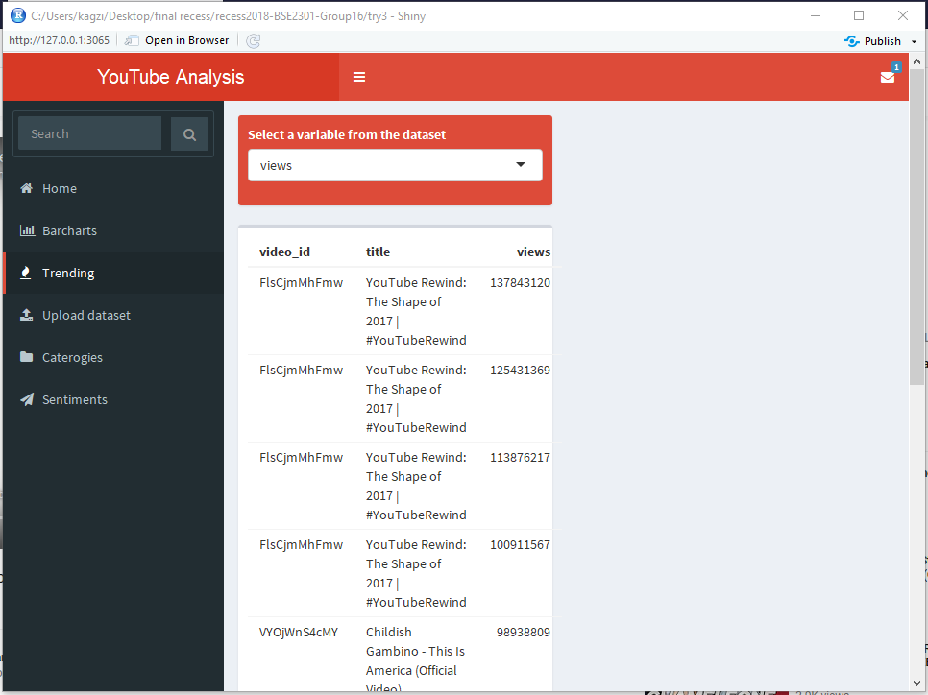

## Reference Material

|  |  |
| --- | --- |
| [1] | [Online]. Available: <www.nada.kth.se/~karlm/prutt05/lectures/prutt05_lec7.pdf.> |
| [2] | [Online]. Available: <https://www.asc.edu/sites/default/files/org_sections/HPC/.../sw_devel_methods.pdf.> |
| [3] | [Online]. Available: <https://developers.google.com/youtube/v3/getting-started.> |
| [4] | [Online]. Goals of software design: [www.nada.kth.se/~karlm/prutt05/lectures/prutt05\_lec7.pdf](http://www.nada.kth.se/~karlm/prutt05/lectures/prutt05_lec7.pdf) |

.

1. http://www.cs.concordia.ca/~ormandj/comp354/2003/Project/ieee­SDD.pdf [↑](#footnote-ref-1)