AfriAssistive Platform — Product & Technical Documentation
Version: 0.1 (draft) · Date: 7 Oct 2026 · Status: Pre-build design Companion document: AfriAssistive_Venture_Plan_v2_Researched.docx (business case)
How to read the status tags - ✅ = checked in a source during research (see Appendix D). - [V] = unverified, confirm before relying on it. - [A] = my assumption or recommendation, not a fact. Nothing here is legal advice. Have a Kenyan lawyer review the compliance sections before launch.

Contents

  - Purpose and scope

  - Users, personas and jobs-to-be-done

  - Requirements

  - System architecture

  - Data model

  - API design

  - Key workflows

  - AI and hybrid services (phase 2–3)

  - Security, privacy and compliance

  - Integrations

  - Engineering practices and operations

  - Analytics and KPIs (definitions)

  - Roadmap

  - User stories and acceptance criteria (MVP samples)

  - Risks and open questions
- Appendix A — Glossary
- Appendix B — Sample WhatsApp flows
- Appendix C — Sample MVP database indexes and policies (outline)
- Appendix D — Sources checked during research (Oct 2026)

0. Purpose and scope
The platform is the operating system of the AfriAssistive service chain: it connects users and caregivers, clinicians, partners/payers, the workshop and repair hubs, and funders around one record per person and one passport per device.
In scope (MVP → v1): intake and referral, consent, assessment, device registry with QR passport, work orders and QA, delivery and acceptance, fitting and follow-up, repair tickets and spares, care-plan subscriptions and M-Pesa payments, partner dashboards, impact reporting.
Later (v2+): AI features (scan-to-design, predictive maintenance, Swahili assistant, forecasting), IoT sensors, franchise/hub management, interoperability with national health systems.
Out of scope for now: e-commerce for unrelated products, clinical diagnosis, any feature that makes clinical decisions without a clinician.

Design principles
- Service chain first, technology second. Every feature must reduce device abandonment, repair time, or cost-to-serve.
- Offline-first, low-bandwidth, low-end Android. Field staff work in places with weak connectivity.
- Accessible by default. The users are people with disabilities; accessibility is a core requirement, not polish (WCAG 2.2 AA, screen-reader, large-text, high-contrast, Swahili/English, USSD/WhatsApp fallback).
- Privacy by design. Disability and health data are sensitive personal data under Kenyan law ✅.
- Human in the loop. AI assists clinicians and technicians; it never replaces clinical sign-off.
- Open and portable. Open-source stack, open data formats, no lock-in to one cloud.

1. Users, personas and jobs-to-be-done
Persona | Who | Main jobs | Primary channel
Beneficiary / caregiver | Person needing a device, or parent/guardian | Request help, give consent, track order, get repairs, pay care plan | WhatsApp, SMS/USSD, PWA
Community referrer | CHW, teacher, disability officer, church/faith leader | Refer people, check status | WhatsApp, PWA (offline)
Clinician | Physiotherapist, orthopaedic technologist, OT | Assess, prescribe, fit, follow up, record outcomes | Tablet PWA (offline)
Technician / fabricator | Workshop CAD and fabrication staff | See work orders, print queue, QA checks, log batches | Workshop screens, tablet
Repair hub agent | Local repairer | Receive tickets, order spares, close repairs | Phone PWA
Partner officer | NGO, county, NCPWD, KEMSA, hospital | Place bulk orders, accept deliveries, view dashboards | Web
Finance/ops admin | AfriAssistive staff | Invoices, reconciliation, inventory, staffing | Web
Funder / auditor | Donors, CSR, investors | Impact and spend reports | Read-only web, exports
Platform admin / DPO | Tech + data protection officer | Access control, audits, DSAR handling | Web

2. Requirements

2.1 Functional modules (MoSCoW and phase)
# | Module | Key capabilities | Priority | Phase
M1 | Identity & access | Phone-number login (OTP), org accounts, RBAC, session and device management | Must | MVP
M2 | Intake & referral | Self-referral, referrer form, duplicate detection, triage queue, WhatsApp/USSD entry | Must | MVP
M3 | Consent & privacy | Layered consent (care, data sharing, research, photos/scans), guardian consent for minors, withdraw/erase, audit trail | Must | MVP
M4 | Assessment & prescription | Structured assessment forms, measurements, photos, prescription of device type/size, clinician sign-off | Must | MVP
M5 | Device registry & passport | Unique serial + QR, model/version, BOM, batch, QA record, owner, status, warranty, history | Must | MVP
M6 | Production & QA | Work orders, print/fabrication queue, material usage, QA checklists, test results, release gate | Must | MVP
M7 | Delivery & acceptance | Delivery lists, proof of delivery (signature/photo/OTP), partner acceptance forms | Must | MVP
M8 | Fitting & follow-up | Fitting records, training checklist, 2-week/3-month/12-month follow-ups, adverse event log | Must | MVP
M9 | Service & repair | Tickets via QR/WhatsApp, hub assignment, spares, turnaround SLA, loan devices | Must | MVP
M10 | Payments & care plans | M-Pesa STK push, instalments, care-plan subscriptions, invoices, sponsor-a-device, reconciliation | Must | MVP-lite → v1
M11 | Inventory & procurement | Materials, spares, reorder points, suppliers, batch/lot traceability | Should | v1
M12 | Partner & tender portal | Bulk orders, framework agreements, milestone billing, delivery acceptance, dashboards | Should | v1
M13 | Impact & analytics | KPI dashboards, cohort follow-up, donor report export, anonymised open data | Should | v1
M14 | Communications | WhatsApp templates, SMS, reminders, bulk campaigns with opt-in | Should | v1
M15 | Hub/franchise management | Hub onboarding, certification, stock, performance | Could | v2
M16 | AI services | See section 7 | Could | v2–v3
M17 | Interoperability | Health information exchange, national registries, KEMSA logistics data | Could | v2 [V]

2.2 Non-functional requirements
Area | Requirement
Performance | Core screens usable on 3G; initial PWA load < 3 s on mid-range Android; API p95 < 500 ms for reads [A]
Offline | Field flows (referral, assessment, fitting, delivery, repair close-out) work offline with conflict-safe sync
Availability | 99.5% monthly for MVP; scheduled maintenance outside 06:00–20:00 EAT [A]
Backups / DR | RPO ≤ 1 h, RTO ≤ 4 h; encrypted backups; quarterly restore test [A]
Security | Encryption in transit and at rest, RBAC + least privilege, MFA for staff, immutable audit logs, secrets in vault
Accessibility | WCAG 2.2 AA; screen reader support; text scaling to 200%; high contrast; no colour-only meaning; large touch targets; captions on videos
Localisation | English + Swahili at launch; i18n-ready for Sheng, Luo, Kikuyu, Kalenjin [A]
Data residency | Primary store or at least one serving copy in Kenya for health data (see 8.2)
Maintainability | Modular monolith, typed APIs, ≥ 70% test coverage on core domain logic [A]
Observability | Structured logs, metrics, traces, error tracking, uptime checks, payment reconciliation alerts

3. System architecture

3.1 Context
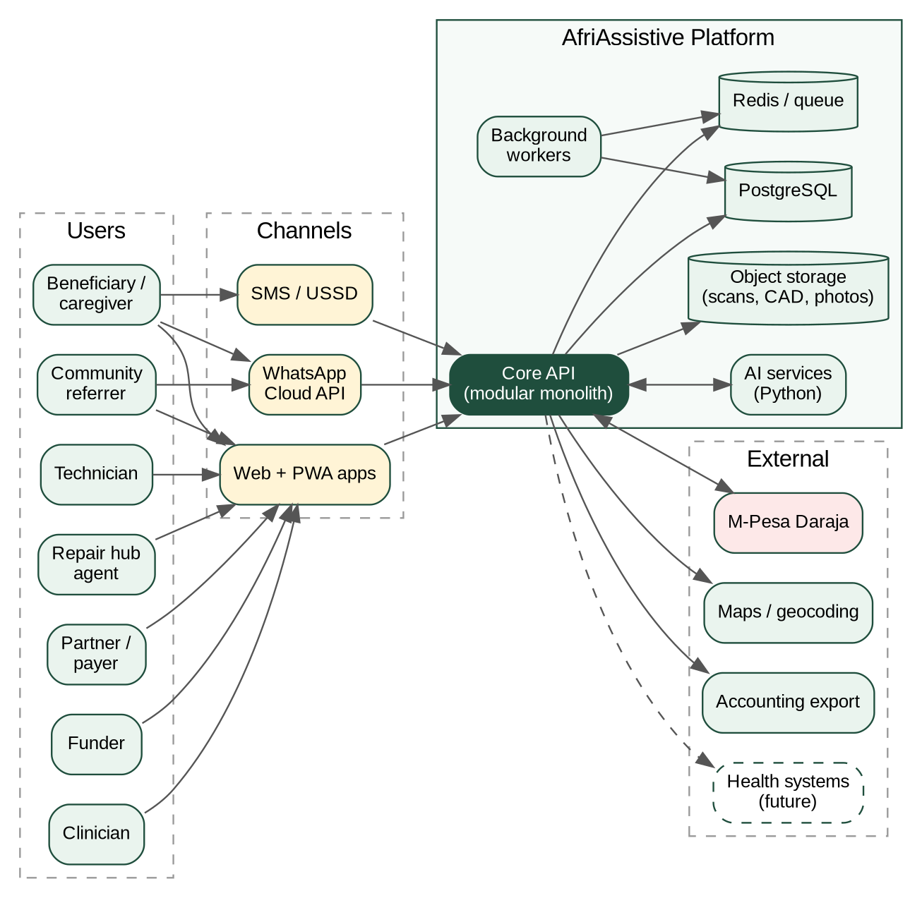
Figure 1: System context

3.2 Recommended stack [A]
Chosen for a small team, strong typing, offline support, and low cost. Adjust to your strengths.
Layer | Choice | Why
Web/PWA | Next.js (React, TypeScript) + Tailwind + Radix/Headless UI | SSR for light first load, strong a11y primitives
Offline | Service Worker + IndexedDB (Dexie) + background sync, optional RxDB | Offline forms with sync queue
Mobile (later) | React Native (Expo) if PWA limits hit (camera, bluetooth, NFC) | Reuse TS code
Core API | NestJS (TypeScript) modular monolith, REST + OpenAPI | Fast delivery, clear module boundaries
AI services | FastAPI (Python) separate service | ML ecosystem
Database | PostgreSQL 16 (+ PostGIS for hubs/geo, pgcrypto) | Relational integrity, auditability
Queue / cache | Redis + BullMQ | Webhooks, notifications, sync, jobs
Object storage | S3-compatible (MinIO or provider) | Scans, CAD, photos, PDFs
Auth | Keycloak or Ory (OIDC), phone OTP for end users, TOTP/WebAuthn for staff | Standards-based
Search | Postgres full-text first; OpenSearch later | Keep ops light
Messaging | WhatsApp Cloud API, Africa’s Talking (SMS/USSD) [V pricing/availability] | Reach users where they are
Payments | M-Pesa Daraja (STK Push, C2B, B2C); cards/mobile alternatives later | Dominant channel in Kenya
Infra as code | Terraform + Docker + GitHub Actions | Reproducible, portable
Observability | OpenTelemetry → Grafana stack, Sentry | Open tooling
Hosting | Kenya-based data centre or cloud region with Kenyan serving copy (see 8.2) | Compliance

3.3 Architectural decisions (ADR summary)
ADR | Decision | Rationale
ADR-01 | Modular monolith, not microservices | Small team; split AI service only
ADR-02 | PWA first with offline sync | Fastest to ship; install-free for referrers
ADR-03 | Event log table (outbox) for domain events | Reliable notifications, audit, future integrations
ADR-04 | Append-only audit log; soft-delete + crypto-erase for erasure | Traceability plus erasure rights
ADR-05 | Idempotency keys on all payment and webhook endpoints | M-Pesa retries and duplicate callbacks
ADR-06 | Pseudonymous IDs in analytics; PII stays in operational schema | Privacy and safe sharing with funders
ADR-07 | Feature flags for AI and experimental modules | Safe rollout
ADR-08 | Cloud-agnostic containers | Avoid lock-in; support Kenyan hosting

3.4 Deployment topology (MVP)
- 1× app VM/cluster node (API, web, workers) + 1× managed or self-hosted PostgreSQL with daily encrypted backups + object storage + Redis.
- Separate staging and production; seeded synthetic data in staging; no real personal data outside production.
- CDN for static assets; WAF/rate limiting at the edge.
- Estimated MVP infra budget: USD 100–300 per month [A], dominated by hosting, messaging and SMS volume.

4. Data model

4.1 Core entity relationships (simplified)
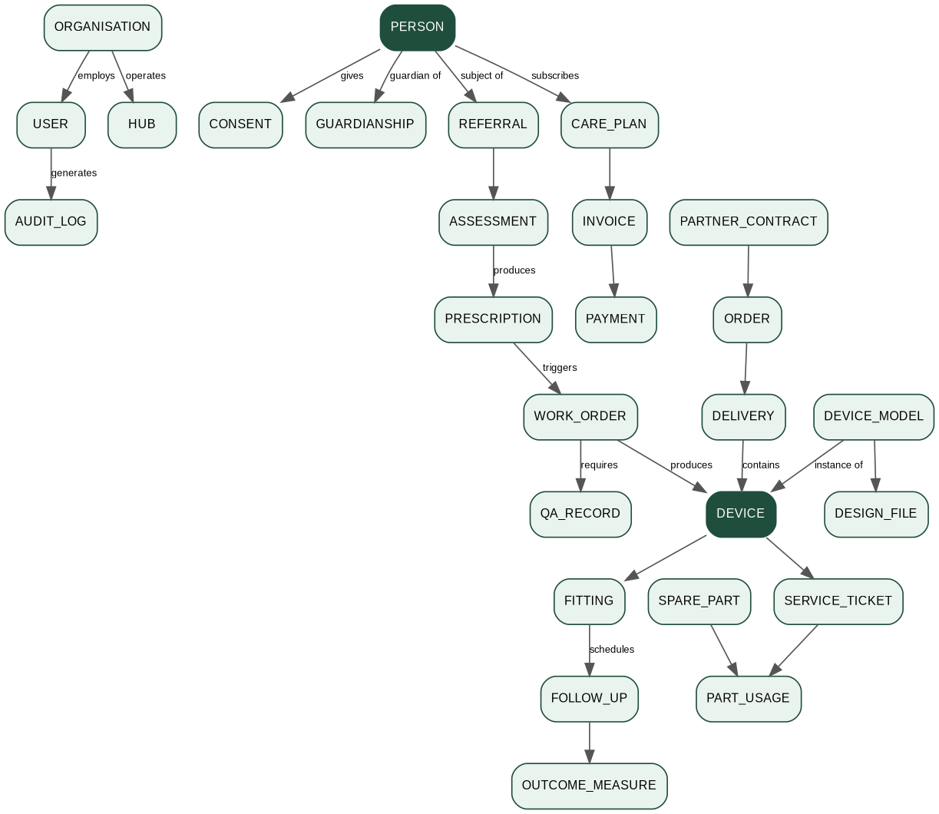
Figure 2: Core entity relationships (simplified)

4.2 Key tables and critical fields
Table | Important fields (not exhaustive)
person | id (UUID), national_id_hash (optional), name, dob or age band, sex, phone (E.164), county, sub_county, geo (coarse), language, disability_domain (coded), guardian flag, status
consent | id, person_id, purpose (care / data_sharing / research / media / marketing), granted_by (self/guardian), version_of_text, granted_at, withdrawn_at, evidence (signature/OTP/recording ref)
referral | id, person_id, source (self/CHW/clinic/school/NGO), referrer_id, reason, urgency, status, assigned_to, created_at
assessment | id, referral_id, clinician_id, form_version, measurements (JSONB), functional_scores (JSONB), photos (refs), notes, signed_at
device_model | id, category (Tier 1/2/3), name, version, standard_refs (ISO etc.), bom (JSONB), design_files, status (draft/validated/retired)
device | id, serial, qr_token, model_id, batch_id, status (in_production/in_stock/delivered/in_repair/retired), owner_person_id or owner_org_id, manufactured_at, warranty_until
work_order | id, prescription_id, model_id, qty, priority, due_date, status, assigned_to, material_usage (JSONB)
qa_record | id, work_order_id, checklist_version, results (JSONB), tester_id, passed, signed_at
fitting / follow_up | device_id, clinician_id, date, adjustments, training_done, next_follow_up_due, adverse_event flag
outcome_measure | follow_up_id, instrument (e.g. Washington Group, WHODAS, PWI [V choice]), score, raw (JSONB)
service_ticket | id, device_id, channel, issue_code, severity, hub_id, status, opened_at, closed_at, loan_device_id, cost
care_plan | id, person_id/org_id, tier (Basic/Standard/Plus), price, start, status, payment_method
invoice / payment | amounts in KES minor units, status, mpesa_receipt, checkout_request_id, idempotency_key, reconciled_at
partner_contract / order / delivery | framework terms, milestones, acceptance sign-off
audit_log | actor, action, entity, entity_id, before/after (hashed where sensitive), ip/device, ts (append-only)
event_outbox | id, type, payload, created_at, processed_at (for reliable events)

4.3 Data classification
Class | Examples | Controls
Highly sensitive | Disability/health data, photos, 3D scans, assessments, outcome scores, guardian-child links | Field-level encryption, strict RBAC, audit on every read, residency in Kenya
Sensitive | Phone, location, payments | Encryption at rest, masked in UI, access logs
Operational | Device, inventory, production | Standard controls
Public/anonymised | Aggregated KPIs | k-anonymity thresholds (e.g. no cell < 10 [A]) before sharing

5. API design
- Style: REST over HTTPS, JSON, OpenAPI 3.1 spec as source of truth; versioned at /api/v1.
- Auth: OIDC bearer tokens; scopes per module; org-scoped tenancy via org_id claim.
- Conventions: cursor pagination, ETag + If-Match for optimistic concurrency (important for offline sync), RFC 7807 problem details, Idempotency-Key header for POST that creates money or physical items.
- Rate limiting: per token and per IP.

5.1 Representative endpoints
Area | Endpoint | Notes
Auth | POST /auth/otp/request, POST /auth/otp/verify | Phone-first
People | POST /people, GET /people/{id}, PATCH /people/{id} | Row-level security by role/org
Consent | POST /people/{id}/consents, POST /consents/{id}/withdraw | Versioned text
Referrals | POST /referrals, GET /referrals?status=triage, POST /referrals/{id}/assign | Works offline via sync batch
Assessments | POST /referrals/{id}/assessment, POST /assessments/{id}/sign | Clinician only
Prescriptions | POST /assessments/{id}/prescriptions | Creates work order on approval
Work orders | GET /work-orders, POST /work-orders/{id}/qa, POST /work-orders/{id}/release | Release blocked until QA pass
Devices | GET /devices/{id}, GET /d/{qr_token} (public minimal passport), POST /devices/{id}/retire | Public view hides personal data
Fittings | POST /devices/{id}/fittings, POST /follow-ups/{id}/complete
Tickets | POST /tickets (also from WhatsApp), POST /tickets/{id}/assign, POST /tickets/{id}/close | SLA timers
Payments | POST /care-plans, POST /payments/stk-push, POST /webhooks/mpesa/stk | See 6.2
Partners | POST /orders, POST /deliveries/{id}/accept | Milestone billing
Analytics | GET /analytics/kpis?period=, POST /reports/impact | Aggregated, thresholded
Compliance | POST /dsar/export, POST /dsar/erase | Data subject rights
Webhooks in | /webhooks/whatsapp, /webhooks/sms, /webhooks/mpesa/* | Signature checks, replay protection

5.2 Example: public device passport (QR scan)
GET /d/9fK3...x
200 OK
{
"serial": "AA-WC-2026-000142",
"model": "Community Wheelchair v1.2",
"status": "delivered",
"manufactured": "2026-11-03",
"warranty_until": "2027-11-03",
"service": { "report_issue_url": "https://.../help?d=9fK3...x", "whatsapp": "+254..." },
"safety_notice": null
}
No owner name, location or health information appears on the public view.

6. Key workflows

6.1 Referral to device delivery
Step | From → To | Action
1 | Referrer/Beneficiary → Platform | Submit referral and consent (WhatsApp, PWA or offline)
2 | Platform | De-duplicate, triage score (rules), assign clinician
3 | Platform → Clinician | Task appears (offline-capable)
4 | Clinician → Platform | Assessment and signed prescription
5 | Platform → Workshop | Work order created
6 | Workshop → Platform | Build, QA checklist, release device with QR serial
7 | Platform → Hub/Delivery | Delivery task
8 | Hub/Delivery → Platform | Delivery proof (OTP, photo or signature)
9 | Platform → Beneficiary | Fitting and follow-up schedule; care-plan offer
10 | Clinician → Platform | Fitting record; follow-ups at 2 weeks, 3 and 12 months

6.2 Care-plan payment via M-Pesa (STK Push)
Step | From → To | Action
1 | Platform | Create invoice and idempotency key
2 | Platform → Daraja | STK Push request (amount, phone, reference)
3 | Daraja → User phone | PIN prompt
4 | User → Daraja | Enters PIN
5 | Daraja → Platform | Callback (ResultCode, receipt, CheckoutRequestID)
6 | Platform | Verify callback, match CheckoutRequestID, de-duplicate
7 | Platform | Mark payment, activate care plan, queue receipt
8 | Platform → User | WhatsApp/SMS receipt
9 | Platform ↔ Daraja | Nightly reconciliation against transaction status/statements
Rules: never trust the client for payment status; accept only server callbacks matched by CheckoutRequestID; handle duplicate and late callbacks; reconcile daily; store only the last four digits of any card/account data. Daraja endpoint specifics and callback IP/auth requirements must be confirmed in Safaricom docs [V].

6.3 Repair ticket
- User scans QR or messages WhatsApp → ticket created with device ID and photos.
- System assigns the nearest hub (PostGIS), starts SLA timer, checks care-plan entitlement.
- Hub agent diagnoses (checklist), reserves spares, repairs or issues loan device.
- Close with cost, parts, turnaround; user rates the service; failure code feeds quality analytics and design changes.

7. AI and hybrid services (phase 2–3)
Principle: build the non-AI workflow first, collect data, then add AI where it measurably helps. All outputs are recommendations, reviewed by a qualified person.
ID | Use case | Inputs | Approach | Evaluation | Guardrails | Phase
A1 | Scan-to-design assist (socket/insole/orthosis) | Phone or depth scan, measurements | Photogrammetry/mesh cleanup, template-based parametric CAD; ML only for landmark detection | Fit error vs clinician casting (mm), remake rate | Clinician approves every design; keep manual fallback; clinical validation study before scale | v2–v3
A2 | Predictive maintenance | Repair history, usage hours, terrain/region, optional IoT (tilt, load, wheel rotations) | Start with survival analysis / gradient boosting on ticket data | Precision/recall for failure within 90 days, spares stock-out rate | Opt-in telemetry, minimal data, offline-tolerant | v2
A3 | Demand and spares forecasting | Orders, referrals, seasonality, partner pipelines | Time-series baselines (ETS/Prophet-like) | MAPE per SKU, stock-outs | Human review of reorder suggestions | v2
A4 | Swahili/English assistant (WhatsApp) | User messages, approved FAQ/knowledge base | Retrieval-augmented generation over vetted content; intent routing to forms | Task completion, escalation rate, safety audits | No medical advice; always offer human; log and review conversations; consent for processing | v2
A5 | Referral triage support | Referral form fields | Rules first; light ML ranking later | Agreement with clinician priority | Never auto-reject; fairness checks by sex, age, county | v2
A6 | Accessibility helpers | Text/voice | On-device or API TTS/ASR where good Swahili models exist [V] | User testing with blind/low-vision and deaf users | Offline fallback, co-design with users | v3
ML governance: model cards, dataset documentation, bias review, versioned models, shadow mode before live, kill switch, quarterly review. If any software feature influences clinical decisions, check whether it could be regulated as a medical device (Pharmacy and Poisons Board) [V].

8. Security, privacy and compliance

8.1 Roles and permissions (RBAC)
Capability | Beneficiary | Referrer | Clinician | Technician | Hub agent | Partner | Finance | Admin/DPO
View own record | ✔ | – | – | – | – | – | – | –
Create referral | ✔ | ✔ | ✔ | – | – | ✔ | – | –
View assessments | – | – | ✔ (assigned) | – | – | – | – | audit only
Sign prescription | – | – | ✔ | – | – | – | – | –
Work orders / QA | – | – | view | ✔ | – | view | – | ✔
Device passport (full) | own | – | ✔ | ✔ | ✔ | org devices | – | ✔
Tickets | own | – | ✔ | – | ✔ | org | – | ✔
Payments / invoices | own | – | – | – | – | org | ✔ | audit
Aggregated analytics | – | – | – | – | – | ✔ | ✔ | ✔
Export / erase (DSAR) | request | – | – | – | – | – | – | ✔
Use attribute-based rules on top (org, county, assignment) and PostgreSQL row-level security for tenancy.

8.2 Kenyan legal and regulatory notes (verify with counsel)
- Data Protection Act 2019 classifies health data as sensitive ✅. Register as data controller/processor with the ODPC, appoint a Data Protection Officer, keep a data protection policy and records of processing [V details].
- DPIA required for high-risk processing; this platform (disability/health data, children, scans, AI) qualifies [A] ✅ (DPIA rules are in Part VIII of the General Regulations).
- Children: processing a child’s data needs guardian consent and extra safeguards ✅ (Act has a children provision).
- Cross-border transfers: sending Kenyan personal data to a server abroad counts as a transfer, so using a foreign cloud triggers the transfer rules and ODPC notification (2026 guidance, as reported) ✅. The General Regulations require specified processing, including primary or secondary health care (per the reported 2026 guidance), to be done on a server and data centre in Kenya, or at least one serving copy stored in Kenya ✅. Design decision: keep the primary production database in a Kenyan data centre, or keep a continuously synced serving copy there; keep AI training on pseudonymised data. Confirm whether AfriAssistive’s activity counts as health care for this rule [V].
- Digital Health Act 2023 and national health information rules: may require facility/system registration and interoperability [V].
- Medical device oversight: the Pharmacy and Poisons Board registers devices by risk class ✅; clarify classification of each product and any software component [V].
- Accessibility and disability law: Persons with Disabilities Act 2025 ✅.
- Payments: if holding customer funds or issuing credit, check Central Bank of Kenya licensing; using Daraja merchant tills avoids holding funds [V].
- Consumer protection and digital credit: if you offer instalments, check consumer credit rules and any digital credit licensing [V].

8.3 Technical security controls
- TLS 1.2+; HSTS; encrypted DB volumes; field-level encryption for health and scan data (envelope encryption with KMS/Vault); secrets never in code.
- MFA for staff; short-lived tokens; device binding for clinician tablets; remote wipe.
- Least-privilege service accounts; network segmentation; WAF; rate limiting; bot protection on public forms.
- Signed webhooks; replay protection; strict input validation; CSP; dependency and container scanning in CI; SAST/DAST; yearly penetration test.
- Audit: log every read of sensitive records with purpose; tamper-evident (hash-chained) audit table; alert on bulk exports.
- Retention: define per data type (e.g. clinical records per health regulations, payments per tax law) [V]; erase or anonymise after retention.
- Breach response: runbook, 72-hour ODPC notification target [V], user notification templates.
- Backups: encrypted, tested, stored in a second Kenyan location.

8.4 Ethics and safeguarding
Informed consent in plain language (Swahili/English, audio option), no-penalty withdrawal, photo/scan use limited to purpose, research use opt-in only, complaints channel, adverse-event reporting, safeguarding policy for children and vulnerable adults, user advisory board with people with disabilities.

9. Integrations
Integration | Purpose | Notes
M-Pesa Daraja | STK Push, C2B payments, B2C refunds/payouts | Sandbox first; production needs Safaricom onboarding and paybill/till [V]
WhatsApp Cloud API | Notifications, referrals, repair tickets, assistant | Template approval; opt-in; costs per conversation [V]
Africa’s Talking (SMS/USSD) | Fallback reach; USSD menu for feature phones | Short code lead time [V]
Maps/geocoding | Hub assignment, delivery routing | Offline-friendly tiles for field
Accounting export | Invoices to QuickBooks/Zoho/Odoo | CSV/API
KEMSA / procurement | Align specs and product codes; share stock and delivery data | Government-led integration; start with documents and CSV [V]
Health information systems | Aggregate reporting, referrals | Future; follow national standards [V]
Identity | Optional ID verification for partners and staff | Avoid storing ID numbers unless required

10. Engineering practices and operations
- Repo layout (monorepo):
/apps/web # Next.js PWA (beneficiary, clinician, partner, admin)
/apps/api # NestJS modular monolith
/apps/workers # queues, webhooks, reconciliation
/services/ai # FastAPI ML services
/packages/ui # accessible component library
/packages/domain # shared types, validation (zod), i18n
/infra # Terraform, Docker, Helm/compose
/docs # ADRs, runbooks, API spec, DPIA
- Branching and CI/CD: trunk-based with short branches; GitHub Actions: lint → unit tests → contract tests (OpenAPI) → security scans → build → deploy to staging → manual gate → production; database migrations versioned and reversible.
- Testing: unit (domain logic), integration (Postgres, Redis), contract tests for payments and webhooks (recorded sandbox), e2e (Playwright) including offline scenarios, accessibility tests (axe + manual screen-reader), load tests for sync and payment callbacks, usability tests with real users.
- Environments: local (docker compose), staging (synthetic data), production.
- Monitoring and alerts: payment callback failures, reconciliation mismatches, ticket SLA breaches, sync backlog, error rates, queue depth.
- Runbooks: payment outage, data breach, failed sync, restore from backup, WhatsApp template rejection, stuck production batch.

11. Analytics and KPIs (definitions)
KPI | Definition | Source
Time to device | referral created → delivery accepted (median days) | referral, delivery
Fit success | % fittings with no adjustment needed at follow-up 1 | fitting/follow_up
Active use | % devices still used at 3/6/12 months | follow_up, outcome
Failure rate | tickets with severity ≥ moderate per 100 device-months | service_ticket
Repair turnaround | median hours ticket open → closed | service_ticket
Cost per active user-year | total cost / users still active | finance + registry
Care-plan retention | % subscribers active after 6/12 months | care_plan
Equity | % devices to low-income, women/girls, children, rural counties | person + referral
Gross margin per product | revenue − direct cost | invoice + production
Outcome change | change in functional/participation score baseline → follow-up | outcome_measure
Publish metric definitions and do not report any cell with fewer than a threshold of people.

12. Roadmap

12.1 MVP (about 12 weeks, 2–3 engineers + part-time designer [A])
Weeks | Deliverables
1–2 | Discovery with 5 clinicians, 5 users/caregivers, workshop staff; UX flows; DPIA draft; ODPC registration started; repo, CI/CD, auth skeleton
3–4 | People, consent, referral, triage queue; offline sync foundation; Swahili/English i18n
5–6 | Assessment forms, prescription, device models and registry, QR passport
7–8 | Work orders, QA checklist, release gate, delivery and acceptance
9–10 | Fitting/follow-up, service tickets, hub assignment, spares basic
11 | M-Pesa STK care-plan flow (sandbox → pilot), receipts, reconciliation
12 | Dashboards, pilot hardening, accessibility audit, pen test, go-live runbook
MVP exit criteria: run the 50-device pilot entirely on the platform; 100% of devices have a passport and QA record; consent captured for all users; at least 20 care-plan payments reconciled; zero critical security findings; WCAG 2.2 AA audit passed on core flows.

12.2 Beyond MVP
Release | Focus
v1 (months 4–9) | Partner/tender portal, inventory, WhatsApp automation, impact reports, USSD, accounting export
v2 (months 9–18) | Predictive maintenance, forecasting, assistant (A4), hub/franchise tools, IoT pilot, interoperability pilot
v3 (18+ months) | Scan-to-design (A1) with clinical validation, regional multi-country config, open data portal

12.3 Team [A]
Full-stack lead (you), second full-stack/mobile engineer, product/UX designer (accessibility experience), part-time ML engineer from v2, clinical advisor, DPO/legal adviser (external), QA/accessibility tester with disability lived experience.

13. User stories and acceptance criteria (MVP samples)
- As a CHW, I can submit a referral offline, and it syncs when I have signal. AC: queue shows “pending sync”; no duplicate on retry; consent captured before submit.
- As a clinician, I can sign a prescription and the system creates a work order. AC: unsigned prescriptions cannot create work orders; audit entry written.
- As a technician, I cannot release a device without a passing QA record. AC: release endpoint returns 409 if QA missing/failed.
- As a caregiver, I can scan the QR and report a fault in under one minute on WhatsApp or web. AC: ticket created with device ID; confirmation message in chosen language.
- As a hub agent, I can close a repair offline and record parts used. AC: inventory decremented on sync; conflicts resolved by rules.
- As a payer, I can pay my care plan by M-Pesa and receive a receipt. AC: only a verified callback activates the plan; duplicates do not double-charge.
- As a partner officer, I can accept a delivery with signature or OTP. AC: acceptance triggers milestone invoice.
- As a data subject, I can withdraw consent and request my data. AC: export within defined SLA; erasure honours legal retention exceptions.
- As a screen-reader user, I can complete the referral and ticket flows. AC: all controls labelled, focus order logical, no keyboard traps.
- As a funder, I can download an anonymised impact report. AC: no small-cell disclosure; definitions included.

14. Risks and open questions
Risk / question | Mitigation / next step
Data residency and DPIA outcome may force hosting choice | Decide hosting early; confirm with lawyer/ODPC; keep cloud-agnostic
Payment integration delays (Safaricom onboarding) | Start onboarding in week 1; design for manual M-Pesa till reconciliation as fallback
Offline sync conflicts and data loss | Event-sourced sync queue, ETags, conflict rules, extensive offline e2e tests
Low digital literacy and connectivity | WhatsApp/USSD, voice, assisted-mode with referrers, training
Exclusion through accessibility gaps | Co-design with users, accessibility audits each release
AI harms or over-reliance | Human in loop, shadow mode, bias reviews, kill switch
Scope creep and small team | Strict MVP; defer inventory, partner portal, AI
Who is the data controller (AfriAssistive, clinic partner, or both)? | Define joint-controller or processor agreements with clinical partners
Which instruments for outcomes (WG, WHODAS, PWI)? | Decide with clinical advisor and funders
Does SHA/KEMSA integration become a requirement? | Track benefit decisions; keep claims module optional

Appendix A — Glossary
AT assistive technology · APL WHO Priority Assistive Products List · DPIA data protection impact assessment · DSAR data subject access request · ODPC Office of the Data Protection Commissioner · PPB Pharmacy and Poisons Board · KEMSA Kenya Medical Supplies Authority · NCPWD National Council for Persons with Disabilities · POMSF/SHA health financing bodies · STK Push M-Pesa payment prompt on the phone · PWA progressive web app.

Appendix B — Sample WhatsApp flows
- Referral: “Habari! Karibu AfriAssistive. 1) Request a device 2) Report a fault 3) Check my order 4) Talk to a person.” → collects name, county, who needs help, type of need, consent, photo (optional) → confirmation + reference number.
- Fault report: user sends QR code number or photo → asks issue type → creates ticket → returns hub, expected time, loan device option.
- Care-plan payment: shows plan options → STK Push → confirmation receipt.

Appendix C — Sample MVP database indexes and policies (outline)
- Unique: device.serial, device.qr_token, payment.idempotency_key, payment.mpesa_receipt.
- Index: referral(status, assigned_to), service_ticket(hub_id, status, opened_at), device(owner_person_id), GiST on hub.geo.
- RLS: policies on person, assessment, fitting by org_id and assignment; admin bypass logged.

Appendix D — Sources checked during research (Oct 2026)
- Data Protection Act 2019 text and General Regulations 2021 (Kenya Gazette Supplement 236; ODPC and ICNL copies): health data as sensitive; DPIA, transfers, localisation parts.
- AWS summary of Kenyan DPA requirements (aws.amazon.com/compliance/kenya_public_sector_guidance_on_DPA_requirements) on cross-border flows and in-Kenya serving copies.
- Reported ODPC 2026 cross-border transfer guidance (captaincompliance.com) on transfers to foreign cloud and in-Kenya processing for primary/secondary health care. Read the original ODPC note before relying on this.
- Pharmacy and Poisons Board device registration summaries (regdesk.co, omcmedical.com, meddeviceguide.com).
- Persons with Disabilities Act 2025 summary (taxnews.ey.com/news/2025-1780).
- Business-case sources: see Section 20 of the venture plan.

