SMART LAKESIDE FISH MANAGEMENT SYSTEM
Integrating Mobile Money, SMS/USSD Alerts, IoT-Based Stock Monitoring and Catch-to-Sale Traceability
NAME: WANGARI NGUGI
ADM NO: DIT/2025/44628
INSTITUTION: MOUNT KENYA UNIVERSITY
UNIT CODE: DIT/2108
UNIT NAME: COMPUTER PROJECT DEVELOPMENT APPROACHES
SUPERVISOR: MR KELVIN NJAGI
DATE: 6/18/2026

DECLARATION
I hereby declare that this project is my original work and has not been submitted to any other institution for academic credit. I was also given guidance by Mr. Kelvin Njagi, my lecturer from Mount Kenya University.
Student Name: .............................................
Signature: ....................................................
Date: ...............................................................
Supervisor
Mr. Kelvin Njagi
Lecturer, Mount Kenya University
Signature: ..................................................
Date: ......................................................

DEDICATION
I dedicate this project to my family and friends, whose unwavering support and encouragement have been my source of strength throughout this journey, and to the lakeside fishing communities whose daily challenges inspired this work.

ACKNOWLEDGEMENT
I would like to express my heartfelt gratitude to God for His guidance and blessings throughout the journey of preparing this project proposal. Additionally, I would like to express my sincere gratitude to my lecturer, Mr. Kelvin Njagi, who has contributed to the development of this project proposal. Your support and guidance have been invaluable in shaping my ideas and vision. I am truly grateful for your assistance and encouragement throughout this process.

Contents

CHAPTER ONE: INTRODUCTION

1.0 Introduction
The fishing industry contributes significantly to food security, employment, and economic growth in lakeside communities across Kenya, particularly around Lake Victoria, which accounts for the majority of the country's freshwater fish catch. Despite this importance, many fish trading businesses still rely on manual record-keeping methods, which result in data inaccuracies, loss of records, inefficient inventory management, and delayed reporting. Beyond record-keeping, most traders lack digital payment reconciliation, timely stock alerts, and any way to prove where a batch of fish came from.
This proposal presents the Smart Lakeside Fish Management System, a web-based platform that automates fish inventory, customer, and supplier management, sales recording, and report generation, while adding three realistic and market-relevant innovations built around technology that is already widely used in Kenya: M-Pesa mobile money payments, SMS/USSD notifications for traders who do not own smartphones, and simple QR-code based batch traceability. A fourth innovation, IoT-based digital weighing and cold-chain monitoring, is scoped as a future phase once the core platform is validated, keeping the project technically achievable within an academic timeline while still demonstrating a clear path to a genuinely smart system.
The system will be developed using the PHP/Laravel framework, MySQL database, HTML, CSS, JavaScript (Bootstrap), and XAMPP for local development, with the Safaricom Daraja API for M-Pesa integration and the Africa's Talking API for SMS/USSD services. An Agile, iteration-based development approach will be used so that each new feature (payments, notifications, traceability) can be built, tested with real users, and refined independently.

1.1 Background of the Study
Fish trading businesses located around Lake Victoria, Lake Naivasha, and other lakeside regions contribute significantly to local and national economies. Kenya's fisheries sub-sector supports the livelihoods of an estimated two million people directly and indirectly, from fishermen and boat owners to traders, transporters, and retailers, and fish products remain an important source of affordable protein and export income.
Despite the importance of this sector, many businesses continue to use manual methods for recording fish stock, sales, customer information, and supplier records. Manual record keeping often leads to errors, data redundancy, delayed reporting, and difficulties in managing inventory. It also makes it difficult for traders to reconcile cash sales against mobile money payments, which now make up the majority of retail transactions in Kenya, and leaves no verifiable trail of where a batch of fish was sourced, which matters increasingly to hotels, supermarkets, and export buyers who ask for traceability.
The integration of information technology, mobile money, and low-cost messaging services can improve operational efficiency by automating these processes without requiring traders to own expensive smartphones or reliable broadband internet. This study therefore proposes the development of a Lakeside Fish Management System that is not only computerised but also mobile-money aware, SMS-reachable, and traceability-ready, to genuinely fit the operating environment of lakeside fish businesses.

1.2 Problem Statement
Many fish businesses operating around lake regions face numerous challenges due to manual and partially digitised record management systems. These challenges include:
- Inaccurate and duplicated inventory records kept in notebooks and receipt books.
- Loss of important business information due to damaged or misplaced paper records.
- Delayed report generation, making it hard for owners to make timely decisions.
- Poor customer management and no record of repeat customers or credit balances.
- Difficulty tracking profits and sales trends across days, weeks, and seasons.
- No automated reconciliation between cash, till, and M-Pesa payments, leading to unnoticed shortfalls.
- No way to notify traders or customers of low stock, order status, or payment confirmation without a smartphone or data bundle.
- No mechanism to trace a batch of fish back to its supplier or landing site when quality or safety concerns arise.

1.3 Proposed Solution
A computerised, mobile-money-aware management system is required to streamline business processes and improve efficiency. The Smart Lakeside Fish Management System will provide:
- A centralised web dashboard for inventory, sales, customer, supplier, and order management.
- M-Pesa STK Push integration so customers can pay directly into the system and payments reconcile automatically.
- SMS and WhatsApp notifications for low-stock alerts, order confirmations, and daily sales summaries, reachable even on basic feature phones.
- QR-code batch traceability so every recorded delivery can be traced from supplier/landing site to the customer who bought it.
- Simple analytics dashboards that highlight sales trends and flag fish types nearing reorder level, as a lightweight first step toward demand forecasting.
- A future-phase pathway to IoT-enabled digital weighing scales and cold-chain temperature sensors for automatic stock capture and spoilage alerts.

1.4 Objectives

1.4.1 General Objective
To design and develop a Smart Lakeside Fish Management System that automates inventory, customer, supplier, sales, and order management, while integrating mobile money payments, SMS/USSD notifications, and batch traceability to make the system realistic and useful for lakeside fish trading businesses.

1.4.2 Specific Objectives
- To design a relational database for fish inventory, sales, customer, supplier, and order management.
- To develop a customer registration and management module.
- To automate sales recording, order processing, and receipt generation.
- To integrate M-Pesa (Daraja API) for online payment collection and automatic reconciliation.
- To implement an SMS/WhatsApp notification module for low-stock alerts, order confirmations, and daily summaries.
- To implement a QR-code based traceability feature that links each sale to its recorded fish batch and supplier.
- To generate accurate, exportable reports for management decision-making and enhance security and accessibility of business records.

1.5 Justification
The study will benefit the following stakeholders:
Business Owners
- Improved inventory control and reduced stock losses.
- Automatic reconciliation of cash and M-Pesa payments for better financial management.
- Increased efficiency and reduced dependence on paper records.
Employees
- Reduced paperwork and faster service delivery.
- Instant low-stock and order alerts via SMS even without a smartphone.
Customers
- Improved customer service and faster, cashless order processing.
- Confidence in product origin through batch traceability.
Researchers and Future Developers
- Reference material for future studies on digitising informal-sector agribusiness in Kenya.

1.6 Scope of the Study
The Minimum Viable Product (MVP) covered by this project will include:
- Fish stock management, customer management, supplier management, sales and order management, and report generation.
- User authentication and role-based access (Admin, Staff/Attendant, Manager).
- M-Pesa STK Push payment collection and confirmation logging.
- SMS/WhatsApp notifications for stock and order events.
- QR-code generation and lookup for batch traceability.
The following are explicitly out of scope for this phase, and are identified as future work to keep the project realistic and deliverable within the academic timeline:
- Physical IoT hardware (digital weighing scales and cold-chain sensors) — the system will be designed with an API endpoint ready to receive this data, but the hardware itself will not be built or deployed in this phase.
- A full native mobile application — the customer/fishermen interface will be a mobile-responsive web app (PWA) rather than a native Android/iOS app.
- Multi-branch/multi-currency support and integration with export/customs systems.

1.7 Project Budget

Table 1: Budget
Item No. | Item | Cost (KSh)
1 | Printing and Photocopying | 3,000
2 | Internet Services | 3,500
3 | Transport | 4,000
4 | Stationery | 1,500
5 | Software and Development Tools (domain + hosting, 1 year) | 6,000
6 | Africa's Talking SMS credit (testing bundle) | 1,500
7 | M-Pesa Daraja API (sandbox testing — free; go-live paybill setup) | 2,500
8 | Contingency (10%) | 2,200
Total cost |  | 24,200
Note: M-Pesa Daraja sandbox access and Africa's Talking test credit are free, which keeps the added innovation realistic on a student budget; only the eventual production paybill/short-code registration and top-up credit carry a real cost, and both are optional until the system is piloted with a live business.

1.9 Time Schedule
Activity | Duration
Proposal Writing | Week 1
Requirement Gathering | Week 2 - 3
System Design (incl. ERD/DFD updates for new modules) | Week 3 - 4
Core Module Coding (inventory, sales, customers, suppliers) | Week 4 - 6
M-Pesa, SMS/WhatsApp and QR Traceability Integration | Week 6 - 8
Testing (unit, integration, user acceptance) | Week 8 - 9
Documentation | Week 9 - 10
Presentation | Week 10

1.10 Grand Chart
Activity | W1 | W2 | W3 | W4 | W5 | W6 | W7 | W8 | W9 | W10
Proposal Writing | ✓ | ✓
Requirement Gathering |  | ✓ | ✓
System Design |  |  | ✓ | ✓
Core Coding |  |  |  | ✓ | ✓ | ✓
Integrations (M-Pesa/SMS/QR) |  |  |  |  |  | ✓ | ✓ | ✓
Testing |  |  |  |  |  |  |  | ✓ | ✓
Documentation |  |  |  |  |  |  |  |  | ✓ | ✓
Presentation |  |  |  |  |  |  |  |  |  | ✓

1.11 Feasibility Study

Technical Feasibility
- Computers and internet connectivity are available at the business premises.
- MySQL database and PHP/Laravel are mature, well-documented, and free to use.
- M-Pesa Daraja and Africa's Talking both provide free sandbox environments for development and testing, so the integrations can be built and demonstrated without production costs.

Economic Feasibility
- Low development cost using open-source software and free-tier APIs during development.
- Expected efficiency gains (fewer stock losses, faster reconciliation) outweigh the modest ongoing SMS/hosting costs.

Operational Feasibility
- The interface is designed to be simple for users with basic computer literacy.
- SMS/USSD notifications extend usability to staff and fishermen who do not own smartphones, minimising training and adoption barriers.

Schedule Feasibility
- The ten-week plan separates core functionality from the added integrations, so the base system remains a deliverable fallback even if an integration is delayed.

CHAPTER TWO: LITERATURE REVIEW

2.1 Introduction
This chapter reviews literature related to fish management systems, inventory management systems, database technologies, mobile money and messaging integration, and existing solutions relevant to the proposed system.

2.2 Overview of Fish Management Systems
Fish management systems assist businesses in managing inventory, sales, customer information, and operational records electronically, replacing error-prone manual ledgers with searchable, centralised digital records.

2.3 Inventory Management Systems
Inventory management systems are computerised applications that monitor stock levels, purchases, and sales while minimising losses. Modern inventory systems increasingly incorporate automatic reorder alerts and integration with point-of-sale and payment systems, which this project adopts through its low-stock notification and M-Pesa reconciliation features.

2.4 Database Management Systems
Database systems facilitate data storage, retrieval, and security. Examples include MySQL, PostgreSQL, Oracle, and SQL Server. MySQL was selected for this project because it is open-source, well supported by the Laravel framework, and widely used in similar academic and small-business systems in Kenya, keeping the project both realistic and maintainable.

2.5 Review of Existing Systems
Manual Systems
- Advantages: Low setup cost.
- Disadvantages: Error-prone, time-consuming, poor data security, and no reconciliation with digital payments.
Computerised Systems
- Advantages: Accurate records, faster processing, improved reporting.
- Disadvantages: Initial setup costs and training requirements, which this project mitigates through a simple interface and SMS-based alternative channel.

2.6 Case Studies

2.6.1 Case Study 1: Fish Landing Management System at Lake Victoria, Kenya
Background: Fish landing beaches around Lake Victoria handle large quantities of fish every day. Traditionally, fish records were maintained manually using notebooks and paper forms.
Problem: The manual system resulted in loss of sales records, difficulty tracking fish stock, delays in preparing reports, fraud and inaccurate records, and poor monitoring of fishermen's catches.
Solution: A computerised fish management system was introduced to register fishermen, record daily fish landings, monitor fish stock, track fish sales, and generate management reports.
Outcome: The system improved inventory accuracy, revenue tracking, record security, decision-making, and report generation.
Lessons for the Proposed Project: The Lakeside Fish Management System should automate stock recording and reporting to improve efficiency and transparency.

2.6.2 Case Study 2: Fish Market Inventory System in Kisumu County
Background: Fish traders in Kisumu County purchase fish from fishermen and sell them to hotels, supermarkets, and individual customers.
Problem: The market experienced overstocking and shortages, manual sales recording, slow customer service, and difficulty calculating profits.
Solution: An inventory management system was implemented to track fish purchases, update inventory automatically after sales, monitor stock levels, and generate daily sales reports.
Outcome: Benefits included faster customer service, reduced inventory losses, better stock planning, and increased business profitability.
Lessons for the Proposed Project: The proposed system should include automatic stock updates after every sale and provide low-stock alerts, which this project extends into SMS-based alerts.

2.6.3 Case Study 3: Fish Farm Management System in Uganda
Background: Commercial fish farms in Uganda produce fish for local markets and export. Managing ponds, fish growth, and sales manually proved inefficient.
Problem: The farms faced poor production records, inaccurate inventory, difficulty monitoring fish growth, and delayed financial reporting.
Solution: A computerised fish farm management system was developed to register fish ponds, monitor fish feeding schedules, record harvesting activities, manage fish inventory, and produce financial reports.
Outcome: The system enabled improved production planning, better inventory management, accurate financial records, and faster report generation.
Lessons for the Proposed Project: Although focused on fish farming, the study demonstrates the value of digital record-keeping and reporting for fisheries management.

2.6.4 Case Study 4: Mobile Money and SMS-Based Agribusiness Platforms in Kenya
Background: Kenyan agri-tech platforms such as M-Farm and Twiga Foods pioneered the use of SMS and mobile money to connect small-scale farmers and traders to markets and buyers without requiring smartphones or bank accounts.
Problem: Small traders lacked market price information, a reliable way to receive payment confirmations, and trust in transaction records.
Solution: SMS-based price alerts and mobile money (M-Pesa) integration were used to confirm transactions instantly and reduce disputes over payment.
Outcome: Traders reported faster payment confirmation, reduced cash-handling risk, and greater trust between buyers and sellers.
Lessons for the Proposed Project: The Smart Lakeside Fish Management System should combine M-Pesa payment confirmation with SMS notification, following a pattern already proven to work for informal-sector trading in Kenya.

2.7 Emerging Technologies Relevant to the Proposed System
Mobile Money Integration
Safaricom's Daraja API allows third-party applications to trigger STK Push payment prompts on a customer's phone and receive instant payment confirmation callbacks, enabling automatic reconciliation between sales records and actual payments received.
SMS and USSD Gateways
Providers such as Africa's Talking and Twilio offer APIs that let a web application send SMS notifications or serve USSD menus, extending digital services to users without smartphones or data bundles — a critical consideration for lakeside trading communities.
QR-Code Traceability
Batch traceability using QR codes is already used in produce and dairy supply chains to let a buyer scan a code and see where a product came from. Applying the same low-cost approach to fish batches gives the system a genuine traceability feature without needing blockchain infrastructure, which would be disproportionate for a system of this scale.
IoT-Based Stock and Cold-Chain Monitoring
Digital weighing scales and temperature sensors can automatically log stock quantities and cold-chain conditions, reducing manual data entry and catching spoilage risk early. This project scopes IoT hardware as future work, but designs its database and API layer so this data can be added without redesigning the system.

2.8 Research Gap
Most small-scale fish traders continue to rely on manual systems. Existing computerised solutions reviewed in the case studies above focus on inventory and sales digitisation but rarely integrate mobile money reconciliation, SMS-based alerts for non-smartphone users, or batch traceability, and are often too expensive or generic to be customised for lakeside fish businesses. The Smart Lakeside Fish Management System addresses this gap by combining proven, low-cost Kenyan mobile technologies with fish-business-specific inventory and traceability features.

2.9 Conceptual Framework
Inputs
- Fish stock data, customer information, supplier information, sales transactions.
- M-Pesa payment confirmations.
- Batch/delivery details for traceability.
Process
- Data capture, data processing, stock updating.
- Payment reconciliation and notification triggering.
- Traceability logging and QR-code generation.
- Report generation and trend analysis.
Outputs
- Inventory, sales, customer, and supplier reports.
- SMS/WhatsApp alerts and digital receipts.
- Scannable batch traceability records.

CHAPTER THREE: RESEARCH METHODOLOGY

3.1 Introduction
This chapter outlines the methodology used to develop the proposed system, including the research design, data collection methods, and system development methodology.

3.2 Research Design
The study will employ a system development research design, combining requirements analysis with iterative prototyping so that the mobile money, SMS, and traceability features can be validated with real fish traders before being finalised.

3.3 Data Collection Methods
Interviews
Fish traders and business owners will be interviewed to understand daily operations, pain points, and willingness to adopt mobile money and SMS features.
Observation
Current business operations, including how payments and stock deliveries are currently handled, will be observed on site.
Document Analysis
Existing records, receipt books, and business documents will be reviewed to understand the data structures currently in use.

3.4 System Development Methodology
An Agile, incremental development methodology will be adopted in place of a strict Waterfall approach. This better suits the addition of the mobile money, SMS/USSD, and traceability features, since each can be developed and user-tested as a separate increment without delaying the delivery of the core inventory and sales system. Stages include:
- Requirements Analysis
- System Design
- Incremental Development (core system first, then integrations)
- Testing after each increment
- Implementation and user feedback
- Maintenance

CHAPTER FOUR: SYSTEM ANALYSIS AND REQUIREMENTS

4.1 Introduction
This chapter presents the analysis of the existing system, identifies its weaknesses, and describes the proposed Smart Lakeside Fish Management System. It also outlines the system requirements, functional and non-functional requirements, technology stack, and the system models used during design.

4.2 System Analysis
System analysis is the process of studying the current system to identify its strengths, weaknesses, and user requirements before designing a new system. The analysis involved collecting information through interviews with fish traders and system users, observation of daily fish business operations, questionnaires administered to users, and review of existing records and documents.

4.3 Analysis of the Existing System
The current lakeside fish business relies on a manual record-keeping system using notebooks, receipt books, and paper files.
Current Activities
- Recording fish deliveries from fishermen.
- Recording customer purchases, often in cash or informally confirmed M-Pesa transfers.
- Tracking inventory manually.
- Preparing reports and calculating daily sales manually.

4.4 Problems Identified in the Existing System
- Manual record keeping and loss of important records.
- Slow report preparation and poor inventory tracking.
- Duplicate data and human calculation errors.
- Difficult retrieval of information and poor customer service.
- Lack of data security and no automatic backups.
- No reconciliation between cash/M-Pesa payments and recorded sales.
- No way to trace a batch of fish back to its source.

4.5 User Requirements
The users require a system capable of:
- User login with role-based access.
- Registering fishermen/suppliers and recording fish deliveries.
- Managing fish inventory and registering customers.
- Recording sales and accepting M-Pesa payments.
- Receiving SMS/WhatsApp alerts for low stock and order status.
- Generating a scannable traceability code for each batch.
- Searching records, generating reports, and printing receipts.

4.6 Functional Requirements
User Management
- Login, logout, change password, manage user accounts and roles.
Fishermen/Supplier Module
- Add, edit, delete, and search fishermen/suppliers.
Fish Inventory Module
- Add fish, update stock, delete stock, search inventory, and auto-generate a batch traceability code on each delivery.
Customer Module
- Register customers, update customer records, search customers.
Sales & Payment Module
- Record sales, calculate total cost, trigger M-Pesa STK Push, confirm payment via callback, print receipt with QR traceability code, update inventory automatically.
Notification Module (New)
- Send SMS/WhatsApp alerts for low stock, order confirmation, and payment confirmation.
- Send a daily sales summary SMS to the business owner.
Traceability Module (New)
- Generate a unique QR code per fish batch linking to supplier, delivery date, and quantity.
- Allow a customer or auditor to scan the code and view the batch history.
Reports Module
- Generate daily, weekly, and monthly sales reports, fish stock reports, customer and supplier reports, and a payment reconciliation report (cash vs M-Pesa).

4.6.1 Non-Functional Requirements
- Performance: Core pages should load within 2-3 seconds on a typical lakeside 3G/4G connection.
- Security: Passwords hashed, role-based access control, M-Pesa callback validated with API keys/secrets, no card or full M-Pesa numbers stored in plain text.
- Usability: Simple interface requiring minimal training; SMS channel available for users without smartphones.
- Reliability/Availability: Daily automated database backups; SMS notifications queued and retried if the gateway is briefly unavailable.
- Scalability: Database schema designed to support additional branches or sensor data sources in future without redesign.

4.7 System Design

4.7.1 Context Diagram
The context diagram identifies the following external entities and their data exchanges with the system: Admin/User Management data, Fish Stock Data and Supplier Data (Admin); Customer Data, Registration Details, Order Details and Payment (Customer); Supplier Information, Fish Supply Details and Delivery Note (Supplier); and Report Requests and Business Reports (Manager/Owner).

4.7.2 Data Flow Diagram
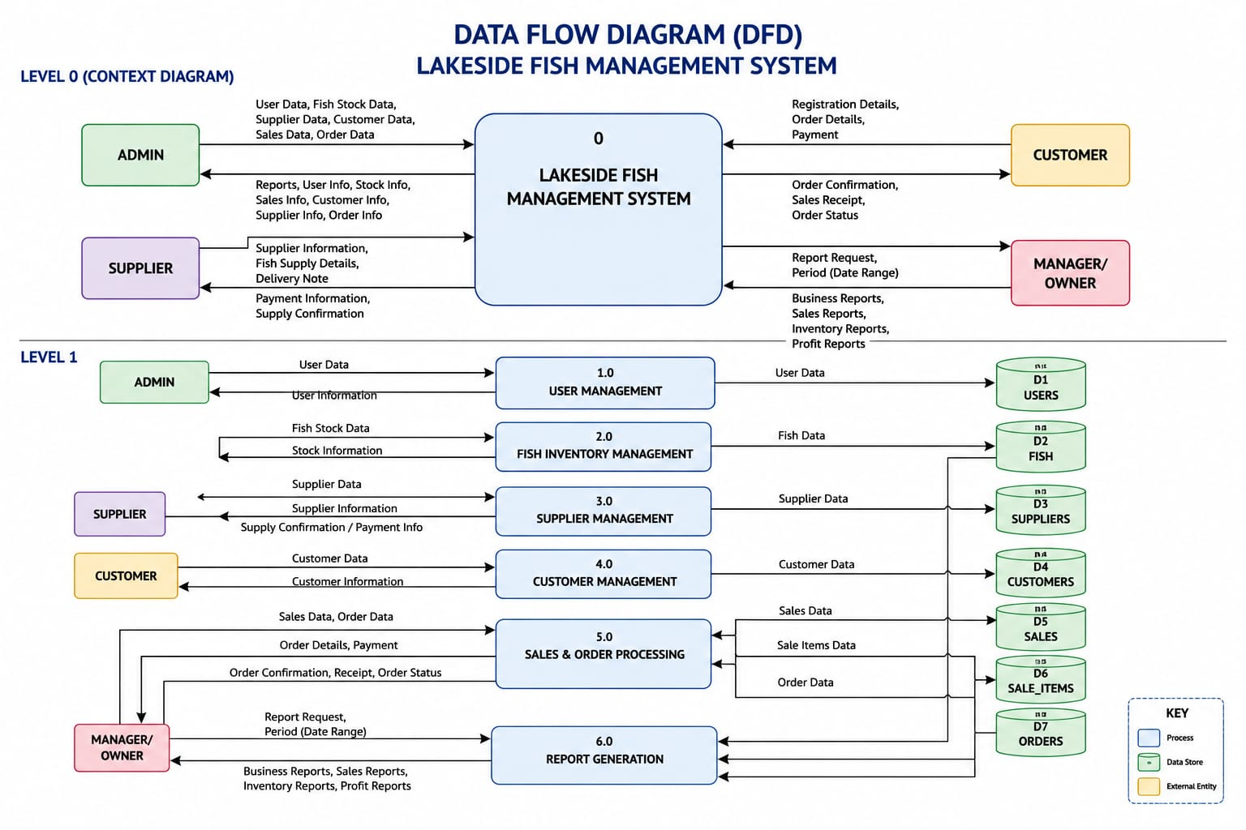
Figure 1: Data Flow Diagram (Level 0 and Level 1) — Lakeside Fish Management System

4.7.3 Entity Relationship Diagram
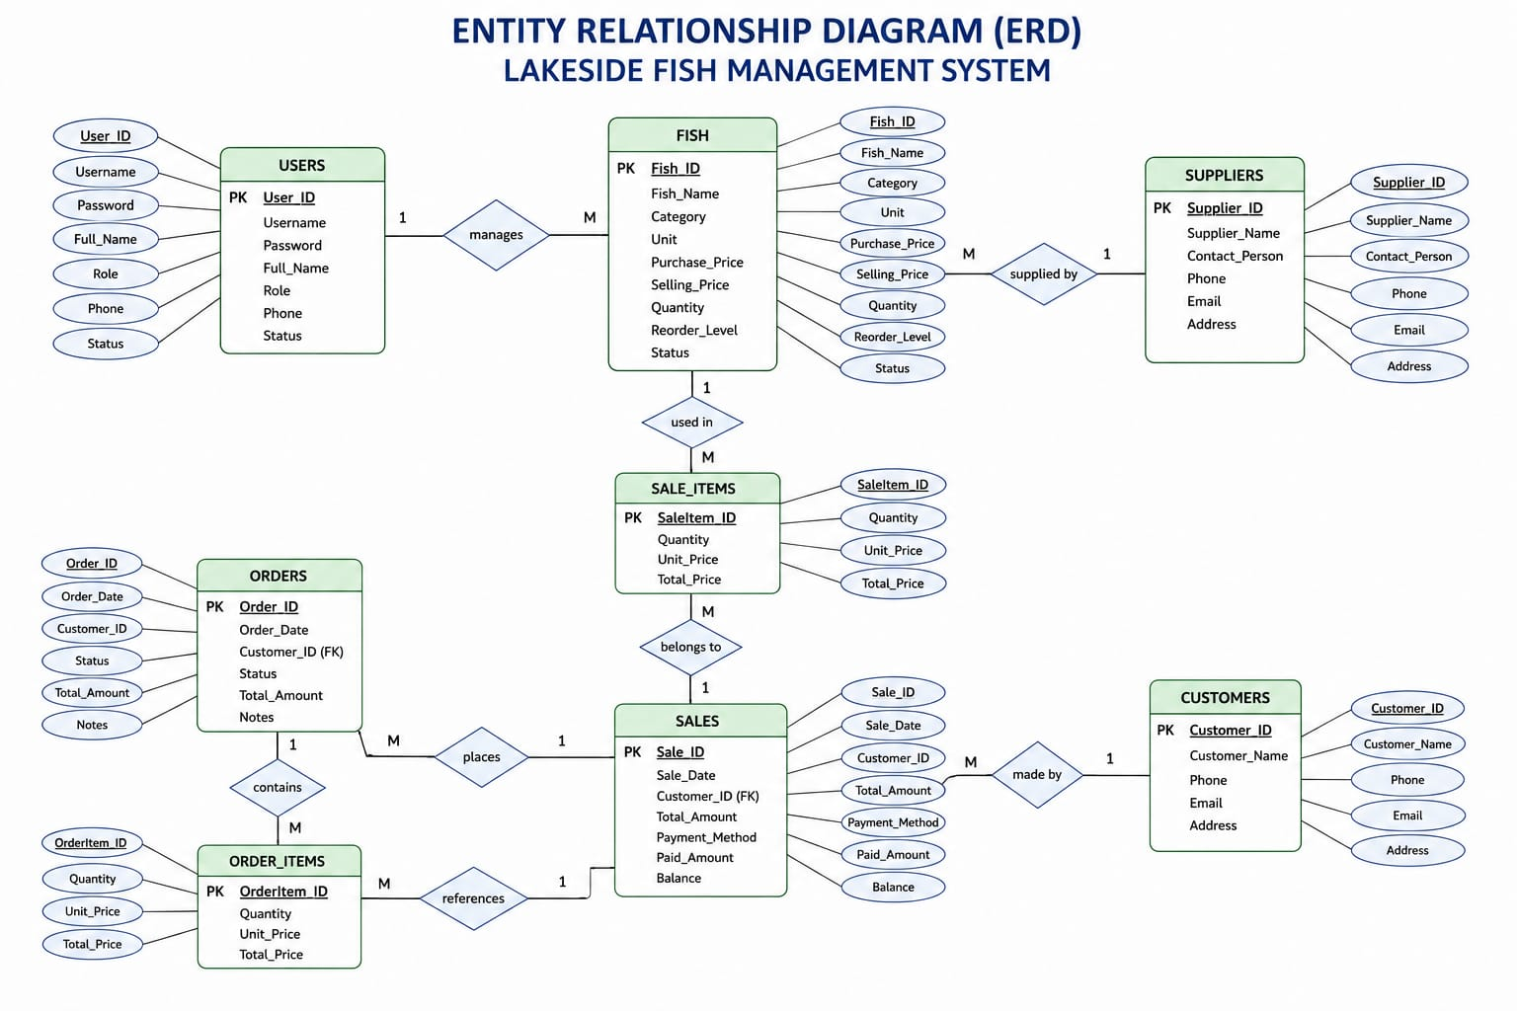
Figure 2: Entity Relationship Diagram — core entities (Users, Fish, Suppliers, Sales, Sale_Items, Orders, Order_Items, Customers)
To support the new mobile money, notification, and traceability features, the following entities extend the ERD above in the physical database design:
New Entity | Key Fields | Purpose
PAYMENTS | Payment_ID (PK), Sale_ID (FK), MpesaReceipt, Amount, Phone, Status, Timestamp | Logs every M-Pesa STK Push attempt and confirmation for reconciliation.
NOTIFICATIONS | Notification_ID (PK), Recipient, Type (SMS/WhatsApp), Message, Status, Timestamp | Tracks all outgoing alerts for auditing and retry handling.
BATCH_TRACEABILITY | Batch_ID (PK), Fish_ID (FK), Supplier_ID (FK), QRCode, DeliveryDate, LandingSite | Links a fish batch to its supplier/origin and generates the scannable QR code.

4.7.4 System Flowchart
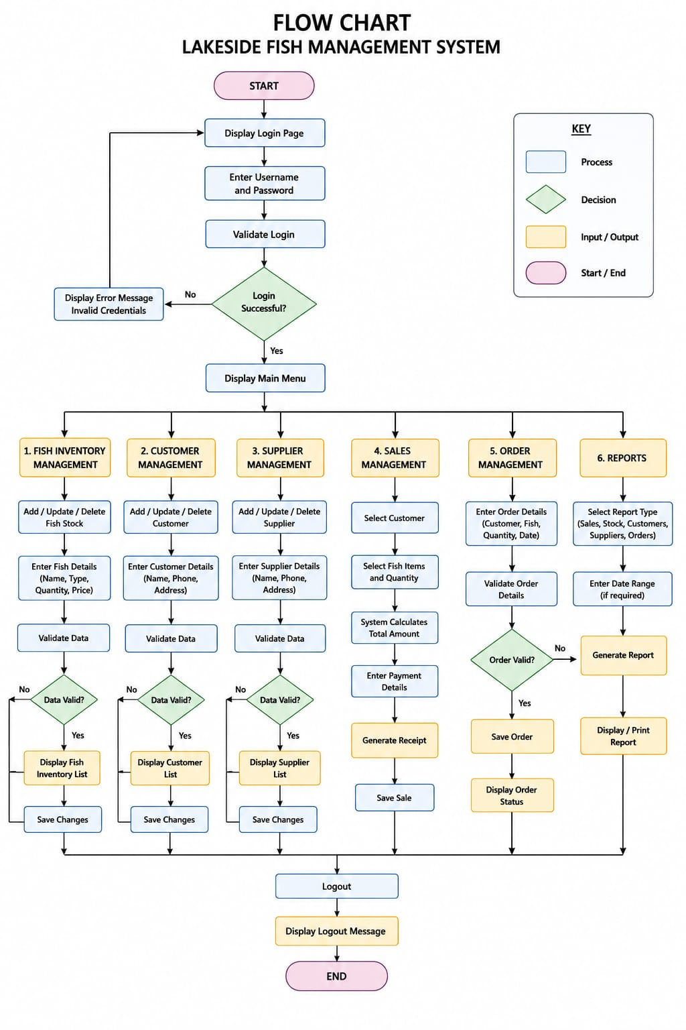
Figure 3: System Flowchart — Lakeside Fish Management System

4.7.5 Proposed Enhanced System Architecture
The diagram below illustrates how the new mobile money, notification, and traceability integrations layer onto the core system without disrupting its existing structure, and shows where a future IoT gateway would plug in.
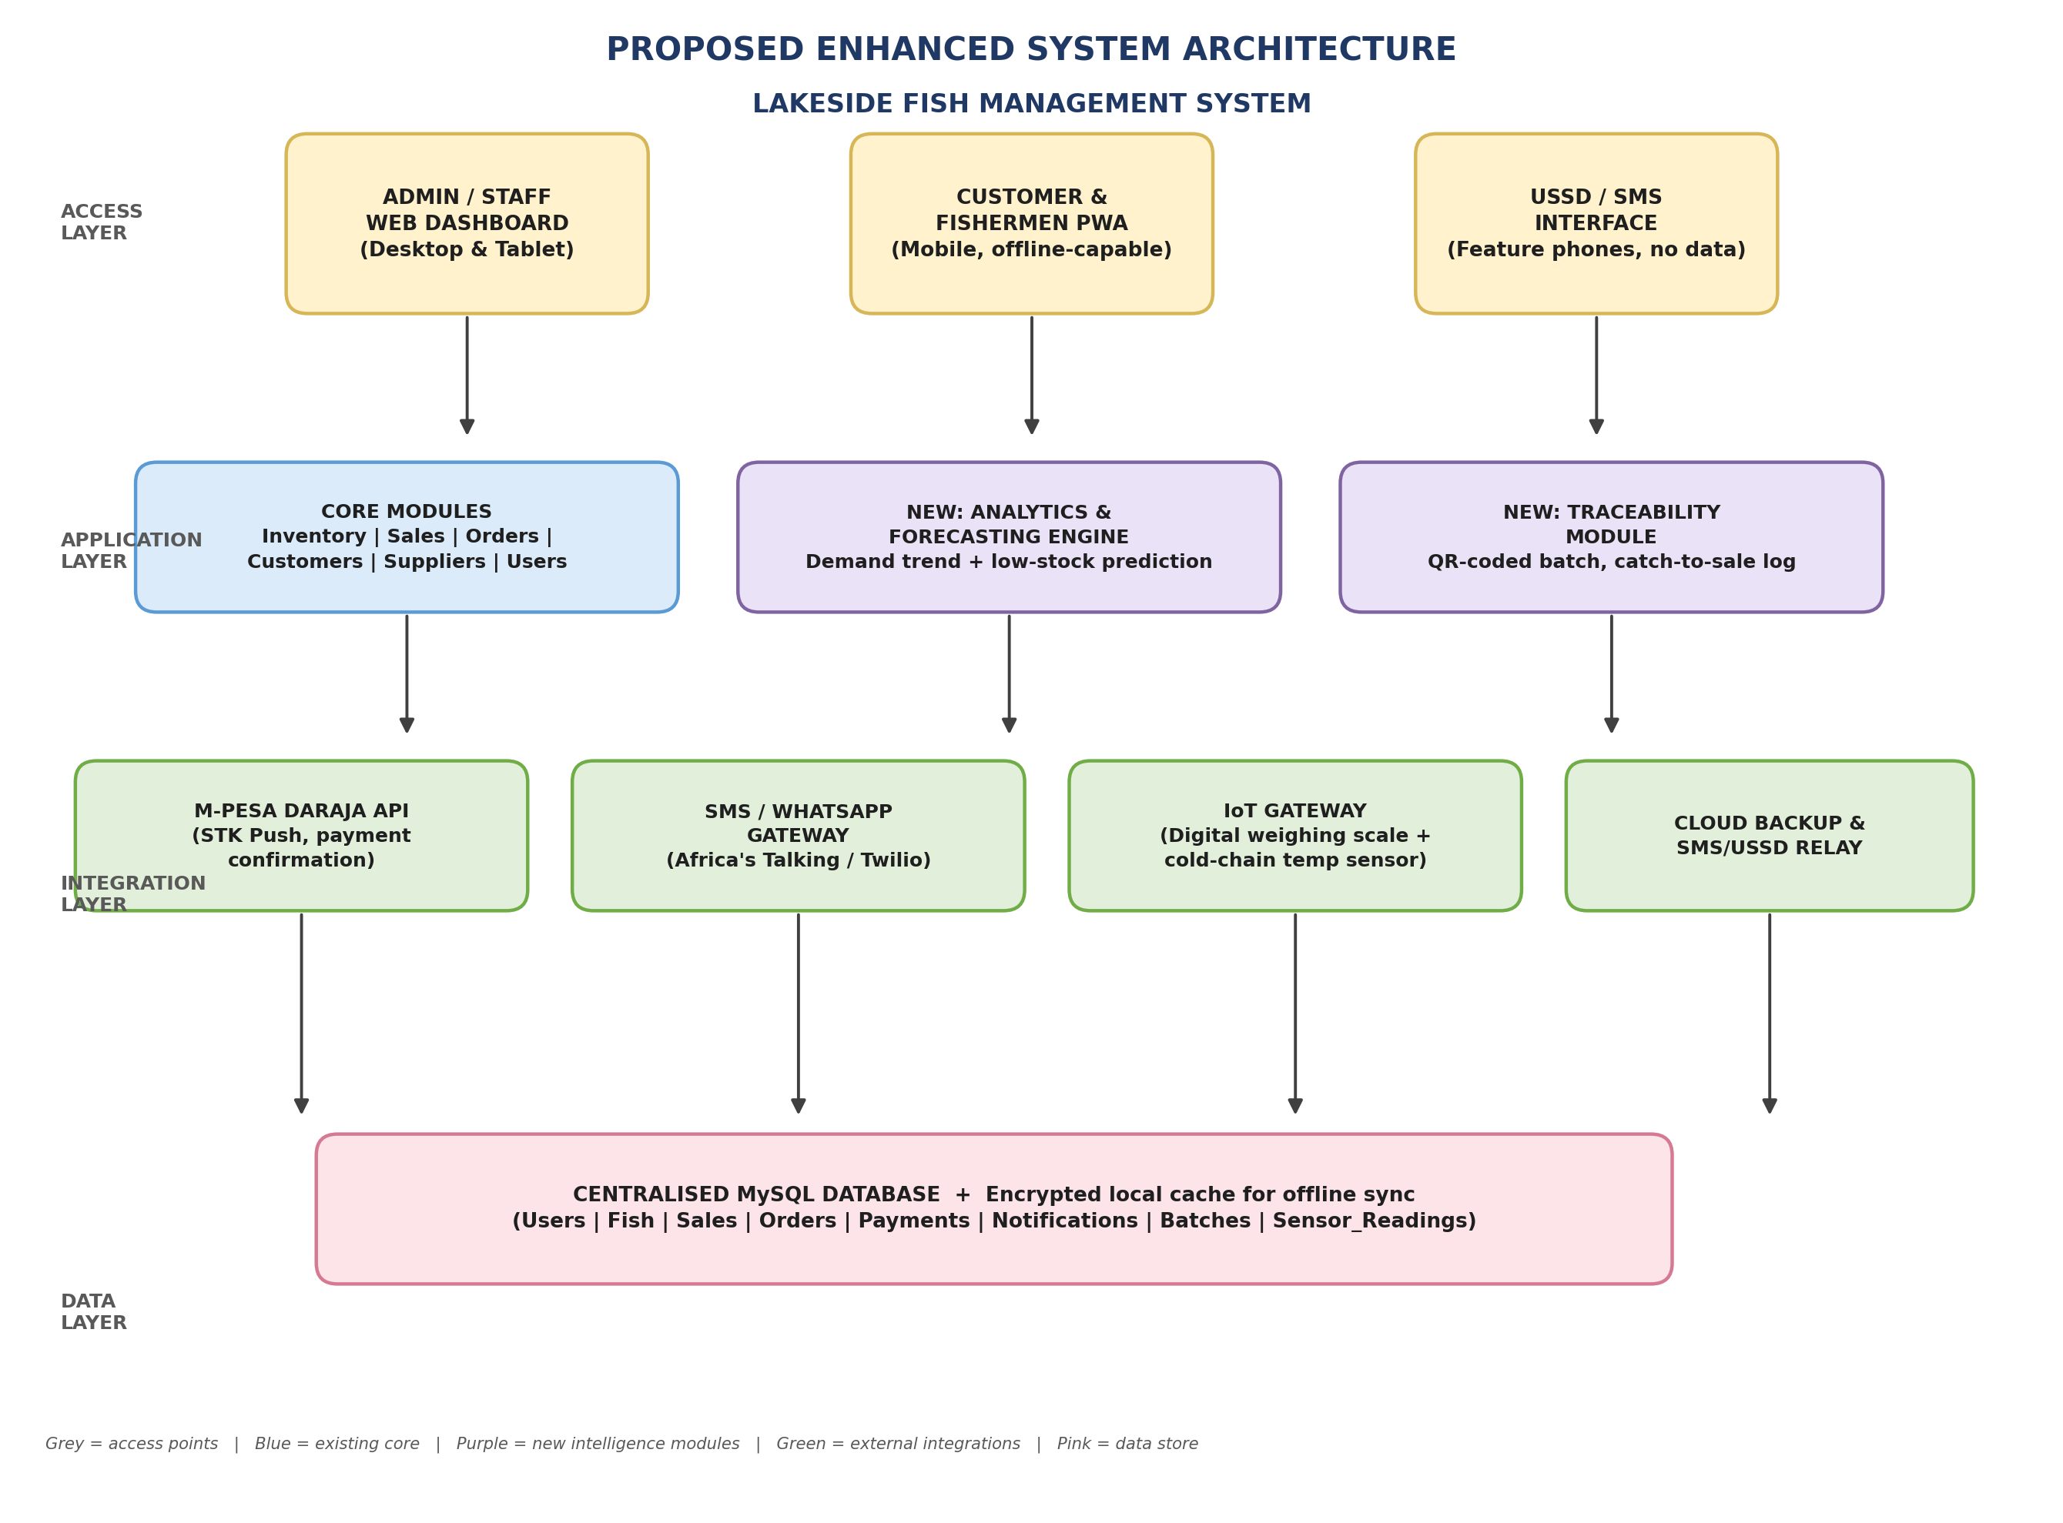
Figure 4: Proposed Enhanced System Architecture — access, application, integration, and data layers

4.8 Technology Stack
Layer | Technology | Reason for Choice
Frontend | HTML5, CSS3, JavaScript, Bootstrap | Responsive, mobile-friendly interface; widely documented for student projects.
Backend | PHP (Laravel framework) | Rapid development, strong ecosystem, easy Daraja/SMS API integration via HTTP clients.
Database | MySQL (via XAMPP in development) | Open-source, reliable, well-supported by Laravel's Eloquent ORM.
Payments | Safaricom Daraja API (M-Pesa STK Push) | Dominant mobile money platform in Kenya; free sandbox for development.
Notifications | Africa's Talking SMS/USSD API | Kenyan-focused gateway with free test credit and simple REST API.
Traceability | PHP QR-code library (e.g., endroid/qr-code) | Open-source, generates scannable codes without external service cost.
Version Control / Hosting | Git and a low-cost shared/VPS host | Enables iterative Agile development and affordable deployment for a pilot.

References
- Coronel, C., & Morris, S. (2020). Database systems: Design, implementation, and management (13th ed.). Cengage Learning.
- Dennis, A., Wixom, B. H., & Tegarden, D. (2021). Systems analysis and design: An object-oriented approach with UML (6th ed.). Wiley.
- Elmasri, R., & Navathe, S. B. (2021). Fundamentals of database systems (7th ed.). Pearson.
- Kendall, K. E., & Kendall, J. E. (2020). Systems analysis and design (10th ed.). Pearson.
- Laudon, K. C., & Laudon, J. P. (2022). Management information systems: Managing the digital firm (17th ed.). Pearson.
- Pressman, R. S., & Maxim, B. R. (2020). Software engineering: A practitioner's approach (9th ed.). McGraw-Hill Education.
- Sommerville, I. (2020). Software engineering (10th ed.). Pearson.
- Silberschatz, A., Korth, H. F., & Sudarshan, S. (2020). Database system concepts (7th ed.). McGraw-Hill Education.
- Connolly, T., & Begg, C. (2020). Database systems: A practical approach to design, implementation and management (6th ed.). Pearson.
- Rosenblatt, H. J. (2020). Systems analysis and design. Cengage Learning.
- PHP Documentation Group. (2025). PHP Manual. https://www.php.net/docs.php
- Apache Friends. (2025). XAMPP. https://www.apachefriends.org/
- Oracle Corporation. (2025). MySQL documentation. https://dev.mysql.com/doc/
- W3Schools. (n.d.). PHP Tutorial. https://www.w3schools.com/php/
- Mozilla Developer Network. (2025). HTML: Hypertext Markup Language. https://developer.mozilla.org/docs/Web/HTML
- Mozilla Developer Network. (2025). CSS: Cascading Style Sheets. https://developer.mozilla.org/docs/Web/CSS
- Mozilla Developer Network. (2025). JavaScript Guide. https://developer.mozilla.org/docs/Web/JavaScript
- Bootstrap Authors. (2025). Bootstrap Documentation. https://getbootstrap.com/docs/
- World Wide Web Consortium (W3C). (2025). Web Standards. https://www.w3.org/
- Fish Base. (2025). Fish Base: A global information system on fishes. https://www.fishbase.se/
- Safaricom PLC. (2025). Daraja API Documentation. https://developer.safaricom.co.ke/
- Africa's Talking. (2025). SMS and USSD API Documentation. https://developers.africastalking.com/
- Laravel. (2025). Laravel Documentation. https://laravel.com/docs

