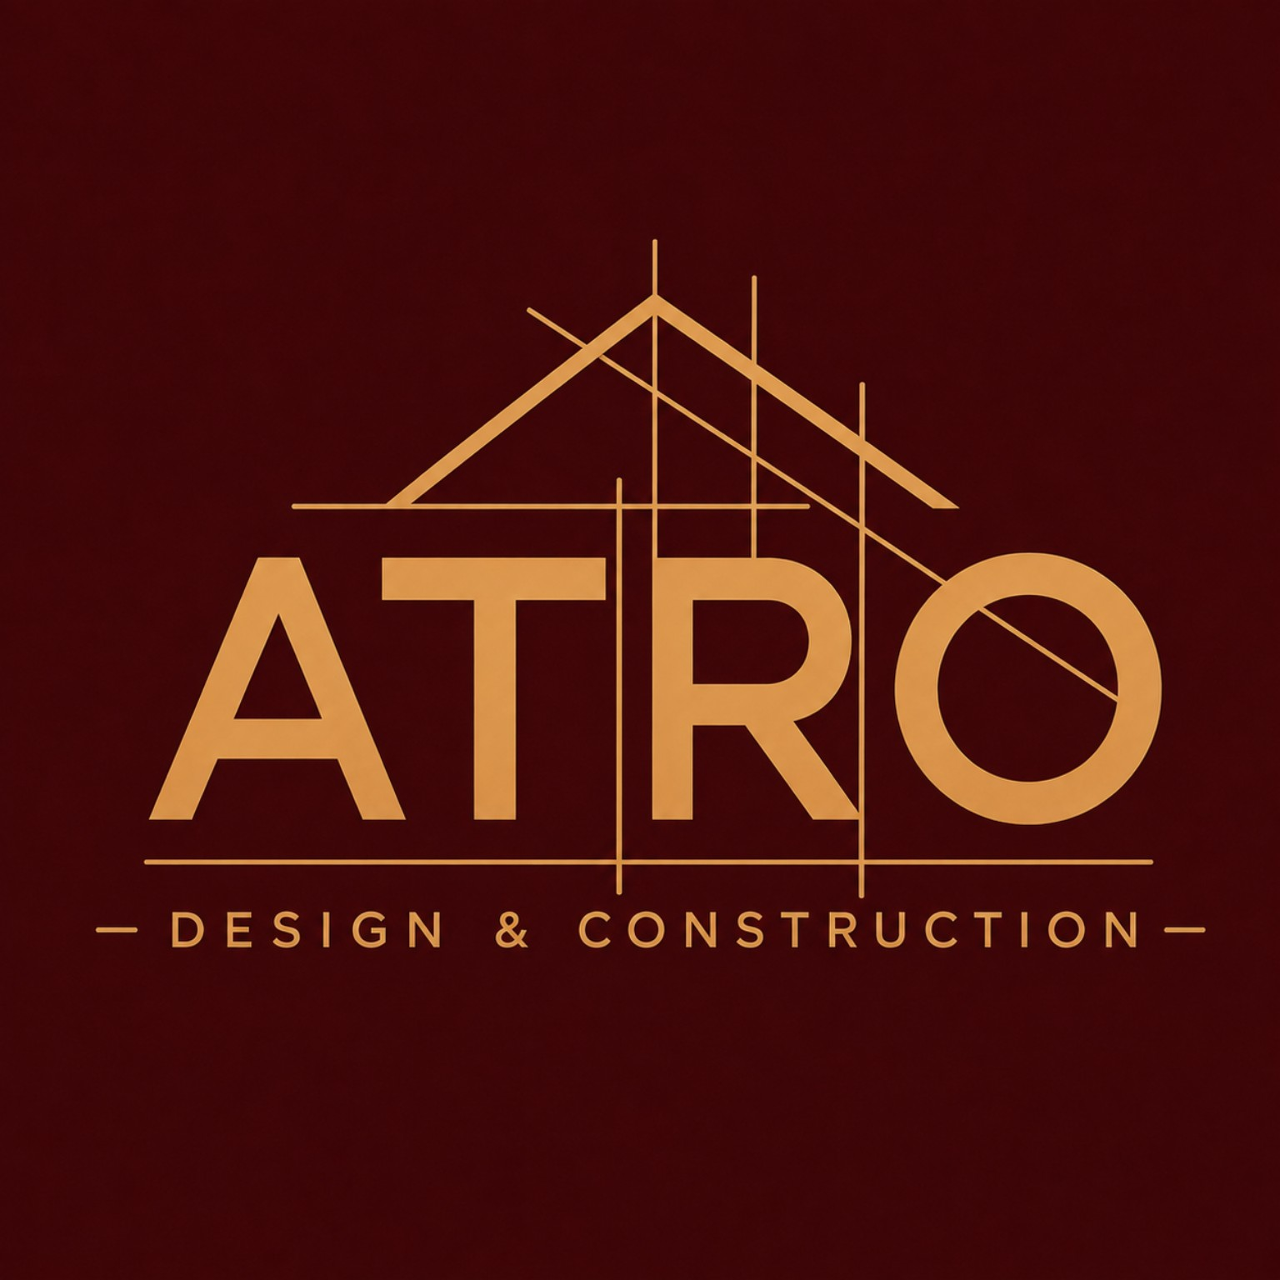

ATRO DESIGN & CONSTRUCTION

DIGITAL PLATFORM
PROJECT PROPOSAL & DEVELOPMENT DOCUMENTATION

“Designing & Building Better Structures — Online.”

Prepared for: ATRO Design & Construction
Scope: Corporate website, project portfolio & digital lead-generation platform
Market: Kenya, scalable to the wider East African region
Version 1.0 — September 2026

Table of Contents
1. Executive Summary
2. Project Background & Objectives
3. Brand Foundation
4. Competitive & Market Benchmark
5. Information Architecture
6. Page-by-Page Specification
7. Signature Innovations — What Makes This Platform ATRO's Own
8. UI/UX Design System — Modern Principles Applied
9. Recommended Technical Architecture
10. Content, Photography & Data Governance
11. SEO & Local Search Strategy
12. Project Phases & Timeline
13. Roles & Responsibilities
14. Developer Deliverables
15. Acceptance Checklist
16. Appendix

1. Executive Summary
ATRO Design & Construction has outlined a clear brief for a premium, credible, technically-minded digital presence. This document extends that brief into a complete project proposal: it benchmarks ATRO against leading construction, architecture and real-estate platforms (both global and Kenyan), translates the brand identity into a working design system, and proposes a set of original, market-differentiating features — anchored by a Zone Intelligence Engine that makes the platform location-aware for Kenya's fragmented, geography-driven construction market.
The recommendation is to build a fast, mobile-first, headless platform that a non-technical ATRO team member can manage entirely, launched as a focused Version 1 (per the brief's own instruction: “do not overbuild V1”), with a clear roadmap toward richer, AI-assisted and client-facing features in later phases.
Build principle: the website should not just look good — it should sell confidence. A visitor should leave believing ATRO understands design, understands construction, communicates clearly, manages projects professionally, and can be trusted with a serious building project.

2. Project Background & Objectives

2.1 Company Snapshot
- Company: ATRO Design & Construction
- Positioning: Design • Construction • Consultancy • Innovation
- Market: Kenya, with capability to serve the wider African market
- Primary audiences: homeowners, property developers, commercial clients, institutions, churches, contractors/partners, and Kenyans in the diaspora managing projects at home

2.2 Core Objectives
- Convert visitors into qualified, well-informed enquiries — not just page views.
- Establish ATRO as a professional, technically credible, design-and-build company — not a generic contractor.
- Give ATRO's non-technical team full content control (projects, services, team, insights) without developer involvement.
- Build a platform that is genuinely differentiated in the Kenyan construction-website landscape, not a templated brochure site.
- Create a foundation that scales cleanly into future tools (client portals, progress tracking, cost-planning workflows) without a rebuild.

3. Brand Foundation
The supplied logo is the primary brand mark and must never be redrawn, distorted or given added effects. The palette below was sampled directly from the approved logo artwork, with an accessible UI variant proposed for interface elements (buttons, links, form states) where the raw logo maroon is too dark to pair reliably with body text at web contrast ratios.
Swatch | Role | Hex | Usage
■ | Brand Maroon (logo) | #3C0508 | Logo background, hero overlays, print
■ | UI Primary Burgundy | #5C1018 | Buttons, nav, section backgrounds, headings
■ | Architectural Gold | #C9924F | Accents, dividers, icons, hover states — used sparingly
■ | Gold — Light | #E4B87A | Highlights on dark backgrounds
■ | Warm White / Off-White | #F7F3EC | Page background, cards
■ | Charcoal | #2A2A28 | Body text, primary type colour
■ | Neutral Grey | #8C8C89 | Secondary text, captions, borders

3.2 Typography & Visual Language
- Headings: a restrained serif or high-contrast sans (e.g. a Georgia/Fraunces-class serif for editorial weight, or Söhne/General Sans for a sharper technical feel) — bold, architectural, never decorative.
- Body: a clean humanist sans-serif (Inter, Söhne, or system UI stack) at a comfortable reading size — legibility over style.
- Buttons & cards: rectangular with subtle corner rounding, minimal shadow, generous internal spacing — no playful pill shapes, no clip-art iconography.
- Imagery: real ATRO sites, materials, teams and finished structures; editorial cropping; large hero images over stock-photo grids.

4. Competitive & Market Benchmark
To make sure ATRO's platform is genuinely best-in-class rather than a copy of the brief, the following benchmark reviews leading global construction/design-build websites and the current state of Kenyan construction company websites.

4.1 Global Benchmark — What the Best Do
Pattern observed | Where it shows up | What ATRO should take from it
Sector/segment-based navigation | Large multi-market contractors (e.g. Turner, McCarthy-style firms) | Let visitors self-select by project type (residential, commercial, institutional, church) instead of one generic ‘services’ list.
Before/after and progress photography | Award-winning regional contractors | Use paired or slider imagery on select projects to visibly demonstrate quality of finish.
Certifications, awards & safety record surfaced everywhere, not buried | National GCs and design-build firms | Add a lightweight ‘Trust Strip’ component reusable across Home, About and Services.
Specific, non-generic value propositions | Firms that state exact self-performance/technical capabilities | Replace generic ‘quality and reliability’ language with ATRO-specific technical claims (BOQ-led costing, integrated design+build, site-based project consultancy).
Portfolio-first, minimal-text project pages | Boutique architecture/remodel studios | Confirms the brief's direction: large imagery, short scope/role/outcome copy, no walls of text.
Persistent, single, unambiguous CTA | Almost all top-tier contractor sites | One CTA family throughout: Start a Project / Request a Consultation — never competing CTAs on one screen.

4.2 Kenyan Market — The Gap ATRO Can Own
Established Kenyan contractors and developers (firms such as Cementers, Laxmanbhai, Landmark Holdings and Intex, among others) generally maintain a corporate presence, but the sector as a whole is dominated by dated, text-heavy, desktop-first sites: static project lists with no filtering, no service-area clarity, weak mobile performance, and contact flows that stop at a phone number rather than a structured enquiry.
- Gap 1 — No location clarity: Kenyan buyers and diaspora clients cannot easily tell where a firm actually builds, or what to expect in their county/area.
- Gap 2 — Weak lead qualification: Most sites offer a phone number or a generic contact form, with no structure to a project type, budget range or stage of the enquiry.
- Gap 3 — Poor mobile performance: Heavy, unoptimised imagery on sites that are mostly visited on mid-range Android phones over mobile data.
- Gap 4 — No WhatsApp-first journey: WhatsApp is the dominant informal communication channel in Kenya, yet it is rarely integrated as a structured, trackable lead channel.
Positioning takeaway: ATRO does not need to out-shout local competitors with colour or animation — it needs to out-clarify them, on location, on process and on mobile.

5. Information Architecture

5.1 Primary Navigation
Home · About · Services · Projects · Our Process · Insights · Contact — with a persistent “Start a Project” CTA in the header at all times, sticky on scroll.

5.2 Full Sitemap
- Home
  - About — Story, Vision & Mission, Values, Philosophy, Team, Credentials
  - Services — overview + one detail page per service (Architectural Design, Structural Design, Construction & Project Execution, BOQ/Cost Planning, Project Management & Site Consultancy, Interior/Spatial Design, Precast & Construction Solutions)
  - Projects — filterable portfolio + individual project detail pages
  - Our Process — the 8-step journey as an interactive, scrollable timeline
  - Where We Build — NEW: the Zone Intelligence page (service-area map, county coverage, local FAQs)
  - Insights — articles/resources for SEO and authority-building
  - Contact — structured enquiry form, WhatsApp, office details, map
  - Legal — Privacy Policy, Terms, Cookie Notice

6. Page-by-Page Specification

6.1 Home
Answers three questions in the first screen: Who is ATRO? What does ATRO do? What should I do next?
- Hero: full-width construction/architecture image or render; headline “Designing & Building Better Structures”; sub-copy on integrated design, construction and consultancy; primary CTA “Start a Project”, secondary “View Our Projects”.
- Trust strip: 3–5 credibility points (Design + Construction, Technical Consultancy, Quality & Cost Control, Transparent Project Management, Kenya-based Delivery).
- Services preview cards linking to detail pages.
- Featured projects (3–6), each tagged with its delivery zone.
- ‘Why ATRO’ section — integrated thinking, technical approach, cost awareness, quality focus, communication, modern methods.
- Zone Intelligence teaser: “Check if we build in your area” mini-widget.
- Final CTA band in burgundy/gold: “Have a project in mind?”

6.2 Services
Each service page states, plainly: what is included, typical project types, expected client inputs, and a direct enquiry CTA — never vague marketing language. Where a service touches statutory approvals or regulated professional sign-off, copy must avoid implying registration or licensing that has not been verified.

6.3 Projects / Portfolio
- Filter by project type (Residential, Commercial, Institutional, Renovation, Church, School) and by status (Completed, Ongoing, Proposed).
- NEW: filter/sort by zone (e.g. Nairobi, Kiambu, Coast, Diaspora-managed).
- Consistent card image ratios; project detail pages with hero image, scope, location, status, challenge, ATRO's role, solution, and a lightbox gallery.
- Ongoing projects always clearly labelled as ongoing — never presented as complete.

6.4 About, Our Process, Insights, Contact
Follow the brief's direction directly: About communicates story and values without becoming a biography; Our Process is a visual 6–8 step journey (Consultation → Assessment → Concept & Design → Cost Planning → Approvals → Construction → Monitoring → Handover); Insights builds authority through educational content; Contact is a structured enquiry form (name, phone, email, project type, location/zone, approximate budget, stage, target start date, description, optional attachments) with WhatsApp, email and social clearly shown, spam protection, and instant admin notification.

7. Signature Innovations — What Makes This Platform ATRO's Own
The brief asks for a credible, premium brand site. The features below are proposed additions that push the platform beyond the benchmark — designed around how Kenyan clients actually search for, evaluate and commit to a construction partner.

7.1 Zone Intelligence Engine (flagship innovation)
A location-aware layer that runs across the whole platform, not just a single map page.
- Coverage map: an interactive map (county/area based) showing where ATRO currently delivers projects, with a simple “Is ATRO available in your area?” lookup.
- Zone-tagged projects: every project and testimonial is tagged to a zone, so the portfolio can be filtered and the homepage can surface ‘Recent work near you’ based on the visitor's approximate location (with consent).
- Zone-aware enquiry routing: the contact form's ‘Location’ field automatically routes the enquiry (and its WhatsApp follow-up) to the right regional contact or response workflow, and can flag zones outside current coverage before the client wastes time drafting a full brief.
- Zone landing pages: lightweight, SEO-targeted pages (“Construction Company in Kiambu”, “Building Contractors Nairobi”) generated from the same underlying project/zone data — directly addressing the SEO keyword directions in the brief without duplicating content by hand.
- Diaspora mode: a zone-aware variant for diaspora visitors that foregrounds remote-project-management proof points, time-zone-aware contact options and WhatsApp/video-call scheduling.

7.2 Guided Enquiry & Cost-Range Wizard
Rather than a flat contact form, a short guided flow (project type → zone → approximate size/scope → stage → budget band) that ends in a clear, appropriately-caveated indicative range and a warm handoff to the standard enquiry form — improving lead quality without ever presenting the range as a firm quote.

7.3 Living Project Timeline
For ongoing projects, an opt-in, lightweight photo-timeline component (milestone photos with dates and short captions) that turns ‘Ongoing’ tags into visible proof of progress — a strong differentiator against competitors who only show finished-project photography.

7.4 Conversational Concierge
A scoped, clearly-labelled AI assistant that answers structural/service/process questions from ATRO's own content, helps visitors find the right service or project examples, and hands off to a human (WhatsApp or the enquiry form) the moment a question requires a commitment, a price or professional judgement. In line with 2026 UX best practice, this is designed to reduce friction and clarify next steps, not to replace human sign-off on anything technical or contractual.

7.5 WhatsApp-First Contact Layer
Kenya's dominant communication channel is treated as a first-class contact method, not an afterthought: a persistent, thumb-reachable WhatsApp entry point on mobile, pre-filled with the visitor's selected zone and project type so the conversation starts with context already captured.

7.6 Bilingual-Ready Content Layer
Content structured from day one to support an English/Kiswahili toggle, even if only English ships at launch — avoiding a costly re-architecture later.

7.7 Client Transparency Portal (Phase 2+)
A lightweight, password-protected view for active clients showing project milestones, approved documents and progress photos — building on the same project/zone data model, introduced only once V1 is stable, per the brief's ‘do not overbuild V1’ instruction.

8. UI/UX Design System — Modern Principles Applied
The design system translates 2026 web design and UX practice into ATRO's premium-architectural brand, without chasing trend for its own sake.
- Purposeful micro-interactions: subtle hover states, confirmation feedback on form submission, gentle image reveals on scroll — motion that confirms and guides, never decorates. Full support for reduced-motion accessibility settings.
- Accessibility as a baseline, not an afterthought: strong colour contrast (validated against the burgundy/gold palette), full keyboard navigation, descriptive alt text on every project image, readable base font sizes.
- Calm personalisation: zone-aware content and the concierge adapt what's shown, but the interface itself stays consistent and predictable — personalisation should feel considerate, not intrusive.
- Editorial, architectural visual language: large imagery, strong grid alignment, generous whitespace, restrained bento-style card layouts for services and projects.
- Performance as design: sub-2.5 second target load time, image lazy-loading, modern compressed formats (WebP/AVIF) — treated as a design requirement, not a backend afterthought, especially for Kenyan mobile networks.
- Human trust signals: real project photography and real team presence throughout, avoiding generic stock imagery and avoiding an over-produced, AI-generated look that could undercut credibility.

9. Recommended Technical Architecture
Layer | Recommendation | Why
Frontend | Modern component framework (e.g. Next.js/React) with static generation for content pages | Fast loads on mobile data, strong SEO, smooth transitions
CMS | Headless CMS (e.g. Sanity or Strapi) with a Projects/Zones/Services content model | Lets ATRO staff manage projects, zones, services and insights without a developer
Maps | Lightweight map library (Leaflet/MapLibre with OpenStreetMap tiles, or Google Maps where budget allows) | Powers the Zone Intelligence Engine without high per-load licensing cost
Messaging | WhatsApp Business Platform / click-to-chat integration | Matches how Kenyan clients actually prefer to communicate
Forms & notifications | Server-side validated forms, spam protection (honeypot/CAPTCHA), transactional email + WhatsApp notification to ATRO admin | Reliable, spam-resistant lead capture
Hosting | CDN-backed static/hybrid hosting (e.g. Vercel/Netlify or equivalent) on ATRO's domain | Speed, reliability, simple SSL/HTTPS management
Analytics | Google Analytics 4 (or equivalent) with conversion tracking on forms, CTA clicks and WhatsApp taps | Measures which zones/services actually convert

10. Content, Photography & Data Governance
- Only real ATRO project photography and professional renders — no generic construction stock imagery as the dominant visual language.
- Every published photo is labelled, captioned where useful, and approved for public use before publication.
- Client information, drawings, addresses and project values are never published without explicit permission.
- Statutory/regulated-role language is reviewed before publication to avoid implying registrations that are not confirmed.

11. SEO & Local Search Strategy
Technical SEO foundation (clean URLs, meta titles/descriptions, heading hierarchy, image alt text, sitemap.xml, robots.txt) is a developer deliverable; the Zone Intelligence Engine directly supports the brief's target keyword directions by generating location-specific landing pages from real project data:
- construction company in Kenya • design and construction company Kenya
- building contractors Nairobi / Kiambu / Kenya
- architectural and structural design Kenya • project management construction Kenya
- house construction company Kenya • commercial construction Kenya • construction consultancy Kenya

12. Project Phases & Timeline

Phase 1 — Foundation (V1 Launch)
Wireframes and sitemap approval, full brand-aligned UI design, Home/About/Services/Projects/Process/Contact, CMS, structured enquiry form with WhatsApp and email notification, core Zone Intelligence coverage map, basic SEO, analytics, HTTPS/security, mobile-first testing, deployment and handover training.

Phase 2 — Depth & Conversion
Zone-tagged filtering across Projects, zone landing pages, Guided Enquiry & Cost-Range Wizard, Insights/blog, Living Project Timeline for ongoing projects, bilingual content structure.

Phase 3 — Advanced Experience
Conversational Concierge, Client Transparency Portal, downloadable company profile, online consultation booking, newsletter/insights subscription — introduced only once V1 is proven, in line with the brief's explicit instruction not to overbuild V1.

13. Roles & Responsibilities
ATRO / Client provides | Developer / Technical Team delivers
Approved logo and brand assets | UI/UX design system
Company description, vision and mission | Responsive frontend and backend
Service descriptions and scope | CMS setup and training
Project information and approved photos | Forms, notifications and Zone Intelligence Engine
Team/professional information | SEO implementation
Contact details and social handles | Analytics and conversion tracking
Testimonials and approvals for publication | Security, backups and deployment

14. Developer Deliverables
- Wireframes / sitemap sign-off before full development
- Desktop + mobile UI design, fully responsive build
- CMS/admin access with training
- Working enquiry system with WhatsApp integration
- Zone Intelligence Engine (map, filtering, routing)
- SEO-ready structure, analytics and conversion tracking
- Performance optimisation and security configuration
- Cross-browser/cross-device testing
- Deployment to ATRO domain and hosting, with full documentation of logins, hosting, domain, CMS and integrations

15. Acceptance Checklist
- Logo and brand colours used consistently across every page
- Home page communicates ATRO's value within the first screen
- All primary services have clear descriptions and CTAs
- Projects are visually strong, zone-tagged and easy to browse
- Contact form works and notifications reach ATRO instantly
- WhatsApp contact works smoothly on mobile
- Zone Intelligence coverage map and lookup function correctly
- Site is responsive on common phone, tablet and desktop sizes, with no horizontal scrolling
- Images are optimised and pages load quickly on mobile data
- Basic SEO and analytics/conversion tracking are implemented and working
- CMS allows ATRO to update all core content independently
- HTTPS/security is active; no broken links, placeholder text or template branding remains
- All client-provided project information has been approved before publication

16. Appendix

16.1 Brand Colour Reference
Brand Maroon #3C0508 · UI Primary Burgundy #5C1018 · Architectural Gold #C9924F · Gold Light #E4B87A · Warm White #F7F3EC · Charcoal #2A2A28 · Neutral Grey #8C8C89

16.2 Sources Consulted for Benchmarking
- Colorlib — “27 Best Construction Company Website Examples 2026”
- Azuro Digital — “10 Best Construction Website Designs of 2026”
- OpenAsset — “25 Construction Website Examples in 2026 to Inspire and Convert”
- Construction Kenya, ensun.io, ProBuilders Kenya — Kenyan construction company listings and profiles
- WebFX, Coalition Technologies, Tubik Studio, Veza Digital — 2026 UI/UX and AI-in-design trend reports
- Mapme, WPResidence, Webstix — service-area and zone-based interactive mapping approaches

ATRO — DESIGN & CONSTRUCTION

