Smart Pool Table Unit — Phase 1
Standalone GSM-Based Payment & Auto-Release Unit — Technical Specification

1. Design Intent
Phase 1 is a fully self-contained unit. It requires no internet connection, no cloud server, and no venue WiFi. A GSM module with a SIM card receives the M-Pesa payment confirmation SMS directly, the on-board controller parses it, converts the amount into game credits at a configurable price, and displays the queue on an LCD. The customer presses a single button to release the balls, and one credit is deducted.
This gives the business a production-grade, deployable unit at minimum complexity, while keeping a clean upgrade path to the networked multi-table system described in the main proposal.

2. Operating Principle
- The SIM inside the device is the number registered to receive the Till's M-Pesa confirmation messages.
- On payment, M-Pesa sends a confirmation SMS; the GSM module receives it and passes it to the controller over UART.
- The controller validates the sender and message format, extracts the amount and transaction code, and credits games = amount ÷ price per game.
- Any remainder is retained as a balance toward the next game.
- The LCD continuously displays the number of games queued and the current price.
- Each button press fires the solenoid for a set pulse duration, releasing the balls, and decrements the credit count by one.

3. Power Architecture
Mains power does not feed the electronics directly. The 12V adapter passes through the master ON/OFF switch into a charger/BMS module, which maintains the 18650 battery pack. The battery rail then supplies all loads at all times. This is a true pass-through UPS topology: there is no switchover delay when mains fails, and the battery naturally absorbs the solenoid's inrush current, which would otherwise cause brown-out resets of the controller.
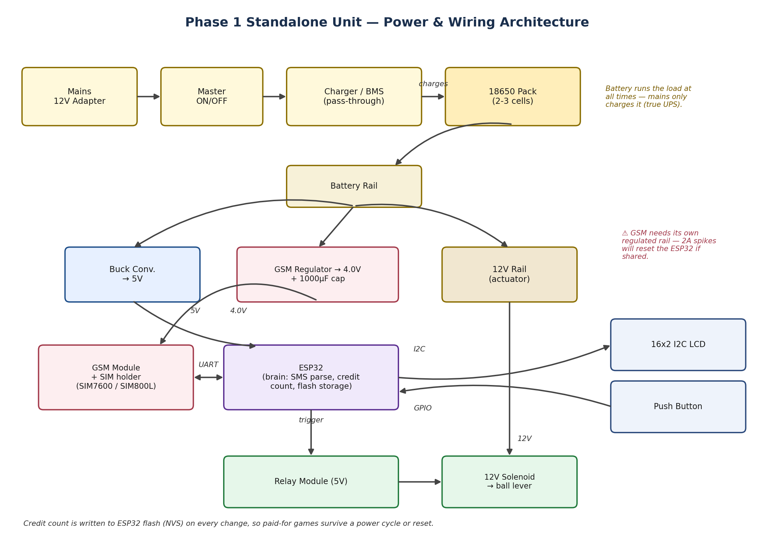

4. Bill of Materials
Component | Function | Notes
ESP32 | Main controller: SMS parsing, credit accounting, LCD, button, relay control | Adequate GPIO and on-board flash for non-volatile credit storage
GSM module + SIM holder | Receives M-Pesa confirmation SMS over the cellular network | SIM7600 preferred for wider voltage tolerance; SIM800L is a lower-cost alternative
16x2 I2C LCD | Customer-facing display: games queued, price, prompts, status messages | I2C keeps wiring to two signal lines
Tactile push button | Customer trigger to release balls and consume one credit | Debounced in firmware
Relay module (5V) | Switches the solenoid circuit from the controller's logic pins | Isolates the actuator's current draw from control electronics
12V solenoid | Trips the table's existing ball-release lever | Reuses the original coin mechanism; no redesign of the ball lock
Buck converter (12V→5V) | Supplies the controller and LCD | Shared battery rail source
GSM regulator (→4.0V) + 1000µF capacitor | Dedicated supply for the GSM module | Mandatory — see Section 5
18650 cells (2–3) + BMS/charger | Battery backup and power conditioning | Charges from mains; carries the load continuously
12V mains adapter | Primary power input and battery charging source | Feeds the charger, not the board
Master ON/OFF switch | Single physical control for the entire unit | Positioned immediately after the power inlet

5. Critical Design Risks

5.1 GSM power supply
The GSM module draws current spikes of up to approximately 2A during network transmission and operates below 5V. If it shares a rail with the controller, these spikes cause resets and dropped messages. It must be given its own regulated supply with a large bulk capacitor placed directly at its power pins. This is the most common cause of failure in builds of this type and is treated as a mandatory design requirement, not an optimisation.

5.2 Credit persistence across power loss
Game credits represent money already paid. If the unit resets while a customer holds unused credits, those credits must survive. The credit count and balance are therefore written to the controller's non-volatile flash on every change, not held in volatile memory.

5.3 Duplicate transaction handling
If the GSM module re-reads its message inbox after a reboot, previously processed payments could be credited twice. The firmware maintains a rolling log of recent transaction codes in flash and ignores any message whose code has already been processed.

5.4 Single-till limitation
Because the unit relies on receiving the Till's confirmation SMS, one SIM corresponds to one Till. This design is therefore inherently single-table. Serving multiple tables on a shared Till requires the networked architecture described in the main proposal. This should be understood as a deliberate Phase 1 scope boundary.

6. Firmware Logic
CREDITS and BALANCE held in non-volatile flash
PRICE_PER_GAME configurable (default 100)

on_sms_received(msg):
if sender is MPESA and message format valid:
code, amount = parse(msg)
if code in recent_transaction_log: ignore
else:
BALANCE += amount
games = BALANCE / PRICE_PER_GAME
CREDITS += games; BALANCE = remainder
save_to_flash(); display("Paid! N games")

on_button_press():
if CREDITS > 0 and battery above threshold:
pulse_relay(400ms); CREDITS -= 1
save_to_flash(); display("Enjoy! N left")
else:
display("No games. Pay Till XXXXX")

7. Handled Conditions
Condition | System behaviour
Partial payment below one game price | Amount retained as a balance and displayed; credited once the total reaches the game price
Payment confirmation delayed by network | Display shows a waiting message so the customer does not pay a second time
Mechanism jams after release | Concealed staff override button grants a release without consuming a credit
Battery below safe threshold | Warning displayed; solenoid actuation refused to avoid a partial throw jamming the mechanism
Mains power failure | Battery carries the load with no interruption; credits and balance unaffected
Price change required | Adjustable without reflashing, via an administrative SMS from a whitelisted number

8. Remote Administration
Because the unit already has a cellular connection, the owner can administer any deployed unit from any location by SMS from a whitelisted number, with no additional hardware:
- Set the price per game
- Request a status report (credits outstanding, battery level, signal strength)
- Grant a complimentary game remotely

9. Upgrade Path
The firmware is structured so that payment detection is a replaceable module. The enclosure, display, button, actuator and power design remain unchanged across all phases:
- Phase 1: SMS-based detection, local credit accounting, no internet dependency
- Phase 2: same hardware, payment detection switched to an online payment API over the existing cellular data connection, enabling per-table identification and digital receipts
- Phase 3: addition of a central hub and per-table nodes, plus the management application for owners and location managers

10. Approval Points
- Confirm the default price per game and whether location managers may adjust it
- Confirm the GSM module selection, balancing unit cost against supply robustness
- Confirm whether a concealed staff override button is included in the pilot build
- Approve construction of a single pilot unit for mechanical testing against an existing table

