Smart Pool Table Unit — Phase 2
Networked Payment & Backend Integration — Technical Specification

1. Design Intent
Phase 2 connects the Phase 1 unit to a real backend, replacing SMS-based payment detection with a live payment API integration. Every physical component from Phase 1 — LCD, button, relay, solenoid, power design, and local flash credit storage — is unchanged. Only the payment-detection layer and the addition of a network connection are new.
Two decisions shape this phase: payment is collected via M-Pesa Paybill with the account number set to the table's ID, and the backend is built on TanStack Start deployed to Vercel. Both choices are reflected throughout this document.

2. What Changes From Phase 1
Aspect | Phase 1 | Phase 2
Payment detection | GSM module reads M-Pesa confirmation SMS locally | Backend receives Daraja payment callback; unit polls backend for credit
Table identification | Not applicable — one SIM per till, one table per till | Account number on the Paybill payment = the table's own ID
Connectivity | None required beyond the SIM's SMS channel | WiFi (primary) with GSM mobile data as fallback
Receipts | Not available | SMS receipt triggered by the backend on confirmed payment
Multi-table support | One unit per till, no differentiation possible | Each unit reports its own table ID — multiple units can share infrastructure without a hub
Admin control | SMS commands (SET PRICE, STATUS, FREE) | Same SMS commands retained as an offline fallback

3. Payment Flow
QR codes are deliberately deferred to a later iteration so that customers without a smartphone are not excluded at launch. The Paybill flow works from any phone capable of using the standard M-Pesa menu.
- The unit's LCD displays the venue's Paybill number and that table's account number, e.g. “Paybill: XXXXXX, Acct: TBL-03”
- The customer pays through the standard M-Pesa Paybill menu on their own phone
- M-Pesa passes the account number straight through to Safaricom's Daraja API
- Daraja calls the backend's callback endpoint with the account number (table ID) and amount — no session-matching logic is required, since the table reference arrives directly in the payment data
- The backend credits the correct table in the database immediately
- The unit polls its own status endpoint every few seconds and picks up the new credit on its next poll
- The backend triggers an SMS receipt to the customer
QR codes can be added later purely as a convenience layer — a smartphone user scans instead of typing the Paybill and account number — without changing any backend or firmware logic.

4. System Architecture
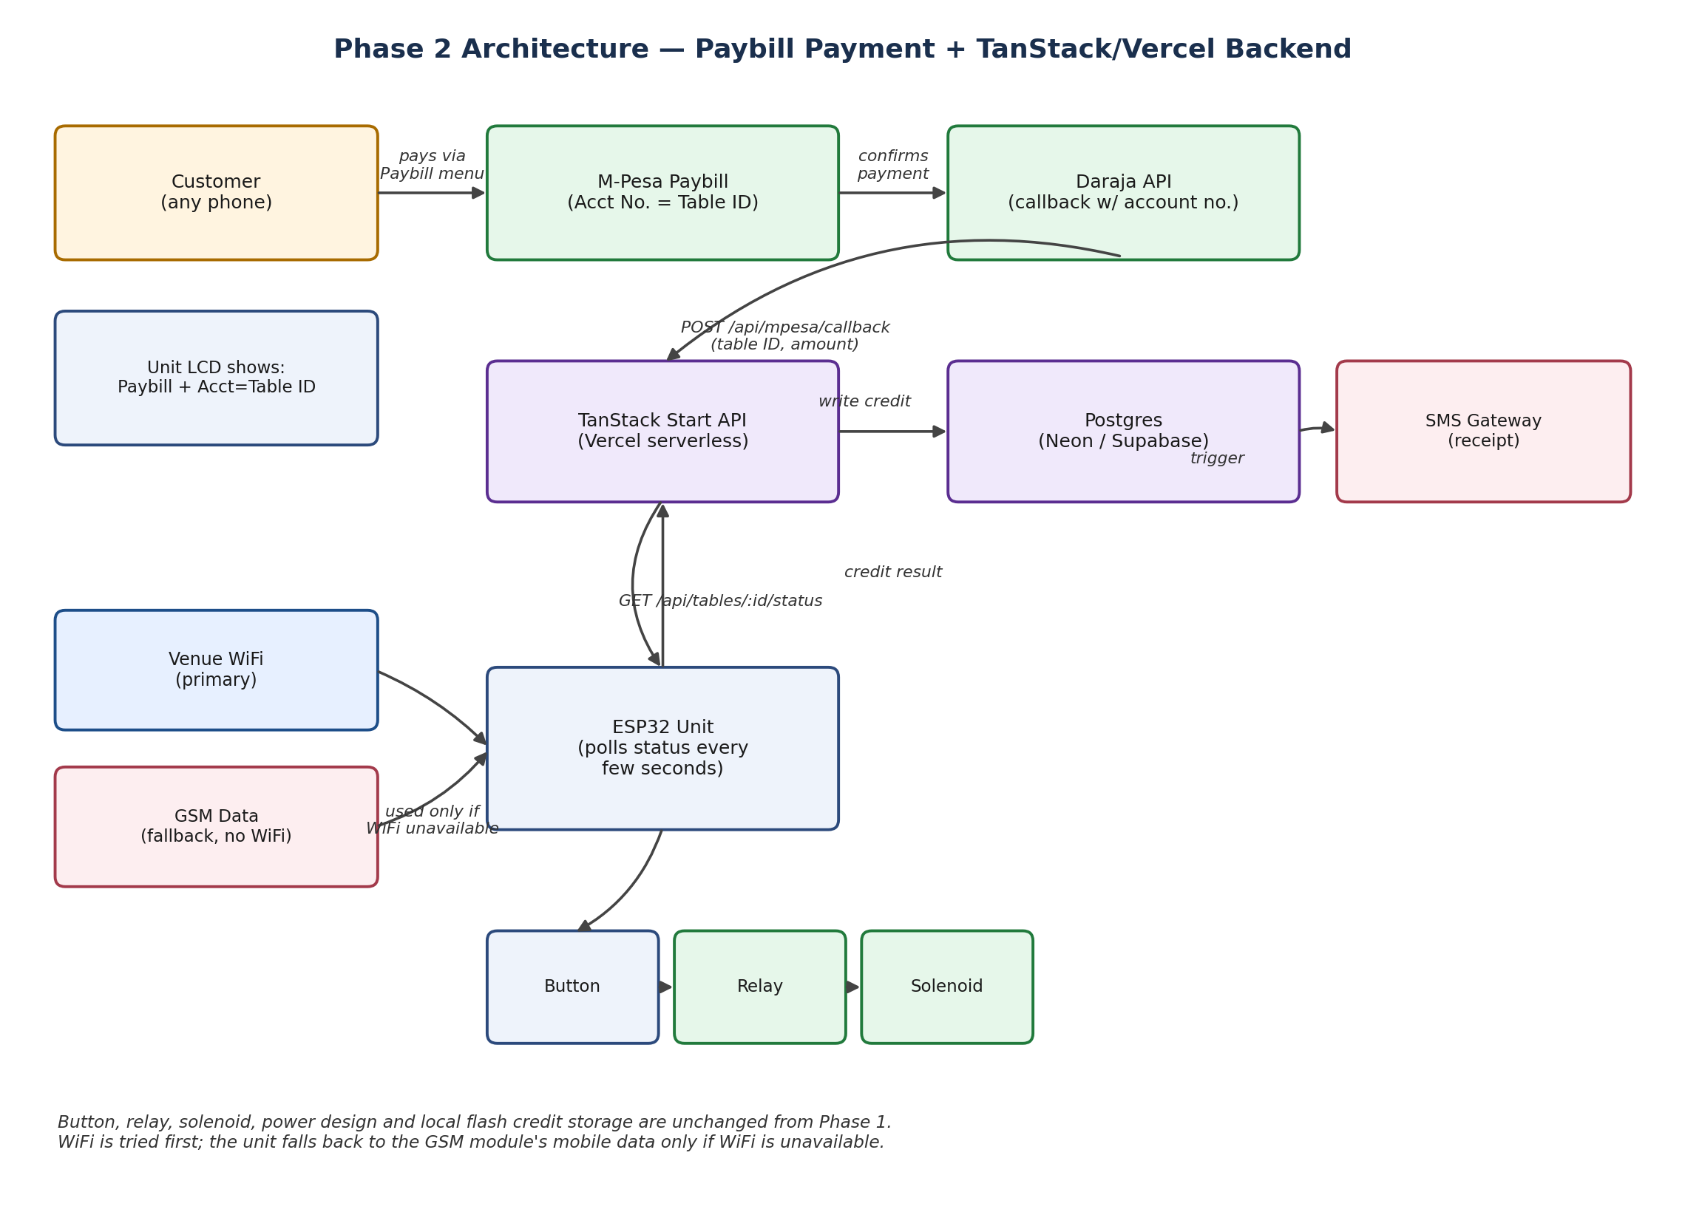

5. Backend (TanStack Start on Vercel)

5.1 Why this fits
The unit's polling model (“any payment for me?” every few seconds) and Daraja's callback are both simple request/response interactions with no need for a persistent connection — a natural fit for Vercel's serverless functions, and directly supported by TanStack Start's server routes.

5.2 API routes required
Route | Purpose
POST /api/mpesa/callback | Receives Daraja's payment confirmation; extracts account number (table ID) and amount; writes a confirmed transaction
GET /api/tables/:id/status | Polled by the unit; returns pending credit count and current price for that table
POST /api/tables/:id/consume | Called by the unit when a credit is consumed via the button, keeping the backend's record in sync
GET /api/tables/:id/config | Returns configuration such as price per game, allowing remote updates without reflashing

5.3 Database
A managed Postgres instance (Neon or Supabase, both pairing naturally with Vercel) stores locations, tables, and transactions. This is the same core schema the Phase 3 management platform will build on — designing it now avoids rework later.
tables: id, name, paybill_account_ref, price_per_game, status
transactions: id, table_id, amount, source (mpesa/cash), txn_ref, created_at

5.4 A note on real-time updates for later
Vercel serverless functions do not hold long-lived connections, which is not a limitation for Phase 2 — polling and webhooks cover everything the unit needs. It becomes relevant only in Phase 3, when the Boss and Manager apps need live “table just went busy” push updates. At that point, a small dedicated real-time layer (a managed service such as Supabase Realtime, Ably, or Pusher, or a lightweight persistent process on a platform like Fly.io or Railway) sits alongside the Vercel backend. Flagging this now only so the database schema is designed once rather than redesigned in Phase 3.

6. Firmware Changes
- Remove: the SMS payment parser used in Phase 1 (sms_parser.cpp's payment-parsing path)
- Add: an HTTP client that polls the status endpoint on an interval, and WiFi connection logic with automatic fallback to the GSM module's mobile data when WiFi is unavailable
- Keep: flash-based local credit storage — if connectivity drops mid-session, the unit must not lose track of a credit it has already confirmed
- Keep: the admin SMS commands (SET PRICE, STATUS, FREE) as a resilience fallback if the backend or connection is down

7. Connectivity Logic
on_boot():
try connect_wifi(saved_credentials), timeout 10s
if failed: switch_to_gsm_data()

loop():
every POLL_INTERVAL_SECONDS:
response = http_get(status_endpoint_for(table_id))
if response.ok: sync_credits_from(response)
else: retry with backoff; fall back to GSM data if WiFi link is down

8. Approval Points
- Confirm the venue's Paybill setup and how table account references will be assigned (e.g. TBL-01, TBL-02)
- Confirm hosting choice for Postgres (Neon vs. Supabase) — Supabase has the advantage of already including a real-time layer usable in Phase 3
- Confirm SMS gateway provider for receipts
- Approve building the backend and updated firmware for a single-table pilot before extending to multiple units

